REQUIREMENTS ENGINEERING
Digital Art Commission & Watermarking Portal
NAME | IBRAHIM KHALEEL
SRN | PES2UG25CS809
DATE | 20/08/2026
DOMAIN | Media, Events & Community
ACTORS | Client / Buyer, Digital Artist
PROJECT | Digital Art Commission & Watermarking Portal

1. FUNCTIONAL & NON-FUNCTIONAL REQUIREMENTS
Req ID | Type | Description | Priority | Acceptance Criteria | Rationale
FR-001 | Functional | The system shall allow Clients / Buyers to browse published digital artworks and view artwork details. | High | When a Client / Buyer opens the artwork gallery, all currently published artworks shall be displayed with their available details. | Helps buyers discover artists and select suitable digital artwork.
FR-002 | Functional | The system shall allow Clients / Buyers to submit digital art commission requests to Digital Artists. | High | When valid commission details are submitted, the system shall create a commission request and make it available to the selected Digital Artist. | Enables buyers to request customized digital artwork.
FR-003 | Functional | The system shall allow Digital Artists to accept, reject, and manage commission requests. | High | When an authorized Digital Artist updates a valid commission request, its status shall be updated and visible to the Client / Buyer. | Supports organized commission workflow and communication.
FR-004 | Functional | The system shall allow Digital Artists to upload completed artwork and apply a watermark before delivery. | High | When a valid artwork file is uploaded, the system shall apply the configured watermark and make the watermarked version available for delivery. | Protects artists' work from unauthorized reuse before final delivery.
FR-005 | Functional | The system shall allow Clients / Buyers to make payment and download the final watermarked artwork. | High | After a successful payment, the system shall confirm the transaction and allow the Client / Buyer to download the permitted artwork. | Provides a complete commission-to-delivery process.
FR-006 | Functional | The system shall allow Digital Artists to publish completed digital artworks for browsing. | Medium | When an authorized Digital Artist selects Publish for a valid artwork, the artwork shall appear in the published artwork gallery. | Helps artists showcase their work and attract potential clients.
NFR-001 | Nonfunctional | The system shall display artwork gallery, commission, and delivery pages within 3 seconds under normal operating conditions. | High | At least 9 out of 10 page-load tests shall complete within 3 seconds. | Ensures a responsive user experience.
NFR-002 | Nonfunctional | The system shall restrict commission-management, artwork-upload, watermarking, and publishing operations to authorized Digital Artists. | High | An unauthorized Client / Buyer attempting to perform restricted operations shall be denied access in 100% of test attempts. | Protects artwork and commission data from unauthorized modification.

2. UML USE-CASE DIAGRAM
The diagram models the two primary actors, their major interactions with the portal, and «include» / «extend» relationships.
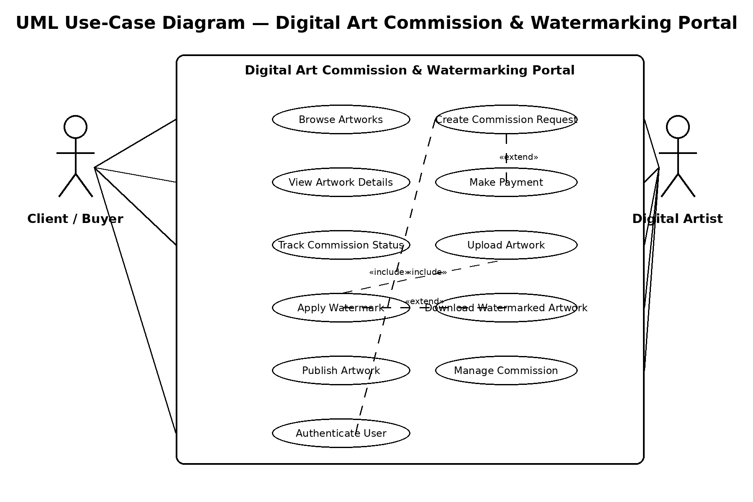

3. USE-CASE FLOW SPECIFICATION
Use Case: Submit Digital Art Commission
Use Case ID: UC-01
Primary Actor: Client / Buyer
Preconditions
- The Client / Buyer is authenticated in the Digital Art Commission & Watermarking Portal.
- The artwork gallery is accessible.
- The selected Digital Artist is available for commissions.
- The commission form is available.
Postconditions
- A commission request is successfully created.
- The request is associated with the selected Digital Artist and Client / Buyer.
- The commission status is initialized for further processing.
- The system displays a confirmation to the Client / Buyer.
Main Success Scenario
- The Client / Buyer opens the artwork gallery.
- The system displays published digital artworks.
- The Client / Buyer selects an artwork or Digital Artist.
- The system displays the relevant artwork and commission information.
- The Client / Buyer selects the commission option.
- The system validates the commission details.
- The Client / Buyer submits the commission request.
- The system creates the commission request and assigns it to the selected Digital Artist.
- The system displays a confirmation message indicating that the request was submitted successfully.
Alternate Flow
AF-01: Commission Request Cannot Be Submitted
- The Client / Buyer submits the commission request.
- The system detects missing or invalid required information.
- The system does not create the commission request.
- The system displays a message identifying the required correction.
- The Client / Buyer is returned to the commission form.

Use Case: Apply Watermark to Artwork
Use Case ID: UC-02
Primary Actor: Digital Artist
Brief Flow: The Digital Artist uploads completed artwork → the system validates the file → the system applies the configured watermark → the watermarked artwork is stored for protected delivery.

