NAME – Ibrahim khaleel
SECTION – D
SRN – PES2UG25CS809
LAB – 2

TITLE - Digital Art Commission Portal

DELIVERABLES

1. Jira Backlog with Epics & User Stories

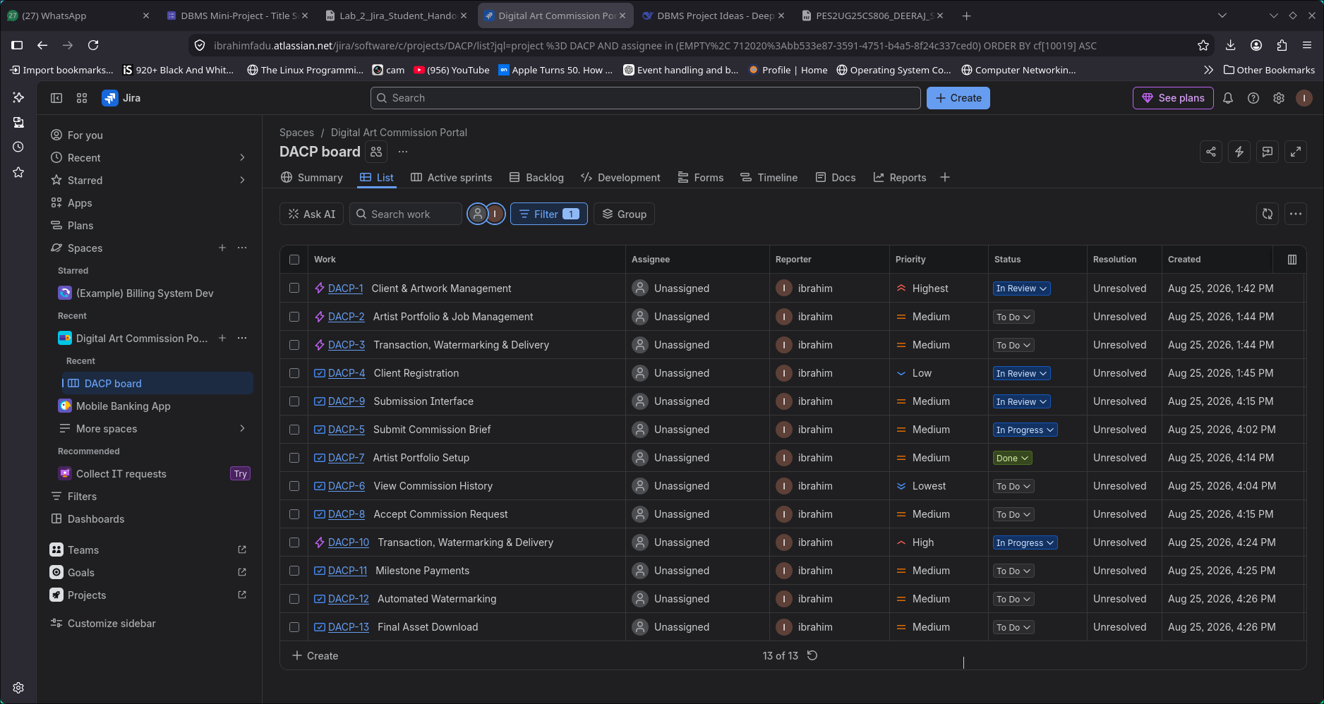

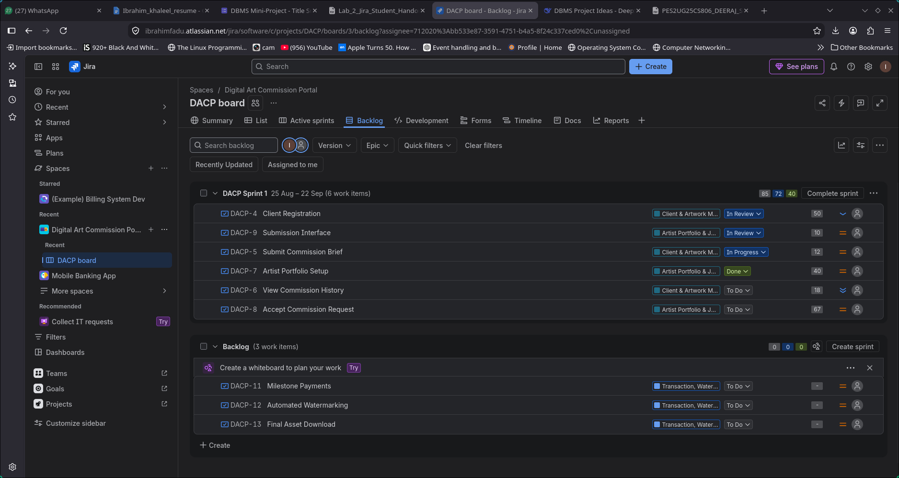
2. Story Point Assignments

3. Sprint Board / Active Sprint View

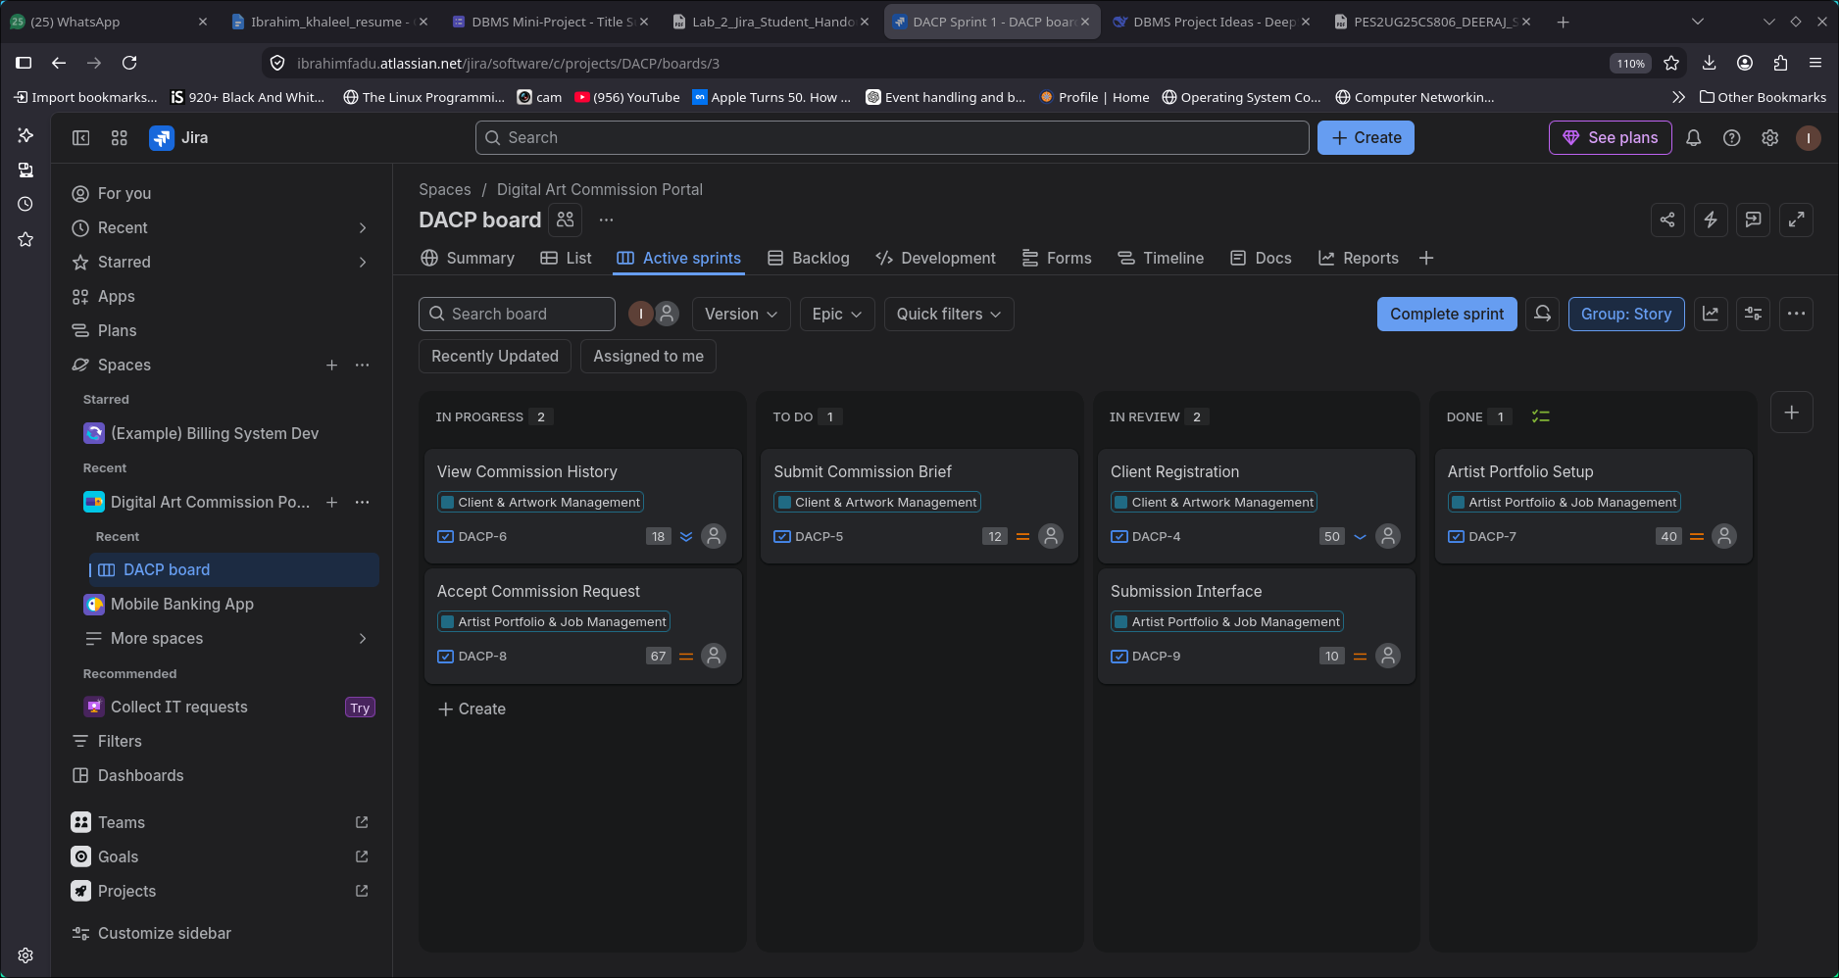

4. Burndown Chart
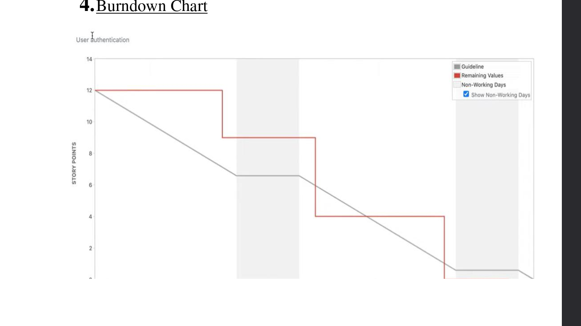

5. Brief Reflection Document answering the 4 reflection
questions:
i. Did your estimations reflect the actual effort?
Yes, the story point estimations were reasonably close
to the actual effort required. The Fibonacci scale helped
us differentiate between simple, moderate, and complex
tasks.
ii. Was your backlog well-prioritized?
Yes, the backlog was prioritized based on the
importance of each feature to the users and the overall
functionality of the system. High-priority features were
planned earlier in the sprints.
iii. How did your simulated sprint align with your
plan?
The simulated sprints generally followed the planned
backlog and allowed us to track the progress of the
selected user stories from To Do → In Progress →
Done.
iv. What insights did the burndown chart give
about your team’s capacity?CommentHighlight
The burndown chart helped us understand how quickly
work was being completed during the sprint. It also
showed the remaining workload and helped evaluate
the team's progress and capacity.

