SE LAB 3

Name: Ibrahim khaleel
SRN: PES2UG25CS809
SECTION: D

UML COMPONENT DIAGRAM

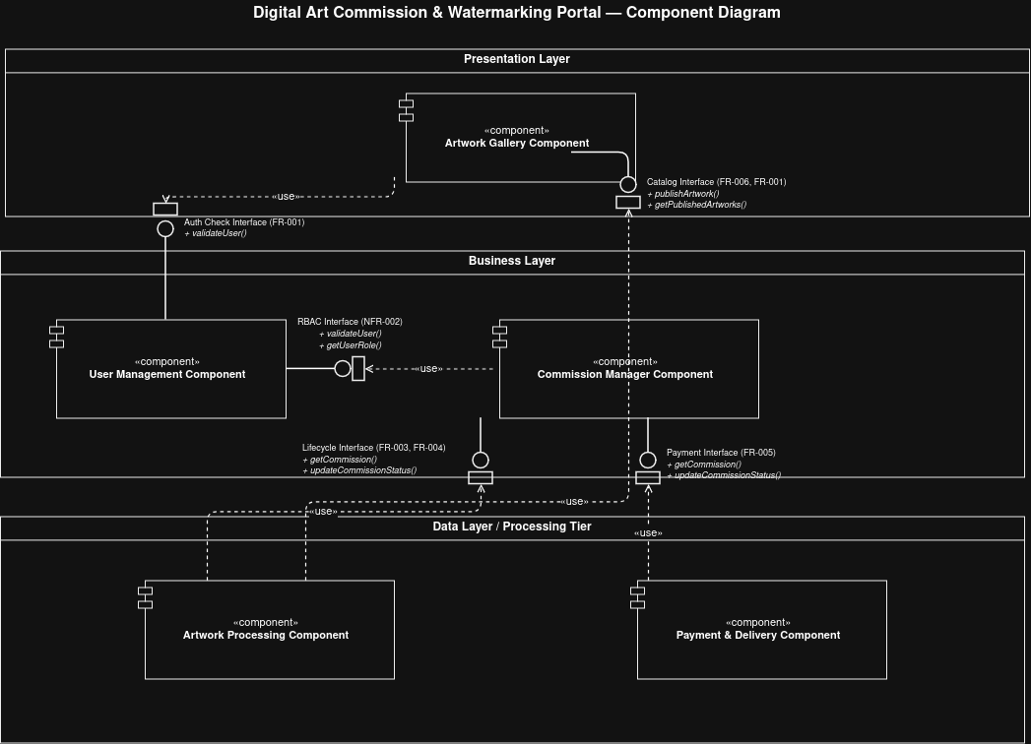

Written Justification - Digital Art Commission & Watermarking Portal

Architecture Selection
We chose Layered Architecture (3-Tier) for the Digital Art Commission & Watermarking Portal System.

Justification

Reason 1: Centralized Security Enforcement for Authorized Operations
The system has strict authorization requirements (NFR-002) where only Digital Artists can perform commission management, artwork upload, watermarking, and publishing operations. A layered architecture allows us to implement all security checks at the Business Logic Layer, creating a consistent "gatekeeper" that validates user roles before any sensitive operation executes.
For example, when a user attempts to upload artwork and apply a watermark (FR-004), the Business Logic Layer first validates via the User Management Component that the user has the "Digital Artist" role. This centralized approach ensures:
- Unauthorized users cannot bypass security controls
- All operations follow the same validation rules
- Security auditing is simplified and consistent
- NFR-002 is enforced across all restricted operations
This separation of security logic from presentation and data layers makes the system more secure and maintainable than a monolithic approach where security might be scattered across the codebase.

Reason 2: Performance Optimization for Gallery Browsing
NFR-001 requires gallery, commission, and delivery pages to load within 3 seconds under normal operating conditions (at least 9 out of 10 page-load tests). With a layered architecture, we can optimize the Data Access Layer specifically for read-heavy operations like gallery browsing.
The Artwork Gallery Component can:
- Use caching mechanisms for frequently accessed artwork thumbnails
- Implement database indexing for fast searches and filtering
- Utilize connection pooling for efficient database access
- Separate read operations (gallery browsing) from write operations (commission submissions, artwork uploads)
This separation ensures the high-traffic gallery browsing remains fast even when resource-intensive operations like watermarking or payment processing are running simultaneously in other layers.1
All access to the Data Access Layer passes through these security checks, enforcing NFR-002 consistently across all operations and preventing unauthorized access to sensitive artwork and commission data.

