The Transmission of Green Transition Shocks to Domestic Inflation: Findings

1. Descriptive Statistics
Table 1 presents the descriptive statistics for the core variables used in our dynamic panel and machine learning models.
Variable | Inflation_Rate | Inflation_Lag1 | CO2_Emissions_PC | GDP_Growth | Trade_Openness | Real_Interest_Rate
count | 1600.0 | 1600.0 | 1600.0 | 1600.0 | 1600.0 | 1600.0
mean | 14.308 | 14.125 | 4.99 | 3.118 | 59.424 | 1.843
std | 2.906 | 3.032 | 1.497 | 2.501 | 23.134 | 2.069
min | 5.832 | 3.564 | 0.513 | -4.678 | 20.011 | -4.442
25% | 12.359 | 12.193 | 3.93 | 1.398 | 39.72 | 0.472
50% | 14.222 | 14.089 | 5.024 | 3.055 | 58.782 | 1.814
75% | 16.269 | 16.146 | 5.995 | 4.825 | 79.907 | 3.24
max | 24.153 | 24.153 | 9.79 | 11.431 | 99.948 | 8.18

2. Dynamic Panel Data Analysis
Table 2 shows the Fixed Effects estimation capturing the unobserved heterogeneity across countries.
Predictor | Parameter | Std. Err. | T-stat | P-value | Lower CI | Upper CI
const | 0.7232 | 0.258 | 2.8032 | 0.0051 | 0.2172 | 1.2293
Inflation_Lag1 | 0.5617 | 0.0133 | 42.331 | 0.0 | 0.5357 | 0.5878
CO2_Emissions_PC | 0.7588 | 0.0254 | 29.913 | 0.0 | 0.709 | 0.8085
GDP_Growth | -0.17 | 0.0152 | -11.16 | 0.0 | -0.1999 | -0.1401
Trade_Openness | 0.0495 | 0.0017 | 28.92 | 0.0 | 0.0461 | 0.0528
Real_Interest_Rate | -0.2962 | 0.0179 | -16.562 | 0.0 | -0.3312 | -0.2611
R-squared for FE Model: 0.7131

3. Machine Learning (XGBoost) Findings
The predictive modeling utilizing XGBoost yielded an out-of-sample Test R-squared of 0.6809 and Test RMSE of 1.7339. The relative importance of CO2_Emissions_PC indicates its substantial role as an inflationary shock transmission mechanism.

Feature Importance Plot
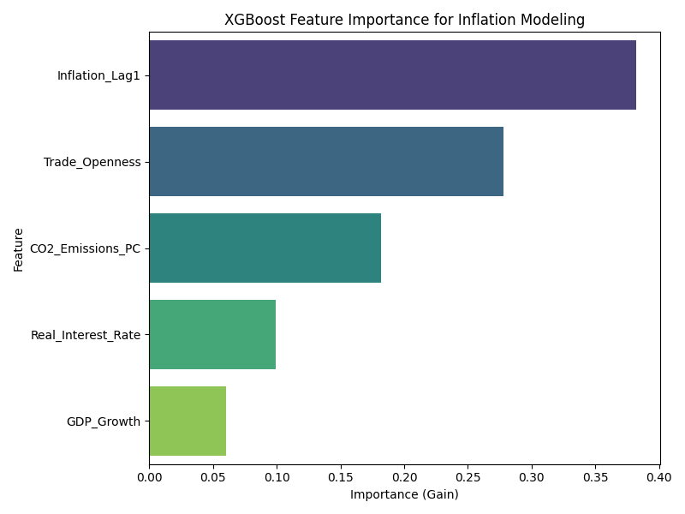

Scatter Plot: CO2 Emissions vs Inflation
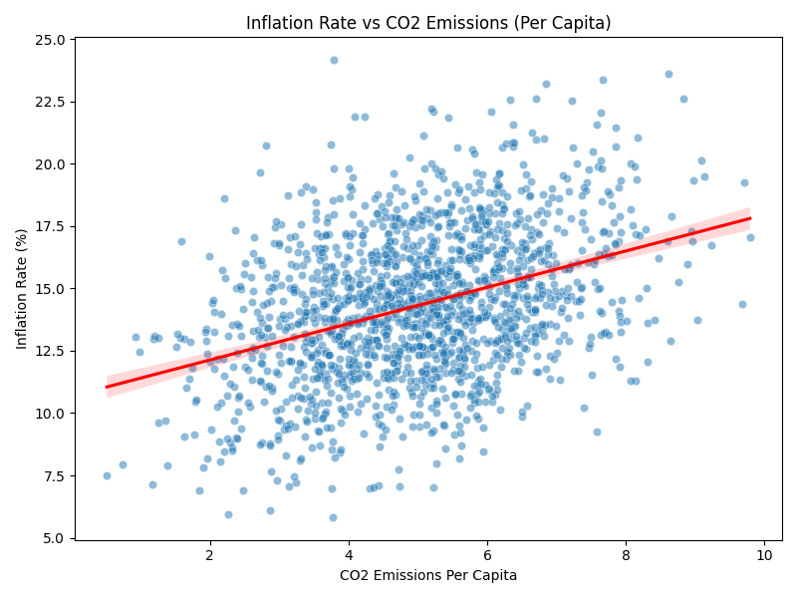

4. Advanced XGBoost & SHAP Diagnostics
To further dissect the non-linear relationship and the magnitude of the green transition shock, we employ SHAP (SHapley Additive exPlanations) values. The summary plot below demonstrates the directional impact of each feature, while the dependence plot isolates the effect of CO2 emissions on domestic inflation.

SHAP Summary Plot
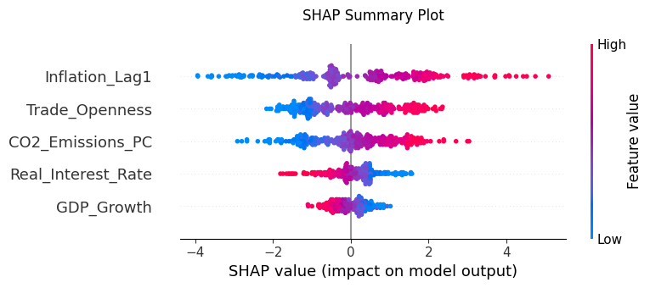

SHAP Dependence Plot (CO2 Emissions)
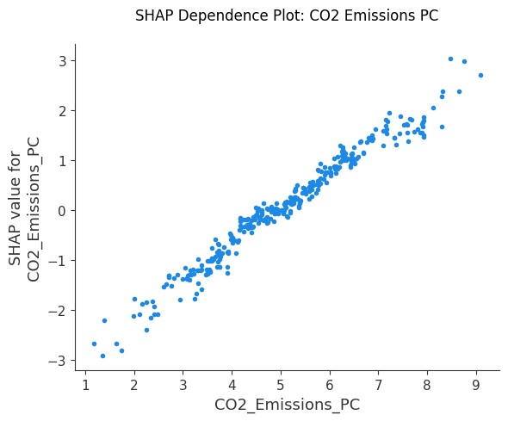

5. Panel Data Visualization
The structural dynamics of the panel data are visualized through macro trends over time and cross-sectional heterogeneity.

Macro Trend: Global Average Inflation and CO2
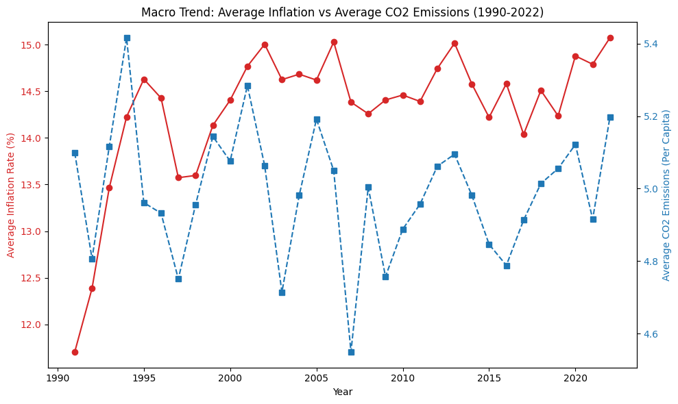

Cross-Sectional Heterogeneity (Inflation Variance by Country)
