The Transmission of Green Transition Shocks to Domestic Inflation: Findings

1. Descriptive Statistics
Table 1 presents the descriptive statistics for the core variables used in our dynamic panel and machine learning models.
Variable | Inflation_Rate | Inflation_Lag1 | CO2_Emissions_PC | GDP_Growth | Trade_Openness | Real_Interest_Rate
count | 1600.0 | 1600.0 | 1600.0 | 1600.0 | 1600.0 | 1600.0
mean | 14.308 | 14.125 | 4.99 | 3.118 | 59.424 | 1.843
std | 2.906 | 3.032 | 1.497 | 2.501 | 23.134 | 2.069
min | 5.832 | 3.564 | 0.513 | -4.678 | 20.011 | -4.442
25% | 12.359 | 12.193 | 3.93 | 1.398 | 39.72 | 0.472
50% | 14.222 | 14.089 | 5.024 | 3.055 | 58.782 | 1.814
75% | 16.269 | 16.146 | 5.995 | 4.825 | 79.907 | 3.24
max | 24.153 | 24.153 | 9.79 | 11.431 | 99.948 | 8.18

2. Dynamic Panel Data Analysis
Table 2 shows the Fixed Effects estimation capturing the unobserved heterogeneity across countries.
Predictor | Parameter | Std. Err. | T-stat | P-value | Lower CI | Upper CI
const | 0.7232 | 0.258 | 2.8032 | 0.0051 | 0.2172 | 1.2293
Inflation_Lag1 | 0.5617 | 0.0133 | 42.331 | 0.0 | 0.5357 | 0.5878
CO2_Emissions_PC | 0.7588 | 0.0254 | 29.913 | 0.0 | 0.709 | 0.8085
GDP_Growth | -0.17 | 0.0152 | -11.16 | 0.0 | -0.1999 | -0.1401
Trade_Openness | 0.0495 | 0.0017 | 28.92 | 0.0 | 0.0461 | 0.0528
Real_Interest_Rate | -0.2962 | 0.0179 | -16.562 | 0.0 | -0.3312 | -0.2611
R-squared for FE Model: 0.7131

3. Machine Learning (XGBoost) Findings
The predictive modeling utilizing XGBoost yielded an out-of-sample Test R-squared of 0.6809 and Test RMSE of 1.7339. The relative importance of CO2_Emissions_PC indicates its substantial role as an inflationary shock transmission mechanism.

Feature Importance Plot
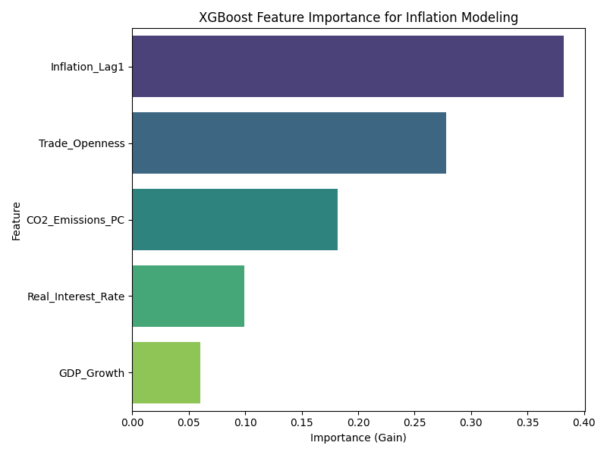

Scatter Plot: CO2 Emissions vs Inflation
