**Hang man game**

**DETAILS:**

University: Ghulam Ishaq Khan Institute of Engineering Sciences and Technology

Course: Data Structures and Algorithms Lab (CS221 L)

Instructor: Sir Usama Arshad

**GROUP MEMBERS:**

Muhammad Saadullah (2021446)

Syed Ibrahim Hamza (2021623)

Talha Wajid (2021672)

We have made “Hang man game” via C++ programming language. In this game, player has to guess a random word with its given hint.

The data structures we used are linked list, binary search tree and vectors.

The word’s length which player has to guess is stored in the linked list by underscores. As the player guesses the correct letter, the underscore changes to the letter guessed.

Each letter the player enters is first passed to binary search tree so that no duplicate letters are entered by player.

The category file, which is randomly selected, words are stored in vector which is then randomly selected and becomes the word to be guessed.

**Main menu:**

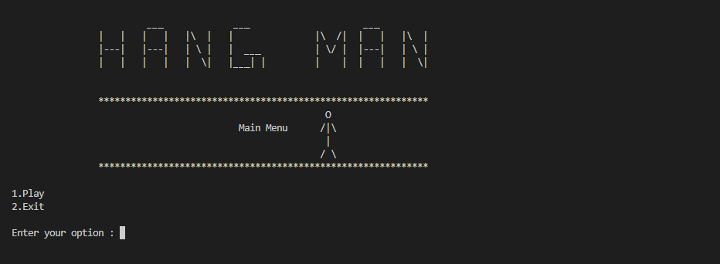

**Gameplay:**



