

E-Commerce Customer Behavior and RFM Analytics - Final Project Report

Student: Syed Ibrahim Hamza

Instructor: Dr. Reza Jafari

School: George Washington University

Course: DATS 6401 – Visualization of Complex Data

Date: 05/03/2026

Live Dashboard: https://ecommerce-rfm-dashboard-701238022699.us-east1.run.app/

Table of Contents
List of Figures and Tables 3
Abstract 6
Introduction 7
Dataset Description 8
Data Preprocessing 9
Outlier Detection and Removal 12
Principal Component Analysis 16
Normality Testing 23
Data Transformation 27
Heatmap and Pearson Correlation Coefficient Matrix 29
Statistical Analysis 31
Static Data Visualization 32
Subplots 65
Tables 68
Interactive Dashboard 69
Overall Observations 77
Conclusion 79
References 80
Appendix A: Supporting Python Code 81

List of Figures and Tables
Figure 1: LineTotal Distribution Before and After Outlier Removal Using IQR 13
Figure 2: Price Distribution Before and After Outlier Removal Using IQR 14
Figure 3: Quantity Distribution Before and After Outlier Removal Using IQR 14
Figure 4: Scree Plot of Principal Components 16
Figure 5: Cumulative Explained Variance 17
Figure 6: PCA Scatter Plot (2D) 18
Figure 7: PCA Scatter Plot (3D) 19
Figure 8: PCA Biplot of RFM Features 20
Figure 9: Singular Values by Principal Component 21
Figure 10: QQ Plot for Recency 24
Figure 11: QQ Plot for Frequency 25
Figure 12: QQ Plot for Monetary Value 26
Figure 13: Quantity Distribution Before and After Transformation 27
Figure 14: Price Distribution Before and After Transformation 28
Figure 15: LineTotal Distribution Before and After Transformation 28
Figure 16: Pearson Correlation Heatmap of RFM Variables 29
Figure 17: Spearman Correlation Heatmap of RFM Variables 30
Figure 18: Scatter Matrix of RFM Variables 32
Figure 19: Multivariate KDE – Frequency vs Monetary Value 33
Figure 20: Multivariate KDE – Recency vs Frequency 33
Figure 21: Multivariate KDE – Recency vs Monetary Value 34
Figure 22: Histogram + KDE of Recency 35
Figure 23: Histogram + KDE of Frequency 35
Figure 24: Histogram + KDE of Monetary Value 36
Figure 25: Boxplot of Recency 37
Figure 26: Boxplot of Frequency 37
Figure 27: Boxplot of MonetaryValue 38
Figure 28: Filled KDE Plot of Recency 38
Figure 29: Filled KDE Plot of Frequency 39
Figure 30: Filled KDE Plot of Monetary Value 39
Figure 31: Violin Plot of Recency 40
Figure 32: Violin Plot of Frequency 40
Figure 33: Violin Plot of Monetary Value 41
Figure 34: Scatter Plot of Frequency vs Recency 41
Figure 35: Scatter Plot of MonetaryValue vs Frequency 42
Figure 36: Scatter Plot of MonetaryValue vs Recency 43
Figure 37: Regression Plot of Frequency vs Recency 43
Figure 38: Regression Plot of Monetary Value vs Frequency 44
Figure 39: Regression Plot of Monetary Value vs Recency 44
Figure 40: Joint Plot of Frequency vs Recency 45
Figure 41: Joint Plot of Monetary Value vs Frequency 46
Figure 42: Joint Plot of Monetary Value vs Recency 47
Figure 43: Hexbin Plot of Frequency vs Recency 48
Figure 44: Hexbin Plot of Monetary Value vs Frequency 48
Figure 45: Hexbin Plot of Monetary Value vs Recency 49
Figure 46: Pair Plot of RFM Variables 50
Figure 47: Contour Plot of Monetary Value vs Recency 51
Figure 48: Rug Plot of Recency 51
Figure 49: Rug Plot of Frequency 52
Figure 50: Rug Plot of Monetary Value 52
Figure 51: Line Plot of Recency 53
Figure 52: Line Plot of Frequency 53
Figure 53: Line Plot of Monetary Value 54
Figure 54: Area Plot of Recency 55
Figure 55: Area Plot of Frequency 55
Figure 56: Area Plot of Monetary Value 56
Figure 57: Multivariate Boxplot of Frequency by Recency Segment 56
Figure 58: Boxen Plot of Frequency by Recency Segment 57
Figure 59: 3D Plot of RFM Variables 58
Figure 60: Count Plot of Transaction Status 59
Figure 61: Top 10 Countries by Total Revenue 59
Figure 62: Transaction Status by Purchase Quarter 60
Figure 63: Price Category Distribution by Purchase Quarter 60
Figure 64: Distribution of Price Categories 61
Figure 65: Heatmap of Price Category by Country 62
Figure 66: Cluster Map of Country Activity by Purchase Quarter 62
Figure 67: Strip Plot of Log(Quantity) by Purchase Quarter 63
Figure 68: Strip Plot of Log(LineTotal) by Price Category 63
Figure 69: Distribution of Log(Quantity) by Day of Week 64
Figure 70: Customer Behavior Through RFM 65
Figure 71: Transaction and Sales Patterns 66
Figure 72: Data Overview and Preprocessing Tab 69
Figure 73: Data Cleaning Tab 70
Figure 74: Outlier Detection Tab 71
Figure 75: Normality Testing Tab 72
Figure 76: Data Transformation Tab 72
Figure 77: Principal Component Analysis Tab 73
Figure 78: Numerical Analysis Tab 74
Figure 79: Categorical Analysis Tab 74
Figure 80: Statistical Analysis Tab 75
Figure 81: Repo structure 85

Table 1: First Five Observations of the Cleaned Dataset 9
Table 2: Descriptive Statistics of the Cleaned Dataset 10
Table 3: Missing Values Before and After Preprocessing 10
Table 4: Outlier Removal Comparison Across Methods 12
Table 5: PCA Variance Summary 17
Table 6: PCA Loadings for RFM Features 21
Table 7: Normality Test Results for RFM Variables 23
Table 8: Best Transformation Method Summary 27
Table 9: Descriptive Statistics of RFM Variables 31

Abstract
This project will give an in-depth analysis of customer purchasing habits based on the Online Retail II dataset - a very large (more than 1 million records) transverse dataset of transactions from a UK retail business’ eCommerce platform. This dataset contains a variety of numeric and categorical variables such as product prices and quantities, customer identifiers, date/time of purchase, and location.

The objectives of this project are to create the entire data analysis pipeline for converting raw transactional data into useful insights through the application of statistical techniques and graphical analysis. The data processing workflow involves: Data Preprocessing, Feature Engineering, Identifying Outliers, Testing for Normality, Transforming Data, Analyzing Correlations, Building Statistical Models, and reducing high dimensionality through the use of Principal Component Analysis (PCA). Lastly, customer behavior will be analyzed based on Recency, Frequency, and Monetary (RFM) measurements to aid with segmentation and clustering.

Static visualizations allow the identification of distributions, relationships, and temporal trends within a dataset. Statistical methods such as hypothesis testing, correlation testing, and multi-dimensional kernel density estimation have been used to validate visualizations produced from the data set. An interactive dashboard has been created using Dash in order to provide users with a means of interacting with the data set at different stages of the analysis.

The final deployment of the system is based on the Google Cloud Platform and utilizes Docker containers for an easily scalable and widely accessible way to explore the data set. Analysis of the data revealed that the distribution of customer purchasing patterns is highly skewed in favor of a relatively small number of customers generating a large amount of total revenue from sales. The purpose of this project was to demonstrate how visualizations, when combined with statistical analyses, can help find and understand significant trends in complicated but real-world datasets.

Introduction
The sheer volume of transactional data generated every day by today's e-commerce systems means that the transactions that happen on those sites contain a wealth of information about purchases made by customers, products and their attributes, and customers' behaviors over time. Because of this, analysis of this data is a key component in gaining insight into how customers behave and determining what type of items customers tend to purchase, which will allow businesses to make better decisions based upon evidence and data rather than solely based on gut feeling.

This project will develop a full-cycle analytical pipeline using Python for the purpose of exploring and interpreting transactional information collected at retail stores. The pipeline will contain all of the necessary components of an analytic workflow including the preparation and cleaning of data, the development of features, exploratory data analysis (EDA), detecting and removing outliers, performing statistical tests, transforming data into the appropriate format for analysis, analyzing correlations among the different types of data, and applying dimensionality reduction techniques. In addition, a model called Recency, Frequency, and Monetary (RFM) modeling, which uses customer behavioral data collected over time to help predict future purchasing behaviors will be used to gain knowledge regarding customer segments and performing clustering.

The analysis and output of the analysis will include static visualizations as well as dynamic visualizations. Static visualizations will be created to illustrate details regarding the distribution of values, relationships among different variables, and any anomalies within the data. Dynamic visualizations will be provided through an interactive dashboard developed using the Dash web application framework. The Dash web application and dashboard has been deployed on the Google Cloud Platform allowing users to access and interact with this analysis results in real time.

The outcome of this analysis and report will demonstrate how to effectively combine statistical methods with visualization techniques to discover meaningful insights from the complexity of real-world retail datasets.

Dataset Description
For conducting the analysis, the starting point for the project was to create an data set from records of customer transactions from an e-commerce business based in the UK, referred to as the "Online Retail II Data Set." This data set consists of records of customer purchases made between 2009 and 2011, with a total of 1,067,371 transactions, composed of eight original variables.

After preprocessing and feature engineering, the analysis completed on the Original Retail II Data Set included 1,033,036 transactions containing 17 total variables (numerical and categorical), allowing for extensive multivariate analysis.

The key variables in the dataset include:
- Numerical Variables: Quantity, Price, LineTotal, Year, Month, Day, Hour
- Categorical Variables: Invoice, StockCode, Description, Country, TransactionStatus, PurchaseQuarter, PriceCategory, DayOfWeek
- Customer Identifier: CustomerID
Additional variables were created through feature engineering like adjusting for PurchaseQuarter, TransactionStatus (i.e., Completed vs. Cancelled), and including the LineTotal (i.e., Price multiplied by Quantity). Other time-related attributes were also extracted from the invoice timestamp like Year; Month; Day; Hour; and DayOfWeek.

The customer purchase behavior in this analysis is mostly modelled using Recency, Frequency and Monetary value (RFM) data, with the Monetary value being calculated from the previously calculated LineTotal. Using the information in the data for independent and dependent variables will allow researchers and analysts to better analyze customer purchase behaviors through understanding how to evaluate and identify patterns and relationships.

The characteristics of the dataset have real-world applications within retail in helping to describe and demonstrate key operational challenges experienced, such as missing customer identifiers, skewed distributions, cancellations and extreme values. As a result of these characteristics, the dataset is well-suited as a tool for demonstrating techniques for data preprocessing, statistical analyses, and data visualization within a realistic operational or business setting.

Data Preprocessing
Data preprocessing is a critical step in preparing raw transactional data for analysis. The dataset contains missing values, duplicate records, and domain-specific irregularities such as negative quantities and prices. A structured data cleaning pipeline was implemented to address these issues and prepare the dataset for further analysis.

The preprocessing steps included:
- Removal of duplicate records
- Handling missing values in customer identifiers and descriptions
- Conversion of timestamp variables into datetime format
- Feature engineering to create new analytical variables
- Extraction of temporal features from invoice timestamps
- Creation of transaction status indicators for cancellations and adjustments

The effectiveness of preprocessing is evaluated by comparing the dataset before and after cleaning, as well as examining summary statistics and sample observations.

Table 1: First Five Observations of the Cleaned Dataset

The cleaned dataset shows that feature engineering has been successfully applied. New variables such as LineTotal, TransactionStatus, PurchaseQuarter, and PriceCategory are present alongside the original features. Temporal variables such as Year, Month, Day, Hour, and DayOfWeek have been extracted from the invoice timestamp, enabling time-based analysis.

The dataset structure confirms that each transaction contains both numerical and categorical attributes, supporting multivariate analysis and visualization.

 | Quantity | Price | CustomerID | LineTotal | Year | Month | Day | Hour
count | 1033036 | 1033036 | 797885 | 1033036 | 1033036 | 1033036 | 1033036 | 1033036
mean | 10.07688 | 4.61398 | 15313.06 | 18.25254 | 2010.436 | 7.393369 | 15.34747 | 13.0254
std | 175.1976 | 122.3975 | 1696.467 | 295.6873 | 0.576568 | 3.500953 | 8.642656 | 2.439641
min | -80995 | -53594.4 | 12346 | -168470 | 2009 | 1 | 1 | 6
25% | 1 | 1.25 | 13964 | 3.75 | 2010 | 4 | 8 | 11
50% | 3 | 2.1 | 15228 | 9.92 | 2010 | 8 | 15 | 13
75% | 10 | 4.15 | 16788 | 17.7 | 2011 | 11 | 23 | 15
max | 80995 | 38970 | 18287 | 168469.6 | 2011 | 12 | 31 | 21
Table 2: Descriptive Statistics of the Cleaned Dataset

The descriptive statistics indicate that the dataset contains highly skewed distributions and extreme values. The Quantity variable shows a wide range, including both large positive and large negative values, reflecting bulk purchases and cancellations. Similarly, the Price and LineTotal variables exhibit large standard deviations and extreme maximum values, indicating the presence of high-value transactions.

The presence of negative values in Quantity and LineTotal confirms that cancellations and returns are recorded in the dataset. These values are not treated as errors but represent meaningful business events. The large difference between the mean and median values across several variables suggests that the data is not normally distributed and contains heavy tails.

These characteristics highlight the need for outlier detection, normalization, and transformation in later stages of the analysis.

Variable | Missing (Raw) | Missing (Cleaned)
Description | 4382 | 4275
CustomerID | 243007 | 235151
Table 3: Missing Values Before and After Preprocessing

The dataset contains a significant number of missing values in the CustomerID field, which remains partially unresolved after preprocessing. This is expected in real-world retail data, where some transactions are not associated with identifiable customers. These records are retained for aggregate analysis but excluded from customer-level modeling such as RFM analysis.

The Description field contains a small number of missing values, which do not significantly impact on the overall analysis. No missing values are present in critical numerical variables such as Quantity, Price, and LineTotal after preprocessing.

Overall, the preprocessing pipeline successfully improves data quality while preserving important transactional information required for analysis.

Outlier Detection and Removal
The dataset contains extreme values in key numerical variables such as Quantity, Price, and LineTotal. These outliers arise due to bulk purchases, cancellations, and accounting adjustments. While some extreme values are meaningful in a business context, their presence significantly distorts statistical analysis and visualization.

To address this issue, three outlier detection methods were applied:
- Interquartile Range (IQR)
- Z-score method
- Isolation Forest (machine learning-based method)

Each method was evaluated by comparing the distribution of variables before and after outlier removal.

Method | Original Size | New Size | % Removed
IQR | 1,033,036 | 827,470 | 19.90%
Z-score | 1,033,036 | 1,030,662 | 0.23%
Isolation Forest | 1,033,036 | 1,012,430 | 1.99%
Table 4: Outlier Removal Comparison Across Methods

The IQR method removes approximately 19.9% of the dataset, indicating the presence of many extreme values. In contrast, the Z-score method removes only 0.23% of observations, suggesting that it is less sensitive to skewed distributions. The Isolation Forest method removes approximately 1.99% of the data, providing a balanced approach between statistical and model-based detection.

Based on these results, the IQR method is selected for further analysis because it effectively removes extreme values while preserving the overall structure of the dataset.

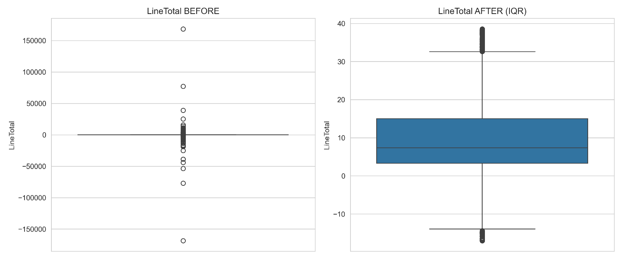
Figure 1: LineTotal Distribution Before and After Outlier Removal Using IQR

The LineTotal variable exhibits extreme values in the original dataset, with both large positive and negative values representing bulk purchases and cancellations. These extreme values significantly distort the scale of the data.
After applying the IQR method, the distribution becomes more compact, with many values concentrated within a narrower range. The removal of extreme outliers improves the interpretability of the dataset and reduces the impact of extreme transactions on subsequent analysis.

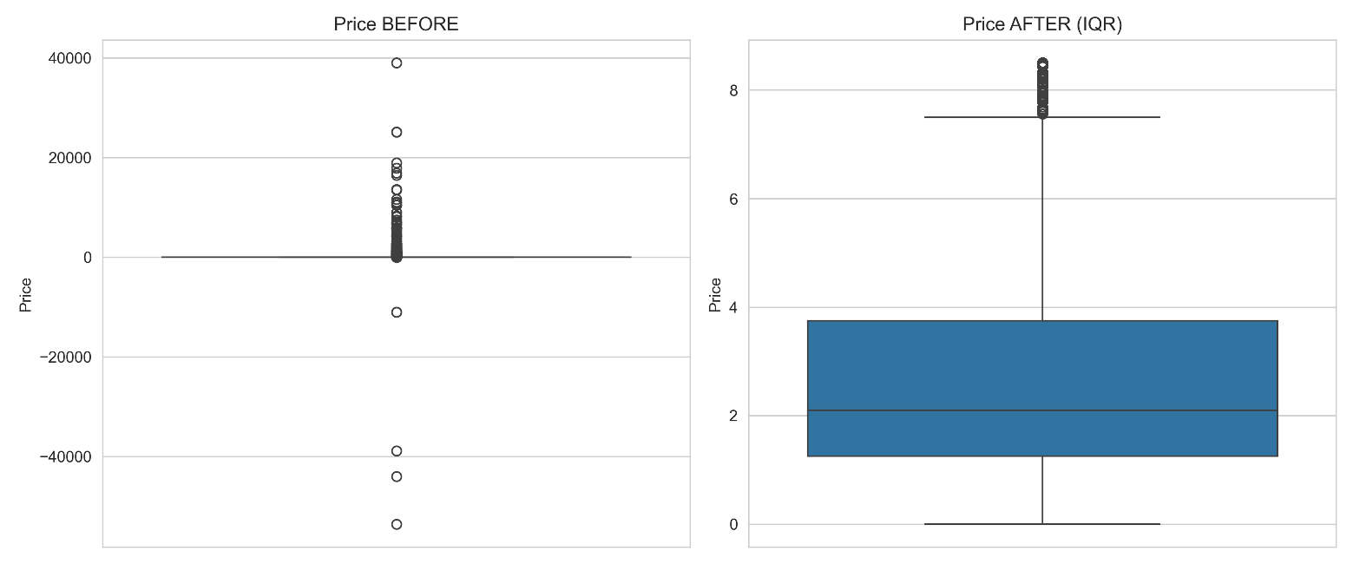
Figure 2: Price Distribution Before and After Outlier Removal Using IQR

The Price variable shows a highly skewed distribution in the original dataset, with several extreme values that exceed typical product pricing. These values may correspond to data entry errors or unusually high-priced items.
After applying the IQR method, the distribution becomes significantly more stable, with most values falling within a reasonable range. This indicates that the IQR method effectively removes unrealistic price values while preserving the core distribution of the data.

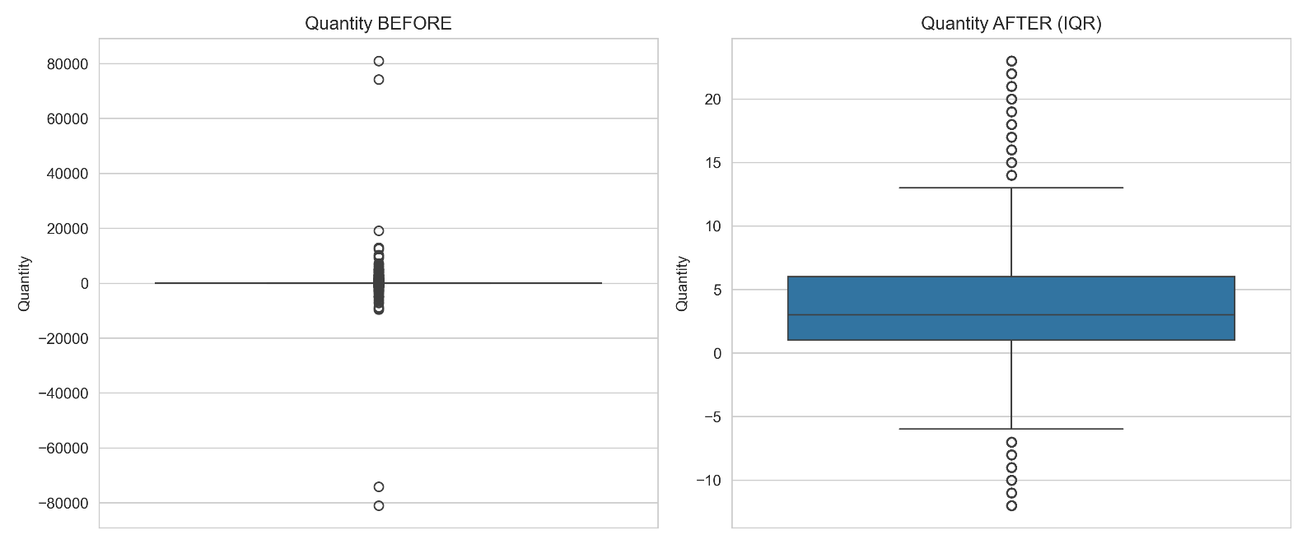
Figure 3: Quantity Distribution Before and After Outlier Removal Using IQR
The Quantity variable contains extreme positive and negative values in the original dataset, reflecting bulk orders and cancellations. These extreme values result in a highly dispersed distribution.
After outlier removal using the IQR method, the distribution becomes more concentrated around typical purchase quantities. This improves the reliability of statistical analysis and ensures that extreme transactions do not dominate the dataset.

Overall, the presence of significant outliers confirms that the dataset is highly skewed and contains heavy-tailed distributions. The IQR method is effective in removing extreme values while maintaining meaningful transactional data. This cleaned dataset is used in subsequent stages of the analysis, including normality testing, transformation, and PCA.

Principal Component Analysis
Principal Component Analysis (PCA) was applied to reduce the dimensionality of the RFM (Recency, Frequency, MonetaryValue) dataset while preserving as much variance as possible. PCA transforms the original correlated variables into a new set of uncorrelated variables called principal components.

Before applying PCA, the data was standardized to ensure that all variables contributed equally to the analysis.

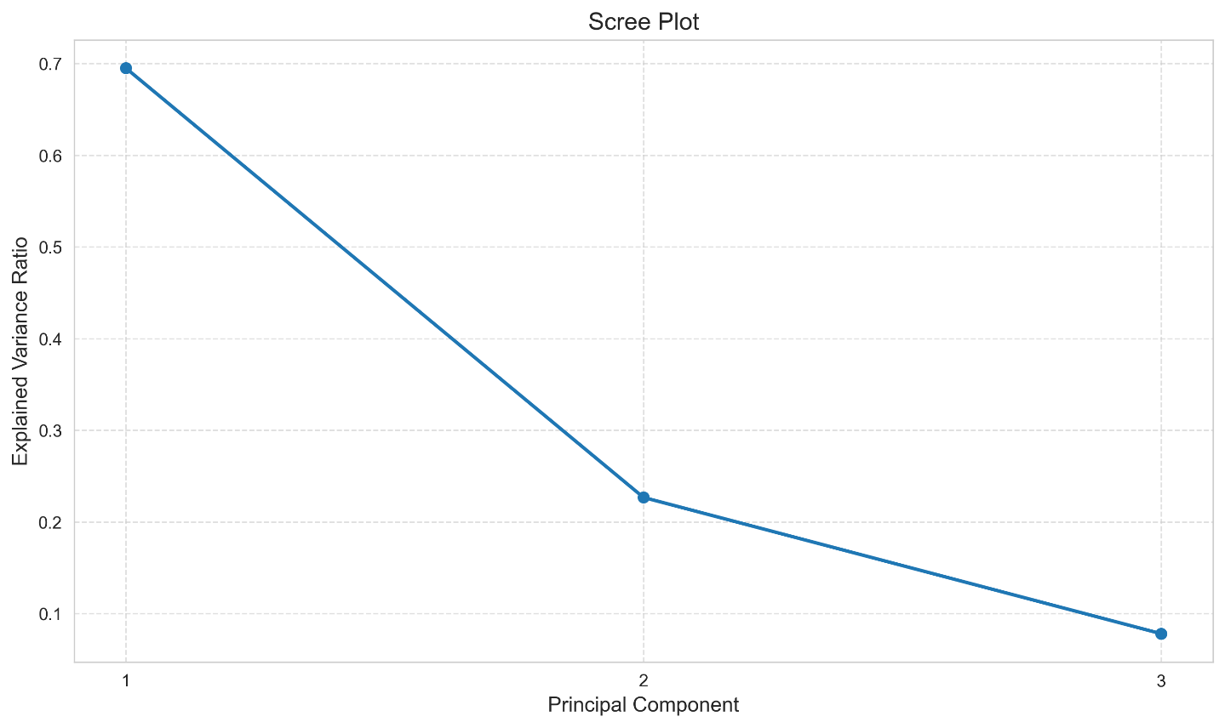
Figure 4: Scree Plot of Principal Components

The scree plot shows a sharp decline in explained variance after the first principal component and a clear elbow at the second component. This indicates that the first two components capture the majority of the variance, while the third component contributes relatively little additional information.

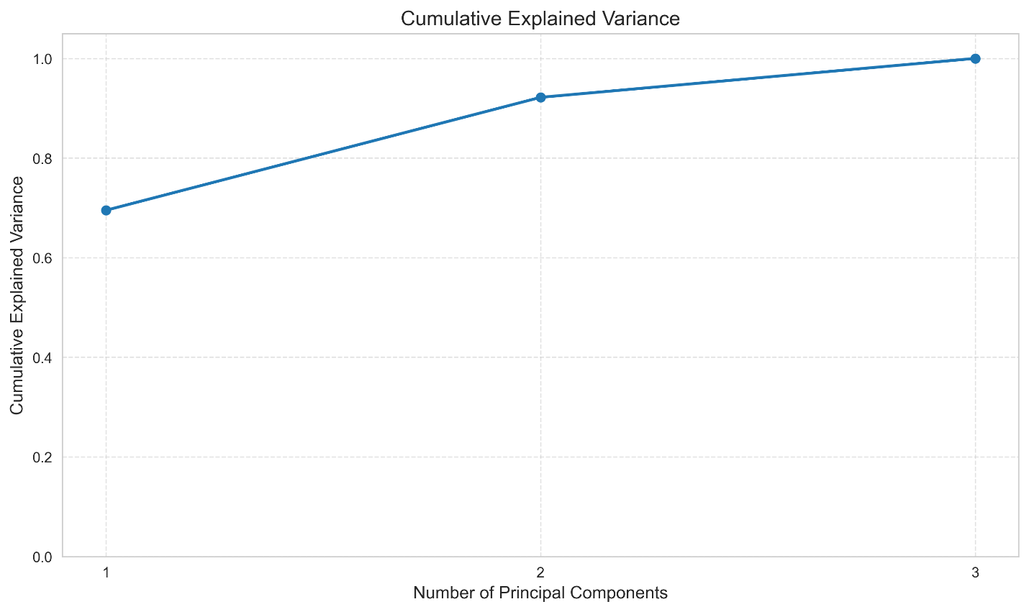
Figure 5: Cumulative Explained Variance

The cumulative explained variance shows that the first principal component explains approximately 69.5% of the total variance, while the first two components together explain over 92%. This confirms that a two-dimensional representation is sufficient to capture most of the underlying structure in the dataset.

Component | Explained Variance | Explained Variance Ratio | Cumulative Variance Ratio | Singular Value
PC1 | 2.09 | 0.70 | 0.70 | 102.15
PC2 | 0.68 | 0.23 | 0.92 | 58.35
PC3 | 0.23 | 0.08 | 1 | 34.26
Table 5: PCA Variance Summary

The variance summary confirms that PC1 is the dominant component, followed by PC2, with PC3 contributing minimal additional information. This supports dimensionality reduction from three variables to two principal components without significant loss of information.

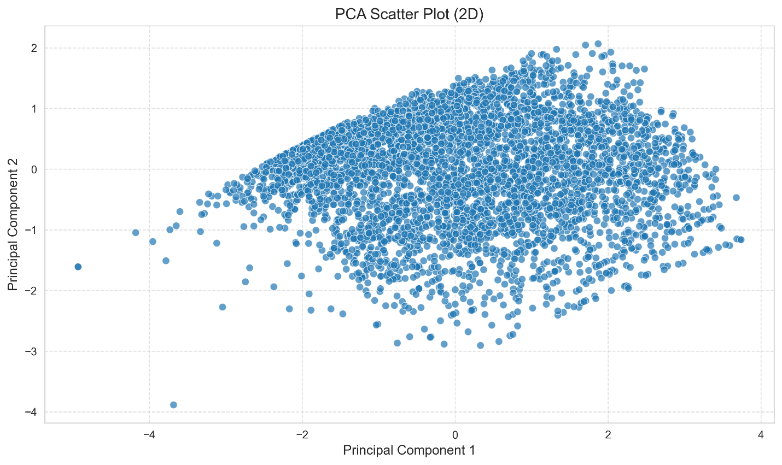
Figure 6: PCA Scatter Plot (2D)

The PCA scatter plot shows the distribution of customers in the reduced two-dimensional space. The spread along PC1 indicates a dominant behavioral gradient, likely driven by purchasing intensity (frequency and monetary value), while PC2 captures secondary variation related to recency.

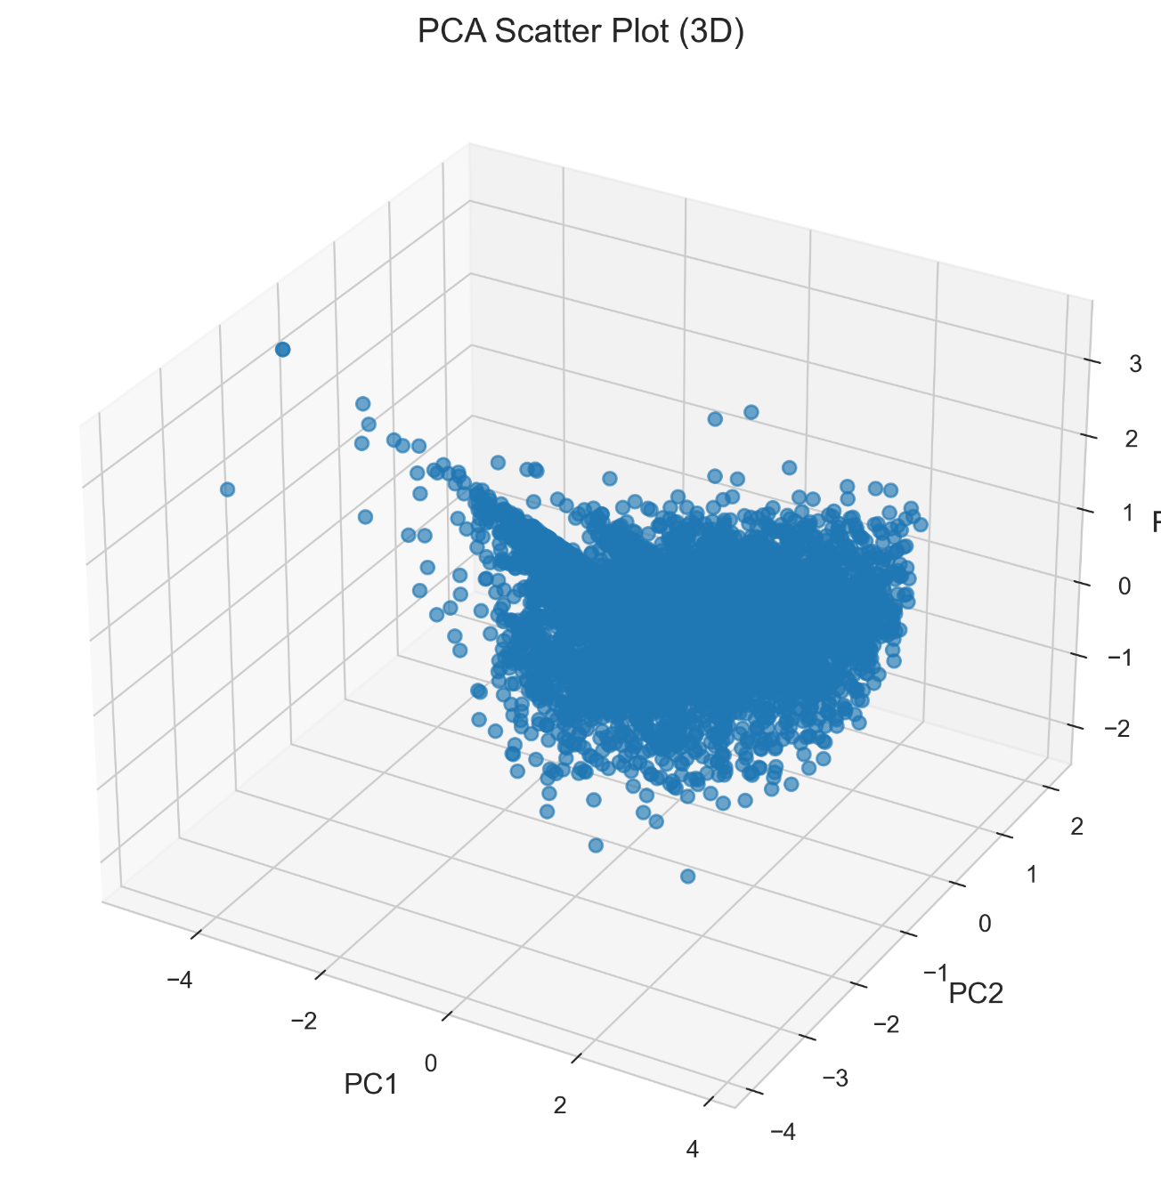
Figure 7: PCA Scatter Plot (3D)

The 3D PCA plot shows that the third component adds limited additional separation. Most of the structure is already captured in the first two components, confirming that dimensionality reduction to two components is sufficient for visualization and analysis.

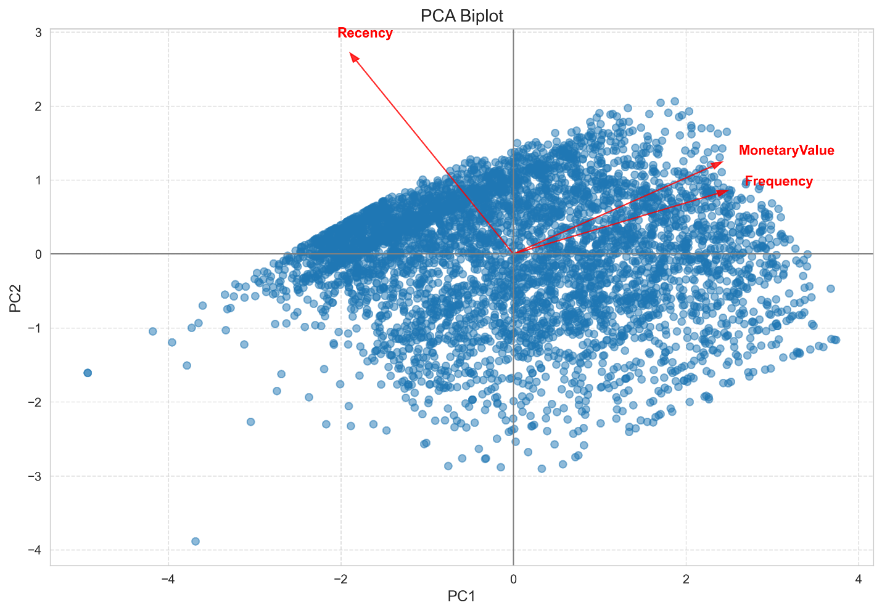
Figure 8: PCA Biplot of RFM Features

The PCA biplot shows the relationships between the original variables and the principal components. Frequency and MonetaryValue are strongly aligned in the same direction, indicating a positive correlation between purchase frequency and spending behavior.

Recency points in the opposite direction, suggesting an inverse relationship with Frequency and MonetaryValue. This means that customers who have purchased recently tend to buy more frequently and spend more, while customers with high recency (inactive customers) tend to have lower engagement and monetary value.

Feature | PC1 | PC2 | PC3
Recency | -0.47928 | 0.873775 | 0.082506
Frequency | 0.628693 | 0.276207 | 0.726949
Monetary Value | 0.612401 | 0.400283 | -0.68172
Table 6: PCA Loadings for RFM Features

The loadings table shows the contribution of each original variable to the principal components. PC1 is primarily influenced by Frequency and MonetaryValue, while PC2 is dominated by Recency. This confirms the interpretation that PC1 represents customer value, while PC2 represents recency behavior.

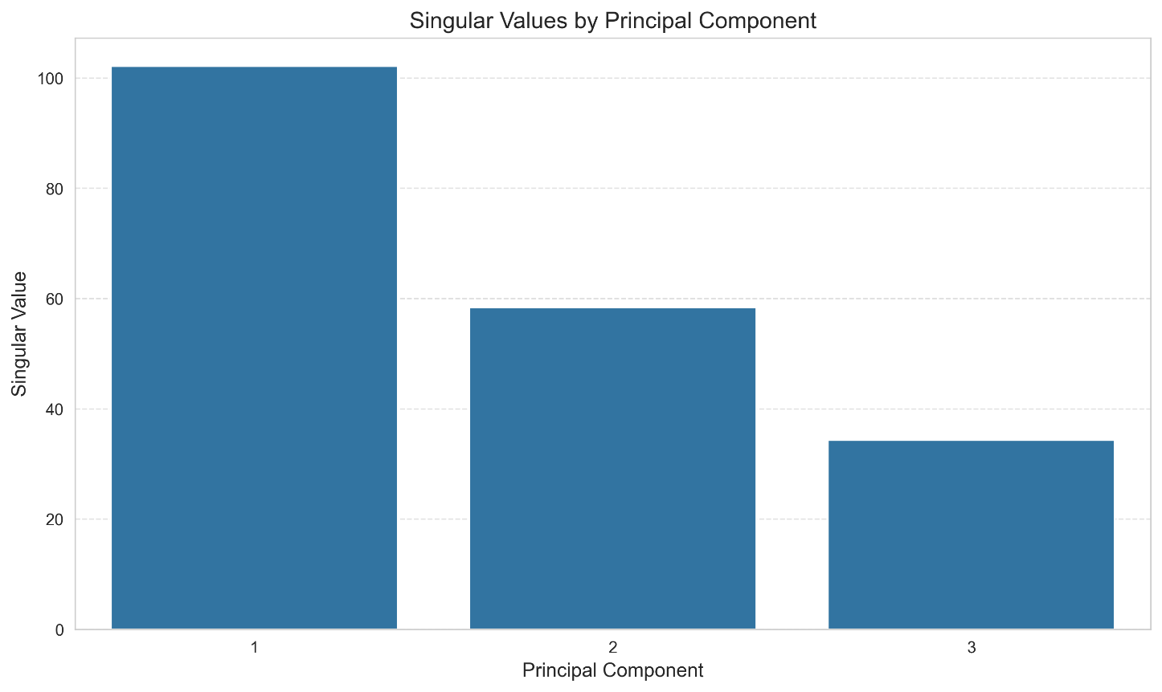
Figure 9: Singular Values by Principal Component
The singular values decrease from PC1 to PC3, indicating that each successive component captures less variation. This aligns with the explained variance results and further confirms the dominance of the first principal component.
Metric | Value
Condition Number | 2.98

The condition number of the PCA decomposition is 2.98, which indicates that the dataset is well-conditioned and does not suffer from severe multicollinearity. This suggests that the PCA results are stable and reliable.

Overall, PCA successfully reduced the dimensionality of the dataset while preserving over 92% of the variance using only two components. The analysis reveals that customer behavior is primarily driven by purchasing intensity (Frequency and MonetaryValue), with Recency acting as an inverse indicator of engagement. These results validate the effectiveness of PCA for simplifying the dataset and preparing it for further analysis and visualization.

Normality Testing
Statistical methods often assume that data follows a normal (Gaussian) distribution. To evaluate this assumption, normality testing was performed on the key RFM variables: Recency, Frequency, and MonetaryValue.

Three statistical tests were used:
- Shapiro–Wilk test
- Kolmogorov–Smirnov test
- D’Agostino K² test

In addition, Quantile–Quantile (QQ) plots were used to visually assess deviations from normality. These methods provide both statistical and graphical evidence regarding the distribution of the data.

Feature | N | Test | Statistic | p-value | Decision | Notes
Recency | 5004 | Shapiro-Wilk | 0.874669 | 0 | Not Normal | Sampled to 5000
Recency | 5004 | Kolmogorov-Smirnov | 0.170578 | 0 | Not Normal | Against fitted normal distribution
Recency | 5004 | D'Agostino KÂ² | 698.2168 | 0 | Not Normal | Full sample used
Frequency | 5004 | Shapiro-Wilk | 0.801264 | 0 | Not Normal | Sampled to 5000
Frequency | 5004 | Kolmogorov-Smirnov | 0.204881 | 0 | Not Normal | Against fitted normal distribution
Frequency | 5004 | D'Agostino KÂ² | 1396.284 | 0 | Not Normal | Full sample used
MonetaryValue | 5004 | Shapiro-Wilk | 0.845803 | 0 | Not Normal | Sampled to 5000
MonetaryValue | 5004 | Kolmogorov-Smirnov | 0.14654 | 0 | Not Normal | Against fitted normal distribution
MonetaryValue | 5004 | D'Agostino KÂ² | 956.2218 | 0 | Not Normal | Full sample used
Table 7: Normality Test Results for RFM Variables

The results of all three statistical tests indicate that none of the RFM variables follow a normal distribution. For all features, the p-values are effectively zero, leading to the rejection of the null hypothesis of normality.

The Shapiro–Wilk test, which is sensitive to deviations from normality, confirms strong non-normality across all variables. Similarly, the Kolmogorov–Smirnov and D’Agostino K² tests provide consistent results, reinforcing the conclusion that the dataset does not follow a Gaussian distribution.

These findings suggest that parametric statistical methods that assume normality may not be appropriate without transformation.

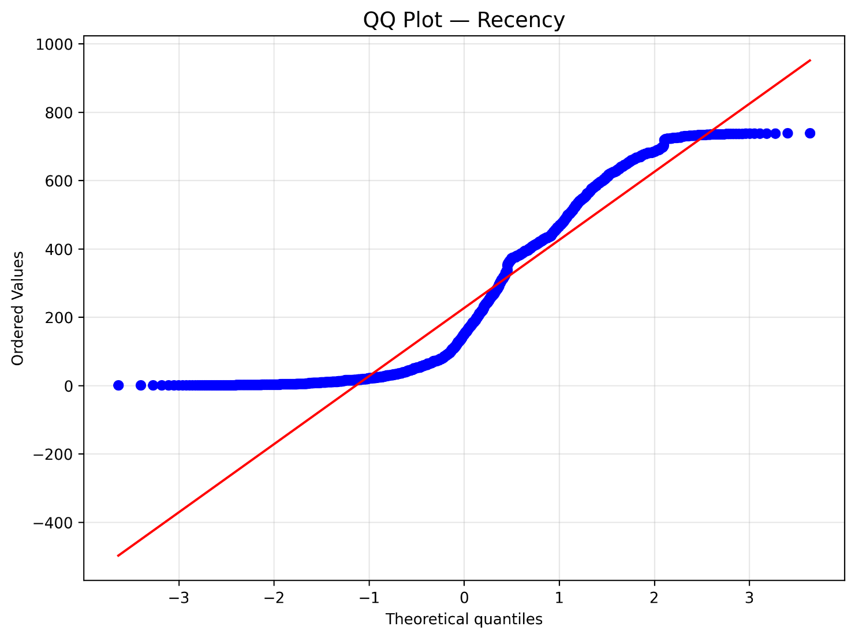
Figure 10: QQ Plot for Recency

The QQ plot for Recency shows a clear deviation from the reference line, particularly in the upper quantiles. This indicates that the distribution is right-skewed, with a long tail of higher values. The deviation from linearity confirms that Recency does not follow a normal distribution.

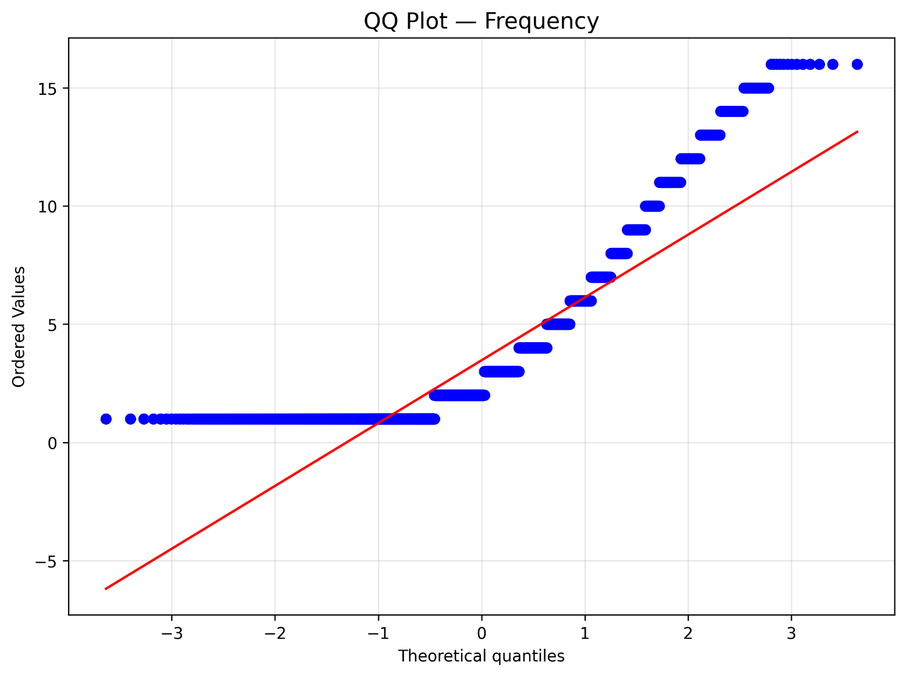
Figure 11: QQ Plot for Frequency

The QQ plot for Frequency exhibits a step-like pattern due to its discrete nature and shows significant deviation from the theoretical normal line. This indicates that the data is not normally distributed and contains clustering at lower values with a long right tail.

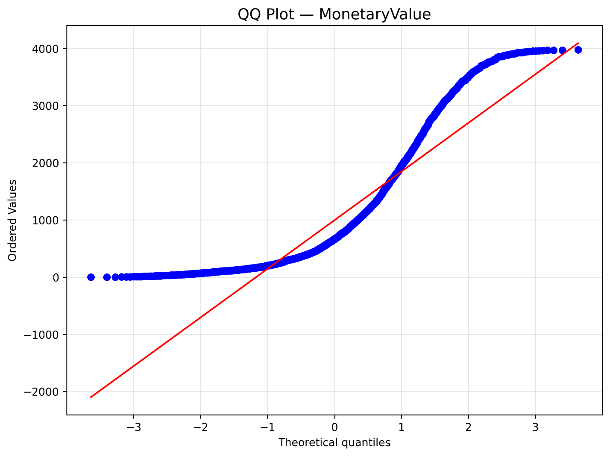
Figure 12: QQ Plot for Monetary Value

The QQ plot for MonetaryValue shows strong curvature and deviation from the reference line, particularly in the upper quantiles. This indicates the presence of heavy tails and extreme values. The distribution is highly skewed, confirming that it does not follow a normal distribution.

Overall, both statistical tests and graphical analysis confirm that all RFM variables are non-normally distributed. This is expected in real-world retail data, where customer behavior tends to be highly skewed, with a small number of customers contributing disproportionately to overall activity and revenue.

These results justify the need for data transformation techniques, which are applied in the next section to improve the distributional properties of the data.

Data Transformation
The normality testing results showed that the numerical variables were not normally distributed. Therefore, data transformation was applied to reduce skewness, improve symmetry, and prepare the data for later statistical analysis, PCA, and clustering.

The transformation methods applied were Log transformation, Box-Cox transformation, Standardization, and MinMax scaling. Since Log and Box-Cox require positive values, only strictly positive records were used for transformation comparison.

Feature | Method | Avg_p_value | Skewness | Kurtosis | Abs_Skewness | Abs_Kurtosis | Score
LineTotal | Box-Cox | 1.48E-10 | 0.026552 | 0.570323 | 0.026552 | 0.570323 | 0.419603
Price | Box-Cox | 1.43E-23 | 0.129477 | 1.385274 | 0.129477 | 1.385274 | 0.349457
Quantity | Box-Cox | 6.31E-48 | 0.137072 | -1.14614 | 0.137072 | 1.146143 | 0.357026
Table 8: Best Transformation Method Summary

The transformation results show that Box-Cox performed best for Quantity, Price, and LineTotal. Although the transformed variables still fail formal normality tests due to the large sample size, Box-Cox substantially improves skewness and kurtosis compared with the original distributions.

LineTotal shows the strongest improvement, with skewness reduced to 0.0266 and kurtosis reduced to 0.5703. Price and Quantity also show major reductions in skewness, confirming that Box-Cox is the most effective transformation method for this dataset.

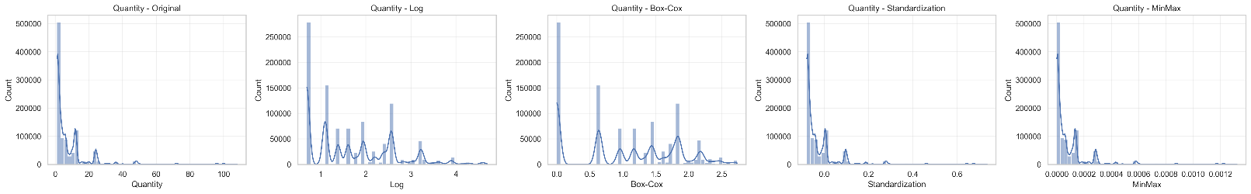
Figure 13: Quantity Distribution Before and After Transformation
The original Quantity distribution is strongly right skewed, with most transactions concentrated at low quantities and a long tail of larger purchases. Log transformation improves the spread, but Box-Cox provides the most balanced distribution. Standardization and MinMax scaling change the scale but do not meaningfully change the shape of the distribution.

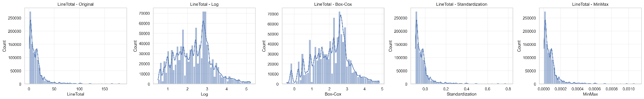
Figure 14: Price Distribution Before and After Transformation
The original Price distribution is highly skewed, with most products having low prices and a small number of extreme high-price values. The Box-Cox transformation produces the strongest improvement in symmetry. Standardization and MinMax scaling preserve the original skewed shape, confirming that scaling alone does not solve non-normality.

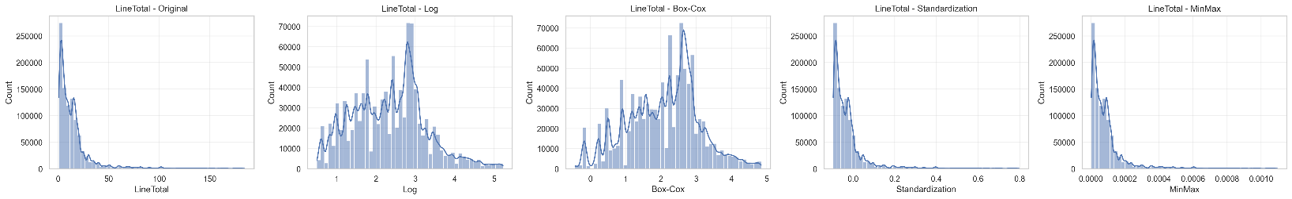
Figure 15: LineTotal Distribution Before and After Transformation
The original LineTotal distribution is strongly right skewed because most transactions have low revenue while a smaller number of transactions have much higher revenue. Log transformation improves the distribution, but Box-Cox produces the most symmetric result. This supports the conclusion that Box-Cox is the preferred transformation for revenue-related analysis.

Overall, transformation improved the distributional properties of the numerical variables, especially for LineTotal. Box-Cox was selected as the best transformation method because it produced the lowest skewness and most balanced kurtosis across the tested variables. However, the data still remains statistically non-normal due to the large sample size and real-world structure of retail behavior.

Heatmap and Pearson Correlation Coefficient Matrix
To analyze relationships between RFM variables, both Pearson and Spearman correlation matrices were computed and visualized using heatmaps. These methods provide insight into linear and monotonic relationships between Recency, Frequency, and Monetary Value.

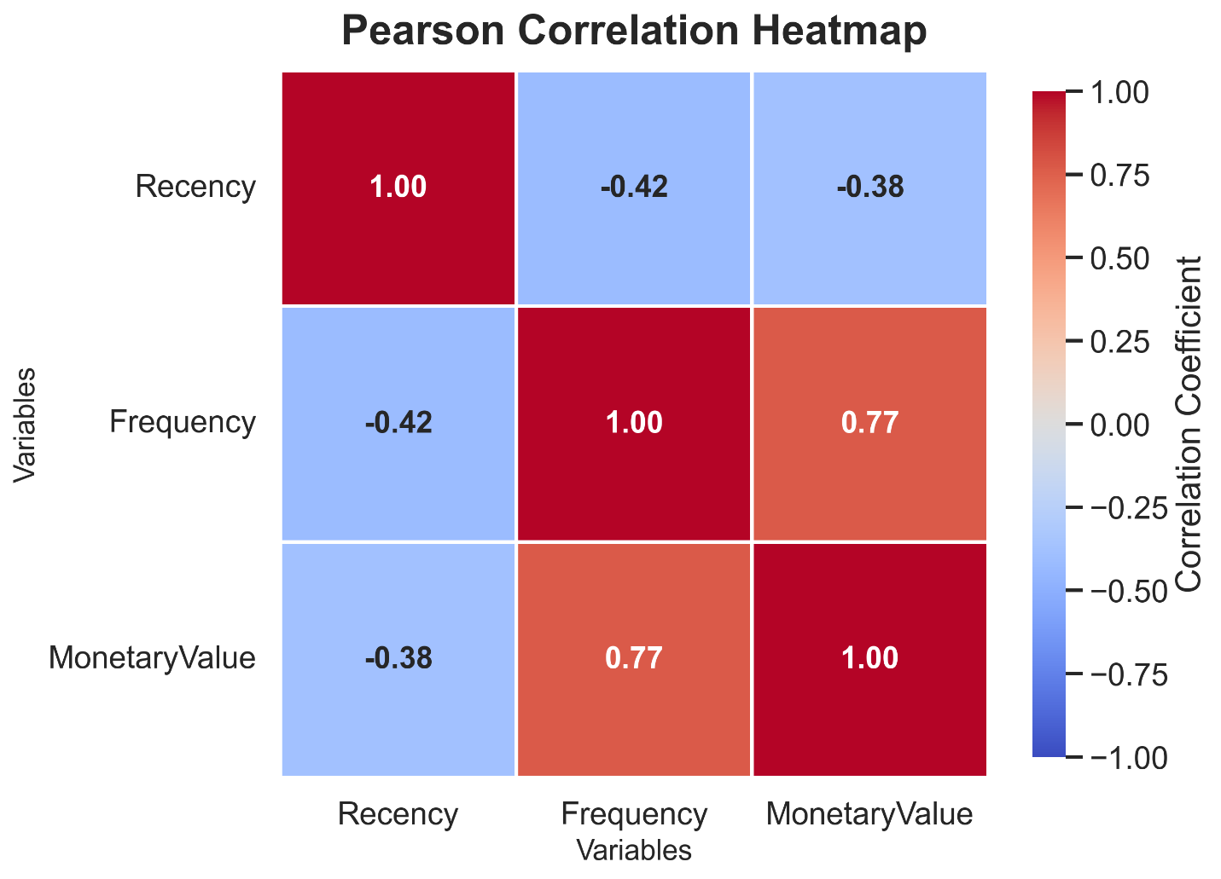
Figure 16: Pearson Correlation Heatmap of RFM Variables
The Pearson correlation heatmap illustrates the linear relationships between the RFM variables.
Frequency and Monetary Value show a strong positive correlation of 0.77, indicating that customers who purchase more frequently tend to spend more overall. Recency exhibits a moderate negative correlation with Frequency (-0.42) and Monetary Value (-0.38), suggesting that customers who have purchased more recently are more likely to purchase frequently and contribute higher revenue.
These results confirm that customer engagement is positively associated with purchasing frequency and spending and negatively associated with inactivity.

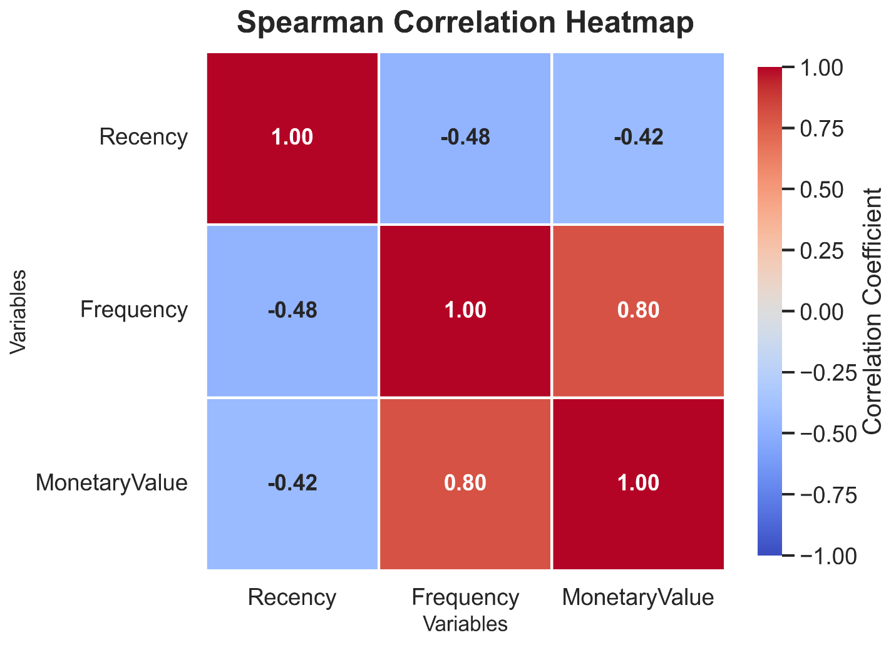
Figure 17: Spearman Correlation Heatmap of RFM Variables

The Spearman correlation heatmap captures monotonic relationships between variables, making it more robust to non-normal data distributions.
The correlation between Frequency and Monetary Value increases to 0.80, indicating a strong monotonic relationship. Recency shows stronger negative correlations with Frequency (-0.48) and Monetary Value (-0.42) compared to Pearson results.
This indicates that relationships between variables are not strictly linear but follow consistent monotonic trends, which is typical in real-world retail datasets.

Statistical Analysis
Statistical analysis was conducted to summarize the distribution and variability of RFM variables and to provide deeper insight into customer behavior.

Table 9: Descriptive Statistics of RFM Variables

The descriptive statistics summarize the central tendency, dispersion, and distribution shape of Recency, Frequency, and Monetary Value.
Recency has a mean of 226.57 and a median of 150.50, indicating a right-skewed distribution where most customers are relatively recent, but a portion of customers have been inactive for longer periods.
Frequency has a mean of 3.48 and a median of 2.00, with a skewness of 1.58, showing that most customers purchase infrequently while a smaller group purchases much more often.
Monetary Value has a mean of 994.85 and a median of 663.90, with a skewness of 1.30, indicating that a small number of customers contribute disproportionately to total revenue.
These statistics confirm that customer behavior is highly skewed and unevenly distributed, which is characteristic of retail transaction data.

Static Data Visualization
This section presents a comprehensive visual analysis of the RFM variables using multiple visualization techniques. These plots provide insights into distribution, relationships, density, and structural patterns in customer behavior.

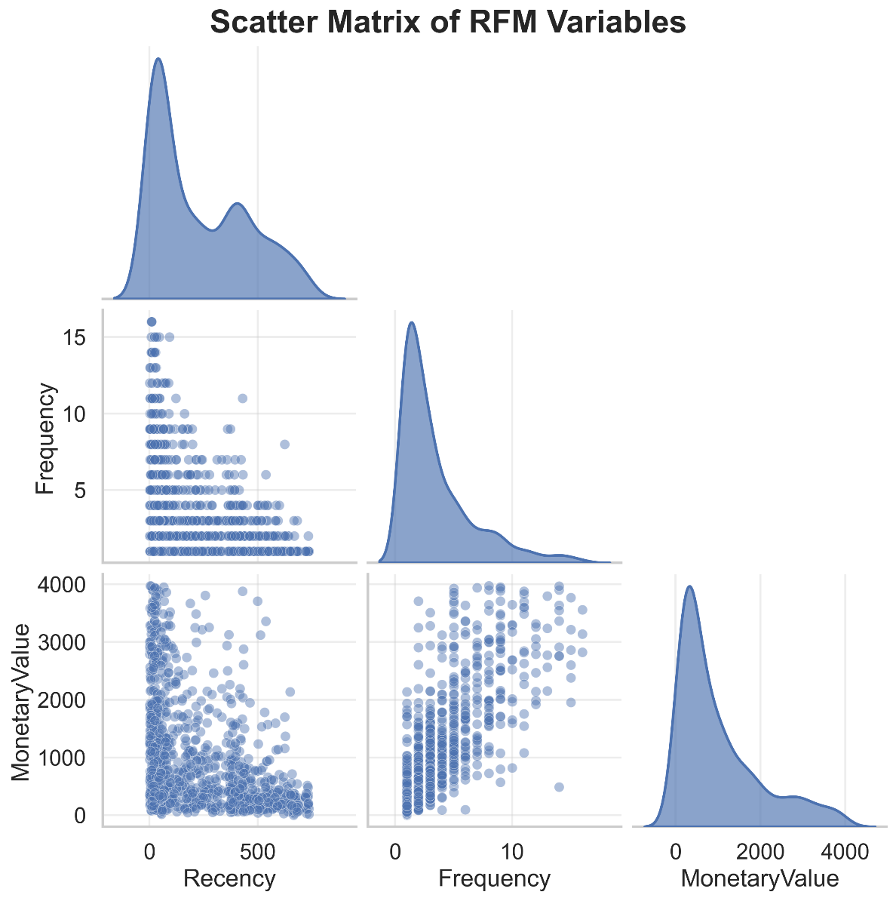
Figure 18: Scatter Matrix of RFM Variables

The scatter matrix provides a comprehensive view of pairwise relationships between RFM variables.
Most observations are concentrated on the lower ranges of Frequency and Monetary Value, indicating that the majority of customers are low-frequency and low-spending. The vertical banding observed in Frequency reflects its discrete nature as a count variable.
The plots also show a negative relationship between Recency and the other variables, where recently active customers tend to have higher purchase frequency and spending.

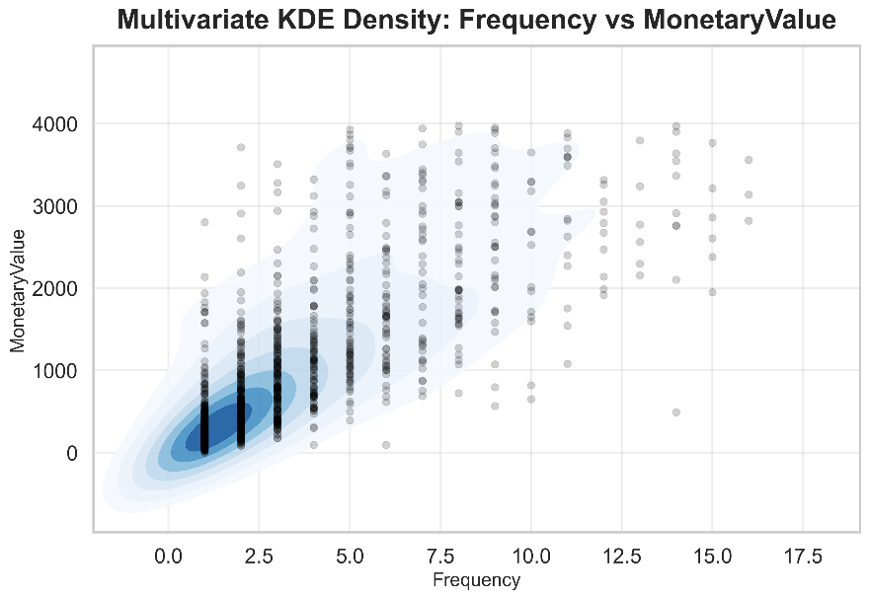
Figure 19: Multivariate KDE – Frequency vs Monetary Value

The KDE plot shows the density distribution between Frequency and Monetary Value.
The highest density occurs among low-frequency and low-spending customers. However, as Frequency increases, Monetary Value also increases, indicating that repeat purchasing is strongly associated with higher spending.

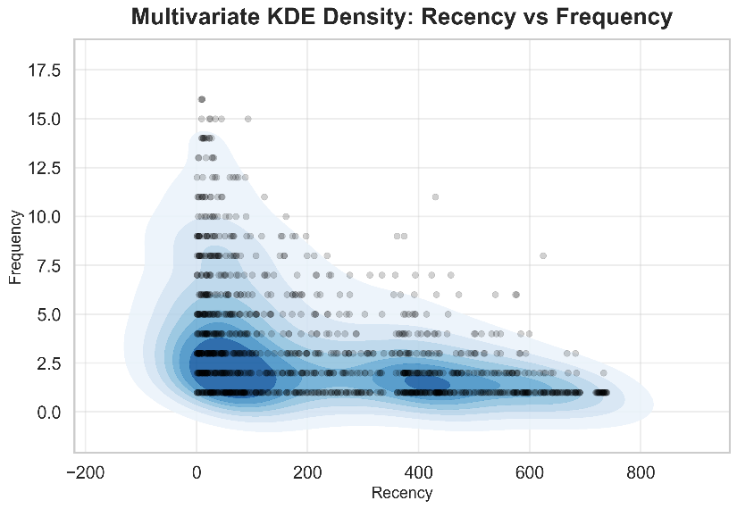
Figure 20: Multivariate KDE – Recency vs Frequency
This KDE plot illustrates the relationship between Recency and Frequency.
Higher-frequency customers are concentrated at lower Recency values, indicating that recently active customers tend to purchase more often. As Recency increases, Frequency decreases, forming a clear inverse relationship.

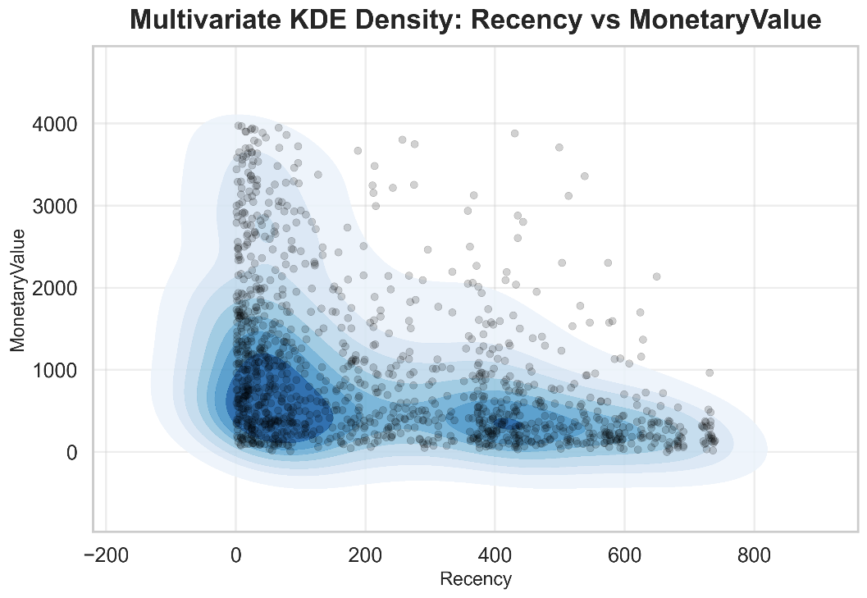
Figure 21: Multivariate KDE – Recency vs Monetary Value

The KDE plot shows that higher Monetary Value is concentrated among customers with low Recency values.
Customers with higher Recency (inactive customers) are mostly associated with lower spending levels, reinforcing the inverse relationship between inactivity and customer value.

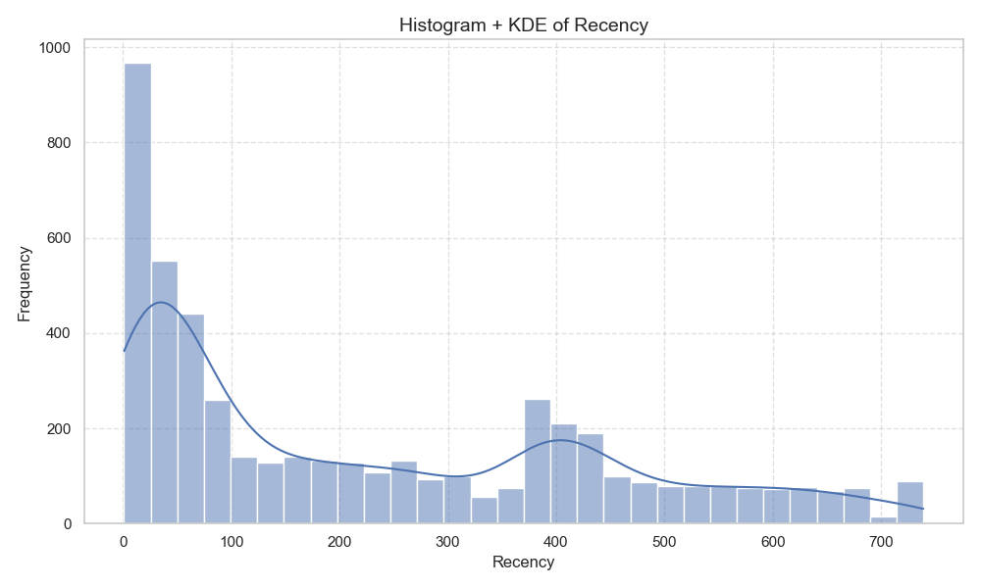
Figure 22: Histogram + KDE of Recency
The histogram and KDE plot for Recency shows that many customers purchased relatively recently, while a long right tail represents customers who have been inactive for longer periods. The distribution is not symmetric, confirming that customer activity is unevenly distributed over time.
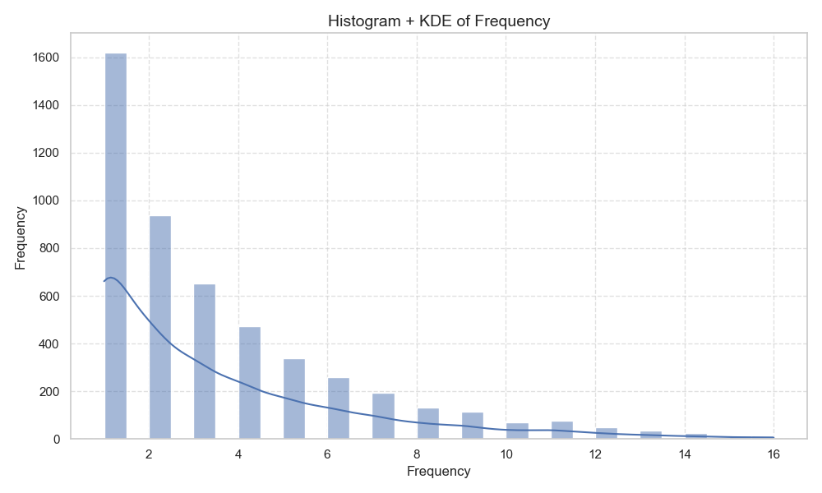
Figure 23: Histogram + KDE of Frequency
The histogram and KDE plot for Frequency shows that most customers purchased only one or two times. The distribution has a strong right skew, indicating that only a small number of customers made repeated purchases.

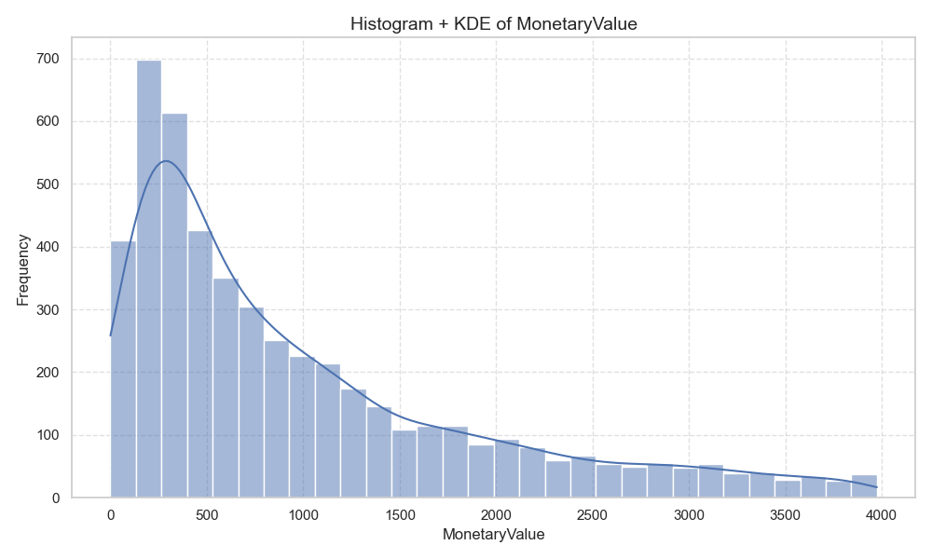
Figure 24: Histogram + KDE of Monetary Value

The histogram and KDE plot for Monetary Value shows that most customers generated relatively low revenue, while a small group contributed much higher spending. This confirms that customer value is highly skewed.

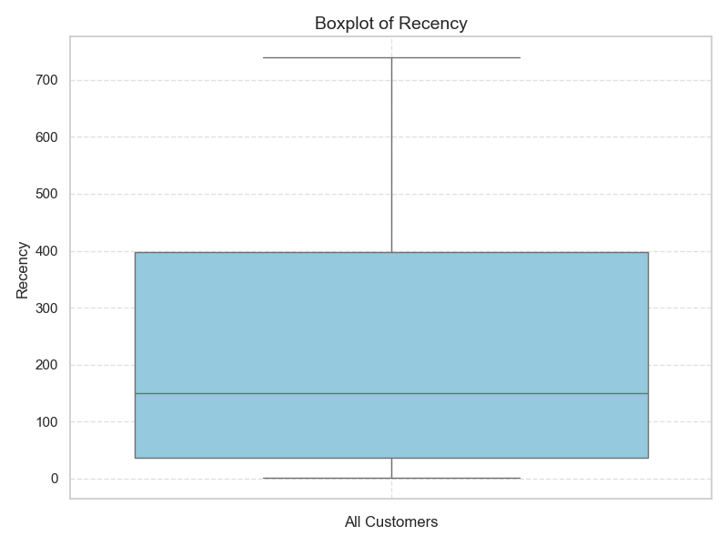
Figure 25: Boxplot of Recency
The boxplot of Recency shows a wide spread of customer inactivity values. The median is much closer to the lower part of the distribution than the upper range, indicating that many customers are relatively recent while others have been inactive for much longer.
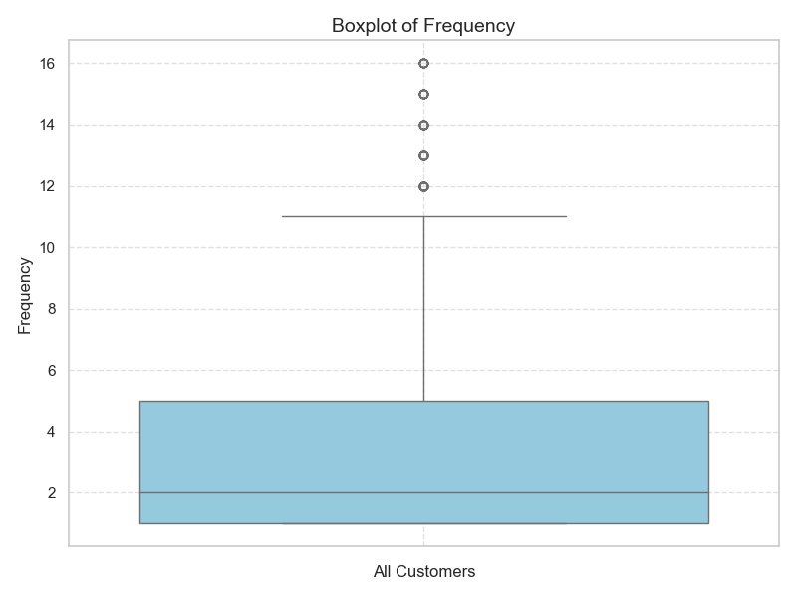
Figure 26: Boxplot of Frequency
The boxplot of Frequency shows that most customers have low purchase frequency, with a median around two purchases. Several high-frequency customers appear as outliers, showing that a small customer group purchases much more often than the majority.

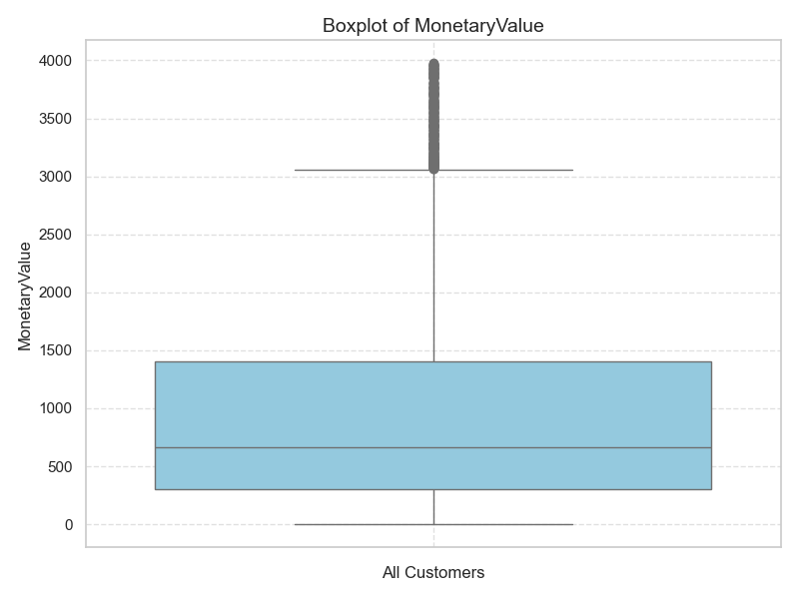
Figure 27: Boxplot of MonetaryValue
The boxplot of Monetary Value shows many high-value outliers. This indicates that although most customers spend within a lower range, a smaller group contributes substantially higher revenue.

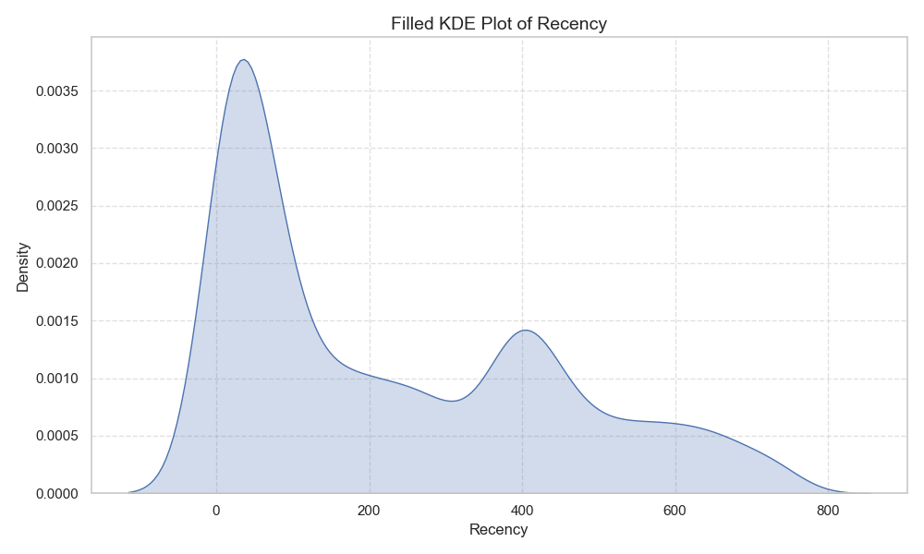
Figure 28: Filled KDE Plot of Recency
The filled KDE plot of Recency shows strong density near lower recency values and additional density around later inactivity periods. This suggests multiple customer behavior groups, including recently active customers and older inactive customers.

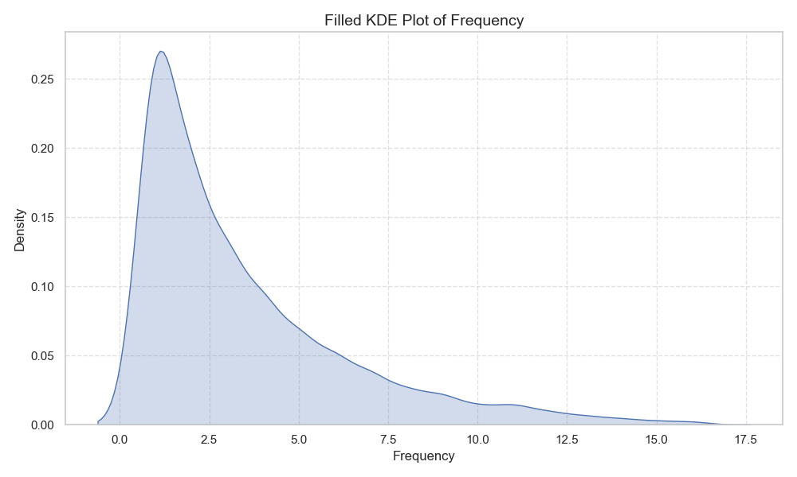
Figure 29: Filled KDE Plot of Frequency
The filled KDE plot of Frequency shows the highest density at low purchase counts. This confirms that most customers purchase only a few times, while repeat buyers form a smaller group.

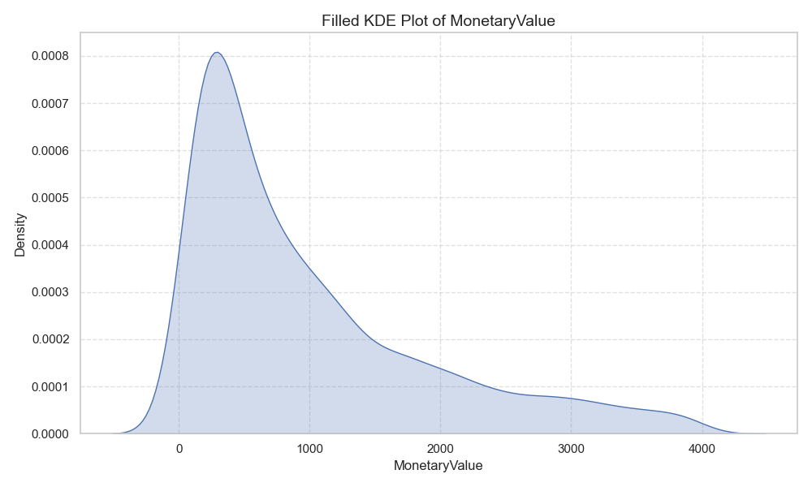
Figure 30: Filled KDE Plot of Monetary Value
The filled KDE plot of Monetary Value shows that the highest customer density occurs at lower spending levels. The long right tail indicates that a smaller group of customers contributes much higher monetary value.

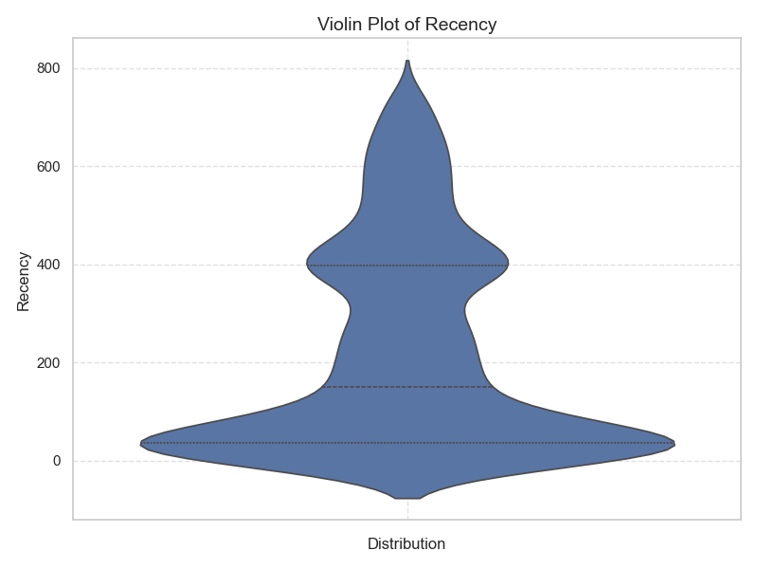
Figure 31: Violin Plot of Recency
The violin plot of Recency shows the shape and density of customer inactivity. The wider sections indicate where more customers are concentrated, showing strong density among recent customers and additional spread among inactive customers.
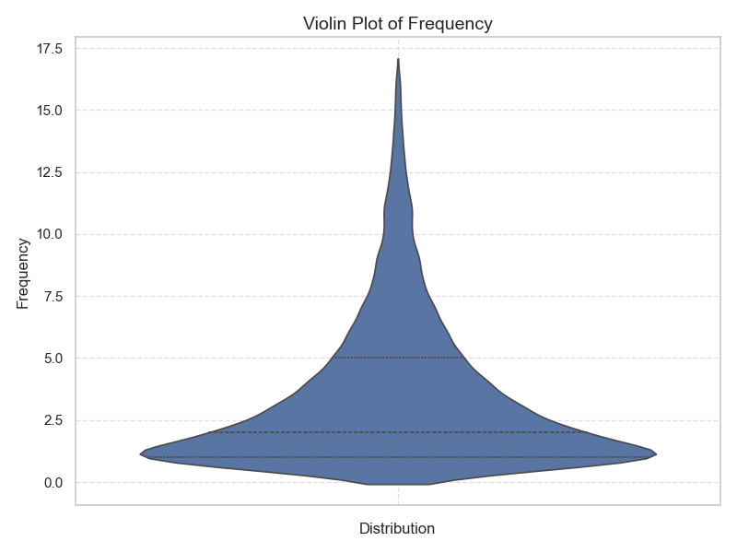
Figure 32: Violin Plot of Frequency
The violin plot of Frequency shows that the distribution is concentrated at lower frequency values. The long upper extension indicates that only a small group of customers purchases repeatedly.
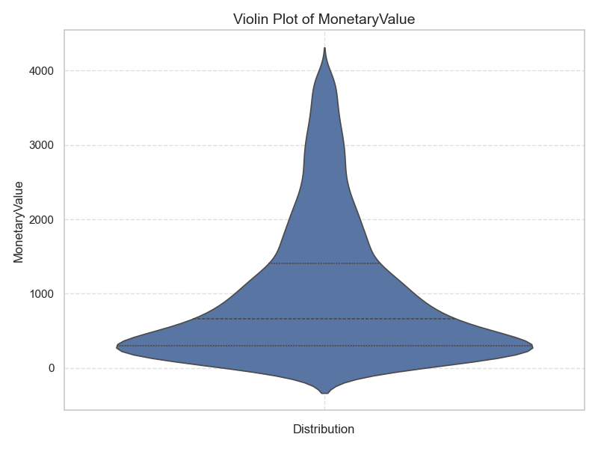
Figure 33: Violin Plot of Monetary Value
The violin plot of Monetary Value shows dense concentration at lower revenue values and a long upper spread. This confirms that customer spending is uneven and concentrated among a smaller high-value group.

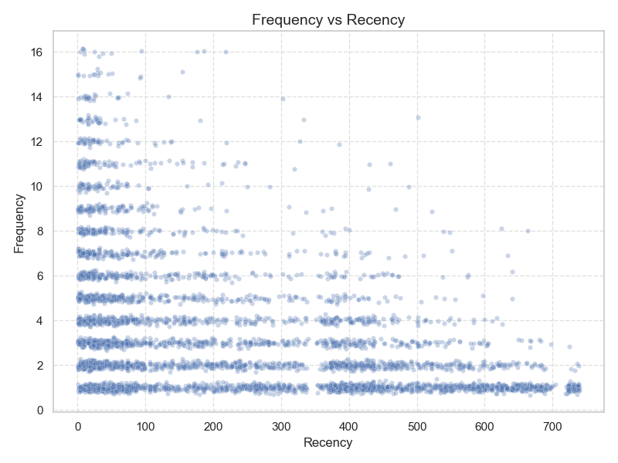
Figure 34: Scatter Plot of Frequency vs Recency
The scatter plot of Frequency versus Recency shows a negative relationship. Customers with lower recency values tend to have higher purchase frequency, while customers with higher recency values generally purchase less often.
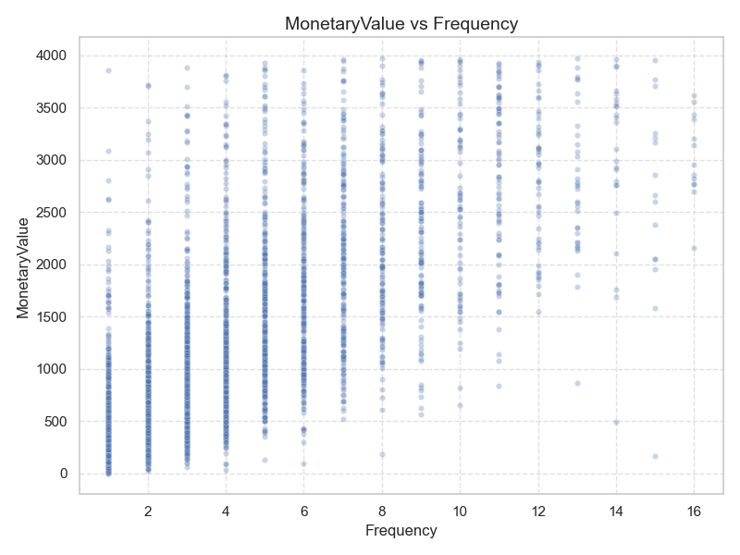
Figure 35: Scatter Plot of MonetaryValue vs Frequency
The scatter plot of MonetaryValue versus Frequency shows a positive relationship. As purchase frequency increases, monetary value generally increases, confirming that repeat customers tend to generate higher revenue.

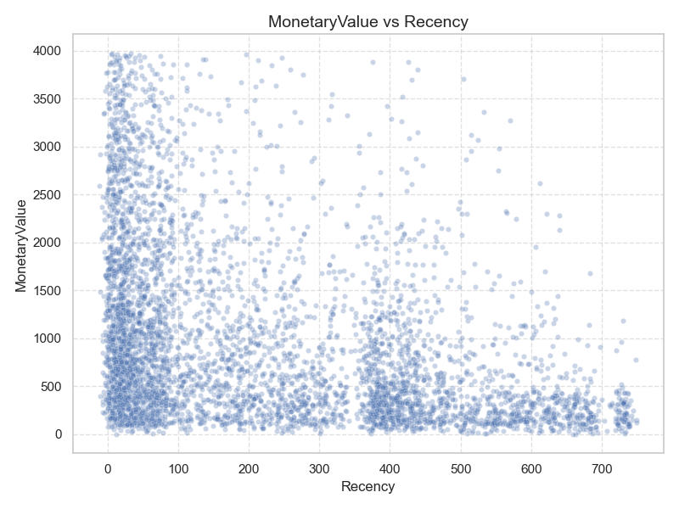
Figure 36: Scatter Plot of MonetaryValue vs Recency
The scatter plot of Monetary Value versus Recency shows that higher spending is concentrated among customers with lower recency values. Customers inactive for longer periods generally show lower monetary value.
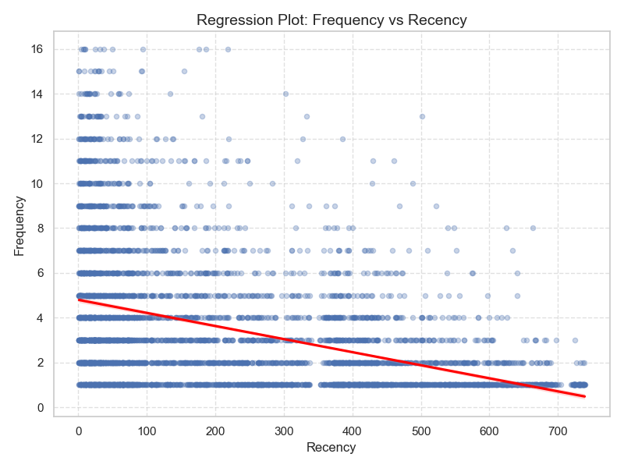
Figure 37: Regression Plot of Frequency vs Recency
The regression plot shows a negative relationship between Frequency and Recency. The downward trend line confirms that customers who have been inactive longer tend to purchase less frequently.

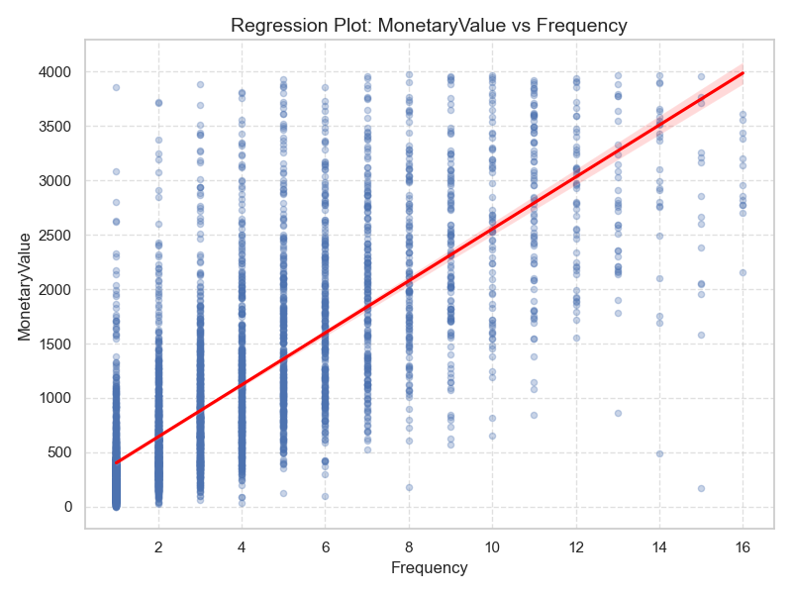
Figure 38: Regression Plot of Monetary Value vs Frequency
The regression plot shows a strong positive relationship between Frequency and Monetary Value. The upward trend line confirms that customers who purchase more often tend to spend more.

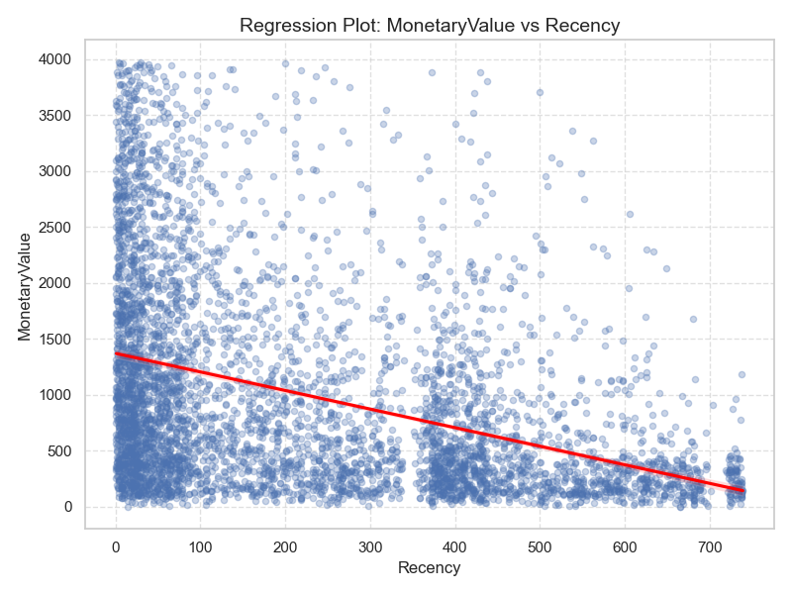
Figure 39: Regression Plot of Monetary Value vs Recency
The regression plot shows a negative relationship between Monetary Value and Recency. This indicates that customers with longer inactivity periods tend to contribute less revenue.

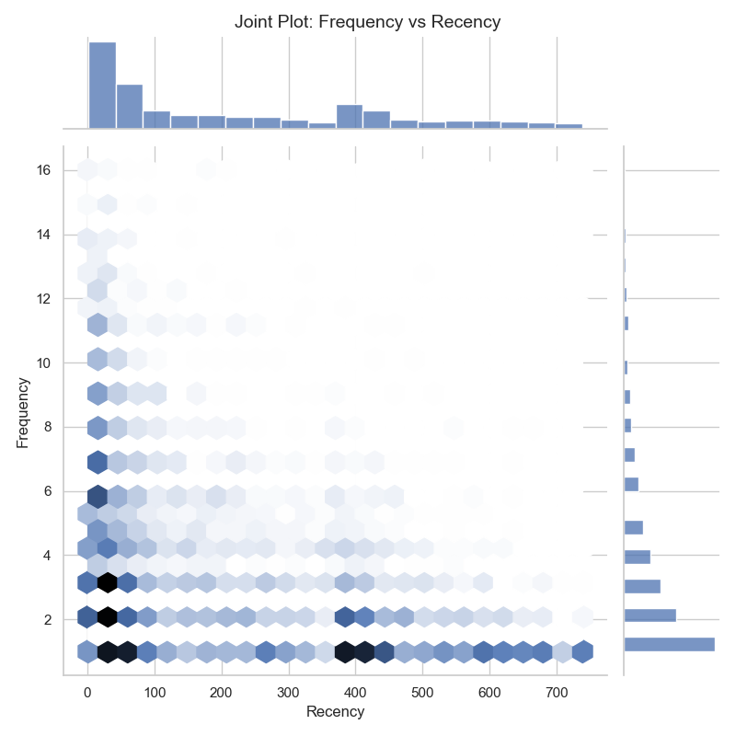
Figure 40: Joint Plot of Frequency vs Recency
The joint plot combines the relationship between Frequency and Recency with marginal distributions. It shows that high-frequency customers are mostly concentrated among lower recency values, while high-recency customers usually have low frequency.

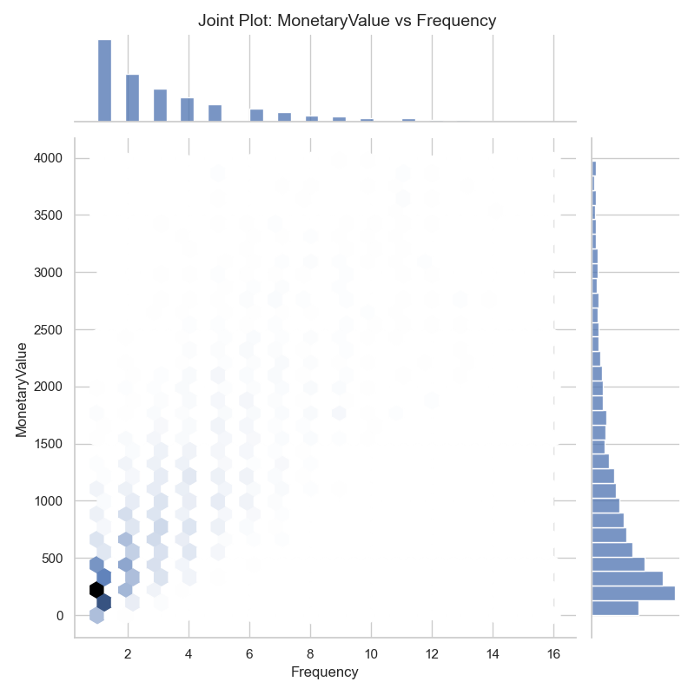
Figure 41: Joint Plot of Monetary Value vs Frequency
The joint plot of Monetary Value and Frequency shows that higher frequency is associated with higher monetary value. The marginal distributions also confirm that most customers remain concentrated at lower frequency and spending levels.

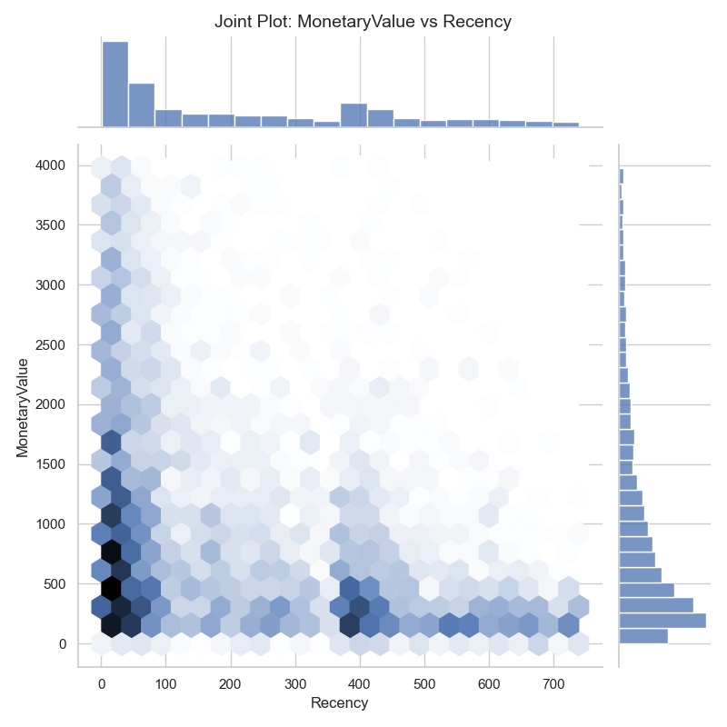
Figure 42: Joint Plot of Monetary Value vs Recency
The joint plot of Monetary Value and Recency shows that high spending is more common among recently active customers. Customers with high recency values are mostly concentrated at lower spending levels.

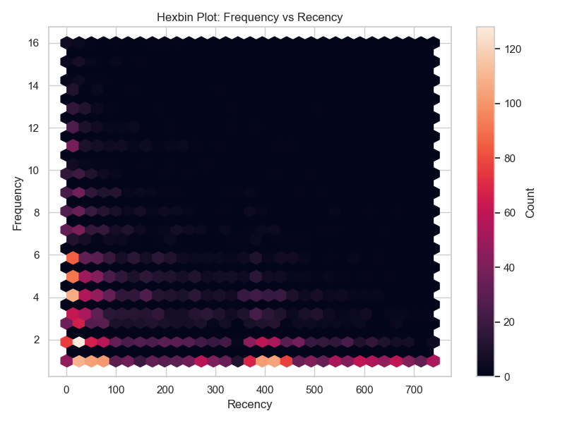
Figure 43: Hexbin Plot of Frequency vs Recency
The hexbin plot of Frequency versus Recency improves visibility in dense regions. The highest concentration appears at low frequency values, especially across recency ranges, confirming that many customers purchase only once or twice.

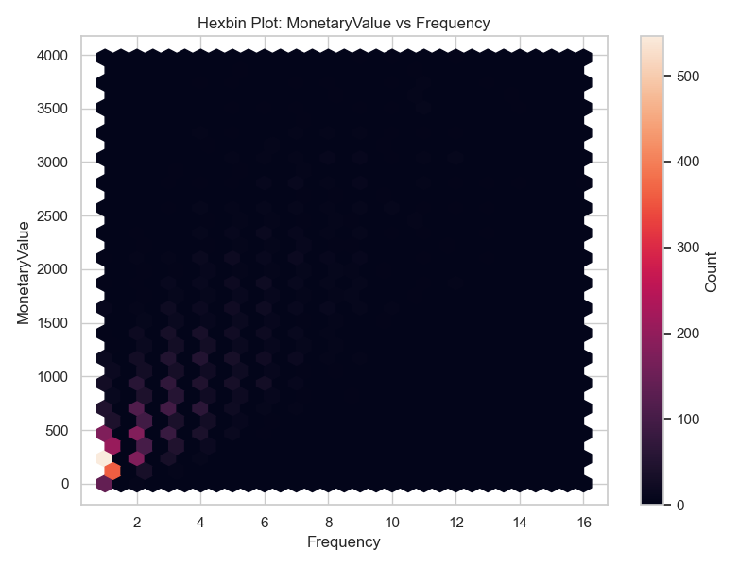
Figure 44: Hexbin Plot of Monetary Value vs Frequency
The hexbin plot of Monetary Value versus Frequency shows the highest density among low-frequency and low-spending customers. Density decreases as both frequency and spending increase, showing that high-value repeat customers are less common.
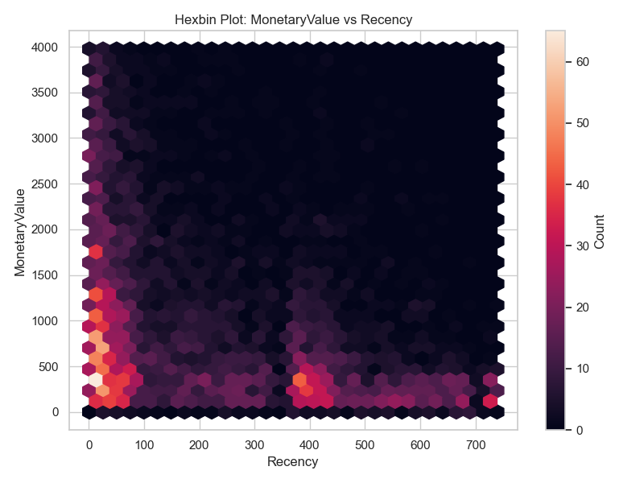
Figure 45: Hexbin Plot of Monetary Value vs Recency
The hexbin plot of Monetary Value versus Recency shows that high spending is more concentrated at lower recency values. Customers with high recency are mostly located in low monetary value regions.

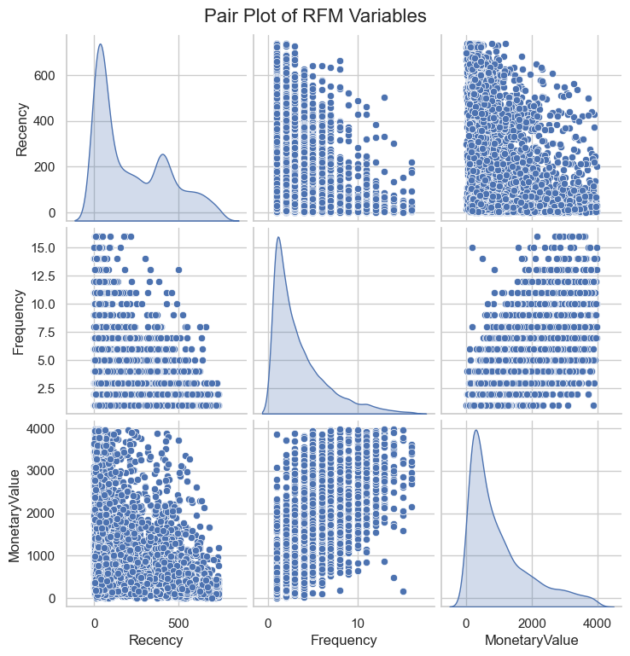
Figure 46: Pair Plot of RFM Variables

The pair plot provides a complete pairwise view of Recency, Frequency, and Monetary Value. It confirms skewed distributions on the diagonal and shows positive association between Frequency and Monetary Value, along with negative relationships involving Recency.

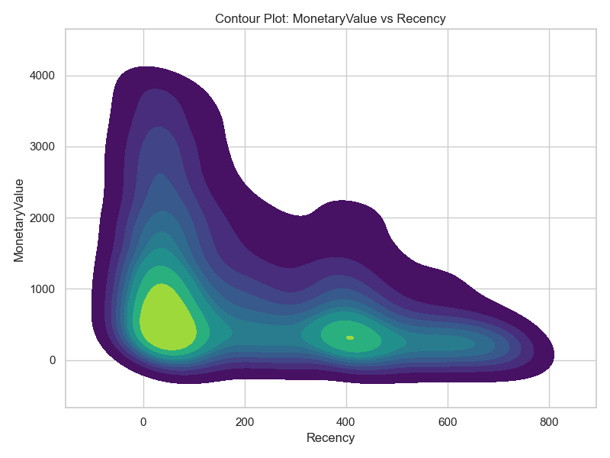
Figure 47: Contour Plot of Monetary Value vs Recency
The contour plot shows density regions between Monetary Value and Recency. The densest areas occur among customers with lower recency and lower-to-moderate monetary value, while high spending is less common and concentrated among more active customers.

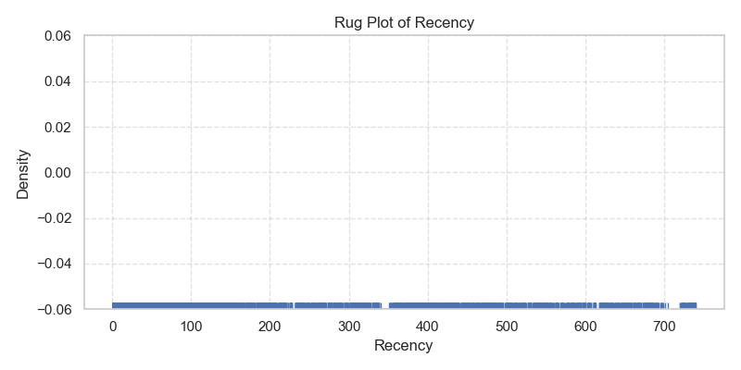
Figure 48: Rug Plot of Recency
The rug plot of Recency shows individual customer positions along the axis. The concentration of marks near lower values confirms that many customers purchased recently, while scattered marks across higher values represents inactive customers.

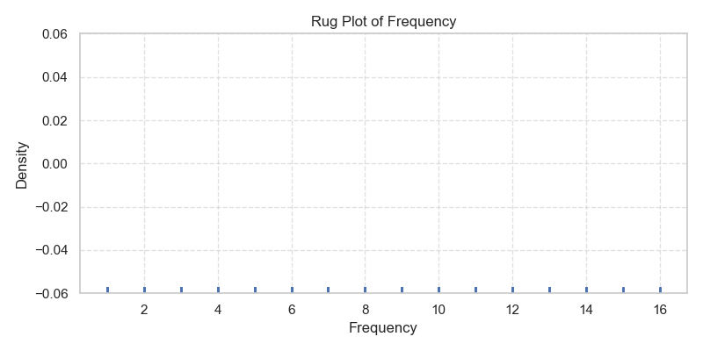
Figure 49: Rug Plot of Frequency
The rug plot of Frequency shows that customer purchase counts are discrete and concentrated at lower values. Most marks appear near low frequencies, confirming that repeat purchases are less common.
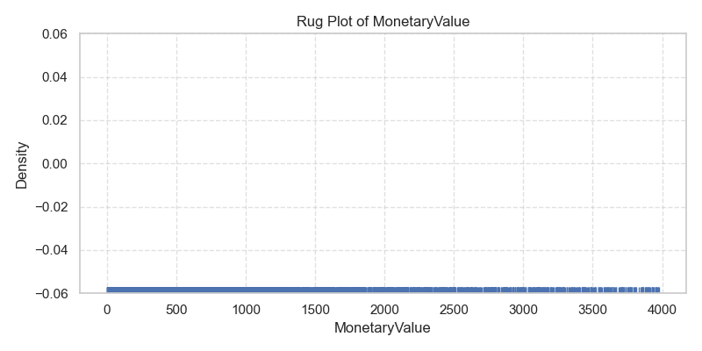
Figure 50: Rug Plot of Monetary Value

The rug plot of Monetary Value shows dense concentration at lower spending values with sparse marks at higher values. This confirms that high-value customers are relatively rare.

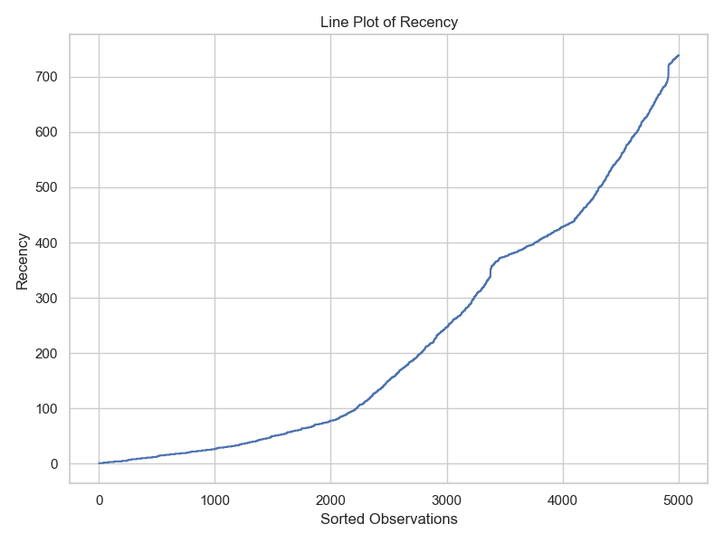
Figure 51: Line Plot of Recency
The line plot of sorted Recency values shows a gradual increase followed by a steeper rise near the upper end. This indicates that a subset of customers has much longer inactivity periods.

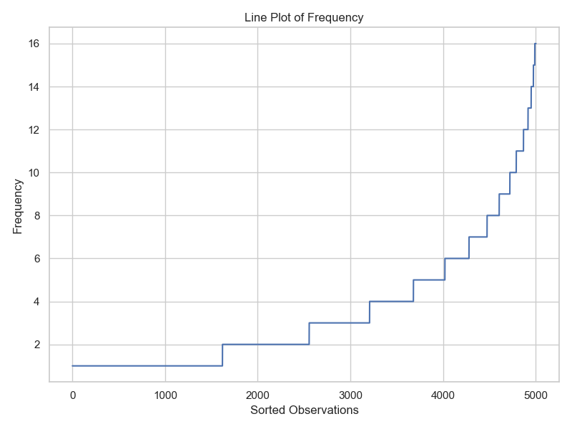
Figure 52: Line Plot of Frequency
The line plot of sorted Frequency values shows a step-like increase because Frequency is a discrete count variable. Most customers remain at low frequency values, while only a small number reach high purchase counts.

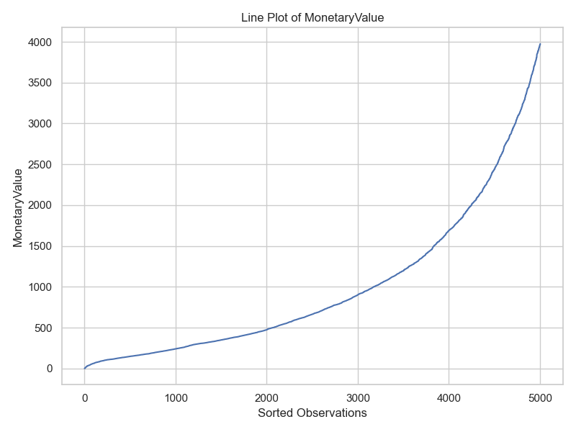
Figure 53: Line Plot of Monetary Value
The line plot of sorted Monetary Value shows a steep rise near the upper end, confirming that a small group of customers contributes disproportionately high revenue.

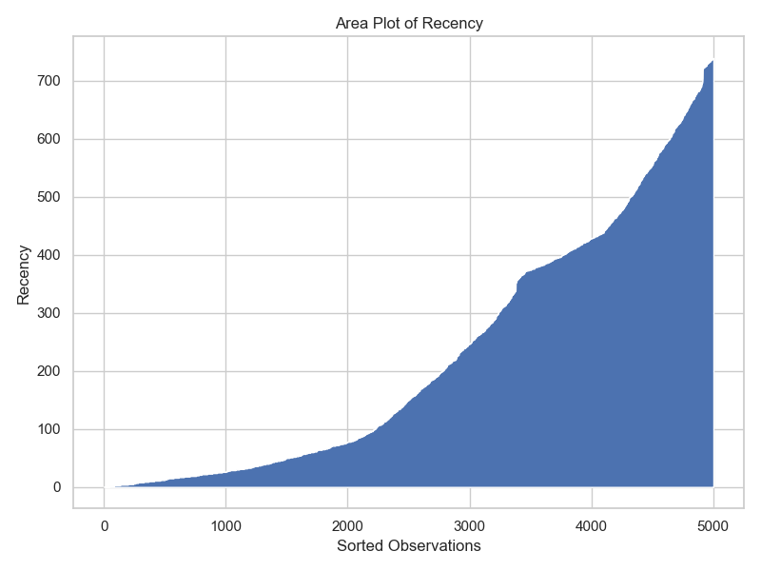
Figure 54: Area Plot of Recency
The area plot of Recency shows the cumulative shape of sorted inactivity values. The increasing curve highlights the presence of customers with long inactivity periods.

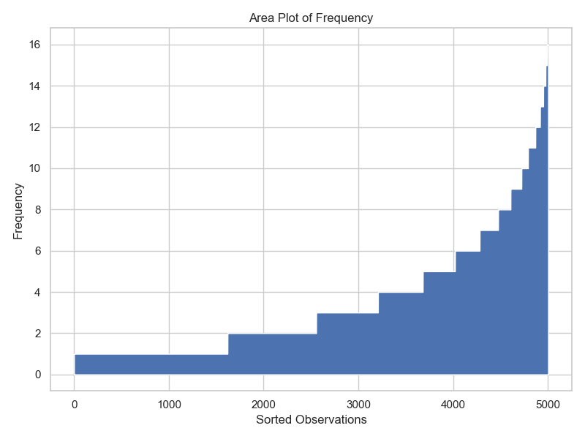
Figure 55: Area Plot of Frequency
The area plot of Frequency shows that most customers remain at low purchase counts. The steep rise near the end indicates that high-frequency customers form only a small portion of the dataset.

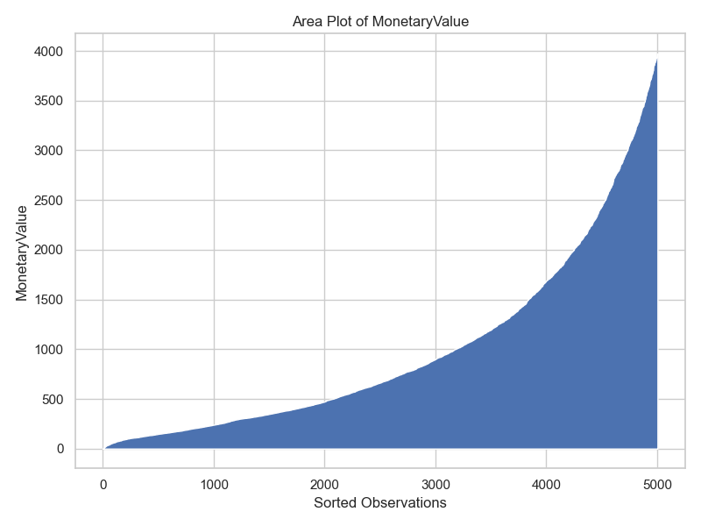
Figure 56: Area Plot of Monetary Value

The area plot of Monetary Value shows a strong upward curve near the highest values. This reinforces the conclusion that revenue contribution is concentrated among a limited group of high-value customers.

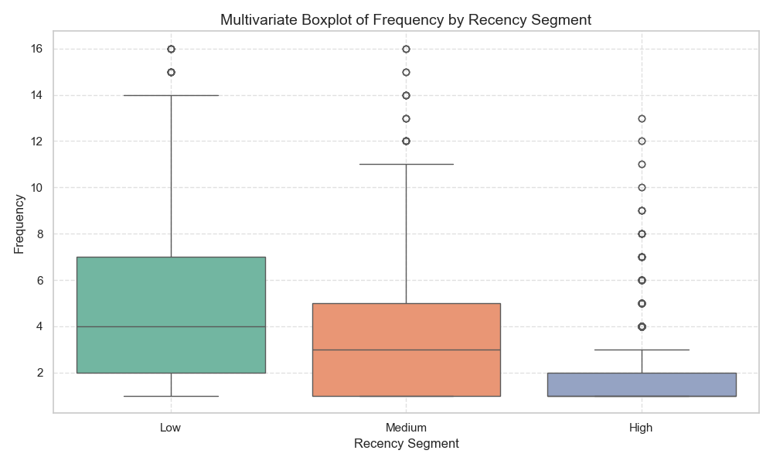
Figure 57: Multivariate Boxplot of Frequency by Recency Segment
The multivariate boxplot shows that customers in the low-recency segment have the highest median frequency. Customers in the high-recency segment have the lowest frequency, confirming that recent customers are more engaged.

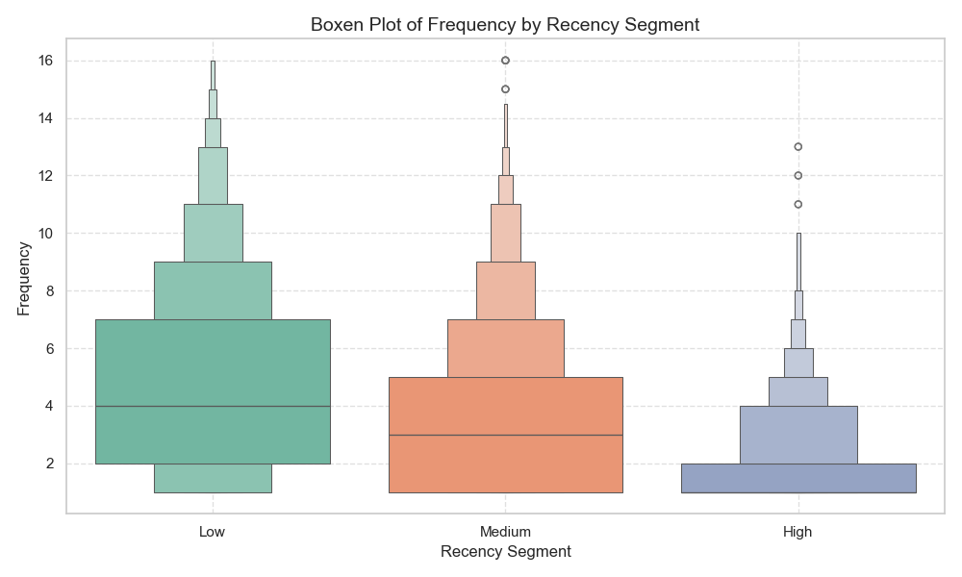
Figure 58: Boxen Plot of Frequency by Recency Segment

The boxen plot provides deeper quantile-level detail for frequency across recency segments. It shows that the low-recency segment has a wider and higher frequency distribution, while the high-recency segment is concentrated at low purchase counts.

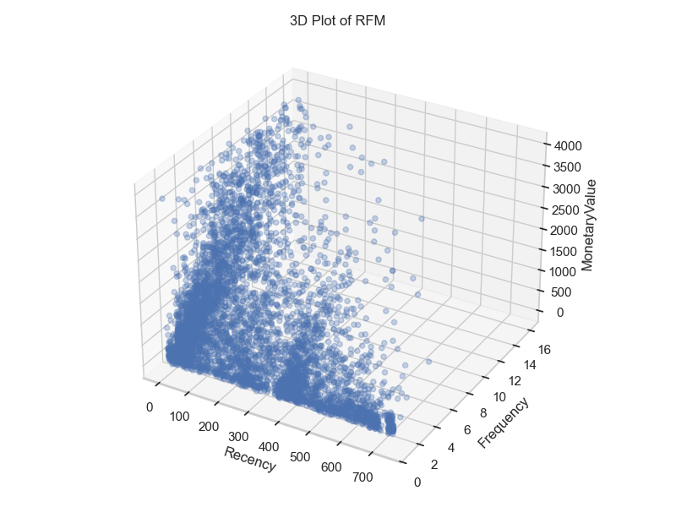
Figure 59: 3D Plot of RFM Variables

The 3D plot shows the joint relationship between Recency, Frequency, and Monetary Value. Most customers are concentrated in low-frequency and lower monetary value regions, while fewer customers extend into high-frequency and high-value areas.

Now we will explore categorical exploratory data analysis (EDA) performed on key categorical variables such as TransactionStatus, Country, PurchaseQuarter, PriceCategory, and DayOfWeek.
The objective is to analyze transaction distribution, revenue contribution, purchasing patterns across time, and category-based behavior. Various visualization techniques including count plots, bar charts, grouped and stacked bar plots, heatmaps, cluster maps, pie charts, and strip plots are used to uncover meaningful insights from categorical features.

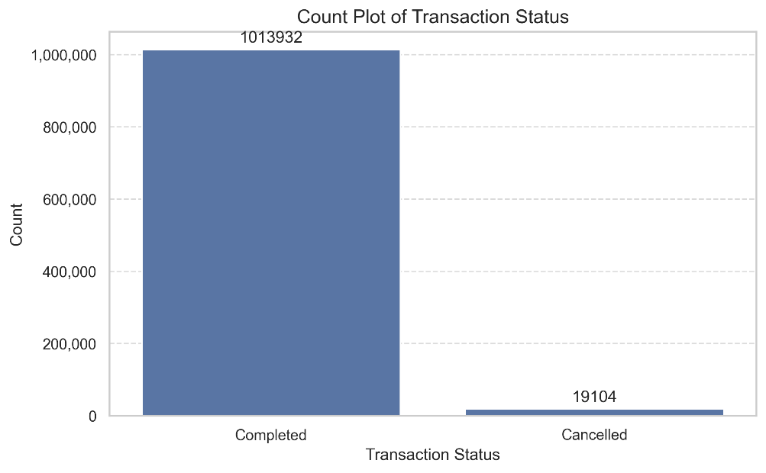
Figure 60: Count Plot of Transaction Status
The count plot shows that most transactions are completed, accounting for approximately 98.15% of all records, while cancelled transactions make up only 1.85%. This indicates a very low cancellation rate and suggests stable transaction completion behavior in the dataset.

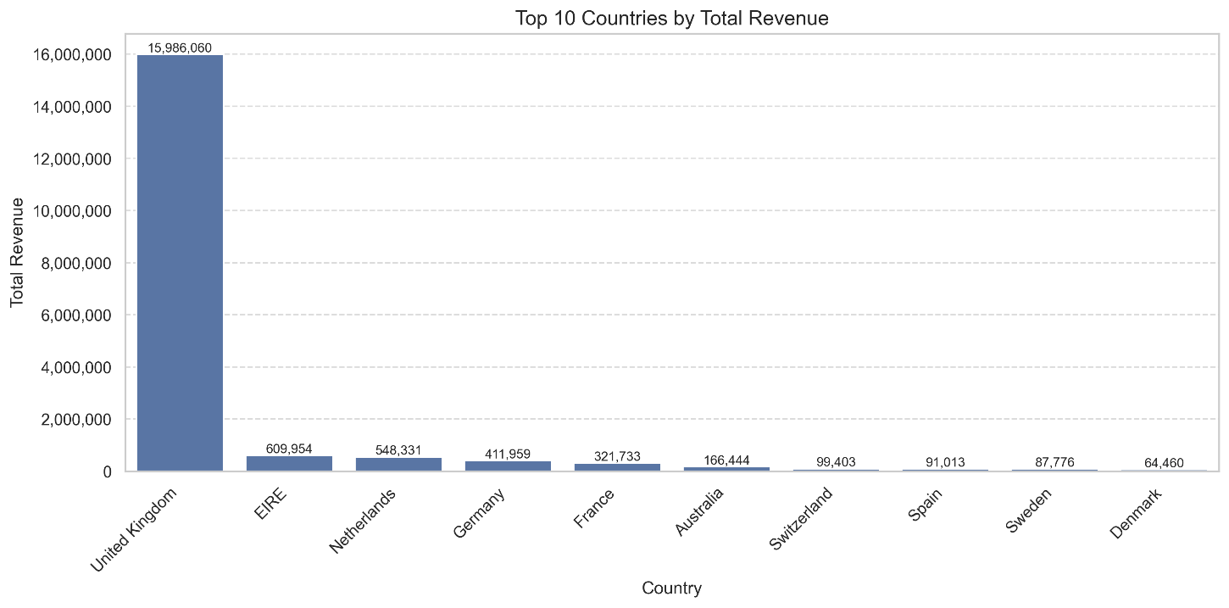
Figure 61: Top 10 Countries by Total Revenue
The bar plot shows that the United Kingdom dominates total revenue generation by a significant margin compared to all other countries. Other countries such as EIRE, Netherlands, and Germany contribute moderately, but their revenue levels are substantially lower. This indicates a strong geographic concentration of sales in the UK.
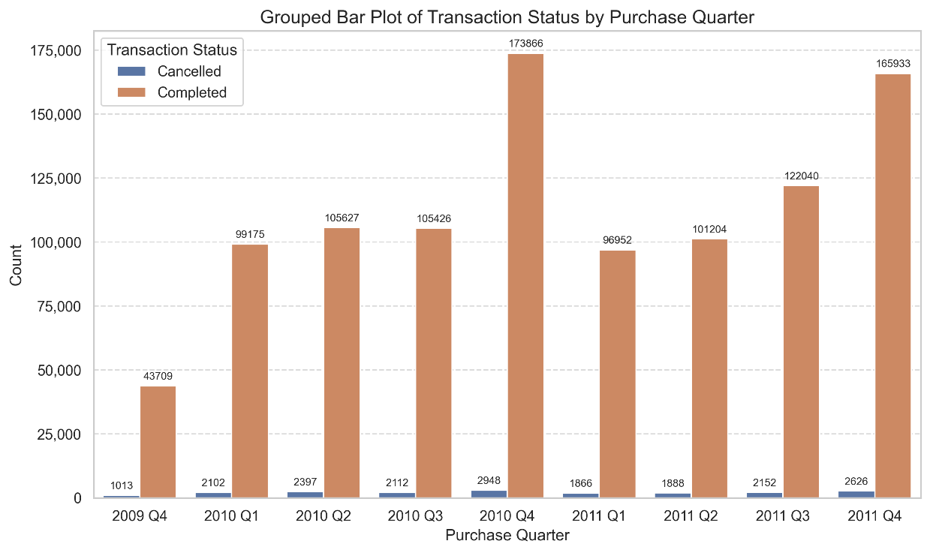
Figure 62: Transaction Status by Purchase Quarter
The grouped bar plot shows transaction counts across quarters for both completed and cancelled transactions. Completed transactions consistently dominate in every quarter, with the highest volume observed in 2010 Q4. Cancelled transactions remain relatively low and stable across all periods.

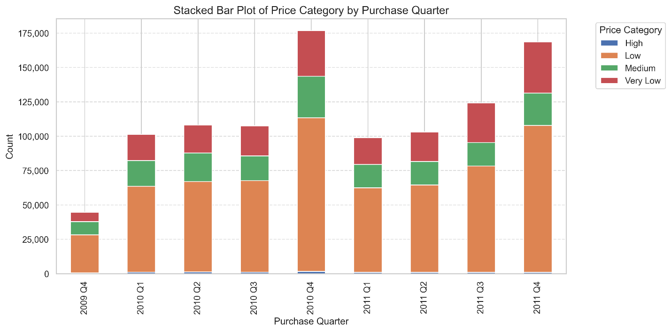
Figure 63: Price Category Distribution by Purchase Quarter
The stacked bar plot shows that the Low price category dominates across all quarters. Medium and Very Low categories contribute moderately, while High price category transactions are minimal. The overall distribution remains consistent over time, indicating stable pricing behavior.

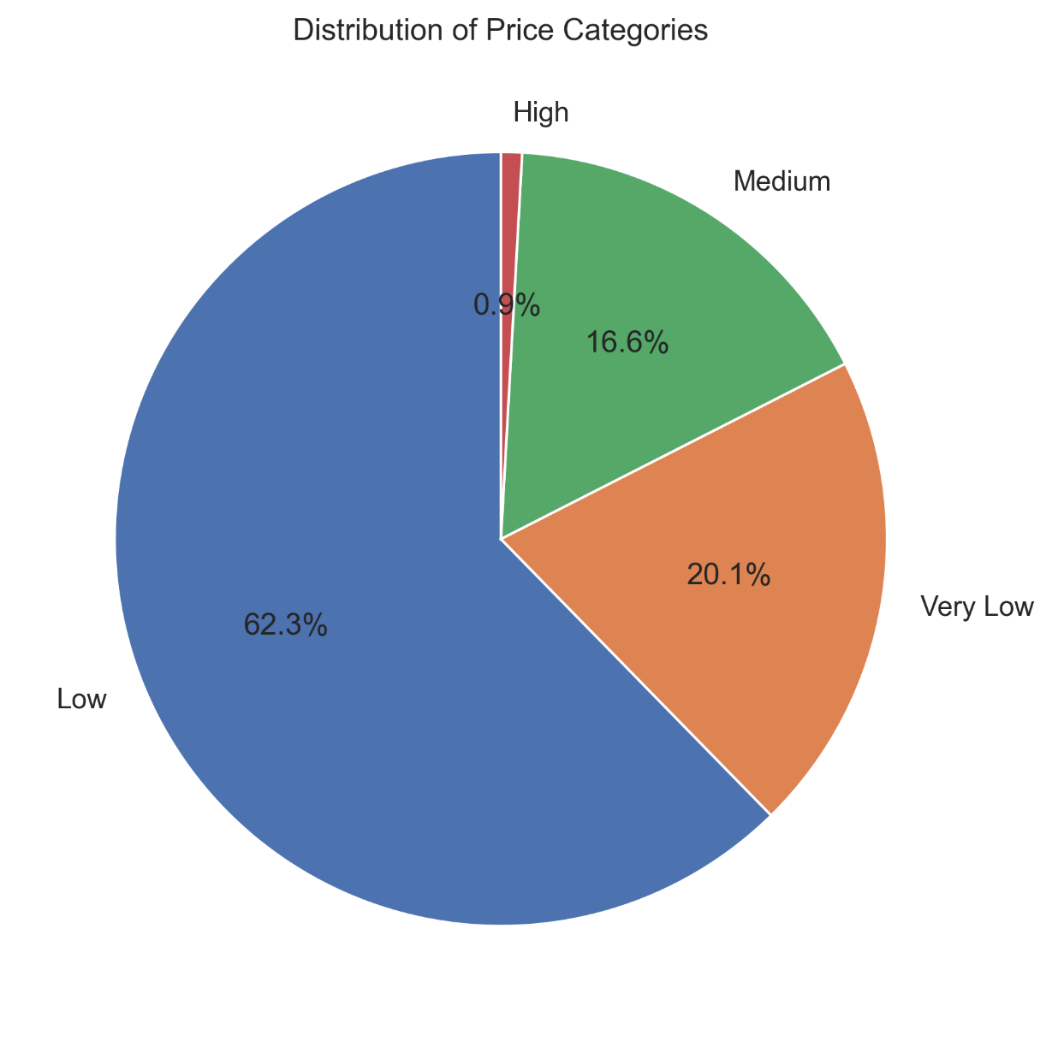
Figure 64: Distribution of Price Categories
The pie chart shows that the Low price category accounts for the majority of transactions, representing approximately 62.3%. Very Low and Medium categories follow, while High price items contribute less than 1%. This confirms that most transactions occur at lower price levels.

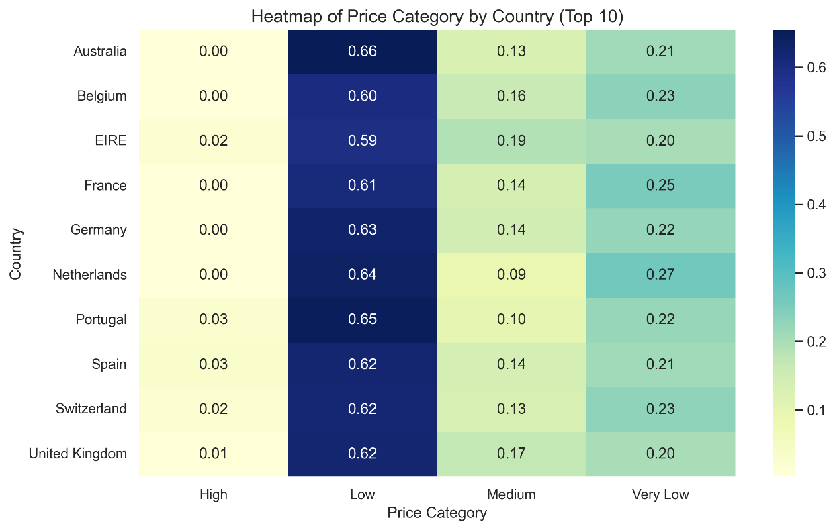
Figure 65: Heatmap of Price Category by Country
The heatmap shows the proportion of price categories across different countries. The Low price category has the highest concentration across all countries, while High price transactions remain minimal. Some variation exists in Medium and Very Low categories, indicating slight regional differences in purchasing behavior.

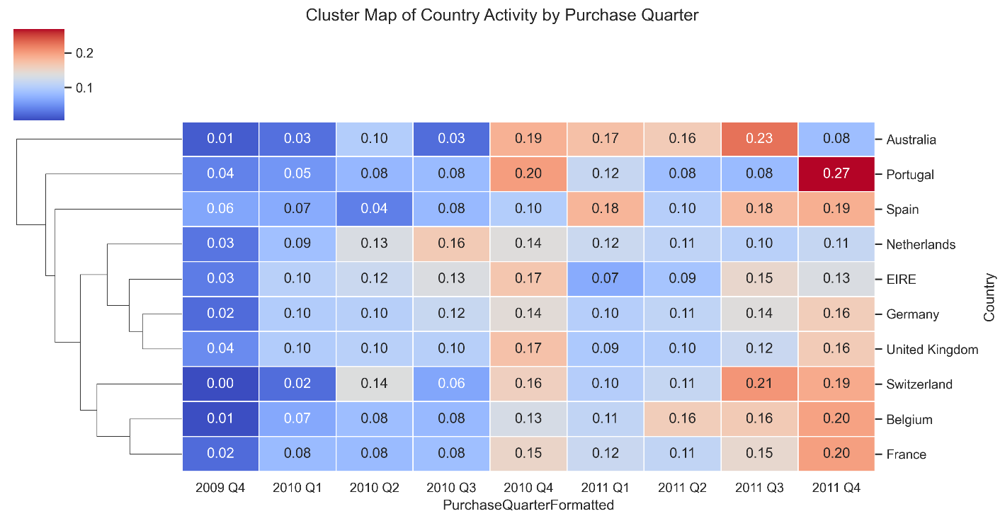
Figure 66: Cluster Map of Country Activity by Purchase Quarter
The cluster map groups countries based on similar purchasing patterns across quarters. Countries such as the United Kingdom, Germany, and Netherlands show similar activity trends, while others form separate clusters. This indicates shared seasonal purchasing behavior among certain regions.

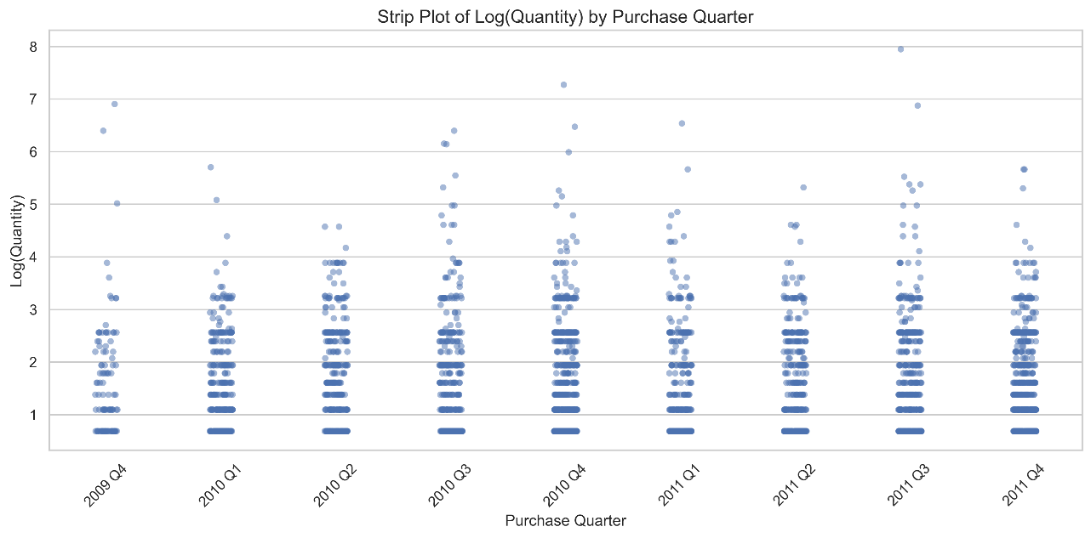
Figure 67: Strip Plot of Log(Quantity) by Purchase Quarter
The strip plot shows the distribution of log-transformed quantities across quarters. The spread is relatively consistent across all periods, indicating stable purchasing volume over time. No single quarter dominates significantly, suggesting balanced transaction activity.
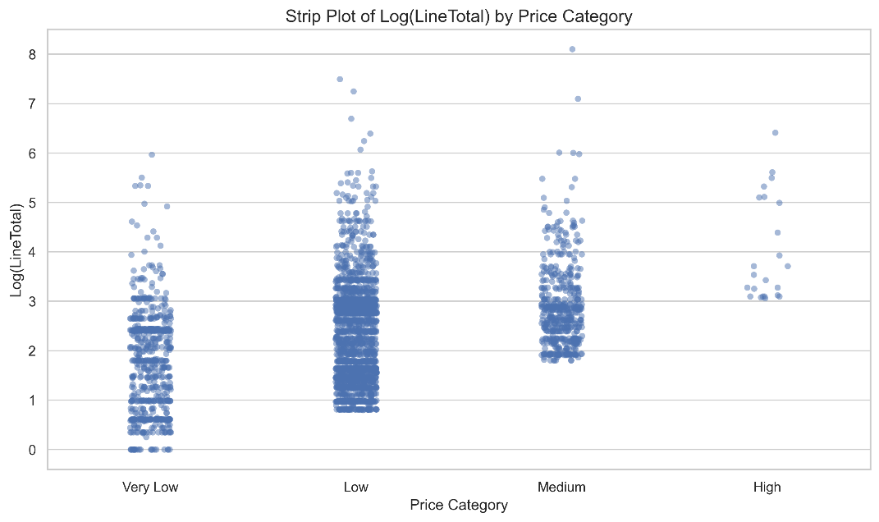
Figure 68: Strip Plot of Log(LineTotal) by Price Category
The strip plot shows that higher price categories correspond to higher transaction values. The High category exhibits larger log-transformed values, while Low and Very Low categories are concentrated at lower ranges. This confirms the expected relationship between price category and transaction value.
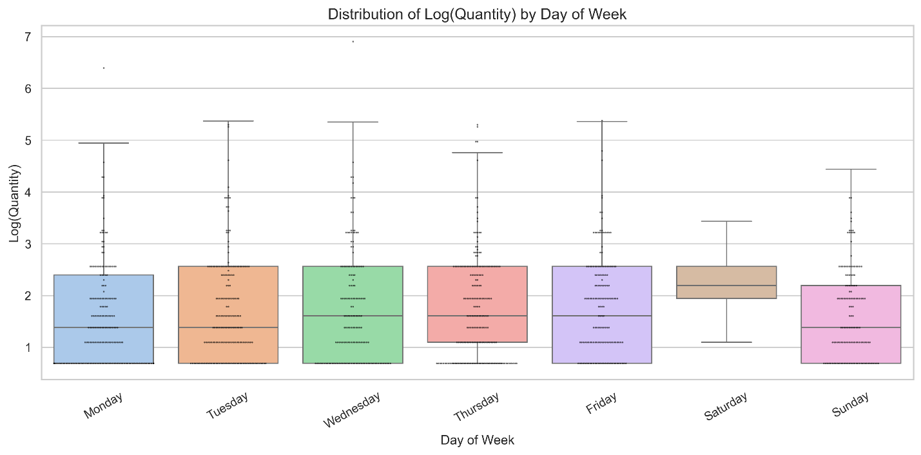
Figure 69: Distribution of Log(Quantity) by Day of Week
The boxplot combined with swarm points shows that purchasing behavior is relatively consistent throughout the days of the week. While slight variations exist, no single day exhibits extreme dominance. This indicates that customer purchasing activity is evenly distributed throughout the week.

Overall, the categorical analysis reveals strong patterns in transaction behavior. The dataset is dominated by completed transactions and low-price purchases. Revenue is heavily concentrated in the United Kingdom, indicating geographic dependence.

Temporal analysis shows that purchasing behavior remains relatively stable across quarters and days of the week, with no extreme fluctuations. Price category analysis confirms that most transactions occur in lower price ranges, while high-value purchases are rare.

These findings provide important context for customer segmentation and support the results observed in numerical and RFM-based analysis.

Subplots
Subplots are used to present multiple related visualizations within a single figure, allowing for direct comparison and a more comprehensive understanding of patterns across variables. This approach improves interpretability by combining complementary perspectives into a unified analytical view.

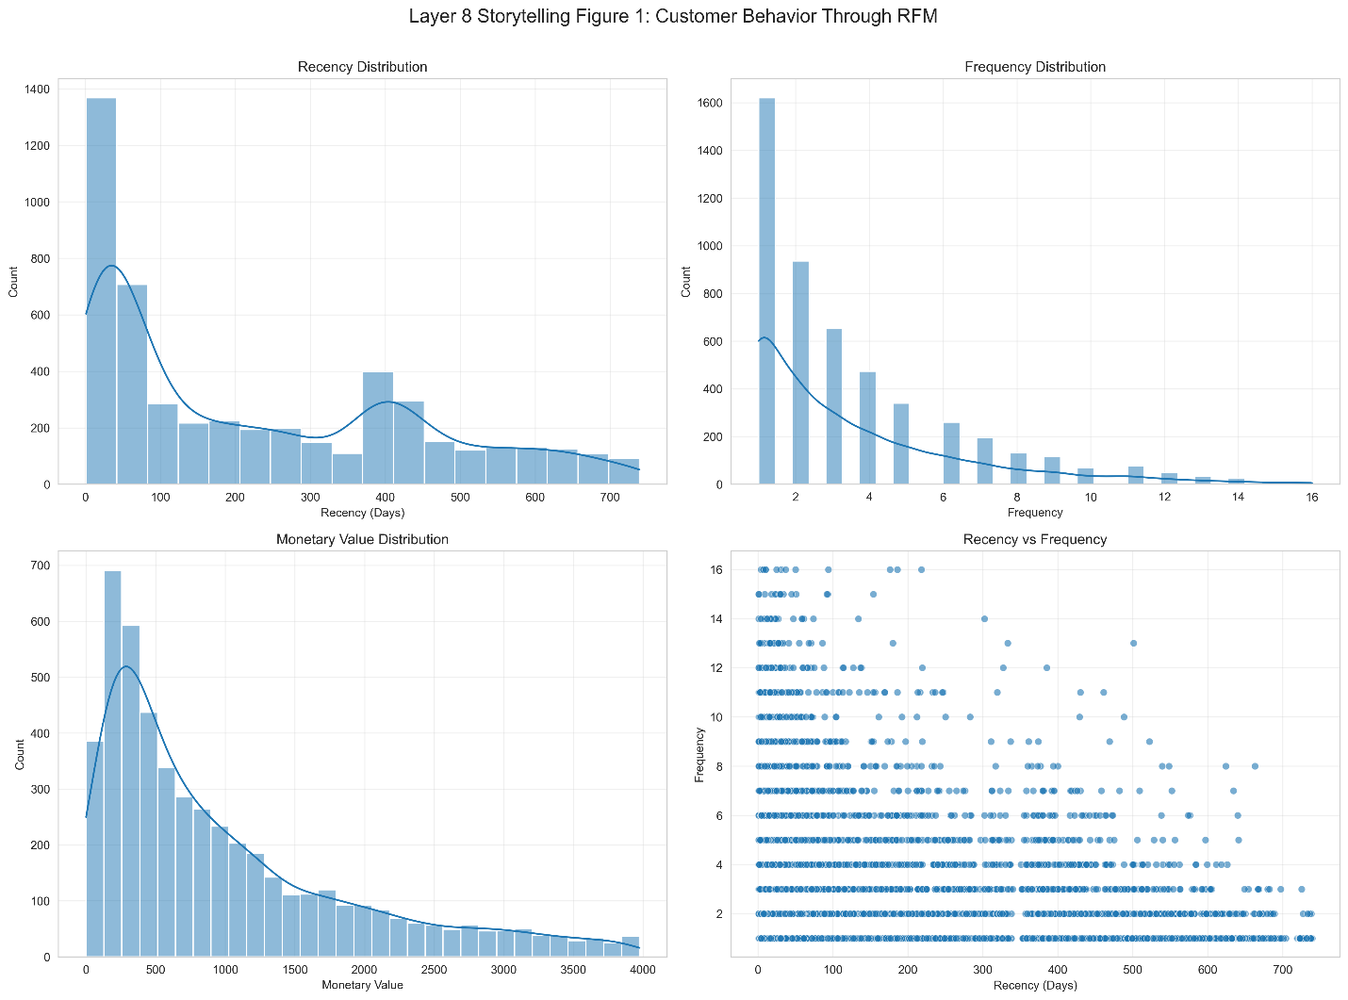
Figure 70: Customer Behavior Through RFM
These subplots present a combined view of the three core RFM variables along with their pairwise relationships, providing a unified perspective of customer behavior.

The Recency distribution is right-skewed, indicating that many customers have purchased recently, while a long tail represents customers who have been inactive for extended periods. Frequency is also highly skewed, showing that most customers make only a few purchases, while smaller subset purchases more frequently. Monetary Value follows a similar pattern, where most customers contribute relatively low spending and a limited group contributes significantly higher revenue.

The Recency versus Frequency scatter plot highlights an inverse relationship between inactivity and engagement. Customers with lower recency values tend to have higher purchase frequency, while customers with higher recency values generally purchase less often. This reinforces the idea that recent engagement is strongly associated with higher customer activity.

Overall, the figure demonstrates that customer value is unevenly distributed, with a small group of highly engaged customers driving a disproportionate share of purchasing behavior. This insight is critical for identifying high-value customer segments in subsequent analysis.

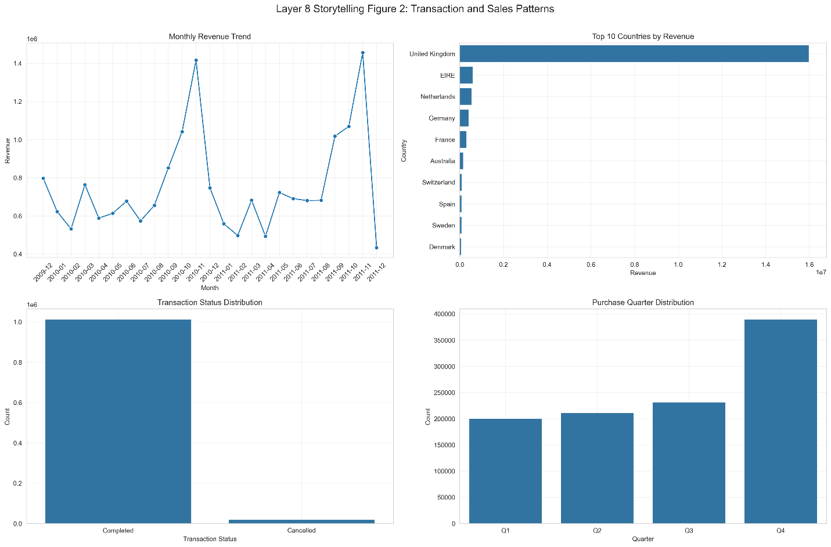
Figure 71: Transaction and Sales Patterns
These subplots expand the analysis from customer-level behavior to broader business performance patterns.

The monthly revenue trend shows clear variation over time, suggesting the presence of seasonality and fluctuating demand across different periods. Certain months exhibit significantly higher revenue, indicating peak sales periods.

The country-level revenue distribution reveals a strong geographic concentration, with the United Kingdom contributing most total revenue. Other countries contribute relatively small portions, indicating heavy reliance on a primary market.

The transaction status distribution shows that completed transactions dominate the dataset, while cancelled transactions represent only a small fraction. This suggests that the transaction process is stable with relatively low cancellation rates.

The purchase quarter distribution provides additional seasonal context, showing that transaction activity increases toward later quarters, particularly in Q4. This pattern suggests stronger purchasing behavior toward the end of the year.

Together, these subplots provide a comprehensive view of when revenue occurs, where it originates, and how transaction activity is distributed across time and geography. These insights are important for understanding both temporal dynamics and geographic dependencies in the dataset.

Tables
Tables are used throughout the report to present precise numerical summaries and support the visual insights derived from graphical analysis. These include descriptive statistics, correlation matrices, and results of data transformations.

Descriptive tables provide a clear understanding of central tendencies, variability, and distribution characteristics of key variables such as Recency, Frequency, and Monetary Value. Correlation matrices quantify relationships between variables, supporting findings observed in scatter plots and regression analysis.

Transformation tables document the effects of normalization and scaling techniques, ensuring transparency in preprocessing steps and validating improvements in data distribution.

Each table is placed within its relevant section to maintain contextual clarity and enhance interpretability, allowing for structured progression from raw data to analytical insights.

Interactive Dashboard
The interactive dashboard was designed to replicate and extend all components of the static analysis in an interactive format. Each section of the static phase, including preprocessing, statistical analysis, and exploratory data analysis, is represented as a dedicated tab within the dashboard.

This structure ensures consistency between static and interactive analysis while enabling users to dynamically explore the dataset through filters, controls, and interactive visualizations.

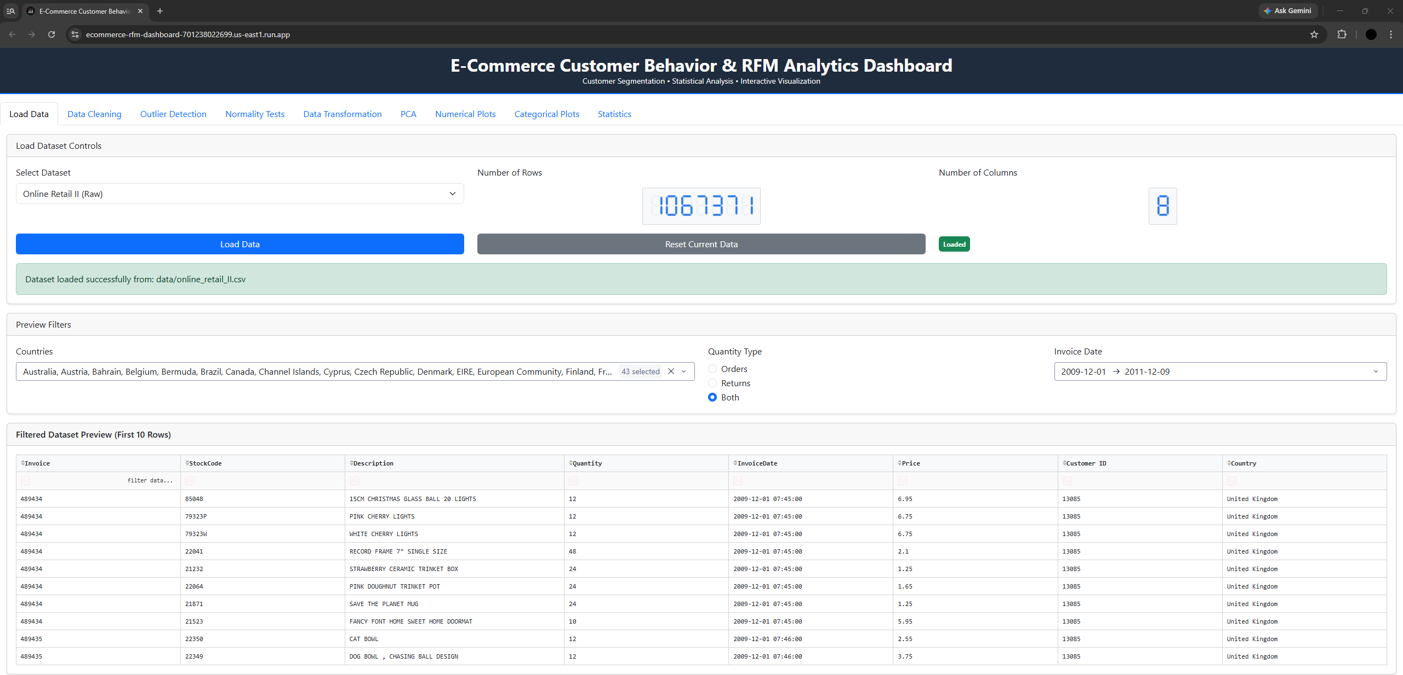
Figure 72: Data Overview and Preprocessing Tab
This tab serves as the entry point of the dashboard, providing an overview of the dataset and enabling initial data loading and filtering. It displays key metadata, including the total number of rows (1,067,371) and columns (8), confirming the scale and structure of the dataset.
The dataset selection and loading controls allow users to switch between data sources and reset the analysis environment dynamically. The successful loading message ensures transparency in the workflow.
Interactive filters enhance usability by allowing users to subset the data based on:
- Country selection (multi-select across 40+ regions)
- Transaction type (Orders, Returns, or Both)
- Invoice date range
The filtered dataset preview provides a real-time view of the first few rows, enabling quick validation of applied filters and data integrity.

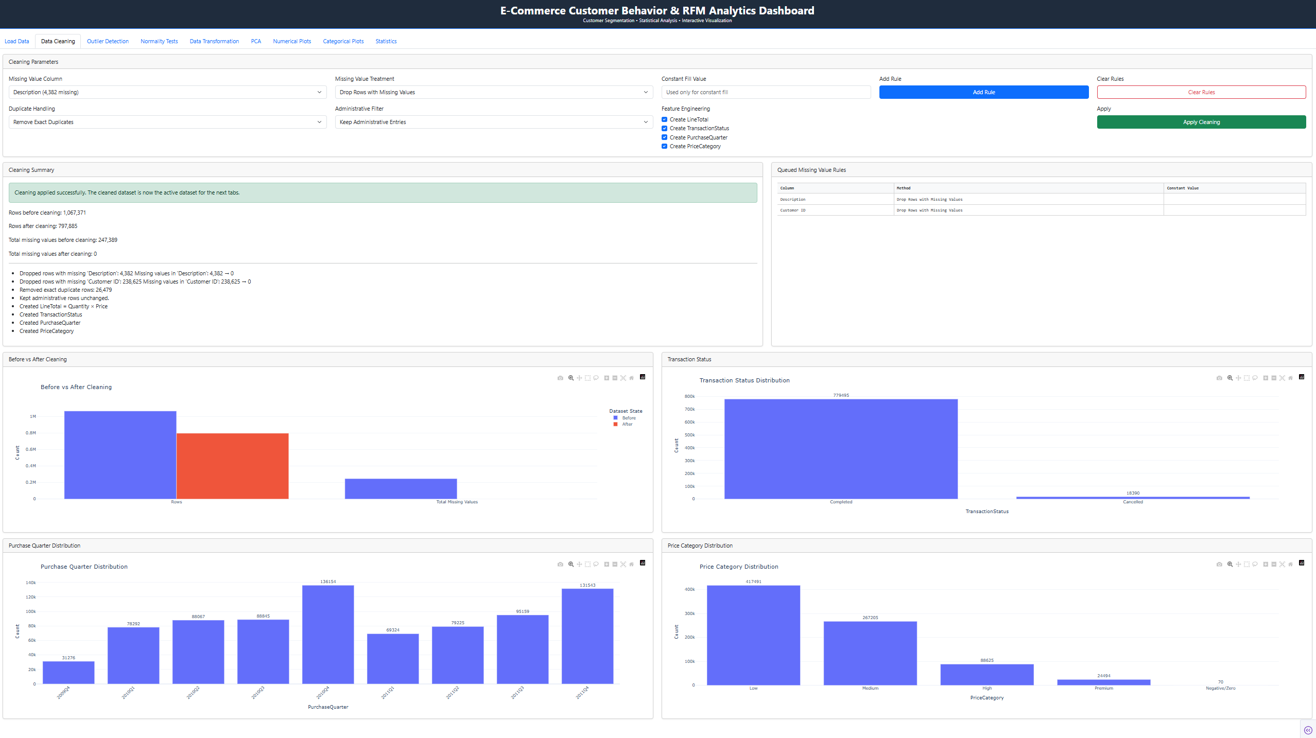
Figure 73: Data Cleaning Tab
This tab provides an interactive interface for data preprocessing and cleaning, allowing users to define and apply data quality rules before analysis.
Key preprocessing operations performed include:
- Handling missing values by dropping rows with missing entries in critical fields such as Description and Customer ID
- Duplicate removal, eliminating redundant transactional records
- Feature engineering, including creation of derived variables such as LineTotal, TransactionStatus, PurchaseQuarter, and PriceCategory
The cleaning summary panel highlights the impact of preprocessing:
- The dataset size reduced significantly from over 1 million rows to a cleaner subset after removing missing and duplicate entries
- Missing values were effectively eliminated, improving data consistency and reliability
The Before vs After Cleaning visualization clearly demonstrates the reduction in dataset size and missing values, validating the effectiveness of the cleaning process.
Additional visualizations provide insight into the cleaned dataset:
- The Transaction Status distribution confirms that completed transactions dominate, with cancellations forming only a small fraction
- The Purchase Quarter distribution shows increasing activity toward later quarters, particularly in Q4 periods
- The Price Category distribution indicates that most transactions fall within lower price ranges, with significantly fewer high-value transactions
Overall, this tab ensures that the dataset is properly prepared for downstream analysis by improving data quality, reducing noise, and enabling the creation of meaningful analytical features.

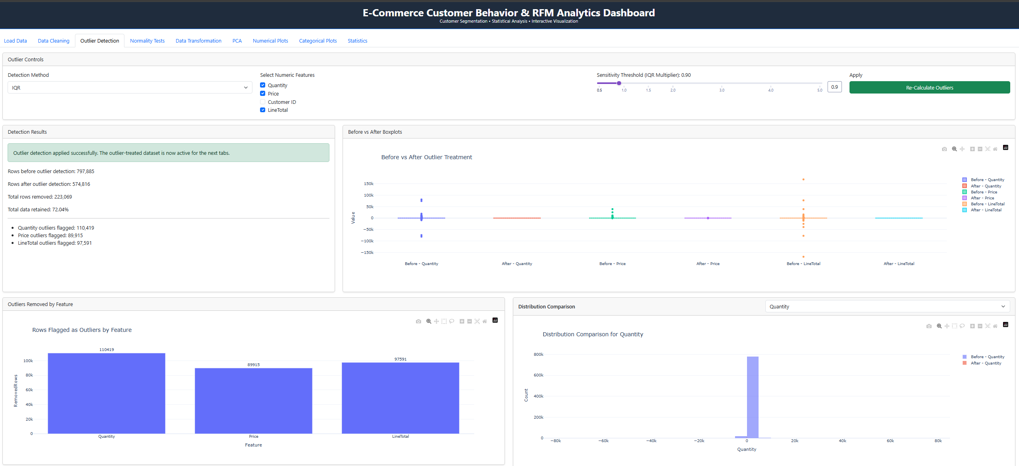
Figure 74: Outlier Detection Tab
This tab enables detection and removal of extreme values using the IQR method across key numerical features (Quantity, Price, LineTotal).
A substantial number of outliers are identified and removed, reducing the dataset size while retaining approximately 72% of the data. Quantity shows the highest number of outliers, followed by LineTotal and Price.
The before-and-after visualizations confirm that extreme values are effectively reduced, resulting in tighter distributions and improved data consistency.
Overall, the tab ensures that subsequent analyses are not distorted by extreme observations.

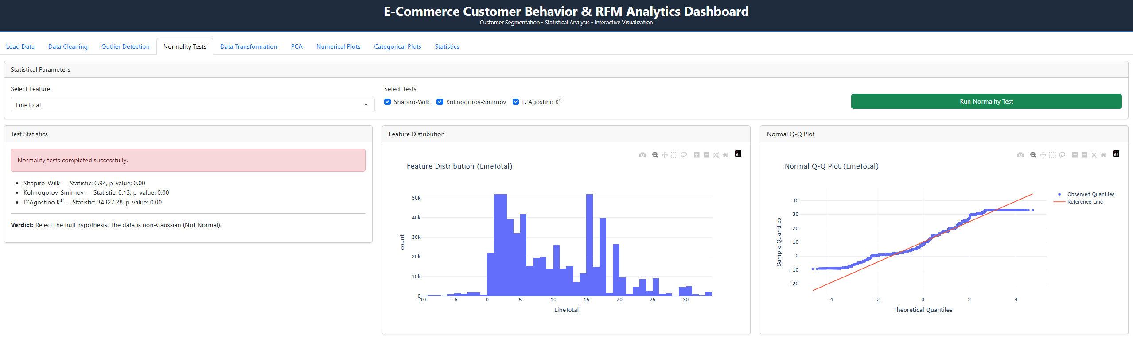
Figure 75: Normality Testing Tab

This tab evaluates the distribution of numerical features using statistical normality tests and visual diagnostics.
All applied tests (Shapiro-Wilk, Kolmogorov-Smirnov, and D’Agostino K²) return p-values of 0.00, leading to rejection of the null hypothesis of normality. The histogram shows a skewed distribution, and the Q-Q plot deviates significantly from the reference line.
Overall, the feature exhibits a non-Gaussian distribution, justifying the need for transformation before further statistical analysis.

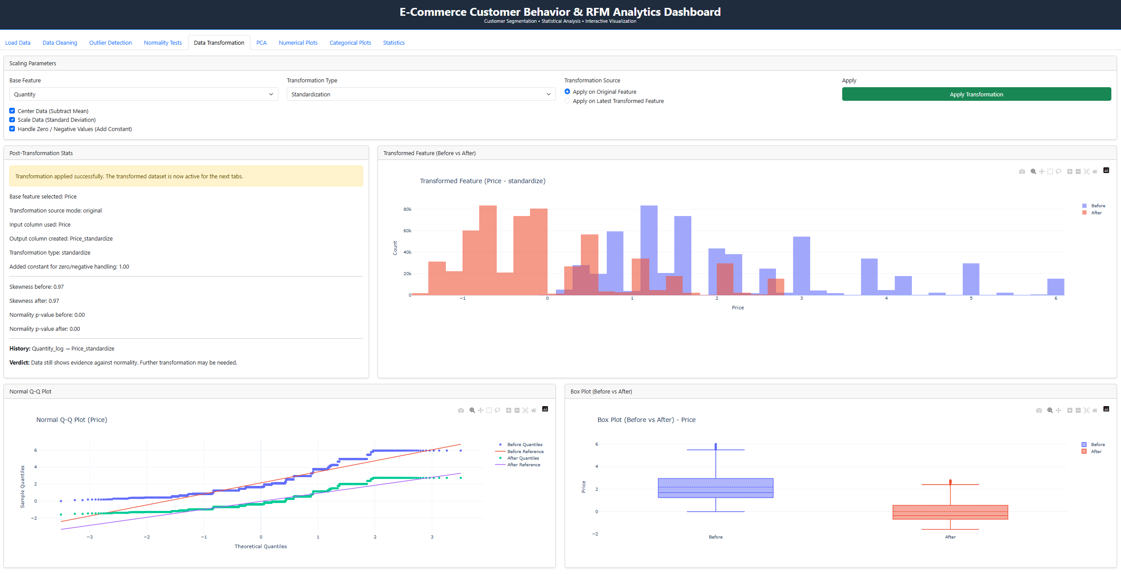
Figure 76: Data Transformation Tab

This tab applies feature transformation techniques to improve data distribution and prepare variables for statistical modeling. In this case, standardization is applied to the Price variable.
The transformation rescales the data to have a mean of zero and unit variance, which is reflected in the shifted and more centered histogram after transformation. The boxplot comparison shows reduced spread and better alignment around the central tendency.
However, the Q-Q plot and statistical summary indicate that the data still deviates from normality, suggesting that standardization alone is insufficient to fully normalize the distribution.
Overall, the transformation improves comparability and scale but highlights the need for more advanced transformations (e.g., log or Box-Cox) for achieving normality.

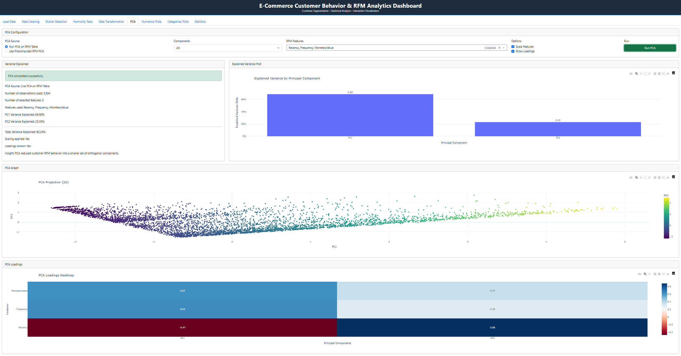
Figure 77: Principal Component Analysis Tab
This tab performs dimensionality reduction on the RFM features (Recency, Frequency, MonetaryValue) to capture the underlying structure of customer behavior.
The explained variance plot shows that the first two principal components account for over 90% of the total variance, indicating that most of the information in the data can be represented in two dimensions.
The 2D PCA projection reveals a clear gradient pattern, suggesting continuous variation in customer behavior rather than sharply defined clusters.
The loadings heatmap indicates that:
- MonetaryValue and Frequency contribute positively to the first component
- Recency has a negative contribution, reinforcing its inverse relationship with customer engagement
Overall, PCA effectively summarizes the RFM features, highlighting key behavioral patterns while reducing dimensional complexity.

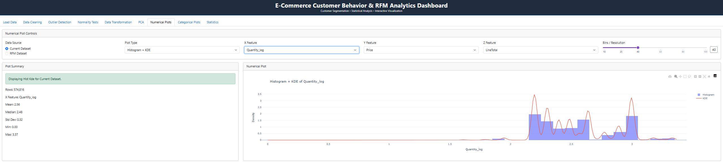
Figure 78: Numerical Analysis Tab
This tab enables interactive exploration of numerical variables using various plot types. In this view, a histogram with KDE is used to analyze the distribution of log-transformed Quantity.
The distribution appears more compact and less skewed compared to the raw variable, indicating that the log transformation has improved symmetry. The KDE curve highlights multiple peaks, suggesting the presence of common purchase quantity patterns.
Summary statistics further confirm a controlled spread with reduced variance.
Overall, the transformation makes the variable more suitable for statistical analysis while preserving key behavioral patterns.

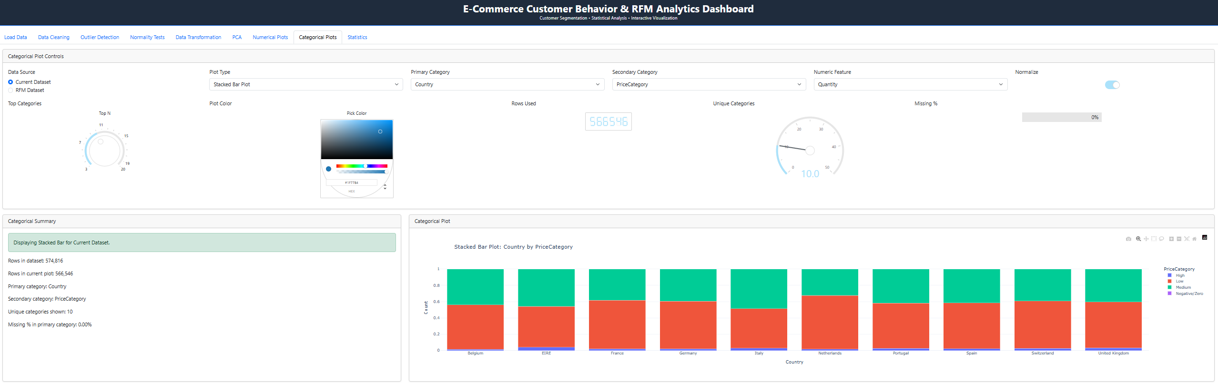
Figure 79: Categorical Analysis Tab
This tab supports interactive analysis of categorical variables through configurable visualizations. In this view, a stacked bar plot illustrates the distribution of price categories across countries.
The normalized representation shows that Low price transactions dominate across all countries, with Medium and Very Low categories contributing moderate shares, while High price transactions remain minimal.
The relative consistency in composition across countries suggests similar pricing structures and purchasing behavior geographically, despite differences in total volume.
Overall, the visualization highlights that revenue is largely driven by lower-priced items across all markets.

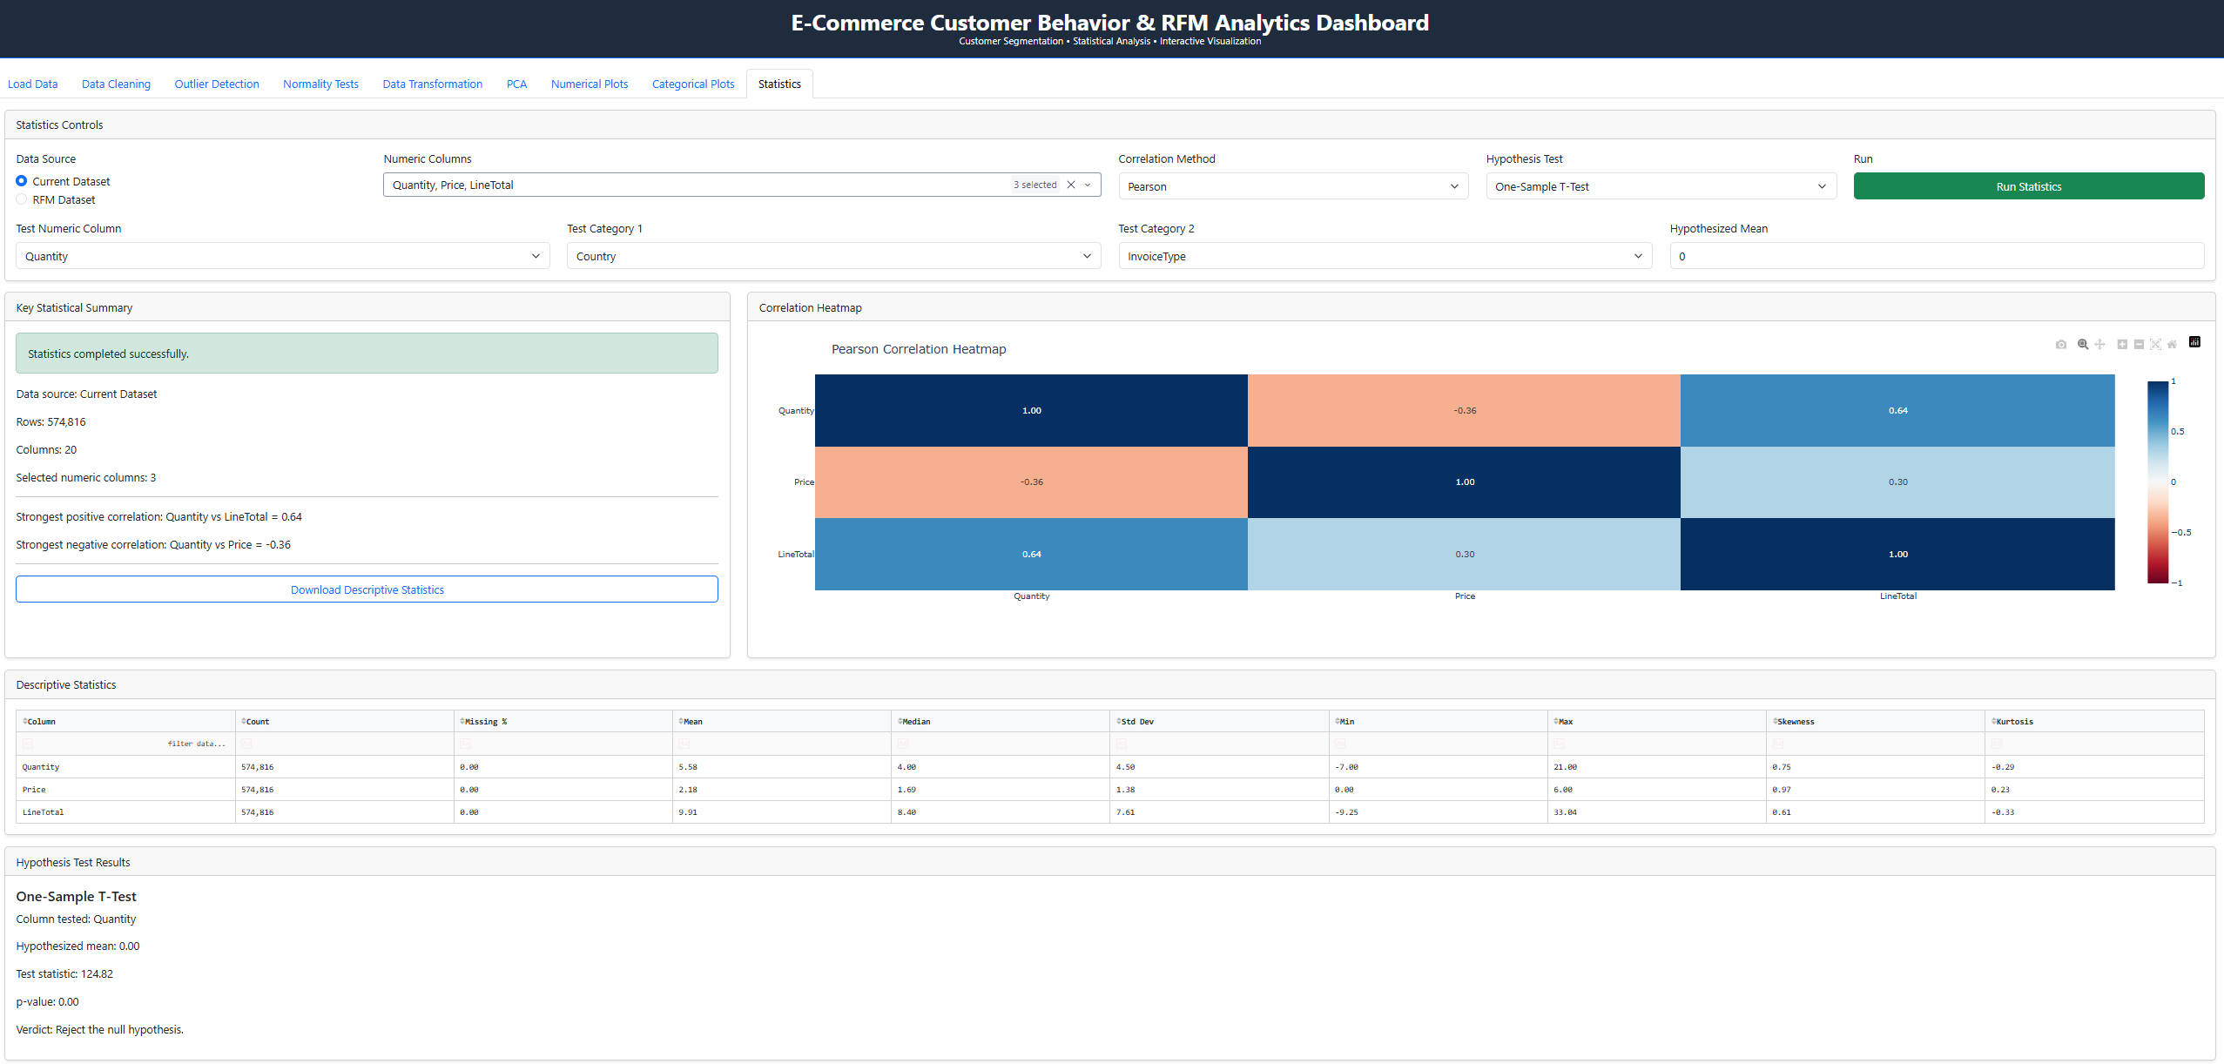
Figure 80: Statistical Analysis Tab
This tab provides a consolidated statistical overview, including descriptive statistics, correlation analysis, and hypothesis testing.
The Pearson correlation heatmap indicates a moderate positive relationship between Quantity and LineTotal (0.64), confirming that higher purchase volumes drive revenue. A weak negative correlation between Quantity and Price (-0.36) suggests that lower-priced items tend to be purchased in higher quantities.
Descriptive statistics show moderate variability and positive skewness across variables, reinforcing earlier observations of non-normal distributions.
The one-sample t-test (p-value = 0.00) leads to rejection of the null hypothesis, indicating that the mean quantity significantly differs from the hypothesized value.
Overall, the tab confirms key statistical relationships and supports the validity of observed purchasing patterns.

The interactive dashboard provides a dynamic extension of the static analysis, allowing users to explore the dataset through flexible and responsive visualizations. Each tab presents a representative sample visualization; however, multiple plot types, variables, and configurations are available for deeper exploration. All graphs are fully interactive, enabling filtering, zooming, and parameter adjustments in real time. This enhances analytical capability by allowing users to investigate patterns, validate insights, and customize views beyond the fixed representations shown in the report.

Overall Observations
The analysis of the Online Retail dataset reveals several consistent and meaningful patterns across customer behavior, transactional activity, and revenue generation.

A key observation is the highly skewed nature of all primary numerical variables: Recency, Frequency, and Monetary Value. Majority of customers exhibit low purchase frequency and relatively low spending, while a small subset of customers contributes disproportionately to total revenue. This long-tailed distribution indicates the presence of high-value customers, which is a critical insight for customer segmentation and targeted marketing strategies.

Recency analysis shows that a large portion of customers have made recent purchases, suggesting active engagement within the customer base. However, the presence of a long tail of inactive customers highlights potential opportunities for re-engagement campaigns. The inverse relationship observed between Recency and Frequency confirms that customers who purchase more recently tend to be more active overall, reinforcing the importance of recency as a strong indicator of customer engagement.

Frequency and Monetary Value exhibit a positive relationship, indicating that customers who purchase more often also tend to spend more. This relationship supports the identification of loyal, high-value customers and justifies the use of RFM analysis as an effective segmentation technique.

From a categorical perspective, transaction behavior is highly stable. Completed transactions account for most records, with cancellation rates remaining consistently low across all time periods. This suggests a reliable transaction system with minimal disruption due to returns or cancellations.

Revenue distribution is heavily concentrated geographically, with the United Kingdom contributing most of the total sales. Other countries play a comparatively smaller role, indicating a strong dependency on a single primary market. This concentration presents both an opportunity for focused market optimization and a risk due to limited geographic diversification.

Temporal analysis reveals moderate seasonality in purchasing behavior. Transaction volumes and revenue tend to increase toward later quarters, particularly in Q4, suggesting the influence of seasonal demand patterns such as holiday shopping periods. However, day-of-week analysis indicates relatively consistent purchasing behavior, with no significant variation across weekdays.

Price category analysis shows that most transactions occur within lower price ranges, with the “Low” category dominating the dataset. High-value transactions are relatively rare but contribute significantly to overall revenue, further emphasizing the importance of identifying and retaining high-spending customers.

Data distribution analysis, including KDE plots and QQ plots, confirms that the variables deviate significantly from normality, exhibiting strong skewness and heavy tails. This justifies the application of log transformations and scaling techniques to stabilize variance and improve the suitability of the data for statistical modeling and machine learning algorithms.

Overall, the dataset reflects a typical retail environment characterized by a large base of low-value customers and a smaller segment of highly valuable customers driving revenue. The insights derived from this analysis provide a strong foundation for advanced modeling, including customer segmentation, predictive analytics, and personalized marketing strategies.

Conclusion
This project shows how raw transactional data can be turned into meaningful insights using a complete data analysis workflow. The visualizations clearly highlight that customer behavior is highly uneven. Most customers purchase infrequently and spend small amounts, while a small group contributes a large share of total revenue. The relationship between Recency, Frequency, and Monetary Value is consistent across multiple analyses. Customers who purchased recently tend to buy more often and spend more, while inactive customers show lower engagement and value. These patterns confirm the usefulness of RFM analysis for understanding customer behavior and identifying high-value segments.

The interactive dashboard adds significant value by allowing users to explore the data beyond static visuals. Instead of viewing fixed results, users can apply filters, adjust parameters, and interact with the graphs in real time. This makes it easier to explore specific segments, test different scenarios, and better understand patterns in the data. The dashboard also brings together all stages of the analysis in one place, making the workflow more practical and easier to follow.

In terms of usability, the dashboard is straightforward and easy to navigate. The tab-based layout follows the same structure as the report, so users can move through the analysis step by step. Controls such as dropdowns, sliders, and filters make it accessible even for users without a strong technical background. The design focuses on clarity, which helps users quickly interpret results without confusion.

Functionally, the dashboard is comprehensive and flexible. It supports data cleaning, outlier detection, statistical testing, transformation, PCA, and both numerical and categorical analysis. Users can change inputs and immediately see how results are affected, which improves both understanding and efficiency. The deployment on the cloud also ensures that the dashboard is accessible and scalable.

Overall, this project demonstrates how combining statistical analysis, visualization, and interactivity can provide a deeper understanding of customer behavior. The results and the dashboard together offer a practical tool for analyzing retail data and supporting data-driven decisions.

References
UCI Machine Learning Repository. Online Retail Dataset.
https://www.kaggle.com/datasets/mashlyn/online-retail-ii-uci

Pandas Documentation. https://pandas.pydata.org

NumPy Documentation. https://numpy.org/

Matplotlib Documentation. https://matplotlib.org/

Seaborn Documentation. https://seaborn.pydata.org/

Scikit-learn Documentation. https://scikit-learn.org/

Investopedia. RFM (Recency, Frequency, Monetary Value).
https://www.investopedia.com/terms/r/rfm-recency-frequency-monetary-value.asp

Plotly Dash Documentation. https://dash.plotly.com/

Full code repository: https://github.com/ibrahimhamza01/ecommerce-rfm-dashboard

Appendix A: Supporting Python Code

App.py:
from dash import Dash, dcc, html, Input, Output
import dash_bootstrap_components as dbc
from layouts.load_data_layout import layout as load_data_layout
from callbacks.load_data_callbacks import register_callbacks as register_load_data_callbacks
from layouts.data_cleaning_layout import layout as data_cleaning_layout
from callbacks.data_cleaning_callbacks import register_callbacks as register_data_cleaning_callbacks
from layouts.outlier_layout import layout as outlier_layout
from callbacks.outlier_callbacks import register_callbacks as register_outlier_callbacks
from layouts.normality_layout import layout as normality_layout
from callbacks.normality_callbacks import register_callbacks as register_normality_callbacks
from layouts.transformation_layout import layout as transformation_layout
from callbacks.transformation_callbacks import register_callbacks as register_transformation_callbacks
from layouts.pca_layout import layout as pca_layout
from callbacks.pca_callbacks import register_callbacks as register_pca_callbacks
from layouts.numerical_layout import layout as numerical_layout
from callbacks.numerical_callbacks import register_callbacks as register_numerical_callbacks
from layouts.categorical_layout import layout as categorical_layout
from callbacks.categorical_callbacks import register_callbacks as register_categorical_callbacks
from layouts.statistics_layout import layout as statistics_layout
from callbacks.statistics_callbacks import register_callbacks as register_statistics_callbacks
app = Dash(
__name__,
external_stylesheets=[dbc.themes.BOOTSTRAP],
suppress_callback_exceptions=True,
)
app.title = "E-Commerce Customer Behavior & RFM Analytics"
server = app.server
app.layout = dbc.Container(
[
dcc.Store(id="raw-data-store"),
dcc.Store(id="current-data-store"),
dcc.Store(id="metadata-store"),
dcc.Store(id="history-store", data=[]),
# CLEAN HEADER
html.Div(
[
html.H2(
"E-Commerce Customer Behavior & RFM Analytics Dashboard",
className="text-center text-white fw-bold",
style={"margin": "0"},
),
html.P(
"Customer Segmentation • Statistical Analysis • Interactive Visualization",
className="text-center text-light",
style={"margin": "0", "fontSize": "14px"},
),
],
style={
"backgroundColor": "#1f2c3d",
"padding": "12px",
"borderBottom": "2px solid #0d6efd",
"marginBottom": "15px",
},
),
dbc.Tabs(
id="main-tabs",
active_tab="tab-load-data",
children=[
dbc.Tab(label="Load Data", tab_id="tab-load-data"),
dbc.Tab(label="Data Cleaning", tab_id="tab-data-cleaning"),
dbc.Tab(label="Outlier Detection", tab_id="tab-outlier-detection"),
dbc.Tab(label="Normality Tests", tab_id="tab-normality-tests"),
dbc.Tab(label="Data Transformation", tab_id="tab-data-transformation"),
dbc.Tab(label="PCA", tab_id="tab-pca"),
dbc.Tab(label="Numerical Plots", tab_id="tab-numerical-plots"),
dbc.Tab(label="Categorical Plots", tab_id="tab-categorical-plots"),
dbc.Tab(label="Statistics", tab_id="tab-statistics"),
],
className="mb-3",
),
html.Div(id="tab-content"),
],
fluid=True,
className="p-0",
)
@app.callback(
Output("tab-content", "children"),
Input("main-tabs", "active_tab"),
)
def render_tab_content(active_tab):
if active_tab == "tab-load-data":
return load_data_layout
if active_tab == "tab-data-cleaning":
return data_cleaning_layout
if active_tab == "tab-outlier-detection":
return outlier_layout
if active_tab == "tab-normality-tests":
return normality_layout
if active_tab == "tab-data-transformation":
return transformation_layout
if active_tab == "tab-pca":
return pca_layout
if active_tab == "tab-numerical-plots":
return numerical_layout
if active_tab == "tab-categorical-plots":
return categorical_layout
if active_tab == "tab-statistics":
return statistics_layout
return dbc.Alert("Tab not found.", color="danger")
register_load_data_callbacks(app)
register_data_cleaning_callbacks(app)
register_outlier_callbacks(app)
register_normality_callbacks(app)
register_transformation_callbacks(app)
register_pca_callbacks(app)
register_numerical_callbacks(app)
register_categorical_callbacks(app)
register_statistics_callbacks(app)
if __name__ == "__main__":
app.run(debug=True)

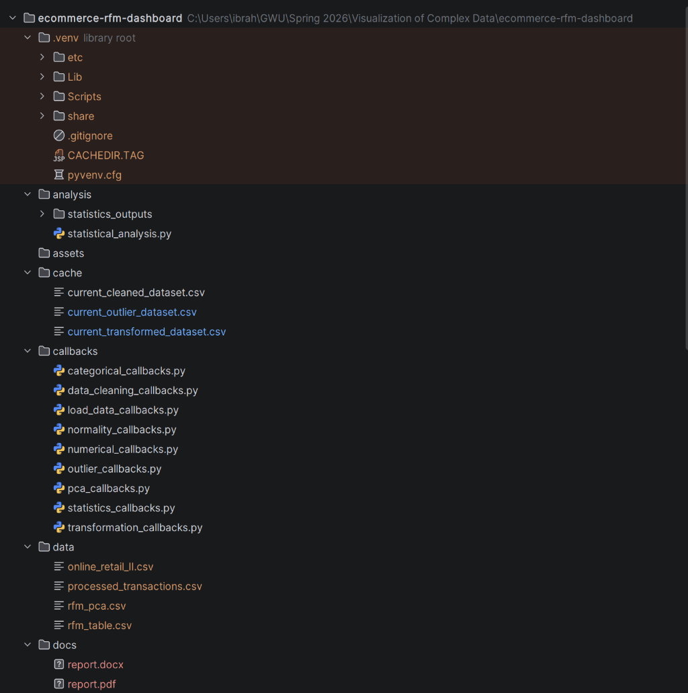

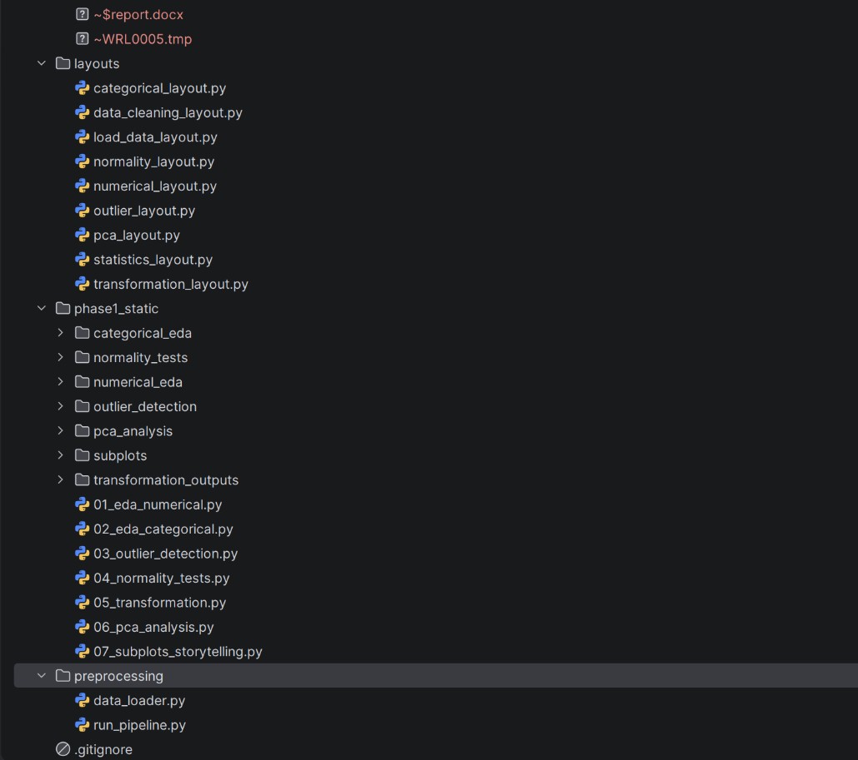

Figure 81: Repo structure

