E-Learning Platform



* Introduction

The E-Learning Platform is an innovative digital tool designed to provide users with a seamless learning experience, offering a broad array of courses, interactive lessons, quizzes, and assessment tools. The platform aims to deliver accessible, high-quality education that caters to the diverse needs of students, professionals, and lifelong learners. The goal of this project is to develop an intuitive, scalable, and secure platform that promotes engagement and knowledge retention through multimedia content, personalized learning paths, and collaborative features.

* Functional Requirements
* Platform Structure

• **User Registration and Authentication**

* Users (students, instructors, and administrators) can create accounts and log in securely.
* Multi-role functionality allows for different access levels and features for each role.
* Social media login and email verification options are available.

• **Course Management**

* Instructors can create, update, and delete courses, manage course materials, and set prerequisites.
* Courses can include videos, readings, assignments, quizzes, and downloadable resources.
* Courses are organized into categories, with filtering options for easy navigation.

• **Content Delivery and Interaction**

* Lessons include video, audio, text, and interactive elements like quizzes and polls.
* Students can progress through self-paced or scheduled courses with adaptive recommendations.
* Real-time chat, discussion boards, and Q&A sessions facilitate peer and instructor interactions.

• **Assessment and Feedback**

* Quizzes, exams, and assignments are available for student assessment.
* Automated grading is available for objective questions (e.g., multiple choice).
* Students and instructors can review assessment results, and instructors can provide feedback.

• **Progress Tracking and Analytics**

* Students can view their progress and receive completion certificates.
* Instructors have access to course analytics to monitor student performance.
* Administrators can access platform-wide analytics, including engagement metrics.

• **Notifications and Reminders**

* Users receive notifications for course updates, deadlines, and messages.
* Email and in-app notifications remind students of upcoming deadlines or course activities.

• **Payment System**

* Integration with payment gateways for course enrollment and premium features.
* Different pricing models available (subscription-based, one-time payments, etc.).
* Platform Users

**1. Students**

The **Student** role represents the learners who will be using the platform to enroll in courses, complete lessons, participate in discussions, and track their progress. Here are their key abilities:

* **Account Management**
  + Register for an account and log in securely.
  + View and update their profile details, including basic information and profile picture.
* **Course Enrollment and Progress**
  + Browse, search, and filter courses by categories or keywords.
  + Enroll in courses, either free or paid, depending on course requirements.
  + View their enrolled courses, and track progress within each course.
  + Resume incomplete courses from the last completed section or lesson.
* **Learning Content Access**
  + Access course materials, including videos, readings, downloadable resources, and assignments.
  + Take quizzes and exams embedded within course content.
* **Engagement and Interaction**
  + Participate in discussion boards and post questions or responses within each course.
  + Interact with peers and instructors through real-time chat or scheduled Q&A sessions.
* **Progress Tracking and Certification**
  + Review quiz scores, assignment feedback, and overall performance.
  + Access completion certificates after finishing a course.
* **Notifications and Reminders**
  + Receive notifications about upcoming deadlines, messages, or course updates.
  + Set reminders for unfinished tasks or scheduled lessons.

**2. Instructors**

The **Instructor** role represents users who create and manage courses, monitor student progress, and facilitate learning experiences. Here’s what they can do:

* **Course Creation and Management**
  + Create new courses and add content, including multimedia elements like videos, documents, and quizzes.
  + Organize course content into modules or lessons with a structured flow.
  + Set prerequisites, determine course visibility (public or private), and define enrollment requirements (e.g., free or paid).
* **Student Progress and Performance Monitoring**
  + Track enrolled students’ progress through analytics, seeing completion rates, quiz scores, and other performance metrics.
  + Identify students who might need extra help or intervention based on performance data.
* **Assessment and Feedback**
  + Design and manage assessments, including quizzes, assignments, and exams.
  + Automatically grade objective questions and manually review and grade subjective answers.
  + Provide feedback on assignments, with the option to leave comments or suggestions.
* **Engagement and Interaction**
  + Facilitate discussions by answering questions, starting new discussion topics, and moderating content.
  + Schedule and conduct live Q&A sessions or office hours through the platform.
* **Notifications and Updates**
  + Send updates to students about course changes, deadlines, or new content.
  + Receive alerts about students’ questions, comments, or flagged issues.

**3. Administrators**

The **Administrator** role encompasses the highest level of control over the platform, responsible for maintaining platform security, managing user access, and ensuring smooth operation. Their abilities include:

* **User and Role Management**
  + Manage student and instructor accounts, including creating, updating, or deactivating accounts as necessary.
  + Assign roles to users and manage permissions, ensuring each user has access only to the appropriate sections of the platform.
* **Course Oversight and Quality Control**
  + Approve or review courses before they are published to ensure they meet platform standards.
  + Monitor course content and user activity for inappropriate or violating material.
  + Manage course categories, ensuring an organized and accessible structure for users.
* **Platform Monitoring and Maintenance**
  + Monitor system performance, load, and user activity to prevent issues.
  + Manage backups, run diagnostics, and implement security measures to safeguard data.
  + Conduct regular maintenance and updates to ensure platform reliability.
* **Payment and Revenue Management**
  + Oversee payment processing and manage revenue-related activities for premium courses.
  + Access financial reports, track revenue from paid courses, and resolve payment issues as necessary.
* **Data Analytics and Reporting**
  + Access comprehensive reports on platform usage, user demographics, course popularity, and completion rates.
  + Analyze user engagement and course success to guide decisions on platform improvements.
* Non-Functional Requirements

• **Performance**

* The platform should load within 3 seconds under normal conditions.
* Capable of handling at least 5,000 concurrent users without degradation.

• **Scalability**

* Designed to scale with an increasing number of users and courses.
* Cloud storage for multimedia content to facilitate scaling.

• **Reliability and Availability**

* Minimum uptime of 99.5%, with effective load balancing and failover systems.
* Backups scheduled regularly to prevent data loss.

• **Security**

* Secure authentication and data encryption.
* Compliance with privacy standards (e.g., GDPR) for handling user data.
* Regular security audits and vulnerability checks.

• **Usability**

* Intuitive, user-friendly interface with clear navigation.
* Accessibility features for users with disabilities (e.g., screen reader compatibility).

• **Maintainability**

* Well-documented codebase for ease of updates and bug fixes.
* Modular design allowing independent updates and feature additions.
* System Requirements

• **Frameworks**:

* .NET 6 (or the latest stable LTS version of .NET)
* ASP.NET Core for web developmentc

• **Database**:

* SQL Server (Express edition for development or local SQL Server if available)
* Entity Framework Core (for ORM functionality in ASP.NET)

• **Web Technologies**:

* HTML, CSS, JavaScript, Bootstrap (for front-end development)
* jQuery or another JavaScript framework (optional)

• **Version Control**: Git (GitHub or Azure DevOps for repository hosting).

🡪Class diagram

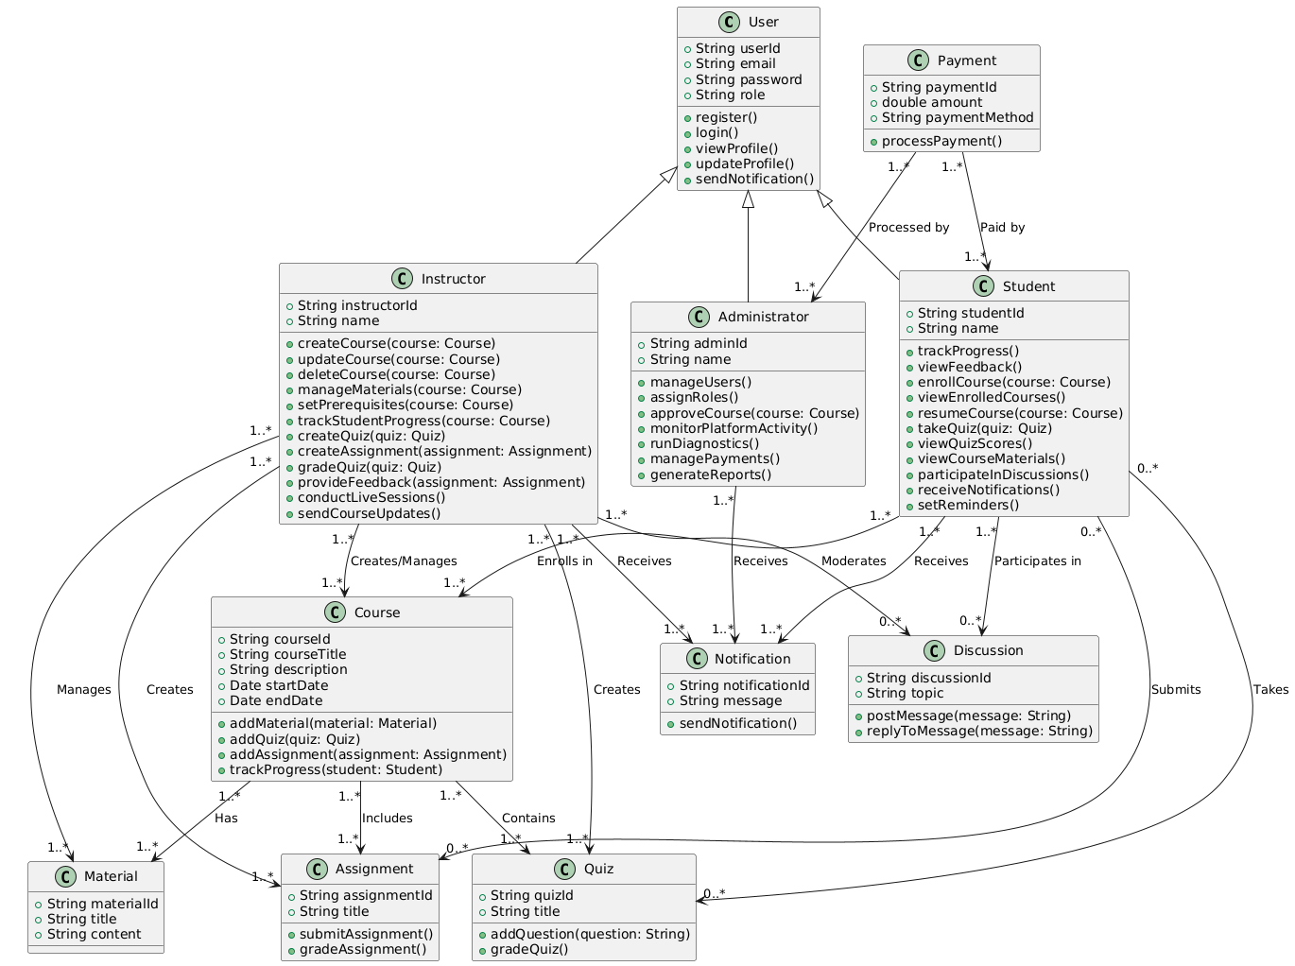

🡪 Context diagram

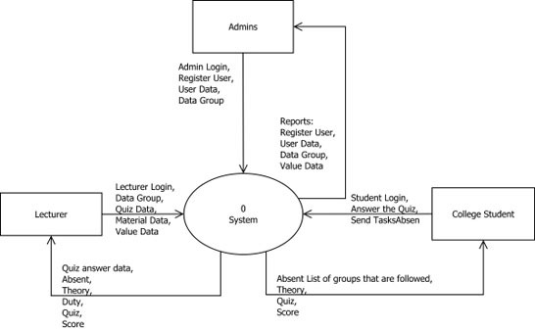

🡪 Context diagram

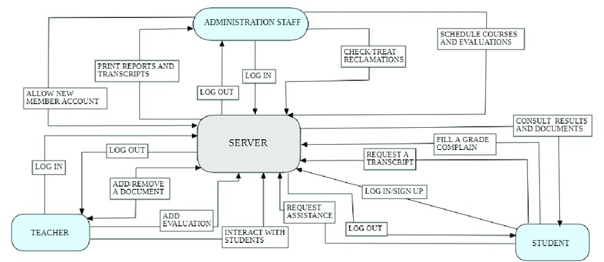

🡪Use case diagram

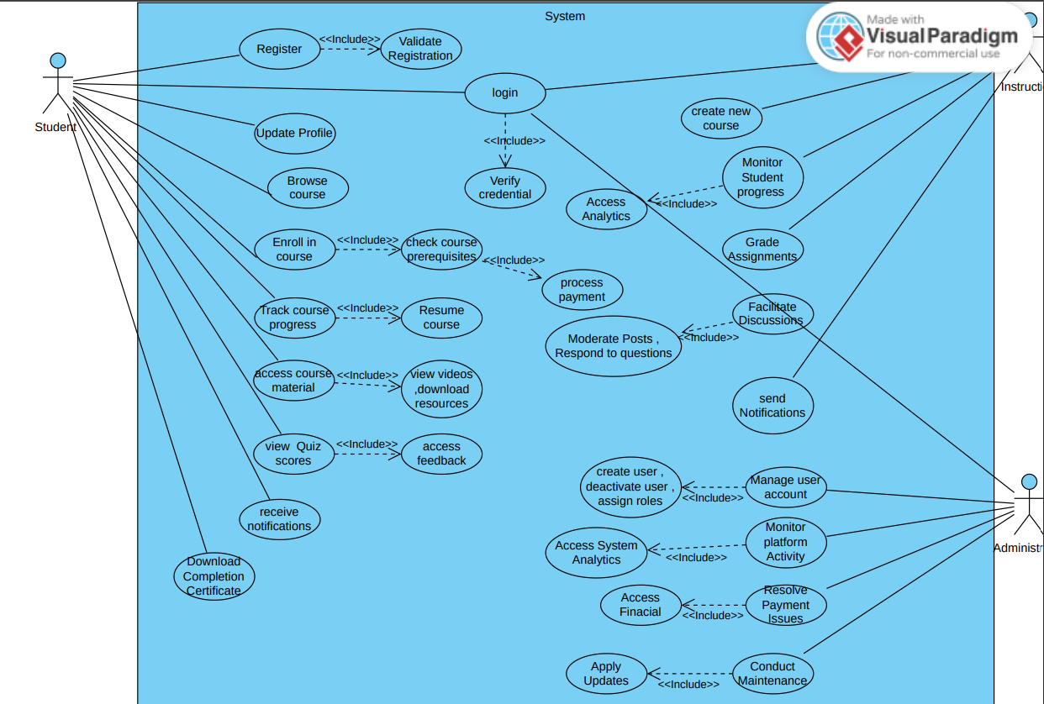

🡪 Sequence Diagrams

* + course creation

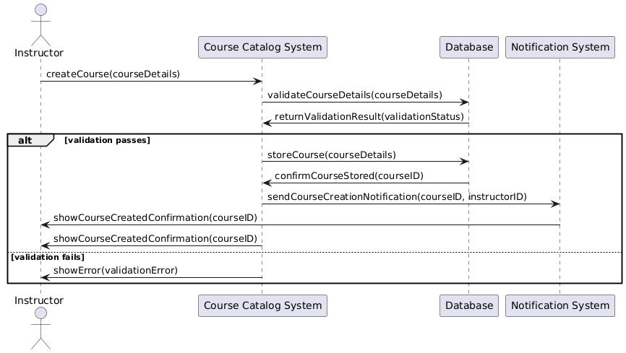

🡪 Payment

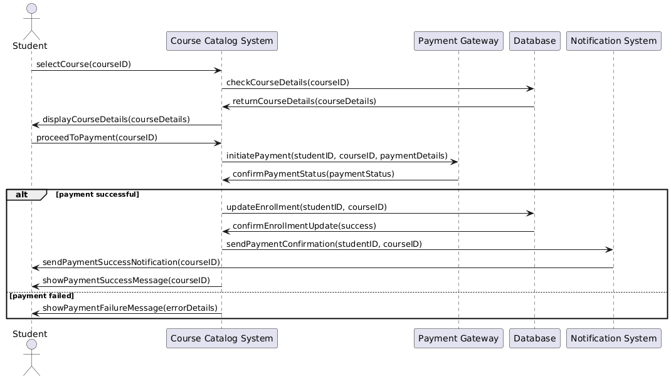

🡪 Course enrollment

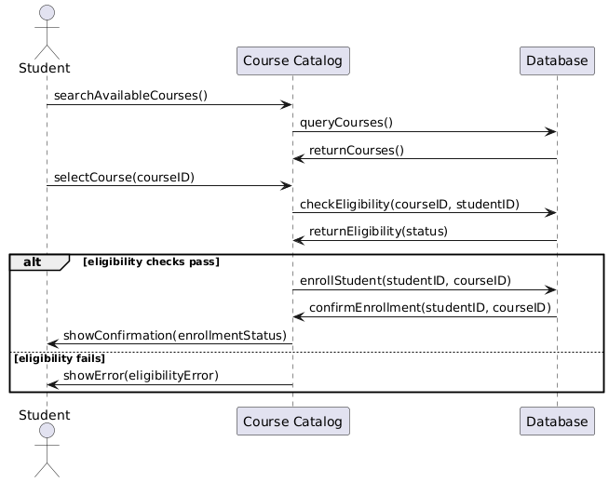

🡪 Quiz attempt

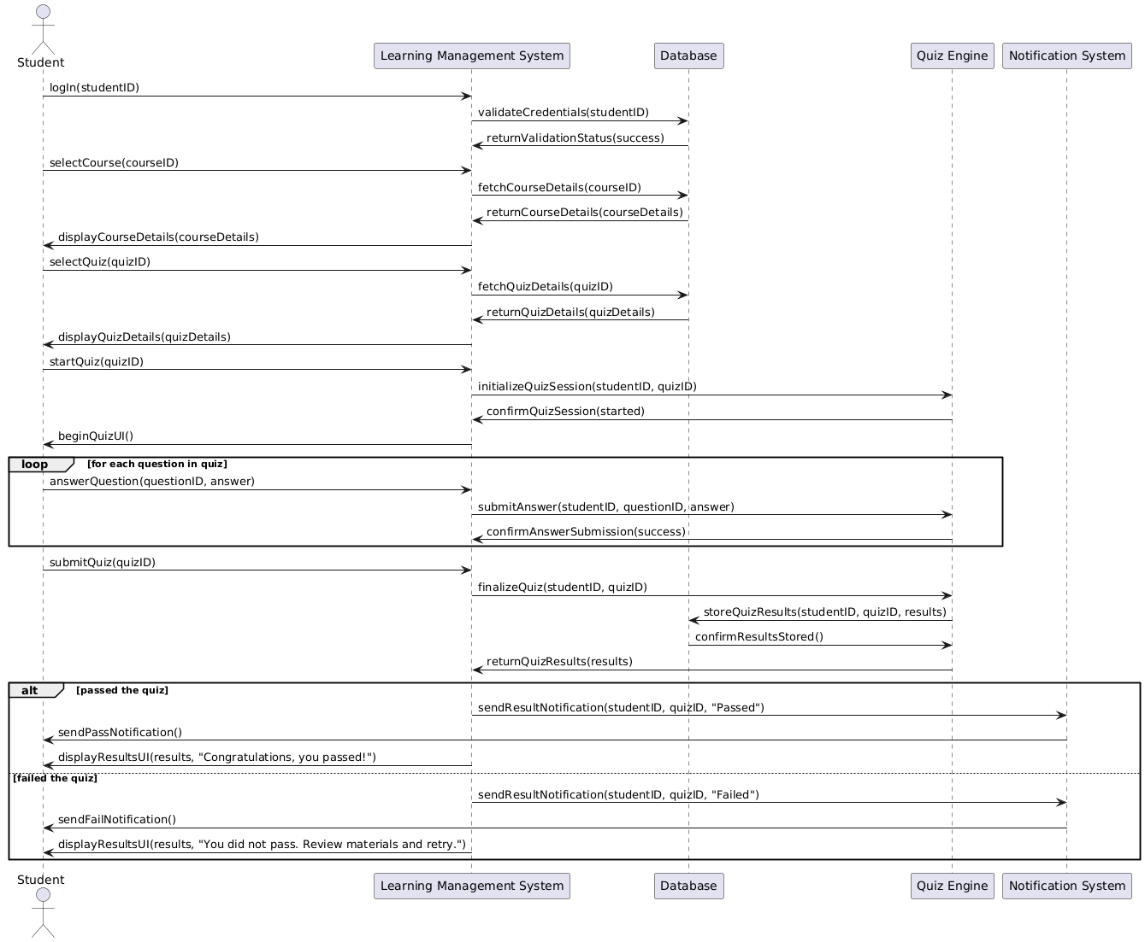

🡪 Student login

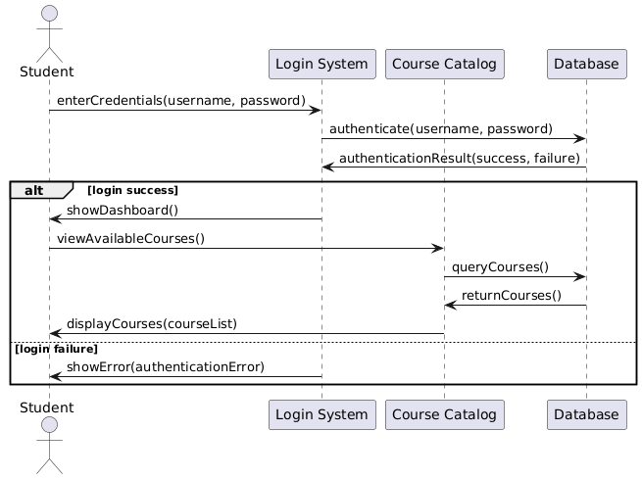

🡪 User management

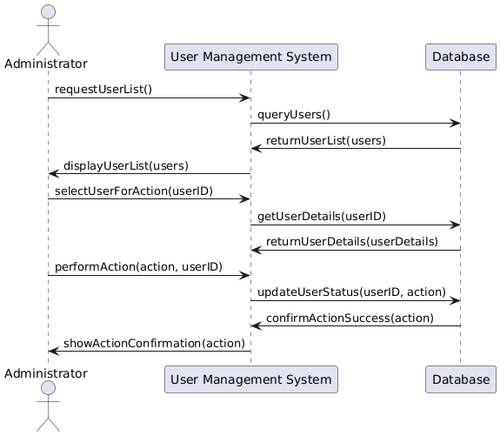

🡪 Acitvity diagram

