**Phase 1**

**Elder Care Agent**

| **Name** | **ID** |
| --- | --- |
| Ahmed Ali Ali Mahmoud | 20200031 |
| omar salah eldin ahmed ahmed | 20200347 |
| Ibrahim Hisham ahmed | 20200005 |
| Ali Maher Abdelaziz | 20200332 |
| Abdelrahman Ahmed Samir Ahmed | 20200278 |

**Stage#1:**

**1) Problem definition and Planning**:

The elderly care robot is designed for elderly people and takes care of them and their health. As it lives with them in the same place and simulate the Work of a nurse as it gives the patient his medicine in the right time and provides them with good health care.

**-The need of the agent:**

1. Eating
2. Moving
3. Hygiene
4. Health care
5. Taking medicine
6. Communication
7. Entertainment

**2) Environment type:**

**-**Man made environment.

-**with properties** :

1. Deterministic
2. Episodic
3. Discrete
4. Accessible
5. Static

**3) Agent type:**

1. LOGIC-BASED AGENTS (Single Agent)

**4) PEAS:**

1. **Performance**
2. Battery life
3. Quickley response
4. Health
5. Accuracy of treatment appointment
6. Memory size
7. **Environment**
8. Hospital
9. Elderly home
10. **Actuator**
11. Monitor
12. Wheels
13. Arms
14. Pressure measuring tool
15. Blood Glucose Monitor
16. **Sensors**
17. Monitor
18. Camera
19. Ultrasonic
20. Thermometer
21. Pressure sensor

**Stage#2:**

1. **Problem state space:**

**-Actions:**

1. Up
2. Down
3. Right
4. Left
5. Recharge battery
6. Giving and Taking Medicine
7. Measure blood pressure
8. Measure Blood Glucose
9. Measure temperature

**-State graph:**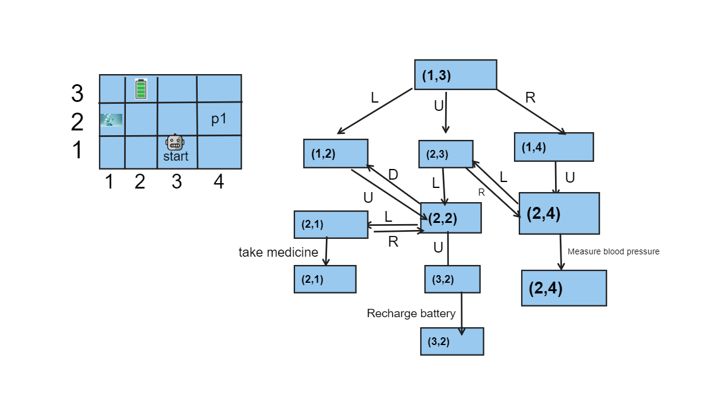

1. **Initial state: (1,3)**
2. **Goal states**
3. Battery charge.
4. Get medicine and drive it to the patient.
5. Blood Pressure, Blood Glucose and Temperature measured.
6. **Successor function (Set of actions and paths costs):**
7. **To charge the robot from Start (1,3) to Battery Charger (3,2)**.
8. From (1,3) move left to (1,2)
9. From (1,2) move up to (2,2)
10. From (2,2) move up to (3,2)
11. Start charging battery.
12. **Go to patient from Start (1,3) to patient (2,4)**
13. From (1,3) move up to (2,3)
14. From (2,3) move right to (2,4)
15. Measure any tests for patient and make some Entertainment
16. **Go to take Medicines from Start (1,3) to Medicine Room (2,1)**
17. from (1,3) move up (2,3)
18. from (2,3) move left (2,2)
19. from (2,2) move left (2,1)
20. take medicals
21. **Go to Patient to give him the Medicine.**
22. **If** the robot has the medical
23. move right (1,3) to (1 ,4)
24. move up (1,4) to (2,4)
25. give him the medical

2-**Else**

1. go to step 3 to take medical
2. go right (2,1) to (2,2)
3. Go right (2,2) to (2,3)
4. Go right from (2,3) to (2,4)
5. Give him the medical

-And the last step in each step is the **Actions**.

1. **Transition function**
2. Result ((2,3), Right) = (2,4)
3. Result ((2,4), Measure blood pressure) = (2,4)
4. **Solution/plan (Show Transformation from Initial state to Goal state):**
5. To charge the robot from Start point (1,3) to Battery Charger point (3,2):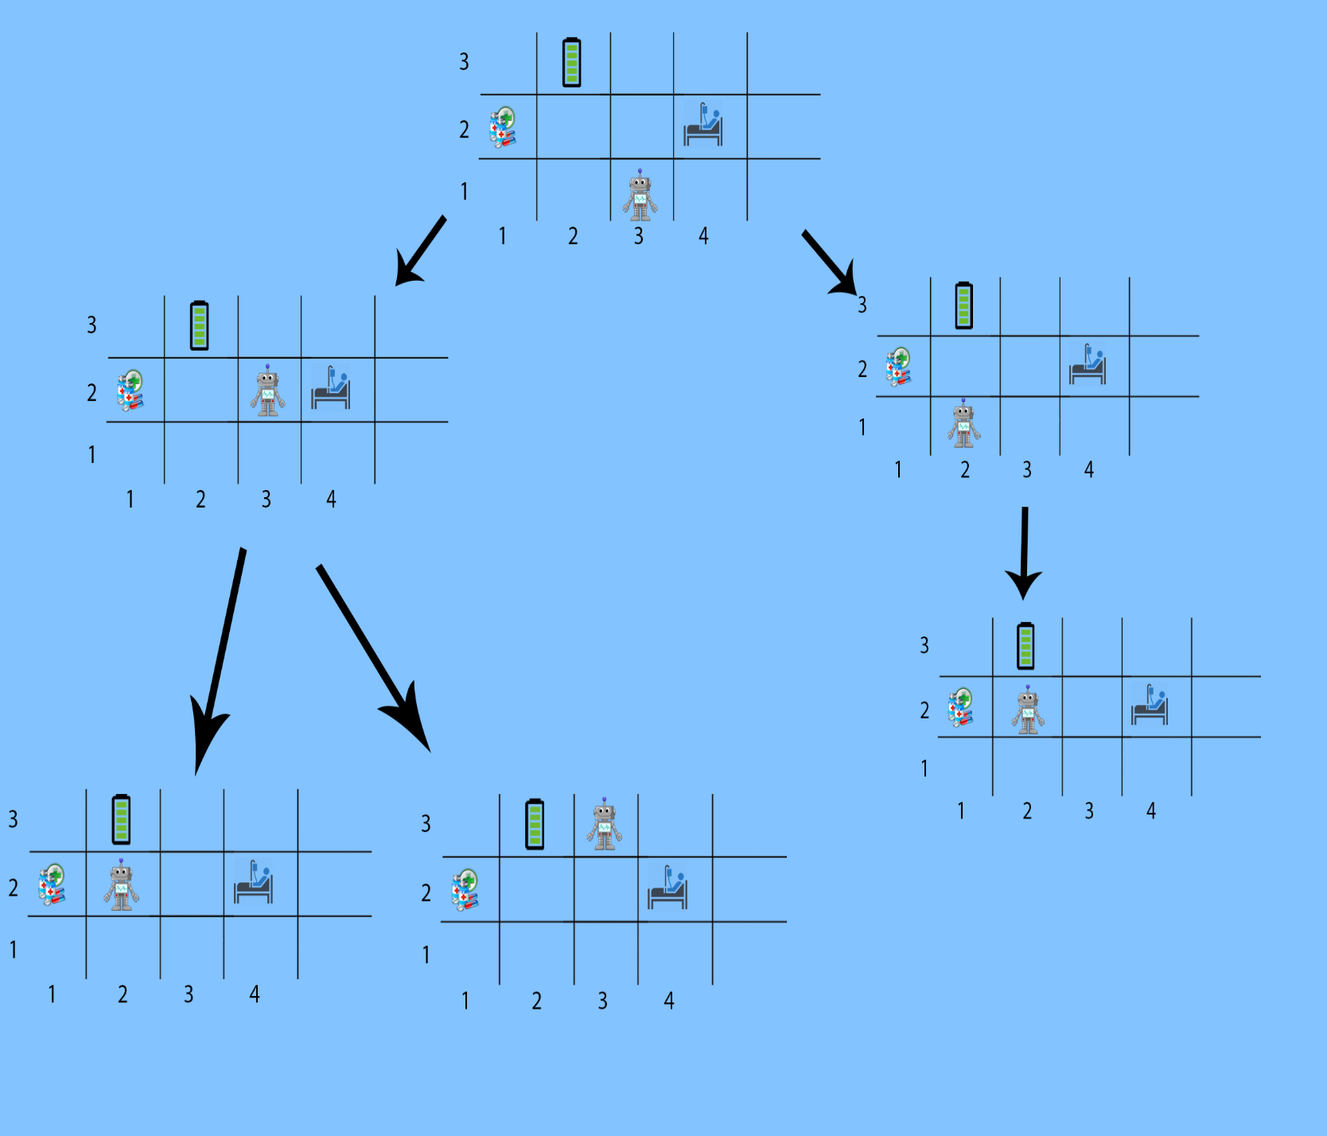
6. Robots go to patient from Start point (1,3) to patient point (2,4)

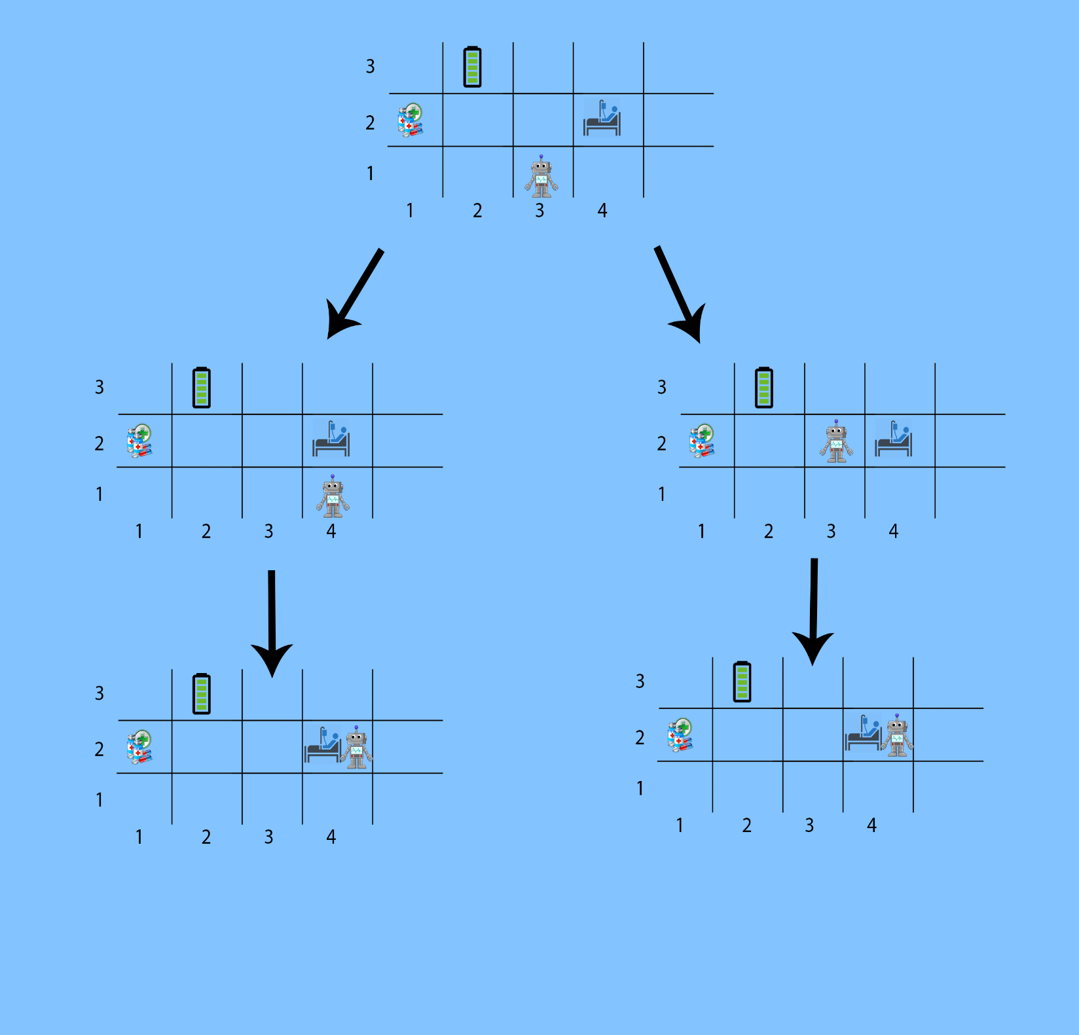

1. Robot go to take Medicines, moves from Start (1,3) to Medicine Room (2,1) 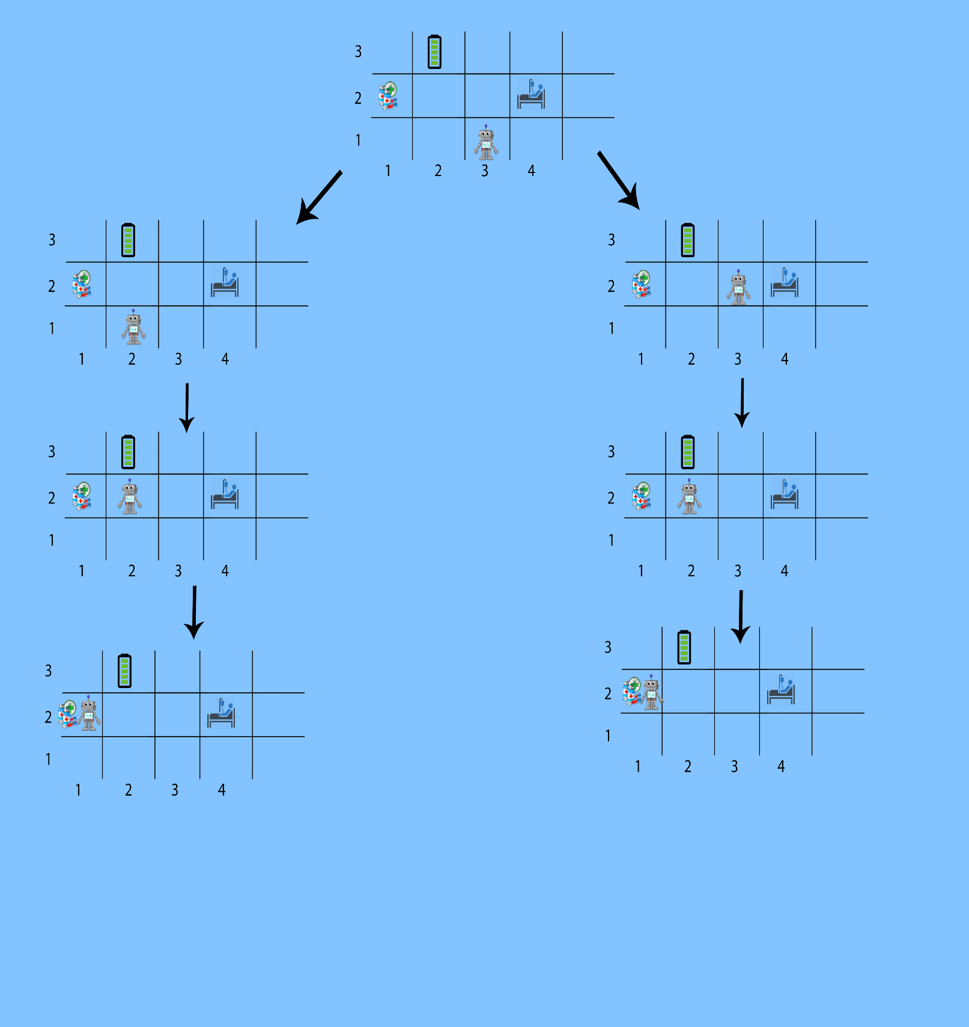
2. Robot goes to give the medicine to the patient in case the robot already has it.

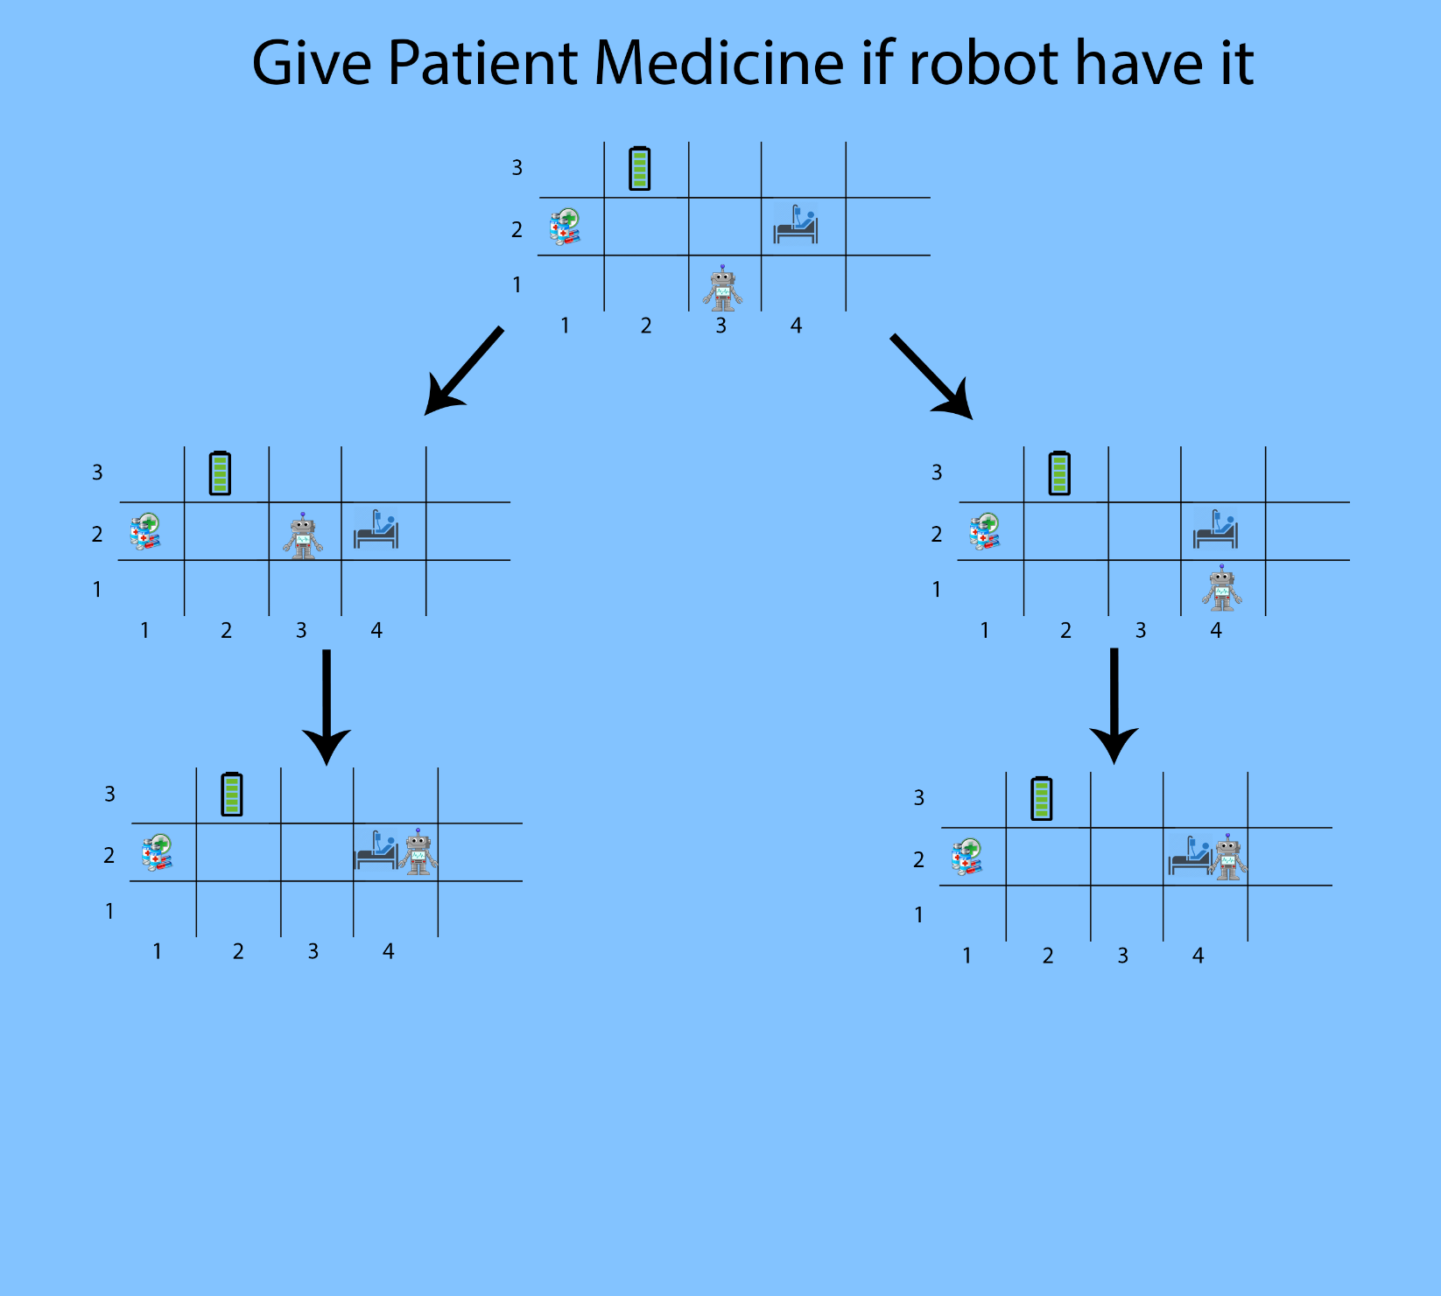

1. Robot goes to give the medicine to the patient in case the robot doesn’t have it.

