



MyHR.
Employee Management System – User Guide

Submission by

Muhammad Ibrahim Shoeb (OZLVV3)

Department of Automation and Applied Informatics
VIK, BME
Budapest, Hungary

Table of Contents
1. Purpose and Roles 3
2. Log In, Log Out, and Switch Language 3
3. Dashboard 4
4. Employee Management 4
Add employees 4
Other or miscellaneous employees 4
View and edit employees 5
5. Organization Hierarchy 6
6. Promotion Race and Sub-Race 6
7. Commendations 7
8. Sanctions 8
9. Import, Export, and Backup 9
10. User Management and Audit 9
11. Working With Larger Data Sets 10

1. Purpose and Roles
MyHR is an offline desktop HR system for employee records, organization hierarchy, promotion races, commendations, sanctions, salary increments, imports, exports, backups, and audit review.
Role | Main Access
Administrator | All pages, Settings, salary ranges, promotion rules, annual increments, user management, export, backup, password changes.
HR Officer | Dashboard, Employees, Hierarchy, Promotions, Commendations, Sanctions, Audit Log, and Import Data. Settings is admin-only.

2. Log In, Log Out, and Switch Language
- Open MyHR.
- Choose English, Hungarian, or Arabic on the login screen.
- Enter username and password.
- Press Sign In.
Default Account | Username | Password
Administrator | admin | admin123
HR Officer | hr_officer | hr123

- Use Logout at the bottom of the left sidebar to sign out and return to the login screen.
- Arabic uses right-to-left layout for the application session.
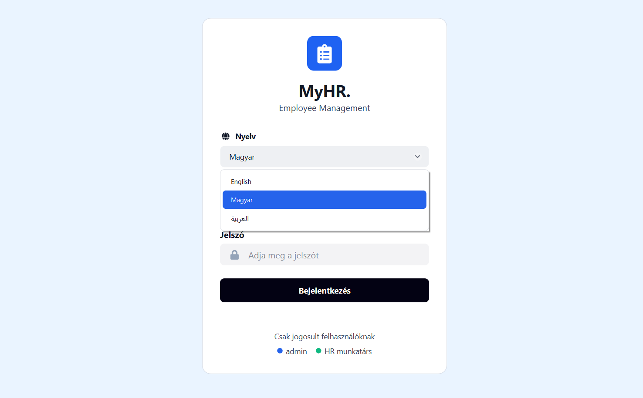
- Only application UI text is translated. Client-entered data, names, notes, emails, employee IDs, job titles, CSV headers, audit descriptions, and database values remain exactly as entered.

3. Dashboard
- Review total employees, pending promotions, active sanctions, commendations this month, recent activity, and upcoming promotions.
- Use Review in Salary Increments Due to approve one or all yearly salary increments.
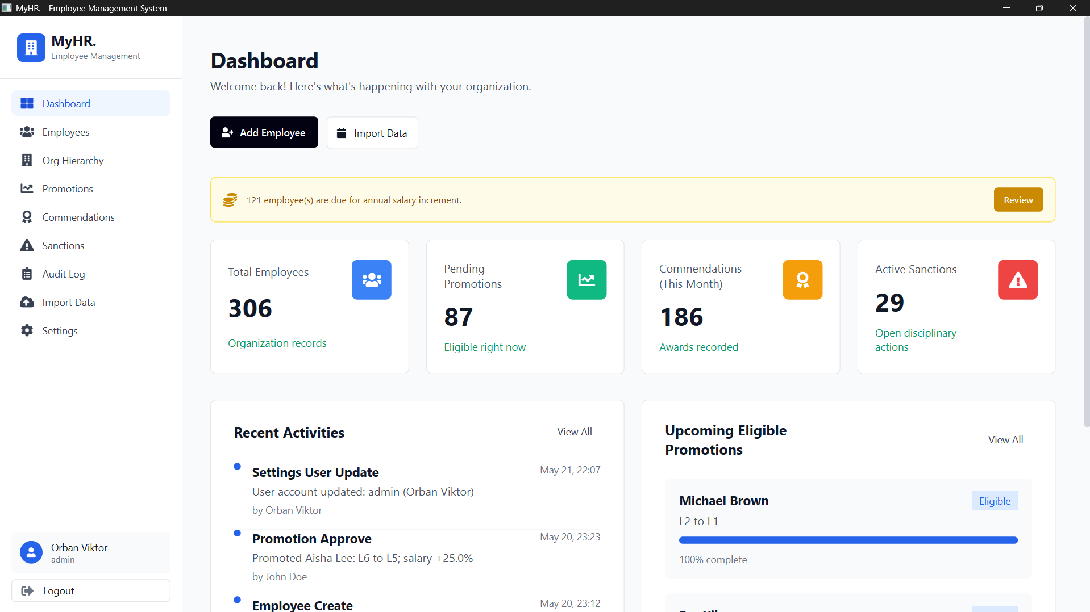
- Approved increments update employee salary, create salary history, and write an audit log entry.

4. Employee Management

Add employees
- Open Employees and press Add Employee.
- Fill personal details, work details, degree, position, join date, base salary, status, org unit, and manager.
- Choose BSc, MSc, PhD, or Other. BSc starts at L7, MSc at L6, PhD at L5, and Other uses the Other/Misc track.
- Watch the live salary range warning. The record cannot be saved if salary is outside the admin-defined range.
- Save the employee. MyHR generates an employee ID and logs the action.

Other or miscellaneous employees
- Use Other for janitors, guards, cleaners, painters, window cleaners, and similar roles.
- The displayed level is Other/Misc, not L7 to L1.
- They are assigned to the OTHERS branch and can report only to the OTHERS head, CEO, or a configured employee responsible for Other staff.
- They receive annual increments, but they do not have main level promotions, commendations, or sanctions.
- The demo database includes an Other Employees Head reporting to the CEO, plus janitor, cleaner, window cleaner, security guard, and painter examples.

View and edit employees
- Use search, filters, and Previous/Next pagination on the employee list. Search supports name, employee ID, position, and email.
- Open the profile with View. Personal Details shows the main race and sub-race immediately.
- Promotion History shows promotions and annual increment milestones as an audit-style history.
- Use Edit to update the employee. Use Delete only when a record was created by mistake because related employee history is removed too.
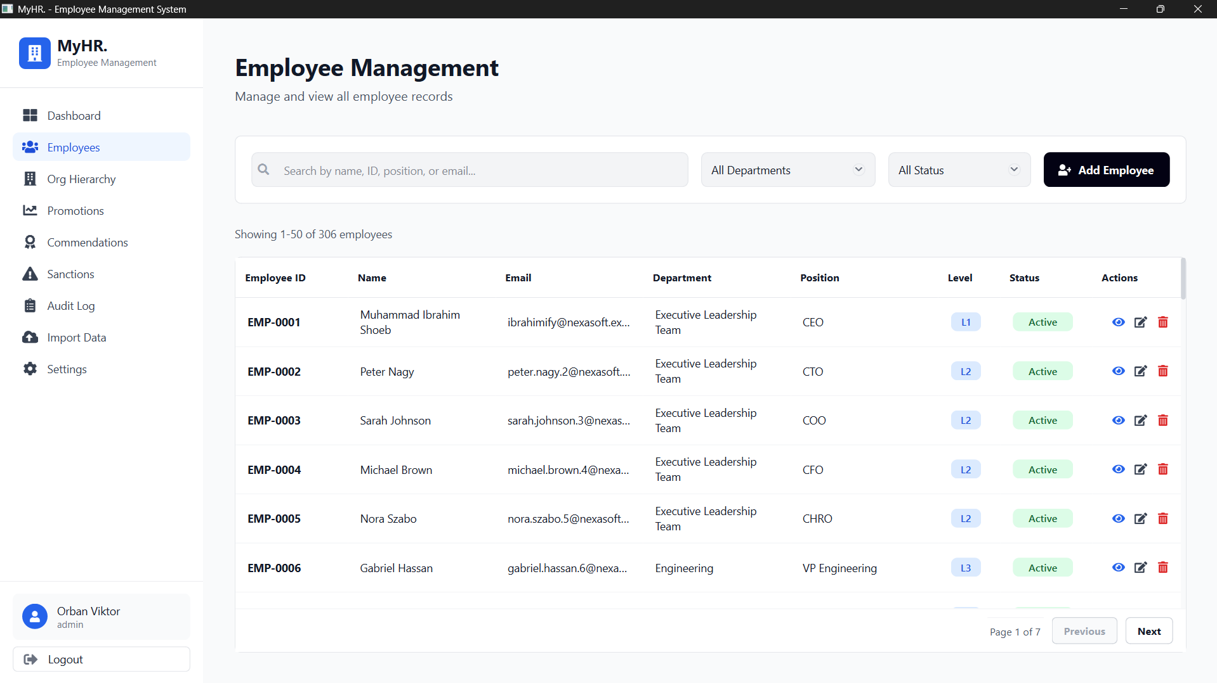
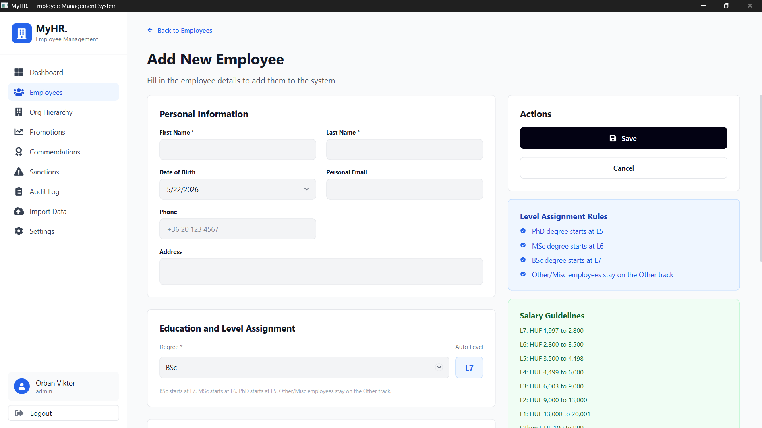

5. Organization Hierarchy
Type | Rule
Organization | Root only. Only one organization is allowed.
Division | Must be under an organization.
Department | Must be under a division.
Unit | Must be under a department.
Team | Must be under a unit.
Position | Must be under a team.
OTHERS | Special branch for Other/Misc employees.

- Use Add Unit or Add Department to create nodes.
- Unavailable unit types are disabled until their required parent exists.
- Assign a Head or In-Charge where needed.
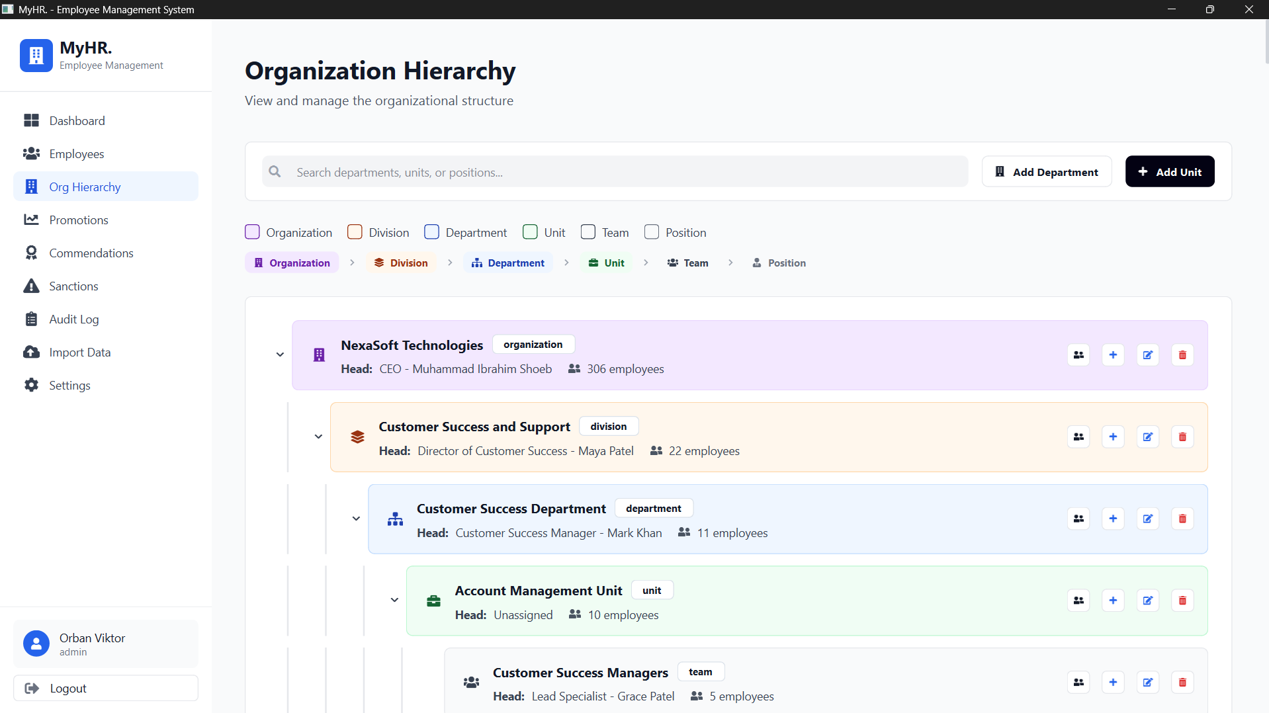
- Click populated units or teams to view employees in that scope.

6. Promotion Race and Sub-Race
The main race is the level movement, for example L7 to L6. The sub-race is the yearly checkpoint inside the race, for example L7.1 and L7.2.
Item | Meaning
Main race | Configured in Settings as level-to-level months, for example L7 to L6 in 36 months.
Sub-race | Yearly milestones inside the main race. Completed steps turn green in the profile UI.
Annual increment | Applied yearly at the employee's anniversary using the configured percentage or fixed amount.
Promotion increase | Applied on promotion using the next level's configured promotion salary increase.
Commendation | Reduces months remaining for standard employees.
Active sanction | Adds months remaining until resolved.

- Open Promotions.
- Review eligible employees and soon-eligible employees.
- Press Approve for an eligible employee.
- Confirm the salary and level change.
- MyHR updates the employee, creates promotion history, and writes the audit log.
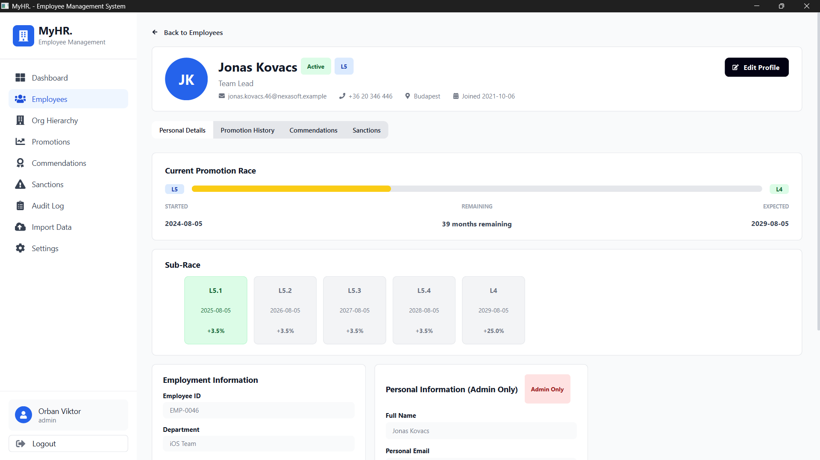
- The Promotion History tab is paginated so long-running organizations can review history without loading every row into the table at once.

7. Commendations
- Open Commendations and choose Issue Commendation.
- Choose Single Employee or Team Award.
- Choose Category 1 (-1 month), Category 2 (-3 months), or Category 3 (-6 months).
- Each standard employee can receive up to three commendations in the current role.
- Team awards skip employees who already reached the limit.

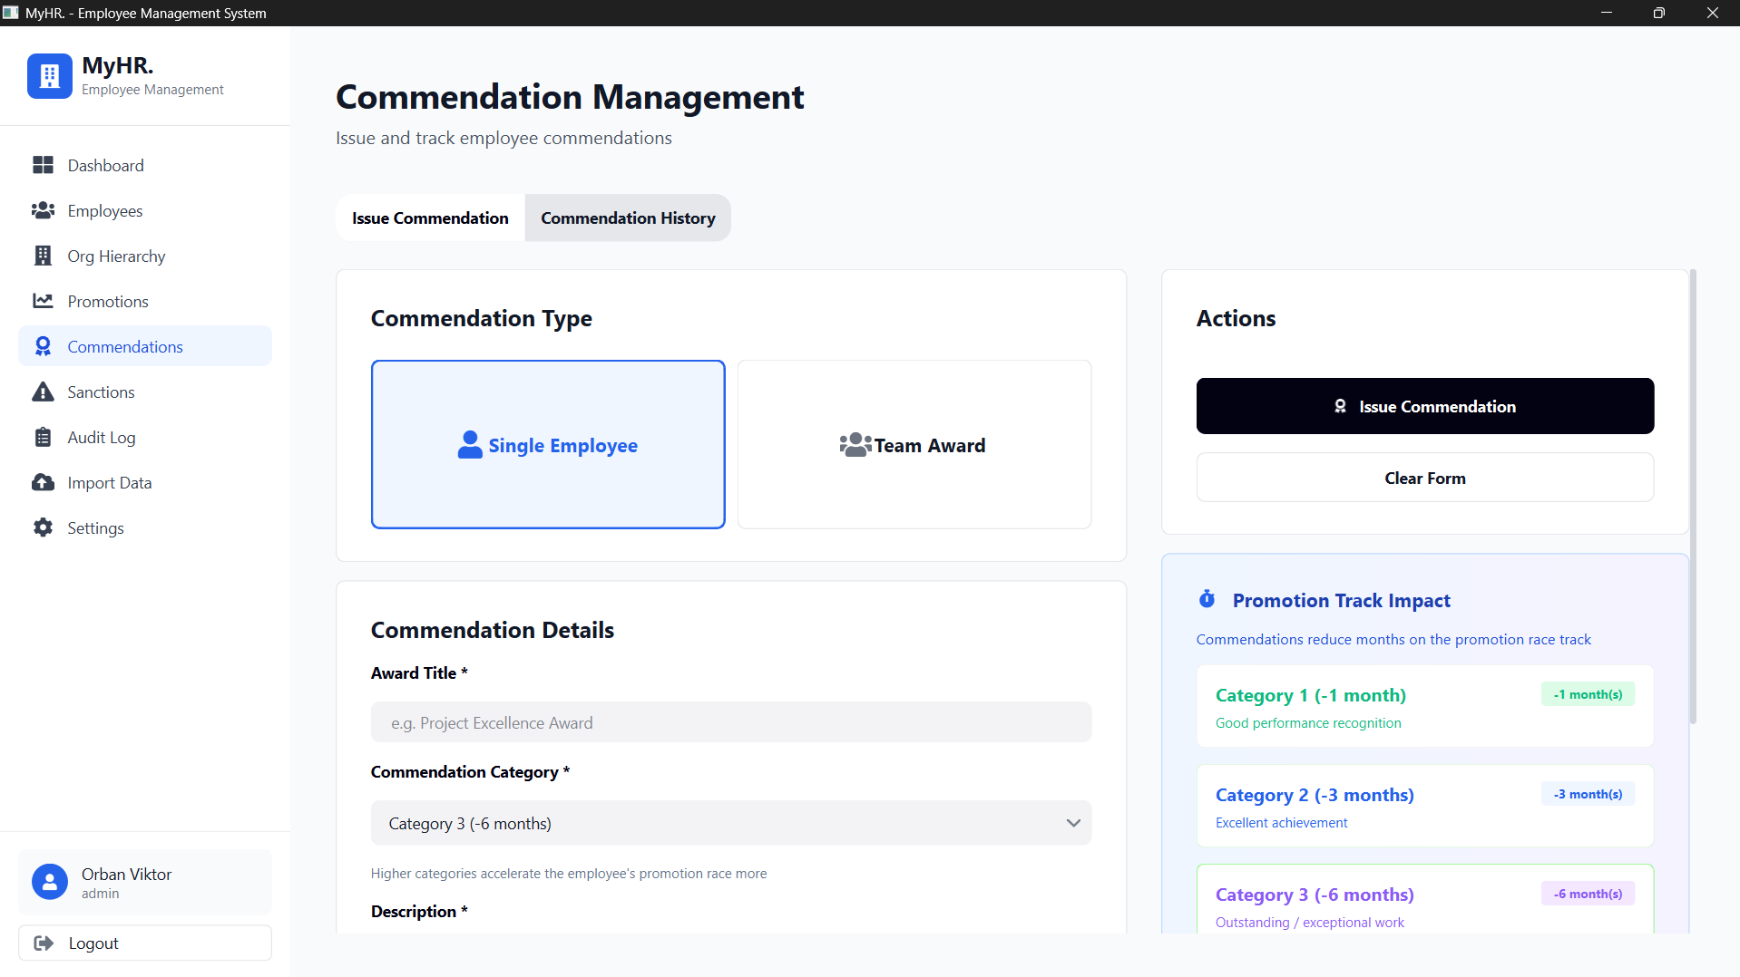
8. Sanctions
- Open Sanctions and choose Issue Sanction.
- Select employee, sanction type, reason, and delay from 1 to 12 months.
- Active sanctions delay the promotion race.
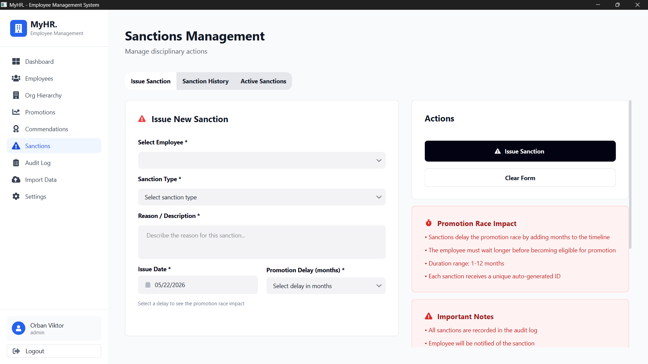
- Use Active Sanctions to mark a sanction resolved. Resolved sanctions stay in history but stop adding active delay.

9. Import, Export, and Backup
- Import Data accepts CSV and XLSX files.
- Required headers are first_name, last_name, department, degree, position, join_date, and base_salary.
- Optional headers include division, unit, team, work_email, work_phone, personal_email, phone, address, status, manager_work_email, commendation_months, active_sanction_months, and sanction_type.
- The preview marks valid rows and rows needing review before anything is written.
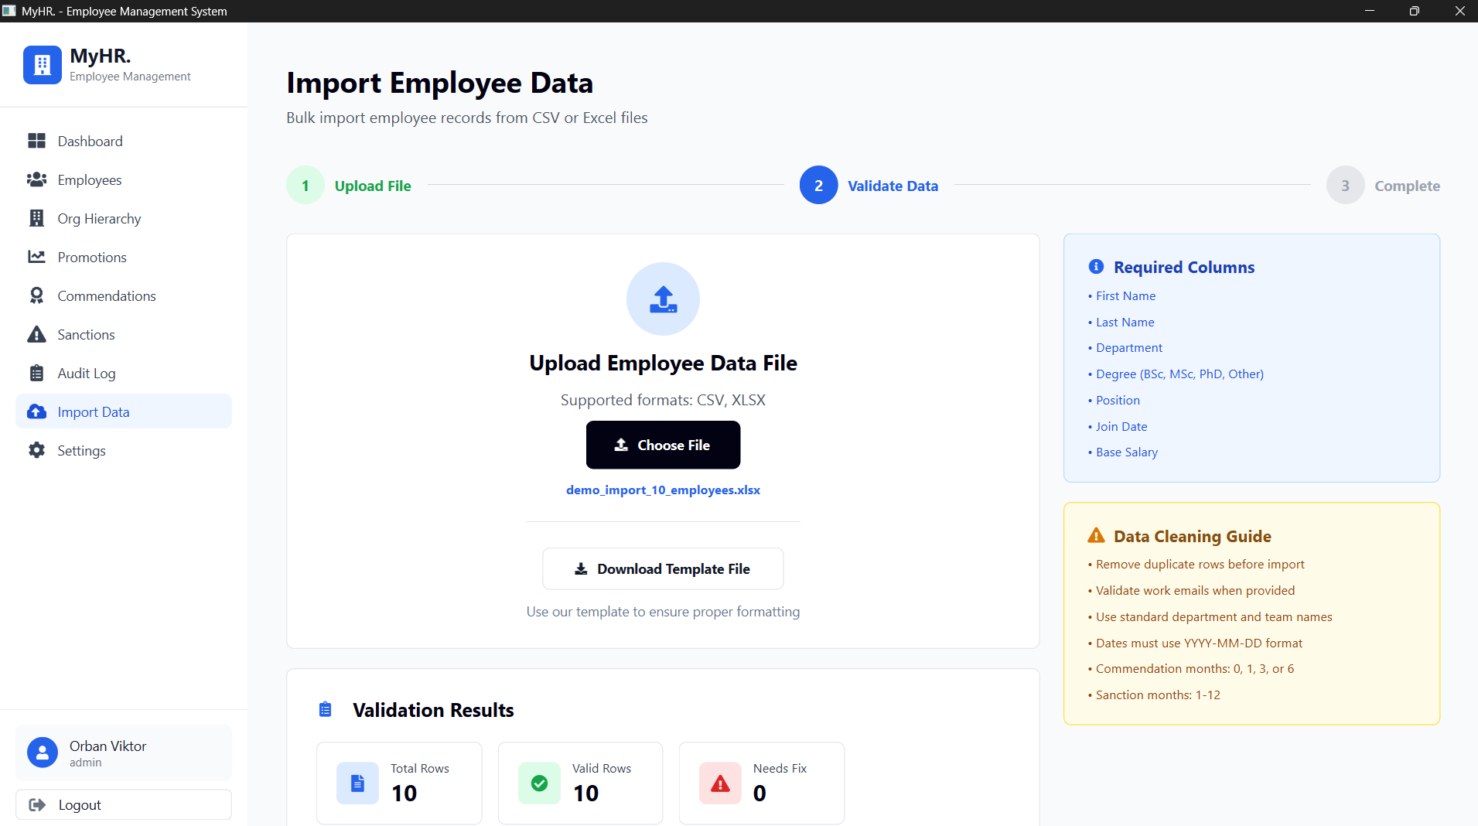
- Admin can export employees and create a SQLite database backup from Settings > Database.

10. User Management and Audit
- Admin uses Settings > User Management to change password and manage system users.
- The admin account can be edited for handover.
- HR Officer accounts can be created, edited, deactivated, and reactivated.
- Deactivation is a soft delete: the HR account cannot log in, but the record remains for audit history.
- Audit Log shows user identity as username: full name, for example admin: John Doe.
- Past audit entries keep their original username and full-name snapshot even if the account changes later.

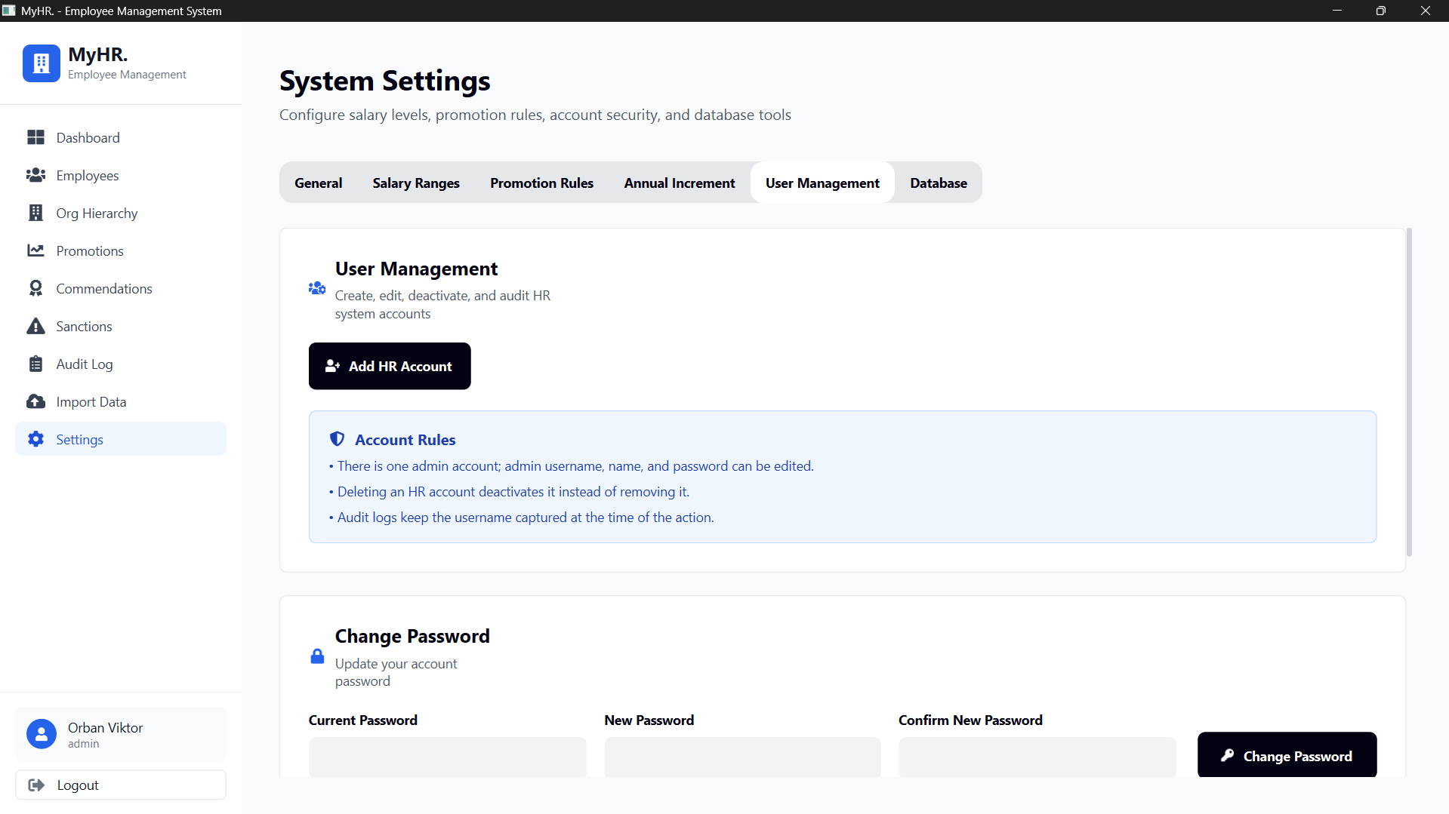
11. Working With Larger Data Sets
- Employee lists are paginated. Use Previous and Next instead of expecting every employee to appear on one long page.
- Promotion History is also paginated because annual increments and promotions can create many records over time.
- Dashboard and promotion eligibility are calculated live from the database using optimized list queries.
- If the application feels slow, check whether a very large export, import, or backup is running at the same time.

