NAME- MOHD IBRAHIM MIRZA

[EMAIL-mohd.ibrahim.mirza@gmail.com](mailto:EMAIL-mohd.ibrahim.mirza@gmail.com)

ASSIGNMENT PART-3

* Create a file like nano file1.txt
  + Edit some data and then save the file
* Now we will copy date from file1 to new file2
  + cp file1.txt file2.txt
  + Then see the output of file2.txt, cat file2.txt
  + Give screenshot

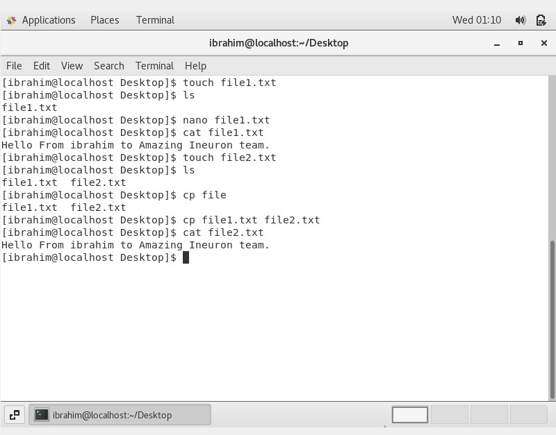

* Now we will move the file2.txt to new folder /home
* mv file2.txt /home
* Then go to home directory and check ls, file exits or not?
* Given screenshot

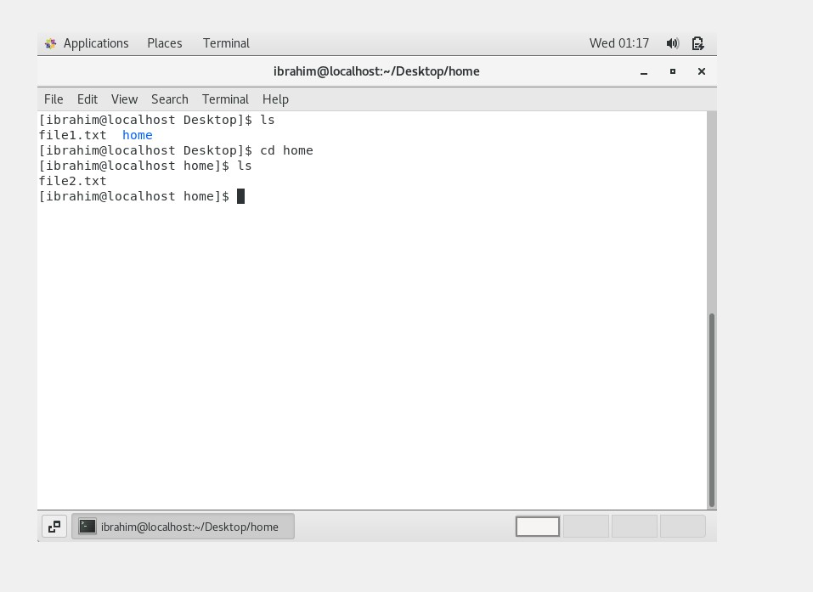

* Then we create a new file3.txt and file4.txt in home directory and add
* content in it.
* Now do echo “Hello I am newline” > file3.txt and provide the
* output of file3.txt
* Now do echo “Hello I am newline” >> file4.txt and provide the
* output of file4.txt

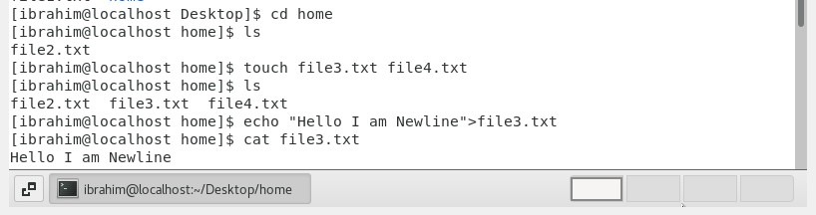

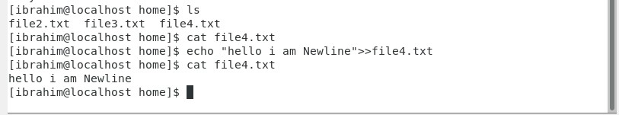

* Tell the different between both step you follow and the reason

behind it.

As per my understanding, the “>” is the output redirection operator used for overwriting files that already exist in the directory. While, the “>>” is an output operator as well, but it appends the data of an existing file. Often, both of these operators are used together to modify files in Linux.

5. For remove a file or directory you can use the below two commands

o To delete a file – rm <any filename>

