MOHD IBRAHIM

[EMAIL-mohd.ibrahim.mirza@gmail.com](mailto:EMAIL-mohd.ibrahim.mirza@gmail.com)

**Assignment for IAM**

**Assignment 1 :- Create an IAM user with username of your own wish and grant**

**administrator policy.**

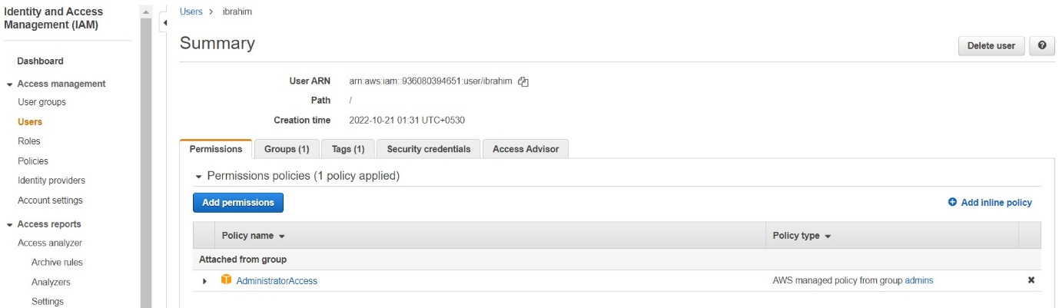

**Assignment 2: - Hello students, in this assignment you need to prepare a**

**developers’ team of avengers.**

**- Create 3 IAM users of avengers and assign them in developer’s groups with**

**IAM policy.**

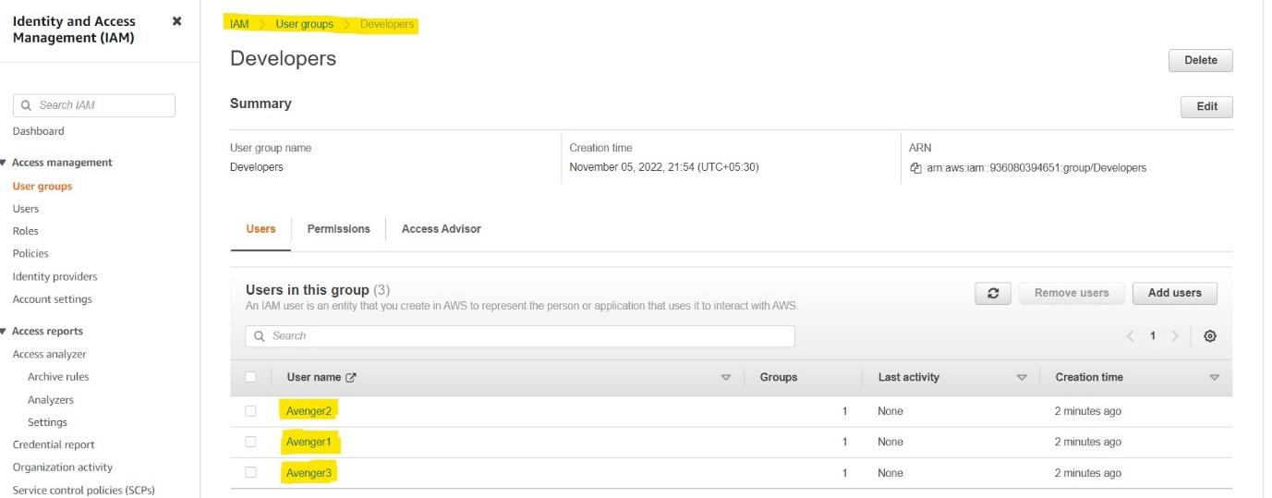

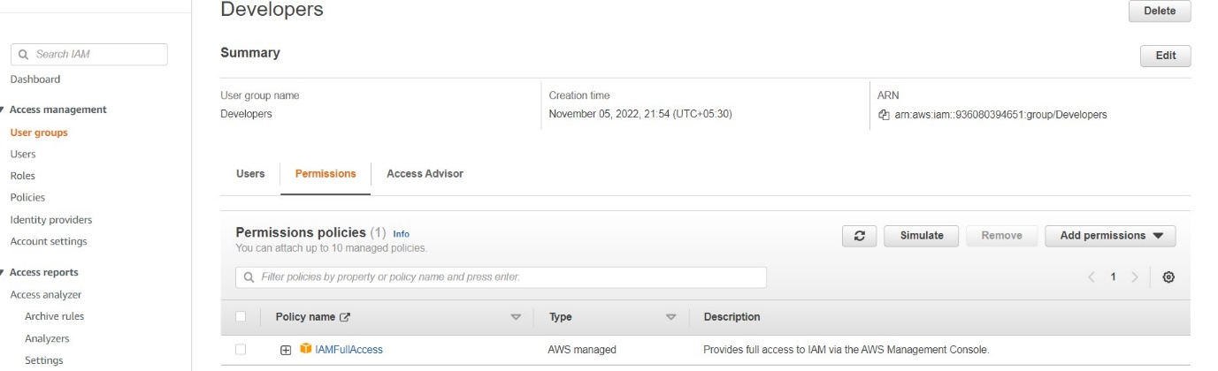

Assignment 3:- Define a condition in policy for expiration like

"DateGreaterThan": {"aws:CurrentTime":

"2020-04-01T00:00:00Z"},

"DateLessThan": {"aws:CurrentTime":

"2020-06-30T23:59:59Z"}

Define the span of 4 months as per your wish

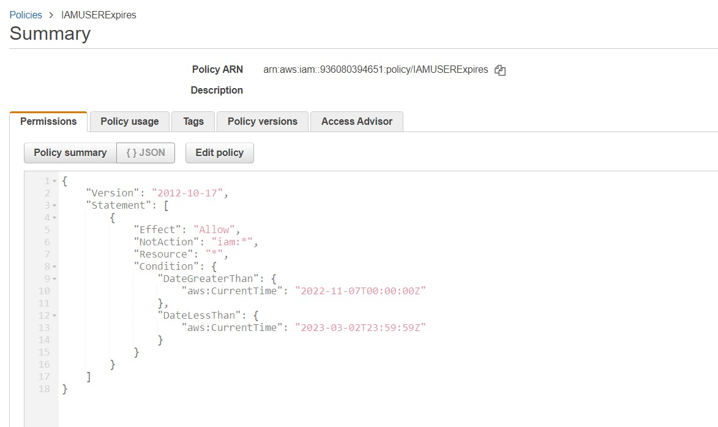

**Assignment 4 :- Launch your Linux instance in IAM and update your machine.**

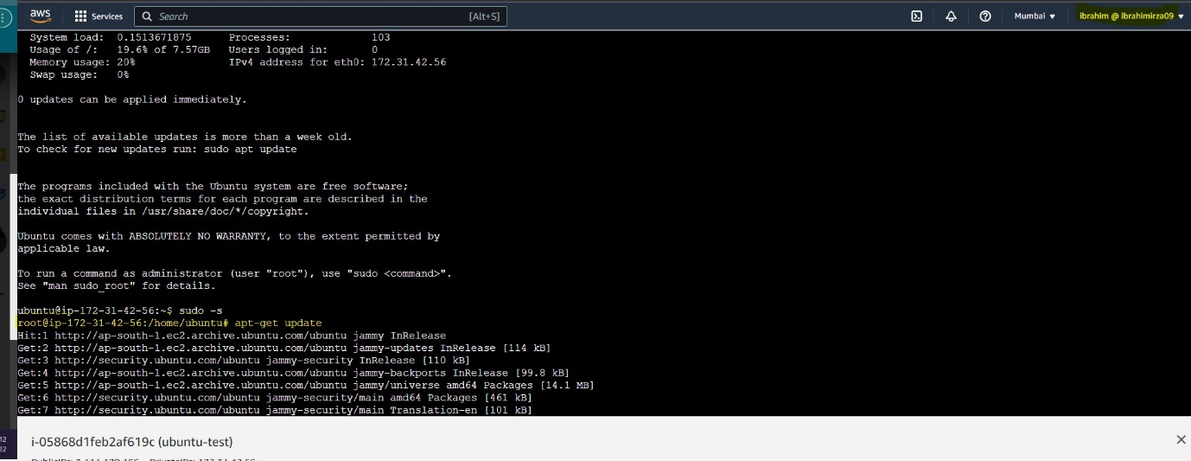

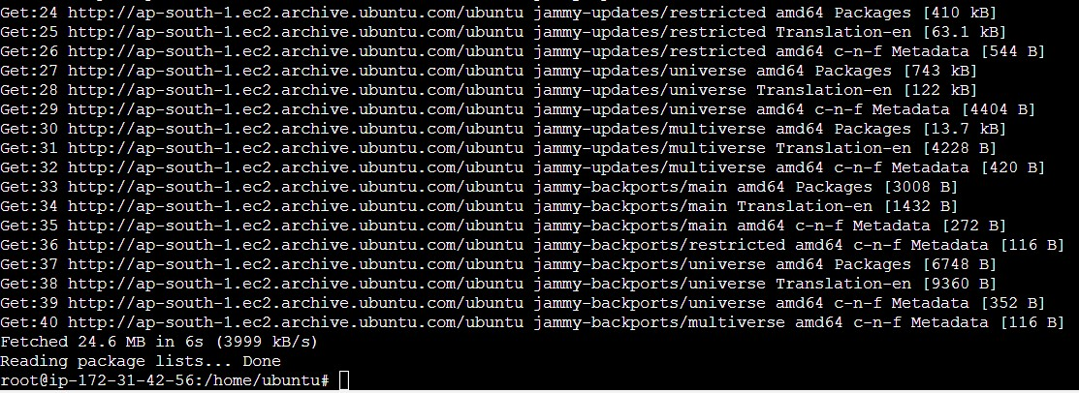

**Assignment 3 :- Prepare 15 authentic MCQ questions related to IAM.**

Q1. An IAM user:

|  |  |
| --- | --- |
| (a) | is an entity that you create in AWS |
| (b) | is to give people the ability to sign in to the AWS Management Console for  interactive tasks and to make programmatic requests to AWS services using the API or CLI |
| **(c)** | **A and B both** |
| (d) | None of these |

Q2. Which of these is IAM principal?

(a) A user

(b) A role

(c) An application

**(d) All of these**

Q3. IAM group:

(a) Is same as IAM users

**(b) Can be used to specify permissions for a collection of users**

(c) Is truly an identity

(d) All of these

|  |  |  |  |  |  |  |  |  |
| --- | --- | --- | --- | --- | --- | --- | --- | --- |
| Q4. Identify the wrong statement.   |  |  | | --- | --- | | (a) | Identity and access management (IAM) is a framework for business processes  that facilitates the management of electronic or digital identities | | (b) | With IAM technologies, IT managers can control user access  to critical information within their organizations | | (c) | Identity and access management products offer role-based access control | | **(d)** | **In IAM roles are defined according to the ability of an individual user to perform**  **a specific task, such as view, create or modify a file** | |

Q5. IAM role:

(a) Have credentials (password or access keys) associated with it

(**b) Does not have any credentials (password or access keys) associated with it**

(c) May or may not have credentials (password or access keys) associated with it

(d) None of these

Identify the wrong statement.

(a) IAM can provide shared access to the AWS account

**(b) IAM is paid service in AWS**

(c) IAM can provide granular permissions

(d) IAM supports multifactor authentication

Names of IAM identities (users, roles, and groups):

**(a) Must be unique within the AWS account**

(b) Must be unique within the availability zone

(c) Must be unique within the region

(d) Must be unique within the AWS cloud whole

How many maximum groups can be created in an AWS account?

(a) 25

(b) 50

**(c) 100**

(d) 200

An IAM user cannot be a member of more than __ groups.

**(a) 10**

(b) 20

(c) 50

(d) 100

AWS supports ______ types of policies.

(a) 4

(b) 5

**(c) 6**

(d) 7

How many maximum managed policies can be assigned to an IAM entity?

(a) 2

(b) 5

**(c) 10**

(d) 20

When you first create an Amazon Web Services (AWS) account, you begin with a single sign-in identity that has complete access to all AWS services and resources in the account. This identity is called:

**(a) Root user**

(b) Main user

(c) Super user

(d) None of these

Which of these is Identity in IAM?

(a) Users

(b) Groups

(c) Roles

**(d) All of these**