CASE STUDY: JALGUARD
A Portable Water Screening and Digital Surveillance System for Emerging Contaminants

1. Introduction

Water quality monitoring is an important part of providing safe drinking water. Conventional water testing focuses on several established parameters, but emerging contaminants such as microplastics and per- and polyfluoroalkyl substances (PFAS) require specialised monitoring approaches.

Microplastics are small plastic particles that can enter water sources through wastewater, surface runoff and other environmental pathways. PFAS are a large group of synthetic chemicals that have attracted attention because many of these compounds persist in the environment. Their presence and concentration can vary between water sources.

The main challenge is not simply detecting contamination. Water samples must also be collected, tested, recorded and compared over time. When testing depends entirely on specialised laboratories, frequent screening of multiple locations can become difficult.

JalGuard is a proposed portable water screening and digital surveillance system designed to investigate a more accessible approach to monitoring emerging contaminants. The concept combines a microplastic screening module, a proposed PFAS sensing module and a digital system for storing and reviewing sample information.

The project is being developed as a prototype. Its purpose is to explore how sample preparation, optical measurement, chemical sensing and digital reporting can be combined in a single platform.

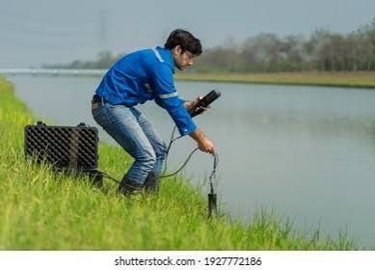
2. Background and Problem Statement

Traditional water testing methods are designed for specific parameters and contaminants. Emerging contaminants may require additional sample preparation, specialised analytical methods and trained personnel.

Microplastic monitoring presents challenges because particle size, shape, colour and composition vary. Visual examination can help identify particles that may be microplastics, but appearance alone cannot reliably confirm that a particle is plastic. More advanced methods may be required to determine its polymer identity.

PFAS monitoring presents a different challenge. Individual PFAS compounds may occur at very low concentrations, and their chemical properties differ. Reliable identification and quantification require suitable analytical methods and carefully controlled measurements.

The US Environmental Protection Agency describes laboratory methods such as Methods 533 and 537.1, which use solid-phase extraction and liquid chromatography–tandem mass spectrometry (LC-MS/MS) to measure selected PFAS in drinking water.

These methods provide an established analytical reference, but their equipment and laboratory requirements differ from those of a compact field device.

Another challenge is data management. A test result is more useful when it is connected to the sample ID, collection location, date, testing method and quality-control status. Without these details, comparing results from different locations or different testing dates becomes difficult.

JalGuard addresses these challenges by proposing a portable screening workflow with digital recordkeeping. It is intended to support preliminary monitoring, not to replace validated laboratory analysis.


3. Objectives of JalGuard

The project has five main objectives:

1. Develop a portable platform for collecting and handling water samples.
2. Investigate optical screening of particles captured from water samples.
3. Research suitable sensing technologies for detecting selected PFAS compounds, initially PFOA and PFOS.
4. Integrate measurement information with digital sample records.
5. Design a workflow that can be tested, improved and potentially scaled after technical validation.

The project separates the two detection approaches because microplastics and PFAS have different physical and chemical properties. A camera-based system suitable for particle imaging cannot automatically identify dissolved PFAS compounds.

The initial development priority is to establish a workable microplastic screening demonstrator while evaluating the feasibility of the PFAS sensing module.
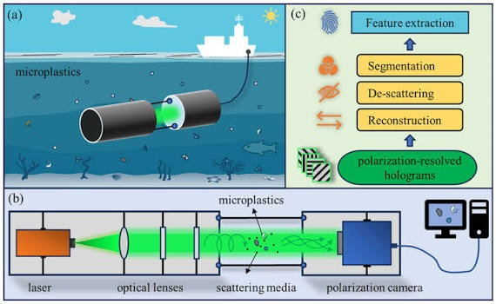
4. Proposed Technical Approach

JalGuard is based on a modular architecture. Each module performs a different function, while the digital layer connects the information generated by both modules.

4.1 Water Sample Collection

The process begins with collecting water in a clean, appropriately selected sample container. Each sample should receive a unique identification number.

The sample record can include the collection date, source type, location and any relevant observations. Consistent sample handling is important because contamination introduced during collection or preparation may affect the result.

For microplastic studies, suitable procedural blanks and contamination-control measures are particularly important. Fibres from clothing, containers or the surrounding environment can interfere with particle counts.

4.2 Sample Preparation and Filtration

For the microplastic module, a measured volume of water is passed through a suitable filter or particle-capture arrangement. The filter retains particles within the effective capture range of the selected setup.

The filter pore size must be selected according to the intended particle-size range and the practical limits of the optical system. A single filter should not be assumed to capture every microplastic particle.

The filter is then positioned in an optical chamber for imaging. The chamber should provide stable positioning and controlled illumination so that images can be compared more consistently.

The PFAS module requires a separate sample-preparation and sensing workflow. Its materials and procedures must be selected according to the chosen PFAS analytical approach.

4.3 Microplastic Optical Screening

The proposed optical module uses a camera or suitable microscope camera to capture images of particles collected on the filter.

White LED illumination can provide visible-light images. Optional UV illumination may be investigated if a suitable fluorescence-based method is selected and shown to provide useful information.

Image-processing software, such as Python with OpenCV, can be used to identify particle candidates based on measurable image features. Depending on image quality and the available training data, these features may include particle size, shape, colour and edge characteristics.

An optional machine-learning model could be evaluated later to classify particle candidates. However, its reliability would depend on representative training images, independent testing and appropriate controls.

The output should distinguish between candidate particles, likely non-plastic material and uncertain observations. Image-based screening alone cannot confirm the polymer composition of every particle. Selected samples should be compared with an appropriate laboratory identification method, such as FTIR or Raman spectroscopy.

4.4 PFAS Sensing Module

The PFAS module is a separate research component intended to investigate the detection of two selected compounds: PFOA and PFOS.

The sensing technology has not yet been finalised. Potential research directions include electrochemical sensing and optical or fluorescence-based sensing. A suitable target-recognition material or sensing chemistry would be required.

The proposed workflow is:

Water sample → Suitable sample preparation → Target-specific sensing element → Signal reader → Signal processing → Calibration and quality checks → Screening result.

The sensing element must produce a measurable response that can be distinguished from responses caused by other substances in the sample.

PFOA and PFOS should be evaluated separately. A sensor that responds to one compound cannot automatically be assumed to detect the other.

Before numerical concentrations can be reported, the system must be evaluated using appropriate reference samples. Testing should establish the calibration relationship, detection limit, selectivity, repeatability and effect of interfering substances.

Results should also be compared with a suitable laboratory reference method. Until these requirements are met, the PFAS module should be described as a proposed sensing system rather than a validated detector.

4.5 Processing and Digital Reporting

The processing layer combines the information generated by the optical and PFAS modules.

An ESP32 may be suitable for basic device control, communication and data acquisition where compatible with the selected hardware. Image processing may be performed on a laptop, smartphone or another capable processor, depending on the final design.

The software can associate each measurement with a sample ID and its collection details. It can also record the measurement method, timestamp, quality-control status and any uncertainty associated with the result.

A dashboard or report can then present the available results in a consistent format. Data can be stored locally during initial development, with synchronisation and mapping features considered in later versions.

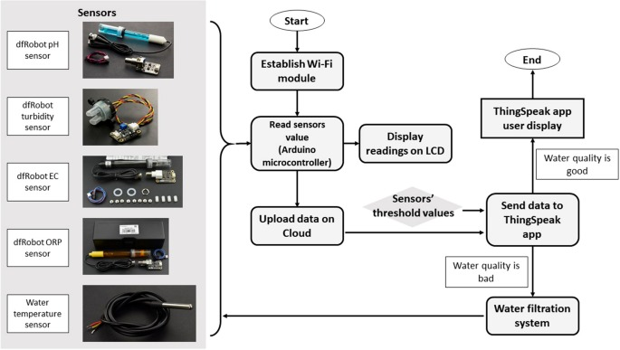
5. Hardware Architecture

The proposed hardware is divided into the following components.

Sample inlet and container: Used to receive and handle the water sample. The final design must prevent unintended contamination and make sample handling repeatable.

Filter holder: Holds the selected filter in a stable position during filtration and imaging. It should be removable for cleaning or replacement where appropriate.

Optical chamber: Provides a controlled space for the filter, illumination and camera. The camera must be positioned so that the relevant filter area can be imaged with sufficient focus and contrast.

Camera module: Captures images for the microplastic screening workflow. Camera resolution, lens characteristics, working distance and illumination must be evaluated together.

White LED illumination: Provides consistent visible light for imaging. The arrangement should reduce glare and shadows as far as practical.

Optional UV illumination: May be included only if the selected optical method requires it. UV response alone is not proof of microplastic identity, and suitable safety precautions are necessary.

ESP32 controller: Can manage compatible sensors, control functions and communication. It does not independently identify PFAS or perform all image-processing tasks.

Proposed PFAS cartridge and signal reader: Reserved for the selected target-specific sensing method. The cartridge design and reader specifications remain dependent on experimental feasibility results.

Power supply and management: Supplies power to the electronics and illumination. Battery capacity and expected runtime must be calculated after component selection and power testing.

The internal layout should separate the optical chamber from the electronics and provide practical access to the filter holder, camera and any replaceable sensing components.

No final dimensions, battery runtime, waterproof rating or enclosure specifications should be treated as confirmed until the design has been built and tested.

6. Software Architecture

The software is responsible for processing images, managing measurements and maintaining sample records.

6.1 Image Processing

Python and OpenCV are potential tools for the microplastic screening module. The software can perform image correction, background adjustment, particle segmentation and feature extraction.

The initial version should focus on repeatable image capture and basic particle analysis. More advanced classification should be introduced only when sufficient labelled data are available.

6.2 Machine Learning

A machine-learning model may be considered for distinguishing particle candidates from common non-plastic material.

Its performance should be measured using independently labelled test images rather than only the images used during development. The model should also be tested on different filters, lighting conditions and water samples.

A classification result must not be treated as definitive polymer identification without appropriate validation.

6.3 PFAS Signal Processing

The PFAS software path will depend on the sensing method eventually selected. It may process electrical or optical signals, apply a validated calibration relationship and flag measurements that fail quality checks.

The software cannot compensate for a sensing element that lacks sufficient selectivity or sensitivity. Reliable chemical detection depends on the sensor and its validation, not merely on the processing algorithm.

6.4 Digital Record Management

The digital interface can maintain a record containing:

- Sample identification number.
- Collection date and location.
- Test module and measurement method.
- Image or sensor measurement data, where available.
- Screening result and quality-control status.
- Notes on uncertainty and laboratory confirmation, where applicable.

Location can be entered manually during the first prototype stage. GPS integration, offline synchronisation, mapping and alerts can be considered after the core measurement workflow is functional.

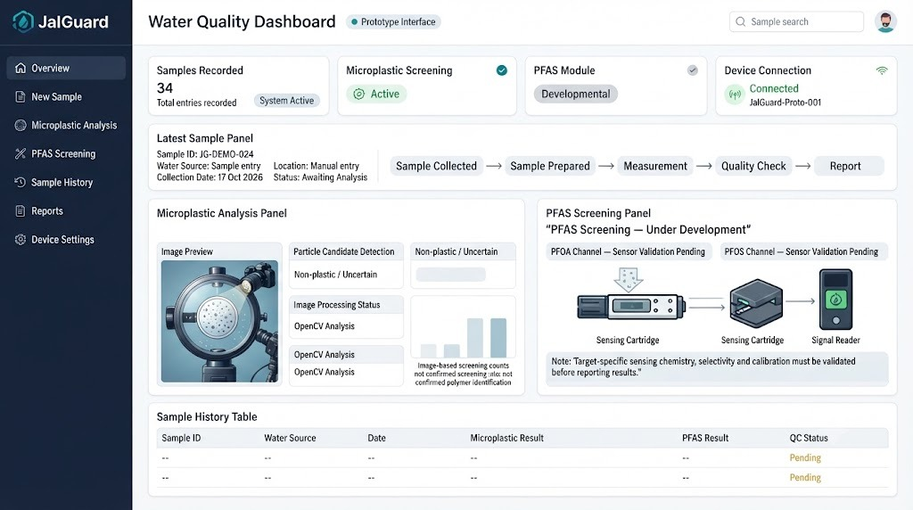
7. End-to-End Working Process

The proposed JalGuard workflow consists of the following steps.

Step 1: Collect the sample.
Water is collected using a suitable container, and a unique sample ID is assigned.

Step 2: Record sample details.
The source, collection date and location are entered into the digital record.

Step 3: Prepare the sample.
The sample is handled according to the requirements of the selected testing module. The microplastic workflow uses a suitable filtration arrangement.

Step 4: Capture the microplastic image.
The filter is placed inside the optical chamber, and the camera captures images under controlled illumination.

Step 5: Process the image.
The software analyses visible particle candidates and generates a preliminary screening output.

Step 6: Perform PFAS sensing, when available.
The prepared sample is tested using the selected PFOA/PFOS sensing method. The signal is processed only after the method and its calibration have been established.

Step 7: Apply quality checks.
The system records whether the measurement passed the applicable checks. Invalid or uncertain measurements should not be presented as reliable positive or negative results.

Step 8: Display and store the result.
The available screening information is linked to the sample record.

Step 9: Confirm selected findings.
Samples requiring further investigation are sent for appropriate laboratory analysis.

Step 10: Review results over time.
Once sufficient validated records are available, the digital system can help compare locations, identify recurring observations and support follow-up testing.

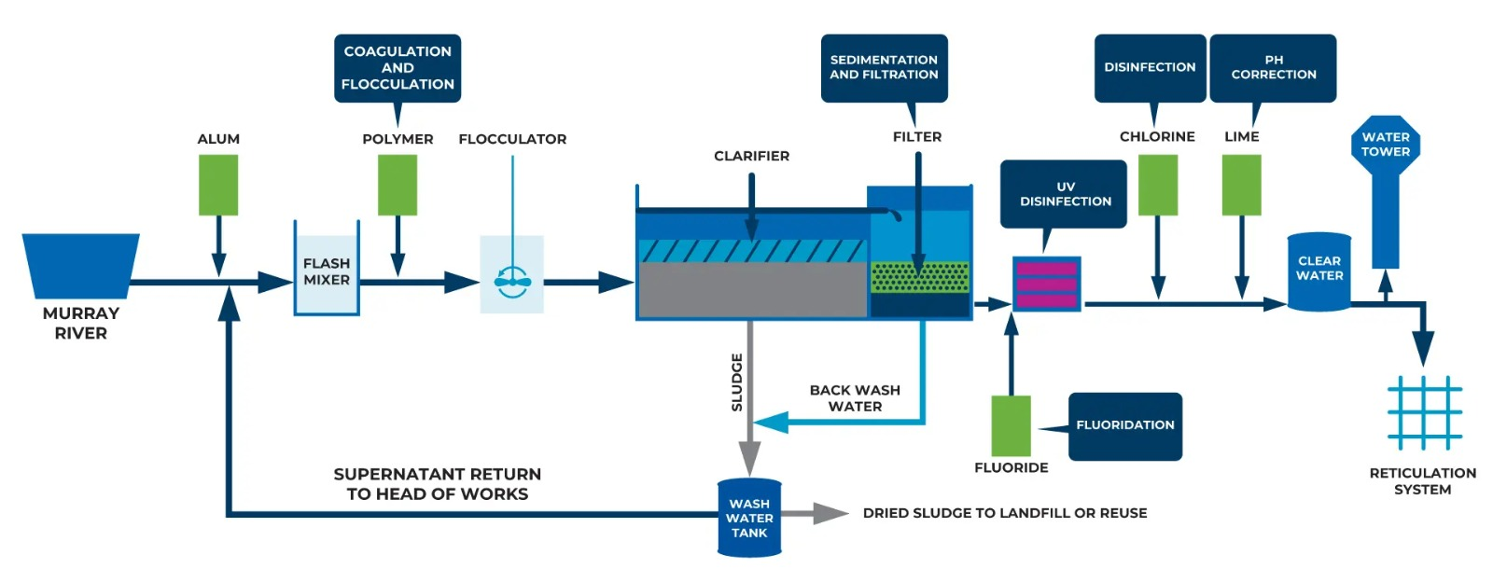
8. Existing Methods and the Need for JalGuard

JalGuard is not intended to replace established laboratory instruments. Its proposed role is to investigate whether some preliminary screening and data-recording tasks can be made more accessible.

For PFAS, the US EPA documents Methods 533 and 537.1 for measuring selected PFAS in drinking water using solid-phase extraction and LC-MS/MS. These methods demonstrate why reliable PFAS measurement requires a suitable analytical procedure rather than a general-purpose water sensor.

For microplastics, optical imaging can assist with particle screening, but reliable identification depends on sample preparation, contamination control and the method used to confirm particle composition.

The potential contribution of JalGuard is the integration of field-level sample handling, preliminary screening and digital records in one modular workflow. Whether this integration provides a practical advantage must be established through testing, usability evaluation and comparison with existing methods.

The project should therefore be evaluated on measurable performance, ease of use, repeatability, cost of operation and the quality of its records rather than on claims that it is the first or only system of its kind.

9. Feasibility and Development Plan

JalGuard contains components with different levels of technical difficulty.

The sample container, filter holder, optical enclosure, camera integration and basic image-processing workflow are reasonable starting points for a student prototype.

The PFAS module presents a greater research challenge because a suitable sensing material, signal reader and validated measurement procedure must first be identified.

A phased development plan will reduce the risk of attempting to build every component simultaneously.

Phase 1: Optical prototype

Build the filtration and imaging arrangement. Establish consistent image capture, particle counting and sample-record creation.

Phase 2: Microplastic validation

Test the imaging workflow using controlled samples, procedural blanks and suitable reference methods. Measure repeatability and document the limitations of image-based classification.

Phase 3: PFAS feasibility study

Compare published PFOA and PFOS sensing approaches. Select a candidate method based on reported performance, practical availability, selectivity and suitability for the intended concentration range.

Phase 4: PFAS sensing demonstrator

Develop or integrate the selected sensing method under suitable laboratory supervision. Evaluate calibration, detection limits, interference and repeatability.

Phase 5: System integration

Connect the available measurement outputs to a common digital record system. Keep unvalidated modules clearly identified.

Phase 6: Field evaluation

Evaluate sample handling, usability, environmental conditions and consistency. Compare selected samples with suitable laboratory results before making performance claims.

10. Validation and Quality Control

Validation is essential because a device may produce a readable signal without reliably identifying the intended contaminant.

For the microplastic module, testing should include procedural blanks, repeat measurements, controlled samples and comparison with a suitable particle-identification method. Particle counts should be reported with their relevant size range and limitations.

For the PFAS module, validation should establish the target compounds, calibration range, detection limit, selectivity, repeatability and the effects of substances present in real water. PFOA and PFOS must be evaluated separately unless a multi-target method has been demonstrated to distinguish them reliably.

Results should be compared with an appropriate laboratory reference method. Measurement uncertainty and failed quality checks should be documented rather than hidden.

Until validation is complete, JalGuard results should be described as preliminary screening observations. The system should not be used to certify drinking-water safety or replace accredited laboratory testing.

11. Expected Outcomes

The expected outcomes of the development work are:

1. A portable optical setup for preliminary microplastic particle screening.
2. A repeatable workflow for sample identification and digital recordkeeping.
3. A documented feasibility assessment of sensing methods for PFOA and PFOS.
4. A modular hardware architecture that can accommodate a PFAS sensing component if a suitable method is established.
5. A testing framework for measuring repeatability, selectivity, uncertainty and practical usability.
6. A foundation for comparing screening observations across different sample locations and testing dates.

These are development goals, not confirmed results. Their achievement will depend on the performance demonstrated during prototype testing.

12. Challenges and Limitations

Several technical challenges must be addressed before JalGuard can be considered a reliable field-screening product.

Particle identification: Camera images may contain dust, fibres and other particles that resemble microplastics.

Sample contamination: Fibres or particles introduced during collection and preparation can distort the results.

Small particle detection: Optical performance depends on the camera, lens, lighting, filter and intended particle-size range.

PFAS selectivity: A suitable sensing material must distinguish the target compounds from interfering substances.

Low concentrations: Detecting PFAS at environmentally relevant concentrations may require highly sensitive measurement and careful sample preparation.

Calibration: Numerical concentration estimates require validated calibration procedures and suitable reference measurements.

Field conditions: Changes in temperature, lighting, sample composition and operator technique may affect performance.

Data reliability: Digital records must preserve the distinction between measured results, uncertain observations and laboratory-confirmed findings.

These limitations should guide the design and testing process rather than be treated as issues that can be solved through software alone.

13. Future Scope

After successful initial testing, JalGuard could be developed further through improved optical hardware, a validated PFAS sensing cartridge, automated quality checks and a more complete digital reporting interface.

Additional features could include offline data storage, location-based mapping, sample-history tracking and alerts for samples requiring further investigation.

The system could also be evaluated for use by field workers, water-monitoring teams and research institutions. Any wider deployment would require appropriate training, quality-control procedures and evidence that the selected methods work under real operating conditions.

Expansion to additional PFAS compounds should be considered only when suitable sensing methods are available and independently validated.

14. Conclusion

JalGuard is a proposed modular system for preliminary screening and digital monitoring of emerging contaminants in water. Its design separates microplastic particle imaging from PFAS chemical sensing because the two contaminants require different detection methods.

The microplastic module offers a practical starting point for building and evaluating a physical prototype using filtration, controlled illumination, a camera and image-processing software.

The PFAS module requires further research to identify a suitable sensing approach for PFOA and PFOS. Its performance must be established through calibration, interference testing and comparison with laboratory measurements before concentration estimates or reliable detection claims can be made.

The project's value will depend on how well it performs under controlled and real-world conditions, how clearly it communicates uncertainty and how reliably it records the results.

By developing and validating each module separately before integration, JalGuard can progress towards a credible field-screening platform without overstating its current capabilities.

References

1. World Health Organization. *Microplastics in Drinking-water: Technical Document*. 2019.
https://www.who.int/publications-detail-redirect/9789241516198

2. United States Environmental Protection Agency. *EPA PFAS Drinking Water Laboratory Methods*.
https://www.epa.gov/pfas/epa-pfas-drinking-water-laboratory-methods

3. United States Environmental Protection Agency. *PFAS Analytical Methods Development and Sampling Research.
https://www.epa.gov/water-research/pfas-analytical-methods-development-and-sampling-research

4. United States Environmental Protection Agency. *Method 533: Determination of PFAS in Drinking Water by Isotope Dilution Anion Exchange Solid Phase Extraction and LC-MS/MS.
https://www.epa.gov/dwanalyticalmethods/method-533-determination-and-polyfluoroalkyl-substances-drinking-water-isotope

Project status: JalGuard is a proposed prototype under development. Any performance figures, detection limits, accuracy values, cost estimates or deployment claims should be added only when supported by documented testing or a clearly identified engineering estimate.

