**COMSATS University Islamabad (CUI)**

**Project Proposal**

**for**

**NeuroLearn**

Version 1.1

***By***

**Ibrahim Murtaza CIIT/FA21-BCS-031/ISB**

**Muhammad Ahmad CIIT/FA21-BCS-047/ISB**

***Supervisor*Ms. Gulmina Rextina**

***Bachelor of Science in Computer Science (2021-2025)***

Table of Contents

Abstract 1

1. Introduction 2

2. Problem Statement 2

3. Problem Solution/Objectives of the Proposed System 2

3.1 Objectives 3

4. Related System Analysis/Literature Review 3

5. Vision Statement 4

6. Scope 4

7. Modules 5

7.1 Module 1: User Authentication & Profile Management 5

7.2 Module 2: Q/A Retrieval-Augmented Generation (RAG) Assistant 5

7.3 Module 3: Summarization 6

7.4 Module 4: Gamification & Rewards 6

7.5 Module 5: Collaborative Chat Rooms and Video Conference Rooms 6

7.6 Module 6: Smart Schedule Planner 6

7.7 Module 7: Smart Study Insights & Progress Tracker 7

7.8 Module 8: Quiz and Practice 7

7.9 Module 9: Peer Networking 7

7.10 Module 10: Hire a Tutor 7

7.11 Module 11: Sentiment Analysis and Engagement Monitor 7

8. System Limitations/Constraints 8

9. Data Gathering Approach 8

10. Tools and Technologies 8

11. Project Stakeholders and Roles 9

12. Module based Work Division 9

13. Gantt Chart 9

14. Mockups 11

15. References 13

16. Plagiarism Report 14

**Project Category:**

* Web Application
* Problem Solving and Artificial Intelligence
* Image Processing

# Abstract

NeuroLearn is an AI-driven educational assistant designed to address the gaps in traditional learning by providing personalized and efficient study support. The goals of NeuroLearn are to extract comprehensible information from the resources provided by the students, enable peer-to-peer engagement through collaboration rooms, improve user motivation through rewards, facilitate effective study planning, provide personalized feedback, and to ease the process of learning which many students find tiresome. By developing an inclusive system that also employs effective learning techniques like *Spaced Repetition[1], Active Recall[2] and Pomodoro Technique[3],* NeuroLearn seeks to address the issues that students face while learning*.* NeuroLearn's integration of AI will provide data-driven insights and adaptive learning experiences to increase productivity, retention, and engagement, which is a major step towards modern and customized educational solutions.

# Introduction

**NeuroLearn** redefines the educational landscape by blending AI-driven personalization with effective and interactive tools designed for modern learners. Traditional learning systems often fail to offer the adaptability and individualized support necessary for sustained engagement and effective learning. NeuroLearn bridges this gap by providing a comprehensive platform where students can receive real-time answers through Retrieval-Augmented Generation (RAG), generate tailored summaries, analyze emotional and engagement patterns with sentiment insights, and connect with like-minded peers through intelligent networking features. With dynamic tools such as adaptive schedules, collaborative study rooms, and gamified rewards, NeuroLearn fosters motivation, organization, and productivity. By addressing the key pain points in learning, NeuroLearn aims to assist learners by providing them with the right and efficient tools that can reduce their hostility towards learning.

# Problem Statement

Students today often struggle with staying organized, managing study schedules, and maintaining consistent engagement. Traditional learning systems rarely adapt to individual learning styles or provide personalized resources and real-time feedback, leaving many students unmotivated and unable to identify their areas of improvement.

Additionally, students face an overwhelming amount of study material including documents, PDFs, PowerPoint presentations, and other resources which can be daunting and difficult to process. With limited time and often inconsistent motivation, many students lack an efficient way to absorb key information quickly. Current platforms fail to offer both the depth of personalized support needed for complex material retention and the convenience of summarizing vast resources, which leads to disorganized study sessions, decreased retention, and missed academic opportunities.

Without a flexible, all-in-one platform to streamline time management, support efficient content processing, and facilitate collaborative study, students’ learning experiences and achievements remain constrained.

# Problem Solution/Objectives of the Proposed System

NeuroLearn provides an AI-driven, all-in-one solution to enhance student organization, engagement, and learning efficiency in a personalized, interactive way. By integrating advanced technologies, NeuroLearn helps students manage large volumes of study material, stay organized, and engage in a tailored, productive study experience.

By using Natural Language Processing (NLP), NeuroLearn aims to develop an interactive chatbot that empowers students with real-time Q&A support, implemented using Retrieval-Augmented Generation (RAG) techniques and provides comprehensible and digestible responses to the user prompts in the context of uploaded resources (docx, PDFs, PPTs, JPEGs. It further provides cross-language media summarizations. The system can also extract relevant information from a YouTube video using YouTube APIs, STT tools and OpenCV and provide cross-language notes and summaries. The introduction of rewards and points will encourage the students to participate in learning and stay motivated. Virtual collaborative chat & video conference rooms will foster a productive learning space for students. Furthermore, NeuroLearn also provides students with a smart schedule planner that can help students in scheduling their daily routine. The use of smart schedule planner can be further extended to lay out a complete plan for the accomplishment of user prompted milestones.

In addition, NeuroLearn integrates **Emotion & Engagement Analytics**, offering detailed insights into student behavior, identifying areas of disengagement or distress, and providing tutors with actionable reports to personalize learning strategies. The **Peer Networking** feature helps students connect with like-minded peers for support, collaboration, and motivation. Additionally, the AI-driven **Sentiment & Engagement Insight Module** tracks students' emotional engagement during lessons, offering feedback that helps both learners and educators adapt to enhance the learning experience.

NeuroLearn offers a comprehensive solution that aims to tackle the problem of low memory retention, engagement, and learning efficiency by implementing research-proven techniques like *Spaced Repetition, Active Recall and Pomodoro Technique.*

## Objectives

***BO1****: Make learning effective by already proven techniques.*

***BO2****: Provide diverse study materials like summaries, detailed notes and flashcards.*

***BO3****: Provide a collaborative setting for students to study virtually.*

***BO4****: Motivate students to partake in studies through gamified rewards.*

***BO5****: Smart schedule planning for students based on their personal preferences and interests.*

***BO6****: Reduce hostility towards studies.*

***BO7****: Provide students with the tools of quizzes and practice tests to self-assess.*

***BO8****: Progress reports for feedback.*

# Related System Analysis/Literature Review

Table 1 Related System Analysis with proposed project solution

|  |  |  |
| --- | --- | --- |
| **Application Name** | **Weakness** | **Proposed Project Solution** |
| Quizlet | Limited AI personalization; lacks comprehensive Q/A support. | NeuroLearn’s adaptive Q/A support and AI-driven content summarization reduce study time and boost retention by targeting individual knowledge gaps, making it a comprehensive tool for personalized learning. |
| Duolingo | Primarily language-focused with no cross-subject or collaboration support. | NeuroLearn extends support to a variety of subjects, offers adaptive learning paths, and facilitates collaboration through study groups. |
| Khan Academy | Offers mostly static video content with no interactive or real-time feedback mechanism. | NeuroLearn emphasizes interactive feedback, AI-driven insights, and gamified progress tracking. |
| Notion | Strong organization features but lacks AI-powered educational tools or structured learning recommendations. | NeuroLearn integrates AI-driven content personalization, quizzes, and study insights. |
| NotebookLM | Primarily focuses on document-based Q/A and summaries but lacks collaboration, gamification, or structured learning paths. | NeuroLearn expands on Q/A support and summarization with additional features like gamification, collaborative study groups, smart schedule planner and adaptive learning techniques (e.g., Spaced Repetition, Pomodoro). |

# Vision Statement

NeuroLearn aims to provide a dynamic, cooperative, cross language and captivating learning environment with individualized support that uses cutting-edge AI technologies. NeuroLearn wants to provide every student with the resources they need to make difficult material easier to understand, increase motivation, improve retention, and turn learning into a productive, fulfilling process that is customized to meet their requirements.

# Scope

NeuroLearn is an AI-powered educational platform that aims to improve learning by providing individualized, flexible resources and efficient study techniques. Students will receive simplified cross language study material, personalized study guides, timetables, and feedback from the platform according to their individual learning styles and performance. With the use of advanced AI technologies like Natural Language Processing (NLP) and Retrieval-Augmented Generation (RAG), NeuroLearn will provide real-time Q&A assistance and simplify complicated information. To increase productivity, attention, and memory, it will use research proven learning strategies like the Pomodoro Technique, spaced repetition, and active recall. To assist and reinforce learning, the site will include interactive study tools including quizzes, flashcards, and self-testing. A smart scheduling tool will help students efficiently manage their study time and prevent fatigue. Peer-to-peer technologies like forums, group projects, and shared study materials will support collaborative learning and provide a community-driven learning environment. Students will receive individualized insights into their progress through real-time statistics and feedback, which will assist them in identifying their areas of strength and growth. Additionally, Peer Networking allows students to connect with peers for collaboration and motivation, fostering a supportive learning community. NeuroLearn also includes Emotion & Engagement Analytic**s** to track student behavior and emotional engagement, providing valuable insights for personalized learning. Students will stay motivated and engaged in their learning process with the support of gamification features like progress monitoring and incentive systems. NeuroLearn will concentrate on developing a welcoming and adaptable atmosphere where students stay involved and feel empowered to take charge of their education. However, neither in-person tutoring nor integration with other Learning Management Systems (LMS) will be provided by the platform.

# Modules

## Module 1: User Authentication & Profile Management

***FE-1:*** Enable secure user registration using email, phone number, or third-party accounts (e.g., Google, Facebook).***FE-2:***Provide login/logout functionality with options for "Remember Me" and multi-device support.***FE-3:***Offer password recovery via email or SMS with robust validation mechanisms.***FE-4:***Allow users to create detailed profiles, including preferences, learning goals, and language settings.  
***FE-5:***Enable users to update account information, such as profile pictures and passwords.***FE-6:***Manage user roles and permissions (e.g., student, tutor)

## Module 2: Q/A Retrieval-Augmented Generation (RAG) Assistant

***FE-1****:* Provide real-time responses to queries based on user-uploaded files (e.g., PDFs, DOCs, PPTs).

***FE-2****:* Use RAG techniques to ensure contextual and accurate responses.

***FE-3****:* Allow users to ask questions using voice commands and receive voice-based answers.

***FE-4****:* Highlight sources of the responses within the provided material.

***FE-5****:* Support multimedia queries (e.g., questions tied to specific topics, timestamps, or audio files).

***FE-6****:* Translate responses into multiple languages for wider accessibility.

***FE-7****:* Users can upload multiple files and specify connections, enabling the AI to analyze content collectively for broader context.

## Module 3: Summarization

***FE-1****:* Generate concise summaries from documents like PDFs, DOCs, JPEGs, and PPTs.

***FE-2****:* Let users choose between short, medium, or detailed summaries.

***FE-3****:* Allow users to input specific questions, generating summaries relevant to those queries.

***FE-4****:* Combine insights from multiple documents into a cohesive summary.

***FE-5****:* Create detailed notes and flashcards from user-provided content.

***FE-6****:* Summarize YouTube videos with timestamps and key takeaways.

***FE-7****:* Provide audio summarization through speech-to-text tools.

***FE-8****:* Translate summaries into multiple languages for wider accessibility.

***FE-9****:* Automatically categorize and tag summarized content for easier retrieval.

## Module 4: Gamification & Rewards

***FE-1:***Award points, badges, and milestone achievements based on completed tasks and learning streaks.  
***FE-2:***Display leaderboards to foster friendly competition within groups or classes.***FE-3:*** Host time-limited competitions such as "Weekend Learning Blitz" events where users can earn unique rewards by achieving specific goals within a set period.*.****FE-4:***Unlock rewards like themes, avatars and study tools for sustained engagement.***FE-5:***Provide challenges or group tasks to enhance collaborative motivation.

## Module 5: Collaborative Chat Rooms and Video Conference Rooms

***FE-1****:* Create and manage virtual study groups with chat, audio, and video functionalities.

***FE-2****:* Enable sharing of resources like notes, flashcards, and quizzes within the group.

***FE-3****:* Provide a collaborative whiteboard for brainstorming and interactive study sessions.

***FE-4****:* Allow moderators to manage sessions, set roles, and control access.

***FE-5****:* Transcribe group discussions for future reference.

***FE-6****:* Generate summaries of the group discussions.

## Module 6: Smart Schedule Planner

***FE-1****:* Generate personalized weekly and monthly timetables based on user goals and deadlines.

***FE-2****:* Create tasks and to-do-list for the achievement of a certain goal or milestone.

***FE-3****:* Dynamically adjust plans based on missed tasks or new priorities.

***FE-4****:* Suggest tasks based on user productivity patterns (e.g., light tasks during low energy periods).

***FE-5****:* Integrate schedules with external calendar apps for seamless planning.

***FE-6****:* Notify users of upcoming deadlines and overdue tasks with reminders.

***FE-7****:* Automatically categorize and tag goals for easier access and engagement.

## Module 7: Smart Study Insights & Progress Tracker

***FE-1****:* Provide weekly and monthly progress reports with graphical insights.

***FE-2****:* Highlight areas of strength and suggest improvements for weaknesses.

***FE-3****:* Use AI to predict when users might achieve certain goals based on current progress.

***FE-4****:* Offer detailed reports on peak productivity times and learning behaviors.

***FE-5****:* Offer tailored recommendations to optimize study methods and resources.

***FE-6****:* Track overall learning trends, including time spent, retention rates, and achievement metrics.

***FE-7****:* Display visual dashboards for a quick overview of progress.

## Module 8: Quiz and Practice

***FE-1****:* Automatically generate quizzes from uploaded content, tailored to user preferences.

***FE-2****:* Allow users to create topic-specific or comprehensive practice tests.

***FE-3****:* Provide real-time feedback and explanations for incorrect answers.

***FE-4****:* Support quiz modes like timed and untimed.

***FE-5****:* Adjust the difficulty of questions based on user performance trends.

## Module 9: Peer Networking

***FE-1****:* Automatically suggest potential peers based on shared academic interests, study goals, or activities.

***FE-2****:* Suggest peers based on mutual connections or shared group activities.

***FE-3****:* Enable users to send connection requests to suggested peers.

***FE-4****:* Suggest peers based on common participation in group-based activities, such as study groups or collaborative projects.

***FE-7****:* Notify users when new peer suggestions are available or when mutual connections join the platform.

## Module 10: Hire a Tutor

***FE-1:***Match students with tutors based on subject preferences and learning goals.***FE-2:***Allow tutors to host one-on-one virtual sessions through video calls.***FE-3:***Facilitate sharing of exclusive study materials by tutors.***FE-4:***Enable tutors to provide feedback and suggest personalized learning plans.***FE-5:***Allow students to rate and review tutors for quality assurance*.*

## Module 11: Sentiment Analysis and Engagement Monitor

***FE-1****:* Analyze students' facial expressions and body language during video lessons to detect emotions.

***FE-2****:* Monitor tone and voice modulation in students' speech to assess their emotional state and engagement levels.

***FE-3****:* Generate real-time sentiment reports showing students' mood and engagement during specific segments of the lesson.

***FE-4****:* Provide detailed analytics of student behavior over time, highlighting patterns of disengagement or distress.

***FE-5****:* Categorize student reactions based on the content being taught, allowing tutors to identify which topics generate the most interest or confusion.

***FE-6****:* Alert tutors in real-time when a student’s emotional state suggests a need for intervention or extra support.

***FE-7****:* Provide tutors with personalized recommendations on how to adjust teaching strategies based on student emotions and engagement patterns.

***FE-8****:* Enable video-based sentiment analysis for both live and recorded sessions, ensuring feedback can be provided for asynchronous learning as well.

# System Limitations/Constraints

***LI-1:***Generalization of individual student needs.

***LI-2:***The system may struggle with providing quality content for advanced or less common topics.

***LI-3:***The system may not always give the most accurate feedback.

***LI-4:***Cross language content may not always provide the real essence of documents and domain-specific terminologies.

# Data Gathering Approach

Interviews with students and educational specialists will provide crucial details on learning challenges and desirable traits. A larger audience will get questionnaires to collect quantitative information on preferences, learning styles, and particular needs. To get detailed feedback on the platform's usability and effectiveness in addressing common learning issues, focus groups will also be conducted. Finally, market research will be conducted to identify existing solutions, gaps, and opportunities for development.

# Tools and Technologies

Table 2: Tools and Technologies for Proposed Project

|  |  |  |  |
| --- | --- | --- | --- |
| **Tools**  **And**  **Technologies** | **Tools** | **Version** | **Rationale** |
| MS Visual Studio | 2015 | IDE |
| Python | |  | | --- | |  |  |  | | --- | | 3.10 | | For AI/NLP processing and algorithms |
| MongoDB | 5.0 | NoSQL database for scalability and flexibility |
| Figma | N/A | UI/UX |
| **Technology** | **Version** | **Rationale** |
| React JS | 17.0 | Front-end Development |
| NodeJS/Express | 16.0 | Back-end Development |
| TensorFlow/PyTorch | Latest | AI/ML model training and deployment |
|  | LangChain | Latest | RAG Q/A Assistant |
|  | OpenCV | Latest | Image Processing |

# 

# Project Stakeholders and Roles

Table 3 Project Stakeholders for Proposed Project

|  |  |
| --- | --- |
| **Project Sponsor** | COMSATS University Islamabad, Islamabad Campus |
| **Stakeholder** | * Ibrahim Murtaza * Muhammad Ahmad * Project Supervisor: Ms Gulmina Rextina |

# Module based Work Division

Table 4 Team Member Work Division for Proposed Project

|  |  |  |
| --- | --- | --- |
| **Student Name** | **Student Registration Number** | **Responsibility/ Module / Feature** |
| Ibrahim Murtaza | FA21-BCS-031 | Module 1-5 |
| Muhammad Ahmad | FA21-BCS-047 | Module 6-9 |

# Gantt Chart

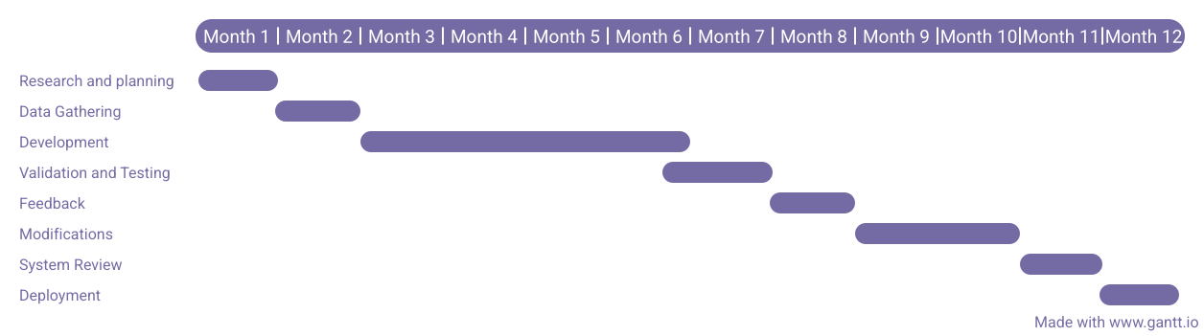

# Mockups

**Figure 1 - Progress Screen Figure 2 - Summarizer Screen**

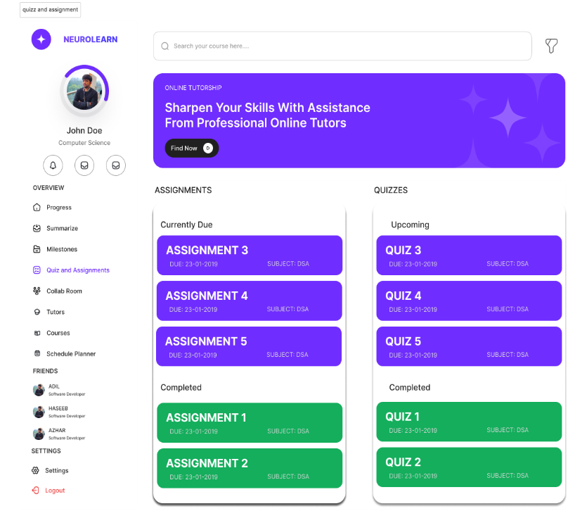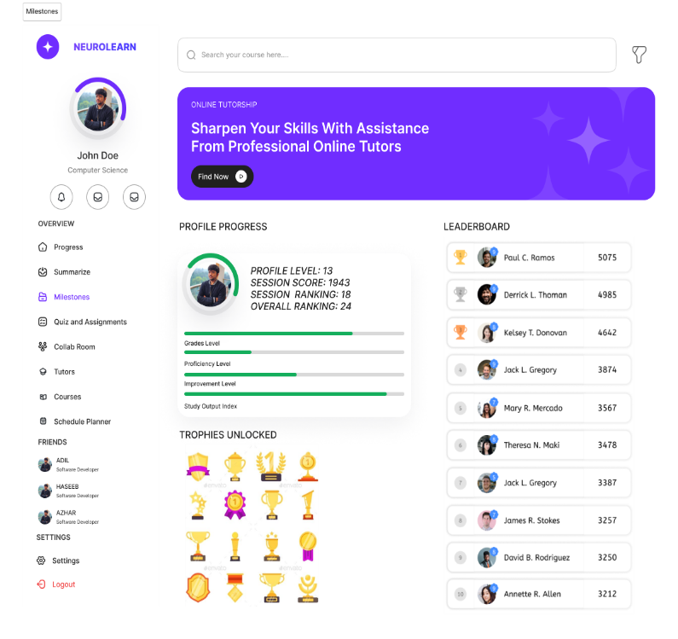

Figure 3 - Milestones Screen Figure 4 - Quiz and Assignments Screen

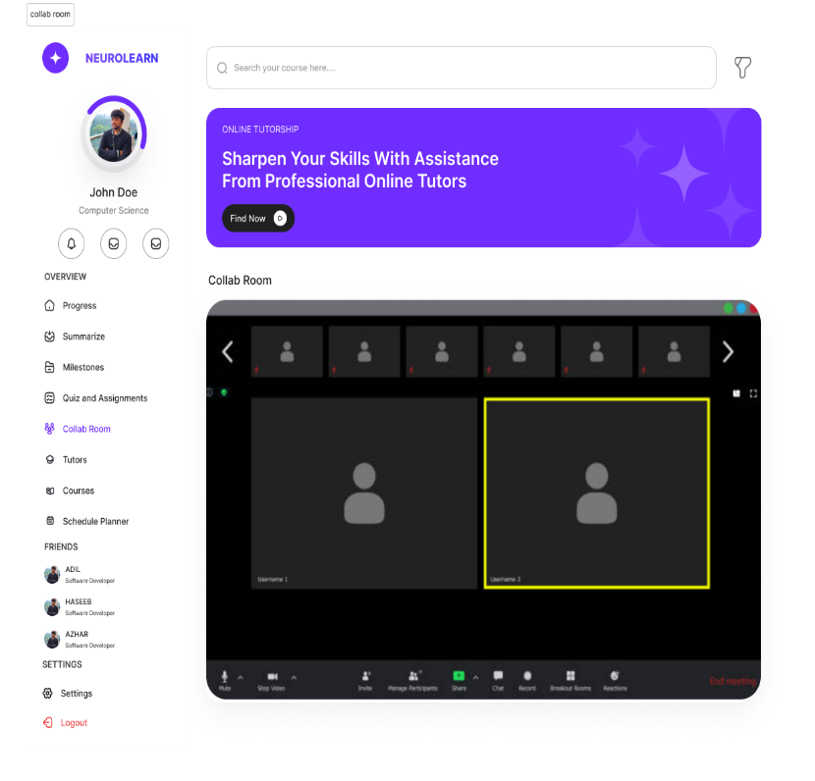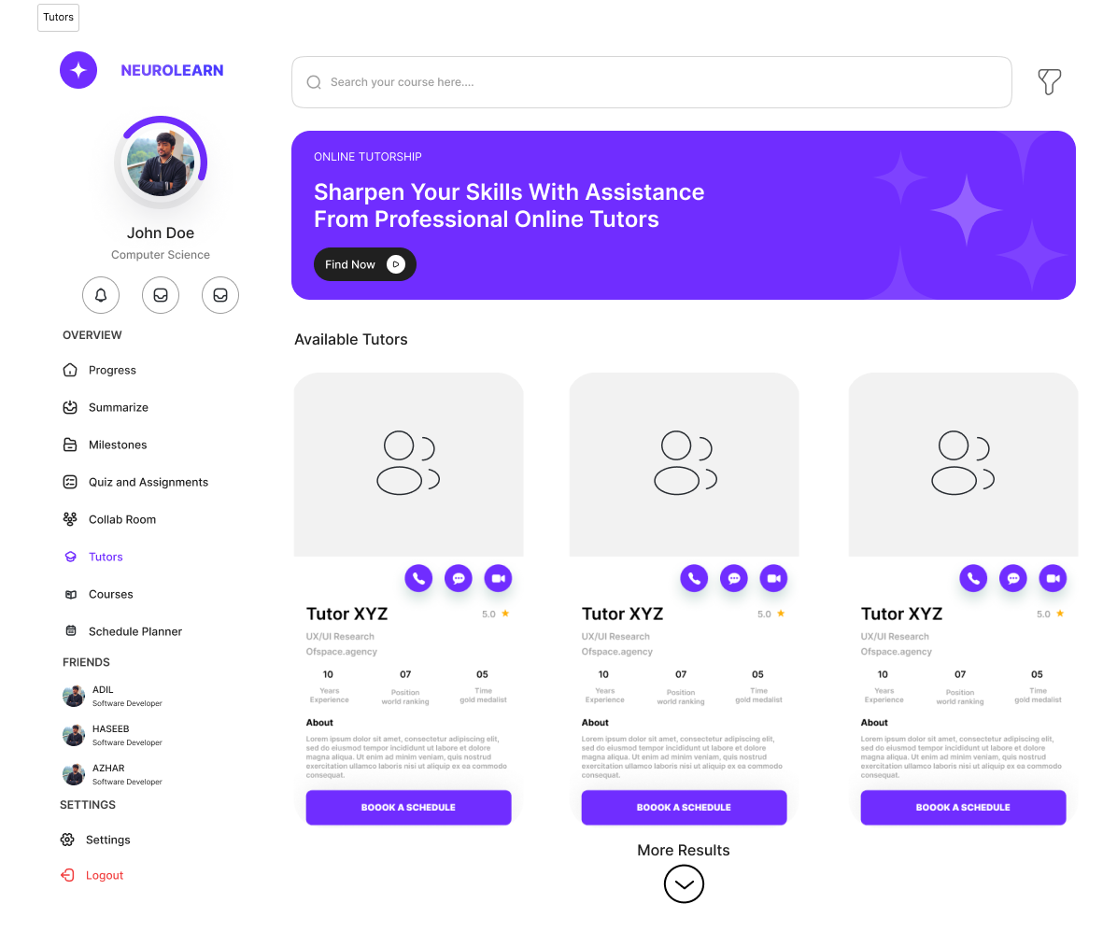

**Figure 5 - Collab Room Screen Figure 6 - Hire a Tutor Screen**

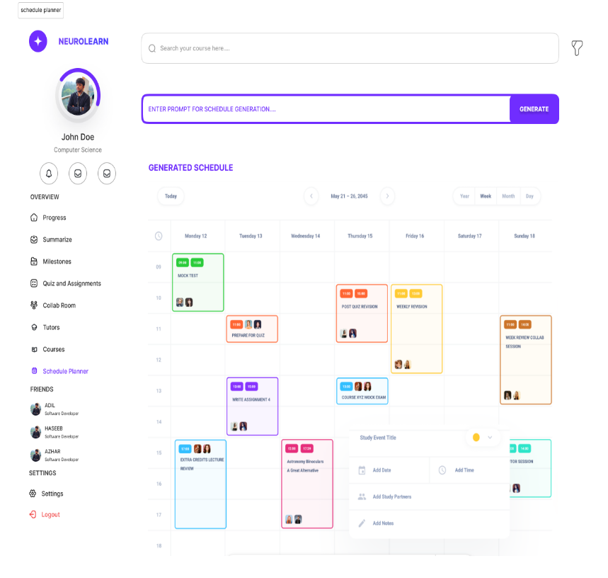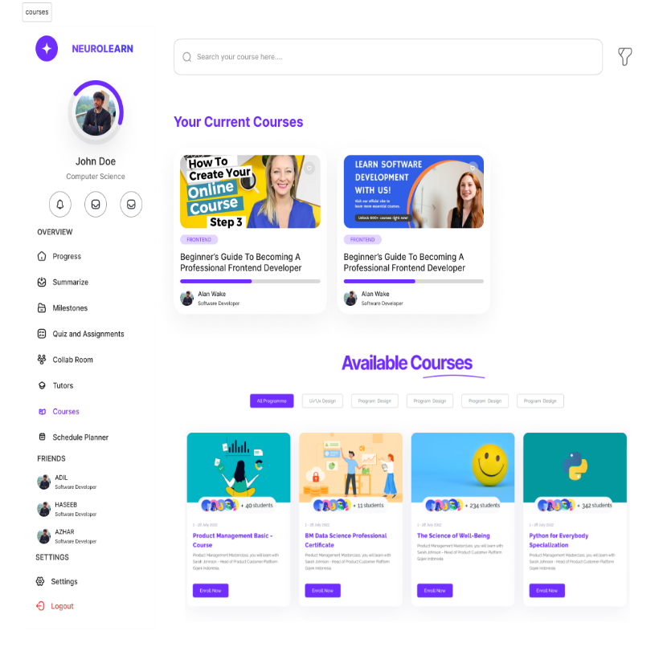

**Figure 7 - Courses Screen Figure 8 - Schedule Planner Screen**

# 

# References

1. Luckin, R. (2018). *Enhancing Learning and Teaching with Technology: What the Research Says*. UCL Institute of Education Press.
2. Wang, F., & Hannafin, M. J. (2005). *Design-Based Research and Technology-Enhanced Learning Environments*. Educational Technology Research and Development, 53(4), 5-23.
3. Woolf, B. P. (2010). *Building Intelligent Interactive Tutors: Student-Centered Strategies for Revolutionizing e-Learning*. Morgan Kaufmann.
4. Godsey, M. (2015). The Future of Education: How AI is Changing the Classroom.
5. [Pedró, Francesc](https://unesdoc.unesco.org/query?q=Author:%20%22Pedr%C3%B3,%20Francesc%22&sf=sf:*&queryDisplay=Person%20as%20author%3A%20%22Pedr%C3%B3%2C%20Francesc%22), [Subosa, Miguel](https://unesdoc.unesco.org/query?q=Author:%20%22Subosa,%20Miguel%22&sf=sf:*&queryDisplay=Person%20as%20author%3A%20%22Subosa%2C%20Miguel%22), [Rivas, Axel](https://unesdoc.unesco.org/query?q=Author:%20%22Rivas,%20Axel%22&sf=sf:*&queryDisplay=Person%20as%20author%3A%20%22Rivas%2C%20Axel%22), [Valverde, Paula](https://unesdoc.unesco.org/query?q=Author:%20%22Valverde,%20Paula%22&sf=sf:*&queryDisplay=Person%20as%20author%3A%20%22Valverde%2C%20Paula%22). Artificial Intelligence in Education:Opportunities,Challenges,andFutureDirections(<https://unesdoc.unesco.org/ark:/48223/pf0000366994>)
6. [Lijia Chen](https://ieeexplore.ieee.org/author/37088392960); [Pingping Chen](https://ieeexplore.ieee.org/author/38248057100); [Zhijian Lin](https://ieeexplore.ieee.org/author/37086521017). Artificial Intelligence in Education: A Review(<https://ieeexplore.ieee.org/document/9069875>)
7. Mohammad Hasan Rashed Polas, Asghar Afshar Jahanshahi, Bulbul Ahamad. (2023). The Future of Artificial Intelligence in Education 4.0: How to Go Green in the Post-COVID-19 Context(<https://www.researchgate.net/publication/373235279_The_Future_of_Artificial_Intelligence_in_Education_40_How_to_Go_Green_in_the_Post-COVID-19_Context>)
8. Niklas Humble, Peter Mozelius. (2024). The Impact of Artificial Intelligence on Cognitive Load in Computing Education (<https://www.researchgate.net/publication/384808790_The_Impact_of_Artificial_Intelligence_on_Cognitive_Load_in_Computing_Education>)
9. Zouhaier Slimi. (2022). The Impact of Artificial Intelligence on Higher Education: An Empirical Study(<https://files.eric.ed.gov/fulltext/EJ1384682.pdf>)

# Plagiarism Report

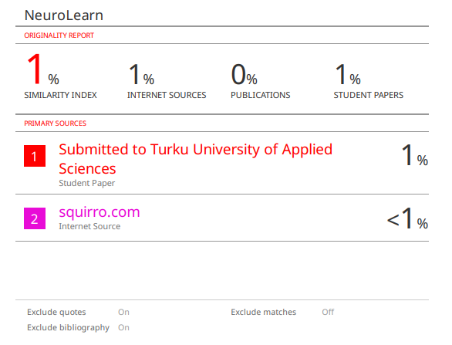

1. Spaced Repetition: A method of reviewing information at gradually increasing intervals to boost long-term retention.
2. Active Recall: A learning approach focused on retrieving information from memory, enhancing understanding through self-testing.
3. Pomodoro Technique: A time management strategy involving 25-minute focused work sessions followed by short breaks to maintain productivity.