**Department of Electrical and Computer Engineering**

**North South University**



**Senior Design Project**

**Assistive Device for Visually Impaired People Using Raspberry Pi**

**Mohammad Ibrahim ID # 1520671042**

**Kawcher Ahmed ID # 1520667642**

**Md. Abdullah Al Shafi ID # 1521270042**

**Najmul Hoq ID # 1520836642**

**Faculty Advisor:**

**Mirza Mohammad Lutfe Elahi**

**Senior Lecturer**

**ECE Department**

**Spring 2019**

**Declaration**

This is to declare that no part of this report or the project has been previously submitted elsewhere for the fulfillment of any other degree or program. Proper acknowledgement has been provided for any material that has been taken from previously published sources in the bibliography section of this report.

.........................................................

Mohammad Ibrahim

ECE Department

North South University, Bangladesh

........................................................

Kawcher Ahmed

ECE Department

North South University, Bangladesh

.........................................................

Md. Abdullah Al Shafi

ECE Department

North South University, Bangladesh

.........................................................

Najmul Hoq

ECE Department

North South University, Bangladesh

**Approval**

The Senior Design Project entitled “**Assistive Device for Visually Impaired People Using Raspberry Pi**” by Mohammad Ibrahim (ID#1520671042), Kawcher Ahmed (ID#1520667642), Md. Abdullah Al Shafi (ID#1521270042) and Najmul Hoq (ID#1520836642) has been accepted as satisfactory and approved for partial fulfillment of the requirement of BS in CSE degree program on May, 2019.

|  |
| --- |
| **Supervisor’s Signature** |
|  |
| **Mirza Mohammad Lutfe Elahi Senior Lecturer**  Department of Electrical and Computer Engineering  North South University  Dhaka, Bangladesh. |
| **Department Chair’s Signature** |
| **Dr. K. M. A. Salam**  **Professor**  Department of Electrical and Computer Engineering  North South University  Dhaka, Bangladesh. |

**Acknowledgement**

First of all, we would like to express our profound gratitude to our honorable course instructor, **Mirza Mohammad Lutfe Elahi,** for his constant and meticulous supervision, valuable suggestions, his patience and encouragement to complete the thesis work.

We would also like to thank the ECE department of North South University for providing us with the opportunity to have an industrial level design experience as part of our curriculum for the undergraduate program.

Finally, we would like to thank our families and everybody who supported us and provided with guidance for the completion of this project.

**Abstract**

Assistive device for visually impaired people can improve mobility as well as the safety of them. This device detects and localizes objects and yellow footway, and recognizes face of the known people. Then the information is sent to the visually impaired people by voice instruction. In addition, this device reads any printed text and converts into speech. Object detection is done by tensorflow object detection API. The yellow footway is detected using color detection in python with OpenCV and Haar feature based cascade classifier method is used for face recognition and human body detection. An OCR (optical character recognition) technology Python-tesseract (pytesseract) extracts text from images and processes the text. Converting all information to speech is done with the help of an offline python text to speech library named pyttsx3. GPS module is constructed in the device and it sends the location to the server and then from the server to the tracker app. This device will assist the blind and partially sighted people in the known and unknown environment without the help of other persons.

**Table of Content**

Chapter 1:

Project Overview 1

1.1 Introduction 2

1.2 Project Objective 3

1.3 Report Outline 3

Chapter 2: Related Work 4

Literature Review 5

Chapter 3: Design Approach 7

3.1 Introduction 8

3.2 Instrument Setup 8

3.3 Block Diagram 9

3.4 Flow Chart 11

Chapter 4: Instrument Hardware 13

4.1 Introduction 14

4.2 Components 14

Chapter 5: Detection Process 17

5.1 Introduction 18

5.2 Object detection with Tensorflow object detection API 18

5.3 Yellow footway detection using OpenCV 18

5.4 Face Detection using Haar feature based cascade classifier 19

5.4.1 Face Detection and Data gathering 20

5.4.2 Train the Recognizer 21

5.4.3 Face Recognition 21

Chapter 6: Text to Speech 22

6.1 Introduction 23

6.2 Optical Character Recognition (OCR) 23

6.3 Text to Speech API (pyttsx3) 25

Chapter 7: Tracking Application 26

7.1 Introduction 27

7.2 Server 27

7.3 Android Application 27

7.4 Application Feature 27

7.4 Block Diagram 28

Chapter 8: Results and Discussion 29

8.1 Introduction 30

8.2 Layout 30

8.3 Analysis 30

Chapter 9: Expenses 33

Chapter 10: Concluding Remark 35

10.1 Conclusion 36

10.2 Future Work 36

Bibliography 37

**List of Figures**

|  |  |  |
| --- | --- | --- |
| ***Fig No.*** | ***Figure Caption*** | ***Page No.*** |
| ***3.1*** | Instrument Setup | 8 |
| ***3.2*** | Camera Module Connection with Raspberry Pi | 9 |
| ***3.3*** | GPS Module Connection with Raspberry Pi | 9 |
| ***3.4*** | Block Diagram of the System | 10 |
| ***3.5*** | Flowchart Diagram of the System | 11 |
| ***4.1*** | Raspberry Pi 3B | 14 |
| ***4.2*** | Raspberry Pi Camera Module | 15 |
| ***4.3*** | GPS Module NEO6MV2 | 15 |
| ***5.1*** | Object Detection with Tensorflow Object Detection API | 18 |
| ***5.2*** | Yellow Footway Detection using OpenCV | 19 |
| ***5.3*** | Diagram of Face Recognition using OpenCV Haar Cascade Classifier | 20 |
| ***6.1*** | Block Diagram of Text to Speech | 23 |
| ***6.2*** | Working Process of OCR | 24 |
| ***6.3*** | Working Process of Text to Speech API | 25 |
| ***7.1*** | Block Diagram of Tracking Application | 28 |
| ***8.1*** | External Layout of the System | 30 |
| ***8.2*** | (a) Object Detection, (b) Human Detection, (c) Face Recognition, and (d) Text to Speech | 31 |

**List of Tables**

|  |  |  |
| --- | --- | --- |
| ***Table No.*** | ***Table Caption*** | ***Page No.*** |
| ***9.1*** | Project Expense | 33 |

# Chapter 1

# Project Overview

### 1.1 Introduction

In present world statistics say that, 285 million people are visually impaired as they are incapable to read text indoor and outdoor. Lots of advancement happened in technology in this fast few years to comfort the normal human being. Not only normal person but those having disabilities can also use this growing technology for their ease. Going to one place to another place for the blind is a tough job. Walking On the public road is the biggest issues they faced and always needed someone's constant support and guidance.

At the present time, the government takes a step to build a yellow path on the footpath for visually impaired people. But most of the time visually impaired people face complication to walk in that way. There can be possibilities to move away from this yellow road when they walk alone. Sometimes there can be obstacles or unwanted objects on the walking way which create an interruption to move on. Impaired people face a great difficulty with reading materials. Sometimes it's necessary to track visually impaired people. Therefore, they require support from assistive technology to carry out different occasions.

The goal of this project is to design a system that will revoke all these troubles for the blind people. In our project, we focus on developing assistive technology for all these obstacles avoidance and can able read the text by visually impaired people. Firstly, our visually impaired assistive system detected the yellow path on the footpath and sent voice notice if he or she moves away from the yellow path. As well as this system notified him or her if there has any unwanted object on the path to avoid those.

In the obstacle detection feature, camera took video and analyze this compare through dataset and then sent the audio message to the user so that user can avoid obstacles. In yellow path detection feature, we used color detection to detect yellow path. If the visual impaired people went out of the yellow path, then the system would give an audio signal. The system also had another feature that will convert any text image to audio speech.

In the text to speech feature, we used OCR (Optical Character Recognition) technique that will work with pytesseract module to form a text from capture image. We used offline python text to speech library named pyttsx3 to convert the text to audio speech. There also had a GPS module in this system. This module will send the current location of the user to the server and the location will be shown in the android application.

## 1.2 Project Objective

The objective of the project is to design and implement an assistive device for the visually impaired person using tensorflow, OCR and Haar cascade method base classifier. It is designed using Raspberry pi 3 B connect with Wearable glass camera, GPRS, headphone as a core element of the system. It has three switches four changing modes like on/off, object/yellow path detection mode, face/human detection mode and text to speech mode.

## 1.3 Report Outline

There is some literature review which is related to this project in the second chapter. Chapter three discusses the design approach. Work done on the hardware and working principle of components that are used in this work is presented in chapter four. The detection process using YOLO algorithm is presented in the next chapter. After this chapter, text to speech procedure for OCR and google text to speech techniques demonstrate in chapter six and seven. The eighth chapter provides a concept of designing a tracking software. The last chapter summarizes the work and some suggestions for future work.

# Chapter 2

# Related Work

## Literature Review

As this work focuses on the obstacle avoidance and the guiding information feedback, the related work with respect to such fields are reviewed in this section. In the literature, different technologies such as raspberry pi, camera have been used for aiding blind people avoiding obstacles in the environment. In this section, we present only vision-based methods that are relatively close to our work in this paper. Methods for obstacle detection and warning could be categorized depending on how the obstacles are detected, and how their information is sent to the user. In the text to speech feature, visually impaired people could be able to read text that will be possible using OCR technique.

Obstacle detection is a key problem in computer vision for navigation. Existing methods could be categorized into two main approaches. The first approach learns object model then verifies if a pixel or an image patch satisfies the learned model. A camera captures grayscale images, then pixels are classified into background or objects based on neural network technique [1]. Then, the pixels belonging to the obstacle are enhanced and the background pixels are removed. Joachim et al. [2] detects obstacles utilizing a model of human color vision. The lens position of the auto-focus stereo camera was used to measure the distance of the object center. A method was proposed for appearance-based obstacle detection [3]. Firstly, color image is filtered, then converted to HSI color space. Then the color histogram on the candidate area is computed and compared with reference histogram. Authors [4] developed a method for obstacle avoidance based on stereo vision and a simplistic ground plane detection. The obstacle detection relies on the creation of a virtual polar cumulative grid, which represents the area of interest ahead of the visually impaired user. Once detected, information of obstacles must be conveyed to the blind. In general, the user could be informed through auditory and tactile sense.

Jabnoun, Benzarti, and Amiri [5] used the Scale Invariant Features Transform (SIFT) for key points detection and matching to ensure the identification of the objects. This depth-based wayfinding algorithm is to find candidate traversable directions based on the depth image and the multi-sensor fusion based method is proposed to reduce incorrect measuring data [6]. Long, Tian and Chucai [7] showed a method to detect good quality frames from blurred frames in videos by using Support Vector Machine (SVM) based classier and handle video motions in both indoor and outdoor environments by combining gradient features and statistical features of frequency, entropy, etc. The segmented image is divided into left and right parts, transformed to (stereo) sound that is sent to the user through the headphones [7][9]. There are two features such as feature extraction, in which straight line edge segments are extracted from the image, and figure-ground segmentation, which

assigns a figure or ground label to each feature [10]. Their algorithm extracts straight-line segments from the image and applies simple grouping criteria such as parallelism, edge polarity and color consistency to construct candidate groupings of segments into the figure.

Text to speech is another feature to solve for visually impaired people. This module comprises the image and process image. Roberto Neto and Nuno Fonseca [11] integrated a set of frameworks of Optical Character Recognition (OCR) and Text to Speech Synthesis (TTS) [13] which enables the user and using a smartphone take a picture and hear the text that exists in the picture. In the text to speech feature, OCR technique is the key way to form a text _le from a text image [12]. OCR technique is like a text scanner that has done by the programming. In this feature, a picture is taken by the camera which image instruction is needed for visually impaired people. After that OCR technique is used forconvert a text form and the keyword is sent to the audio device for message generation [14].

# Chapter 3

# Design Approach

## 3.1 Introduction

In this chapter, we will discuss the instrument setup, block diagram of the entire system, and block diagram for the object detection, yellow footway detection and text to speech process.

## 3.2 Instrument Setup

The Project objective is to design the assistive device for a visually impaired person to make them independent to some extent. At present, many countries in the world including Bangladesh takes a step to make the footway in such way so that it can help visually impaired people to walk on. Our project can also help the blind person walk independently in this footway and can trace the location of their own.

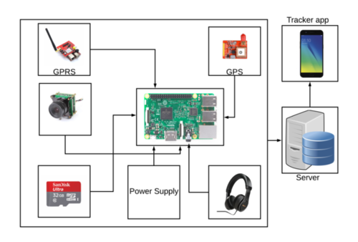

Figure 3.1: Instrument Setup

The instruments set up as shown in Fig. 3.1, consists of eye-glass, camera, Raspberry Pi 3B, GPS module, GPRS module, power supply, and headphone. The system has an eye-glass with a camera. The camera is connected to the raspberry pi. For object detection and yellow footway mode, raspberry pi gets the live video from the camera module. Then it processes the video frame using tensorflow to detect an object and yellow footway for the visually impaired people. Google text to speech gives the audio output to the audio device. GPS and GPRS module are connected to the raspberry pi to get the current location of the user. The location is sent to the server then server sends the location to the android apps. By the tracker apps, the family members of the visually impaired people can track them.

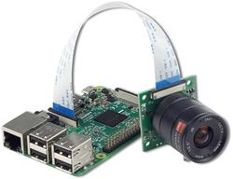

Figure 3.2: Camera Module Connection with Raspberry Pi

Fig. 3.2 represents how camera module is connected to the raspberry pi. A ribbon cable connects the camera to the Raspberry Pi.

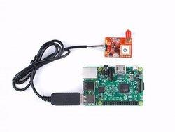

Figure 3.3: GPS Module Connection with Raspberry Pi

Fig. 3.3 represents how the GPS module is connected to the raspberry pi.

## 3.3 Block Diagram

The project has a wearable eyeglass for the visually impaired people which contains a camera. The camera is connected to the raspberry pi. The camera captures the images or video for the system. Raspberry Pi processes the image according to the detection mode. The system detects many objects, it detects yellow footway, and it converts any printed text to speech. Each detection mode gives an audio output which is heard through the audio device. The GPR and GPRS module are used to get the current location of the visually impaired people. The location is sent to the server and server send the location to the android apps according to the request.

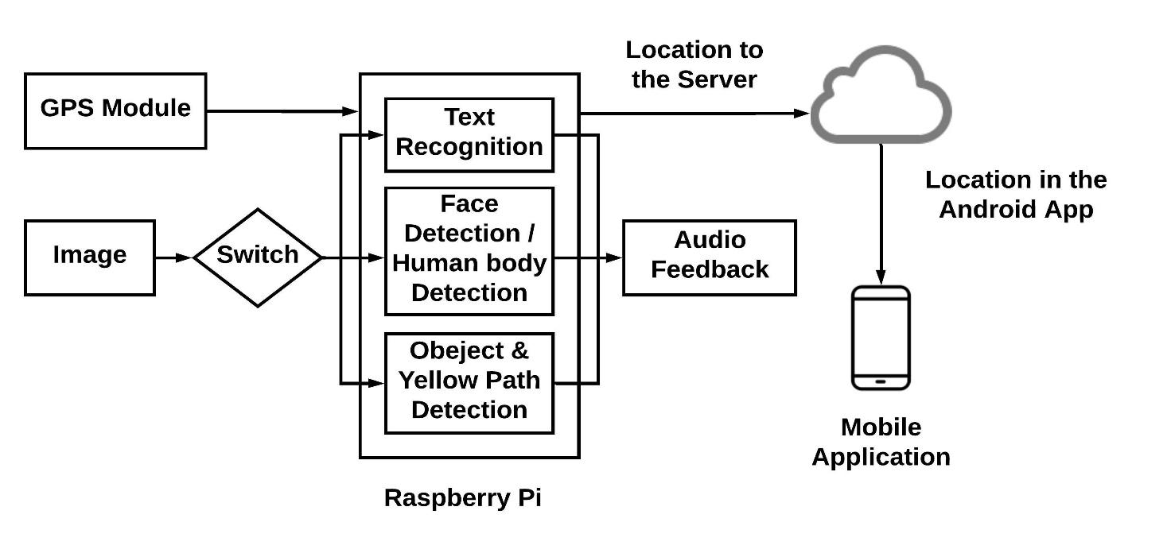

Figure 3.4: Block Diagram of the System

Fig. 3.4 represents the block diagram of the system. The system has a switch to change the option to TTS mode, Object detection mode or Yellow path detection mode. It also consists of a camera module which is connected to the raspberry pi. The diagram showing that all the features is done inside the raspberry pi using some algorithms. When the system in object detection and yellow footway detection mode, raspberry pi gets the video frame from the camera. Then it processes the video frame using tensorflow object detection API and color detection to detect the object and yellow footway in the live video frame. Then an offline text to speech API is used to give an audio command to the user. The audio device gives the audio output from the google text to speech API. The audio device is connected to the raspberry pi. When the system in TTS mode, the camera captures the images and this image processes inside raspberry pi using OCR technology. If the image contains any printed text then OCR technology convert that image into a text _le. Then google text to speech converts that text into an audio file. The audio output from the GTTS can be heard through an audio device like the headphone. GPS and GPRS module are used to track the visually impaired people and also the device.

## 3.4 Flow Chart

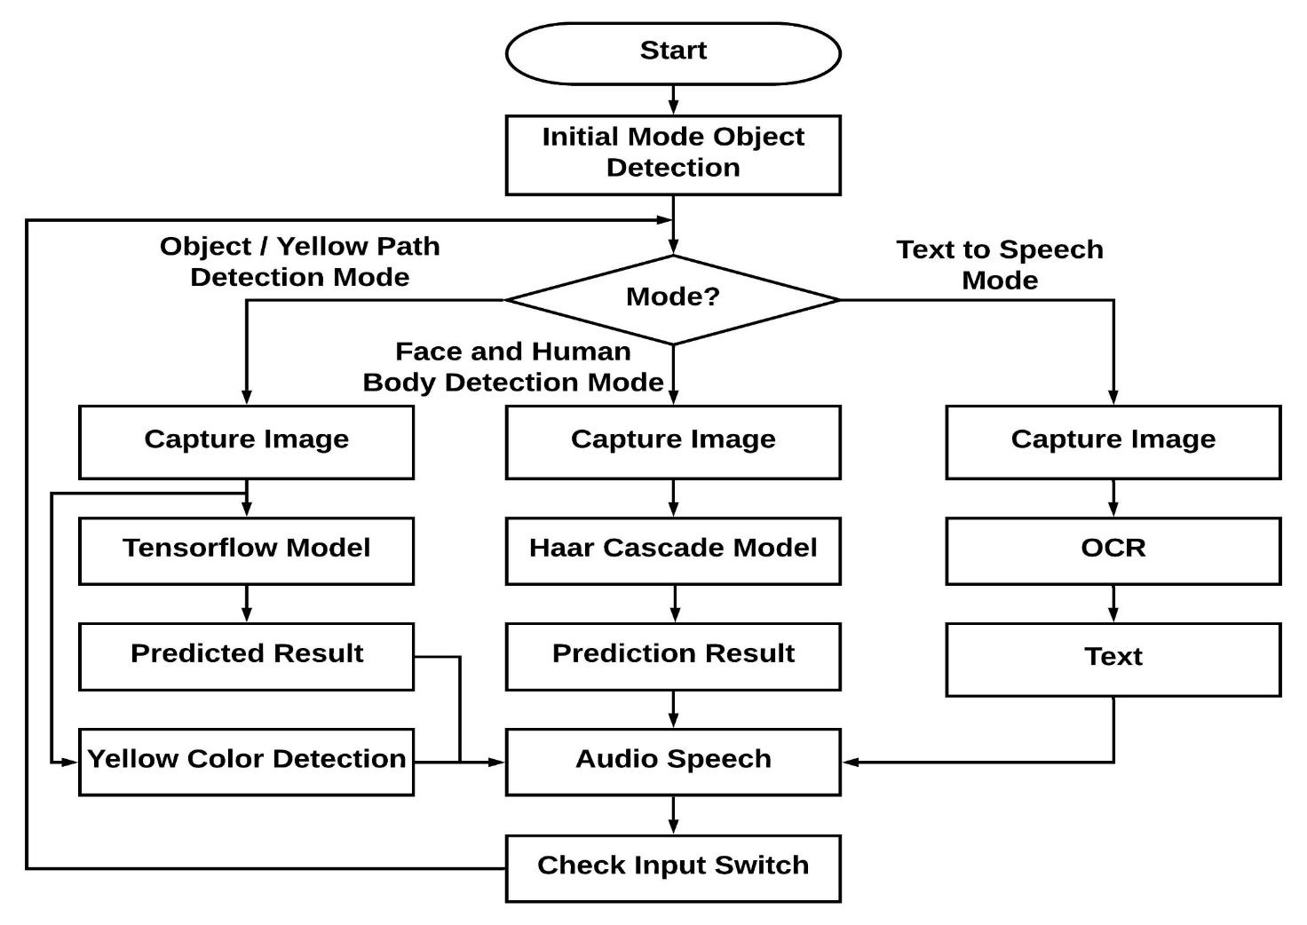

Figure 3.5: Flow Chart of the System

Fig. 3.5 represents the flowchart of object detection or yellow footway detection, face or human body recognition and text to speech technology. When the system switched on, it is initially in object detection and yellow footway detection mode. Before going to the processing system checks the mode. If it is object detection and yellow footway detection mode then the system processes the video frame using tensorflow object detection API to detect the object and using OpenCV for yellow footway. If yellow footway is found in the video frame and any object in the frame then it gives the name of the object as audio feedback. After getting the object name pyttsx3 gives the audio output about the object and yellow footway. Then the system checks the mode again. If the system is in Face or Human detection mode, camera captures images and Haar cascade classifier applied to predict face and human body. And if the system in Text to Speech mode, then the system sends the captured image to the OCR technology. Then OCR technology processes the image to check whether the image contains any printed text. If the image contains printed text then it converts the text in the image into a text file. After getting the text file from the OCR pyttsx3 converts that text into audio speech. Then the system checks the mode again. When the device switched off then the system terminated.

# Chapter 4

# Instrument Hardware

## 4.1 Introduction

Our goal is to make an assistance device for visually impaired people. Also, we need to make it by cost effectively. Because there are several devices are available for visually impaired people. But most of those do not cost effective. So, most of the visually impaired people can't afford those devices. Considering all of this we chose a hardware design for visually impaired people. Those are raspberry pi 3 B, USB camera, headphone and GPS. All our products are cheap and available everywhere. For the power source, we use a USB power bank. A camera is in middle of eyeglass and connect with raspberry pi. Raspberry Pi and another module is in pocket or bag. Completed device visually impaired people can easily able to configure and understand the system.

## 4.2 Components

The Assisting Device for a visually impaired person consists of the following component.

1. Raspberry pi 3 B+
2. USB camera
3. Headphone
4. GPS

The detailed description of all components is as follows.

1. **Raspberry Pi 3B**

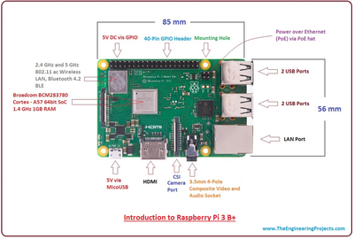

Figure 4.1: Raspberry Pi 3B

Fig. 4.1 represents a Raspberry Pi 3B is a wonderful little piece of hardware. We can easily setup OS in raspberry pi and able to do what we want. Just like as this is a mini computer. Bellow figure shows the part of raspberry pi 3B.

1. **USB camera**

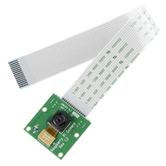

Figure 4.2: Raspberry Pi Camera Module

Fig. 4.2 represents a raspberry pi camera module. For camera module, we use Raspberry Pi Camera Board v1.3. It is a 5MP camera and it able to take 1080p video and photo.

1. **Headphone**

To provide text to speech and object detection audio result we use any mobile headphone.

Better headphone makes a better sound.

1. **GPS**

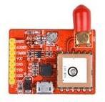

Figure 4.3: GPS Module NEO6MV2

Fig. 4.3 represents a GPS module. We use GPS Module NEO6MV2. This module has a built-in voltage regulator and it is sometimes referred to as GY-GPS6MV2. It is compatible with various light controller boards designed to work with a GPS module.

# Chapter 5

# Detection Process

## 5.1 Introduction

In this chapter, we will define object detection process using Tensorflow object detection API, OpenCV for yellow path and Haar feature based cascade classifier.

## 5.2 Object detection with Tensorflow object detection API

Object Detection is the process of finding real-world object instances like car, bike, TV, flowers, and humans in still images or Videos. It allows for the recognition, localization, and detection of multiple objects within an image which provides us with a much better understanding of an image as a whole.

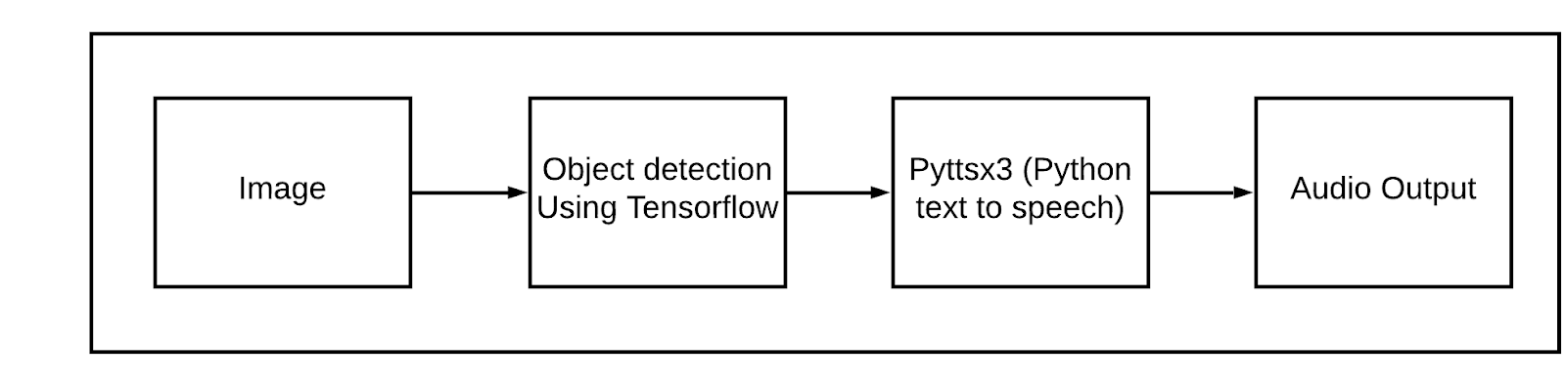 Figure 5.1: Object Detection with Tensorflow Object Detection API

Fig. 5.1 represents the working process of object detection using tensorflow object detection API. When the device in object detection mode, then camera captures image. And the image is sent to the tensorflow object detection API. Tensorflow object detection API can only detect objects belonging to the classes present in the dataset used to train the network. After getting the name of the object google text to speech API is used for the audio command about the object.

## 5.3 Yellow footway detection using OpenCV

Usually, our camera works with RGB color mode, which can be understood by thinking of it as all possible colors that can be made from three colored lights for red, green, and blue. We used here with BGR (Blue, Green, Red) instead. With BGR, a pixel is represented by 3 parameters, blue, green, and red. Each parameter usually has a value from 0 – 255 (or O to FF in hexadecimal). For example, a pure blue pixel on your computer screen would have a B value of 255, a G value of 0, and a R value of 0. OpenCV works with HSV (Hue, Saturation, Value) color model, that it is an alternative representation of the RGB color model. For yellow color detection we defined the lower and upper boundaries of the object to be tracked in the HSV color space. The system takes a frame from video and then convert it into HSV. If it found yellow color on the frame then it makes a box around the yellow color. Then it identifies the middle position of the box. If the middle position is greater than the frame’s middle position then the device says yellow path in the right side otherwise it says yellow path in the left side.

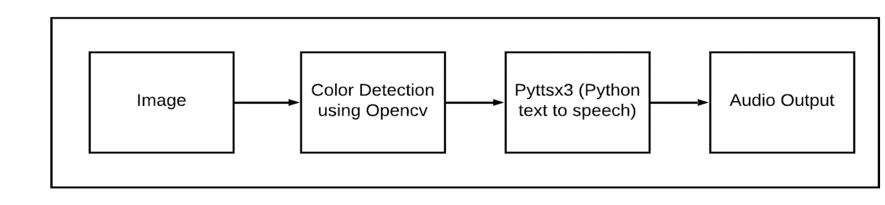

Figure 5.2: Yellow Footway Detection using OpenCV

Fig. 5.2 represent the working process of yellow footway detection using OpenCV. When the system in Yellow footway detection mode, then camera captures video. And the video is sent to the raspberry pi. Inside the raspberry pi, OpenCV is used to detect the Yellow footway. Then text to speech API is used to give audio command to the visually impaired people.

## 5.4 Face Detection using Haar feature based cascade classifier

To create a complete project on Face Recognition, we worked on 3 very distinct phases:

1. Face Detection and Data Gathering
2. Train the Recognizer
3. Face Recognition

Fig. 5.3 represents the diagram of the face recognition process using OpenCV and Haar feature based cascade classifier. The first phase of this process is data gathering which gathers the face of persons as dataset. After this phase, train all the data and identified by id so that it can learn. Then recognition phase is started by recognizer using OpenCV.

Figure 5.3: Diagram of Face Recognition using OpenCV Haar Cascade Classifier

### 5.4.1 Face Detection and Data gathering

The most basic task on Face Recognition is Face Detection. Object Detection using Haar feature-based cascade classifiers is an effective object detection method proposed by Paul Viola and Michael Jones in their paper, "Rapid Object Detection using a Boosted Cascade of Simple Features" in 2001. It is a machine learning based approach where a cascade function is trained from a lot of positive and negative images. It is then used to detect objects in other images. We worked with face detection using haar feature-based cascade classifier. Initially, the algorithm needs a lot of positive images (images of faces) and negative images (images without faces) to train the classifier. Then we need to extract features from it. OpenCV comes with a trainer as well as a detector.

OpenCV already contains many pre-trained classifiers for face, eyes, smile, etc. We used haarcascade_frontalface_default.xml pre-trained classifier for face detection. Initially we have assigned an id before start the camera. When device detect face then it captures and save image with the assigned id up to a specific range to trained those images later.

### 5.4.2 Train the Recognizer

On this second phase, we took all user data from our dataset and "trainer" the OpenCV Recognizer. This is done directly by a specific OpenCV function. The result is a .yml file that is saved on a in a specific directory.

### 5.4.3 Face Recognition

Here, we capture a fresh face on our camera and if this person had his face captured and trained before, our recognizer makes a "prediction" returning its id and an index, shown how confident the recognizer is with this match.

# Chapter 6

# Text to Speech

## 6.1 Introduction

In this chapter, we will discuss about the block diagram of text to speech feature, working process of optical character recognition (OCR), working process of an offline text-to-speech (pyttsx3) API and the flowchart of text to speech feature. This section represents the automatically printed text reader for visually impaired people, developed on Raspberry Pi.

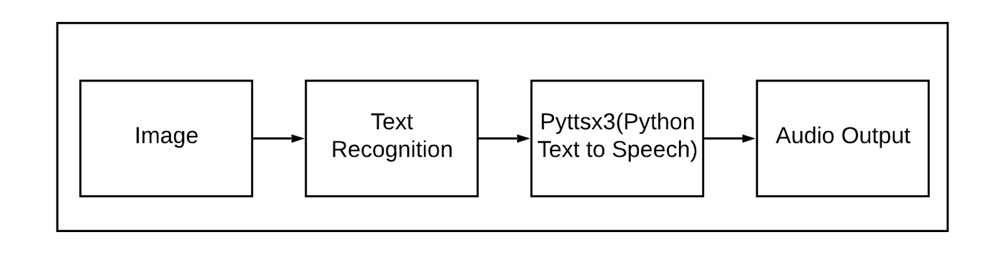

Figure 6.1: Block Diagram of Text to Speech

Fig. 6.1 represents the block diagram of text to speech. When the capture button is clicked, this system captures the document image placed in front of the camera which is connected to the raspberry pi through USB and the images is sent to the raspberry pi. It uses Optical character recognition (OCR) technology for the identification of the printed characters using image sensing devices and computer programming. It converts images into a text file which is converted into an audio file using pyttsx3 text to speech API.

## 6.2 Optical Character Recognition (OCR)

Optical Character Recognition is a text recognition method that allows the written text or printed copies of the text to be rendered into editable soft copies or text files. OCR is used for the scanning of text from the images and converting that image into the editable text file.

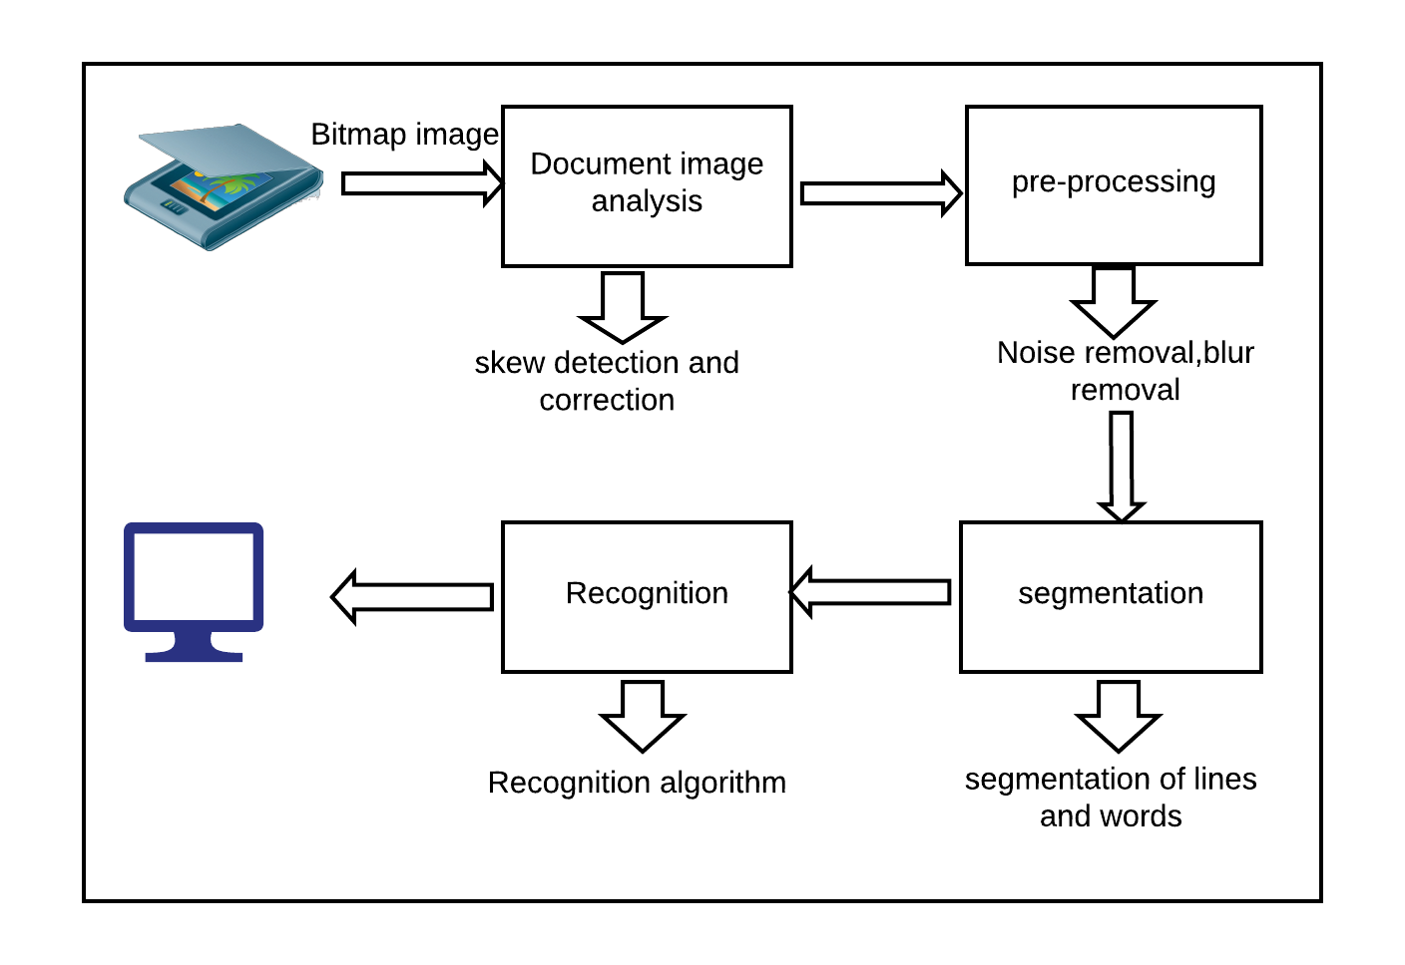

Figure 6.2: Working Process of OCR

Fig. 6.2 represents the working process of OCR technology. At first OCR technology scan the document image. Then it analyses the image for skew detection and correction. Then it processes the image for blur removal from the image. Then it divides each line and word into segments. Then recognition algorithm recognizes each character and generate a text file.

### 6.3 Text to Speech API (pyttsx3)

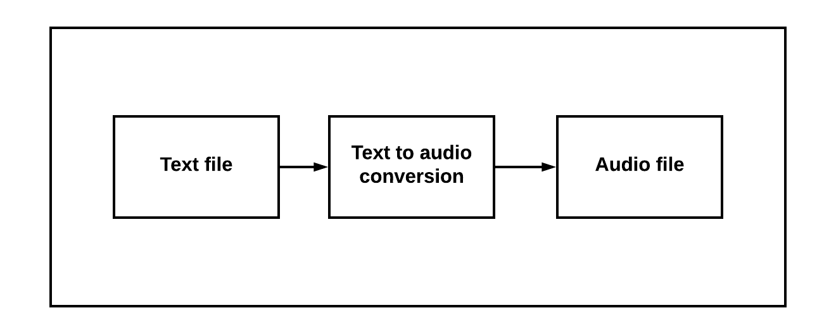Figure 6.3: Working Process of Text to Speech API

Fig. 6.3 represents the working process of the offline text to speech API. When pyttsx3 get the text file from the OCR technology then it converts the text file into audio. After converting the text file into an audio file then it generates an audio output which can be heard through audio devices.

# Chapter 7

# Tracking Application

## 7.1 Introduction

In this chapter we will discuss about the working process of tracking application. In this feature, we are working with a location tracking system of visually impaired people. This system work with an app. First of all, there is a GPRS module in our assistance device which updates the location. GPRS module works like a network system which provides the user exact location. The GPRS module works with raspberry pi. Raspberry Pi takes an update from the GPRS module and send an HTTP request to the server. After processing the request server stores and give the details of location of visually impaired people. There is an application which connects with server. When user sends a request to the server, server gives a response with a location. And then, family members of visually impaired people can find the location in Google map.

## 7.2 Server

Users location is sent to the server through GPS and GPRS module. The server is sent the location to the Android apps when it gets the request from the apps.

## 7.3 Android Application

There is an application for tracking the location of visually impaired people. Through the application family members of the visually impaired people can find their location from anywhere. When a user of the application wants to access the location, the application sends a request to the server and the server gives a response with a location by the help of GPS module and raspberry pi.

## 7.4 Application Feature

The application has a login and sign-in layout. When the user login to the apps then he/she directly see the location of the visually impaired people by the google map API.

## 7.4 Block Diagram

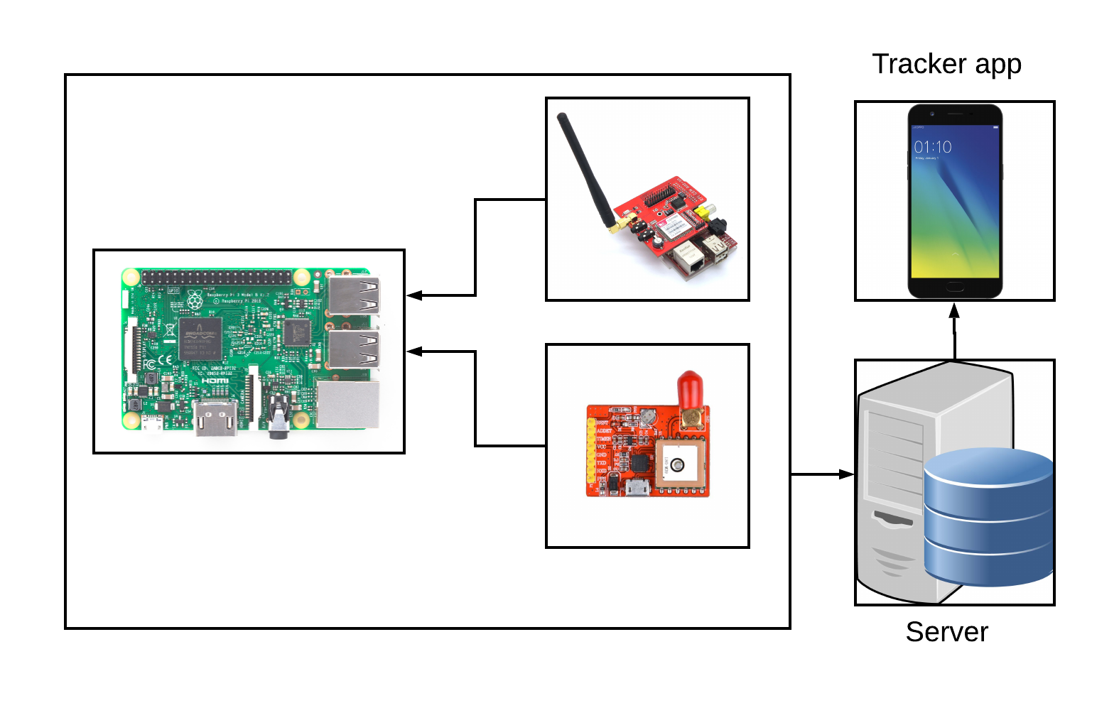

Figure 7.1: Block Diagram of Tracking Application

Fig. 7.1 represents the block diagram of the tracking system. GPS module which is connected to the raspberry pi is used to get the current location. The location is sent to the server and then from the server it is sent to the android apps.

# Chapter 8

# Results and Discussion

## 8.1 Introduction

In this section, we will talk about the results we obtained, and its analysis. This shows how we obtained our results and what was our findings regarding the project. We will also discuss how we analyzed our project for the betterment of it.

## 8.2 Layout

After the analysis of our system individually, we have seen the project works perfectly. Which means, we have effectively implemented the prototype of the entire system, which we planned initially. The whole system has two main parts and we combined them to make the system more efficient.

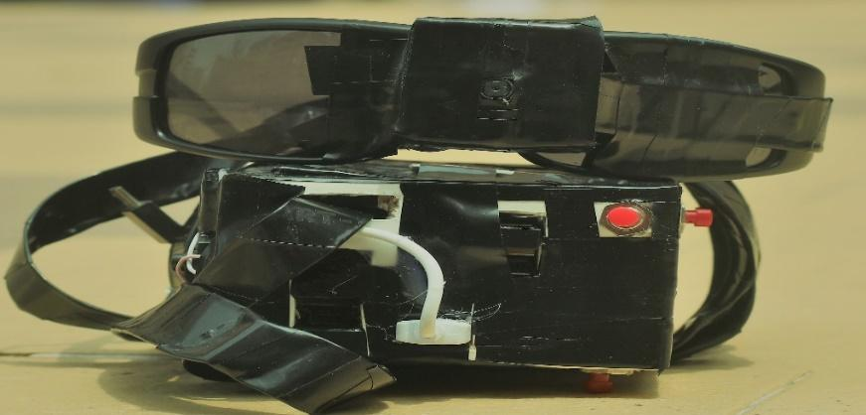

Figure 8.1: External Layout of the System

In Fig. 8.1, the external part is shown. It has a camera in a wearable glass and a box. There is a raspberry pi and GPS module inside the box. The camera module is attached with a glass and connected to the Raspberry Pi.

## 8.3 Analysis

In our project, there are some features like object detection, yellow path detection, face recognition and text to speech feature. We have found different accuracy for different features.

* We found the average accuracy of object detection with tensorflow API is around **60%-70%** within **2m.** If distance becomes lower, the accuracy increases.
* The frame per second (FPS) in Raspberry Pi for object detection is **0.9-1.0**.
* The Accuracy for text to speech feature is **70%-75%** within **0.5m**.Our system takes three images for any click in Text to Speech mode and gives audio feedback from the best images. If image captures in better light, the accuracy will rise up to **95%**.
* Device can recognize face **60%-70%** accurately for 100 trained images within **2m**. For 300 trained images, the accuracy will be **80%-85%**.

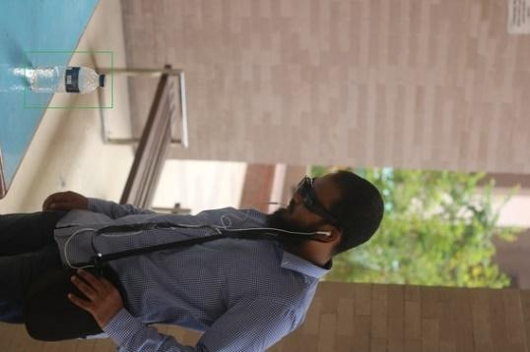 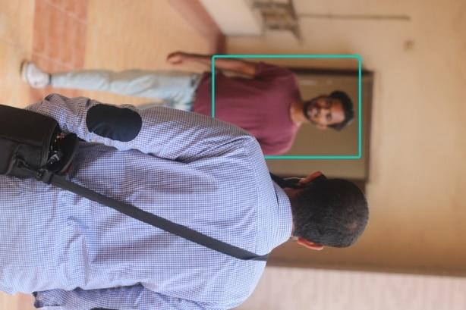



Figure 8.2: (a) Object Detection, (b) Human Detection

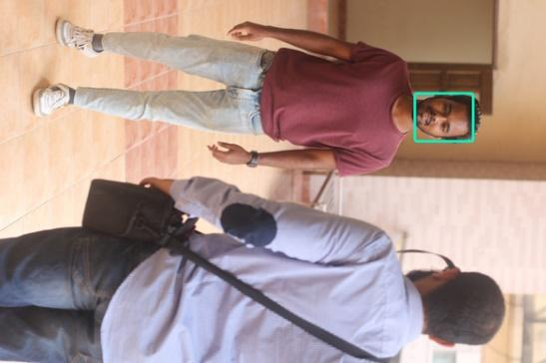 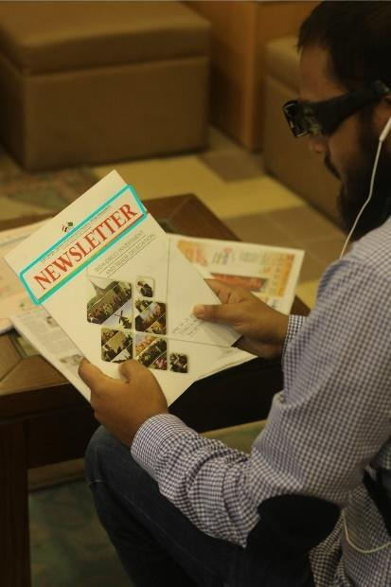

Figure 8.2: (c) Face Recognition, and (d) Text to Speech

# 

# 

# 

# 

# 

# 

# 

# 

# 

# 

# 

# 

# 

# Chapter 9

# Expenses

There is needed some devices such as raspberry pi, camera, power bank, stick, GPS module and so on. In the following table, the hardware devices with estimated budget is illustrated.

Table - 9.1 Project Budget

|  |  |  |  |
| --- | --- | --- | --- |
| **Component** | **Unit** | **Price** | **Price (Taka)** |
| Raspberry Pi 3 Model B | 1 | 3600 | 3600 |
| Memory Card | 1 | 750 | 750 |
| Raspberry Pi Camera Module | 1 | 1420 | 1420 |
| GPS Module NEO6MV2 | 1 | 1575 | 1575 |
| Raspberry Pi Camera Ribbon | 1 | 120 | 120 |
| Wearable Glasses | 1 | 800 | 800 |
| Power Bank | 1 | 650 | 650 |
| Switch | 4 | 40 | 160 |
|  |  | **Total** | 9075 |

# Chapter 10

# Concluding Remark

## 10.1 Conclusion

This report presents a smart guiding device for visually impaired users, which can help them to move safely. And it has also a GPS tracking system that can help them to find out their location. This device is easy to use for visually impaired users. Visually impaired people are neglected in our society because they cannot move by themselves. We are developed and tested in different scenarios, and results show that the beep sound based guiding instructions are the most efficient and well-adapted. In our system, the Image processing technique is able to provide a complete guidance to move on, detect an obstacle, detect the length of the obstacle, giving a proper warning, give the direction of the yellow path for the visually impaired people so that they can move on without others help. We know the that, some impaired people are not totally impaired, they can move on with instructions. However, our result shows that subjects can move on independently with instruction from the device. After all, this type of attention could be connected for future improvement.

## 10.2 Future Work

In the future, we will extend our project with real-time face detection which will help the visually impaired people to recognize the known people. We will also extend our project with zebra crossing feature which will help the visually impaired people to cross the road without any hesitation. Visually impaired people unable to deal with a specific bus. We have a plan to work with this kind of problem. We will make a system feature which will work as bus detection and that will help the visually impaired people to identify the specific bus. It will help them to make a trip with a bus. Road Sign detection is another challenge for visually impaired people and we will extend our project to solve this problem.

# Bibliography

[1] V.-N. Hoang, T.-H. Nguyen, T.-L. Le, T.-H. Tran, T.-P. Vuong, and N. Vuillerme, “Obstacle detection and warning system for visually impaired people based on electrode matrix and mobile Kinect," *Vietnam Journal of Computer Science*, vol. 4, no.2, pp. 71-83, 2016.

[2] Ulrich, I., Nourbakhsh, I.: *Appearance-based obstacle detection with monocular color vision*. AAAI (2000).

[3] Rodrguez, S.A., Yebes, J.J., Alcantarilla, P.F., Bergasa, L.M., Almazan, J., Cela, "Assisting the visually impaired: obstacle detection and warning system by acoustic feedback.", *Sensors 12*, pp. 17476-17496 (2012).

[4] Lilit Hakobyan, Jo Lumsden, Dympna O' Sullivan, Hannah Bartlett and MCOptom, “Mobile assistive technologies for the visually impaired", *Survey of Ophthalmology*, vol. 58, issue 6, pp. 513-528, Nov-Dec 2013.

[5] Hanen Jabnous, Faouzi Benzarti and Hamid Amiri, "Object detection and identification for blind people in video scene", *2015 15th International Conference on Intelligent Systems Design and Applications (ISDA),* Marrakech, Morocco, 2015, pp.363-367.

[6] Jinqiang Bai, Shiguo Lian, Zhaoxiang Liu, Kai Wang, Dijun Liu, “Smart Guiding Glasses for Visually Impaired People in Indoor Environment," *IEEE Transactions on Consumer Electronics,* vol. 63, issue 3, pp. 258-266, Aug 2017.

[7] Long Tian, Yingli Tian, Chucai Yi. "Detecting Good Quality Frames in Videos Captured by a Wearable Camera for Blind Navigation," in *International Conference on Bioinformatics and Biomedicine*, 2013, pp. 334-337.

[8] L. Simunovic, V. Andelic, I. Pavlinusic, “Blind people guidance system," in *Central European Conference on Information and Intelligent Systems*, 2012, pp. 427-431.

[9] Samir Patel, Amit Kumar, Pradeep Yadav, Jay Desai, Dipali Patil, "Smartphone-based Obstacle Detection for Visually Impaired People" in *International Conference on Image Analysis and Processing*, Genoa, Italy, 2015, pp.480-488.

[10] Volodymyr Ivanchenko, James Coughlan, and Huiying Shen, "Detecting and locating crosswalks using a camera phone" in *2008 IEEE Computer Society Conference on Computer Vision and Pattern Recognition Workshops*, Anchorage, Alaska, 2008.

[11] Roberto Neto and Nuno Fonseca, "Camera Reading for Blind People", in *HCIST 2014 - International Conference on Health and Social Care Information Systems and Technologies*, Leiria, Portugal, 2014, pp.1200-1209.

[12] Jarlin James, Michael Aldo, Adellina Andrew, "Image Text to Speech Conversion Using OCR Technique in Raspberry Pi," *International Journal of Scientific & Engineering Research*, vol. 9, Issue 3, pp. 66-67, March 2018.

[13] Mr. Mandar Sujit Jadhav, Mr. Sandip Mahasiddha Koli, Mr. Shardul Sharad Kulkarni, Mr. Shaikh Md Saqlain, S. Akhtar, Mr H.D.Ingle, "Raspberry Pi Based Reader for Blind", *International Journal of Innovative and Emerging Research in Engineering*, vol. 5, issue 1, pp. 17-20, 2018.

[14] D.Velmurugan, M.S.Sonam, S.Umamaheswari, S.Parthasarathy, K.R.Arun, "A Smart Reader for Visually Impaired People Using Raspberry PI", *International Journal on Soft Computing*, vol. 6, issue 3, pp. 2997-3001, 2016.