 | Syrian Private University  Faculty of Artificial Intelligence Engineering  Department of Software Engineering
Smart Institute Management System
تقرير عمل منجز لحد الآن
Progress Report: Work Completed to Date (Phase One)
An Arabic web-based system for managing students, teachers, courses, groups, attendance, grades, and finance of educational institutes (sys-institute)
A Graduation Project Submitted in Partial Fulfillment of the Requirements for the Bachelor's Degree in Informatics Engineering, Software Engineering and Intelligent Information Systems.
Prepared by
Ibrahim Nizar Khamis
Aisha Irfan Nashaa
Supervision
Eng. Rania Rajab
October 2026
I. Dedication
We dedicate this work to our parents, whose continuous support, encouragement, and sacrifices have been the foundation of our academic journey.
We would also like to express our sincere gratitude to our supervisor, Eng. Rania Rajab, and to all the professors and instructors at the Syrian Private University for providing us with the knowledge, guidance, and inspiration necessary to complete this project.
Special thanks are extended to our colleagues and friends who supported us throughout the development of this project and contributed to its success.
Finally, we dedicate this work to everyone who has encouraged and motivated us throughout our educational and professional development.
Ibrahim Nizar Khamis and Aisha Irfan Nashaa
II. الملخص بالعربية
يهدف هذا المشروع إلى تطوير نظام ويب عربي متكامل لإدارة المعاهد التعليمية، يجمع في منصة واحدة الأعمال الإدارية والأكاديمية والمالية، ويخدم ثلاثة أدوار رئيسية هي المدير والمدرّس والطالب، ويُستكمل في مرحلته الثانية بميزات الذكاء الاصطناعي لمتابعة الطلاب. تنبع أهمية المشروع من الحاجة إلى بديل منظم عن السجلات الورقية والجداول المتفرقة التي تسبب تكرار البيانات وأخطاء السندات وتعارض الجداول وضعف الرقابة المالية.
يعرض هذا التقرير العمل المنجز حتى الآن في المرحلة الأولى من المشروع، وهو: دراسة مرجعية ومقارنة مع أنظمة مشابهة (Moodle وGoogle Classroom وFedena وTeachworks)، ودراسة المتطلبات وتحديد عشرين حالة استخدام، ومخطط حالات الاستخدام مع وثائق التوصيف التفصيلية، وتصميم قاعدة البيانات (مخطط ERD والمخطط العلائقي لاثني عشر جدولاً)، ومخططات النشاط والتسلسل والبنية المعمارية للنظام، إضافة إلى واجهات النظام العربية (RTL) للأدوار الثلاثة.
اعتُمدت في التصميم تقنيات ويب حديثة، هي لارافيل للواجهة الخلفية، وفيو مع إنرشيا والتصميم عبر تيلويند للواجهة الأمامية، وبوستجريس لقاعدة البيانات، ومكتبة Chart.js للمخططات الإحصائية. وحُصر نطاق هذه المرحلة في عشرين حالة استخدام موزعة على المدير والمدرّس والطالب.
أما ميزات الذكاء الاصطناعي (حالات الاستخدام من 21 إلى 23)، ومنها التنبؤ المبكر بتعثر الطلاب والمساعد الذكي والتوصيات، فهي مخططة للمرحلة القادمة بعد استقرار النظام الأساسي، ويسير العمل وفق خطة من ستة عشر أسبوعاً حتى التسليم النهائي في 15/1/2027.
الكلمات المفتاحية:
نظام إدارة معهد، الصلاحيات والأدوار، الإدارة المالية، الحضور والعلامات، لارافيل، فيو، قواعد البيانات، التعليم الذكي.
III. Abstract
This project aims to develop a complete Arabic web-based system for managing educational institutes, bringing the administrative, academic, and financial work into one platform for three roles: Admin, Teacher, and Student. It will be extended in its second phase with artificial intelligence features for following up students. The importance of the system arises from the need for an organized alternative to paper registers and scattered spreadsheets, which cause duplicated data, receipt errors, schedule conflicts, and weak financial control.
This report presents the work completed to date in the first phase: a reference study and comparison with similar systems (Moodle, Google Classroom, Fedena, and Teachworks); requirements analysis with twenty use cases; the use case diagram with detailed use case descriptions; the database design (an ERD and a relational schema of twelve tables); activity and sequence diagrams and the system architecture; and the Arabic right-to-left (RTL) interfaces for the three roles.
The design relies on modern web technologies: Laravel for the backend, Inertia with Vue 3 and Tailwind CSS for the frontend, PostgreSQL as the database, and Chart.js for statistical charts. The scope of this phase is limited to twenty use cases (UC-01 to UC-20) divided among the Admin, the Teacher, and the Student.
Artificial intelligence features (UC-21 to UC-23), including early prediction of student failure, a smart assistant, and recommendations, are planned for the next phase after the core system stabilizes. The work follows a sixteen-week plan with final delivery on 15 January 2027.
Keywords:
Institute Management System, Role-Based Access Control, Financial Management, Attendance and Grades, Laravel, Vue.js, PostgreSQL, Smart Education
IV. TABLE OF CONTENTS
Dedication 2
Arabic Abstract 3
Abstract 4
Table of Contents 5
List of Figures 7
List of Tables 8
Glossary of Terms and Definitions 9
Chapter One: General Introduction 11
1.1 Project Overview and Background 11
1.2 Problem Statement and Importance 11
1.3 Project Objectives 12
1.4 Project Scope, Constraints, and Assumptions 12
1.5 Project Contribution to the Field 13
1.6 Research Methodology 13
1.7 Document Structure 13
1.8 Definitions and Basic Concepts 14
Chapter Two: Reviewing the Literature and Previous Studies 15
2.1 Previous Studies in Educational and Institute Management Systems 15
2.2 Modern Technologies and Frameworks Used 16
2.3 Comparative Analysis of Systems 16
2.4 Research Gap 16
2.5 Innovation in the Project 17
2.6 Future Trends in the Field 17
Chapter Three: Requirements Analysis and UML Modeling 18
3.1 Feasibility Study 18
3.2 Requirements Gathering 18
3.3 Stakeholders 19
3.4 Functional Requirements 19
3.5 Non-Functional Requirements 20
3.6 Requirements Priorities (MoSCoW) 20
3.7 Modeling Requirements Using UML 21
3.8 Requirements Traceability Matrix 31
Chapter Four: Database Design and System Architecture 32
4.1 High-Level Design 32
4.2 Database Design 33
4.3 Route and Interface Design 36
4.4 Security and Authorization Design 37
4.5 Scalability and Future Development 38
Chapter Five: System Interfaces 39
5.1 Overview of the User Interfaces 39
5.2 Admin Interface 39
5.3 Teacher Interface 40
5.4 Student Interface 41
References 42
V. LIST OF FIGURES
Figure 3.1 Use Case Diagram 22
Figure 3.2 Activity Diagram: Course Registration 25
Figure 3.3 Activity Diagram: Payment Recording 26
Figure 3.4 Activity Diagram: Attendance Recording 27
Figure 3.5 Activity Diagram: Payroll Disbursement 28
Figure 3.6 Sequence Diagram: User Authentication Process 29
Figure 3.7 Sequence Diagram: Payment Recording Process 30
Figure 3.8 Sequence Diagram: Payroll Disbursement Process 31
Figure 4.1 System Block Diagram 32
Figure 4.2 Entity Relationship Diagram (ER Diagram) 34
Figure 4.3 Relational Database Schema 35
Figure 5.1 Admin Dashboard 40
Figure 5.2 Teacher Dashboard 41
Figure 5.3 Student Home Page 41
VI. LIST OF TABLES
Table 2.1 Comparative Analysis of Existing Systems 15
Table 3.1 Stakeholders Analysis 19
Table 3.2 Functional Requirements 19
Table 3.3 Non-Functional Requirements 20
Table 3.4 MoSCoW Requirements Prioritization 20
Table 3.5 Use Case Priority Matrix 22
Table 3.6 Use Case Description: UC-06 Payment and Installment Management 23
Table 3.7 Use Case Description: UC-11 Record Daily Attendance 24
Table 3.8 Requirements Traceability Matrix 31
Table 4.1 Database Tables and Their Purpose 35
Table 4.2 Route Groups 36
Table 4.3 User Roles and Permissions 37
VII. GLOSSARY OF TERMS AND DEFINITIONS
AI (Artificial Intelligence)
Computer systems designed to simulate human intelligence and decision-making processes.
API (Application Programming Interface)
A set of protocols and tools that enable communication between software systems.
MVC (Model-View-Controller)
A software architectural pattern that separates data, business logic, and user interfaces.
RBAC (Role-Based Access Control)
A security approach that grants access to routes and records according to the user role.
RTL (Right-to-Left)
A text direction and layout used for Arabic and other right-to-left languages.
Laravel
A PHP framework used for developing web applications.
Vue.js
A JavaScript framework used for building interactive and responsive user interfaces.
Inertia.js
A library that connects a server-side framework with a Vue frontend without building a separate API.
Tailwind CSS
A utility-first CSS framework used for styling the interface.
Vite
A frontend build tool used to compile and bundle assets.
PostgreSQL
An open-source relational database management system used to store structured data.
Eloquent ORM
Laravel object-relational mapper that lets developers use PHP objects instead of SQL queries.
Middleware
A layer that inspects and filters every HTTP request before it reaches a controller.
Use Case (UC)
A description of how an actor interacts with the system to achieve a goal.
ERD (Entity Relationship Diagram)
A diagram that shows database entities and the relationships between them.
Batch (Group)
A class group linking a course, a teacher, an optional classroom, and a timing.
Enrollment
The registration of a student in a batch, with a status of pending, active, dropped, or completed.
Payroll
A monthly salary record for a teacher or staff member.
Authentication
The process of verifying the identity of a user before granting access to a system.
Authorization
The process of determining what resources and actions an authenticated user is allowed to access.
LMS (Learning Management System)
Software for delivering courses, materials, and assessments online.

Chapter One: General Introduction

1.1 Project Overview and Background
Educational institutes, training centers, and private tutoring academies play a major role in supplementing formal education. Behind every course that is taught, an institute must coordinate a large amount of administrative, academic, and financial work: registering students, assigning teachers and classrooms, scheduling groups, recording attendance, publishing grades and learning materials, collecting tuition installments, paying salaries, and following up on expenses.
In many small and medium-sized institutes this work is still carried out with paper registers, spreadsheets, and messaging applications. Information is scattered across several tools, the same data is entered more than once, and the management has no single reliable view of the institute. Errors in receipts, double payments, schedule conflicts between teachers or classrooms, and lost attendance records are common consequences.
This project presents the Smart Institute Management System (sys-institute), a complete Arabic, right-to-left (RTL) web application that manages the full operational cycle of an educational institute through three roles: Admin, Teacher, and Student. The system is built with Laravel 12 on the server side, Inertia 2 with Vue 3 and Tailwind CSS on the client side, and PostgreSQL as the production database. Its scope is deliberately limited to twenty well-defined use cases (UC-01 to UC-20); the artificial intelligence features (UC-21 to UC-23) are planned for the second phase, after the core system stabilizes. This document reports the work completed to date.

1.2 Problem Statement and Importance
The main problem can be summarized as follows:
The absence of a single, integrated, and secure system that connects the administrative, academic, and financial activities of an institute, so that each role works only with the data it is entitled to see and every financial operation is traceable.
This problem can be divided into several points:
- Fragmented data: students, courses, groups, payments, and grades are kept in different files and tools.
- Weak financial control: installments can exceed the course price, receipts can be duplicated, and salaries can be paid twice.
- Scheduling conflicts: a teacher or a classroom can be assigned to two overlapping groups.
- Limited transparency for students: learners cannot easily follow their schedule, attendance, grades, and remaining fees.
- No role-based protection: any user with access to the data can modify records that do not belong to them.
Importance of solving the problem:
- Administrative importance: reduces manual work and gives the management accurate, up-to-date reports on revenue, expenses, profit, and absence rates.
- Financial importance: is designed to ensure that payments never exceed the remaining balance and that each salary is disbursed exactly once through a locked expense record.
- Academic importance: keeps attendance, grades, materials, and teacher notes organized per group and visible to the right student.
- Technical importance: shows how a modern full-stack framework can be combined with strict role-based security to produce a reliable information system.

1.3 Project Objectives
The main objective is to develop an Arabic web-based institute management system that automates the daily work of administrators, teachers, and students while protecting data integrity.
Sub-objectives:
- Provide secure authentication with three roles and the ability to disable accounts instantly.
- Allow the Admin to manage users, classrooms and labs, courses, and groups (teacher, classroom, and timing) with automatic conflict prevention.
- Manage student enrollment, tuition payments with printable receipts, teacher and staff payroll, and general expenses.
- Generate financial and statistical reports (revenue, profit, absence rates) for decision making.
- Enable teachers to view their schedule, record daily attendance, enter grades, upload materials and assignments, and add academic or behavioral notes.
- Enable students to browse and register for available courses, follow their weekly schedule, attendance, grades, and financial record, and download course materials securely.
- Deliver a fully localized Arabic RTL interface with a consistent layout and clear notifications.
- Design the artificial intelligence features (early prediction of student failure, a smart assistant, and recommendations; UC-21 to UC-23) so that they can be added in the second phase.
The objectives were formulated according to the SMART principle (Specific, Measurable, Achievable, Relevant, and Time-bound).

1.4 Project Scope, Constraints, and Assumptions
First: Project Scope
The project includes the development of:
- A web application (Laravel + Inertia + Vue) with an Arabic RTL interface.
- A role-based access layer for three roles: Admin, Teacher, and Student.
- A relational database (PostgreSQL) containing twelve main entities.
- Twenty use cases, UC-01 to UC-20, which are the single reference for the project scope.
- A requirements study, use case documentation, UML behavior models, and the architectural design of the system.
Second: Constraints
- The scope of the first phase is limited to UC-01 to UC-20; the artificial intelligence use cases (UC-21 to UC-23) are postponed to the second phase.
- The system is developed by two students (Ibrahim Nizar Khamis and Aisha Irfan Nashaa) within a 16-week academic schedule ending on 15 January 2027.
- There is no self-registration: user accounts are created only from the Admin panel.
Third: Assumptions
- The institute staff have basic computer skills and access to a modern web browser.
- The system is designed to run on a server (or a local machine) that supports Laravel 12 and PostgreSQL.
- Course prices, teacher salaries, and room capacities are entered correctly by the Admin.
- The institute works with a single currency, which is configured in the interface.

1.5 Project Contribution to the Field
This project contributes to the field of educational information systems through the following:
- Integrating academic, financial, and operational management in one lightweight system that is suitable for small and medium institutes.
- Defining the business rules at the design level (payment ceilings, single salary disbursement through a locked expense record, schedule conflict prevention, and record protection) instead of relying on user discipline.
- Applying a "scope-first" engineering approach in which a requirements baseline (UC-01 to UC-20) controls every development decision.
- Providing a documented foundation for adding artificial intelligence features (student risk prediction, a smart assistant, and recommendations) in the second phase.

1.6 Research Methodology
The project is based on the Engineering Approach for software development, where the following steps were applied:
- Analyzing the problem and identifying the requirements.
- Studying similar systems (Moodle, Google Classroom, Fedena, and Teachworks).
- Designing the system using UML models and a relational database design.
- Implementing the system using modern web technologies.
In addition, the Descriptive Method was used in studying and analyzing similar systems.

1.7 Document Structure
This document is organized as follows:
- Chapter One: General introduction to the project.
- Chapter Two: Literature review, comparison with similar systems, and the research gap.
- Chapter Three: Requirements analysis and UML modeling.
- Chapter Four: Database design and system architecture.
- Chapter Five: System interfaces (implemented screens).

1.8 Definitions and Basic Concepts
- Institute Management System: an information system that manages students, teachers, courses, groups, finance, and academic records of an educational institute.
- Batch (Group): a class group that links one course with one teacher, an optional classroom, weekly days, a time slot, and a period.
- Enrollment: the single source of truth for a student registration in a batch; its status is pending, active, dropped, or completed.
- Payment and Receipt: a tuition installment paid by a student against an active enrollment, identified by a unique receipt number.
- Payroll: a monthly salary record for a teacher or staff member, which creates a locked expense when it is paid.
- Role-Based Access Control (RBAC): restricting each route and each record to the roles that are entitled to use it.
- Inertia.js: a technique that connects a Laravel backend with a Vue frontend without building a separate REST API.
- RTL: right-to-left layout used for Arabic interfaces.

Chapter Two: Reviewing the Literature and Previous Studies

2.1 Previous Studies in Educational and Institute Management Systems
A study of existing global and local platforms was carried out to identify strengths and weaknesses and to define the added value of the proposed system. The results show that none of the studied systems combines financial administration (installments, invoicing, payroll, and expenses), operational management (classrooms, labs, and scheduling), and academic follow-up (attendance, grades, and materials) in a single simple product that is suitable for small and medium institutes.
A. Learning Management Systems (LMS) such as Moodle and Google Classroom:
They excel at publishing materials, assignments, and quick grading, but they lack administrative and financial functions such as installments, receipts, payroll, expenses, and classroom management.
B. Traditional institute management systems such as Fedena and Teachworks:
They focus on administrative and financial work such as student registration, fees, and attendance, but they offer limited academic tools, an old-fashioned user experience, and they have no support for the Arabic right-to-left interface.
C. Enterprise student information systems such as Classter:
They offer very comprehensive functions, but they are complex and costly for small and medium institutes. Classter was therefore excluded from the comparison table because its price changes according to the package.
Table 2.1 Comparative Analysis of Existing Systems
Feature | Moodle | Google Classroom | Fedena | Teachworks | Proposed system
Courses and learning materials | Yes | Yes | Yes | Partial | Yes
Attendance and absence | Partial | No | Yes | Partial | Yes
Installments and invoicing | No | No | Yes | Yes | Yes
Payroll and expenses | No | No | Yes | Partial | Yes
Classroom and lab management | No | No | Partial | Partial | Yes
Early prediction of student failure (AI) | No | No | No | No | Planned
Smart assistant and recommendations (AI) | No | No | No | No | Planned

Note: the evaluation is based on public knowledge of the systems and on their documentation. "Planned" means the feature is a future extension (UC-21 to UC-23) planned for the next phase.

2.2 Modern Technologies and Frameworks Used
Modern web development in the field of management information systems relies on the following technologies:
- Backend frameworks: Laravel (PHP) with the Eloquent ORM, middleware and validation.
- Frontend frameworks: Vue 3 with Inertia 2 to build single-page-like interfaces without a separate API.
- Styling: Tailwind CSS with a right-to-left layout and the Cairo Arabic font.
- Databases: PostgreSQL as the relational database that stores the structured data of the system.
- Build tools: Vite for compiling and bundling the frontend.
- Charts: Chart.js for the financial and statistical dashboards.
- Python: planned for the artificial intelligence features in the second phase.
These technologies are the foundation upon which the current project is built.

2.3 Comparative Analysis of Systems
A comparison was conducted between the proposed system and the existing systems according to several criteria. The comparison shows the following:
- Functional coverage: the proposed system covers administration, finance, and academics together, while Moodle and Google Classroom cover only the academic side.
- Financial control: the proposed system is designed to enforce payment ceilings, unique receipts, and single salary disbursement, which is not available in the learning platforms.
- Language support: the proposed system is Arabic-first with full RTL support.
- Complexity and cost: the proposed system is lightweight and open-source based, in contrast to enterprise systems.
- Intelligence: AI-based risk prediction is not provided by any of the studied systems and is planned as a future extension of the proposed system.

2.4 Research Gap
Through analyzing the previous systems, the research gap can be identified as follows: there is no simple system that combines financial management and operational management (classrooms, installments, payroll, and expenses) with academic follow-up (attendance, grades, and uploaded materials) in one product with a simple interface that is suitable for small and medium institutes. The gap is distributed over three axes:
- Separation of academic and financial work: learning platforms neglect the financial side.
- Absence of intelligence: no early assistant that depends on attendance and grades to predict student failure.
- Complexity and cost: comprehensive systems are complicated and expensive for small institutes.

2.5 Innovation in the Project
The current project is distinguished by several innovative aspects, including:
- A scope-controlled approach in which the twenty use cases (UC-01 to UC-20) are the only reference for the project scope.
- Business rules for money defined at the design level: payment ceiling, auto-generated receipt numbers, and one-time salary disbursement through a locked expense inside a database transaction.
- Design-level protection of records from accidental deletion with clear messages that suggest deactivation or a status change.
- Designed automatic detection of teacher and classroom scheduling conflicts, and approval of enrollments according to classroom capacity.
- A designed protected file download from a private disk, available only to students whose enrollment is active or completed.
- A design that is ready to receive artificial intelligence features using the same attendance and grade data.

2.6 Future Trends in the Field
This field is moving toward the adoption of advanced technologies, such as:
- Artificial Intelligence (AI): analyzing student behavior and predicting dropout or failure early.
- Smart assistants that answer student questions based on course content.
- Data analytics and dashboards for managers.
- Mobile applications and instant notifications for students and parents.
- Cloud deployment and integration with online payment gateways.

Chapter Three: Requirements Analysis and UML Modeling

3.1 Feasibility Study

3.1.1 Technical Feasibility
The project is technically feasible for the following reasons:
- Availability of mature technologies such as Laravel 12, Vue 3, Inertia 2, and Tailwind CSS.
- Availability of a powerful, free relational database (PostgreSQL) with strong constraint support.
- Availability of a complete local development environment on Windows (PHP, Composer, Node.js, and npm).

3.1.2 Economic Feasibility
- The cost is relatively low since the project is academic.
- All the used tools and libraries are open source, which removes license costs.
- There is no need for complex infrastructure at the current stage; a single server is enough.

3.1.3 Operational Feasibility
- The system is designed to be easy to use thanks to a consistent Arabic interface and short, clear workflows.
- Institute staff can use it without advanced technical experience.
- The system directly supports the end users: administrators, teachers, and students.

3.2 Requirements Gathering
The requirements were collected using the following methods:
- Theoretical Analysis: studying similar systems (Moodle, Google Classroom, Fedena, and Teachworks).
- Problem Analysis: identifying the needs of administrators, teachers, and students.
- Practical Experience: relying on the understanding of how educational institutes operate day to day.
- Supervisor Review: refining the use cases and priorities during the weekly meetings.

3.3 Stakeholders
Table 3.1 Stakeholders Analysis
Stakeholder | Description | Needs
Admin (institute manager) | Responsible for the system, finance, and operations | Manage users, rooms, courses, groups, payments, payroll, expenses, and reports
Teacher | Delivers courses to assigned groups | View schedule, record attendance, enter grades, upload materials, and add notes
Student | Learner enrolled in one or more courses | Register in courses, follow schedule, attendance, grades, finance, and download materials
Supervisor | Academic supervisor of the project | Review the scope, deliverables, and quality of the system

3.4 Functional Requirements
Table 3.2 Functional Requirements
ID | Actor | Requirement | Use case
RE-01 | All users | Log in and log out securely; disabled accounts cannot enter | UC-01
RE-02 | All users | Edit own profile and change password; recover a forgotten password | UC-01
RE-03 | Admin | Add, edit, delete, activate, and deactivate users (student, teacher, staff) | UC-02
RE-04 | Admin | Add, edit, and delete classrooms and labs with type and capacity | UC-03
RE-05 | Admin | Add, edit, and delete courses with subject, price, and duration hours | UC-04
RE-06 | Admin | Create batches and link a teacher, an optional classroom, days, and time | UC-05
RE-07 | Admin | Prevent teacher and classroom schedule conflicts | UC-05
RE-08 | Admin | Approve, reject, or change the status of student enrollments according to room capacity | UC-05 / UC-15
RE-09 | Admin | Record student payments only for active enrollments and never above the remaining balance | UC-06
RE-10 | Admin | Generate and print a receipt (voucher) for each payment with an automatic number | UC-06
RE-11 | Admin | Generate monthly payroll and disburse each salary exactly once | UC-07
RE-12 | Admin | Record general expenses with categories and print an expense voucher | UC-08
RE-13 | Admin | View financial and statistical reports (revenue, profit, absence rates) | UC-09
RE-14 | Teacher | View weekly schedule and assigned batches only | UC-10
RE-15 | Teacher | Record attendance (present, absent, late) for a chosen date including past dates | UC-11
RE-16 | Teacher | Add, edit, and delete grades and assessments for own students | UC-12
RE-17 | Teacher | Upload files and assignments to own batches | UC-13
RE-18 | Teacher | Add, edit, and delete own academic or behavioral notes on students | UC-14
RE-19 | Student | Browse available courses and send a pre-registration request | UC-15
RE-20 | Student | View weekly schedule of enrolled batches | UC-16
RE-21 | Student | View own attendance record | UC-17
RE-22 | Student | View own grades, results, and teacher notes | UC-18
RE-23 | Student | Download materials only when the enrollment is active or completed | UC-19
RE-24 | Student | View financial record: paid and remaining amounts | UC-20

3.5 Non-Functional Requirements
Table 3.3 Non-Functional Requirements
Type | Description
Performance | Pages respond in less than 3 seconds under normal institute load
Security | Role-based access, disabled-account logout, security headers, hashed passwords, protected file downloads
Usability | Simple, consistent Arabic RTL interface with clear toast notifications
Reliability | Financial operations run inside transactions; records with dependants cannot be deleted
Availability | The system is available during the institute working hours
Maintainability | Clean MVC structure and a modular code organization that makes later changes easy
Portability | Runs on Windows and Linux; PostgreSQL is the target database
Scalability | Ability to add features such as exports, notifications, and AI modules later

3.6 Requirements Priorities (MoSCoW)
Table 3.4 MoSCoW Requirements Prioritization
Type | Requirements
Must | Authentication and roles (RE-01), users, courses, classrooms, batches (RE-03 to RE-07), enrollment, payments and receipts, attendance, grades, student dashboard
Should | Payroll, expenses, financial reports, materials and assignments, protected download, teacher notes
Could | Report export (PDF / CSV), assignment submission by students, printing receipts from the student side
Won't (now) | AI features: early failure prediction, smart assistant, and course recommendations (UC-21 to UC-23)

3.7 Modeling Requirements Using UML

3.7.1 Use Case Diagram
The use case diagram in Figure 3.1 shows the three actors and the twenty use cases of the system. Every actor inherits from a general User actor and therefore must authenticate through UC-01. The relationships are: UC-11 and UC-13 include UC-10 (the teacher selects a batch first), UC-14 extends UC-12 (a note can be added while entering grades), and UC-16 extends UC-15 (an enrolled course appears in the weekly schedule once a batch is assigned).
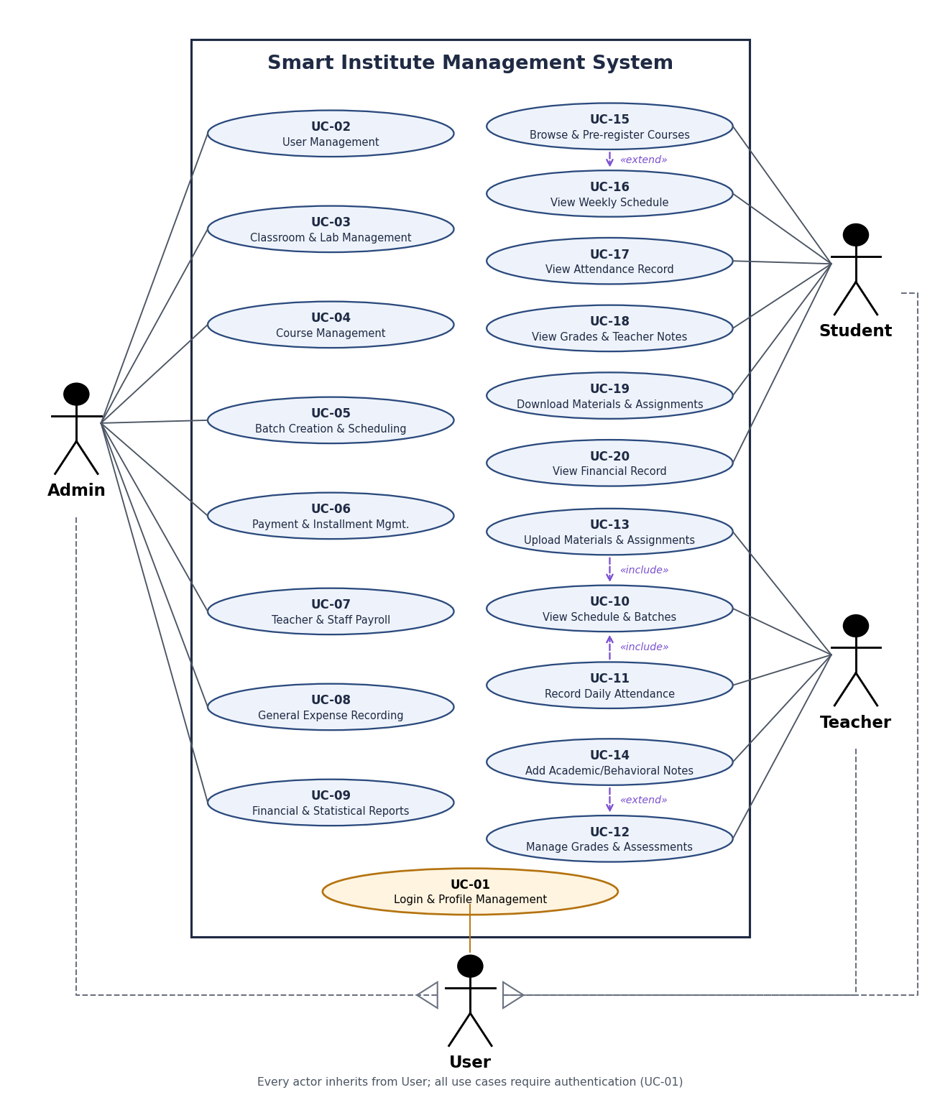
Figure 3.1 Use Case Diagram
Table 3.5 Use Case Priority Matrix
ID | Use case | Actor | Priority
UC-01 | Login and profile management | Admin / Teacher / Student | Very High
UC-02 | User management (students, teachers, staff) | Admin | Very High
UC-03 | Classroom and lab management | Admin | High
UC-04 | Course management (subject, price, hours) | Admin | High
UC-05 | Create batches and link teacher, classroom, and timing | Admin | High
UC-06 | Installment and payment management | Admin | High
UC-07 | Teacher and staff payroll | Admin | Medium
UC-08 | General expense recording | Admin | Medium
UC-09 | Financial and statistical reports | Admin | Medium
UC-10 | View schedule and assigned batches | Teacher | High
UC-11 | Record daily attendance | Teacher | High
UC-12 | Add and edit grades and assessments | Teacher | High
UC-13 | Upload materials and assignments | Teacher | Medium
UC-14 | Add academic or behavioral notes | Teacher | Low
UC-15 | Browse available courses and pre-register | Student | High
UC-16 | View weekly class schedule | Student | High
UC-17 | View attendance record | Student | High
UC-18 | View grades, results, and teacher notes | Student | High
UC-19 | Download materials and assignments | Student | Medium
UC-20 | View financial record (paid and remaining) | Student | Medium

3.7.2 Use Case Description
The high-priority use cases are described in detail. Table 3.6 and Table 3.7 show two representative descriptions, one financial and one academic.
Table 3.6 Use Case Description: UC-06 Payment and Installment Management
Field | Details
Use case | UC-06: Installment and payment management
Primary actor | Admin
Goal | Record student tuition payments safely and issue a receipt for each payment.
Preconditions | 1. Admin is logged in (UC-01). 2. The student has an active enrollment in a batch.
Postconditions | 1. The payment is saved with a unique receipt number. 2. The remaining balance of the enrollment is updated.
Main flow | 1. Admin opens the Payments page.  2. System lists payments and enrollments.  3. Admin selects an enrollment and enters the amount (and optionally a receipt number).  4. System validates that the enrollment is active and the amount does not exceed the remaining balance.  5. System generates a receipt number if none was entered (REC-yymmdd-XXXX).  6. System saves the payment and shows a success toast.  7. Admin opens the printable receipt.
Alternative flows | 4a. The enrollment is not active: the system rejects the payment and explains why.  4b. The amount exceeds the remaining balance: the system rejects the payment (on create and on edit).  5a. The receipt number already exists: the system asks for a different number.

Table 3.7 Use Case Description: UC-11 Record Daily Attendance
Field | Details
Use case | UC-11: Record daily attendance
Primary actor | Teacher
Goal | Record present, absent, or late status for every student in a batch on a chosen date.
Preconditions | 1. Teacher is logged in. 2. The batch is assigned to this teacher.
Postconditions | Attendance records are saved or updated for the selected date.
Main flow | 1. Teacher opens a batch from the schedule (UC-10).  2. Teacher selects the date (today or a past date).  3. System lists the active enrolled students.  4. Teacher marks each student as present, absent, or late.  5. Teacher submits; the system saves the records and shows a success toast.
Alternative flows | 2a. Attendance already exists for the date: the system loads it and updates it instead of creating a duplicate.  1a. The batch belongs to another teacher: the system denies access.

3.7.3 Activity Diagram
The activity diagrams below describe four important workflows: student course registration, payment recording, attendance recording, and payroll disbursement.
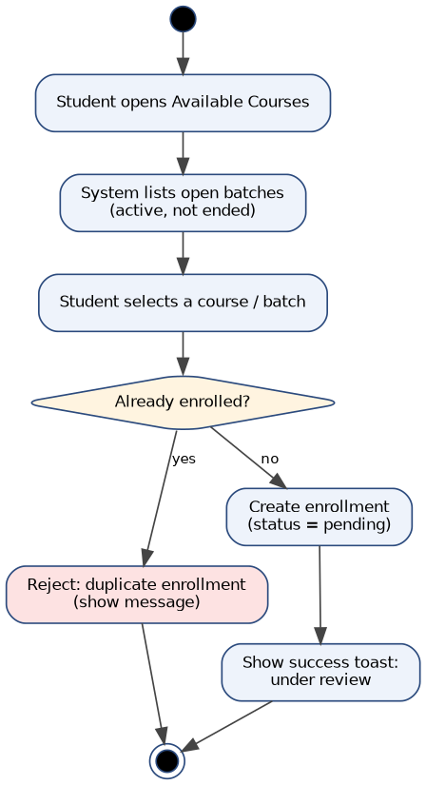
Figure 3.2 Activity Diagram: Course Registration
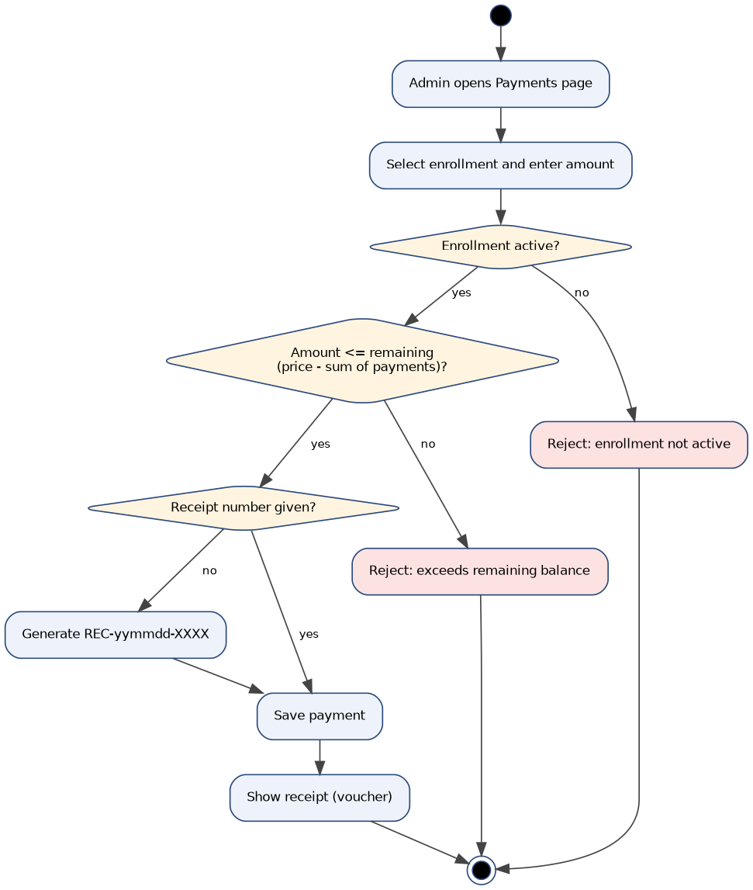
Figure 3.3 Activity Diagram: Payment Recording
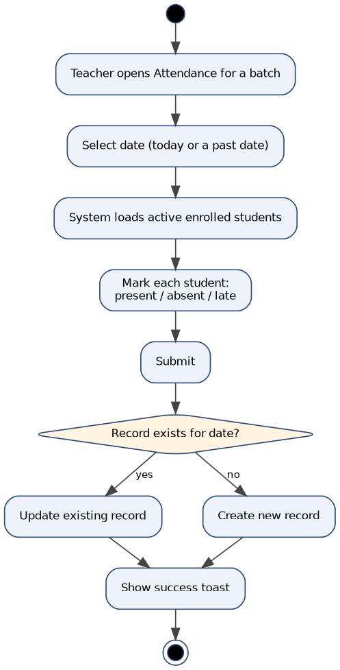
Figure 3.4 Activity Diagram: Attendance Recording
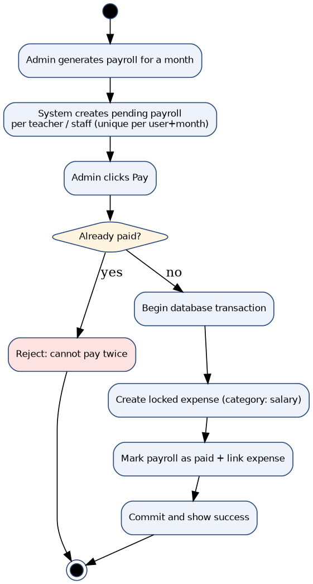
Figure 3.5 Activity Diagram: Payroll Disbursement

3.7.4 Sequence Diagram
The sequence diagrams show the interaction between the user, the Vue pages, the router and middleware, the controllers, and the database for three main scenarios.
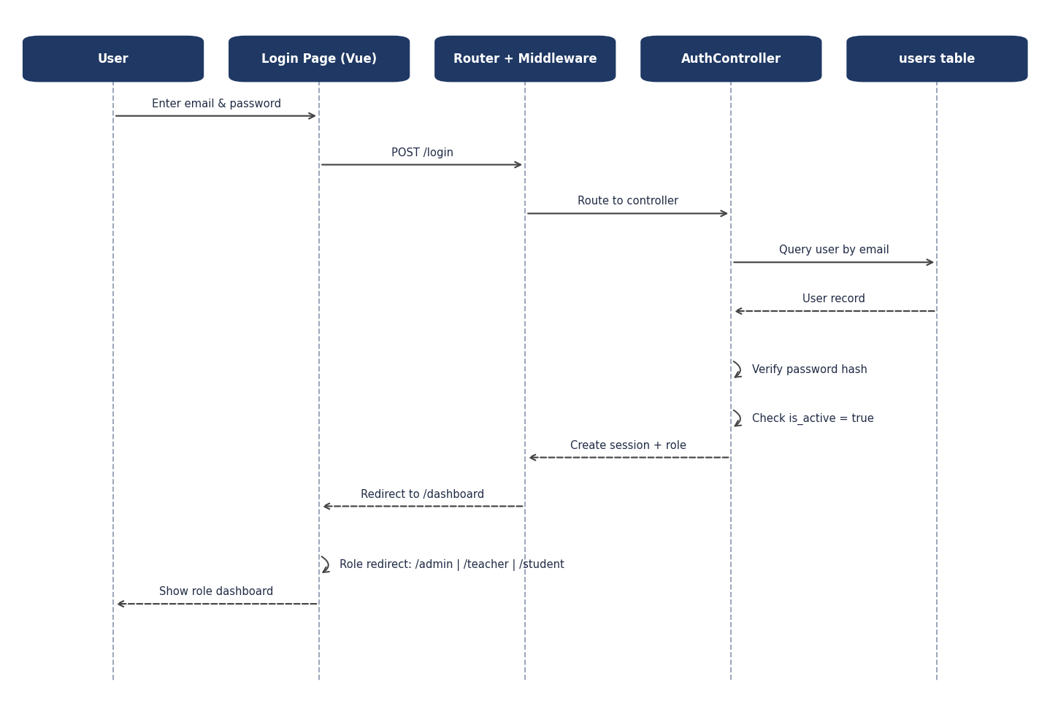
Figure 3.6 Sequence Diagram: User Authentication Process
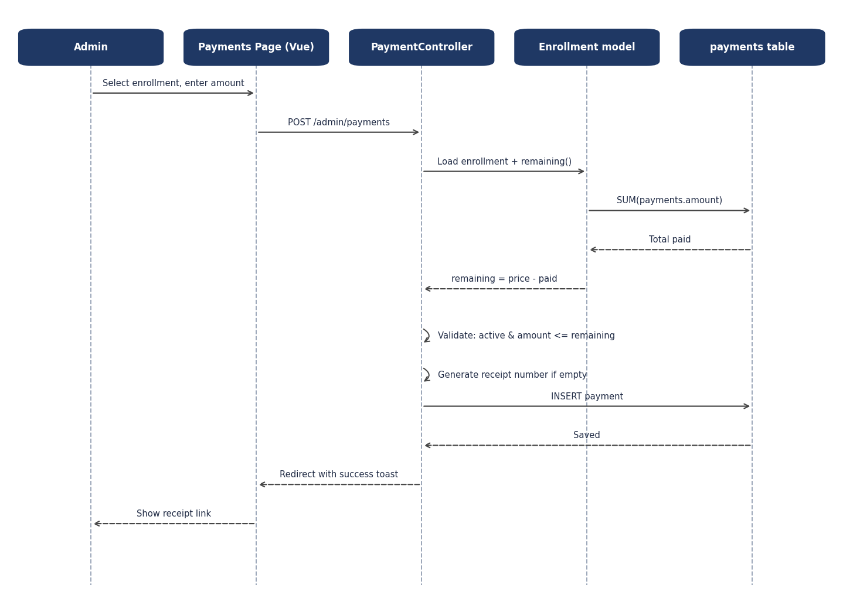
Figure 3.7 Sequence Diagram: Payment Recording Process
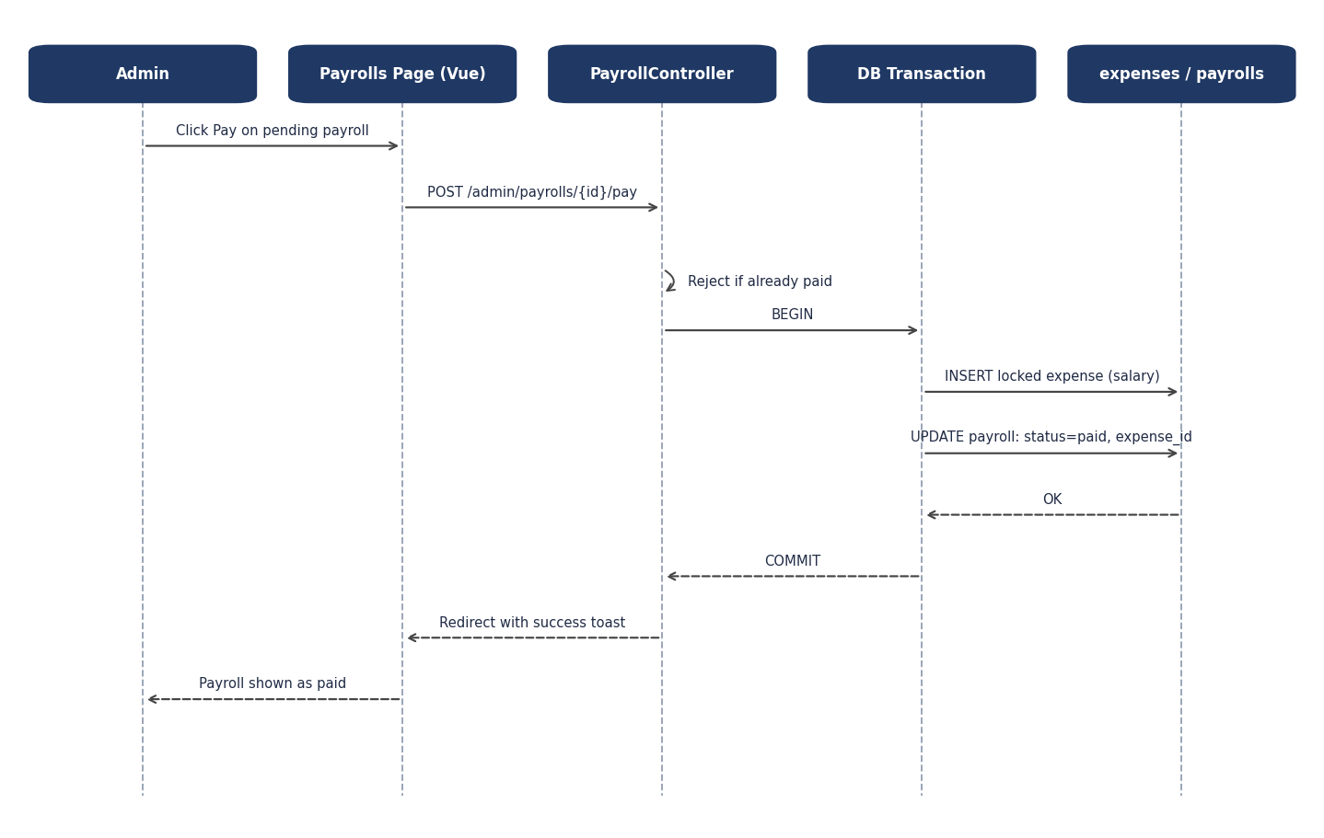
Figure 3.8 Sequence Diagram: Payroll Disbursement Process

3.8 Requirements Traceability Matrix
Table 3.8 maps each requirement to its use case and responsible module.
Table 3.8 Requirements Traceability Matrix
Requirement | Use case | Module (controller)
RE-01, RE-02 | UC-01 | Auth, Profile
RE-03 | UC-02 | Admin/UserController
RE-04 | UC-03 | Admin/ClassroomController
RE-05 | UC-04 | Admin/CourseController
RE-06, RE-07, RE-08 | UC-05 | Admin/BatchController, EnrollmentController
RE-09, RE-10 | UC-06 | Admin/PaymentController
RE-11 | UC-07 | Admin/PayrollController
RE-12 | UC-08 | Admin/ExpenseController
RE-13 | UC-09 | Admin/FinancialReportController
RE-14 to RE-18 | UC-10 to UC-14 | Teacher/*
RE-19 to RE-24 | UC-15 to UC-20 | Student/*
All routes | All | Router and EnsureRole

Chapter Four: Database Design and System Architecture

4.1 High-Level Design

4.1.1 System Block Diagram
Figure 4.1 shows the main layers of the system. Users access the system through a browser; the Inertia and Vue pages send requests to Laravel, where middleware checks the session, the account status, and the role before a controller executes the business logic through the Eloquent models. Data is stored in PostgreSQL, and teaching materials are stored on a private disk.
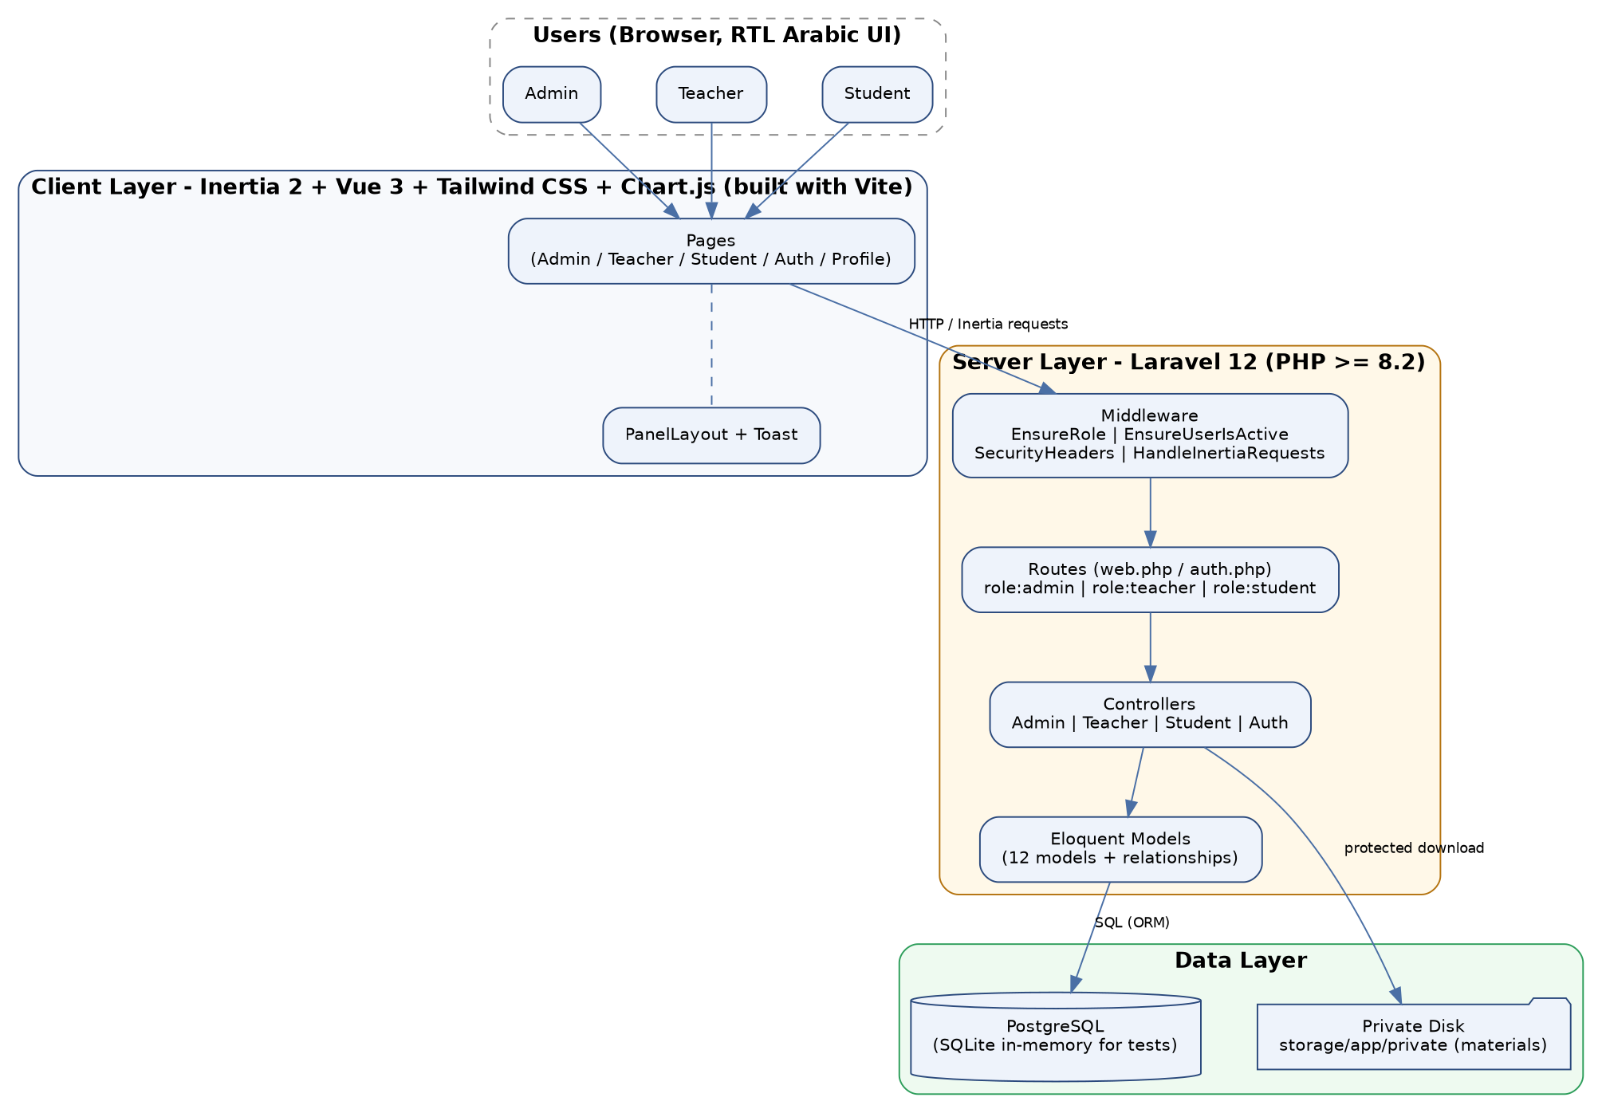
Figure 4.1 System Block Diagram

4.1.2 Adopted Architectural Pattern
The MVC (Model-View-Controller) pattern was adopted through Laravel, with Vue pages (rendered through Inertia) acting as the View. The pattern was selected for the following reasons:
- Separating application logic from the user interface.
- Facilitating maintenance and development.
- Improving code organization by role (Admin, Teacher, Student).
MVC Components:
- Model: Eloquent models (User, Batch, Course, Classroom, Enrollment, Payment, Payroll, Attendance, Grade, Material, StudentNote, Expense) that represent the data and relationships.
- View: Vue 3 pages under Pages/Admin, Pages/Teacher, Pages/Student, Pages/Auth, and Pages/Profile.
- Controller: controllers grouped by role that validate input, apply the business rules, and return Inertia responses.

4.1.3 Architectural Design Description
The system follows a Client-Server architecture, where:
- The user interacts with the frontend (the Vue pages in the browser).
- Requests are sent to the Laravel server through Inertia (no separate REST API layer is required).
- Middleware protects every route group with role:admin, role:teacher, or role:student.
This architecture allows separation of layers, support for future scalability, and the possibility of exposing the same business logic through an API for a mobile application later.

4.2 Database Design

4.2.1 Entity Relationship Model (ER Diagram)
The database design contains twelve main tables. The enrollments table is the single source of truth for student registration, and payrolls are linked to expenses so that every disbursed salary has a locked expense record.
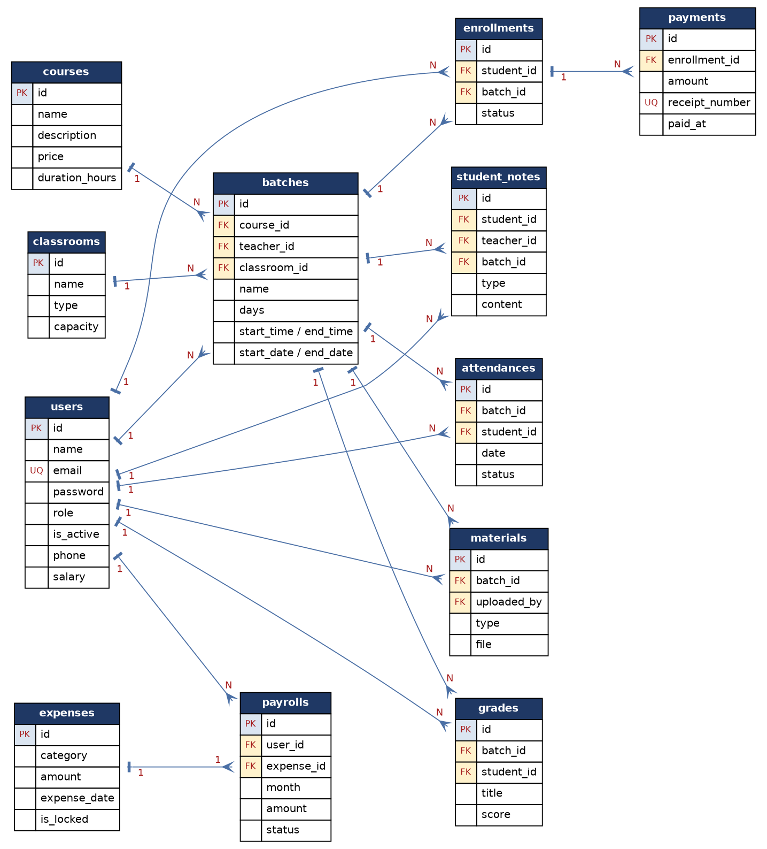
Figure 4.2 Entity Relationship Diagram (ER Diagram)

4.2.2 Relational Scheme
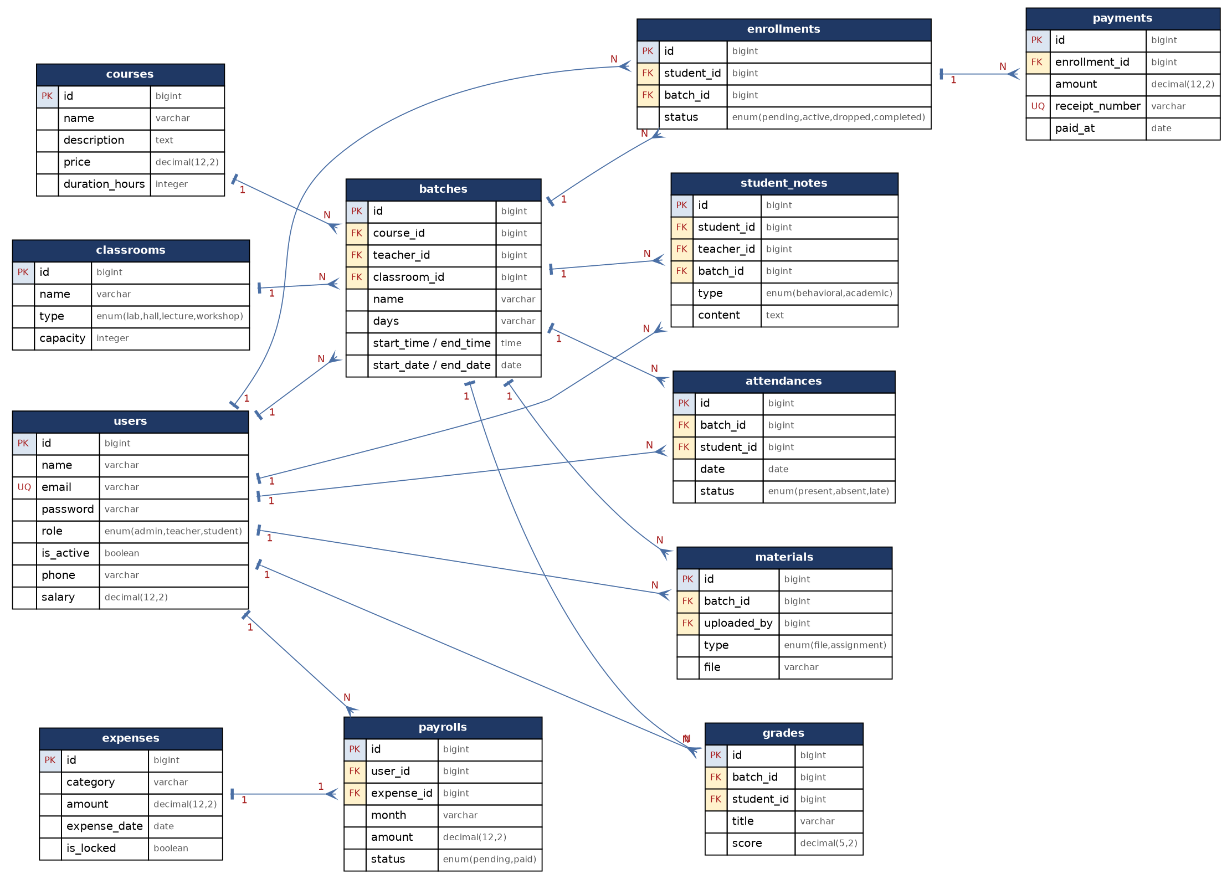
Figure 4.3 Relational Database Schema
Table 4.1 Database Tables and Their Purpose
Table | Purpose | Notes
users | Accounts of all roles | role (admin / teacher / student), is_active, phone, salary
courses | Courses | price decimal(12,2), duration_hours
classrooms | Halls and labs | type: lab / hall / lecture / workshop
batches | Groups | teacher, course, optional classroom, days, start / end time and period
enrollments | Student registration in a batch | Unique per student and batch; status pending / active / dropped / completed
payments | Student payments | Unique receipt number
payrolls | Salaries of staff (UC-07) | Unique per user and month; paid / pending; linked to expenses
expenses | General expenses | Category salary is created only by payroll and is locked
attendances | Attendance | present / absent / late per student, batch, and date
grades | Grades and assessments | Grade or assessment per student and batch
materials | Materials and assignments | File or assignment; files are stored on the private disk
student_notes | Teacher notes | behavioral or academic

4.2.3 Constraints
- Primary key for each table.
- Foreign keys:
  - enrollments to users and batches
  - payments to enrollments
  - payrolls to users and expenses
  - attendances, grades, materials, and student_notes to batches and users
- Unique constraints:
  - users.email
  - enrollments (student, batch)
  - payments.receipt_number
  - payrolls (user, month)
- Business constraints (defined at the controller and model level):
  - Remaining balance = course price minus the sum of payments
  - A payment is accepted only for an active enrollment and never above the remaining balance
  - A teacher or classroom cannot have two overlapping batches
  - Records that have dependants cannot be deleted

4.3 Route and Interface Design
The system relies on server-side routes protected by role middleware instead of a public REST API. The main route groups are:
Table 4.2 Route Groups
Group | Prefix | Protection | Main resources
Admin | /admin | role:admin | dashboard, report-financial, batches, classrooms, courses, users (and toggle), enrollments, payments (and receipt), expenses (and voucher), payrolls (generate, pay)
Teacher | /teacher | role:teacher | dashboard, attendance by batch, grades, materials, notes
Student | /student | role:student | dashboard, available-courses, register-course, materials download
Public | / | none | login, logout, forgot and reset password, role-based dashboard redirect, profile

Example routes:
- Login: POST /login (inputs: email and password; output: authenticated session and redirect by role).
- Record payment: POST /admin/payments (inputs: enrollment, amount, optional receipt number).
- Record attendance: POST /teacher/attendance/store (inputs: batch, date, and a status per student).
- Register in a course: POST /student/register-course (inputs: batch).
- Protected download: GET /student/materials/{material}/download.

4.4 Security and Authorization Design

4.4.1 Authentication Mechanism
- Using a session-based login system with the Laravel authentication layer.
- Storing passwords securely as hashed passwords.
- Logging out disabled accounts immediately through the EnsureUserIsActive middleware.
- No self-registration: accounts are created only from the Admin panel.

4.4.2 Authorization Management
Users are divided into three roles:
Table 4.3 User Roles and Permissions
Role | Permissions
Admin | Full system management: users, classrooms and labs, courses, groups, enrollments, payments, payroll, expenses, and reports. Cannot edit, disable, or delete self or the last active admin.
Teacher | Access only to own batches and the students enrolled in them: schedule, attendance, grades, materials, and own notes (edit and delete own notes only).
Student | Access only to own data: registration, schedule, attendance, grades, notes, financial record, and materials of active or completed enrollments.

4.4.3 System Protection
- Applying server-side input validation to every form.
- Preventing attacks such as SQL injection through the Eloquent ORM and parameter binding, and mass assignment by never passing the whole request to User::create.
- Sending security headers through the SecurityHeaders middleware.
- Storing materials on a private disk and serving them only through an authorized controller.
- Using HTTPS when the system is deployed, with debug mode disabled in the production environment.

4.5 Scalability and Future Development
The system was designed to support future scalability through:
- The possibility of adding Artificial Intelligence modules (UC-21 to UC-23) using the existing attendance and grade data.
- Supporting mobile applications by exposing the same controllers through an API.
- Integration with other systems such as online payment gateways and email or SMS services.
- Improving performance using caching and database indexes.
- Adding report export (PDF and CSV) and per-student absence reports.

Chapter Five: System Interfaces

5.1 Overview of the User Interfaces
This chapter presents the main interfaces of the system as implemented in phase one. The interfaces are built with Vue 3 pages rendered through Inertia and styled with Tailwind CSS. They use an Arabic right-to-left layout, and each role (Admin, Teacher, Student) gets its own portal with a side navigation menu that lists only the pages that role is allowed to open, as defined in the authorization design in Section 4.4.
The figures in this chapter are screenshots of the running system and display sample data entered for demonstration. The three portals are described below in the order of the roles: Admin, Teacher, and Student.

5.2 Admin Interface

5.2.1 Statistics Dashboard
Figure 5.1 shows the Admin dashboard, which is the first page displayed after the administrator logs in. It gives a general overview of the institute and supports the use cases of the Admin role (UC-02 to UC-09). The page contains the following parts:
- Summary cards: number of enrolled students, teachers, courses, active groups, and pending registration requests.
- Financial cards for the current month: revenues, expenses, net amount, and the installments still owed by students.
- Attendance and absence table: for each group, the course name, the number of attendance records, and the counts of absent and late students, with an absence percentage bar and the overall absence rate of the institute.
- Side navigation menu: user management, registration requests (with a badge showing the number of pending requests), courses, classrooms and labs, study groups, installments and payments, payroll, expenses, financial reports, and the account page.
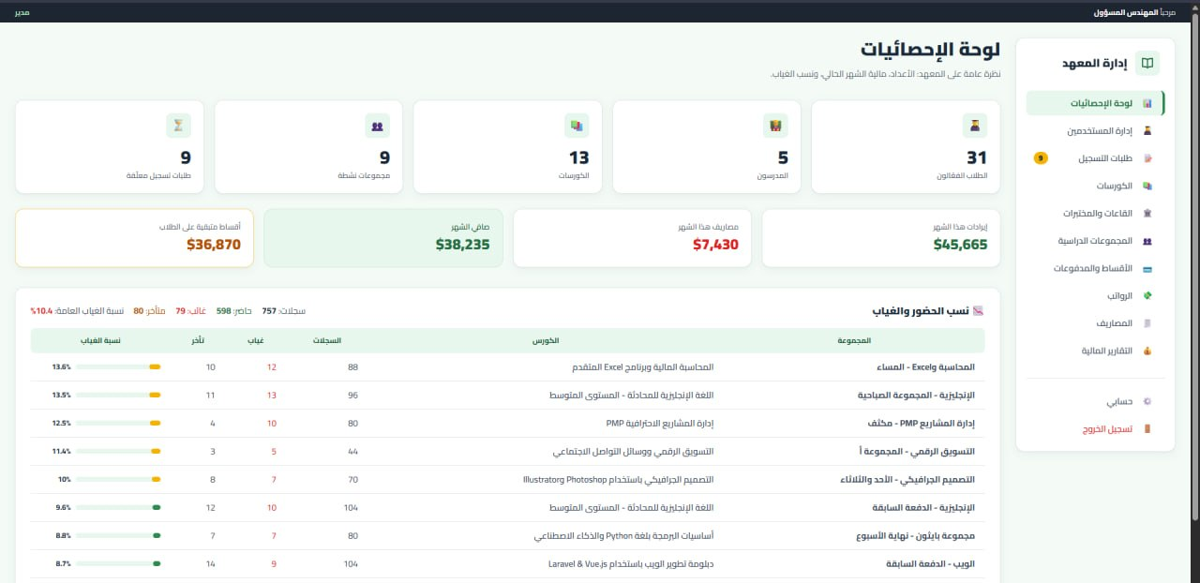
Figure 5.1 Admin Dashboard

5.3 Teacher Interface

5.3.1 Teacher Dashboard: Schedule and Groups
Figure 5.2 shows the Teacher portal, which supports the use cases of the Teacher role (UC-10 to UC-14). The page contains the following parts:
- Weekly lecture schedule: the lectures of the teacher distributed over the days of the week, where the current day is highlighted. Each lecture shows the group name, the time, and the classroom. Groups that have no assigned days are listed in a separate warning line so that the administration can complete them.
- Group cards: for each group, the status (active or finished), the number of students, the course, the days and time, the classroom, and the number of materials or assignments.
- Quick actions on each card: attendance, grades, materials, and notes.
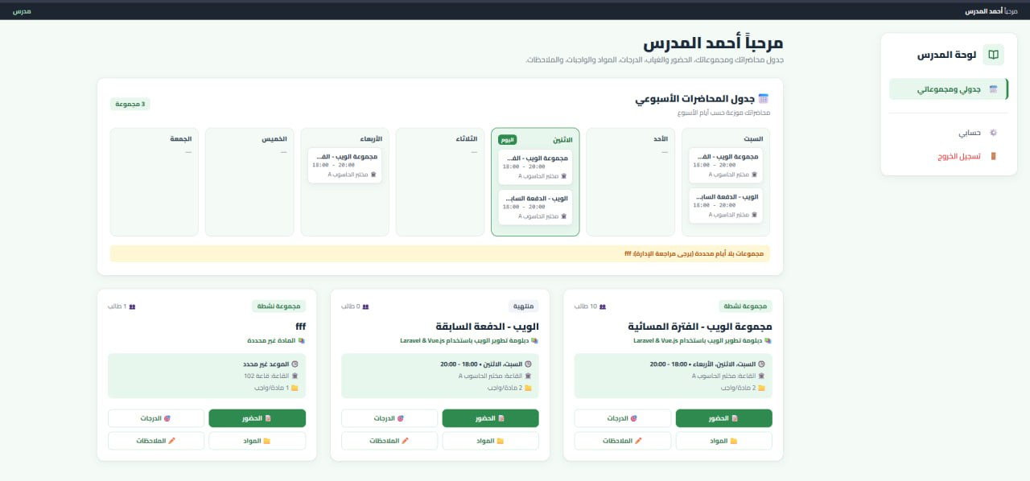
Figure 5.2 Teacher Dashboard

5.4 Student Interface

5.4.1 Student Home Page
Figure 5.3 shows the Student portal, which supports the use cases of the Student role (UC-15 to UC-20). The page contains the following parts:
- Summary cards: the attendance rate, the number of active courses, the number of registration requests under review, and the remaining amount of the installments.
- Today's lectures: the lectures of the current day with the course name, the group, the classroom, and the time.
- Side navigation menu: home, my courses, weekly schedule, attendance record, grades and notes, materials and assignments, financial record, course registration, and the account page.
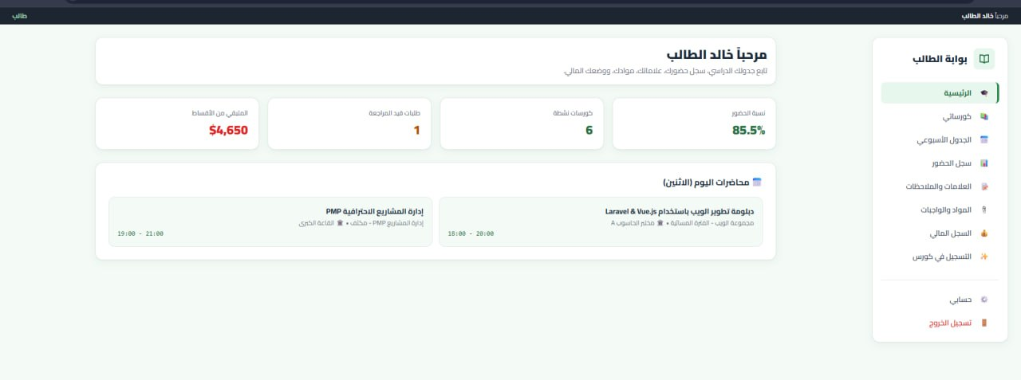
Figure 5.3 Student Home Page

References
- Laravel Documentation, Laravel 12.x. https://laravel.com/docs
- Vue.js Documentation, Vue 3. https://vuejs.org/guide
- Inertia.js Documentation, Version 2. https://inertiajs.com
- PostgreSQL Global Development Group, PostgreSQL Documentation. https://www.postgresql.org/docs
- Tailwind CSS Documentation. https://tailwindcss.com/docs
- Sommerville, I., Software Engineering, 10th ed., Pearson, 2016.
- Moodle Documentation. https://docs.moodle.org
- Fedena School Management Software. https://fedena.com

