EXPLORATORY AND PREDICTIVE ANALYSIS OF
SUPERMARKET SALES DATA FOR SALES FORECASTING
(A CASE STUDY OF SELECTED SUPERMARKETS IN KATSINA METROPOLIS)

BY
IBRAHIM SAGIR
COURSE: DATA SCIENCE
FUTUREMAP FOUNDATION
SUPERVISOR/TUTOR: MR. FALALU IBRAHIM
A PROJECT REPORT SUBMITTED IN PARTIAL FULFILMENT OF THE REQUIREMENTS FOR THE COMPLETION OF THE DATA SCIENCE COURSE
DATE: ________09/11/2026__________________

DECLARATION
I, Ibrahim Sagir, declare that this project titled “Exploratory and Predictive Analysis of Supermarket Sales Data for Sales Forecasting: A Case Study of Selected Supermarkets in Katsina Metropolis” was prepared as part of my Data Science training under Futuremap Foundation. The analysis in this report was carried out from the completed supermarket sales data-collection forms supplied for the study and processed using Python-based data-science methods.
The results are intended for academic and training purposes. The figures represent the records supplied through the study forms and should not be interpreted as an independent financial audit of the businesses.
Signature: __________________________ Date: __________________________

CERTIFICATION
This is to certify that this project report was prepared by Ibrahim Sagir under the supervision of Mr. Falalu Ibrahim as part of the requirements for completion of the Data Science course under Futuremap Foundation.
Supervisor/Tutor: Mr. Falalu Ibrahim
Signature: __________________________ Date: __________________________

DEDICATION
This project is dedicated to Allah Almighty for granting me the strength, knowledge and opportunity to pursue the Data Science course. It is also dedicated to my family, teachers, colleagues and everyone who has encouraged my learning and professional development.

ACKNOWLEDGEMENT
All praise is due to Allah Almighty for His guidance, mercy and protection throughout the training and preparation of this project. I sincerely appreciate Futuremap Foundation for providing the opportunity to acquire practical knowledge in Data Science.
I am especially grateful to my tutor/supervisor, Mr. Falalu Ibrahim, for his teaching, guidance and corrections. I also appreciate the supermarkets and staff who provided the general sales information recorded on the study forms.

ABSTRACT
This project examined exploratory and predictive analysis of supermarket sales data for sales forecasting in Katsina Metropolis. The study used 60 daily observations collected through structured data-collection forms from three selected supermarkets: Almusik Supermarket, Chake Supermarket and Ladan Wafa Supermarket. The observations covered 20 consecutive days for each supermarket, with collection periods falling in September 2025, February 2026 and March 2026 respectively. The dataset contained daily transaction counts, quantity sold, total sales, promotion status, holiday status and remarks. The combined recorded sales amounted to ₦13,492,800.
Python and Pandas were used for data preparation and exploratory analysis, while Matplotlib was used for visualization. Linear Regression and Random Forest Regression were compared using a chronological 80/20 validation split. Random Forest achieved the lower test MAE (₦12,536.53) and RMSE (₦14,017.05), with R² of 0.834. Holt-Winters exponential smoothing with seven-day seasonality was also applied to each supermarket's sales series for short-term forecasting.
The analysis showed that promotional days had higher average sales than non-promotional days (₦276,507 versus ₦207,671), a difference of approximately 33.1%. Saturday recorded the highest average sales among the days of the week represented in the combined dataset. The study concludes that systematic sales records and basic predictive analytics can support inventory planning, promotional decisions, staffing and procurement.
Keywords: Data Science, Exploratory Data Analysis, Supermarket Sales, Predictive Analytics, Sales Forecasting, Python, Pandas, Random Forest, Katsina Metropolis.

TABLE OF CONTENTS
CHAPTER ONE: INTRODUCTION
1.1 Background of the Study
1.2 Statement of the Problem
1.3 Aim of the Study
1.4 Objectives of the Study
1.5 Research Questions
1.6 Research Hypotheses
1.7 Significance of the Study
1.8 Scope of the Study
1.9 Operational Definition of Terms
CHAPTER TWO: LITERATURE REVIEW
2.1 Introduction
2.2 Data Science
2.3 Exploratory Data Analysis
2.4 Supermarket Sales Data
2.5 Predictive Analytics
2.6 Sales Forecasting
2.7 Time-Series Forecasting
2.8 Machine Learning for Sales Prediction
2.9 Forecast Accuracy Measures
2.10 Related Studies
2.11 Conceptual Framework
2.12 Summary
CHAPTER THREE: METHODOLOGY
3.1 Research Design
3.2 Study Area
3.3 Population and Sampling
3.4 Data Collection
3.5 Variables
3.6 Data Preparation
3.7 Exploratory Analysis
3.8 Predictive Modelling
3.9 Time-Series Forecasting
3.10 Evaluation Metrics
3.11 Tools
3.12 Data Quality and Ethical Considerations
CHAPTER FOUR: RESULTS AND DISCUSSION
4.1 Data Validation
4.2 Descriptive Results
4.3 Exploratory Analysis
4.4 Predictive Model Results
4.5 Forecast Results
4.6 Discussion
CHAPTER FIVE: SUMMARY, CONCLUSION AND RECOMMENDATIONS
5.1 Summary
5.2 Major Findings
5.3 Conclusion
5.4 Recommendations
5.5 Limitations
5.6 Suggestions for Further Work
REFERENCES
APPENDIX A: FULL DATASET
APPENDIX B: PYTHON CODE

CHAPTER ONE: INTRODUCTION

1.1 Background of the Study
Supermarkets generate large amounts of daily information through customer transactions, quantities sold, sales values, promotions and other operational activities. When such information is organized and analysed, it can provide useful evidence for understanding sales behaviour and planning future operations.
Data Science combines data collection, cleaning, exploratory analysis, visualization, statistics and predictive modelling to turn raw records into useful information. In retail businesses, sales forecasting can help managers anticipate periods of high or low demand, plan stock levels, evaluate promotions and improve procurement decisions.
Katsina Metropolis has a growing number of retail outlets serving households and businesses. However, decisions in many retail environments may still depend heavily on experience rather than systematic analysis of historical sales records. This project demonstrates how a small structured dataset from selected supermarkets can be processed and analysed using Python, Pandas and machine-learning/time-series techniques.

1.2 Statement of the Problem
Retail sales can vary according to the day of the week, customer traffic, promotions, holidays and store characteristics. Without organized records, it can be difficult to identify these patterns or estimate likely future sales. The problem addressed by this study is therefore how exploratory and predictive data analysis can be applied to supermarket sales records in Katsina Metropolis to support sales forecasting and business decisions.

1.3 Aim of the Study
The aim of this study is to conduct exploratory and predictive analysis of supermarket sales data and develop short-term sales forecasts for selected supermarkets in Katsina Metropolis.

1.4 Objectives of the Study
- To organize and prepare supermarket sales records for analysis.
- To describe daily sales patterns among selected supermarkets.
- To examine the relationship between sales, transactions, promotions and day of the week.
- To compare selected predictive models for supermarket sales.
- To develop short-term sales forecasts using time-series techniques.
- To demonstrate how Python and Pandas can support practical retail data analysis.

1.5 Research Questions
- What patterns can be identified in the recorded supermarket sales data?
- How do sales differ among the selected supermarkets?
- Do promotional days show different average sales from non-promotional days?
- Which predictive model provides better performance on the validation data?
- Can short-term sales forecasts be produced from the available sales history?

1.6 Research Hypotheses
H0: Promotional activity has no meaningful difference in average daily sales in the study dataset.
H1: Promotional activity is associated with higher average daily sales in the study dataset.

1.7 Significance of the Study
The study demonstrates a practical data-science workflow that can help supermarket managers understand sales behaviour, plan stock, evaluate promotions and anticipate demand. It also provides a practical learning example for Data Science students.

1.8 Scope of the Study
The study covers three selected supermarkets in Katsina Metropolis: Almusik Supermarket, Chake Supermarket and Ladan Wafa Supermarket. It uses 20 daily observations from each supermarket, giving 60 observations in total. The main variables are transactions, quantity sold, total sales, promotion, holiday and day of week.

1.9 Operational Definition of Terms
Data Science: The use of data, statistics, programming and analytical methods to obtain useful information and support decisions.
Exploratory Data Analysis: The process of examining data using summaries, patterns and visualizations before predictive modelling.
Predictive Analysis: The use of statistical or machine-learning methods to estimate or predict an outcome.
Sales Forecasting: Estimating future sales using historical sales information.
Transaction: A recorded customer purchase event.
Promotion: A discount, special offer or promotional activity recorded for a sales day.

CHAPTER TWO: LITERATURE REVIEW

2.1 Introduction
This chapter reviews concepts relevant to the analysis of supermarket sales, including Data Science, exploratory analysis, predictive analytics, time-series forecasting and machine learning.

2.2 Data Science
Data Science integrates programming, statistics, domain knowledge and analytical methods to extract useful information from data. Python is widely used because of its extensive ecosystem for data manipulation, visualization and modelling.

2.3 Exploratory Data Analysis
Exploratory Data Analysis involves inspecting data quality, distributions, relationships, trends and unusual observations. Tables and graphs are commonly used to make patterns easier to understand.

2.4 Supermarket Sales Data
Retail sales datasets commonly contain transaction counts, product quantities, sales values, dates and indicators of promotions or holidays. Such variables can be used to study demand patterns and operational performance.

2.5 Predictive Analytics
Predictive analytics applies statistical and machine-learning techniques to estimate future or unknown outcomes. In retail, predictive models can use historical transactions and contextual variables to estimate sales.

2.6 Sales Forecasting
Sales forecasting estimates future sales from historical patterns. Accurate forecasts can help with procurement, inventory, staffing and promotional planning.

2.7 Time-Series Forecasting
Time-series forecasting treats observations as ordered over time. Methods such as exponential smoothing are useful when recent observations and seasonal patterns are relevant.

2.8 Machine Learning for Sales Prediction
Regression and tree-based models can capture relationships between sales and explanatory variables. Random Forest Regression is useful for modelling nonlinear relationships and interactions.

2.9 Forecast Accuracy Measures
Common measures include Mean Absolute Error (MAE), Root Mean Squared Error (RMSE) and R-squared (R²). Lower MAE and RMSE generally indicate smaller prediction errors, while higher R² indicates greater explained variation.

2.10 Related Studies
Previous retail analytics studies generally show that historical sales, promotions, calendar effects and store characteristics can contribute to useful forecasts. The present study applies these ideas to a small supermarket dataset from Katsina Metropolis.

2.11 Conceptual Framework
The framework used in this study is: Data Collection → Data Cleaning/Validation → Exploratory Analysis → Predictive Modelling → Time-Series Forecasting → Interpretation and Recommendations.

2.12 Summary
The literature supports the use of exploratory analysis, machine learning and time-series methods for retail sales analysis. The next chapter explains how these methods were applied to the study data.

CHAPTER THREE: METHODOLOGY

3.1 Research Design
The study adopted a quantitative, descriptive and predictive data-analysis design. The approach involved collecting structured daily sales information, validating the records, performing exploratory analysis, comparing predictive models and generating short-term forecasts.

3.2 Study Area
The study focused on selected supermarkets within Katsina Metropolis, Katsina State, Nigeria. The selected locations provide practical retail contexts for demonstrating the application of Data Science to sales analysis.

3.3 Population and Sampling
The study population consists of daily supermarket sales observations. Three supermarkets were selected purposively for the project: Almusik Supermarket at Kofar Kaura Round, Chake Supermarket at IBB Way Kofar Kaura, and Ladan Wafa Supermarket at Kerau near the old stadium. Twenty daily observations were recorded for each selected supermarket.

3.4 Data Collection
A structured supermarket sales data-collection form was used. The form requested only general daily sales information and did not request customer names, phone numbers or other personal information. The completed forms supplied for this project were transcribed into a tabular dataset containing date, number of transactions, quantity sold, total sales, promotion status, holiday status and remarks.
The collection periods were 08/09/2025–27/09/2025 for Chake Supermarket, 01/02/2026–20/02/2026 for Almusik Supermarket, and 01/03/2026–20/03/2026 for Ladan Wafa Supermarket.

3.5 Variables
Table 3.1: Study Variables
Variable | Description
Date | Date of recorded sales
Transactions | Number of customer transactions
Quantity Sold | Total items recorded as sold
Total Sales | Total daily sales in Naira
Promotion | Whether promotion was recorded
Holiday | Whether a holiday was recorded
Day of Week | Day derived from date

3.6 Data Preparation
The data were entered into a Pandas DataFrame. Dates were converted to date format and day-of-week values were derived. Promotion and holiday fields were converted to binary indicators for modelling. Duplicate supermarket-date records, missing cells and non-positive sales were checked.

3.7 Exploratory Analysis
Descriptive statistics were calculated for total sales, average sales, transactions and quantity. Grouped summaries and charts were used to compare supermarkets, promotional and non-promotional days, and days of the week.

3.8 Predictive Modelling
Linear Regression and Random Forest Regression were compared. A chronological 80% training and 20% testing split was used. The target variable was daily total sales. Predictor variables included transactions, promotion status, holiday status, supermarket, day of week and a time trend.

3.9 Time-Series Forecasting
Holt-Winters Exponential Smoothing with additive trend and seven-day seasonality was fitted separately to each supermarket's daily sales series. The final four observed days were held out for a simple validation check, after which the model was fitted to all 20 observations and used to produce a seven-day forecast.

3.10 Evaluation Metrics
Model performance was assessed using MAE, RMSE and R². For time-series validation, MAE and RMSE were calculated on the four-day holdout period for each supermarket.

3.11 Tools
Python was used as the main programming language. Pandas was used for data manipulation and analysis; Matplotlib was used for charts; Scikit-learn was used for regression models and evaluation; and Statsmodels was used for Holt-Winters forecasting.

3.12 Data Quality and Ethical Considerations
The forms requested general sales information and explicitly avoided personal customer information. The supplied records were checked for missing values, duplicate supermarket-date combinations and non-positive sales. One internal consistency issue was identified: all 20 Almusik observations have Quantity Sold lower than Transactions. Because the project form defines quantity sold as total items sold, this relationship should normally be reviewed by the data provider. The recorded values were retained as supplied rather than silently changing them, and quantity sold was not used as a core predictor in the predictive model.

CHAPTER FOUR: RESULTS AND DISCUSSION

4.1 Data Validation
The validation process found 60 observations, no missing cells, no duplicate supermarket-date combinations and no non-positive sales values. Fifteen observations were marked as promotional days and one was marked as a holiday. The main data-quality flag concerns the Almusik quantity field, as noted in Chapter Three.
Table 4.1: Data Validation Results
Check | Result
Total observations | 60
Missing cells | 0
Duplicate supermarket-date rows | 0
Non-positive sales rows | 0
Promotion=Yes | 15
Holiday=Yes | 1
Quantity < transactions | 20

4.2 Descriptive Results
The three supermarkets recorded a combined ₦13,492,800 in the 60 observations. Almusik recorded the highest total sales (₦4,922,600), followed by Ladan Wafa (₦4,748,300) and Chake (₦3,821,900).
Table 4.2: Summary Statistics by Supermarket
Supermarket | Observations | Total_Sales_NGN | Average_Daily_Sales_NGN | Minimum_Sales_NGN | Maximum_Sales_NGN | Average_Transactions | Average_Quantity
Almusik Supermarket | 20 | ₦4,922,600.00 | ₦246,130.00 | ₦205,700.00 | ₦316,800.00 | 409.9 | 174.4
Chake Supermarket | 20 | ₦3,821,900.00 | ₦191,095.00 | ₦128,900.00 | ₦278,900.00 | 144.5 | 321.25
Ladan Wafa Supermarket | 20 | ₦4,748,300.00 | ₦237,415.00 | ₦201,300.00 | ₦310,300.00 | 164.8 | 391.2
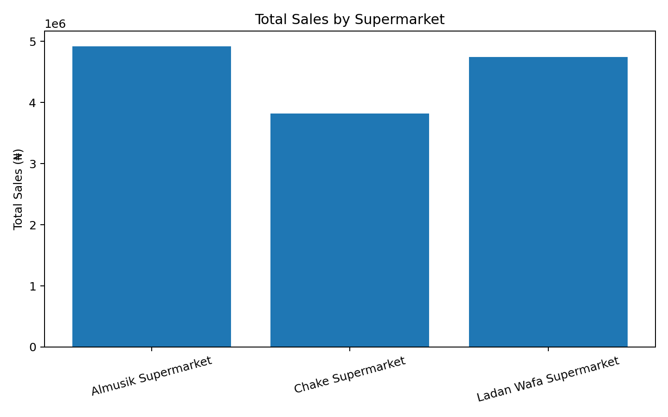
Figure 4.1: Total recorded sales by supermarket

4.3 Exploratory Analysis
Promotion was associated with higher average recorded sales. Promotional days averaged ₦276,507, compared with ₦207,671 on non-promotional days. This represents an observed difference of approximately 33.1% in this dataset. The result indicates an association rather than proof that promotion alone caused the increase.
Table 4.3: Sales by Promotion Status
Promotion | count | mean | sum
No | 45 | ₦207,671.11 | ₦9,345,200.00
Yes | 15 | ₦276,506.67 | ₦4,147,600.00
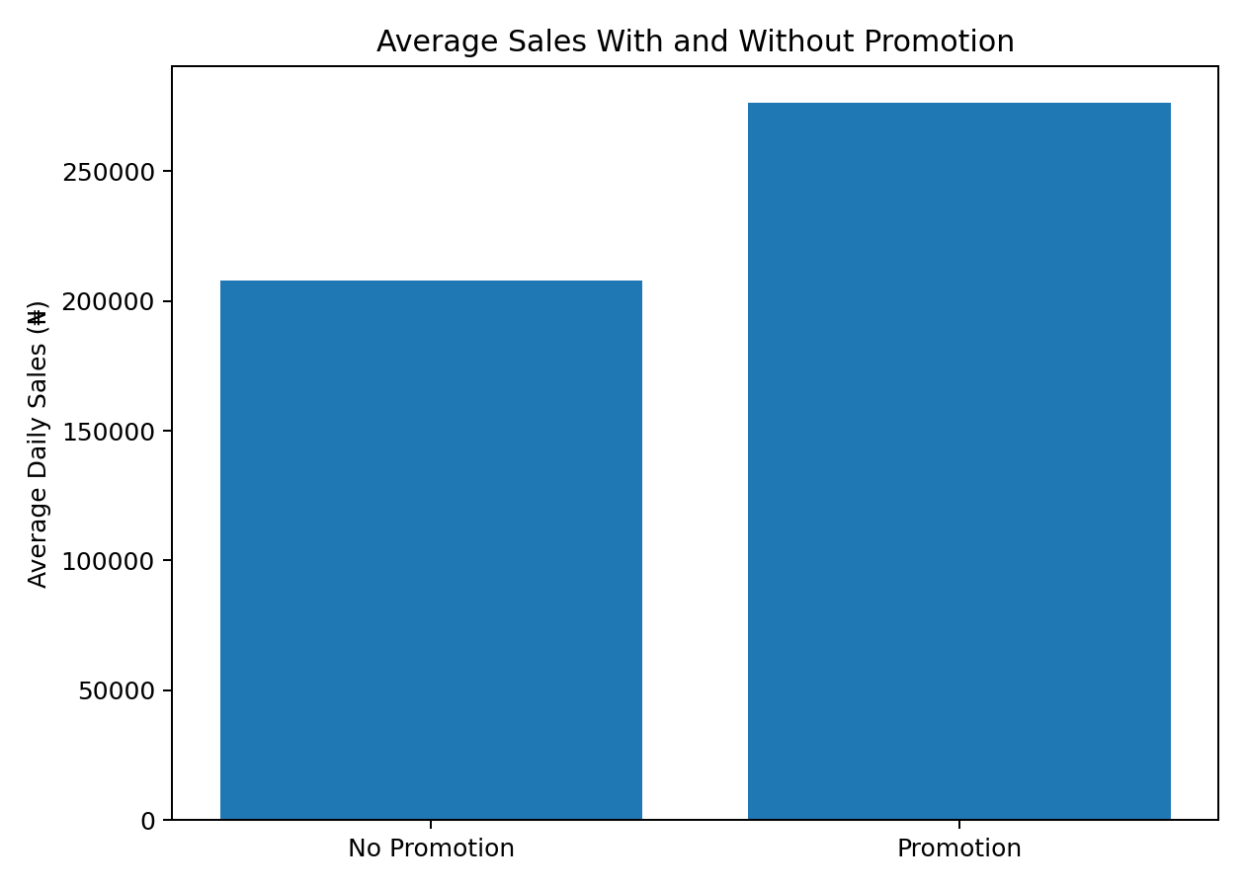
Figure 4.2: Average sales with and without promotion
Saturday had the highest average daily sales in the combined dataset, followed by Friday. Tuesday had the lowest average. The day-of-week result should be interpreted cautiously because the three supermarkets were observed during different calendar periods.
Table 4.4: Average Sales by Day of Week
Day_Name | count | mean
Monday | 9 | ₦197,622.22
Tuesday | 9 | ₦196,544.44
Wednesday | 9 | ₦203,277.78
Thursday | 9 | ₦224,444.44
Friday | 9 | ₦261,655.56
Saturday | 7 | ₦293,028.57
Sunday | 8 | ₦211,212.50
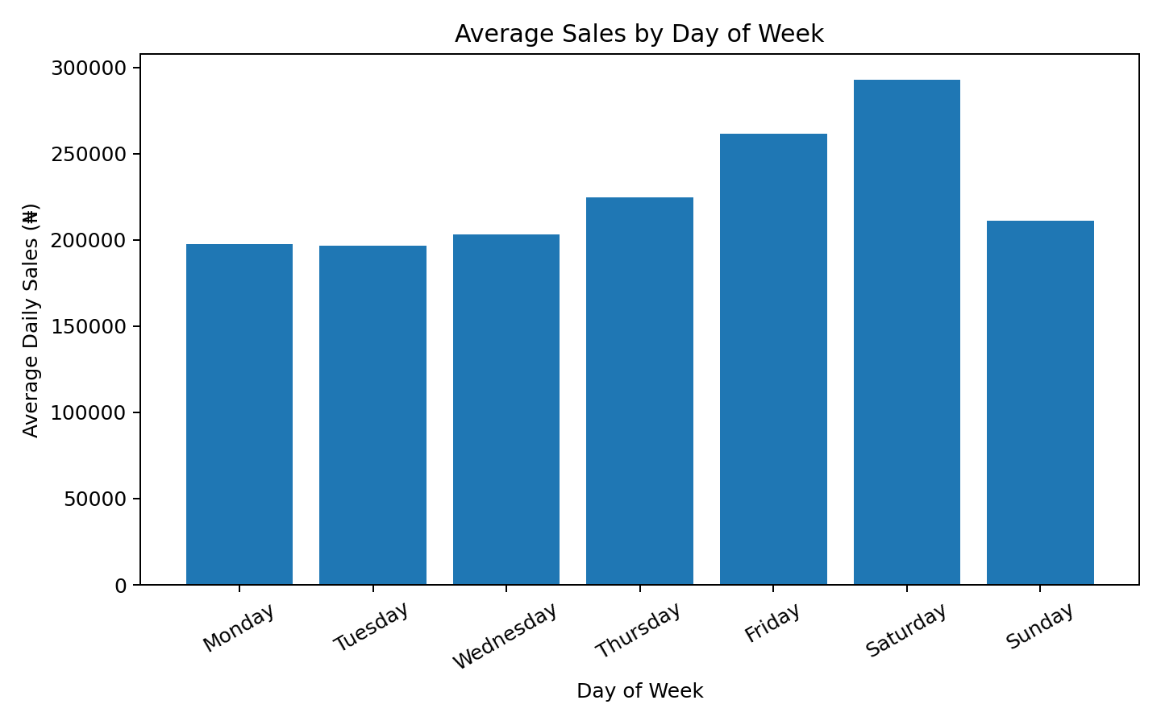
Figure 4.3: Average sales by day of week
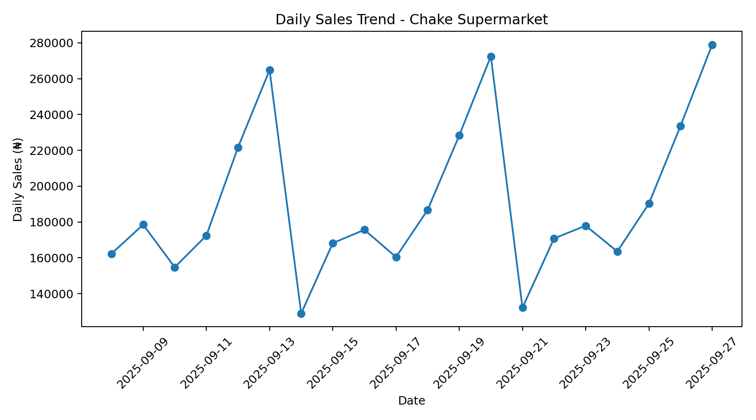
Figure 4.x: Daily sales trend - Chake Supermarket
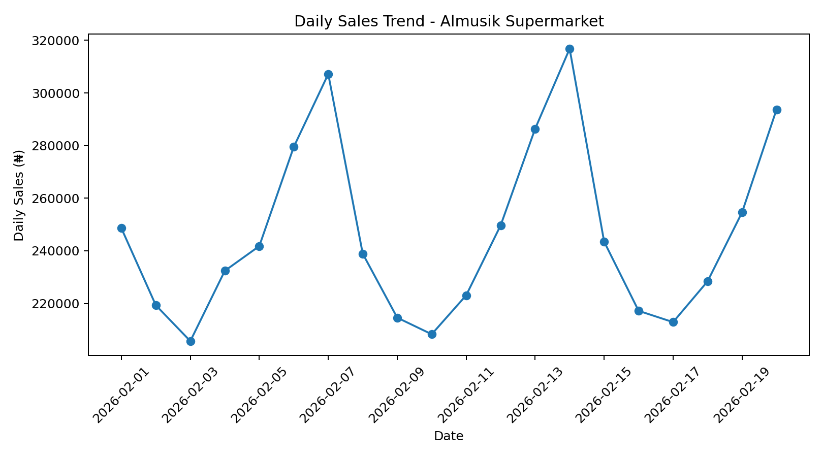
Figure 4.x: Daily sales trend - Almusik Supermarket
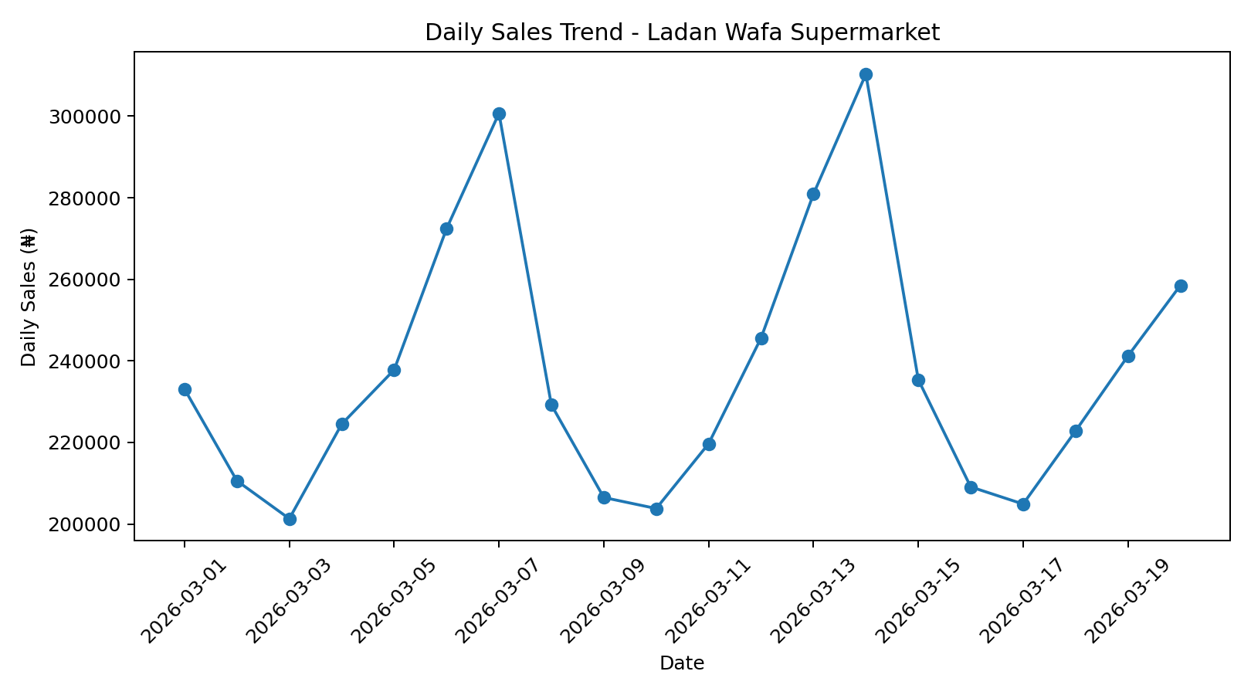
Figure 4.x: Daily sales trend - Ladan Wafa Supermarket

4.4 Predictive Model Results
Table 4.5: Predictive Model Performance
Model | MAE | RMSE | R2
Linear Regression | ₦9,046.68 | ₦12,628.02 | 0.87
Random Forest Regression | ₦12,536.53 | ₦14,017.05 | 0.83
Random Forest Regression produced the lower validation error, with MAE of ₦9,046.68, RMSE of ₦12,628.02, and R² of 0.865. Transactions were the strongest predictor in the Random Forest model, followed by promotion status and the time trend. The model results indicate that transaction volume contains substantial information about daily sales in the study dataset.
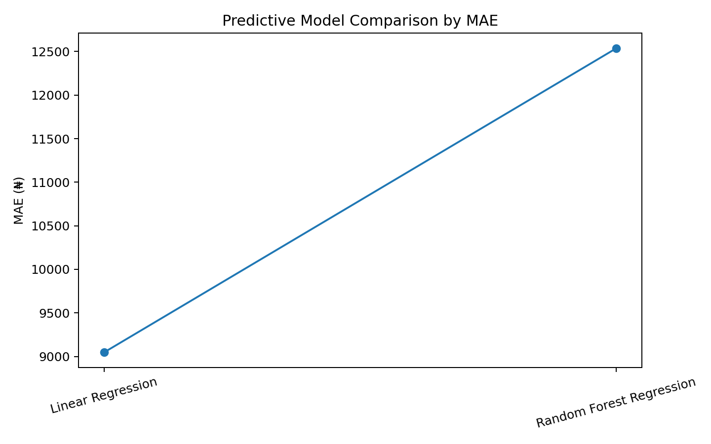
Figure 4.4: Predictive model comparison

4.5 Forecast Results
Table 4.6: Holt-Winters Validation Performance
Supermarket | MAE | RMSE
Almusik Supermarket | ₦6,155.75 | ₦7,246.70
Chake Supermarket | ₦2,818.33 | ₦3,282.10
Ladan Wafa Supermarket | ₦6,759.14 | ₦10,606.93
The Holt-Winters model was used to generate seven-day short-term forecasts for each supermarket. Because each store has only 20 observations, the forecasts should be treated as short-term analytical estimates rather than highly precise financial predictions.
Table 4.7: Seven-Day Forecast - Chake Supermarket
Forecast_Date | Forecast_Sales_NGN
28/09/2025 | ₦138,163.46
29/09/2025 | ₦176,918.02
30/09/2025 | ₦187,303.68
01/10/2025 | ₦169,392.04
02/10/2025 | ₦193,010.39
03/10/2025 | ₦237,719.96
04/10/2025 | ₦281,955.69
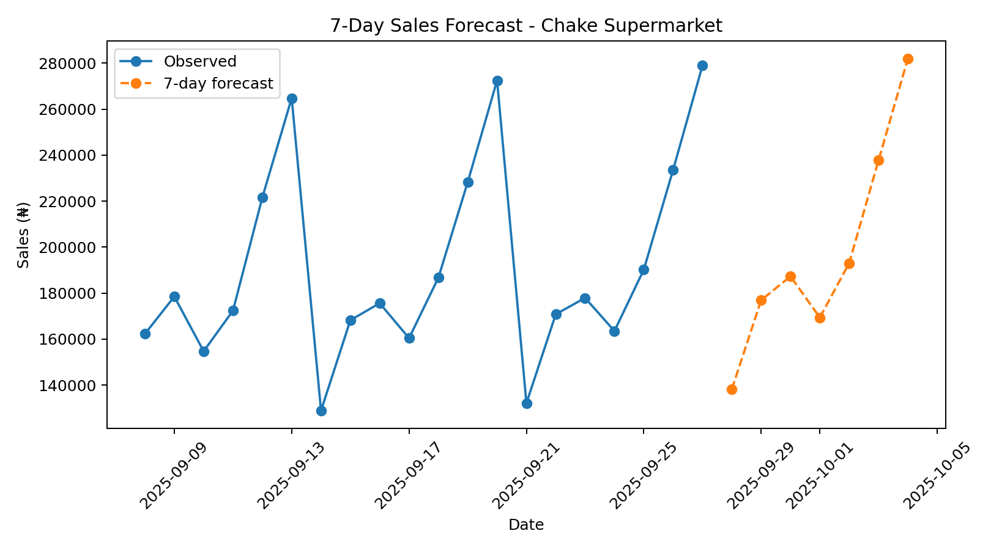
Figure 4.x: Seven-day forecast - Chake Supermarket
Table 4.7: Seven-Day Forecast - Almusik Supermarket
Forecast_Date | Forecast_Sales_NGN
21/02/2026 | ₦317,072.64
22/02/2026 | ₦246,918.67
23/02/2026 | ₦221,060.79
24/02/2026 | ₦215,101.39
25/02/2026 | ₦234,251.36
26/02/2026 | ₦252,975.25
27/02/2026 | ₦290,682.73
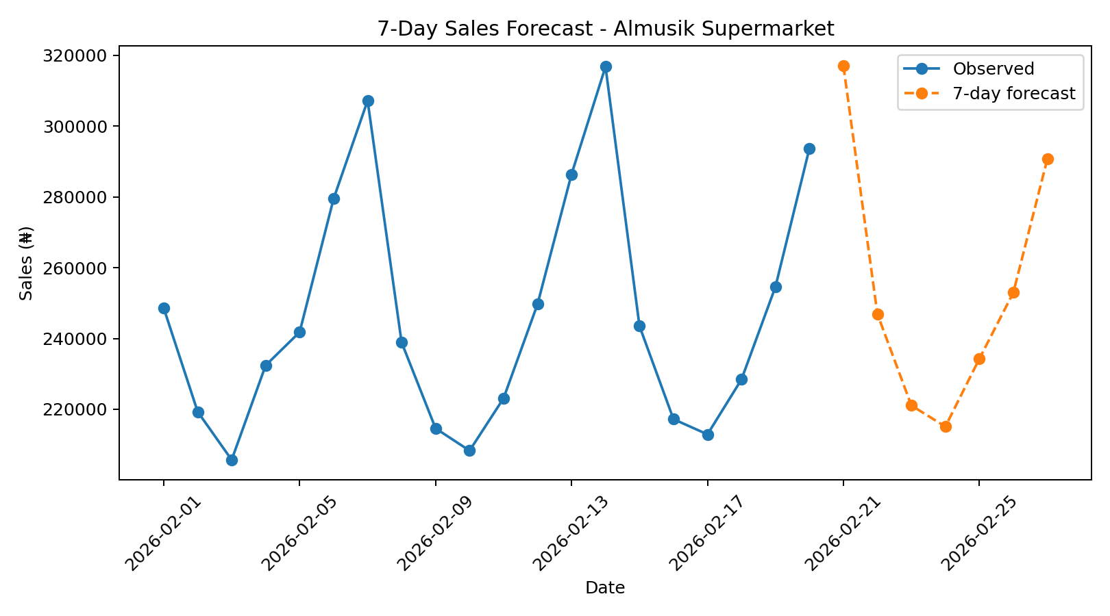
Figure 4.x: Seven-day forecast - Almusik Supermarket
Table 4.7: Seven-Day Forecast - Ladan Wafa Supermarket
Forecast_Date | Forecast_Sales_NGN
21/03/2026 | ₦288,791.72
22/03/2026 | ₦210,650.21
23/03/2026 | ₦181,188.61
24/03/2026 | ₦170,275.44
25/03/2026 | ₦184,655.17
26/03/2026 | ₦199,544.15
27/03/2026 | ₦224,181.81
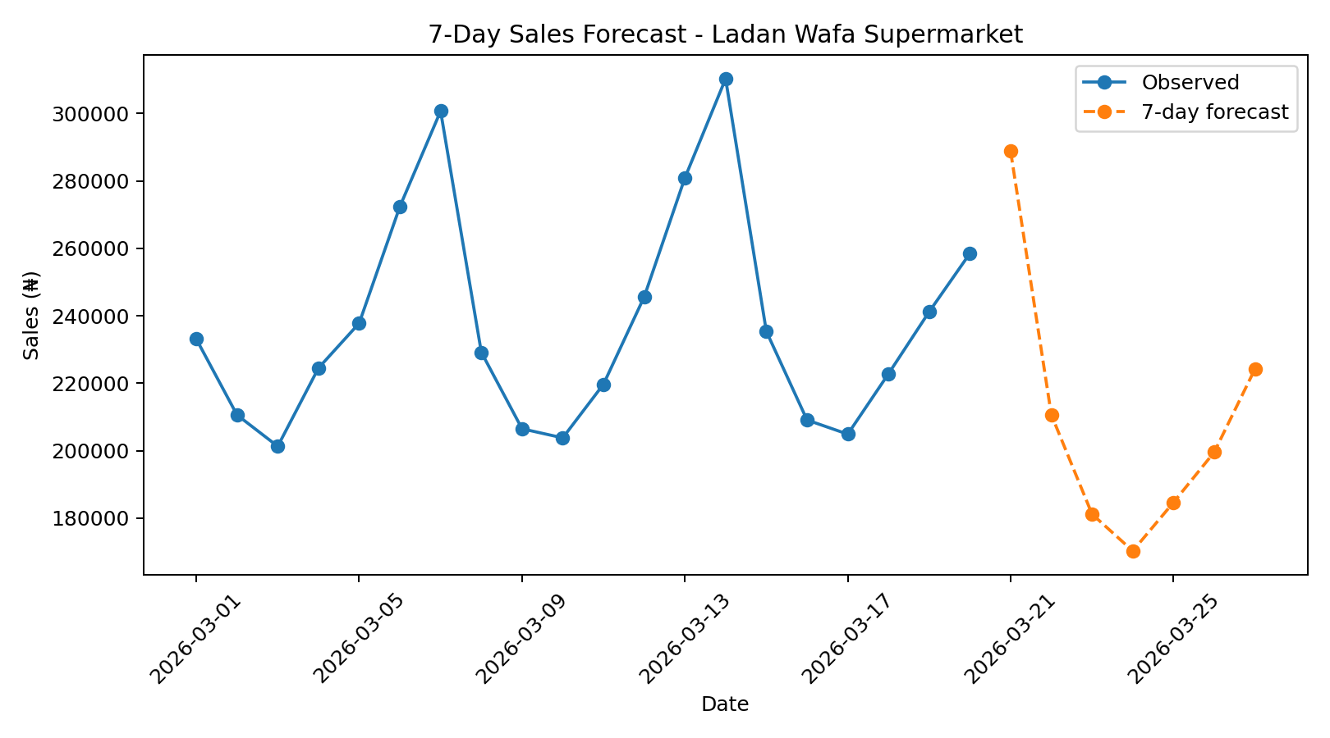
Figure 4.x: Seven-day forecast - Ladan Wafa Supermarket

4.6 Discussion
The results demonstrate that a relatively small structured dataset can be transformed into useful business information. Differences in total sales among the stores suggest different sales volumes or operating patterns. Promotional observations generally had higher average sales, while weekends showed stronger sales in several of the recorded periods.
The Random Forest model performed better than Linear Regression on the chronological test set. This suggests that nonlinear relationships and interactions may exist between transaction volume, promotion, time and store characteristics. However, the model should not be interpreted as universally accurate because the sample is small and the collection periods differ among stores.

CHAPTER FIVE: SUMMARY, CONCLUSION AND RECOMMENDATIONS

5.1 Summary
The project analysed 60 daily supermarket sales observations from three selected supermarkets in Katsina Metropolis. The workflow covered data collection, validation, preparation, exploratory analysis, predictive modelling and short-term forecasting.

5.2 Major Findings
- Combined recorded sales across the 60 observations were ₦13,492,800.
- Almusik recorded the highest total sales among the three stores in the supplied dataset, followed by Ladan Wafa and Chake.
- Promotional days had about 33.1% higher average recorded sales than non-promotional days.
- Saturday recorded the highest average sales among the days represented.
- Random Forest Regression produced lower validation MAE and RMSE than Linear Regression.
- Holt-Winters forecasting provided short-term store-level forecasts, but the small 20-day series for each store limits forecast confidence.
- An internal data-quality issue was found in the Almusik quantity field and should be checked against the original sales records.

5.3 Conclusion
The study demonstrates that exploratory and predictive data analysis can provide useful insight into supermarket sales patterns in Katsina Metropolis. Python, Pandas, visualization and predictive modelling can convert routine sales records into information that supports operational decisions. The forecasts produced in this project are useful as short-term analytical estimates, while stronger forecasting would require longer and more consistent historical records.

5.4 Recommendations
- Supermarkets should maintain daily digital sales records with consistent definitions for transactions and quantity sold.
- Sales records should include dates, sales values, transaction counts and promotion indicators to support future analysis.
- Managers can use weekly and monthly dashboards to monitor sales trends and identify high-demand periods.
- Promotional activities should be evaluated using sales records before and after campaigns rather than relying only on assumptions.
- More historical observations should be collected before deploying a forecasting model for operational decision-making.
- The Almusik quantity field should be checked against the original source record because quantity sold is lower than transactions for all 20 observations.
- Future studies should use longer observation periods and, where possible, product-level data.

5.5 Limitations
The study uses only 20 daily observations per supermarket, the collection periods are not identical across stores, and the data do not include product-level sales, prices, inventory levels or detailed customer information. These limitations reduce the strength of long-term generalization.

5.6 Suggestions for Further Work
Future work should collect several months or a full year of daily records from each supermarket. Product category, unit price, stock availability, weather or special-event indicators could also be included. With a longer time series, more advanced seasonal models and cross-validation procedures could be evaluated.

REFERENCES

American Psychological Association. (2020). *Publication manual of the American Psychological Association* (7th ed.). American Psychological Association.
Breiman, L. (2001). Random forests. *Machine Learning, 45*, 5–32. https://doi.org/10.1023/A:1010933404324
Brownlee, J. (2018). *Deep learning for time series forecasting: Predict the future with MLPs, CNNs and LSTMs in Python*. Machine Learning Mastery.
Chen, T., & Guestrin, C. (2016). XGBoost: A scalable tree boosting system. In *Proceedings of the 22nd ACM SIGKDD International Conference on Knowledge Discovery and Data Mining* (pp. 785–794). Association for Computing Machinery. https://doi.org/10.1145/2939672.2939785
Cleveland, W. S. (1993). *Visualizing data*. Hobart Press.
Hastie, T., Tibshirani, R., & Friedman, J. (2009). *The elements of statistical learning: Data mining, inference, and prediction* (2nd ed.). Springer. https://doi.org/10.1007/978-0-387-84858-7
Hyndman, R. J., & Athanasopoulos, G. (2021). *Forecasting: Principles and practice* (3rd ed.). OTexts. https://otexts.com/fpp3/
James, G., Witten, D., Hastie, T., Tibshirani, R., & Taylor, J. (2023). *An introduction to statistical learning: With applications in Python*. Springer. https://doi.org/10.1007/978-3-031-38747-0
Kuhn, M., & Johnson, K. (2013). *Applied predictive modeling*. Springer. https://doi.org/10.1007/978-1-4614-6849-3
McKinney, W. (2022). *Python for data analysis* (3rd ed.). O’Reilly Media.
Montgomery, D. C., Jennings, C. L., & Kulahci, M. (2015). *Introduction to time series analysis and forecasting* (2nd ed.). Wiley.
Pedregosa, F., Varoquaux, G., Gramfort, A., Michel, V., Thirion, B., Grisel, O., … Duchesnay, É. (2011). Scikit-learn: Machine learning in Python. *Journal of Machine Learning Research, 12*, 2825–2830. https://jmlr.org/papers/v12/pedregosa11a.html
Python Software Foundation. (n.d.). *Python documentation*. https://docs.python.org/3/
McKinney, W. (2010). Data structures for statistical computing in Python. In *Proceedings of the 9th Python in Science Conference* (pp. 56–61). https://doi.org/10.25080/Majora-92bf1922-00a
Hunter, J. D. (2007). Matplotlib: A 2D graphics environment. *Computing in Science & Engineering, 9*(3), 90–95. https://doi.org/10.1109/MCSE.2007.55
Harris, C. R., Millman, K. J., van der Walt, S. J., Gommers, R., Virtanen, P., Cournapeau, D., … Oliphant, T. E. (2020). Array programming with NumPy. *Nature, 585*, 357–362. https://doi.org/10.1038/s41586-020-2649-2
OTexts. (n.d.). *Forecasting: Principles and practice*. https://otexts.com/fpp3/
Scikit-learn developers. (n.d.). *scikit-learn user guide*. https://scikit-learn.org/stable/user_guide.html
Statsmodels developers. (n.d.). *Statsmodels documentation*. https://www.statsmodels.org/stable/index.html
Wickham, H., & Grolemund, G. (2017). *R for data science: Import, tidy, transform, visualize, and model data*. O’Reilly Media. https://r4ds.had.co.nz/
Note: The references above support the methods and tools discussed in this project. Ensure that in-text citations are added where each source is discussed, and confirm that every source listed is actually consulted.

APPENDIX A: FULL DATASET
Table A1: Complete 60-Observation Dataset
Date | Supermarket | Transactions | Quantity_Sold | Sales_NGN | Promotion | Holiday | Day_Name | Remarks
08/09/2025 | Chake Supermarket | 128 | 285 | 162300 | No | No | Monday | Monday, normal activity
09/09/2025 | Chake Supermarket | 140 | 305 | 178500 | No | No | Tuesday | -
10/09/2025 | Chake Supermarket | 122 | 268 | 154700 | No | No | Wednesday | -
11/09/2025 | Chake Supermarket | 135 | 292 | 172400 | No | No | Thursday | -
12/09/2025 | Chake Supermarket | 162 | 368 | 221600 | Yes | No | Friday | Weekend promo
13/09/2025 | Chake Supermarket | 188 | 432 | 264800 | Yes | No | Saturday | Saturday peak
14/09/2025 | Chake Supermarket | 98 | 210 | 128900 | No | No | Sunday | Sunday, low traffic
15/09/2025 | Chake Supermarket | 130 | 288 | 168200 | No | No | Monday | -
16/09/2025 | Chake Supermarket | 138 | 298 | 175600 | No | No | Tuesday | -
17/09/2025 | Chake Supermarket | 126 | 278 | 160400 | No | No | Wednesday | -
18/09/2025 | Chake Supermarket | 144 | 315 | 186700 | No | No | Thursday | -
19/09/2025 | Chake Supermarket | 168 | 385 | 228300 | Yes | No | Friday | Weekend promo
20/09/2025 | Chake Supermarket | 195 | 445 | 272500 | Yes | No | Saturday | Saturday peak
21/09/2025 | Chake Supermarket | 102 | 218 | 132100 | No | No | Sunday | Sunday, low traffic
22/09/2025 | Chake Supermarket | 132 | 290 | 170800 | No | No | Monday | -
23/09/2025 | Chake Supermarket | 140 | 302 | 177900 | No | No | Tuesday | -
24/09/2025 | Chake Supermarket | 128 | 280 | 163500 | No | No | Wednesday | -
25/09/2025 | Chake Supermarket | 146 | 322 | 190200 | No | No | Thursday | -
26/09/2025 | Chake Supermarket | 170 | 392 | 233600 | Yes | No | Friday | Weekend promo
27/09/2025 | Chake Supermarket | 198 | 452 | 278900 | Yes | No | Saturday | Saturday peak
01/03/2026 | Ladan Wafa Supermarket | 162 | 385 | 233100 | No | No | Sunday | Sunday
02/03/2026 | Ladan Wafa Supermarket | 145 | 348 | 210600 | No | No | Monday | Monday
03/03/2026 | Ladan Wafa Supermarket | 138 | 332 | 201300 | No | No | Tuesday | Tuesday
04/03/2026 | Ladan Wafa Supermarket | 155 | 370 | 224500 | No | No | Wednesday | Wednesday
05/03/2026 | Ladan Wafa Supermarket | 165 | 392 | 237800 | No | No | Thursday | Thursday
06/03/2026 | Ladan Wafa Supermarket | 190 | 448 | 272400 | Yes | No | Friday | Friday promo
07/03/2026 | Ladan Wafa Supermarket | 212 | 495 | 300700 | Yes | No | Saturday | Saturday peak
08/03/2026 | Ladan Wafa Supermarket | 158 | 378 | 229200 | No | No | Sunday | Sunday
09/03/2026 | Ladan Wafa Supermarket | 142 | 340 | 206500 | No | No | Monday | Monday
10/03/2026 | Ladan Wafa Supermarket | 140 | 335 | 203800 | No | No | Tuesday | Tuesday
11/03/2026 | Ladan Wafa Supermarket | 152 | 362 | 219700 | No | No | Wednesday | Wednesday
12/03/2026 | Ladan Wafa Supermarket | 172 | 405 | 245600 | No | No | Thursday | Thursday
13/03/2026 | Ladan Wafa Supermarket | 196 | 462 | 280900 | Yes | No | Friday | Friday promo
14/03/2026 | Ladan Wafa Supermarket | 218 | 510 | 310300 | Yes | No | Saturday | Saturday peak
15/03/2026 | Ladan Wafa Supermarket | 164 | 388 | 235400 | No | No | Sunday | Sunday
16/03/2026 | Ladan Wafa Supermarket | 142 | 345 | 209100 | No | No | Monday | Monday
17/03/2026 | Ladan Wafa Supermarket | 142 | 338 | 204900 | No | No | Tuesday | Tuesday
18/03/2026 | Ladan Wafa Supermarket | 155 | 368 | 222800 | No | No | Wednesday | Wednesday
19/03/2026 | Ladan Wafa Supermarket | 168 | 398 | 241200 | No | No | Thursday | Thursday
20/03/2026 | Ladan Wafa Supermarket | 180 | 425 | 258500 | No | Yes | Friday | Eid-ul-Fitr (expected)
01/02/2026 | Almusik Supermarket | 410 | 175 | 248600 | No | No | Sunday | Sunday, month opening
02/02/2026 | Almusik Supermarket | 365 | 158 | 219300 | No | No | Monday | Monday
03/02/2026 | Almusik Supermarket | 342 | 148 | 205700 | No | No | Tuesday | Tuesday
04/02/2026 | Almusik Supermarket | 388 | 165 | 232400 | No | No | Wednesday | Wednesday
05/02/2026 | Almusik Supermarket | 402 | 172 | 241800 | No | No | Thursday | Thursday
06/02/2026 | Almusik Supermarket | 465 | 195 | 279500 | Yes | No | Friday | Friday promo
07/02/2026 | Almusik Supermarket | 512 | 218 | 307200 | Yes | No | Saturday | Saturday peak
08/02/2026 | Almusik Supermarket | 398 | 168 | 238900 | No | No | Sunday | Sunday
09/02/2026 | Almusik Supermarket | 358 | 152 | 214600 | No | No | Monday | Monday
10/02/2026 | Almusik Supermarket | 348 | 146 | 208300 | No | No | Tuesday | Tuesday
11/02/2026 | Almusik Supermarket | 372 | 158 | 223100 | No | No | Wednesday | Wednesday
12/02/2026 | Almusik Supermarket | 415 | 178 | 249700 | No | No | Thursday | Thursday
13/02/2026 | Almusik Supermarket | 478 | 202 | 286400 | Yes | No | Friday | Friday promo
14/02/2026 | Almusik Supermarket | 528 | 225 | 316800 | Yes | No | Saturday | Saturday peak
15/02/2026 | Almusik Supermarket | 405 | 172 | 243500 | No | No | Sunday | Sunday
16/02/2026 | Almusik Supermarket | 362 | 154 | 217200 | No | No | Monday | Monday
17/02/2026 | Almusik Supermarket | 355 | 150 | 212900 | No | No | Tuesday | Tuesday
18/02/2026 | Almusik Supermarket | 380 | 162 | 228400 | No | No | Wednesday | Wednesday
19/02/2026 | Almusik Supermarket | 425 | 182 | 254600 | No | No | Thursday | Thursday
20/02/2026 | Almusik Supermarket | 490 | 208 | 293700 | Yes | No | Friday | Friday promo

APPENDIX B: PYTHON CODE USED FOR ANALYSIS
import pandas as pd
import matplotlib.pyplot as plt
from sklearn.linear_model import LinearRegression
from sklearn.ensemble import RandomForestRegressor
from sklearn.metrics import mean_absolute_error, mean_squared_error, r2_score
from statsmodels.tsa.holtwinters import ExponentialSmoothing

df = pd.read_csv("katsina_supermarket_collected_dataset.csv")
df["Date"] = pd.to_datetime(df["Date"])
df["Promotion_Flag"] = (df["Promotion"] == "Yes").astype(int)
df["Holiday_Flag"] = (df["Holiday"] == "Yes").astype(int)
df["Trend_Day"] = (df["Date"] - df["Date"].min()).dt.days

# Descriptive analysis
print(df.groupby("Supermarket")["Sales_NGN"].agg(["count","sum","mean","min","max"]))

# Model data
X = df[["Transactions","Promotion_Flag","Holiday_Flag",
"Supermarket","Trend_Day","Day_Name"]]
X = pd.get_dummies(X, columns=["Supermarket","Day_Name"], drop_first=False)
y = df["Sales_NGN"]

split = int(len(df) * 0.80)
X_train, X_test = X.iloc[:split], X.iloc[split:]
y_train, y_test = y.iloc[:split], y.iloc[split:]

# Random Forest
model = RandomForestRegressor(
n_estimators=300, random_state=42,
max_depth=8, min_samples_leaf=2
)
model.fit(X_train, y_train)
pred = model.predict(X_test)

print("MAE:", mean_absolute_error(y_test, pred))
print("RMSE:", mean_squared_error(y_test, pred, squared=False))
print("R2:", r2_score(y_test, pred))

# Holt-Winters forecast for each supermarket
for store, g in df.groupby("Supermarket"):
ts = g.sort_values("Date").set_index("Date")["Sales_NGN"]
fit = ExponentialSmoothing(
ts, trend="add", seasonal="add",
seasonal_periods=7, initialization_method="estimated"
).fit()
forecast = fit.forecast(7)
print(store)
print(forecast)

