**Machine Learning**

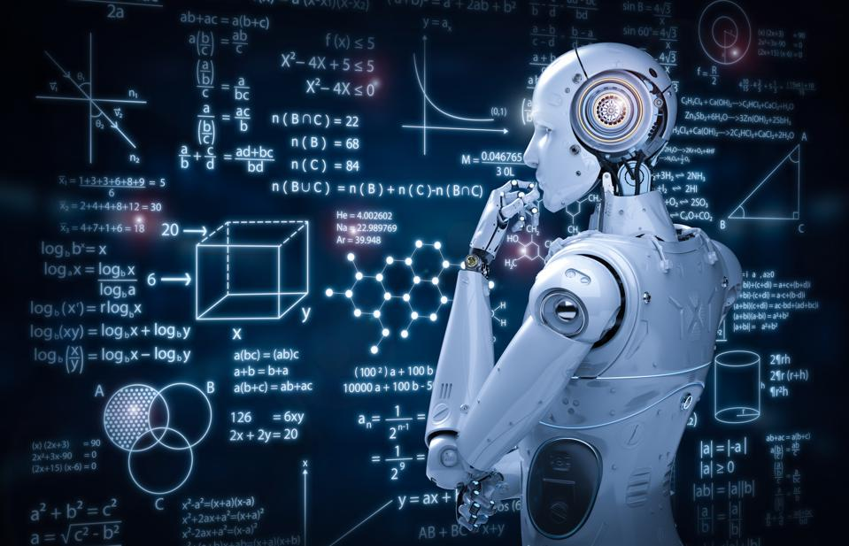

**Team members:**

* **Ibrahim Shaaban Abd El-badeea Ibrahim (Group 1-General)**
* **Ahmed Abd El-Harres Abd El-Rahman Sayed (Group 1-General)**
* **Ahmed Khaled Ragab Metwally (Group 1-General)**
* **Abanob Essam Ayad Aziz (Group 1-General)**
* **Ahmed Gamal Mohammed Saad (Group 1-General)**

**Introduction**

Machine learning is an exciting branch of Artificial Intelligence, and it’s all around us. Machine learning brings out the power of data in new ways, such as Facebook suggesting articles in your feed. This amazing technology helps computer systems learn and improve from experience by developing computer programs that can automatically access data and perform tasks via predictions and detections.

As you input more data into a machine, this helps the algorithms teach the computer, thus improving the delivered results. When you ask Spotify to play your favorite music, it will go to the station you played most often.

Machine makes this all possible.

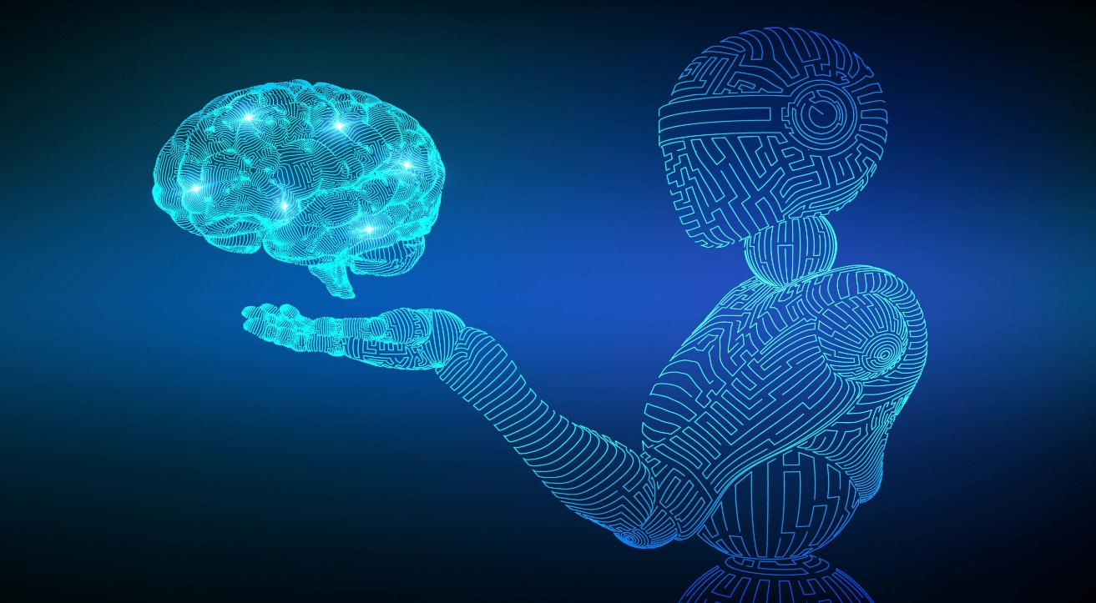

**What is Machine Learning?**

For starters, machine learning is a part of Artificial Intelligence (AI). ML applications learn from experience (data) like humans do without direct programming. When exposed to new data, these applications learn, grow, change, and develop by themselves. In other words, machine learning involves computers finding useful information without being told where to look. Instead, they do this by Analyzing algorithms that learn from.

Machine learning is the ability to adapt to new data independently and through iterations.  Applications learn from previous computations and transactions and use “pattern recognition” to produce reliable and informed results.

## How Machine Learning Works?

The Machine Learning process starts with inputting training data into the selected algorithm. Training data being known or unknown data to develop the final Machine Learning algorithm. The type of training data input does impact the algorithm, and that concept will be covered further momentarily.

New input data is fed into the machine learning algorithm to test whether the algorithm works correctly. The prediction and results are then checked against each other.

If the prediction and results don’t match, the algorithm is re-trained multiple times until the data scientist gets the desired outcome. This enables the machine learning algorithm to continually learn on its own and produce the correct answer, gradually increasing in accuracy over time.

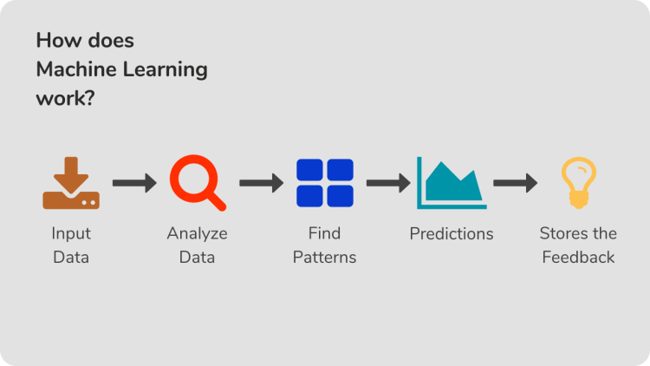

## Why is Machine Learning Important?

To better understand the uses of Machine Learning, consider some instances where Machine Learning is applied: the self-driving Google car; cyber fraud detection; and, online recommendation engines from Facebook, Netflix, and Amazon. Machines can enable all of these things by filtering useful pieces of information and piecing them together based on patterns to get accurate results.

The process flow depicted here represents how Machine Learning works:

The rapid evolution in Machine Learning (ML) has caused a subsequent rise in the use cases, demands—and, the importance of ML in modern lifeز Machine Learning has also changed the way data extraction and interpretation are done by automating generic methods/algorithms, thereby replacing traditional statistical techniques.

## Main Uses of Machine Learning

Typical results from [machine learning applications](https://www.simplilearn.com/tutorials/machine-learning-tutorial/machine-learning-applications) usually include web search results, real-time ads on web pages and mobile devices, email spam filtering, network intrusion detection, and pattern and image recognition. All these are the by-products of using machine learning to analyze massive amounts of data.

Traditionally, data analysis was trial and error-based, an approach that became increasingly impractical thanks to the rise of large data sets. Machine learning provides smart alternatives for large-scale data analysis. Machine learning can produce accurate results and analysis by developing fast and efficient algorithms and data-driven models for real-time data processing.

**Thank You.**