CMPE 382 PROJECT-2
MUHAMMED IBRAHIM UNAL
12583041172

TASK 1
Project relies on Trie data structure to create a dictionary which gets the content from random web queries. Firstly I look for a proper Trie data structure which insert queries into the trie.(I had my implementation from well-known website geekforgeeks.com) However most of the Trie implementations capable of 26 characters which does not satisfy the requirements of the queries. So I increased the range of CHAR_TO_INDEX function which returns the difference between characters as integer. Secondly i add some features which counts the frequency of the queries by modifying the TrieNode struct. I tested my Trie with simple inputs since i make sure my trie works perfect i completed the task1.

*Difficulties
I had some issues while implementing trie. Since i come up with space or other characters like
(!,$,<,%,^,<,%,$,A,0,F) does not specified by Trie. So i had to understand how CHAR_TO_INDEX function and add some features. It make Tries character range 26 to 93 which helps to add other characters to Trie.

#define CHAR_TO_INDEX(c) ((int)c - (int)' ')
index = CHAR_TO_INDEX(key[level]);
if (index > ' ' || index < ' ' + ALPHABET_SIZE)

So with the help of this if condition I was able to read all the extra characters.

TASK 2
After i read the files line by line with fgets function, i inserted each queries into trie and write them to a file called output2.txt.
*Difficulties
Only difficulty i had was the size of the data files. Because first time i try to read files datas were killed. So I decided to take a part of the data and used a counter. I could only manage to read 90 or 100 thousand lines. It varies computer to computer also.
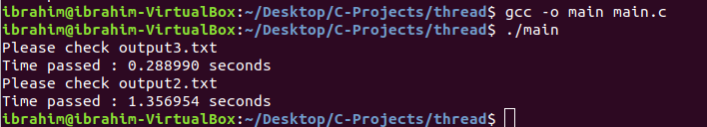

TASK 3

This task ask for reading from the buffer not the file. So I created a buffer with different sizes up to 10 thousand. After i read the files with fread multiple times. I traverse through buffer and write them to output3.txt file line by line.

*Difficulties
I struggled to form the buffer because there is a possibility that fread stays at the middle of the query which does not reach the '\n' character. So after fread operation I checked the character and concataned the rest of the line to buffer then continued file writing part.

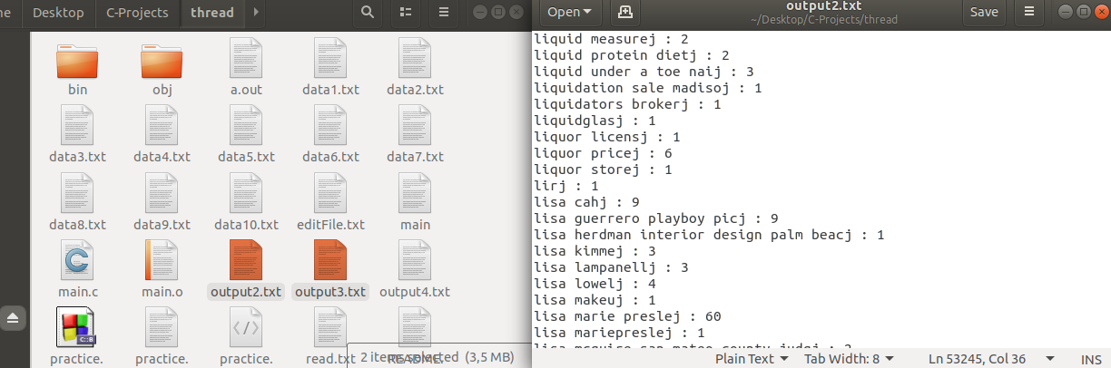

TASK2 AND TASK3 Comparison

Since I used the buffer it gave better result than task2 because reading from file and memory makes difference. Since we have a access to memory it takes less time thank reading from the file and insert it to trie. Which is why these to tasks helped me to understand the difference.

TASK 4
This part involves the usage of the threads so I implemented needed library pthread.h. I just needed to create a thread function which takes its content from task2. Thread function's argumant is the name of file. Since it get the file name it read the file in the function and inserts to the trie. mutex lock and unlock funtions are inserted before and after insert. In the main function "datas" string array holds the data file names. With the help of for loop all of the names are send pthreadcreate and pthreadjoin functions. After all files inserted their input in a threaded version. At the end of function input is written into output4.txt file.

*Difficulties
Since I work with threads I had a lot of segmentation errors just like the previous task However I tried to deal them with debugging. Look for answers from stackoverflow, github etc. Also i come up with a silly error. Since i remove a print statement it gives segmentation error. So i decided to leave it there. However it work in a threaded version as well.

TASK 5
In this part thread function has a local trie which takes it content from specified data file. Then all these tries merged into one trie. So i created a merge function which has no big difference from the function which writes to file. However i had some issues such as segmentation error while creating a merge function and could not fully complete the task even i know what i suppose to do.

TASK 6

I read a huge part of the file and keep it in a variable and then I inserted the trie. It was the fastest operation ever in all tasks. Because as I noticed earlier it was faster than reading from memory rather than file. I had no any issue in this part.

TASK 7

I think tasks already showed us how to improve the performance. Reading from file takes more time but also reading from the memory requires space. So it proves the connection between time and space again. However clearing the buffer after reading might be a solution to improve the performance. Because we already insert the input to trie so there is no need for copy of the same data.

