Testing Tools
Manual Testing

Definition of Testing: -

- Testing is a process where tester intention is to dected number of defect available in Software.
- We need to test one software, because it may have failures at any one of the functionality.
- Test a software with valid & invalid inputs (positive & negative testing)
- We need to test one software to verify uncovered functionalities available in software.

Application: - Developing one software with one specific customer requirements
Product: - Where as product means developing depending upon current marker trend for number of users.
Build: - Finally integrated all modules which are kept in “.exe” (execution) form is called a Build.

Types of Tools: - There are following types of tools available show below

- Functional Tools: - 2. Performance Tools: -
  - WinRunner → Load Runner
  - QTP → J-meter
  - Silk Test → web Tools
  - Rational Robot → J-unit
  - Test ware
  - Compo-ware

3. Defect Tracing Tools: - 4. Configuration Management Tool: -
- QC (Quality Center) → VSS ( Visual Source Safe)
- Clear Quest → CVS ( Congruent Version System)
- Bug-zilla → QC 10 (Quality Center 10)
- Clips

Software Quality Assurance (SQA): - It is a process which is followed by the Management in order to setup agreement between company management & client. It defines to monitors and measure the total strength devolvement team process as well as testing process in order to maintain good relationship between client & company management.

Quality of Testing: -

- A Tester should have good communication skills as well as writing skills.
- A Tester should have complete domain knowledge.
- A Tester should have understood the current project business requirements.
- A Tester should have able to identify the defects in the early stages, in order to avoid cost of the defects.
- A Tester should have communicated with the development team; in order to resolve the issues when ever to required more information.

Software Testing: - Software Testing is conduct testing on one application for verification & validation.

Verification: It done by developers, verified the internal process of the applications.
Validation: - It done by QA Team, where testers will validate the external structure of the application, by putting some data and checking output as per the customer requirements.

Software Development Life Cycle (SDLC):-

It is a mapping between various development stages & testing stages. It defines proper planning for entire project development and also its gives stage by stage to development software. If it is first process in every organization before going for developing a software.

Structure of the QTP (Quick Test Professional) There are four parts can be classified.

- Test Pane:- it will record what ever user can perform

Dialog(“Login”).WinEdit(“AgentName”).Set “mindq”

Here red color indicated “Objects” → (Dialog).
Blue color indicated “Methods” → (WinEdit, Set)
Mother window or Parent window → (Login)
Child window or sub window → (AgentNmae)
Values → (mindq).

- Active Screen: - which will take a snapshot on all objects, images and store some place.
- Data Table: - It is a MS-Excel Sheet if default integrated when I want to pass different values into the QTP (Quick Test Professional) by using Data Table.
Design data table
Data Table:
Run time table / Original table

  - Design data table: - It is a editable the values.
  - Run time data table: - It doesn’t editable the values.

- Debug Viewer: - Finding the errors / ratifies the errors. Check the all syntaxes and everything for finding the errors, to ratify the errors.

→ Any type of the testing application there are two types
  - Test Objects: - The objects which are maintain the object repository.
  - Run time Object: - The objects which are available in the application.

→ Test objects should be equal to the Runtime objects.

(I): SDLC Models: - Software Developing Life Cycle:

(1). Fish Model: -
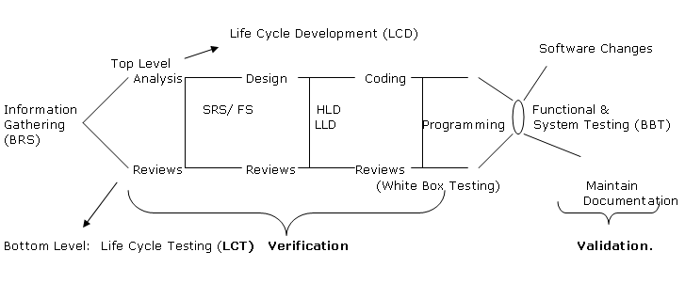
Here:
- Information Gathering: - This is the first step and very crucial step to collecting all information regarding to the developed project or application. This is done by the BRS peoples.

- Analysis: - This is the step in the Fish model here we doing fetched the important data or customer requirements and they developed a SRS (Software Requirement Specification). The document contains the use cases it done by the BRS (Business Requirement Specification) or marketing people.

- Reviews: - It helps check the “Complete and correctness” of the software ands pass on the next step. Check all customer requirements available or not. If any missing to recollected the information from once again client/ customer side.

- Design: - They developed screens of the functions. Its process HLD & LLD.
→ High Level Design/Document (HLD):- It contains the Main modules of application.
→ Low Level Design/Document (LLD):- It Contain the sub-modules of application.

Example: - Web page of Gmail. Here
HLD is Login & Logout (main module). And
LLD is compose mail, forward mail, etc.(sub-module).

- Reviews: - It helps check the “Complete and correctness” of the software ands pass on the next step. Check all customer requirements available or not. If any missing to recollected the information from once again client/ customer side.

- Coding: - Here start the coding to the regarding application or project. They are writing a coding for main module and sub-module based on the customer prefer the language (C, C++, Java or .Net) any platform.

- Reviews: - It helps check the “Complete and correctness” of the software ands pass on the next step. Check all customer requirements available or not.

- Software Changes: - This is done by client / customer side. It can change or updated the old version into a new version.

- Functional Testing: - Here tester can test involved all the modules and sub-modules. If any bugs to identified resend the once again to the developer, and re-testing the testers. Here we consider all things include the conditions, controls everything’s we tested. If once ok to send the team leader and signed the managers to send the client or end user. And it ready to initialed in form of “.exe” format.

- System Testing: - In this phase to check the software and hardware testing.

- Here in this Fish Model half-off the top level is consider as the LCD ( Life Cycle Development), and half-off the bottom model consider as the LCT (Life

Fish Model: - It is a mapping between various development stages and testing stages. It can be followed by large scale organization as it is expensive to develop software.

(1) Business Requirement Speciation (BRS): - It is the first process that should be followed by very organization in order to gather client business requirement. That contains of BRS.

- Purpose
- Objectives
- Scope & Requirement
- Functional & non-functional.
- Security levels
- Existing & non-existing environments, etc.,
This document can also be called “User Requirement Specification” (URS) or “Client / Customer Requirement Specification” (CRS) or “Business Requirement Document” (BRD) or “Functional Requirement Specification” (FRS).

(2) Software Requirement Specification (SRS) / Use case Document (UCD): - After completion of developing of BRS document business analysis people will concentrate to developed a SRS document basing on BRS document. This document defines customer use cases, requirements and system requirements to be developed on new software. The contents of SRS document are

- Use case Diagrams.
- Use cases.
- Task flow Diagrams.
- Pictorial Diagrams (optionally).
- Actors.
- Preconditions.
- Post conditions, etc.
After completion of developing SRS documents it will be send to customer / client to get approval.

NOTE:- A tester will develop test cases basing on this SRS information.

(3) Design: - After completion of information gathering and developing a software design category people will concentrate to design architecture the application. In real times to get approval from client side they will be designing markup design basing on SRS document.

After getting approval from client side they will enter in to detailed design to develop database front-end from objects like textbox, list box, checkbox, radio button, etc., To design a software they follow the below two process

- High Level Design (HLD).
- Low Level Design (LLD).

- High Level Design (HLD):-

High Level Design document define the overall hierarchy of all functionalities from leaf module to root module.

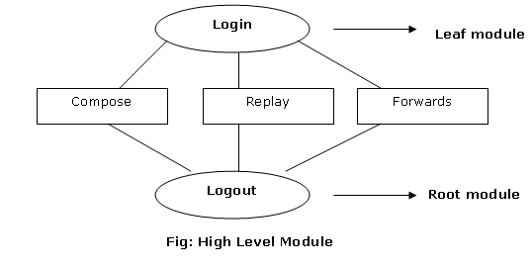

The above design is also called as “External Design” of main modules.

- Low Level Design (LLD): -

Low Level Design document defines the “Internal process of every sub modules” that are available in one application. It is also called as a “Internal Logics”.

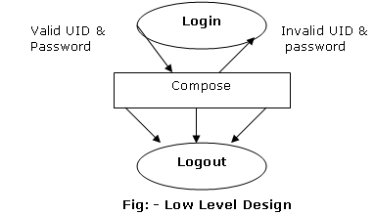

NOTE: - A design will also design UML (Uniform Modified Language) diagrams, data flow diagrams, algorithms, etc.

(4) Coding: - After completion of design software a programmer will concentrate to physically construct software. This also called as “Implementation”. A programmer will follow different technical techniques to code a software. The most commonly followed languages for any software development C, C++, Java, Dot Net, etc. after completion of coding a software a programmer will follow some white box testing (WBT) technique to verify logical errors, syntax errors, loop termination, etc.

Differences between WBT (White Box Testing) and BBT (Black Box Testing):-

White Box Testing (WBT) | Black Box Testing (BBT)
If is followed by developer | It is followed by QA (Quality Assurance) Team.
During this process a programmer will verify the internal logics of the software | During this process a Tester will validate the external structure of application.
After completion of developing programs for different functionalities a programmer will follow Unit testing to verify the program errors and integrates all the modules in to “.exe” form. | After receiving a Build from a developer once Smoke testing is done a tester will validate in 4 types.  1. Usability Testing  2. Functional Testing  3. Performance Testing.  4. Security Testing.

(II) Water Fall Model:-

This is the common and classical of life cycle models, also to as a liner- sequential life cycle model. It is very simple to understand and use. In a Waterfall model, each phase must be completed in its entirety before the next phase can begin. This can be followed by small scale organizations & even some times large scale organizations, when ever they have customer clear requirements. This model is old model where a company can easily developed a software without coming back to previous phases.

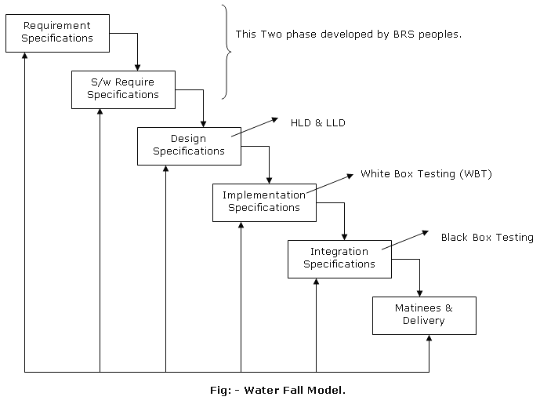

Disadvantages:-

- It consumes more time for develop each every phase.
- We can’t maintain better quality to the customer. Because no reviews are taking can’t place. To overcome this waterfall model company is followed Rapid prototype model as well as incremental models.

V-Model: - (Verification & Validation) or 2V-Model: -

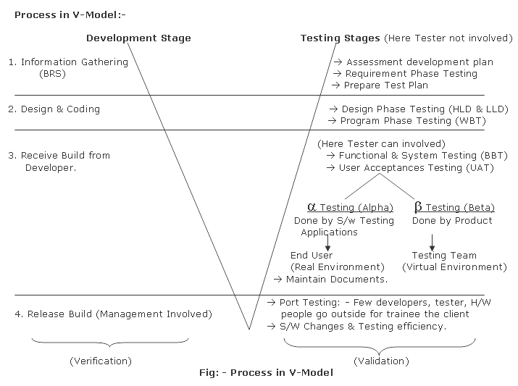
Formula for Defect Removable Efficiency:-

A
Defect Removable Efficiency = ------------
A + B

Here A = Defect by customer Acceptation ratio is <=0.8 its good product.
A = Defect by Tester
B = Defect by Developer.

Definition of V-Model: - It is a mapping between various development stages and testing stages. V – Stands for “Verification & Validation”. It can be followed by large scale organization as it is expensive model. But where as small scales will follows Functional & System Testing as mandatory. Because it is a bottleneck phase.

Actual V-Model: -
B R S
User Accept Test
V
E
R
I
F
I
C
A
T
I
O
N

V
A
L
I
DATION

UAT
S/w R S
System Testing

BBT
H L D
Integrating Test

L L D
Unit Testing
WBT

Coding

Fig: - V-Model

(1) Reviews during BRS & SRS: - In this initial phase BA (Business Analysis) people will develop a SRS document depending upon a BRS and the same people will review their entire SRS document for the completeness & correctness.

BRS Vs SRS:-

- Are they requirement?
- Are they customer requirement?
- Are they under stable (use case description)?
- Are they reasonable with respected budget & time duration?
- Are they testable with respected to particals?

The above reviews can also called as “walk-in through” or “inspection” which is reviewed by BRS.
KOM (Kick of Meeting): - After developing a SRS document & reviews management will arrange one conference meeting to discuss about the current project requirement as well budget issues, time duration etc.

(2) Review during Design: - After completion of information gathering and their reviews design people will concentrate to construct architectures of the application and the same people will reviews HLD & LLD process for the compliment & correctness.

(3) Review during Coding: - After completion of SRS & Design reviews a programmer will construct to physically construct software by coding it. A programmer will follow White Box Testing to review the entire software.

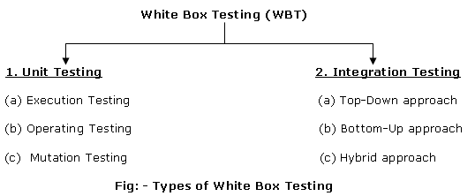

(1) Unit Testing: - (Here Tester not involved only developers)

It is the first technique which is followed by developer after coding a software during this process a programmer will constructs to encounter errors, fault, failures in a written coding.

(a) Execution Testing: - During this process a programmer have to go for complete execution of
the entire programs which are written for the application. During execution testing a
Programmer have to concentrate in the below two types of process.

- Basis path coverage:- Checking their entire logical statement errors and also verify whether every statement are participating during their test execution of the program
- Loop Termination: - Checking whether every loop is participating during their test execution, so that data & control Trans machines will be under control of application.
- Memory Cycle: - Space occupies in the Hard disk.
- Logical Statement Errors.
- Failures and defects etc.,

(b) Operation Testing: - During this process a programmer have to verify how well our
application build is able to run on different types of platforms like windows 7, Xp, MAC, Unix,
etc. and also a programmer have to verify and different types of browsers like Internet
Explore, Firefox, etc.

(c) Mutation Testing: - It is a program logic used by the programmer in the written coding in
order to compile errors available in the entire application. In this process a programmer will
modify the programs here and there in order to encounter errors.

(2) Integrating Testing: - After completed dependent Unit testing a programmer will concentrate to integrate all the modules in order to compose them to form a system, which is called as Build. A programmer has to verify data transmissions control transmission between each every module. So he follows the below three approaches.

- Top-Down approach
- Bottom-up approach
- Hybrid approach / sandwich approach.

- Top-Down Approach: -A Programmer conduct a testing only “Main Module” without going to the under constrictive sub-modules. In this above process “Stub” is a called program, which will prevent the process. The process not to go to sub-modules.
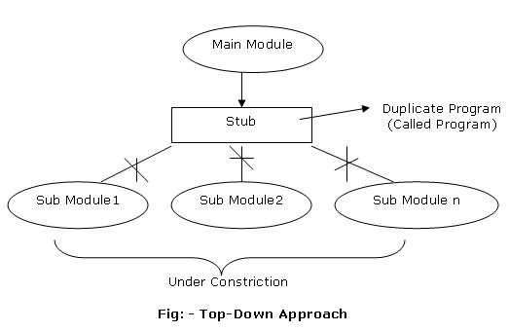

- Bottom-Up Approach: - A programmer conducts a testing only one “sub-functionalities” without coming back to main-modules. “Driver” is a calling program to the sub-functionalities which will prevent not to go to main functionalities.
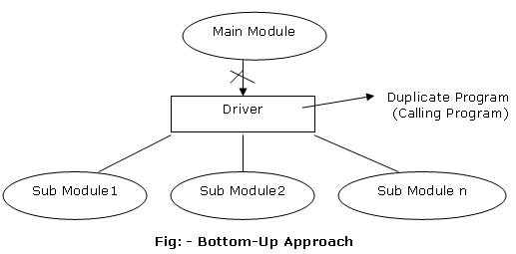

- Hybrid Approach / Sandwich Approach: - It is a combination of both Top-Down and Bottom-Up approach. Where developer will integrate all HLD & LLD modules in order to compose them to from a system which is called as “.Exe” form.

Functional & System Testing ( Black Box Testing )

After completion of entire development team process a tester will receive initial Build from a development team, where tester can download by using FTP (File Transport Protocol) or IP (Internet Protocol).

Smoke Testing: -

Before going for either Manual or Automation testing a tester have to verify the initial build whether it is a stable or un-stable. If it is stable tester will accept, if it is un-stable tester will reject and give strong reason to the development teams which is called as “Smoke Testing”.

Black Box Testing (BBT) is again divided in to the below 4 Techniques.

- Usesibility Testing.
- Functional Testing.
- Performance Testing.
- Security Testing.

(I) Usesibility Testing: - It is the first technique which can be followed in Black Box Testing (BBT). During this process, tester is validating User Friendliness of the application. It is again divided in to the below two techniques.

(1) User Interface Testing (UIT).
(2) Manual Support Testing (MST).

(1) User Interface Testing: - Under this process a tester have to verify all type of Cosmetics functionalities which are available in our application like:

→ Easy of Use: - Checking the Understandable of screens.
→ Look and Feel: - Checking the attractiveness of screens
→ Spell Checks & Labels: - Checking the spellings in the labels or application.

→ Written Alignments (Correct / Proper Alignment): - Checking the orders of objects in the screens.
→ Graphical Checking: - Checking all graphical, like font, logos etc.
→ User Friendliness: - Checking meaningful and User Friendliness error messages.

(2) Manual Support Testing (MST): - Under this process a tester have to validate all types of documents like, pdf files etc. which means that “checking the help document” whereas there are properly develop as per the customer given business requirement.

NOTE:- This Technique can be followed some time by developer, Under UNIT testing. For all usability defects we can given as “low severity”.

*** (II) Functional Testing:- It is a mandatory (compulsory) in Black Box Testing (BBT) during this process, testers have to validate all Customer Business Requirement (CBR), it is again divided in to the below technique.

(a) Functionality Testing.
(b) Input Domain Testing.
(c) Inter System Testing.
(d) Recovery Testing.
(e) Configuration Testing.
(f) Compatibility Testing.
(g) Installation Testing.
(h) Parallel Testing.
(i) Garbage / Sanitation Testing.

(a) Functionality Testing (Requirement Testing): - It is a part in Functional Testing it is also know as “Requirement Testing” or “Correctness Testing” during this process the testers are validating type of business requirement by following the below six coverage’s.

(i). Behavioral Coverage.
(ii). Input Domain Coverage.
(iii). Calculation Coverage.
(iv). Backend Coverage.
(v). Error Handing Coverage.
(vi). Service Level Coverage.

(i) Behavioral Coverage: - A tester have to verify all GUI (Graphical User Interface) objects, properties values behavior like Textbox, Listbox, Push button, etc.

(ii) Input Domain Coverage: - Checking minimum size & maximum size of the inputs.

(iii) Calculation Coverage: - Verifying the Output Correctness.

(iv) Backend Coverage: - Validation database in two types

- Data Validation (Inserting, Modifying, Updating).
- Data Integrity.

- Data Validation: - what operation user performs in the front end side whether it is correctly specify in the backend of our application.

- Data Integrity: - what values we specify in the front end side whether there correctly specified in the backend columns at respective to columns.

(v) Error Handler Coverage: - Preventing “Un expected events occurring during at run time”.

(vi) Service Level Coverage: - Changing order of functionalities of our application.

(b) Input Domain Testing: - It is a part in Functional testing, during this process tester are validating the complete size, type and range every Input objects. So tester will follow the below mathematical notations.

- Boundary Value Analysis.
- Equalance Class Partition.

- Boundary Value Analysis (BVA): - To calculating the size, range and types of objects.

Minimum → Pass
Maximum → Pass
Minimum – 1 → Fail
Maximum – 1 → Pass
Minimum +1 → Pass
Maximum + 1 → Fail.

- Equalance Class Partition: - In this case checking object of values are valid or invalid.

Example (1): - Insurance application follows number of policies when user selects Type ‘A’ policy from type drop down, then system ask age of the person. They age should be gather than 16 years and should less than 80 years. Prepare Boundary Value Analysis (BVA) and Equalance Class Partition (ECP)?

Solution: - Here we come under the range, because its To to From range

1. Boundary Value Analysis: -
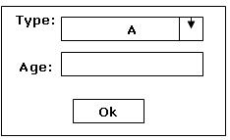
Condition: - 1. age >16 years
2. age< 80 years

Conditions | Values | Results
Minimum ( >16) | 17 Years | Pass
Maximum( <80) | 79 Years | Pass
Minimum – 1 (17-1) | 16 Years | Fail
Maximum -1 (79-1) | 78 Years | Pass
Minimum +1(17+1) | 18 Years | Pass
Maximum+1(79+1) | 80 Years | Fail

2. Equalance Class Partition: -

Condition: - 1. Ranges only.
Valid Range | Invalid Range
0-9 | A – Z
 | a – z
 | Blank space
 | Special characters

Example (2): - A login application process allows user to authorized, username object allows 4 to 20 characters along with alphabets & numeric in lowercase. Where as password object allows only alphabets from 4 to 10 characters along with uppercase. Prepare Boundary Value Analysis (BVA) and Equalance Class Partitions (ECP)?

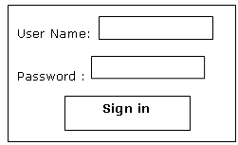
Solution: - In this application have two objected that are username & password. We have prepared two objects one after one.

1. Boundary Value Analysis for Username (Size):-

Conditions: - 1. 4 to 20 characters of alphabets and numeric.
2. Lowercase.

Conditions | Values | Results
Minimum ( 4 ) | 4 | Pass
Maximum( 20) | 20 | Pass
Minimum – 1 (4-1) | 3 | Fail
Maximum -1 (20-1) | 19 | Pass
Minimum +1(4+1) | 5 | Pass
Maximum+1(20+1) | 21 | Fail

Login Page

2. Equalance Class Partition for Username: -

Condition: - 1. Ranges only.
Valid Range | Invalid Range
0-9 | A – Z
a- z | Blank space
 | Special characters

1. Boundary Value Analysis for Password (Text):-

Conditions: - 1. 4 to 10 characters of alphabets.
2. Uppercase.

Conditions | Values | Results
Minimum ( 4 ) | 4 | Pass
Maximum( 10) | 10 | Pass
Minimum – 1 (4-1) | 3 | Fail
Maximum -1 (10-1) | 9 | Pass
Minimum +1(4+1) | 5 | Pass
Maximum+1(10+1) | 11 | Fail

2. Equalance Class Partition for Username: -

Condition: - 1. Uppercase
Valid Range | Invalid Range
a - z | A – Z
 | Blank space
 | Special characters
 | 0 - 9

(c) Inter System Testing (Penetration / Coupling / End-to-End): -

It is also called Penetration or Coupling or End-to-End Testing. During this process a tester have to validates whether our current version(Project) is able to co-existed with other software application which are existing with the customer in order to share common resources. This testing can be followed where we have specific customer requirements.

Example: -

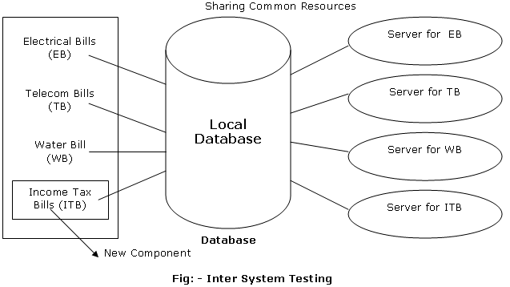

In this above example we have shows that Inter System. Here there do already existing the few applications like “Electrical Bill (EB), Telecom Bills (TB) and Water Bills (WB)”, now we adding new component or application like “Income Tax (ITB) in the co-existed the database. Here tester will to check all the applications are run properly or not. It can check sharing the common resources like printers, etc. will all servers and applications.

(d) Recovery Testing (Reliability Testing): -

It is a Non-Functional Testing, because it is not a customer requirement it is a system requirement testing. Here finding accuracy of testing using recovery testing.

It is also known as Reliability testing during this process a tester has to validate whether our application is able to recover from abnormal conditions to normal conditions by using some backup techniques. In this process the tester may use backups & procedures like restarting a CPU or checking internal backups created by developers.

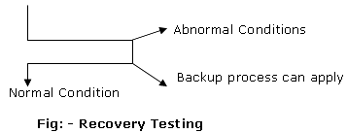

The reasons to go to abnormal conditions are

- Hardware & Software not supporting.
- Database connectivity failures.
- Server connectivity failures.
- Overload.

(e) Configuration Testing: -

During this process a tester have validate whether our application Build supports to different type of hardware devices like different types of printer, NIC (Network Interface Card), topologic, etc. it is also called as a sensitively testing.

(f) Compatibility Testing: -

During this process a tester have to validate how well our application Build will is as able to run on different types of OS(Operating System) and also a tester have to validate to the different types of browsers in order to check the compatibility of an application.

In real time testers will face problems in backward compatibility verification and also a tester can run the test cases on different types of OS(operating System) like Windows7, Xp, etc.,

(g) Installation Testing: -

This process of testing can be followed soon after getting initial Build from a developer. Before going for installing any software a tester have to make sure supported software are properly configured on customer expected configuration system. While installing a software a tester have to go through initialization guide which is provided by developer.

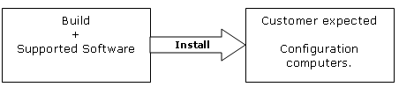

(h) Parallel Testing: -

After a completion of entire functional testing before going to release any product to customer. A tester have to compare new version Build in order to find out different‘s in requirement enhancements etc. and also management will compare our current project product with other company products in order to find out computation in the market.

(i) Garbage / Sanitation Testing: -

during this process a tester have go through SRS (Software Requirement Specification) document to finding out any extra features are added for the current project. If any thing added a tester have to verify that functionality.

(III) Performances Testing: - (it is a only seeing Expectation Values or results only)

This process can be followed whenever we want to go for estimating speed of processing of our application Build, depending upon customer expected configuration system and customer expected load. It again divide into the below following techniques.

- Load Testing.
- Stretch Testing.
- Storage Testing.
- Data Volume Testing.

- Load Testing: -

It can also call “Scalability” Testing (Measuring). The execution of our application Build depending upon customer expected configuration systems and customer expected load in order to estimate the speed of processing of application build. A tester also has to verify.

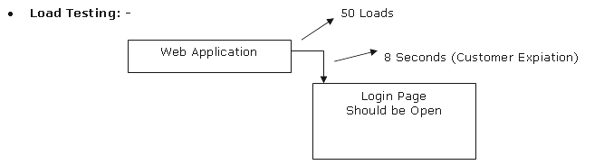
- Stretch Testing: -

The execution of our application build depending upon customer expected configuration and customer expected un-intervals of load to estimate peek load capacity of our application. If tester are getting any variations with the peek load then tester have to inform to the developer to tune the application.

- Storage Testing( Capacity): -

During this process a tester have to validate the maximum storage capacity of our application depending upon customer expected configuration computer. In this process a tester should have minimum Network knowledge to analysis storage capacity.

- Data Volume Testing(Size): -

During this process a tester has to validate the maximum size of the application depending upon customer expected load and configurations.

(iv) Security Testing: -

it is a complex testing in Black Box Testing(BBT). During this process tester have to validate privacy of applications which are developed by development team. This testing can be followed by some experience persons in encryption and decryption will be performed by development team where as testers will follow the below two technique.

- Authorization Testing.
- Access Control Testing.

- Authorization Testing: - During this process a tester have to validate whether our application Builds allows valid users and prevents invalid users.

Example: - All Banking sectors, login operations, credit cards, ATM applications etc.

- Access Control Testing: - During this process a tester have to validate whether valid user is able to use some specific services and also a tester have to validate the access control of the application

Difference between the Functional & Non-Functional Testing?

Functional Testing | Non-Functional Testing
Validating one customer business requirement. | Dealing with System related.
A tester has to give more importance for Functional requirements while designing testing and executing test case. | We give medium priorities while design and running test case.
→ Functionality Testing.  → Input domain Testing.  → Inter System Testing.  → Security Testing. | → Recovery Testing.  → Installation Testing.  → Configuration Testing.  → Capability Testing.  → Parallel Testing.  → Garbage Testing.  → Performance Testing.

User Accepting Testing (UAT): -

After completion of entire functional testing on one application or product management team will concentrate to collected feedback from the real customers and real like customer. In this process we followed two type of testing that are Alpha (α) Testing and Beta (β) Testing.

Alpha (α) Testing | Beta (β) Testing
It is done for software applications. | It is done for software products.
Alpha Testing is done by End-Users in front of the entire development team process. | It is done by Testing Team in front of the real like customer like BRS, developer team.
It is a real-environment. | It is virtual-environment.

In general every client will release Beta (β) version to the customers in order to collect feedback, in real time senariours a tester have to conduct live testing on Beta (β) version in front of the customer.

Maintains Document: -

After completion of successful User Accepting Test(UAT) process a tester have to a maintained all type of documents for feature references, if any customer suddenly request.

Testing During Maintains: -

After completion of successful User Accepting Test(UST), management team will concentrated to release the product / application to the customer. In this process management team will selected few developers and few testers and one hardware engineer to go to onsite in order the train the customer which is called as “Port” testing.

Port Testing: - After reaching to the customer the release team have to train the customer in the below process.

- Compact Installation.
- Input Devices handling.
- Output Devices handing.
- Primary (Current Project) and Secondary (Hardware & Software Devices) handing.
- Co-existing with other software applications.

After completion of training session release team is will be back to company and follows as usual.

Software Changes: -

This comes under maintains or supporting the customer for any enhancements or changes request required for developing new version.

Testing Terminologies (or) Methodologies

(1). Monkey Testing: -

A tester conduct a testing only one basic functionality modules or tester cases which are frequently used by the customer. This terminology can be follow when ever we don’t have sufficient time to concentrate on entire functional testing.

Lack of Time → Monkey Testing
(2). Big-bang Testing: -

When ever a company follows “Single Stage of testing” after compilation of entire development process such companies will follows this terminologies.

Example: - Water-Fall model, it can be followed by Small scale, Medium scale of organization.

*** (3) Incremental Testing: -
*
When ever a company follows “Multiple Stages of development and Multiple Stages of testing from document level to Build level” such companies can follows this terminologies this can be followed by Large Scale organization in order to reaches and develop software’s.

Example: - V-Model & Fish Model.

*** (4) Regression Testing: -
*
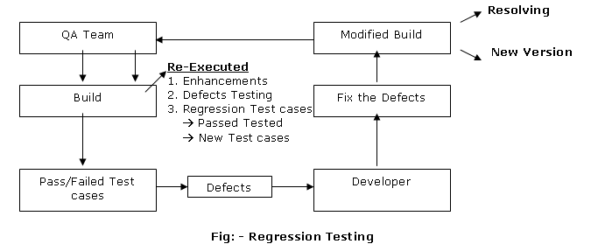
This process is mandatory for every application testing. During this process a tester will “Re-executed all the Test Cases” like “Enhancements, Defects, New Test Cases, Change Request”, etc. on the
Modify Build to ensure “Bug Fix work” and occurrence of any side effects on Old functionality as well as new functionality.
Regression is to be followed and every New version ti ensure or to make free from bugs.

*** (5) Static Vs Dynamic Testing: -
*
Static Testing: -

→ This testing is followed by a programmer, during White Box Testing (WBT). This is also
called as “Verification”.
→ Static means Standalone verification.

Dynamic Testing: -

→ A tester conduct a testing by running the application Build in order to validate customer
business requirements.
→ It comes under “Validation”.

Examples: - Functionality Testing, Performance Testing and Security Testing.

(6) Ad-hoc Testing: -

A tester conduct a testing when ever our application does not consist of proper documentations like SRS Documentation, Test plane Documentation etc.

When ever our application consists of pre-determined ideas, in such cases a tester can take the help of developer to know more about the requirements. In real time scenario’s it can’t be followed commonly, where we can followed only for few functionality, when we don’t have proper requirement.

*** (7) Manual Vs Automation Testing: -
*
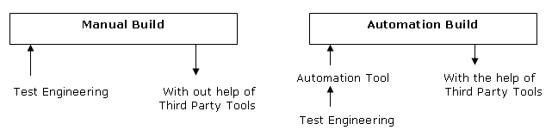

Manual Testing: -

→ “Testing one software without the help of any third party testing tools”. During this process a tester
have to follows some documentations to test any application Manually.

- Test Design Document
- Test Procedures.
- Test Plan.
- Test Execution.
- Test Logs.
- Test Reporting (Defects Reporting).

Automation Testing: -

→ Testing one software with the help of third party testing tools.
→ Automation can be follow to convert Manual operations business in to automated test script.
→ we can use automation tools due to below reasons.

- Lack o Time.
- Regression Testing.

- Re-Testing Purpose.
- When ever we receives the Builds frequently from developer.

(I). Test Stargery: -

It is a Company Level Document developed by QA Manager for entire project testing. This document defines planning, scheduling, environments to used, roles and responsibilities, risks (problems) and mitigation (solutions) etc.

In real times scenarios a tester have to approach QA Manager for any business requirements issues related. QA Manager will monitor the entire application testing weekly once or weekly twice to know the status of ongoing project. This document consist of the below basic components.

QA Document (It is a Company Level Document)

1. Scope & Objective: - Scope is “aim” of the project or purpose of the project and Objectives are “goals” to be achieved for the current project.

2. Communication & Status Reporting: - A tester has to communicate with different peoples in the organization like QA Manager, QA Lead, Client, Developers with QA Team. A tester has to report the status of the ongoing project5 weekly once or weekly twice or monthly once know the status of the ongoing projects.

3. Test Approach: - It is a mapping between various development stages and testing issues or factors. QA Manager will explain what are the issues and factors that are available in our organization in the below table called Test Responsibility Matrix (TRM).

 | Testing Issues | BRS | Design | Coding | System Testing | Maintained
1 | Authorization (Security Level Testing) | ✓ | ✓ | ✓ | ✓ | ╳
2 | Accessible Control (Security Level Testing) | ✓ | ✓ | ✓ | ✓ | ╳
3 | Ease of Use (Usability & UIT Testing) | ╳ | ╳ | ╳ | ✓ | ╳
4 | Correctness (Functional Testing) | ✓ | ✓ | ✓ | ✓ | ╳
5 | Ease of Operate (Compatibility Testing) | ╳ | ╳ | ╳ | ✓ | ╳
6 | Coupling (Inter System Testing) | ✓ | ✓ | ✓ | ✓ | ╳
7 | Portable (Configuration Testing) | ✓ | ✓ | ✓ | ✓ | ╳
8 | Service Level (Functionality Testing) | ✓ | ✓ | ✓ | ✓ | ╳
9 | Audit Trail (Integration Testing) | ╳ | ╳ | ✓ | ╳ | ╳
10 | Continuity of processing (Integration Test) | ╳ | ╳ | ✓ | ╳ | ╳
11 | Performance (Performance Testing) | ✓ | ✓ | ✓ | ✓ | ╳
12 | Methodology (Maintained Testing) | ╳ | ╳ | ╳ | ╳ | ✓
13 | Maintainable (Maintained Testing) | ╳ | ╳ | ╳ | ╳ | ✓
14 | Reliability (Recovery Testing) | ╳ | ╳ | ╳ | ✓ | ╳
15 | File Integrity (Recovery Testing) | ╳ | ╳ | ╳ | ✓ | ╳

Fig: Test Responsibility Matrix (TRM) or Test Matrix (TM)

4. Communication &Defect Tracking: - A tester has to communicate with a developer when there are issues racing in applications
- Miss Communicate.
- Miss Understanding.
- Not Applicable.
- Not Reproducible.

5. Test Environment: - QA Manager will list out different types of Hardware & Software that should be use for our current project, like Operating System (OS), supported software’s, technologies, web server’s hardware configurations etc.

6. Roles & Responsibility: - Roles are “Designations” of the employees and Responsibility taken an each role. QA Manager list out in a table of each every employee roles and responsibility.

Example: -
Names | Roles | Responsibility
Shaik | QA Manager | -------  -------
Mohammad | QA Lead | -------  -------
Fareed  Masthan | QA Team | -------  -------

7. Risks & Mitigations: -
Risks: Risk is a problem that we are facing in organization like lack of time, lack of budget, lack of
Resources, lack of preparation documentations, delays and delivery of build, etc.

Mitigation: To over came the above problems QA Manager will go other alternate things methods
to achieve objectives.

8. Changes Configurations & Maintainers: - How to handle sudden request of customer request or changes that should be followed under maintained which means that a tester have to support the customer when ever the suddenly requesting.

(II). Test Methodology (or) Test Initiation (Project Level Document): -

It is a company level document as well as project level document which should be developing for the entire development team & tester team. This document defines approaches, guidelines, project planning, schedules and tasks that should be followed for the current project. To develop project level document project manager will follow various types of steps as shown below.

Step (1): - Project Manager to requite resources for the current project testing.
Step (2): - Project Manager to go through QA documentation to under stand the approaches we follow.
Step (3): - Project manager to identify the type of the project that is received to our organization.

 | Project Type | BRS | Design | Coding | System Testing | Maintained
1 | Out source Project | ╳ | ╳ | ╳ | ✓ | ╳
2 | Traditional Project | ✓ | ✓ | ✓ | ✓ | ╳
3 | Maintainable Project | ╳ | ╳ | ╳ | ╳ | ✓

Fig: Identify the type of project

NOTE: Depending upon the type of the project, Project Manager will delete some of the Testing
Responsibility Matrix (TRM) columns which are not require for the current project.

Step (4): - Project Manager have to determine current project requirements which are necessary for our
current project testing.

NOTE: Depending upon current requirements Project manager will delete some of the TRM columns for
our current project.

Step (5): - Project Manager identify the feature requirements of the current projects testing, so Project
Manager will add some of the factors which are required in feature for the current projects.

Step (6): - Project manager has to identify the tactical risks that are involved in the selected TRM
Columns, so Project manager dependent upon risks Project Manager will delete some of the
factors from the TRM table and finalize the factors for the entire project testing.

After Finalizing TRM columns Project Manager has to develop Project planning for the entire year by given schedules, tasks, approaches for the entire project.

(III) Test Plan: - (By QA Lead)

After a compilation of both company & project level documents QA Lead will concentrate to develop test plan document IEEE format. To develop test plan document QA Lead have to go through various types of document in order to develop a very good test plan.

Input Process Output

What to Testing Team Format
BRS Document
Test?
Identify the Risks
Who to the Test?
When to test Test Plan
SRS & Design Document
Prepare Test Plan (IEEE)

How to test?
Review the Test Plan
Test Methodology

By Project Manager Finalizing TRM

(i) Testing Team Formation: - It is a first process to be follows by QA Lead in order to develop a good testing team for the current project testing. To form testing team for any organization test lead will follow the below process.

- Available of testing team (size of the QA Team).
- Size of Project.
- Duration of the Project.
- Environment available.

The above four components are dependent to each other in orders to form testing team.

(ii) Identify the Risks: - After completion of testing team formation QA Lead will concentrate to develop & to analysis the risks with the formed team, development team and management.

- Lack of communications skills.
- Lack of domain knowledge for the formed team.
- Delays in deliveries by development team. This means that developers are not releasing current version as per the plan.
- Lack of recourses by development team.
- Lack of budget, duration, resources and environment.

The above challenges are also called as “root causes analysis”.

(iii) Prepare Test Plan (By QA Lead): -

After completion testing team formation and identifying risks QA Lead will concentrates to develop a test plan document for the entire formed QA Team. This document defines approach, roles & responsibilities, time duration of the project and environment to be used. And also explain

- Who to test?
- What to test? To develop the beside test plan some companies follows IEEE format.
- When to test?
- How to test?

- Test plan Id: - The name of the project. Or unique Id of the project.

- Introduction: - QA Lead will describe importance of the test plan document.

- Test Item: - Test lead will be listing out the names of all modules that are available in the project

- Feature to be Tested: - Test lead will be mentioning the names of the current modules for which
a tester needs to be tested.

(5) Feature not to be Tested: - The names of the corresponding modules for which tester need not
be involved in the testing. Because

- Already test cases are available.
- They differed for next version testing.
- Lack of time
- Some of the functionality is deleted.

(6) Test approach: - QA Lead is listing out the issues that are finalized in project level document.

- Suspersion Criteria & Resumption Requirements: - We need to Suspend out application in the initial stage under Smoke testing also we need to Suspend while executing the test cases. If tester are finding any issues.

- Test Deliverables: - Required documents to be developed for the current project testing in real times need to follow the below approach.
Test Case Result
Bugs Result
Requirements PM

Project Plan
PM
Test Plan
Test Speciation
Test Cases
Bugs

TC Coverage Repots
Bugs Repots

Functional Specification PM
Detailed Design (Developer)

Weekly Status Reports

Fig: Test Deliverables

(9) Test Environment: - QA Lead will be listing out various types of Hardware & Software that are to
be used for our current project testing like Hardware which should be configured for different
servers, database as per the client requirements.

(10) Testing Tasks: - All possible works to be done before going for testing any application.

(11) Roles & Responsibilities: - Roles is a Designation of a tester and Responsibilities are a tester
who has to work on different functionalities depending upon the customer business requirements?

(12) Staff & Tanning: - QA Lead will list out the names of the testers selected for the current version
and numbers of days to undergo training.

** (13) Entry Criteria: - This field gives information when a tester has to enter in to one application testing. The received initial build should met the below requirement.

- Development Unit Testing.
- Identification of Resolved Defects.
- Build Notes, Installation and setup instructions.
- Pass smoke test and build verification.
Before a build can be accepted into QA, the following must be met:
- Development Unit Testing: Each new build has to be tested by the development team before released to testing
- Identification of Resolved Defects: Development must fix all defects that were marked for fix. This will be communicated through build notes
- Build Notes, Installation and Setup Instructions: Development must issue for every build. They should include the build number, all changes, and new features from the previous build
- Pass Smoke Test and Build Verification
(14) Exit Criteria: - This indicates when a tester has to stop testing. Testing will be complete when the following conditions have been met in addition too; when QA Development, program management and product management agree that the testing is complete. Execution of all the test cases has occurred.

- All the test cases have been executed.
- All CR’s are closed or deferred.

(15) Test Duration: - Date & time for the above application testing. (Test plan Id).

(16) Approval: - Signature of the QA Manager & Project Manager.

(iV) Review Test plan: -

After completion the developing test plan document QA Manager & Project Manager will review the entire document content field for the completeness and correctness in order to approve for our current project. To review the test plan document, they follow the below documents in order to map with test item, features to be tested, testing approach, testing tasks, test duration. The following below documents mapping.

- BRS Document.
- SRS Document.
- Design Document.
- Test Methodology.
After completion of their entire review by QA Manager he/she wills approval for testing team.

(IV) Test Design (Prepare the Test cases): -

This is the major part involves of the tester for design test cases in the real times. A tester can develop test case for any application like
- New Request.
- Enhancement.
- Defects.
- User Accepting Test (UAT).

Before going for test cases a tester have under gone some training in order to capture them entire customer business requirements as per the test plan. The document tester follows to design testing cases.
- SRS / FS / Requirement Document / Use case Document / Technical document / Design Document
- Test plan document and some time will follow test strategy documents.

To develop test cases, the tester will follow below three methods.

Methods:
- Business Requirement Based Test case design.
- Input Domain Based test case design.
- User Interface (UI) Based test case design.

Method 1: - BRS → SRS → Use Case → Test Cases.

Method 2:- BRS → Design Document → Data Models (ER Models) → Test Cases.

Method 3: - Perform cosmetics functions.

Flow of Test case: -

Requirement BRS

Test Case Use case Test Case
SRS

HLD
Apply (Executing Test Cases)

LLD

Coding.exe

(V) Test Procedure: -

1. Use Case: - Every Use case is derived from SRS document. A Use case defines how to use the functionality in terms of application requirement and also define task flow, actors, pre conditions, post condition of one functionality.

Use Case Template: -

(a) Use case Id: - The name of the use case of the Unique number of use case. Ex: UC_001_login.

(b) Actors /Authors: - The name of the User that should be worked on one functionality.

(c) Pre-condition: - Conditions for the user before using on one functionality.

(d) Post-condition: - System responding to the user.

(e) Task flow diagram / Use case Diagram: - Representing the flow of the above Use case.

(f) Alternate path: - Any dependency available for above Use case.

2. Test Case: - Every Test case is deriving form Use case of SRS document. A test case defines how to test functionality in terms of customer business requirements depending upon input and outputs. A test case is checklist which consists of some test data, specifications, and user interface as well as user actions. In real time tester are develop a test case in MS-Excel Sheets, MS-Word or Quality Center is available.

Procedure to develop Test Case from Use Case: -

Step (1): - A Tester have go through SRS document to Understand the type of the modules as well as
Specifications.
Step (2): - Get one Use case out side from the above collected Use Cases and analysis pre-conditions,
Post-conditions and data can be used etc.
Step (3): - Identify the first Input that should be use the above Use case.
Step (4): - Identify the alternative flow of the Use case.
Step (5): - A Tester have to Identify Outcome & Output of the above Use Cases.
Step (6): - A Tester have to Identify last Input of the above Use cases.

Test Case Template & Procedures: -

Some Organization will follow IEEE format for a developing Test case in MS-Excel Sheets. This Test case template contains all Use cases, Test Case in step by step procedures.

Delhi Public School ( Test Case Template)
Test case Id | Test Name | Step Name | Description | Expected Results | Actual Results | Status | Test Case Type | Designer | Design on | Application Version

Priority | Severity | Environment | Results | Comments

Test Case Template Meaning: -

1. Test Case Id: - A tester has given unique number of Test Case while designing Test Cases.

2. Test Name: - A Tester has maintained the Name of the functionality (Login). For which is developing a
Test cases.

3. Description / Action: - A Tester has to mention navigation steps for the above Test case (Test Case Id).

4. Expected Results: - Outcome of the above Test Case.

5. Status: - Tester has selected the status of the above test cases like.

- Design: - It is default status for every test case, the tester have to select.

- Ready for peer Review: - Once we completed a test case a tester have to change form design status to ready for peer review.
- Repair: - It written test case have any modification QA Manager or QA lead will change from ready for peer review to repair by some comments.
- Ready for External Review: - This can be only chanced by enhancement review which should for client side.
- Ready: - We can change ready status if written test cases meet the requirement.

6. Designer and Design on: - Name of the tester by whom the above test case is designing data & time.

7. Application Version: - A Tester has to select the name of the version for which developing test cases.

8. Test Case Type: - A Tester has to select the name of the test case for which it’s belonging
(Defects & Enhancement)

9. Priority: - A tester have to selected the importance’s of the test case depending upon customer
business requirements. In general there are three type of priority like “High, Medium, Low Priority”

10. Severity: - The Importance’s of the above test case in terms of application requirement. In general there are three types like “High, Medium & Low Severity”.

11. Environment: - Required Hardware & Software for the above test case execution.

12. Test Efforts: (Percentage per hour) - Required time for the above test case execution.

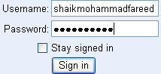
13. Approval: - Signature of QA Manager and QA Lead.

(I) Test case Preparation: -

Use Case (1): - A Gmail application allows user to authorize. A Username object allows alphabets & numeric from 4 to 20 characters long in lowercase. Were as Password object allows only alphabets from 4 to 10 characters long in lowercase. When users click on “sign in” button system will take the users in to main page of Gmail. If any invalid data enter alter messages should be display and should take back to the Login screen.

Solution: - In this application have two objects that are Username & Password. We have prepared two objects one after one.

1. Boundary Value Analysis for Username (Size):-

Conditions: - 1. 4 to 20 characters of alphabets and numeric.
2. Lowercase.

2. Equalance Class Partition for Username: -
Conditions | Values | Results
Minimum ( 4 ) | 4 | Pass
Maximum( 20) | 20 | Pass
Minimum – 1 (4-1) | 3 | Fail
Maximum -1 (20-1) | 19 | Pass
Minimum +1(4+1) | 5 | Pass
Maximum+1(20+1) | 21 | Fail

Condition: - 1. Ranges only.

Valid Range | Invalid Range
0-9 | A – Z
a- z | Blank space
 | Special characters

1. Boundary Value Analysis for Password (Text):-

Conditions: - 1. 4 to 10 characters of alphabets. 2. Equalance Class Partition for Username: -
2. Lowercase.
Condition: - 1. Lowercase
Conditions | Values | Results
Minimum ( 4 ) | 4 | Pass
Maximum( 10) | 10 | Pass
Minimum – 1 (4-1) | 3 | Fail
Maximum -1 (10-1) | 9 | Pass
Minimum +1(4+1) | 5 | Pass
Maximum+1(10+1) | 11 | Fail
Valid Range | Invalid Range
a - z | A – Z
 | Blank space
 | Special characters
 | 0 - 9
Test Case Procedure for Use Case (1): Verify the Loin Functionality.

Test Case Id | Test Case Name | Step Name | Description | Expected Results
TC_UC_001 | Verify the Login Functionality | Step 1 | Purpose:- The purpose of this Test case is to verify whether User is able to Login in to Gmail application with Valid permissions  Actors:- User  Pre-Conditions:- It should be authorized in to Gmail.
 |  | Step 2 | Open IE (Internet Explore) Browser and enter URL: www.gmail.com click on Go button. | User / System is display with “Welcome to Gmail” page with the following fields.  Username : Text  Password : Text
 |  | Step 3 | Enter Username and Password in Text field with Valid text and click on “Sign in” button. | User / System be displayed with main page of Gmail.
 |  | Step 4 | Enter Username and Password in Text field with Invalid text and click on “Sign in” button. | User / System is displayed with alert message  Error Message:  “Invalid Username &  Password”

Use Case (2): - Verify Logon System

Use Case Id : SMF_UC_001
Use Case Name : Logon System | Actors : User
Description: - Every User needs to Logon the System in order to Use its functionality. This Use Case captures the requirements related to Logon System.
Pre-Conditions : - None
User Action | System Response
(1) Use Case starts when user requests system that He/She wants to use the CEIMS functionality. | (1). System Validate the user provided details  (2). System matches the user’s Id with System database.  (3.). User requests system to give Her/His access CEIMS.  (4). System finds user provided details Invalid system  gives alert message and goes back to the Login screen.  (5). System fails to Server User’s request  (a). System any fail to complete the request. It gives alert message with corresponding error message like Database connectivity server down.

Data Elements: -

Sr.No | Name | Data type | Size  Min Max |  | Format | Properties | Display / Input
1 | User Id | Text | 6 | 20 | NA | Mandatory | Input
2 | Password | Text | 6 | 15 | Use as password characters | Mandatory | Input

1. Boundary Value Analysis for Username (Size):-

Conditions: - 1. 6 to 20 characters of alphabets

Conditions | Values | Results
Minimum ( 6 ) | 6 | Pass
Maximum( 20) | 20 | Pass
Minimum – 1 (6-1) | 5 | Fail
Maximum -1 (20-1) | 19 | Pass
Minimum +1(6+1) | 7 | Pass
Maximum+1(20+1) | 21 | Fail

2. Equalance Class Partition for Username: -

Condition: - 1. Ranges only.

Valid Range | Invalid Range
0-9 | Blank space
a- z | Special characters
A – Z

1. Boundary Value Analysis for Password (Text):-

Conditions: - 1. 6 to 15 characters of alphabets & numeric 2. Equalance Class Partition for Username:
2. Lowercase & Uppercase
Condition: - 1. Lowercase, Uppercase & num
Conditions | Values | Results
Minimum (6) | 6 | Pass
Maximum( 15) | 15 | Pass
Minimum – 1 (6-1) | 5 | Fail
Maximum -1 (15-1) | 14 | Pass
Minimum +1(6+1) | 7 | Pass
Maximum+1(15+1) | 16 | Fail
Valid Range | Invalid Range
a - z | Blank space
0 – 9 | Special characters
*
A - Z
Test Case Procedure for Use Case (2): Verify the Logon System.

Test Case Id | Test Case Name | Step Name | Description | Expected Results
TC_UC_002 | Verify the Logon System Functionality | Step 1 | Purpose:- Every User needs to Logon the System in order to Use its functionality. This Test Case captures the requirements related to Logon System  Actors:- User  Pre-Conditions:- None.
 |  | Step 2 | Double click on “.exe” file on desk top icon. | User / System is display with “Login” page of Delhi Public School.
 |  | Step 3 | Enter Username and Password in Text field with Valid text and click on “OK” button. | 1. User / System be validate the entered data with database.  2. If the entered data is valid user is display home page of CEIMS application.
 |  | Step 4 | Enter Username and Password in Text field with Invalid text and click on “OK” button. | 1. User / System is displayed with alert message  2. User/System is displayed with alert message when every database connectivity disconnects or database server down. When even our requirement is incomplete.

Use Case (3): - Verify View / Update Student Details

Use Case Id : SMF_UC_002
Use Case Name: View/Update Student Profile. | Actors : User
Description: - This Use case capture details of View / Update Student Profile details on functionality.
Pre-Conditions : - None
User Action | System Response
(1) Use Case starts when user requests system that He/She wants to use the CEIMS functionality. | (1). System ask user to provide following search details.  Admission Number.  Academic Year.  (2). User provides the search key details and press view button.  (3). System validates the search key details.  (4). System shows that details of the requested Student profile if found.  (5). User can change the student profile details and press update button to save or cancel button to ignore.  (6). If no details found shows message “There is no search criteria”.

Test Case Procedure for Use Case (3): Verify View / Update Student Profile

Test Case Id | Test Case Name | Step Name | Description | Expected Results
TC_UC_003 | Verify the View / Update Student Profile Functionality | Step 1 | Purpose:- This Test case capture details of View / Update Student Profile details on functionality.  Actors:- User
 |  | Step 2 | Loin to School project with valid data prevention. | User / System is display with “Login” page of Delhi Public School successfully.
 |  | Step 3 | Click View/Update Student Profile link | User / System is displayed with update Student Profile page with the following fields  Admission Number.  Academic Year.
 |  | Step 4 | Enter Admission Number & Academic year & click on View button | User / System is displayed with Search results if available or user is displayed with message if no details found.  “There is no search criteria”
 |  | Step 5 | Modify any one of the filed and click on Update button | User/System is displayed with message successfully updated.
 |  | Step 6 | Modify any one of the filed and click on Cancel button | User/System is displayed with message successfully Canceled.

Use Case (4) SBI Form: -

Depositor Name

Area Code

Prefix

Suffix

Command

6 Characters with alpha numeric

3 Digits but with blank space (empty

3 Digits but it should not start with 0 & 1

6 Digits with numeric

FD, TF, BE, CD

Submit

The SBI Bank provides online services to the customer in order to use they services. If the user wants to perform any operations through online then he has to full fill above condition by login into SBI Bank online. Develop a test case for the above scenarios.

1. Verify Depositor Name:-

à Boundary Value Analysis for Depositor Name (Size):- Equalance Class Partition for Depositor Name

Min = Max = 6 Characters à Pass Valid Invalid
Min = Max = 7 Characters à Error 0 – 9 Blank spaces
Min = Max = 5 Characters à Error A – Z Special Symbols
a – z
2. Verify Area Code:-

à Boundary Value Analysis for Area Code (Size):- Equalance Class Partition for Area Code

Min = Max = 3 Digits à Pass Valid Invalid
Min = Max = 2 Digits à Error 0 – 9 A - Z
Min = Max = 4 Digits à Error Blank Space Special Symbols
Blank Space à Pass a – z

3. Verify Prefix: -

à Boundary Value Analysis for Prefix (Size): - Equalance Class Partition for Prefix

Min à 200 à Pass Valid Invalid
Max à 999 à Pass 0 – 9 A - Z
Min – 1 à 199 à Fail (but 0 & 1 a - z
Min + 1 à 201 à Pass should be Special Symbols
Max – 1 à 998 à Pass starts)
Max + 1 à 1000 à Fail

2. Verify Suffix:-
à Boundary Value Analysis for Suffix (Size):- Equalance Class Partition for Suffix

Min = Max = 6 Digits à Pass Valid Invalid
Min = Max = 5 Digits à Error 0 – 9 A - Z
Min = Max = 7 Digits à Error Special Symbols
a – z

Test case for SBI: -

Test Case Id | Test Case Name | Step Name | Description | Expected Results
TC_UC_004 | Verify the Balance text  fields  Functionality | Step 1 | Purpose:- The purpose of this test case is to validate text field available in balance form  Actors:- User  Pre-Condition:- User should existed with balance account.
 |  | Step 2 | Open IE and enter URL: www.sbi.com and click on Go button. | User / System is display with home page of SBI Bank with different links successfully.
 |  | Step 3 | Click on login menu link. | User / System is displayed with login page with the following filed  Account Number: Text  Password : Text  Sign in : Button
 |  | Step 4 | Enter Account Number & Password & Click on Sign in button. | User / System is displayed with “Welcome to SBI” Bank page with different links.
 |  | Step 5 | Navigate to Balance menu link | User/System is displayed with Balance page with the following fields like Depositor Name, Area Code, Prefix, Suffix, Command & Submit button
 |  | Step 6 | Enter valid text in all the above text fields and select any one of the option from command drop down & click on Submit button. | User/System is displayed with home page of any one of the option that is selected in command drop down.
 |  | Step 7 | Repeat Step no. (6) for the remaining options available in command drop down. | User/System is displayed with home page of any one of the option that is selected in command drop down
 |  | Step 8 | Enter all the fields except Area Code and select any one of the option form command click on submit button. | No Error Message should be display to the user.
 |  | Step 9 | Enter Invalid text in any one of the filed & select any option from command and click on submit button. | User is displayed with alert message.

(VI) Review Testing Cases: -

After completion of developing Test cases for the current version of all functionality QA Lead or QA Manager will concentrated to review all the test cases for the completeness & correctness, and develop a documentation called as Requirement Traceable Matrixes (RTM) or Validation Traceable Matrixes (VTM). This document defines mapping between the developer test case and the customer requirements.

BRS, Use Case Design Document | Developed Test Cases
Login | Steps  *********  *********  ********* Deleting  *********
New Student Profile | Steps  *********  *********  ********* Adding  *********

In the above review documents developed by QA Leas or QA Manager in order to maintain completeness & correctness of all test cases. And they will decide what the test cases to be done under Manual are & what are the test cases to be done under Automation. This is the finalized document for entire application testing.

Build Version Control: -
Old Version
Modify Build

Build
+
Supported Software
Soft base in Server

New Version
Install
Hospital B_00.1

FTP / IP Create New Folder.
New Version
QA Environment

QA Team

Fig: - Build Version Control

After completion of entire development team process deployment team will concentrate to deploy the current version build into soft base in server with respected to supported software’s.

A tester will download the current version through FTP / IP in to they system and they installed the current version according to the initialization guide line by the development team. To maintain all types of version like, New, Old & Modified build are versions they may use configuration management tools like Visual Source Safe (VSS) & Congruent Version System (CVS) or Quality Center 10.

A developer will mail to testing team regarding URL to work with local system, IP address to work with remote system and also initializations instructions if required.

Test Harshness: - The application which is readiness to go for the test execution is called as Test Harshness.
Test Harshness = Test Bed + Test Environment

Test Cases Software & Hardware

(VII) Test Execution: -

After completion of entire development team process a tester will receive initial build from development team and once they complete installing successfully they can test the applications in two types there are 1. Manual Testing. 2. Automation Testing.

To executed the application a tester will follow the below testing work flow.

Development Stage Testing Stages

(BVT / TAT / BLT / TT / OT / DT)
Level-0 → Smoke / Sanity Testing

If all Test Case Pass If any Test Case Fail

Smoke Test Case Fail

Resolve If Possible → Automation Testing.

Modify Build

(Defect) Real Time Testing (P0, P1 & P2) Entire functionality Testing
Fix the Defect Level – 1 → Comprehensive Testing
(Stop & Forward)
Modify Build
Level – 2 → Regression Testing.

Master Build
Level – 3 → Final Regression Testing.
High Bug density

Fig: - Work Flow Execution Testing

Level – 0: - This is the first process which should be following for every version testing in order to verify the stability of the application. This can be followed both Manual Testing & Automation Testing. During this process a tester have to verify the basic functionality like checking every menu link & entire some valid or invalid data, to check whether accepting or not etc. A tester will follow the below 8 factors (Octangle Factors) are:

1. Understandable 2. Maintainable 3. Operate able 4. Controllable
5. Simplicity 6. Consistency 7. Testable 8. Automoble

The above 7 factors are followed for Manual Testing Process and 8th Factor is Automation Testing.
If any one of the factor is failure tester can reject the initial build.

Level – 1: - After complete of all possible Smoke/Sanity testing testers will concentrate to execute the entire functionality test cases like Basic Functionality (P0), General Functionality (P1) and Cosmetic Functionality (P2). During test execution, a tester has to compare the given expected results with application behavior values in step by step and they need to maintain documentation is called as “Test Logs”.

Test Logs: - 1. Passed
2. Failed
3. Not Completed
4. No Run
5. Deferred
6. Blocked.
During execution, if tester is finding any mismatches they need to reports Log CR’s (Change Request) in to defect tracking tool

Level – 2: - Regression Testing.

Level – 3: - This level of testing is followed on the Master Build or High Bug density
- Master Build: - The product / application which is readiness to release the customer or the product / application which is totally free from bugs.
- High Bug density: - The average number of bugs found in a modules.

This level testing is following once again to on Master build to ensure bug fix works & accuracy of any side effects.

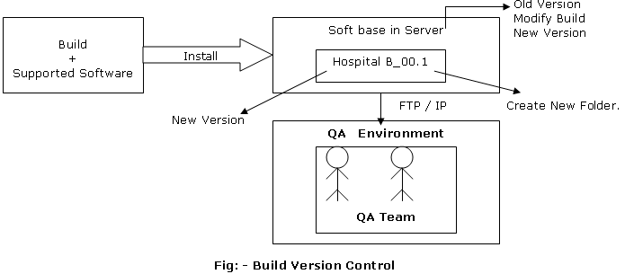

Observations of Testing Tools

S.No | Observation |  | Meaning of Observation
1 | SRS | → | Software Requirement Specification.
2 | SQA | → | Software Quality Assurance
3 | STLC | → | Software Testing Life Cycle.
4 | SDLC | → | Software Development Life Cycle.
5 | QC | → | Quality Center
6 | VSS | → | Visual Source Safe.
7 | CVS | → | Congruent Version System
8 | QTP | → | Quick Test Professional
9 | CR | → | Change Request
10 | UC | → | Use case.
11 | TC | → | Test Case
12 | BRS | → | Business Requirement Specification
13 | URS | → | User/Customer/Functional/Marking Requirement Specification.
14 | FRS | → | Functional Requirement Specifications
15 | KOM | → | Kick of Meeting
16 | CA | → | Chief Architecture
17 | UCD | → | Use case Document
18 | BRD | → | Business Requirement Document
19 | WBT | → | White Box Testing.
20 | BBT | → | Black Box Testing.
21 | FTP | → | File Transport Protocol
22 | IP | → | Internet Protocol
23 | MST | → | Manual Support Testing
24 | CBR | → | Customer Business Requirement
25 | GUI | → | Graphical User Interface
26 | BVA | → | Boundary Value Analysis
27 | ECP | → | Equalance Class Partition
28 | NIC | → | Network Interface Card
29 | OS | → | Operating System.
30 | CR | → | Change Request. Or Tickets
31 | CCB | → | Change Control Board.
32 | UAT | → | User Accepting Testing
33 |  | →

S.No | Observation |  | Meaning of Observation
1 | SRS | → | Software Requirement Specification.
2 | SQA | → | Software Quality Assurance
3 | STLC | → | Software Testing Life Cycle.
4 | SDLC | → | Software Development Life Cycle.
5 | QC | → | Quality Center
6 | VSS | → | Visual Source Safe.
7 | CVS | → | Congruent Version System
8 | QTP | → | Quick Test Professional
9 | CR | → | Change Request
10 | UC | → | Use case.
11 | TC | → | Test Case
12 | BRS | → | Business Requirement Specification
13 | URS | → | User/Customer/Functional/Marking Requirement Specification.
14 | FRS | → | Functional Requirement Specifications
15 | KOM | → | Kick of Meeting
16 | CA | → | Chief Architecture
17 | UCD | → | Use case Document
18 | BRD | → | Business Requirement Document
19 | WBT | → | White Box Testing.
20 | BBT | → | Black Box Testing.
21 | FTP | → | File Transport Protocol
22 | IP | → | Internet Protocol
23 | MST | → | Manual Support Testing
24 | CBR | → | Customer Business Requirement
25 | GUI | → | Graphical User Interface
26 | BVA | → | Boundary Value Analysis
27 | ECP | → | Equalance Class Partition
28 | NIC | → | Network Interface Card
29 | OS | → | Operating System.
30 | CR | → | Change Request. Or Tickets
31 | CCB | → | Change Control Board.
32 | UAT | → | User Accepting Testing
33 |  | →

- SRS → Software Requirement Specification.
- SQA → Software Quality Assurance.
- STLC → Software Testing Life Cycle.
- SDLC → Software Development Life Cycle.
- QC → Quality Center.
- VSS → Visual Source Safe.
- CVS → Congruent Version System.
- QTP → Quick Test Professional.
- CR → Change Request.
- UC → Use case.
- TC → Test Case.
- BRS → Business Requirement Specification.
- URS → User/Customer/Functional/Marking Requirement Specification.
- FRS → Functional Requirement Specifications.
- KOM → Kick of Meeting.
- CA → Chief Architecture
- UCD → Use case Document.
- BRD → Business Requirement Document.
- WBT → White Box Testing.
- BBT → Black Box Testing.
- FTP → File Transport Protocol
- IP → Internet Protocol.
- MST → Manual Support Testing.
- CBR → Customer Business Requirement
- GUI → Graphical User Interface.
- BVA → Boundary Value Analysis.
- ECP → Equalance Class Partition.
- NIC → Network Interface Card.
- OS → Operating System.
- CR → Change Request. Or Tickets
- CCB → Change Control Board.
- UAT → User Accepting Testing.

