Use Case Diagram of Chairman:

Add Branch Head
Add Card type
Reports
Administrator

Use case Diagram of BranchHead:

BranchHead
Enquiry
Registration
Reports
BranchHead

Sequence Diagram of Chairman:

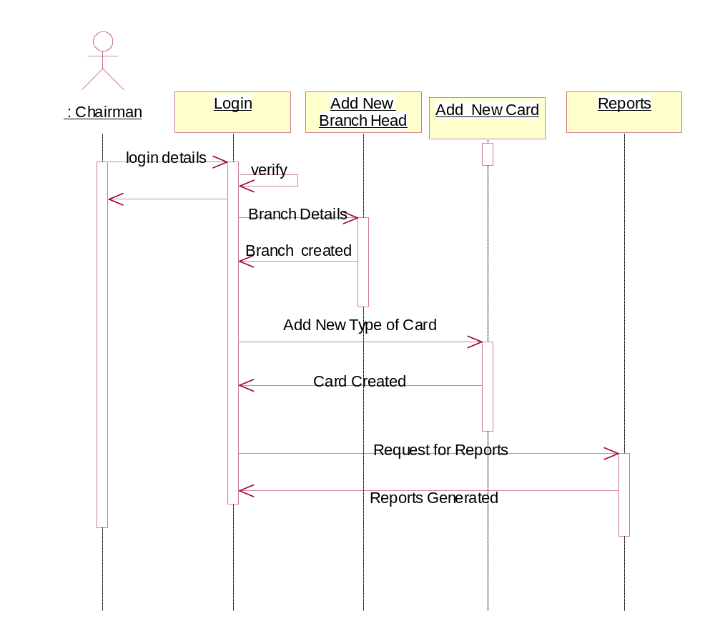

Collaboration Diagram of Chairman :

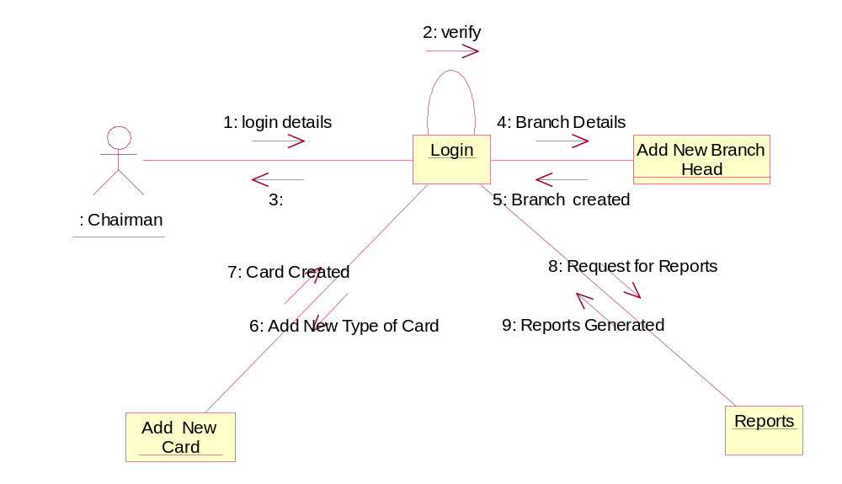

Sequence Diagram of BranchHead:

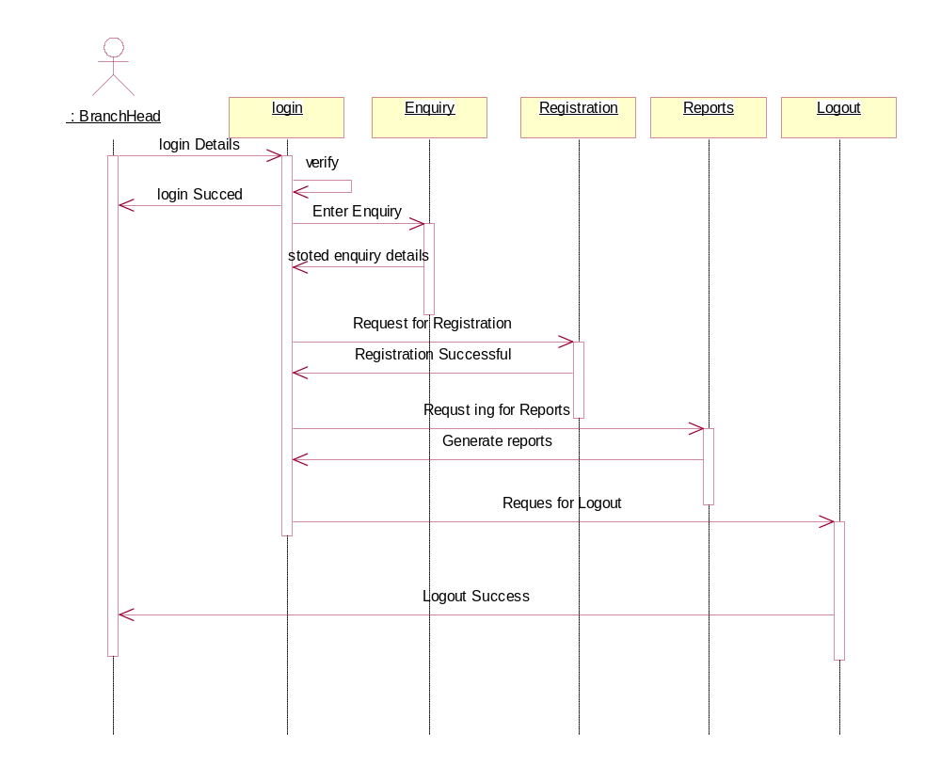

Collaboration Diagram of Branch Head:

