Ch.02 Neutrons Interactions

# Introduction

# Radioactive Decay:

Probability of interactions is the decrease in intensity:

# Number and weight fractions:

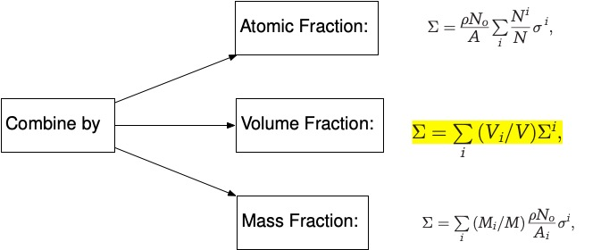

Enrichment fraction

(

(

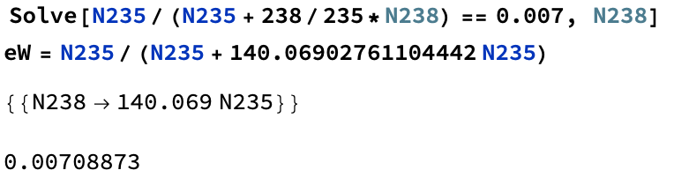



# Using Online Databases for Cross sectional data

<https://nds.iaea.org/exfor/servlet/E4sMakeE4>



# Homework Problems

