KING FAHD UNIVERSITY of PETROLIUM and MINERALS
Physics Department
METHODS OF THEORETICAL PHYSICS (Phys 210)
Spring 2020/2021-202

Exam Final
Instructor Dr. Thamer Al-Aithan
Allowed Time: 2:30

Show your work

Q1. Solve the following differential equation by the method of Frobenius (generalized power series).
x²y’’ − 6y = 0

Q2. Show that
J₁(x) + J₃(x) = (4/x)J₂(x) , where Jp(x) is Bessel function of first kind.

Q3. Use the following property of Bessel DE and Bessel solutions,
x(xy’)’ + (K²x² − p²)y = 0 has solutions J_{p}(Kx) and N_{p}(Kx).
to write the solutions of the following problem.
x²y’’+ xy’+ (16x² − 1)y = 0

Q4.
- Show that R = lx−(1−x²)D and L = lx+(1−x²)D, where D = d/dx, are raising
and lowering operators for Legendre polynomials. More precisely, show
that
RP_{l−1}(x) = lP_{l}(x) and LP_{l}(x) = lP_{l−1}(x).

Assuming that all P_{l}(1) = 1,

b) solve LP₀(x) = 0 to find P₀(x) = 1.

c) then use raising operators to find P₁(x) and P₂(x).

Q5. Solve the semi-infinite plate problem if the bottom edge of width 20 is held at

0º , 0 < x < 10
T ={
100º , 10 < x < 20

and the other sides are at 0.
. 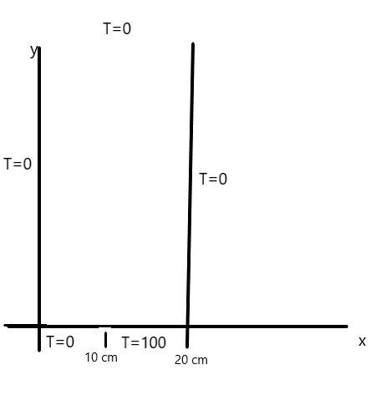
Q6. Find the Cauchy-Riemann equations in polar coordinates.
Hint: Write z = re^{iθ} and f(z) = u(r, θ) + iv(r, θ).

Q7. Evaluate the following line integral in the complex plane

∫e ^{-z} dz

along the positive part of the line y = π;

Q8. . Evaluate the following line integral in the complex plane

∫ dz e^{3z} /( z − ln 2)

if C is the square with vertices ±1 ± i.

Q9.For the following function, say whether the indicated point is regular, an essential
singularity, or a pole, and if a pole of what order it is.

- ( e^{z} – 1)/( z² + 4), z= 2i.
- tan² z , z = π/2
- ( 1 − cos z)/( z⁴), z= 0
- Cos(π/(z-π)), z=π

Q10. If C is a circle of radius ρ about z₀, show that

∫ dz /( z − z_{o})^{k} =2πi , k=1

but for any other integral value of k, positive or negative, the integral is zero.

Q11. Find the residues of the following function at the indicated points.

(z – 2)/z( 1 - z), at z=0 and z=1

Q12. . Evaluate the following by contour integral.

∞
∫ dx.x² /(x⁴ +16)
⁰

Q13. Find the C matrix which diagonalizes the matrix M of the following matrix M. Observe that M is not symmetric, and C is not orthogonal .However, C does have
an inverse; find C⁻¹ and show that C⁻¹MC = D.

5 1
M= 4 2

Q14 Given u = xy + sinz, find

- the gradient of u at (1, 2, π/2);
- how fast u is increasing, in the direction 4i + 3j, at (1, 2, π/2);

Q15 Given

1, −2 < x < 0
f(x) =
-1, 0 < x < 2

find the exponential Fourier transform g(α) and the sine transform gs(α). Write
f(x) as an integral and use your result to evaluate

∞
∫ d α (cos 2α − 1) sin 2α/( α)
⁰

