Ch.01 Nuclear Reactions

Introduction: Mass Energy Equivalence
$$E=m*c^{2}$$

Table 1 Energy density of various fuels adapted from [WP 1]
Storage Material | Energy Type | Specific energy (MJ/kg) | Current uses
Deuterium | Nuclear fusion | 87,900,000 | Experimental
Uranium (in breeder) * | Nuclear fission | 80,620,000 | Nuclear power plants
Thorium (in breeder) | Nuclear fission | 79,420,000 | Experimental
Plutonium 238 | Nuclear decay | 2,239,000 | Space crafts as radioactive thermal generator (RTG)
Liquified Natural Gas** | Chemical | 56 | Power plant, Heating
Diesel | Chemical | 48 | ICE/ Power plants
Gasoline (petrol) | Chemical | 46 | ICE/ Power plants
Coal | Chemical | 30 | Electric power plant
*Fission: U-235 + n (7-8MeV) fission products + 200MeV/reaction ≅ 80 x10⁶ MJ/kg
**Combustion: CH₄ +3 O₂ CO₂ +2 H₂O + 810kJ/mole ≅ 55 MJ/kg or 1.5million times less than U235

1GW Coal plant: 10,000 ton per day
1GW Nuclear plant: 20 ton/year
Ratio: (182500X)!

Nuclear Reaction Fundamentals

The Curve of Binding Energy

Fusion Reactions

Fission Reactions

https://wwwndc.jaea.go.jp/cgi-bin/FPYfig?iso=nU235&typ=g3
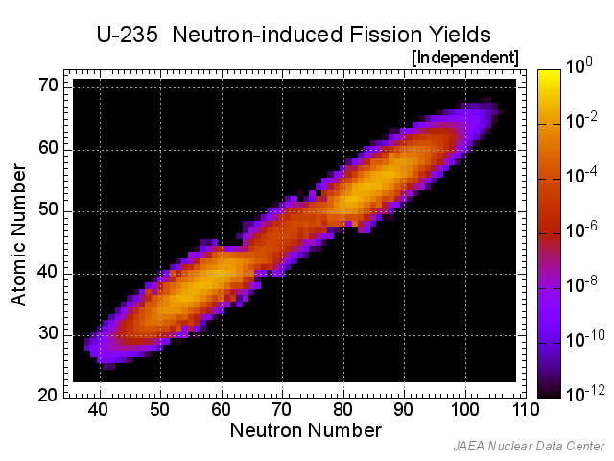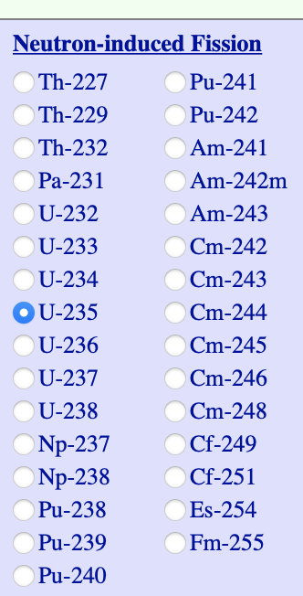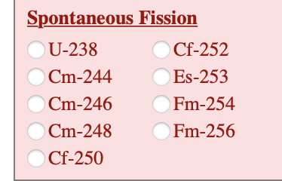

Energy Release and Dissipation

Neutron Multiplication

Fission Products

Fissile and Fertile Materials

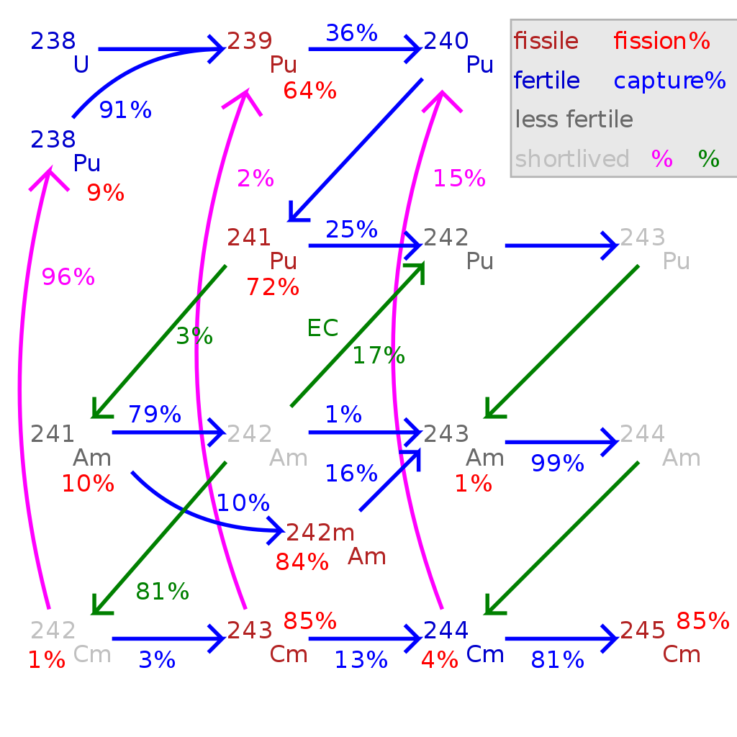
Some other actinides need more than one neutron capture before arriving at an isotope which is both fissile and long-lived
- uranium-236 to neptunium-237 to plutonium-238 to plutonium-239
(wasteful of neutrons and often undesired. (in future accelerator based designs, it might be possible)

Radioactive Decay
There are 43 decay modes! Not all are common though.

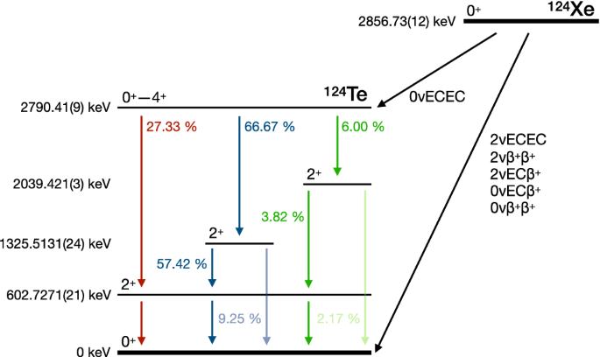
Using IsotopeData[] and decay modes and flattening the table, you could arrive to the most common ones:

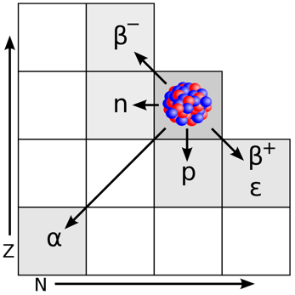

Not all isotopes are equally stable. Radium is an example of variety:

Saturation Activity

File Name: Lewis.Ch01.Equations.Nuclear.Reactions.nb

Decay Chains

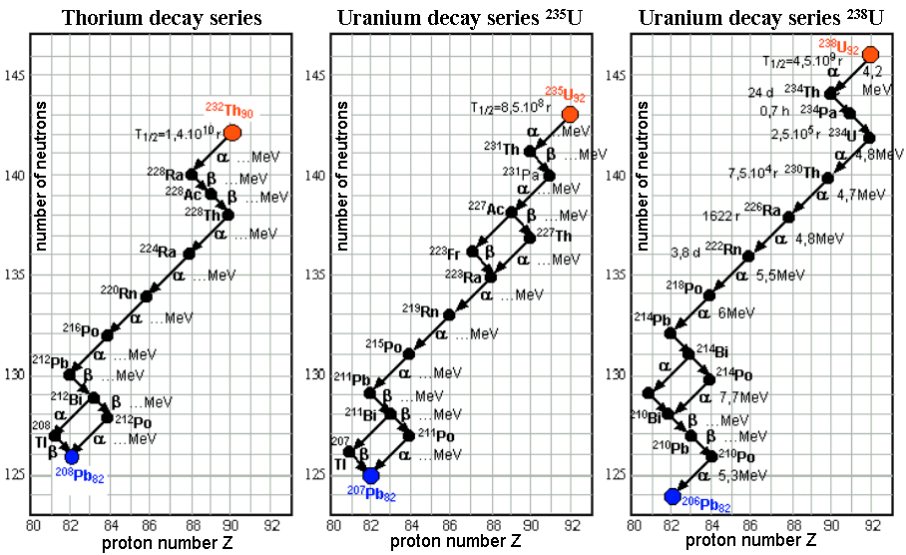
https://astronuclphysics.info/JadRadFyzika4.htm

Appendix: Using Online Databases for Cross sectional data
https://nds.iaea.org/exfor/servlet/E4sMakeE4

Appendix: Greek Alphabet

# | Capital letter | Small case | Greek Name | English counterpart
1 | A | $$α$$ | Alpha | a
2 | $$Β$$ | $$β$$ | Beta | b
3 | $$Γ$$ | $$γ$$ | Gamma | g
4 | $$Δ$$ | $$δ$$ | Delta | d
5 | $$Ε$$ | $$ϵ$$ | Epsilon | e
6 | $$Ζ$$ | $$ζ$$ | Zeta | z
7 | $$Η$$ | $$η$$ | Eta | h
8 | $$Θ$$ | $$θ$$ | Theta | th
9 | $$Ι$$ | $$ι$$ | Iota | i
10 | $$Κ$$ | $$κ$$ | Kappa | k
11 | $$Λ$$ | $$λ$$ | Lambda | l
12 | $$Μ$$ | $$μ$$ | Mu | m
13 | $$Ν$$ | $$ν$$ | Nu | n
14 | $$Ξ$$ | $$ξ$$ | Xi | x
15 | $$\backslash Omicron$$ | $$\backslash omicron$$ | Omicron | o
15 | $$Π$$ | $$π$$ | Pi | p
16 | $$Ρ$$ | $$ρ$$ | Rho | r
17 | $$Σ$$ | $$σ$$ | Sigma | s
18 | $$Τ$$ | $$τ$$ | Tau | t
19 | $$Υ$$ | $$υ$$ | Upsilon | u
20 | $$Φ$$ | $$ϕ$$ | Phi | ph
21 | $$Χ$$ | $$χ$$ | Chi | ch
22 | $$Ψ$$ | $$ψ$$ | Psi | ps
23 | $$Ω$$ | $$ω$$ | Omega | O

http://www.johnkerl.org/doc/ortho/ortho.html

