Ch.02 Neutrons Interactions

Introduction

Radioactive Decay:

$$I\left(x+dx\right)=\left(1-Nσdx\right)I(x)$$
$$\frac{I\left(x+dx\right)-I\left(x\right)}{I\left(x\right)}=-Nσdx$$
$$\ln\left(I\left(x\right)\right)=-Nσx$$
$$I\left(x\right)=I\left(0\right)*e^{-Nσx}≡I\left(0\right)*e^{-Σx}$$

$$I\left(x\right)=I\left(0\right)*e^{-Nσx}≡I\left(0\right)*e^{-Σx}$$

Probability of interactions is the decrease in intensity:
$$MFP:λ=\int_{0}^{∞}{xp\left(x\right)dx}=\int_{0}^{∞}{xΣe^{\left(-Σx\right)}dx=\frac{1}{Σ}}$$
$$N_{0}$$
$$Current population$$
$$N(t)$$
$$Initial$$
$$population$$
$$N_{0}=0$$
$$Activity:λ N(t)$$
$$population$$
$$N_{0}$$
$$Constant Supply: A_{0}$$
$$Activity:λ N\left(t\right)=A_{0}\left(1-e^{-λt}\right)$$

Number and weight fractions:
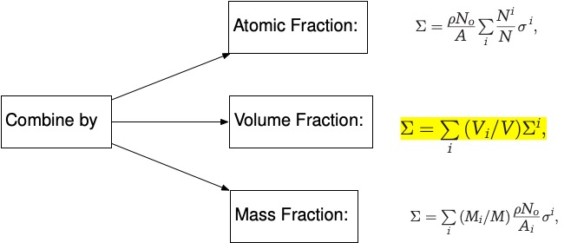
Enrichment fraction

$${\tilde{e}}_{a}=\frac{N^{235}}{N^{235}+N^{238}}$$
$$Σ^{U}=\frac{ρ_{U}*N_{0}}{{\tilde{e}}_{a}*235+\left(1-{\tilde{e}}_{a}\right)*238}*\left({\tilde{e}}_{a}*σ^{235}+\left(1-{\tilde{e}}_{a}\right)*σ^{238}\right)$$
($ρ_{u} is a slight function of enrichment and must be adjusted!)$

($ρ_{u} unless density is always computed based on natural sample or 0.7\% )$
$${\tilde{e}}_{W}=\frac{m^{235}}{m^{235}+m^{238}}$$
$$Σ^{U}=ρ_{U}*N_{0}*\left(\frac{{\tilde{e}}_{W}}{235}*σ^{235}+\frac{\left(1-{\tilde{e}}_{W}\right)}{238}*σ^{238}\right)$$
$${\tilde{e}}_{W}=0.007$$
$${\tilde{e}}_{W}=\frac{m^{235}}{m^{235}+m^{238}}=\frac{235*\frac{N^{235}}{N_{0}}}{\frac{{235*N}^{235}}{N_{0}}+\frac{{238*N}^{238}}{N_{0}}}=\frac{N^{235}}{N^{235}+{\frac{238}{235}*N}^{238}}=0.007$$
$$→N238=N235*140.069 \\ →{\tilde{e}}_{N}=\frac{N^{235}}{N^{235}+N^{238}}=\frac{N^{235}}{N^{235}+140.06902761104442*N^{235}}=0.00708873=0.00709$$

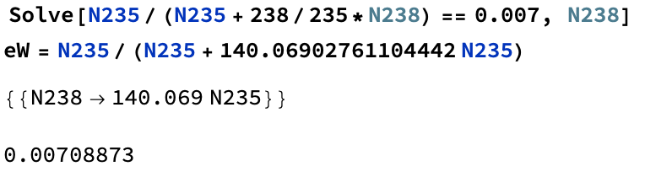

$$σ_{t}=σ_{s}+σ_{a}=σ_{s}+\left(σ_{γ}+σ_{f}\right)$$

Using Online Databases for Cross sectional data
https://nds.iaea.org/exfor/servlet/E4sMakeE4

$$\overline{ξ}=\frac{1}{Σ_{s}}$$

Homework Problems

