* **Objectives**

Michelson Interferometer aims to measure the refractive index of air thru application of its setup.

* **Result & Discussion**

Using refractive index formula ( na = 1 + ***ΔN ƛ0/***  ***L )*** anddata given for ***ΔN*** , ***ƛ0 = 63208 nm*** *and* ***L = 7.5 cm*** the following values for refractive index of air is calculated:

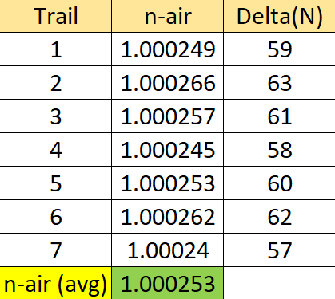

**Q#1:**

IF **nair-real = 1.000293** , then :

**%error = $\frac{| \left(n real - n measured \right)| }{n real} x 100$ = 4%.**

This small percentage may occur due to the imperfection of evacuation where that is going to affect the number of fringes and*nair* is affected ultimately. Also, the percentage is acceptable to some extent.

**Q#2:**

Yes, it is. Because if , e.g., a white light is used, then fringes with different colors are going to showed up on the screen. Where that will make it difficult to count and differentiate between fringes and their position.

**Q#3:**

There are three possible sources of error:

1. The alignment of the apparatus could be not accurate
2. Cell may have not been evacuated totally.
3. Fringes counted could be different due human inaccuracy.

**Q#4**

Given ***n****He* ***= 1.000036* , then :**

***N****He* ***= No x n****He = ( 237042) x 1.000036 = 237050 wavelength,* ***ΔN = 8*** (+1 or -1 ).

* **Conclusion**

To sum up, Michelson Interferometer experiment measured the refractive index of air successfully. Although, there were some significant points I would like to emphasize. One is that manual evacuation process is not accurate, instead if there was an electric evacuation pump, things are going to be more accurate. Second, counting fringes manually could be useful, but finding an alternative way to count the fringes automatically once they generated will let life easier. Third, a wondering crosses my mind, what if we replace the shape of the mirrors and splitter, does that going to reshape the fringes, who knows ? Fourth, I think it is a good idea to link Aether and LIGO as an appendix subjects for those students who are interested. Finally, it was valuable tool that have been added to my Physics-set.