**King Fahd University of Petroleum & Minerals**

**Physics Department**

**PHYS 308 (Term 211)**

**Final Exam (02 hours, 25/25)**

**Sunday, January 02, 2022**

**Clearly circle only the correct answer. Unclear or multiple answers will be considered as wrong.**

**Problem 1. (2.5/25)**

For the following circuit, assuming a constant 0.7 V drop model, determine the value of the diode current when VA = 10 V?



1. 8.6 mA
2. 9.3 mA
3. 0.7 mA
4. 5 mA
5. 0 mA

**Problem 2.** **(2.5/25)**

The following circuit shows a voltage regulator with a zener diode (VZ0 = 5V and rz = 50 Ω), a resistor R of 500 Ω, and a load resistor RL of 1kΩ.

Find the variation in output voltage VO if the source voltage VS varies by ± 500 mV.

1. ± 12.6 mV
2. ± 23.4 mV
3. ± 43.5 mV
4. ± 14.3 mV
5. ± 10.7 mV

**Problem 3.** **(2.5/25)**

In a full-wave bridge rectifier circuit with filter, the ripple voltage Vr is equal to:

$V_{r}=(V_{S} - V_{D})/(fRC)$

$V_{r}=(V_{S} - {2V}_{D})/(2fRC)$

$V_{r}=V_{S}/(fRC)$

$V_{r}=(V_{S} - V_{D})/(2fRC)$

$V_{r}=(V_{S} - {2V}_{D})/(fRC)$

**Problem 4. (2.5/25)**

For the following circuit, assuming the op-amp is ideal, determine the current I1 when Vi = 2 V.



1. 0.2 mA
2. 1.0 mA
3. 2.2 mA
4. 0 mA
5. 2.0 mA

**Problem 5. (2.5/25)**

The op-amp has the following parameters: AOL = 50,000; Zin = 4 MΩ; and Zout = 50 Ω.

Find the value of the output impedance.



1. 380 mΩ
2. 620 mΩ
3. 160 mΩ
4. 720 mΩ
5. 980 mΩ

**Problem 6. (2.5/25)**

The resistor values are Rf = 470 kΩ; R1 = 4.3 kΩ; R2 = 33 kΩ and R3 = 33 kΩ.

Find the output voltage for an input of 80 μV.

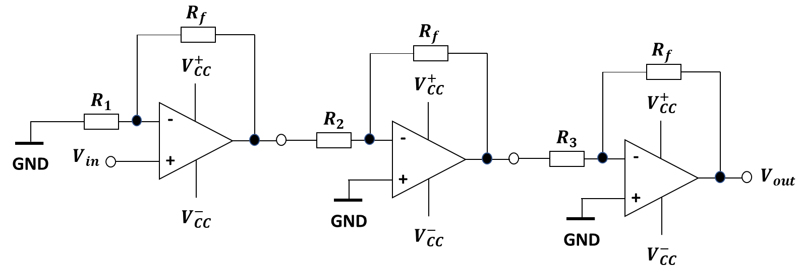

1. 2.4 V
2. 5.6 V
3. 3.3 V
4. 1.3 V
5. 1.8 V

**Problem 7. (2.5/25)**

Determine the voltage VCE in the circuit below. Take β = 100.

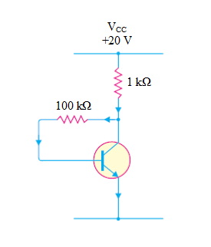

1. 10.4 V
2. 12.8 V
3. 9.50 V
4. 8.20 V
5. 11.3 V

**Problem 8. (2.5/25)**

To ensure active mode operation in a NPN BJT transistor, which of the following conditions is true?

1. VC < VE
2. VB < VE
3. VC > (VB - 0.4 V)
4. VC < (VE + 0.3 V)
5. VC > (VE – 0.7 V)

**Problem 9. (2.5/25)**

Which of the following statements is **NOT TRUE**?

1. Common emitter amplifier can be used as a voltage amplifier
2. Common collector amplifier has very high output resistance
3. Adding a resistor in the emitter of common emitter amplifier will reduce the gain
4. Coupling capacitors are used to keep the DC bias point unchanged when connecting the load and the source

**Problem 10. (2.5/25)**

In the circuit shown below, VCC = 5 V, β = 80, RC = 1 kΩ and IC = 2.5 mA, the value of RB is

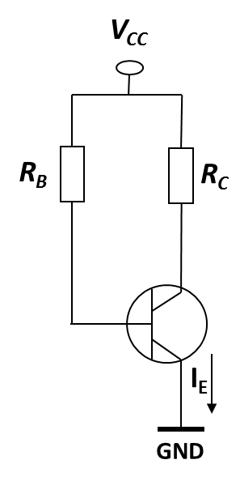

1. 137.6 kΩ
2. 160.5 kΩ
3. 100 kΩ
4. 10 kΩ
5. 5 kΩ