**King Fahd University of Petroleum & Minerals**

**Physics Department**

**PHYS 308 (Term 211)**

**First Major Exam (1 hour 30 minutes, 15/15)**

**The solution must contain all the detailed steps and calculations**

**Monday, October 25, 2021**

**Always take the value of 0.7 V for Silicon**

**Problem 1. (2.5/15)**

The following circuit uses identical diodes with I*S* = 1.5x10-16 A, n = 1 and VT = 0.025 V. Use the exponential model to determine the value of Vo when IB = 3.2 mA and R = 1k**.**

**Solution.**

$$I_{D}=\frac{I_{R}}{2}=1.6 mA$$

$$V_{D}=nV_{T} ln\frac{I_{D}}{I_{S}}=0.025 ln\left(\frac{1.6×{10}^{-3}}{1.5×{10}^{-16}}\right)=0.75 V$$

$$V_{o}=2V_{D}+I_{B}R=1.5+3.2=4.7 V$$

**Problem 2. (2.5/15)**

The following circuit shows a voltage regulator with a Zener diode (VZ0 = 5V, rz = 50 Ω), a resistor R = 500 Ω, and a load resistor RL = 1kΩ.

1. Write an expression for ∆V0/∆VS.
2. Find the variation in output voltage if the source voltage VS varies by ± 500 mV.

a)

b)

**Problem 3. (2.5/15)**

For the circuit below:

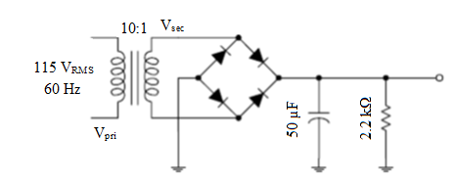

1. Find the output DC voltage.
2. Determine the ripple factor in percentage.
3. Is the capacitor used appropriate for the required ripple factor? Explain
4. Determine the load current.

**Solution.**

See the solution in homework 1.

**Problem 4. (2.5/15)**

Determine the Q-point for the circuit below and draw the dc load line. Find the maximum peak value of base current for linear operation. Assume βDC = 200.

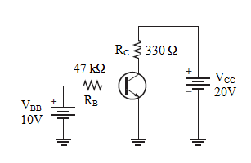



**Problem 5. (2.5/15)**

Determine VCE and IC in the voltage-divider biased transistor circuit of the figure below if βDC = 100.

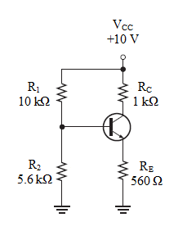

**Solution.**

$$V_{B}≅\left(\frac{R_{2}}{R_{1}+R_{2}}\right)V_{CC}=\left(\frac{5.6 kΩ}{15.6 kΩ}\right)10V=3.59 V$$

$$V_{E}=V_{B}-V_{BE}=3.59 V-0.7 V=2.89 V$$

$$I_{E}=\frac{V_{E}}{R_{E}}=\frac{2.89 V}{560 Ω}=5.16 mA$$

$$I_{C}≅I_{E}=5.16 mA$$

$$V_{C}=V_{CC}-I_{C}R_{C}=10 V-\left(5.16 mA\right)\left(1.0 kΩ\right)=4.84 V$$

$$V_{CE}=V_{C}-V_{E}=4.84 V-2.89 V=1.95 V$$

**Problem 6. (2.5/15)**

Determine whether the transistor in the figure below is in saturation.

Assume VCE (sat) = 0.2 V.

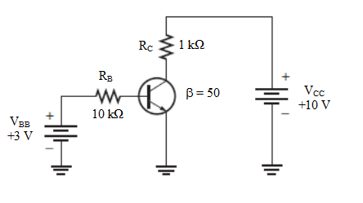

**Solution.**

First, we determine IC(sat).

Now, we see if IB is large enough to produce IC(sat).

This shows that with the specified β, the base current is capable of producing an IC greater than IC(sat). Therefore, the transistor is saturated.