**Problem 1**

For the common-emitter (CE) amplification circuit below:

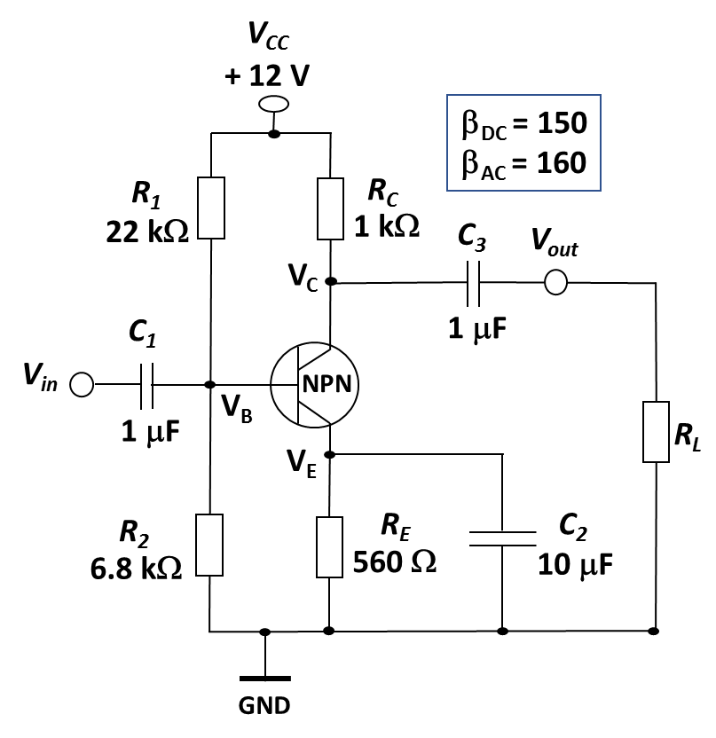

1. Determine the bias current $I_{E}.$ 2 points
2. Determine $R_{in(total)}$ seen by the source ( $V_{in}).$ 2 points
3. Determine the voltage gain from base to collector without the load ($R_{L}$). 2 points
4. Determine the voltage gain from base to collector when a load ($R_{L}=5 k$) is connected to the output. 2 points
5. What will happen to the voltage gain when the bypass capacitor is removed? 1 point
6. Why is a partially bypassed emitter resistor used? 1 point

**Note: In AC analysis, use the simplified *T*-model of BJT at room temperature.**

1. **2 points**

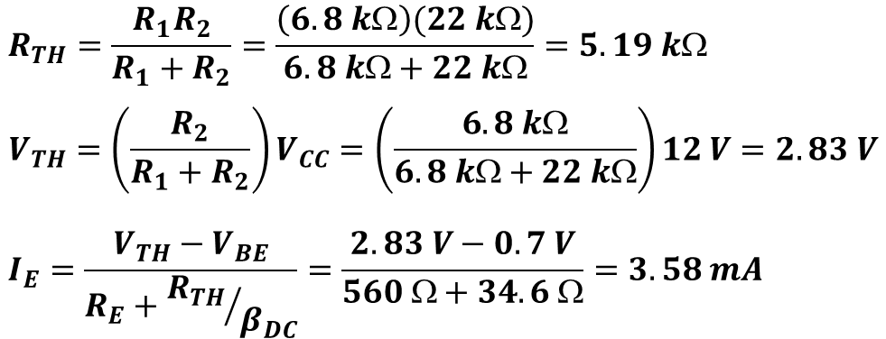

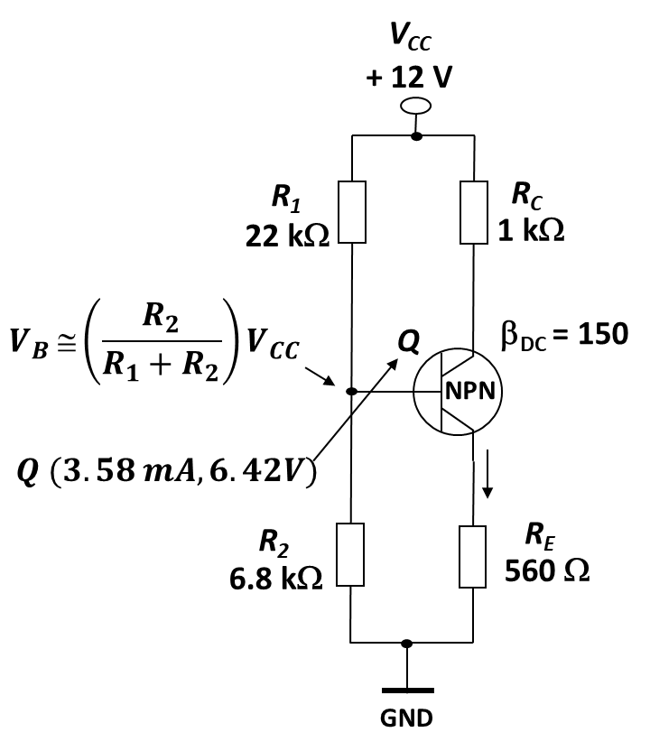

1. **2 points**

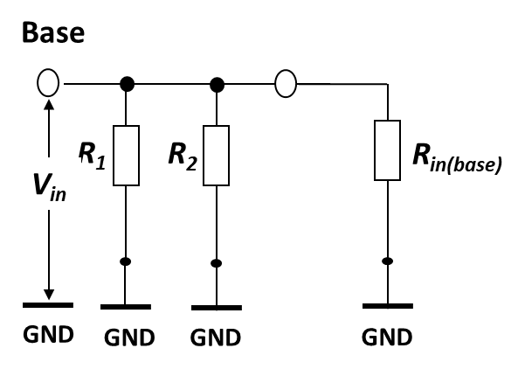

1. **2 points**
$$A=\frac{V_{c}}{V_{b}}=\frac{R_{C}I_{c}}{r_{e}^{'}I_{e}}=\frac{R_{C}I_{e}}{r_{e}^{'}I_{e}}=\frac{R_{C}}{r_{e}^{'}}=\frac{1 k}{6.98 }=143.3$$

2. **2 points**
$$A^{'}=\frac{R_{C}{ R}_{L}}{r_{e}^{'}}=\frac{\frac{R_{C}{×R}_{L}}{R_{C}+R_{L}}}{r_{e}^{'}}=\frac{0.83 k}{6.98 }=118.9$$

3. **1 point**

**The voltage gain will be reduced. The effect of *RE* is to decrease the ac voltage gain. The new gain A will be in this case:**

$$A=\frac{R_{C}}{r_{e}^{'}+R_{E}}$$

1. **1 point**

**A partially bypassed emitter resistor used (with $R_{E}$ partially unpassed), the gain is much less dependent on $r_{e}^{'}$.**

$$A=\frac{R_{C}}{R_{E1}} \left(without load\right) or \frac{R_{C}{ R}_{L}}{R_{E1}} (with load)$$

**Problem 2. (4/10)**

The amplifier circuit uses an op-amp with finite gain A of 10. Find Vout for Vin = 1V.

Take R1 = 1 kΩ and R2 = 2 kΩ.



**Problem 3. (3/10)**

The circuit of a noninverting summing amplifier is shown below. The circuit consists of two inputs $V_{1}$ and $V_{2}$. Calculate the output $V_{out}$ of the amplifier as a function of the two inputs and .

Use superposition principle to find the contribution of V1 to the output voltage (V2= 0).

$$V_{+}=\frac{3}{2+3}V1=0.6 V1$$

$$V_{out}=\left(1+\frac{9}{1}\right)V_{+}=10×0.6 V1=6 V1$$

Use superposition principle to find the contribution of V2 to the output voltage (V1 = 0).

$$V_{+}=\frac{2}{2+3}V2=0.4 V2$$

$$V_{out}=\left(1+\frac{9}{1}\right)V_{+}=10×0.4 V2=4 V2$$

$$V_{out}=6 V1+4 V2$$

**Problem 4. (3/10)**

Calculate the voltage gain, current gain, power gain, and input resistance.

