

GOVERNMENT OF PAKISTAN
PLANNING COMMISSION

DEVELOPMENT OF YAK AT HIGH ALTITUDE AREAS OF PAKISTAN, GILGIT-BALTISTAN
Phase-II

(55.000 MILLION)

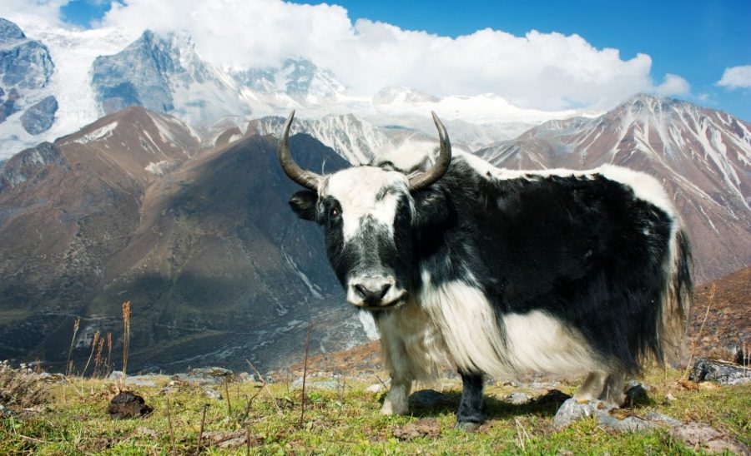

Department of Livestock and Dairy Development Gilgit-Baltistan

Activity/Items of Work | App: Cost | Utilization upto-  June 2026 | 1st Quarter  (July-September)  2026-27 | 2nd Quarter  (October-December)  2026-27 | 3rd Quarter  (Jan-March)  2026-27 | 4th Quarter  (April-June)  202627 | Total
1 | 2 | 3 | 4 | 5 | 6 | 7 | 8
Incentive for dry fodder to yak farmers | 21.410 | 8.268 Million | Incentive for fodder will be paid to 833 farmers @ PKR6000- per farmer/yak | Incentive for fodder will be paid to 452 farmers @ PKR6000- per farmer/yak | Incentive for fodder will be paid to 452 farmers @ PKR6000- per farmer/yak | Incentive for fodder will be paid to 453 farmers @ PKR6000- per farmer/yak | Incentive for fodder will be paid to 2190 farmers @ PKR6000- per farmer/yak


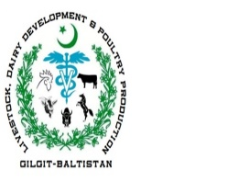
Livestock, Dairy Development &
Poultry Production Gilgit-Baltistan

Registration Form
(Incentive for Dry Fodder)

Name of farmer_______________________________ CNIC No.______________________________
Father Name_____________________ Address_________________________________________

Mobile No.__________________ Bank Name_________________ Account No._______________
No. of Calves _____________________________ Total No. of Yaks________________________
Signature of Farmer:___________________________________

Date:_______/______/___________

Signature of LSA:__________________________

Livestock, Dairy Development &
Poultry Production Gilgit-Baltistan

Prefeasibility Form
(Incentive for Dry Fodder)

Name of farmer___________________________CNIC No.______________________________
Father Name______________________Address_______________________________________
Mobile No._________________ Bank Name______________ Acc. No. __________________
No. of Calves _________________________Total No. of Yaks__________________________
Shed for Calves_______________________ Agri land__________________________________

Prepared by Livestock Assistant_________________________________________________

Checked by Vety. Officer District_________________________________________________

Verified by DD Livestock District________________________________________________

Incharge Project: _________________________ Counter Sig by Director_____________

Selected___________________________ Rejected_______________________________________

