YSSC Web System — Feature Summary
Techstack: Laravel 12 · Livewire 3 · Alpine.js · Tailwind CSS v4 · MySQL · Midtrans Snap

System Architecture Overview
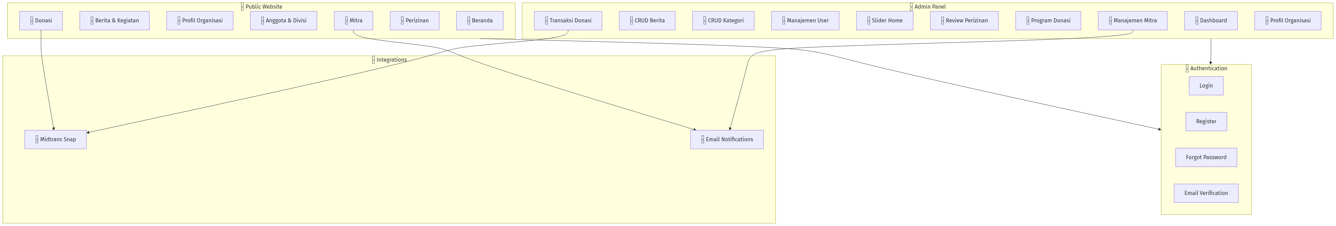
Diagram 0

Public Pages — Feature Map
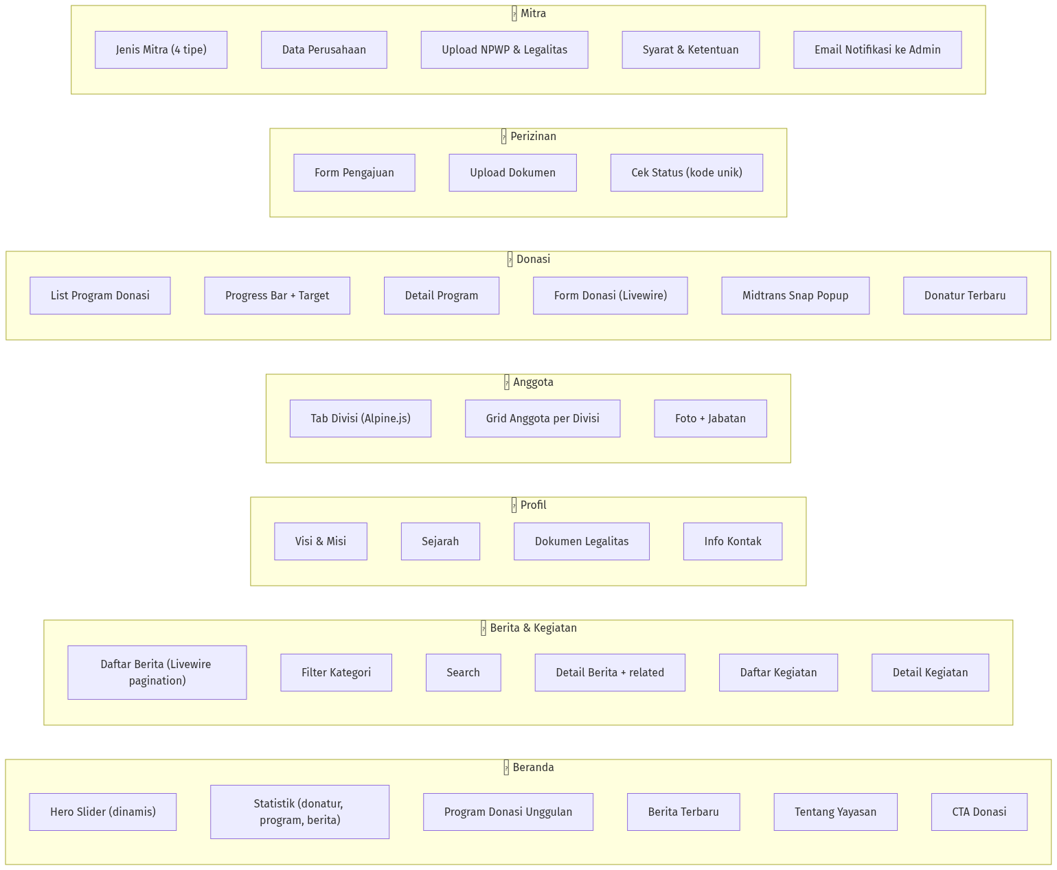
Diagram 1

Donation & Payment Flow (Midtrans)
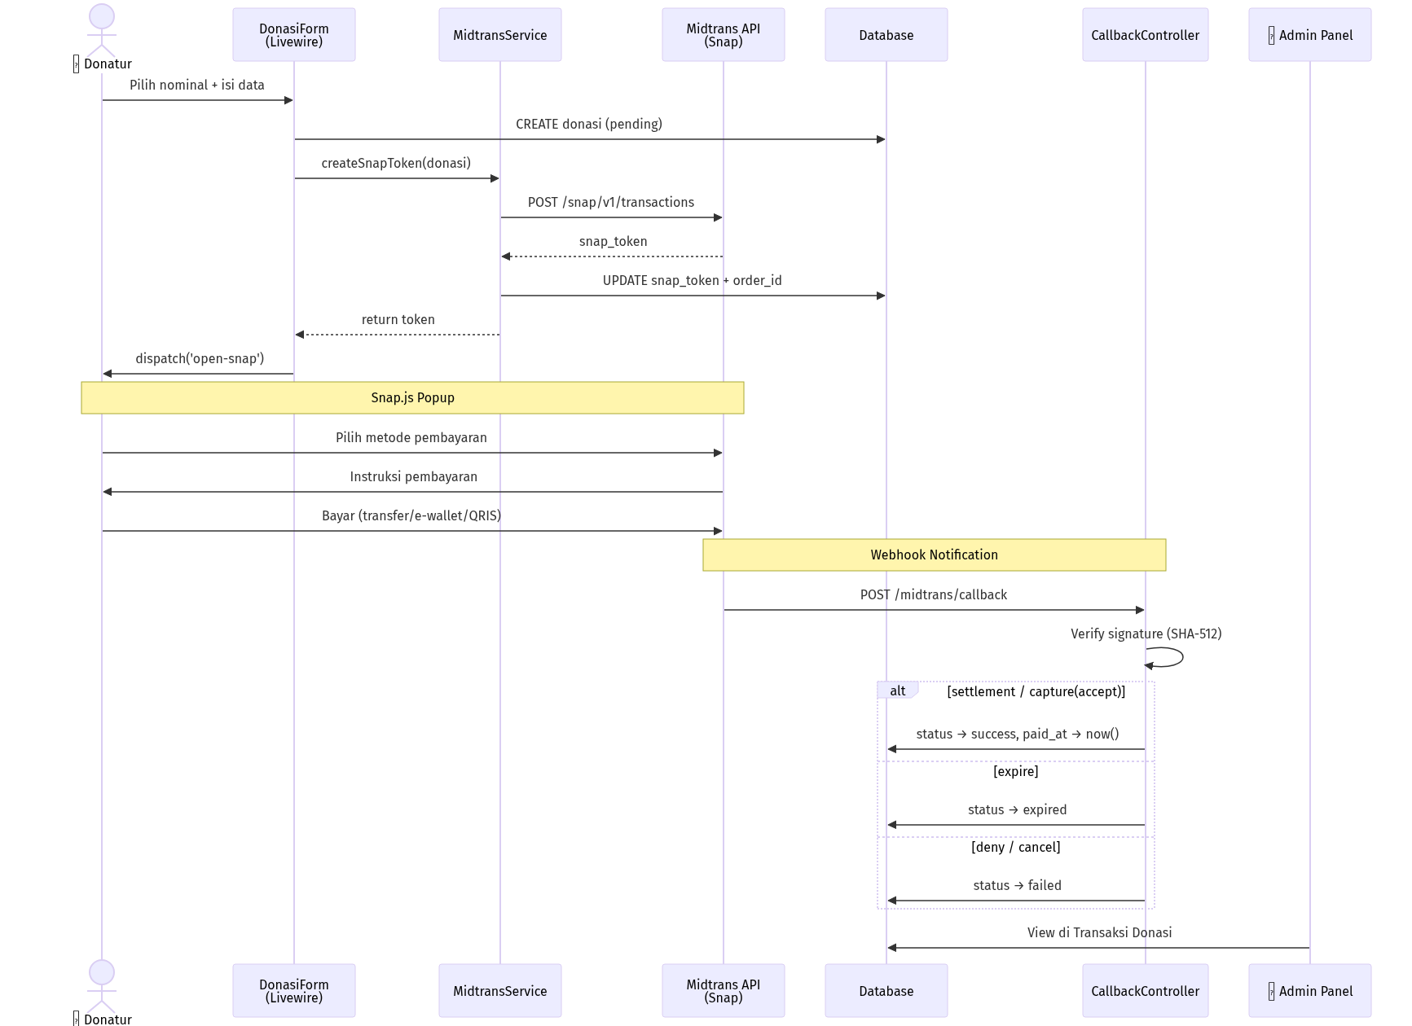
Diagram 2

Mitra Registration Flow
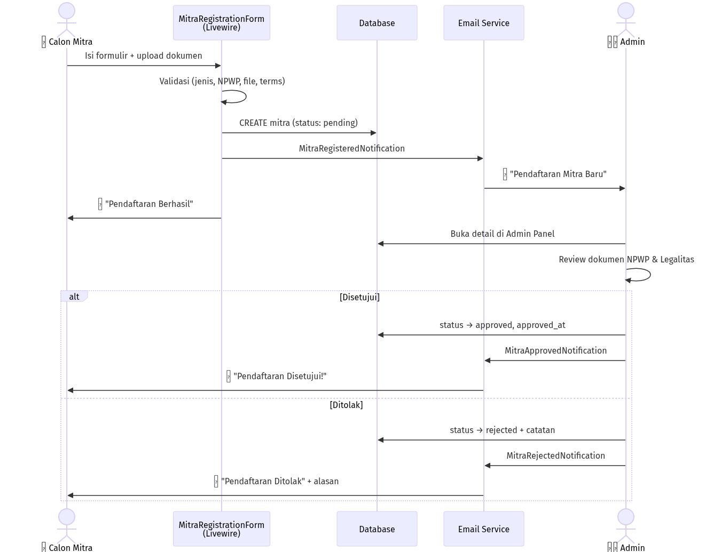
Diagram 3

Admin Panel — Feature Map
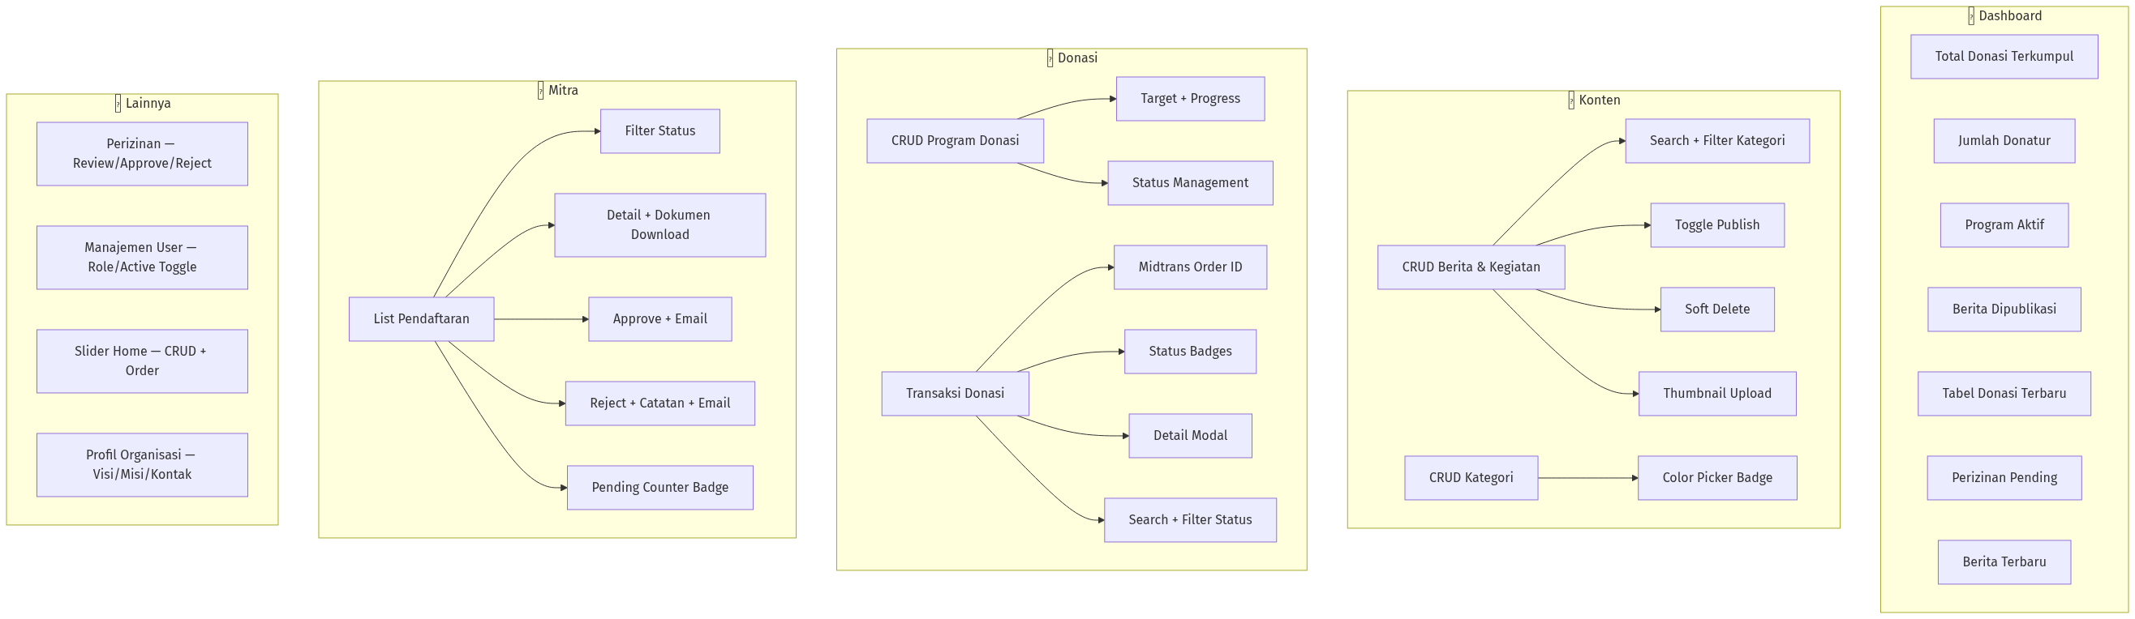
Diagram 4

Database Schema
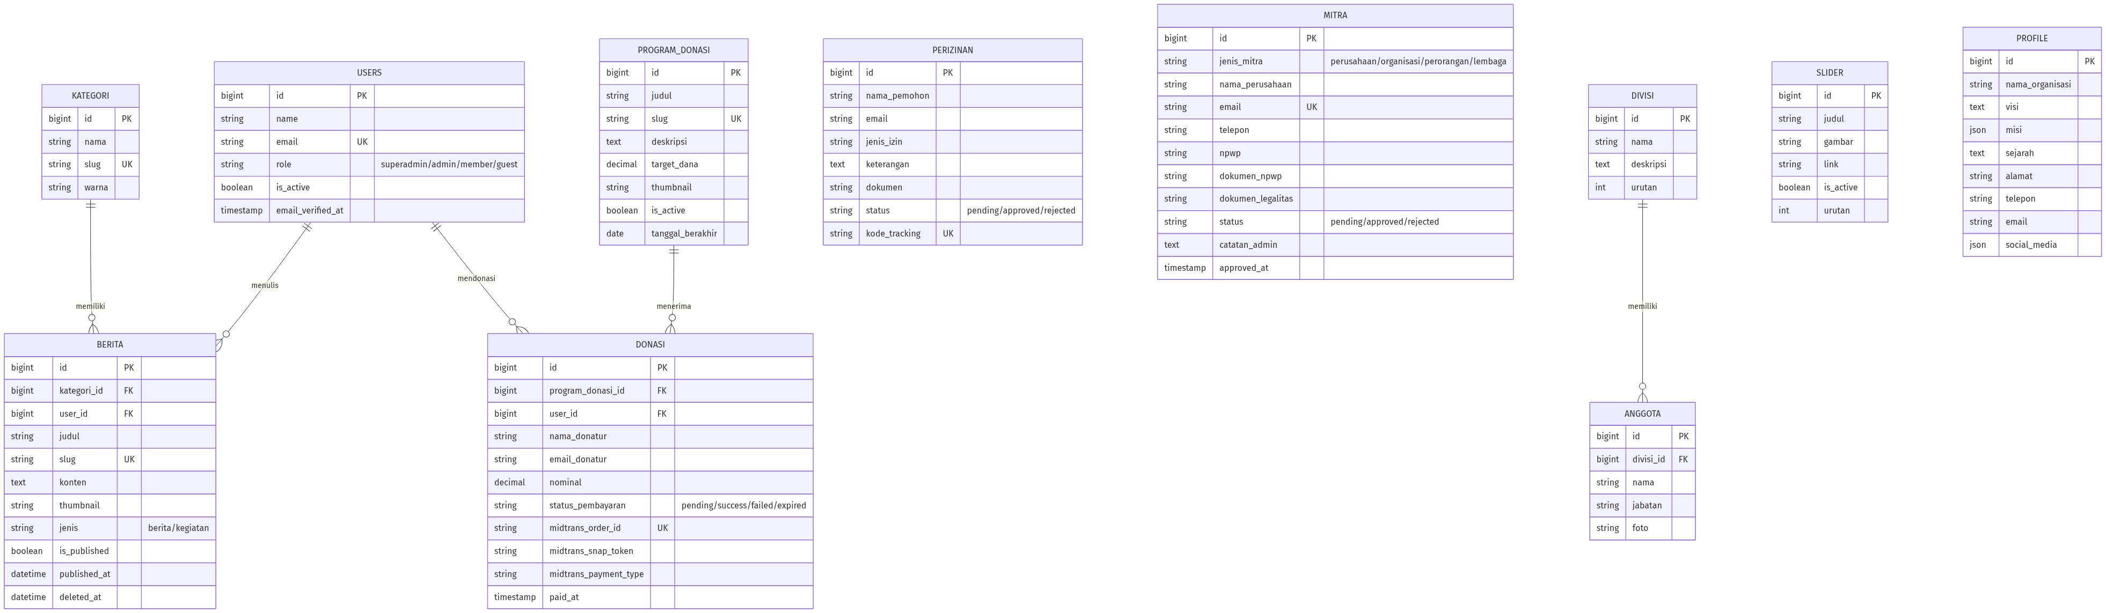
Diagram 5

Route Summary
Method | URI | Feature | Auth
GET | / | Home page | —
GET | /berita | Berita list | —
GET | /berita/{slug} | Berita detail | —
GET | /kegiatan | Kegiatan list | —
GET | /kegiatan/{slug} | Kegiatan detail | —
GET | /profil | Profil organisasi | —
GET | /anggota | Anggota & divisi | —
GET | /donasi | Program donasi list | —
GET | /donasi/{slug} | Detail + form donasi | —
GET | /perizinan | Form pengajuan | —
GET | /perizinan/cek | Cek status | —
GET | /mitra | Registrasi mitra | —
POST | /midtrans/callback | Webhook Midtrans | CSRF-excluded
GET | /admin | Dashboard | admin
GET | /admin/berita | CRUD Berita | admin
GET | /admin/kategori | CRUD Kategori | admin
GET | /admin/users | Manajemen User | admin
GET | /admin/sliders | CRUD Slider | admin
GET | /admin/perizinan | Review Perizinan | admin
GET | /admin/program-donasi | CRUD Program | admin
GET | /admin/transaksi-donasi | Transaksi list | admin
GET | /admin/mitra | Manage Mitra | admin
GET | /admin/profil | Edit Profil | admin

Error Pages
Code | Title | Color
404 | Halaman Tidak Ditemukan | Teal gradient
403 | Akses Ditolak | Amber → Red
419 | Sesi Kadaluarsa | Purple
500 | Terjadi Kesalahan | Red

