

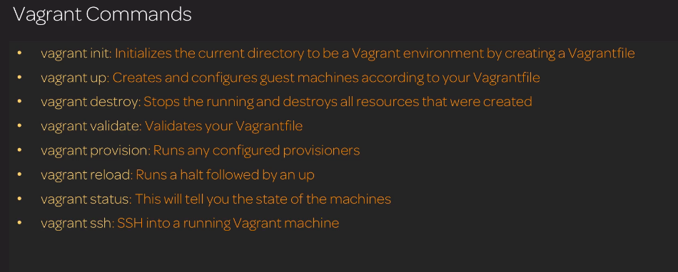

**Install vagrant steps:**

wget -O- https://apt.releases.hashicorp.com/gpg | gpg --dearmor | sudo tee /usr/share/keyrings/hashicorp-archive-keyring.gpg

echo "deb [signed-by=/usr/share/keyrings/hashicorp-archive-keyring.gpg] https://apt.releases.hashicorp.com $(lsb_release -cs) main" | sudo tee /etc/apt/sources.list.d/hashicorp.list

sudo apt update && sudo apt install vagrant

