**28 JAN, 2020**

Dear all,

this is to announce you we have made several changes to the MRC and HTML which will go online during this week. Please find the most important changes below:

**MRC**

* We have a new option to assign media review codes to articles that are tagged only for the NRX portal. You will find a link to the coding pipeline once you have finished coding the media review articles.
* In the reading screen, the numbers for new articles in the sub-profiles will be updated once you open the profile selection menu in the top right corner. This way, you can quickly see if new articles have come in.
* It is now possible to enter a comprehensive briefing in the media review templates. The briefing information can be accessed in the media review overview screen.
* We have reviewed and simplified the navigation in the media review templates and dispatch configurations. For example, saving templates is now more intuitive and the HTML configurator can be accessed directly in the dispatch configuration screen:

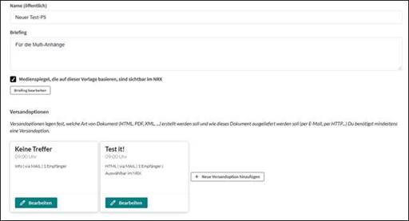

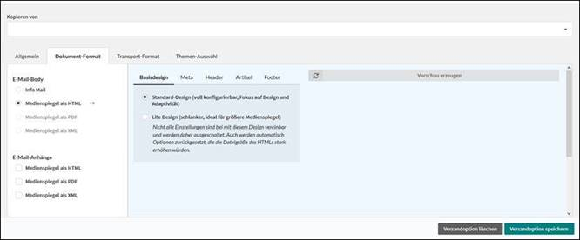

**HTML**

* In the table of contents, it is now possible to list the additional media in an article cluster in a compact way. Print articles are directly linked to the original article from this view.
* There is now an option to include information on the author and the starting page in the table of contents.
* The starting page can also be displayed in the article area.
* Some device-related bugs have been eliminated for the links inside the HTML.