KAI 11 STRIPE API INTEGRATION

1. Generate Stripe Element



1. Card Element
   * Generate Element



* + Create Token



* + Charge

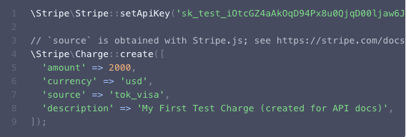

1. Google and Apple Pay
   * Generate Element

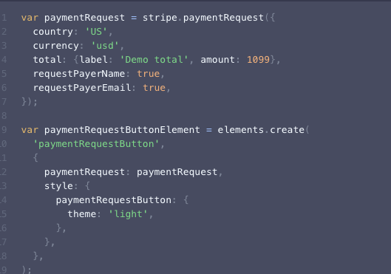

* + Create a Payment Intent

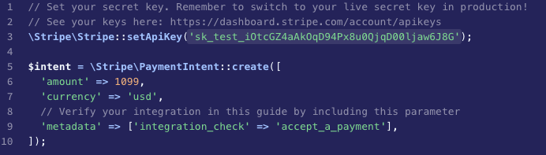

* + Retrieve a Payment Method and Charge

