The colorset 1 to 6 is used to fast access for color scheme/palette combination.
Right clicking on a sakura terminal gives you a menu which includes options.
If you go into that, you can set the color. In the color menu, you will see colorset with a number.
You can, for example, select colorset 1 to be black with white text, which is the default.
Then, say, colorset 2 to be black with green text. And other colorsets if you like. If you change colorset 1, that will be the default.
Now, when you have sakura open, say you're using colorset one, white on black. Hit shift+ctl+F2 and it will change to your colorset 2, green text on black. Like lots of things, simple, once you learn how to do it.

Color scheme defines which color is used for: foreground, background, and for cursor
For example, “white on black” means that foreground color is white, and background color is black.
Foreground color is used for uncolored text and as background when selecting.
Background color is used for non-text area.

Palette is definition of colors by RGB triplet and opacity level (usually 1). Example:

const GdkRGBA solarized_palette[PALETTE_SIZE] = {
{0.027451, 0.211765, 0.258824, 1}, // 0 base02
{0.862745, 0.196078, 0.184314, 1}, // 1 red
{0.521569, 0.600000, 0.000000, 1}, // 2 green
{0.709804, 0.537255, 0.000000, 1}, // 3 yellow
{0.149020, 0.545098, 0.823529, 1}, // 4 blue
{0.827451, 0.211765, 0.509804, 1}, // 5 magenta
{0.164706, 0.631373, 0.596078, 1}, // 6 cyan
{0.933333, 0.909804, 0.835294, 1}, // 7 base2
{0.000000, 0.168627, 0.211765, 1}, // 8 base03 (bg)
{0.796078, 0.294118, 0.086275, 1}, // 9 orange
{0.345098, 0.431373, 0.458824, 1}, // 10 base01
{0.396078, 0.482353, 0.513725, 1}, // 11 base00
{0.513725, 0.580392, 0.588235, 1}, // 12 base0 (fg)
{0.423529, 0.443137, 0.768627, 1}, // 13 violet
{0.576471, 0.631373, 0.631373, 1}, // 14 base1
{0.992157, 0.964706, 0.890196, 1} // 15 base3
};

Note: The font used in the examples is
Hack Nerd Font Regular, size 12

The following screenshots use “white on black” color scheme.
Solarized

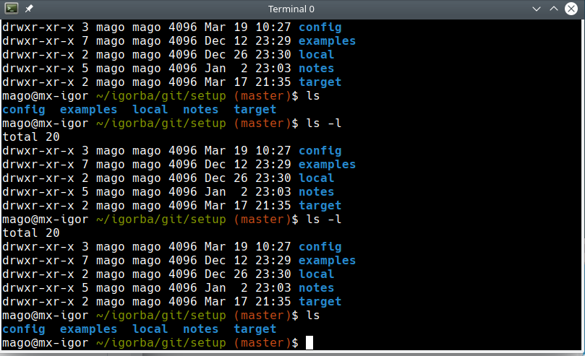
Tango
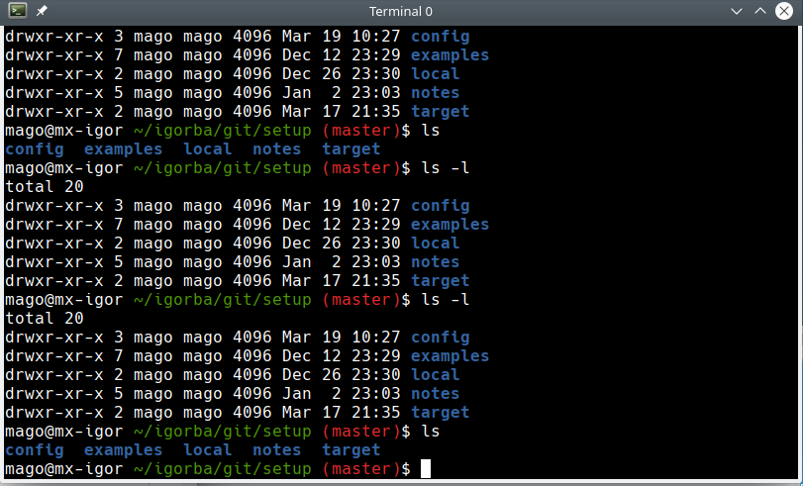

Gruvbox
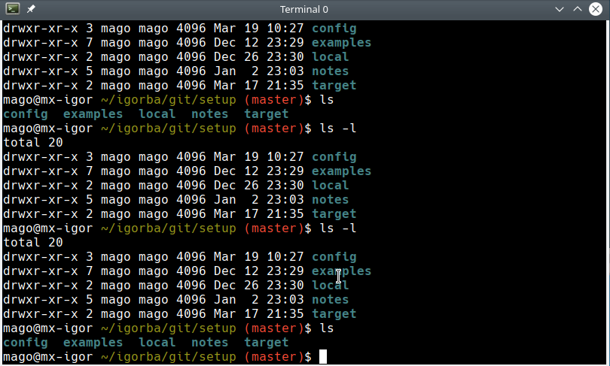
Nord
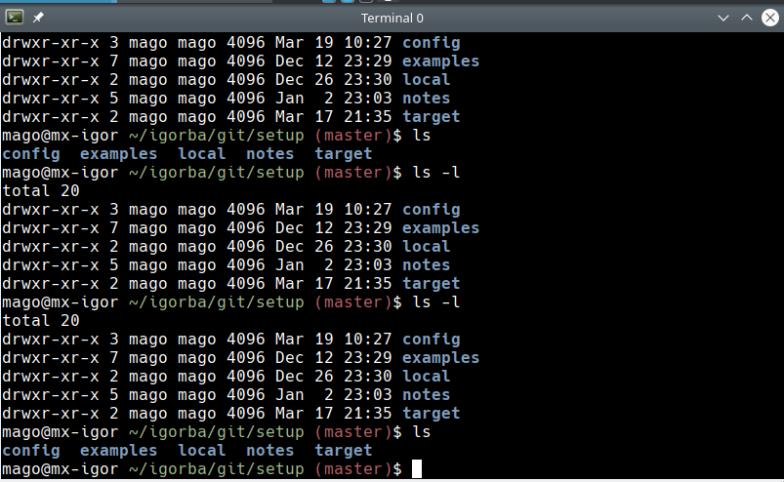
Xterm
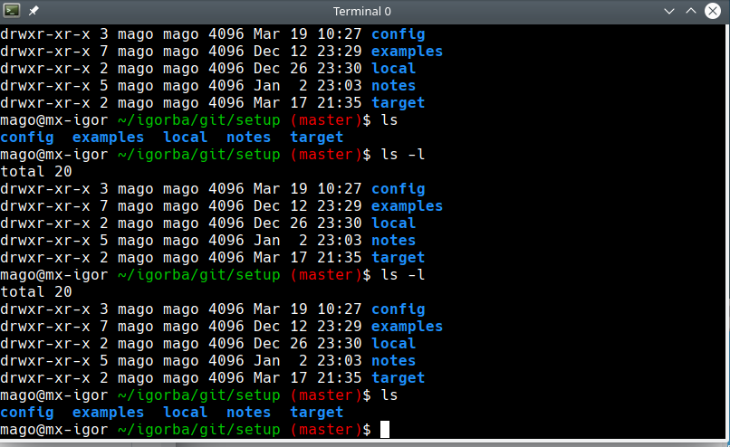
Linux
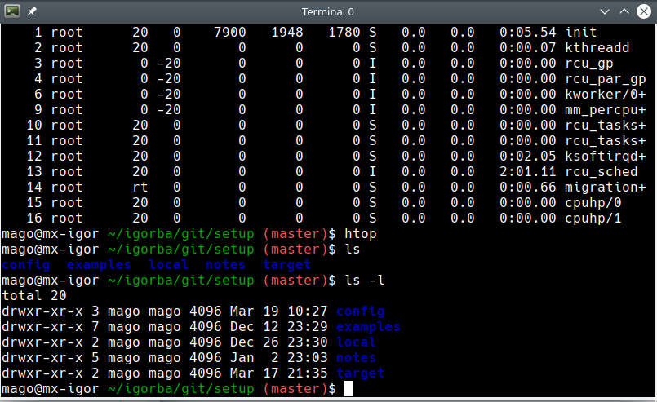
Rxvt
