

**FACULTY OF COMPUTING AND INFORMATICS  
FINAL YEAR PROJECT PROPOSAL  
SEMESTER 2 2020/2021**

**FCI FYP MANAGEMENT SYSTEM USING USER**

**CENTRED DEVELOPMENT**

|  |  |  |
| --- | --- | --- |
| **STUDENT NAME** | **:** | MUHAMMAD IBRAHIM BIN AZMI |
| **MATRIC NO.** | **:** | BI 18110099 |
| **PROGRAM** | **:** | E-COMMERCE / HC13 |
| **SUPERVISOR NAME** | **:** | DR. ZAIDATOL HASLINDA ABDULLAH SANI |

**ABSTRACT**

This project will provide the FYP Committee of University Malaysia Sabah, Labuan International Campus with many conveniences by introducing this method, while saving time. The main purpose of this project is to design and develop an online platform to help to reduce the Faculty of Computing and Informatics (FCI), University Malaysia Sabah Final Year Project (FYP) committee's workload in managing works related to FYP process. This project aims to speed the process, in addition to lowering the workload for the FYP committee. The idea of the project derived from two problem statements which are no formal platform for FYP and insufficient information and interaction in the FYP community. This project has four objectives which are 1) to investigate the concern, needs, and worries of the current FCI FYP Management System, 2) to design the architecture of the system and its functionalities, 3) to develop a systematic online system for FCI FYP community, and 4) to test the reliability of the system. The scope of this project is the complete implementation of a web-based system that is accessible by approved users throughout the campus. The User Centered Development Method is the chosen methodology because this system will be developed around the potential users and by introducing this method, it can facilitate the design and development processes of this system.

|  |  |  |  |  |  |  |
| --- | --- | --- | --- | --- | --- | --- |
| **TABLE OF CONTENTS** | | | | | | |
| TITLE PAGE | | | | |  | |
| **ABSTRACT** | | | | | ii | |
| **TABLE OF CONTENTS** | | | | | iii | |
| **LIST OF TABLES** | | | | | v | |
| **LIST OF FIGURES** | | | | | vi | |
| **LIST OF ABBREVIATIONS** | | | | | vii | |
|  | | | | | | |
|  | **CHAPTER 1: INTRODUCTION** | | | |  | |
| 1.1 | **Introduction** | | | | 1 | |
| 1.2 | **Problem Statement** | | | | 2 | |
| 1.3 | **Project Goal and Objectives** | | | | 3 | |
| 1.4 | **Project Scope** | | | | 4 | |
| 1.5 | **Potential User** | | | | 5 | |
| 1.6 | **Project Framework** | | | | 6 | |
| 1.7 | **Project Timeline (Gantt Chart)** | | | | 7 | |
|  | | | | | | |
|  | **CHAPTER 2: LITERATURE REVIEW** | | | |  | |
| 2.1 | **Introduction** | | | | 8 | |
| 2.2 | **Management System** | | | | 9 | |
| 2.3 | **System Development** | | | | 10 | |
| 2.3.1 | | | Operating System | | 11 | |
| 2.3.2 | | | Programming Language | | 11 | |
| 2.3.3 | | | Database | | 12 | |
| 2.3.4 | | | Web Server | | 13 | |
| 2.4 | **User Centred Development Method** | | | | 14 | |
| 2.5 | **Study on User Gathering Technique** | | | | 15 | |
| 2.6 | **Heuristic Guidelines** | | | | 16 | |
|  | | | | | | |
|  | **CHAPTER 3: METHODOLOGY** | | | |  | |
| 3.1 | **Chosen Methodology** | | | | 19 | |
| 3.2 | **Application of Chosen Methodology** | | | | 20 | |
| 3.2.1 | | Phase I: Specify Context of Use and Requirement (objective 1) | | | 21 | |
| 3.2.2 | | Phase II: Create Design Solution (objective 2) | | | 22 | |
| 3.2.3 | | Phase III: Implementation (objective 3) | | | 23 | |
| 3.2.4 | | Phase IV: Evaluation and Deployment (objective 4) | | | 23 | |
| 3.3 | **Data Analysis** | | | | 24 | |
| 3.3.1 | | | | Interview Questions Outline | | 24 |
| 3.3.2 | | | | Interview Summary | | 26 |
|  | | | | | | |
|  | **CHAPTER 4: DESIGN/FRAMEWORK** | | | |  | |
| 4.1 | **Introduction** | | | | 27 | |
| 4.2 | **Use Case Diagram** | | | | 27 | |
| 4.3 | **Data Flow Diagram** | | | | 28 | |
| 4.3.1 | | Context Diagram | | | 28 | |
| 4.3.2 | | Level-1 DFD | | | 29 | |
| 4.4 | **Entity Relationship Diagram (ERD)** | | | | 30 | |
| 4.5 | **Data Dictionary** | | | | 31 | |
| 4.6 | **Low-Fidelity (Lo-Fi) Design** | | | | 34 | |
|  | | | | | | |
|  | **CHAPTER 5: CONCLUSION** | | | |  | |
| 5.1 | **Introduction** | | | | 37 | |
| 5.2 | **Project Strength** | | | | 37 | |
| 5.3 | **Future Works** | | | | 37 | |
|  | | | | | | |
| **REFERENCES** | | | | | 38 | |
| **APPENDICES** | | | | |  | |
| 1. **Student’s Logbook** | | | | | 41 | |
| 1. **Turnitin Report** | | | | | 45 | |
|  | | | | |  | |

|  |  |  |
| --- | --- | --- |
| **LIST OF TABLES** | | |
| **TABLE NUMBER** | **TITLE** | **PAGE** |
| Table 1 | Interview’s Questions Summary Outline | 24 |
| Table 2 | Course Entity | 31 |
| Table 3 | Batch Entity | 31 |
| Table 4 | Student Entity | 31 |
| Table 5 | Lecturer Entity | 32 |
| Table 6 | Expert Entity | 32 |
| Table 7 | AreaExpert Entity | 32 |
| Table 8 | Project Entity | 33 |
|  |  |  |

|  |  |  |
| --- | --- | --- |
| **LIST OF FIGURES** | | |
| **FIGURE NUMBER** | **TITLE** | **PAGE** |
| Figure 1 | Gantt Chart | 7 |
| Figure 2 | User-Centered Design (UCD) Development Lifecycle | 20 |
| Figure 3 | Use Case Diagram | 28 |
| Figure 4 | Context Diagram | 29 |
| Figure 5 | Level-1 DFD | 29 |
| Figure 6 | Entity Relationship Diagram (ERD) | 30 |
| Figure 7 | FFMS Student’s Propose/Select Project Interface | 34 |
| Figure 8 | FFMS’s Homepage Interface | 35 |
| Figure 9 | FFMS Student’s Homepage Interface | 35 |
| Figure 10 | FFMS Student’s Homepage Interface | 36 |
|  |  |  |

|  |  |
| --- | --- |
| **LIST OF ABBREVIATIONS** | |
|  |  |
| CPU | Central Processing Unit |
| CSS | Cascading Style Sheets |
| dbms | Database management system |
| DFD | Data Flow Diagram |
| ERD | Entity Relationship Diagram |
| FCI | Faculty of Computing and Informatics |
| FFMS | FCI FYP Management System |
| FYP | Final Year Project |
| HTML | Hypertext Markup Language |
| Lo-Fi | Low Fidelity |
| OS | Operating System |
| PHP | Hypertext Pre-processor |
| SDLC | System Development Life Cycle |
| SMP | *System Maklumat Pelajar* |
| SQL | Structured Query Language |
| UCD | User Centred Design |
| UI | User Interface |
| UMSKAL | *University Malaysia Sabah, Kampus Antarabangsa Labuan.* |
| UX | User Experience |
|  |  |

**CHAPTER 1: Introduction**

1.1 Introduction

The Final Year Project (FYP) is the second last process of earning a degree. It also symbolises the end of the student's educational journey before they go to industrial training . FYP students must apply their previously acquired knowledge and skills during their university years. FYP is essential for the candidates before they enter the workforce or continue their academic careers. Students at Universiti of Malaysia Sabah, Labuan International Campus (UMSKAL), Faculty of Computing and Informatics (FCI) must undertake their FYP in the third year under the supervision of FCI members of educator.

In a nutshell, students will have 24 weeks to finish their FYP. After the FYP's proposal has been approved by the FYP's committee, they will work on their FYP's report for the first 14 weeks (FYP 1), from chapter one (1) to chapter four (4), and then complete it till chapter seven (7) in the remaining weeks (FYP 2). They will work on the FYP 1 introduction, literature reviews, methodologies, designs and framework, as well as the FYP 1 findings in FYP 1. Students will continue to work on implementation, finding and discussion, and conclusion in FYP 2, as well as the FYP’s poster. Students must present their FYP progress to their allocated examiners every seven (7) weeks, and they must meet with their assigned supervisor for a minimum of three (3) time meetings, all of which must be recorded in the logbooks. Students are expected to learn more about documentation, which includes data collection and report writing, as part of this project. They will also learn how to produce high-quality work that meets academic and industry requirements.

For this project, FCI FYP Management System will be developed as a web-based system that is usable by students of Faculty of Computing and Informatics, UMSKAL. This system will be able to assist and facilitate FYP committee workloads through the features that available in the system. Using the User-Centered development method, the system will be developed with the involvement of users so that the system can meet their expectation via feedbacks and recommendation.

1.2 Problem Statements

A pre-study via interviewing the FYP coordinator has been done to understand the flow of the current FYP system. Based on the analysis of the interview, these are few problems initially that led to the idea of developing FCI FYP Management System:

1. No formal platform for FYP community.

The current situation of the management of the FYP is that it does not have any system which supports all the processes in a single system. Basically, from the beginning of the FYP process, which is the submission of proposals until final report submission, the present FYP follows a manual method.

1. Insufficient information and interaction in the FYP community.

Since there is no formal portal for the FYP, it is hard to deliver the information regarding the Final Year Project. Lecturers have been using social media (Facebook) and online communicating applications (WhatsApp) to provide information to the students. This problem contributes to the lack of information among the FYP students regarding the FYP.

1. Absence of centralised archive and storage

The materials are scattered and difficult to locate. The manual system also uses so much space to store all the hardcopies.

1.3 Project Goal and Objectives

The goal of this project is to develop a web-based system for UMSKAL FCI Final Year Project’s committee. This system will be develop using User Centred Development method to deliver an appropriate web-based system in term of usability.

To achieve the goal, this project will mainly focus on the following objectives:

1. To investigate the concern, needs, and worries of the current FCI FYP Management System.
2. To design the architecture of the system and its functionalities for FCI FYP Management System using User Centred Development method.
3. To develop a systematic online system for FCI FYP management system.
4. To evaluate the usability of the FCI FYP management system.

1.4 Project Scope

The project scope for this project is the complete implementation of a web-based system that is usable by approved users throughout the campus. This project will entail knowledge and experimentation based on:

* Database design and management
* Server setup
* Web design and development using User Centred Development method

1.5 Potential User

This project includes 3 types of users which are: -

1. FYP Coordinator
2. FYP Supervisors
3. Students.

This system will be administered by FYP coordinator. Supervisors from FCI may be required to supply information to FYP coordinator such as project title, marks, and so on. They can enter data into the system and read reports, but they can't edit them. Students can access FCI FYP Management System using their *Sistem Maklumat Pelajar* (SMP) credential which includes project title listings, registration, and biweekly report submission.

1.6 Project Framework

1. Chapter 1: Introduction

Chapter one of this project’s report will firstly talk about final year project. Then it will focus on discussing the issues faced in the problem statements. Next, it will state out the project goal and objectives. After that it proceed to the project scopes and project’s target user and project’s timelines.

1. Chapter 2: Literature Review

This chapter will study and analyse articles and research that talk about management system. It also studied the necessary components needed for to develop the FCI FYP Management System, User Centred Development Methods, User Gathering Techniques available to be use, and Heuristics Principal Guidelines.

1. Chapter 3: Methodology

In this chapter, the chosen methodology will be detailed, as well as the steps followed during each of the methodology phases.

1. Chapter 4: Design/Framework

This chapter will disclose all workflows, database and interface design in the Use Case Diagram, Class Diagram, Level-1 DFD, EFD, Data Dictionary and Lo-Fi Design.

1. Chapter 5: Conclusion

This chapter will summarise the first 4 chapters.

1.7 Project Timeline (Gantt Chart)

Figure 1 is the Gantt chart for FYP 1. The blue coloured in the table presented the weeks taken for each task to be completed.

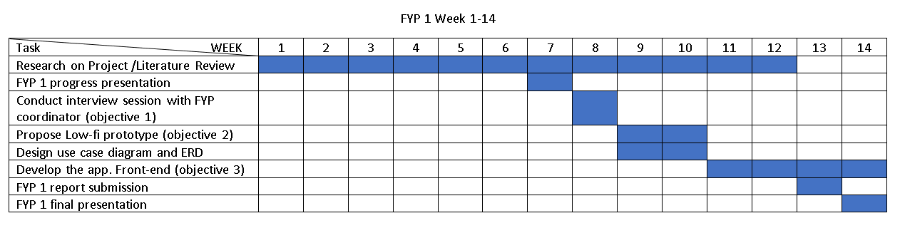

Figure 1: Gantt Chart

**CHAPTER 2: LITERATURE REVIEW**

2.1 Introduction

Before system development started, research and study on several aspects were needed. For instance, study on the related management system based on this project can ensure the understanding of researchers about the system. The system that will be develop will enable users to complete their task online. To ensure that the system runs smoothly, a better understanding of system development is required. User Centered Development method will used to design and build the system. It is also necessary to study tools and techniques. The following chapter is organized as such; Section 2.1 Introduction, Section 2.2 Management System, 2.3 System Development, 2.4 User Centred Development Method, 2.5 Study on User Gathering Techniques, and 2.6 Heuristic Guidelines.

2.2 Management System

A management system is a set of policies, processes, and procedures that can be used to ensure that it can complete the activities necessary to meet its goals. Management system is in continuous change and progress towards achieving institutional efficiency in terms of achievements of the higher education mandates (Samuel et al., 2019). According to Xiu-ying OU (2018), College education management's information development is also a future development trend.

Both technology and management systems have had a positive influence on each other and have continued to grow at equal rates, with technology currently developing faster due to its broader application domains as well as its function in management systems. Higher education institutions require new management system models that make use of technology's evolving features as the primary enabler while also improving the integration of non-technical variables into the overall management system.

2.3 System Development

To build an online system, there are several programming languages that can be used. Studies on the available programming languages have been carried out and two popular languages have been chosen in web-based application development. PHP and ASP.net have been selected from all the available languages so that studies can be performed to determine which programming language will be the most appropriate to be used.

       Tamanna (2011) said that PHP has some advantages over ASP.NET. The benefits displayed on the website are summarized as PHP is easier than ASP.net, PHP is more user-friendly than ASP.net. PHP also has MySQL service that is both free compared to ASP.net and MSSQL that require users to pay. PHP is significantly more popular around the world since it is an open-source programming language, PHP is free whereas ASP.net is not, and PHP is more secure.

Janko (2008) reported that PHP over ASP.net is mostly used by web designers. This is because PHP is a very basic language and PHP is always free. It is possible to create ASP.net applications without purchasing developer software, but all of them have limitations. Compared to PHP, the web design blogs or posts concerning the ASP.net are smaller.

The PHP has a connection to the MYSQL database according to the points mentioned above, in which both are free while licensing fees are required for ASP.net with MSSQL. Although PHP is older than ASP.NET, PHP has more code examples and tutorials than ASP.NET. Most importantly, PHP is an open-source programming language that developers from all over the world can enhance and support when the user requests it (Vats R., 2020)

Another relevant point is that the system is distinct from PHP. Several operating systems, such as Mac OSX, Linux, and Windows, support PHP, while Windows only supports ASP.NET. It is favourable to use this to build website applications due to the platform-independent capacity of PHP. In addition, compared to ASP.NET, there are more websites using PHP and MYSQL, which means that PHP development tools or guides can be easily accessed. In short, for their databases, most well-known websites use PHP as well as MYSQL. As these sites are run by Microsoft, ASP.NET is used only by websites like msn.com.  Computer languages such as PHP and MYSQL are frequently used. There are also some other elements needed to consider in developing an online system.

2.3.1 Operating System

Operating system is the core part of every computer. It served as the main manager for software and hardware to handle different computer programs access to CPU, memory, and storage (GCFLearnFree.org, n.d.). There are many existing operating systems that are available in the open world either its free or paid version such as Microsoft Windows, Mac OS, Linux, Phoenix OS, Ubuntu, and Chrome OS.

* Microsoft Windows OS

Microsoft released the Windows operating system in the mid-1980s (GCFLearnFree.org, n.d.). Windows has had various versions, the most prominent of which being Windows 10 (released in 2015), Windows 8 (2012), Windows 7 (2009), and Windows Vista (released in 2003). (Issued in 2007). Windows is preinstalled on most new PCs, making it the world's most popular operating system.

2.3.2 Programming Language

One of the most important components in developing a web page is to select the best available language. A programming language is a set of commands, instructions, and other structures for developing software as well as used as a bridge to communicate and interact with computers. "High-level languages" are the languages that programmers use to write code. This code can be turned into a "low-level language" that the computer hardware recognises immediately (TechTerms, 2011). Below is the list of programming languages usually used in web development.

1. PHP

PHP is a commonly used programming language and interpreter on Linux Web servers. PHP stands for PHP: Hypertext Preprocessor, which is described as a "recursive acronym". (Herbert K., 2006). PHP was initially formed from Personal Home Page Tools. PHP has been around for nearly two decades and has proved itself as a powerful and dependable solution, acquiring a legion of followers and lovers (Herbert K., 2006). There are numerous advantages to using PHP for web development, including a large library of reference and educational materials, faster website loading times, more database connectivity options, a large collection of open source addons, low-cost website hosting, excellent HTML synergy, and excellent flexibility and combinability.

1. HTML

HTML stands for Hypertext Markup Language and was created by Tim Berners-Lee in 1990. HTML is a markup language that is used to make electronic texts (called pages) that are displayed on the Internet (Computer Hope, 2021). HTML ensures that text and images are formatted correctly in your browser. A browser would not be capable of displaying text as elements or load images or any other elements without HTML.

1. CSS

Cascading Style Sheets (CSS) is an acronym that emphasises the word "style" (Morris S., 2017). CSS and HTML are two computer languages that work in harmony. CSS is used to design page layouts, colours, and fonts, whereas HTML is used to structure a web document by specifying things like headings and paragraphs, as well as allowing you to integrate photographs, video, and other media.

1. JavaScript

JavaScript is a scripting or programming language that allows users to add advanced functionality to your web pages (What Is JavaScript? - Learn Web Development | MDN, 2021). JavaScript, alongside HTML and CSS, is the foundation of front-end web development, enabling interactive elements to be created. To have your login button execute the appropriate activities, JavaScript code would be employed (logging a user in when it is clicked).

2.3.3 Database

Data is there everywhere and so are databases of all kinds, and when it comes to web development, it is a highly database-intensive process now (Wall, M., 2014). Database applications are used to search, sort, filter, and display information based on user requirements. Databases could also contain code that performs analytical calculations on the data in order to facilitate browser queries (How to Set Up and Implement Database for Web Design And Development, 2020). One of many databases that are available for system developers today is MySQL.

* MySQL

MySQL is an open-source client-server relational database management system (RDBMS) (Vats, R., 2020). SQL is a standard language for accessing and manipulating databases (Herawan, 2020). SQL is a language for accessing, updating, and manipulating data in databases. MySQL, on the other hand, is a database that organises data already stored in it. MySQL is the most popular system that allows you to store, modify, and handle data in a tabular format. SQL is a query language for databases, and MySQL is a dbms that allows you to store, modify, and manage data in a tabular format. Any connectors are not supported by SQL. MySQL, on the other hand, comes with a built-in tool for designing and developing databases called MySQL workbench (Vats, R., 2020)

2.3.4 Web Server

A web server is a computer that connects to the Internet and allows physical data to be shared with other web-connected devices, whereas a server is a device that holds both system software and the files that make up a website. Although we can host a website on our own computer, it is more practical to maintain all the content on a web server. We can save our data remotely on a web server, and it is accessible from anywhere with internet access (MDN Web Docs, 2021).

2.4 User Centred Development Method.

User-Centred Design (UCD) or User Centred Development Method is a set of techniques, methods, procedures, and processes as well as a philosophy that places the user at the centre of the development process (Dina et al.,2014). UCD focuses on people and is not restricted to designers; it can also be utilised effectively by non-user experience (UX) designers to get productive results and understand user demands. The purpose of using UCD is to try to satisfy people by creating products that are useful and intelligible and fulfil their requirements and interests. With this method, the system that will be develop will be able to coop with user’s prerequisite.

According to Edward et al. (2016), UCD enabled for incremental adjustments in response to expert criticism of the app's user experience, as well as measures to minimise complexity and enhance user interaction. With the used of UCD, designers can attend to users’ needs with the help of tools such as the user gathering techniques. UCD also enable the developer to fully enhance user’s cooperation to improve the system in a long term as the system up and running it will be resulting in many feedbacks from the users.

2.5 STUDY ON USER GATHERING TECHNIQUES

Implementation of technology to the people who will be using it is critical for a good return on investment with high adaptation rates and satisfied users (White, 2020). According to Eid (2015), prerequisites are one of the most important aspects of a system's success. The procedures used to collect the best needs are equally crucial in ensuring that the best requirements are received. The purpose of user requirements gathering approaches is to collect and gather user expectations or needs in order to create a system that can meet those demands. Interviews, questionnaires, observations, document reading, surveys, and other tools or approaches can all be used to gather user requirements. A few techniques are chosen to be explained such as interviews and questionnaires.

1. Interview

During the system analysis phases of a development project, the interview is the primary method for acquiring information. According to Lim (2002), an interview is very effective for understanding a phenomenon in-dept and it can make a valuable contribution to the course. Client opinions and preferences are important to be implemented into the system to satisfy the client.

1. Questionnaires

According to Yaddanapudi and Yaddanapudi (2019), a questionnaire looks to be nothing more than a series of questions addressed to the novice. However, the survey's results are influenced by the language used in the questions, the kinds of questions used, the order in which they are ordered, and many other factors. A questionnaire is employed in this project to collect information from the FYP coordinator on the FYP process and method, as well as system design needs.

1. Document analysis

Document analysis is one of the user requirements gathering technique that available. This method exists to help researcher to gain the details that are often buried in existing documents. Examining current procedures and documentation can help the analyst gain a better grasp of the business or system's status (Eid, 2015).

2.6 Heuristic Guidelines

A heuristic evaluation is a usability inspection methodology in which one or more usability specialists assess a product's user interface (Muniz, 2019). Early in the design process, heuristics can assist design teams in improving product usability. According to Kölling and McKay (2016), heuristic assessment is a useful tool for analysing the quality of alternatives and detecting possible faults with existing systems for a certain target audience or setting.

There are about 10 notable usability heuristics principles (Nielsen, 1994) for user interface design which are: -

1. Visibility of status

By giving appropriate feedback in a timely manner, the design should constantly keep consumers up to current on what's going on. According to this notion, the user should be informed about what is going on inside the system, and we should offer feedback on his or her activities in a reasonable amount of time. This sort of feedback is typically associated with action points and can take the shape of a colour change, a loader, or time-left visualisations, among other things.

1. Match between system and the real world

Rather than using the internal jargon, the layout should respond to the users in their own language, using words, ideas, and concepts that they are accustomed with.

1. User control and freedom

When executing tasks, users regularly commit errors, and they need a clearly visible "quick escape" that allows them to abandon the unwanted activity without going through a longer procedure. This idea relates to the user's capacity to browse and do tasks at their leisure, as well as the capacity to undo any unintended acts.

1. Consistency and standards

The goal is to maintain consistency so that users never have to guess what various words, situations, or actions mean. For example, if data is shown in a certain table format on one page, it should be shown in the same way the next time it is shown in another pages or if the header is shown in a particular way on the website, it should also be displayed the same way when a user login in and a submit button should look the same on all different pages of the same site.

1. Error prevention

Although reliable error messages are important, a great design will avoid preventing issues from occurring in the first place. For example, remove or check for error-prone variables and provide users with a confirmation option before committing to an action.

1. Recognition rather than recall

Reduce the user's memory burden by making elements, actions, and selections obvious. It should not be necessary for the user to recall data from one section of the interface on to the next. When necessary, critical information on how to utilise the design should be shown or readily available. It is usually preferable to present the user with a range of options rather than expecting him to remember and write everything. The idea is to consume user memory as little as possible.

1. Flexibility and efficiency of use

Shortcuts may enable the advanced user to interact more quickly, allowing the design to accommodate both beginner and experienced users. Allow users to personalize their routine actions. The user interface should be adaptable, allowing it to switch between novice and advanced modes. When installing new software, the user is often asked whether they want to go with the default installation or custom installation. To eliminate the unwanted services, an advanced user opts for a tailored installation.

1. Aesthetic and minimalist design

Information that is no longer relevant or is only used occasionally should be removed from user interfaces. For an interface, each extra unit of data conflicts with the relevant chunks of information, diminishing their liability risk. When this factor is examined, prioritisation comes into play. All the information offered on the page is significant to the designer or developer. Unnecessary items and content that do not serve the page's goals and tasks should be removed from the interface.

1. Help users recognize, diagnose, and recover from errors.

Error messages should be clearly written (no error codes), clearly state the problem, and offer a helpful solution. Unintentional errors occur during the user journey. If those issues are being explained to the user in acceptable language, or if exception handling is being done across the platform so that relevant messages can be given to the user, a check should be conducted.

1. Help and documentation.

It is better if the system does not need to be clarified more. However, documentation may be necessary to help users understand how to do their tasks. If a user stops working, the user interface is not working properly. A successful website allows the user to explore through its features without any manuals or learning. However, if a user is unable to comprehend it, the system should provide appropriate support.

**CHAPTER 3: ANALYSIS AND METHODOLOGY**

The success of FCI FYP Management System can be ensured by using the right methodology for its development. Data analysis from the interview will used to support the process of development. The methodology section contains step-by-step instructions for completing the system. This chapter will cover about the methodology adopted and how to apply it in system development.

3.1 Chosen Methodology

For the methodology, I chose to utilize the User Centered Design (UCD) or User-Driven Development (UDD). The explanation behind picking this approach is a direct result of the idea of the framework that will be created. Despite the need of having a few working features that the user may use once the initial version of the system has been produced, the framework focuses on the expansiveness rather than the profundity of a function. This indicates that the system components are first assembled so that they can be used by the user. The user will then give the developer feedback and adjustments can be made in the next cycle (Goodman, 2020). Because the user's prerequisites are constantly evolving, it is better to progressively perform on the system so that more capabilities can be introduced or modified later.

In web design and development, the project will entirely use the UCD method which includes users as closely to the development of the app:

* To achieve objective 1, I will interview the FYP coordinator.
* To achieve objective 2, I will design a Lo-fi prototype of the app using existing heuristic guideline.
* To achieve objective 3, I will develop the app based on the outcome of Objective 1 and 2.
* To achieve objective 4, I will evaluate the app with all the potential users which are, FYP coordinator, FYP supervisors and students.

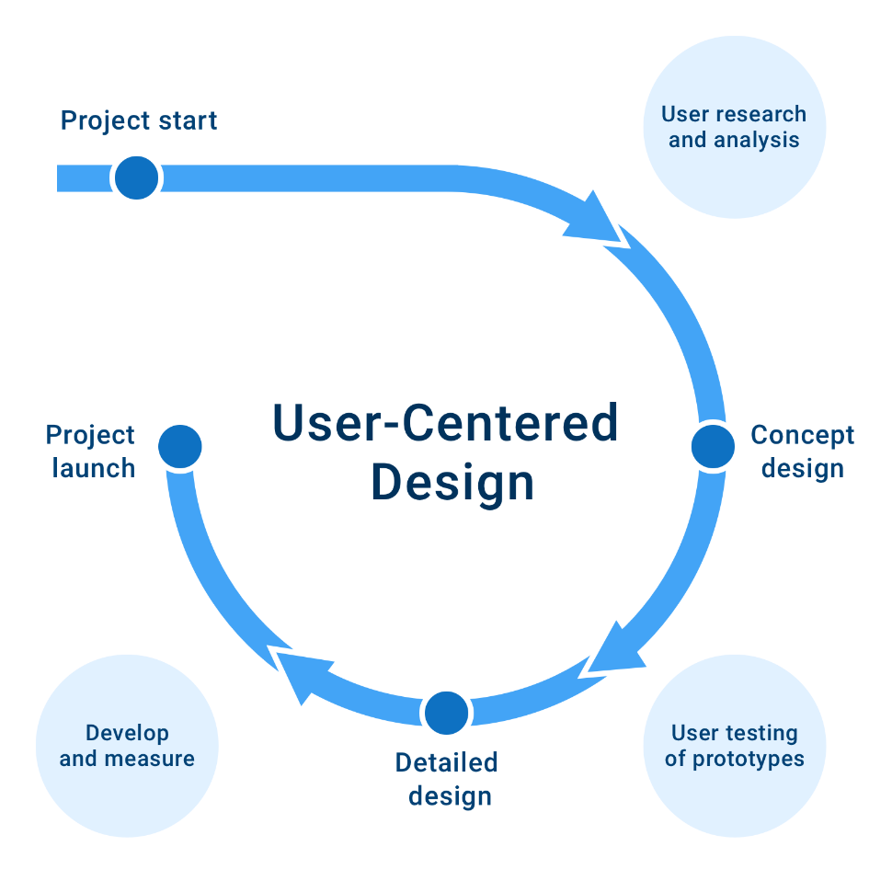

Figure 2: User-Centered Design (UCD) Development Life-Cycle

There are four (4) stages in the UCD which are:

1. Specify Context of Use and Requirements
2. Create Design Solution.
3. Implementation
4. Evaluation and Deployment

3.2 Application of Chosen Methodology

This session of discussion will cover each phase of UCD. Specify context of use and requirements, crease design solution and evaluate, implementation and deployment are the four (4) steps. The discussion will follow the UCD process.

3.2.1 Phase I: Specify Context of Use and Requirement (objective 1)

Main Task:

* Gathering requirements (Interview)
* Define the project’s scope, the problem statement, and the objectives.
* Create a Gantt chart
* Create a use case diagram.
* Create a class diagram.

Planning is the first step in the development of any system. To achieve objective 1, it is necessary to plan to determine whether developing this system is worthwhile. First, FYP coordinator and developer should meet for an interview. Gather all of the requirements from the client and potential users. Developer can define the problem statement, objective, and project scope of the system they are creating by understanding requirements.

       Developers will analyse and validate the potential users' needs once they have decided to build the system. The second round of review and verification aids developers in better understanding user requirements and determining which processes should be included. The next objective is to create a Gantt chart before moving on to the next level. A Gantt chart is a graphical bar chart that shows the progress of a system (Shelly et al., 2008). In the Gantt chart, all processes must be included.

The next step is to create a use case diagram that demonstrates the phases that represent the FYP procedures. This ensures that developers are completely aware of the FYP procedure and the needs of consumers. The use cases that are created should be able to depict the actions that the system's users conduct (Dennis et al., 2010). FYP coordinator and users should be shown the completed use case diagrams for approval.

       During this phase, class diagrams will be created to depict a system's classes, their properties, methods, and relationships between classes. Users' requirements document and use case diagrams will be used to create class diagrams. A class diagram is a pre-processing step that becomes a representative example, and then a working system (Shelly et al., 2008). As a result, it may not be required to show it to project sponsors or users because it offers additional information on software development components that they may not understand.

       System development can move on to the design phase after finishing the planning phase. Use case diagrams and class diagrams should have been produced and ready for reference during the design phase.

3.2.2 Phase II: Create Design Solution (objective 2)

Main task:

* Create the report’s design.
* Come up with a database design.
* Create a user interface design.

The report should be the starting point for the design process. The report should be visually appealing and simple to comprehend. As a result, the information printed in the report should not overflow or be incomplete. Users are the most significant factor in determining a report's usefulness, so they must be included in the report design process. The layout of a report should be determined by the demands of the potential users.

       To achieve objective 2, we need to create a database design, which began with the building of Entity-Relationship Diagrams (ERDs). System entities must be identified and entered into ERD using the class diagrams created during the planning process. Then, in ERD, double-check any data pieces that must be included and assign them to the appropriate entity. Each entity's primary key and foreign key must be assigned based on their dependencies. Finally, for all tables, build a third normal form (3NF) design to ensure that nonkey field data is completely dependent on the primary key. Before the database can be established, these three stages must be accomplished.

       Finally, to complete objective 2, the user interface design will be created. A user interface (UI) explains how people interact with computers (Shelly et al, 2008). As a result, a user-centric interface needs to be developed. Developers must learn to think like users and design user interfaces from that perspective. Using the heuristic principal guidelines by Nielsen J. (1994), a few usability heuristics are chosen:

* + - User control and freedom
    - Consistency and standards
    - Aesthetic and minimalist design

3.2.3 Phase III: Implementation (objective 3)

Main Task:

* + Create the database.
  + Build the system.

The most important and difficult step of the SDLC is development. As a result, each step and process must be carried out with caution. For objective 3, we need to create a database first, using the database design that was created during the design phase and XAMPP's MySQL will be used to generate the database.

      To complete objective 3, the system will be developed after the database has been prepared. The system is built in accordance with the interface design and specifications established in the previous phase. For feedback, users will be shown every completed and tested function. It is permissible to make changes to the interface, features, functionality, and requirements. Based on user feedback, developers will adjust the design. This iterative approach will continue until the system's users are pleased. This is the most time-consuming stage of the UCD because it forms the foundation of the entire process.

3.2.4 Phase IV: Evaluation and Deployment (Objective 4)

Main Task:

* + Evaluation
  + Install the system on the server.

Every developed function must be tested before users for verification. The testing's purpose is to detect and resolve execution errors that could cause the programme to crash, as well as logic issues that may have gone missed during desk checks. To achieve objective 4, the integration testing should be conducted when all functions and features have been developed, tested, and authorised by users. Following the completion of integration testing, the entire system must be tested, and FCI FYP Management System usability will be evaluated by the users. To simulate actual operational settings during this system test, users contribute data, including samples of actual, or live, data, perform queries, and generate reports. If scenarios are provided, scenario testing can be done. The entire system will be deployed onto the server after successful completion of system testing and approval by the project coordinator. The server's connection will also be evaluated.

3.3 Data Analysis

Data analysis is performed after the data have been collected via the interview questions.

3.3.1 Interview Questions Outline

Table 1 shows the outline of the interview’s questions with Dr. Dinna.

|  |  |
| --- | --- |
| **Questions** | **Answers** |
| What is the process and procedure that supervisors need to go through to guide their assigned students? | Basically, is to assist and monitor student under their supervision.  Supervisor should be able to guide the student from the beginning of the project until the end.  However, it is the student’s responsibility in completing their whole FYP Project.  You can refer to the “FYP(IT) Booklet”. |
| Do you face any problems or difficulties in managing these works? | Yes, the workload in monitoring each task for supervisor, examiners and students is very tedious. |
| What features/functions do you deem needed? | A calendar of all important deadlines for every user to see. This should be keyed-in by supervisor at the beginning of the semester.  Activity checklist for coordinator and supervisor  Examiner generator. Means a feature that can assign 2 suitable examiners for each student.  Key-in grades. Allowing the supervisors and examiners to key in directly the FYP marks for both week 7 and 14 for both FYP 1 and FYP 2. |
| Who are the users? Do you think coordinator, SV and students are possible? | Coordinator:   * Monitor grades * Compile the marks and create reports. * Assign examiners and supervisors.   Supervisor:   * Review proposals * Monitor student progress from logbooks being key-in by students. * Key in marks   Students:   * Submit proposal. * Progress report: student can key-in their logbook. * Submit final reports (FYP1 and FYP2) |
| What else do you want to have in the system to ease you as the coordinator | Full control to edit the Percentage (%) marks for both week 7 and week 14. |
| What are the colour themes/layout/fonts that you prefer for the system? | Neat, clean, and easy to navigate. |

Table 1: Interview’s questions summary outline

3.3.2 Interview Summary

From the answers, the processes and procedure, features and functions needed for the system, the users for the system, and the user interface themes have been extracted. Table 1 shows the extracted information. The processes and procedure are that SV should be able to assist, monitor, and guide students during their FYP. For example, regarding the FYP report, SV need to guide the student accordingly using the format provided by the FYP coordinator. After that, for features and functions such as calendar, activity checklist, examiner generator, and key-in grades feature also collected from the interview’s answers. There are also another additional features/functions that will added to the system to according to the answers. Lastly, the themes for user interfaces need to be neat, clean and easy to navigate.

**CHAPTER 4: DESIGN/FRAMEWORK**

4.1 Introduction

To develop a great system, the User Interface (UI) must be thoroughly designed to meet user expectations and provide a positive user experience. Data flow diagram (DFD) and entity relationship diagram (ERD) are crucial throughout the design phase, particularly for FCI FYP Management System, which involves a lot of information processing. The following chapter is organized as such; 4.1 Introduction, 4.2 Use Case Diagram, 4.3 Data Flow Diagram, 4.4 Entity Relationship Diagram (ERD), 4.5 Data Dictionary and 4.6 Low-Fidelity (Lo-Fi) Design.

4.2 Use Case Diagram

A use case diagram is a graphical representation that illustrates the dynamic nature of a system. It consists of actors, use cases, and their connections. The use case diagram demonstrates how users would interact with the proposed system. The diagram is used to gather information about the system's requirements and to discover external and internal concerns that may influence it. By drawing the diagram, the designer can see the interactions and functions. Students, supervisors, and FYP coordinator are the three type of users for the FCI FYP Management System represented in Figure 3. The obligation of each group towards the system is in the middle.

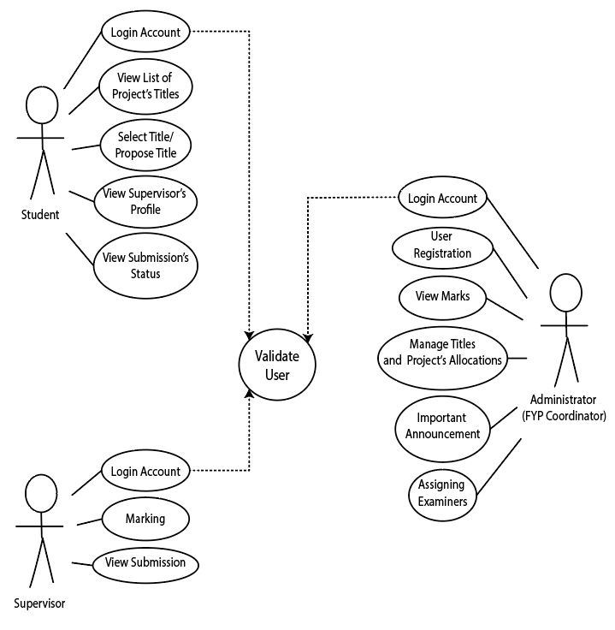

Figure 3: Use Case Diagram

4.3 Data Flow Diagram

4.3.1 Context Diagram

Figure 4 below depicts the relationship among the potential users made up of student, supervisor and FYP coordinator with the FCI FYP Management System. The arrows indicate the direction and the processes between the system and the external entities (potential users).

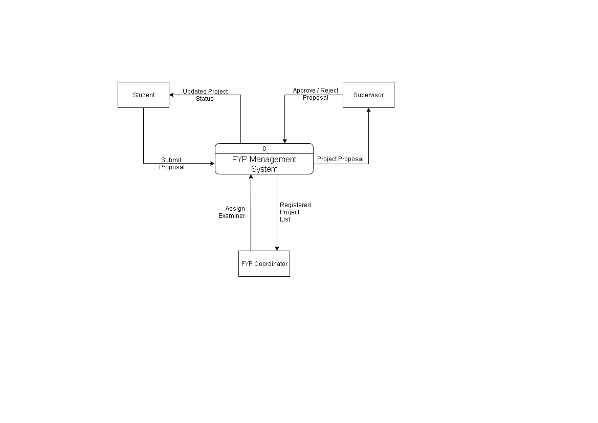

Figure 4: Context Diagram

4.3.2 Level-1 Data Flow Diagram

Figure 5 below shows the Level 1 Data Flow Diagram, which is the decomposition of FCI FYP Management System process show in the Context Diagram. The system contains four processes, three external entities, and two data stores.

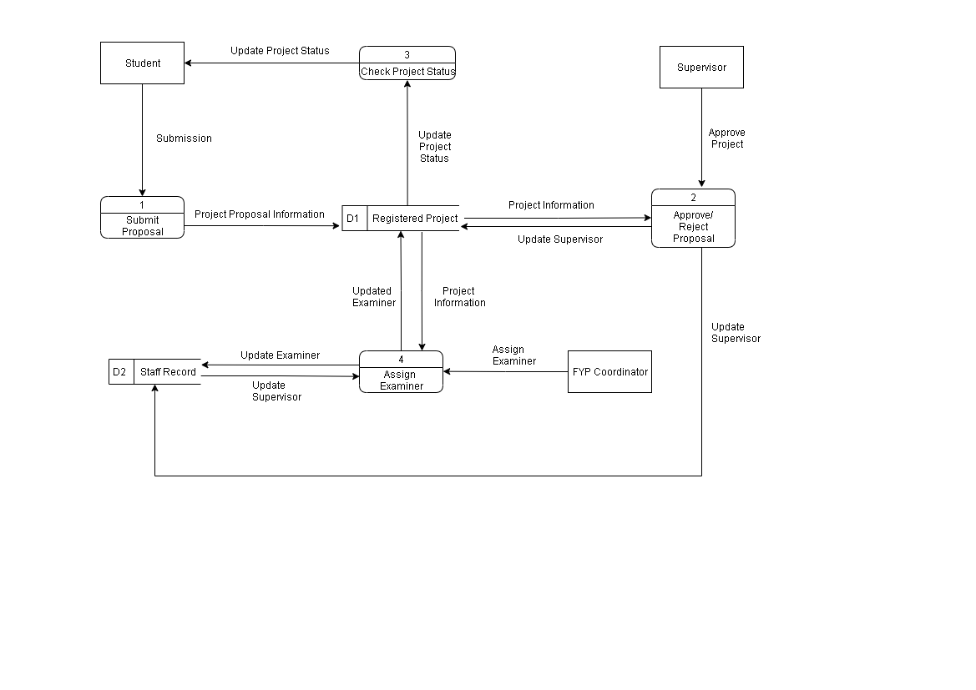

Figure 5: Level-1 DFD

4.4 Entity Relationship Diagram (ERD)

A relational database is designed using an entity relationship diagram (ERD), which allows all data to be stored in tables and structured in rows and columns. We should first fully comprehend the system's needs to design a good ERD. Then we must select what data to include in the database and how to group it into tables. To avoid duplicating data in the same database, all tables must be normalised in third normal form. For example, instead of duplicating all the lecturer's data in Student tables, we may put the lecturer ID in the Student database and retrieve lecturer information using the lecturer ID. This means, we can ensure that the data in our database is consistent. Finally, we need to connect all of the tables together based on their connections.

Figure 6 is the ERD that drawn for FCI FYP Management System database. Most of the queries are from these tables. Primary keys are label with PK whereas foreign keys are label with FK in entity tables beside the attributes.

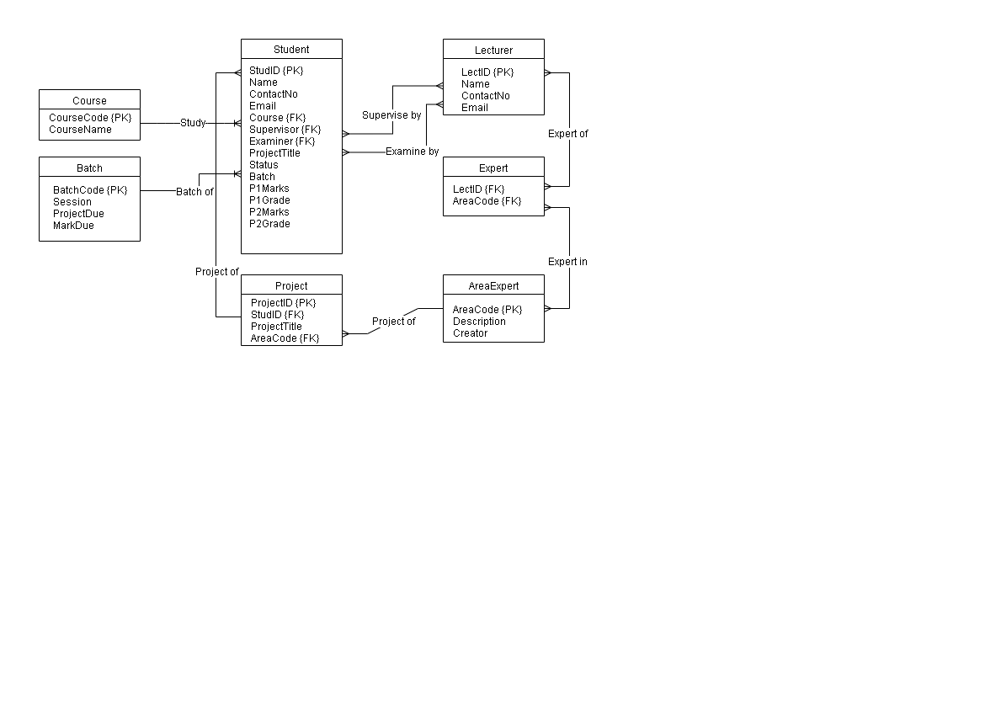

Figure 6: Entity Relationship Diagram (ERD)

4.5 Data Dictionary

A data dictionary is a set of names, definitions, and attributes about data elements that are being used or captured in a database, information system, or part of research project. It will be used as guidance. Below are the tables of entities that being used for in this project.

Course Entity – Store all related information regarding FCI’s course.

|  |  |  |  |
| --- | --- | --- | --- |
| Entity Name | Attributes | Description | Data Type |
| Course | CourseCode | Unique identity of course | char (4) |
| CourseName | Course full name | varchar (100) |

Table 2: Course Entity

Batch Entity – Store all information about student’s batch.

|  |  |  |  |
| --- | --- | --- | --- |
| Entity Name | Attributes | Description | Data Type |
| Batch | BatchCode | Unique identity of batch | char (4) |
| Session | Current FYP student semester’s year | varchar (50) |
| ProjectDue | Due date of project submission | datetime |
| MarkDue | Due date of marks submission | datetime |

Table 3: Batch Entity

Student Entity – Store student’s information.

|  |  |  |  |
| --- | --- | --- | --- |
| Entity Name | Attributes | Description | Data Type |
| Student | StudID | Unique identity of student | char (10) |
| Name | Student’s name | varchar (100) |
| ContactNo | Student’s contact number | integer |
| Email | Student’s email | varchar (50) |
| Course | Student’s registered course | char (4) |
| Supervisor | Student’s FYP supervisor | char (50) |
| Examiner | Student’s FYP examiner | char (50) |
| ProjectTitle | Student FYP Project’s title | varchar (100) |
| Status | Student’s submission status | char (20) |
| Batch | Student’s current semester and year | char (10) |
| P1Marks | Student’s FYP 1 Marks | float |
| P1Grade | Student’s FYP 1 Grade | char (1) |
| P2Marks | Student’s FYP 2 Marks | float |
| P2Grade | Student’s FYP 2 Grade | char (1) |

Table 4: Student Entity

Lecturer Entity – Store FCI lecturer’s information

|  |  |  |  |
| --- | --- | --- | --- |
| Entity Name | Attributes | Description | Data Type |
| Lecturer | LectID | Unique identity of lecturer | varchar (20) |
| Name | Lecturer’s name | char (100) |
| ContactNo | Lecturer’s contact number | integer |
| Email | Lecturer’s email | varchar (50) |

Table 5: Lecturer Entity

Expert Entity – Store FCI lecturer’s expertise.

|  |  |  |  |
| --- | --- | --- | --- |
| Entity Name | Attributes | Description | Data Type |
| Expert | LectID | Unique identity of lecturer | varchar (20) |
| AreaCode | Unique identity of expertise | char (4) |

Table 6: Expert Entity

AreaExpert Entity – Store FCI lecturer’s area of expertise.

|  |  |  |  |
| --- | --- | --- | --- |
| Entity Name | Attributes | Description | Data Type |
| AreaExpert | AreaCode | Unique identity of area of expertise | char (4) |
| Description | Description of expertise | varchar (50) |
| Creator | Lecturer that creates this expertise | char (20) |

Table 7: AreaExpert Entity

Project Entity – Store information of student’s project.

|  |  |  |  |
| --- | --- | --- | --- |
| Entity Name | Attributes | Description | Data Type |
| Project | ProjectID | Unique identity of project | char (5) |
| StudID | Unique identity of student | char (10) |
| ProjectTitle | Student FYP Project’s title | varchar (100) |
| AreaCode | Unique identity of area of expertise | char (4) |

Table 8: Project Entity

4.6 Low-fidelity (Lo-Fi) Design

Low-fidelity design is a quick and easy way to lay out the real system into a low-tech concept (blueprint). In the Lo-Fi, only some of the visual attributes of the final product are presented (such as shape of elements, basic visual hierarchy, etc.) (Babich, 2017). Lo-fi are usually concept sketches, a set of drawings or storyboard, representing the skeleton of the interface (Costa, 2020). In this project, Lo-Fi is used to disclose the project’s user interfaces to the users based on existing heuristic principles guidelines. For the Lo-Fi of FCI FYP Management System, it will be designed using Balsamiq Wireframes application.

A usability heuristic is a tool mainly used to identify any design issues associated with the UI. Using Jakob Nielsen’s heuristics principle, the UI will be design accordingly. In Figure 7, the interface was designed using heuristic’s User Control and Freedom principle. In the left navigation bar, users can directly access their desired pages with provided buttons and if users accidently click on one of the buttons, they can simply click the button to go back to the previous page. Another example of the principle used in the interface is the cancel and reset button used whereas if the user wants to cancel or reset the uploaded file, they can simply click either one to do so.

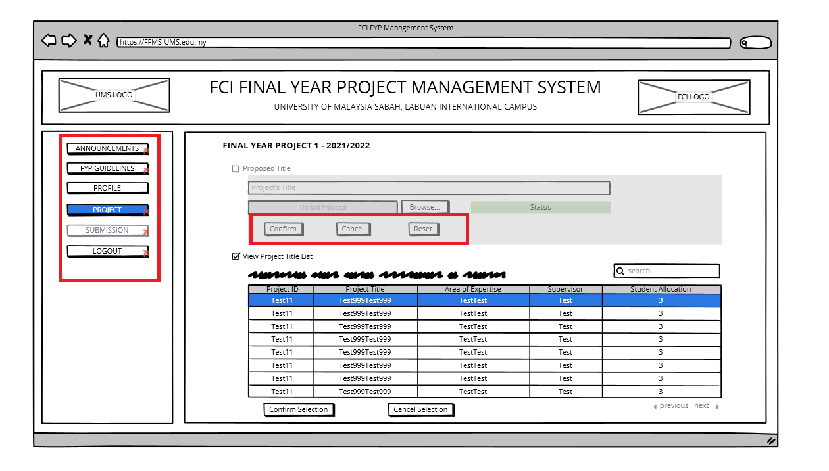

Figure 7: FFMS Student’s Propose/Select Project Interface.

In Figure 8 and 9, both interfaces are designed using heuristic’s Consistency and Standards principle where the header and left navigation bar are identically the same with one another as well as other pages.

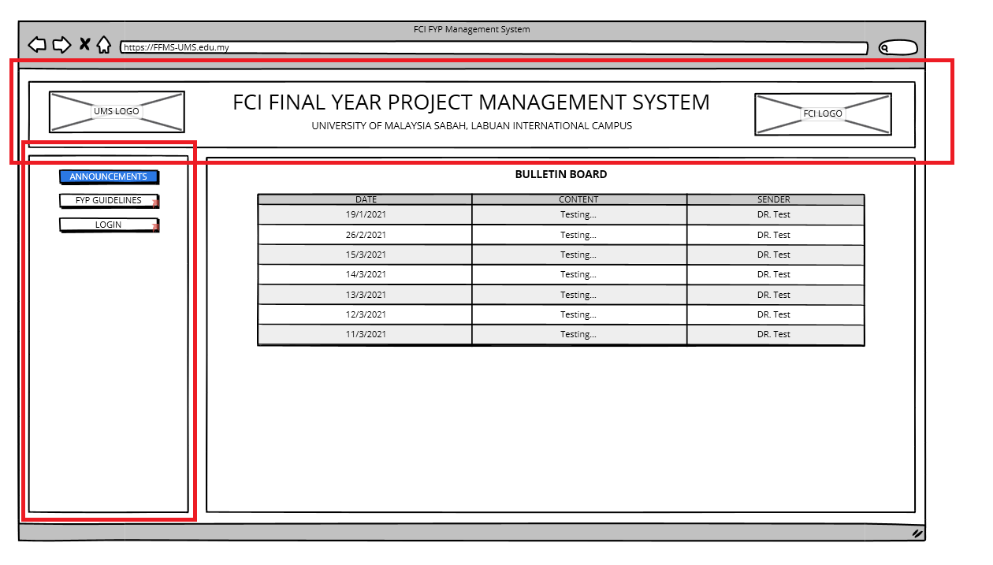

Figure 8: FFMS’s Homepage Interface.

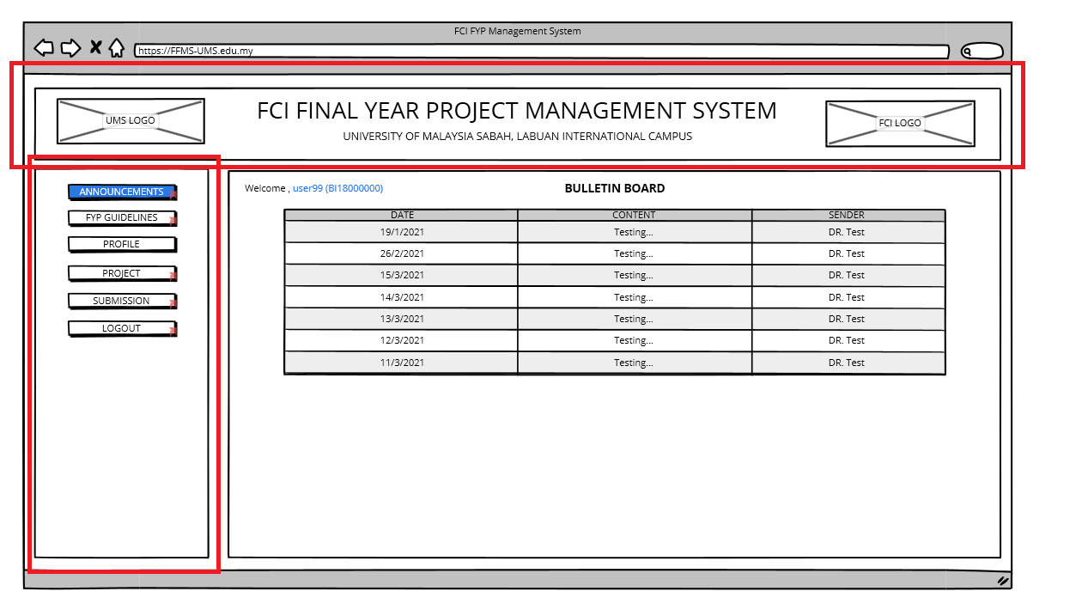

Figure 9: FFMS Student’s Homepage Interface.

Using heuristic’s Aesthetic and Minimalist Design principle, interfaces shown in Figure 10 are designed to display the necessary and useful features and functions so that all the information that is being presented on the page is relevant.

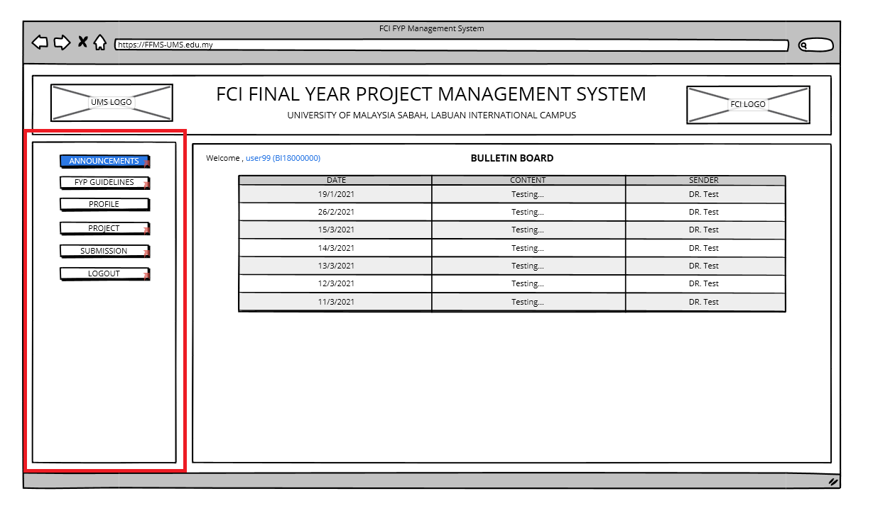

Figure 10: FFMS Student’s Homepage Interface.

**CHAPTER 5: CONCLUSION**

5.1Introduction

This chapter concludes the end of FCI FYP Management System report in FYP 1. This project offers a structured solution to the manual FYP management committee's concerns. The first chapter of this report opens with background of the study and further description of Final Year Project. This is followed by FFMS’s problem statements, goal and objectives, project scope, potential user, project framework and project timeline. Chapter 2 presents a review of the literature that connects management system, system development, user centred development method, user gathering techniques and existing heuristic guidelines in the development of FCI FYP Management System. Chapter 3 provides an overview of Agile SDLC phases to develop the web-based system. Lastly, chapter 4 details the design and framework of this project. The database design and low-fidelity design using existing heuristic principles are also disclosed in this chapter.

5.2 Project Strength

Currently the FYP process is manage manually by the FYP committee with the support of supervisors which come with abundant of workloads. With FCI FYP Management System integrated features, it will be able to reduce their workloads with the reduce numbers of hardcopy that they need to handle physically. For students, using the centralized FCI FYP Management System will make it easier for them to submit their proposals, reports and submissions online through their smart devices.

5.3 Future works

To complete the FCI FYP Management System, I will need to continue developing the front-end and back-end of the systems. The report also needs to be enhanced along with the project development.  The first step into FYP 2 is to integrate the data into the database using XAMPP’s MySQL. With Lo-Fi design and the guidelines of existing heuristics, the front-end (user interfaces) can be built and programmed using HTML and CSS programming languages as well as PHP to build the back-end part. At the end of FYP 2, a poster needs to be created to illustrate the project as a preparation of FYP viva as well as the hardcopy of FYP dissertation.

**REFERENCES**

Babich, N. (2017, November 29). Prototyping 101: The Difference between Low-Fidelity and High-Fidelity Prototypes and When to Use Each. Adobe Blog. https://blog.adobe.com/en/publish/2017/11/29/prototyping-difference-low-fidelity- high-fidelity-prototypes-use.html#gs.2ygd51

Computer Hope. (2021). HTML. Retrieved March 18, 2021, from https://www.computerhope.com/jargon/h/html.htm

Costa, R. (2020, January 16). Low fidelity vs high fidelity wireframes: what’s the difference? Justinmind. https://www.justinmind.com/blog/low-fidelity-vs-high-fidelity- wireframing-is-paper-dead/

Dennis, A., Wixom B.H & Tegarden D. (2010). System Analysis and Design with UML: An Object-Oriented Approach (3rd ed). John Wiley & Sons (Asia).

Dina Salah, Richard F. Paige, and Paul Cairns (2014). A systematic literature review for agile development processes and user centred design integration. In Proceedings of the 18th International Conference on Evaluation and Assessment in Software Engineering (EASE '14). Association for Computing Machinery, New York, NY, USA, Article 5, 1–10. https://doi.org/10.1145/2601248.2601276

Edward Price, George Moore, Leo Galway, and Mark Linden (2016). User Centred Design of a Smartphone-based Cognitive Fatigue Assessment Application. In Proceedings of the 14th International Conference on Advances in Mobile Computing and Multi Media (MoMM '16). Association for Computing Machinery, New York, NY, USA, 120–127. https://doi.org/10.1145/3007120.3007122

Eid, M. (2015). Requirement Gathering Methods. Retrieved March 20, 2021, from https://www.umsl.edu/~sauterv/analysis/F2015/Requirement%20Gathering%20Met hods.html.htm

GCFLearnFree.org. (n.d.) All about Windows. Retrieved March 15, 2021, from https://edu.gcfglobal.org/en/windowsbasics/all-about-windows/1/

Goodman, D. (2020, February 27). Agile Process: Why You Need Feedback Loops During & After Sprints - Iterative Agile Loops. Mendix. https://www.mendix.com/blog/agile- process-why-you-need-feedback-loops-both-during-and-after-sprints/

Herawan (2020). What is MySQL: MySQL Explained for Beginners. Retrieved March 15, 2021, from https://www.hostinger.my/tutorials/what-is-mysql

Herbert K. (2006). PHP (Hypertext Preprocessor). Retrieved March 17, 2021, from https://whatis.techtarget.com/definition/PHP-Hypertext-Preprocessor

How to Set Up and Implement Database for Web Design and development (2020, March 13). AxiomQ Ventures. https://axiomq.com/blog/how-to-set-up-and-implement-database- for-web-design-and-development/

Janko (2008). Discussion: Why web designers often use PHP over ASP.NET? Retrieved March 18, 2021, from https://dzone.com/articles/discussion-why-web-designers-o

Kölling, M., & McKay, F. (2016). Heuristic Evaluation for Novice Programming Systems. ACM Transactions on Computing Education, 16(3), 1–30. https://doi.org/10.1145/2872521

LABFOLDER. (n.d.) Cloud vs local Server – where should you store your data? Retrieved March 17, 2021, from https://www.labfolder.com/cloud-vs-local-server/

Lim, S. (2002). The Self-Confrontation Interview: Towards an Enhanced Understanding of Human Factors in Web-based Interaction for Improved Website Usability. J. Electron. Commerce Res., 3(3), 162-173.

MDN Web Docs (2021). What is a web server? Retrieved March 20, 2021, from https://developer.mozilla.org/en- US/docs/Learn/Common_questions/What_is_a_web_server

MDN Web Docs (2021). What is JavaScript? Retrieved March 20, 2021, from https://developer.mozilla.org/en- US/docs/Learn/JavaScript/First_steps/What_is_JavaScript

Mindfire Solutions. (2018). Advantages and Disadvantages of PHP Frameworks. Retrieved March 15, 2021, from https://medium.com/@mindfiresolutions.usa/advantages-and- disadvantages-of-php-frameworks-c046d50754e5

Modell, M. (2007). The interview and Other Data Gathering Methods. Retrieved March 23, 2021, from shorturl.at/jyNW3

Morris, S. (2017). TECH 101: THE ULTIMATE GUIDE TO CSS. Retrieved March 18, 2021, from https://skillcrush.com/blog/css/

Muniz, F. (2019, September 9). An Introduction To Heuristic Evaluation. Usability Geek. https://usabilitygeek.com/heuristic-evaluation-introduction/

Nielsen, J. (1994). 10 Usability Heuristics for User Interface Design. Nielsen Norman Group. https://www.nngroup.com/articles/ten-usability-heuristics/

Samuel T. Yigzaw, Ilkka Jormanainen, and Markku Tukiainen (2019). Trends in the Role of ICT in Higher Education Knowledge Management Systems: A Systematic Literature Review. In Proceedings of the Seventh International Conference on Technological Ecosystems for Enhancing Multiculturality (TEEM'19). Association for Computing Machinery, New York, NY, USA, 473–480. https://doi.org/10.1145/3362789.3362805

Shelly G.B., Cashman T.J. & Rosenblatt H.J. (2008). Systems Analysis and Design (7th ed). Course Technology, Cengage Learning.

Tamanna (2011). Advantages of PHP over ASP .NET. Retrieved March 17, 2021, from http://www.avigma.com/php-vs-asp/

TechTerms (2011). Programming Language. Retrieved March 18, 2021, from https://techterms.com/definition/programming_language

Vats, R. (2020). SQL Vs MySQL: Difference Between SQL and MySQL. Retrieved March 18, 2021, from shorturl.at/izIOR

Wall, M. (2014). The Role of a Database in a Web Application. Retrieved March 20, 2021, from https://itstillworks.com/role-database-application-7159218.html

White, P. (2020). The user-driven approach that drives success in technology projects. Retrieved April 13, 20201, from https://www.audacia.co.uk/blog/user-driven- development

Xiu-ying Ou (2018). Research on University Education Management System Based on Big Data. In Proceedings of the International Symposium on Big Data and Artificial Intelligence (ISBDAI '18). Association for Computing Machinery, New York, NY, USA, 275–280. https://doi.org/10.1145/3305275.3305330

Yaddanapudi, S., & Yaddanapudi, L. N. (2019). How to design a questionnaire. Indian journal of anaesthesia, 63(5), 335–337. https://doi.org/10.4103/ija.IJA_334_19

**APPENDICES**

1. Student’s Logbook

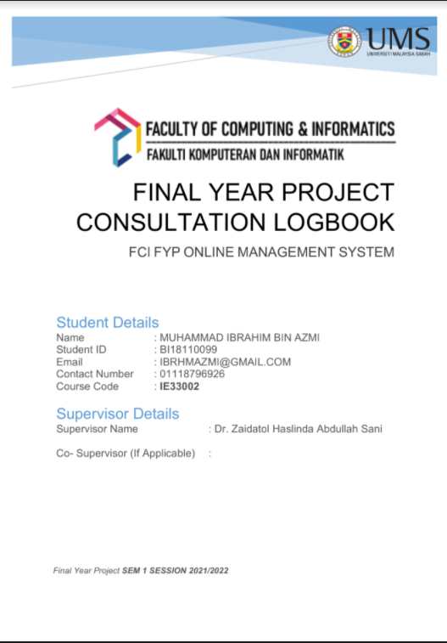

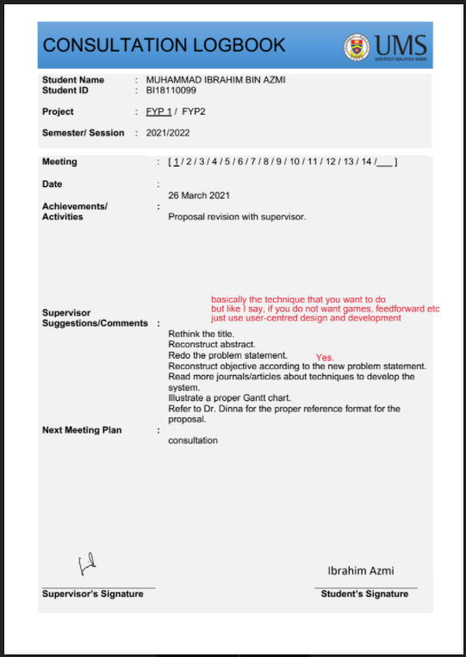

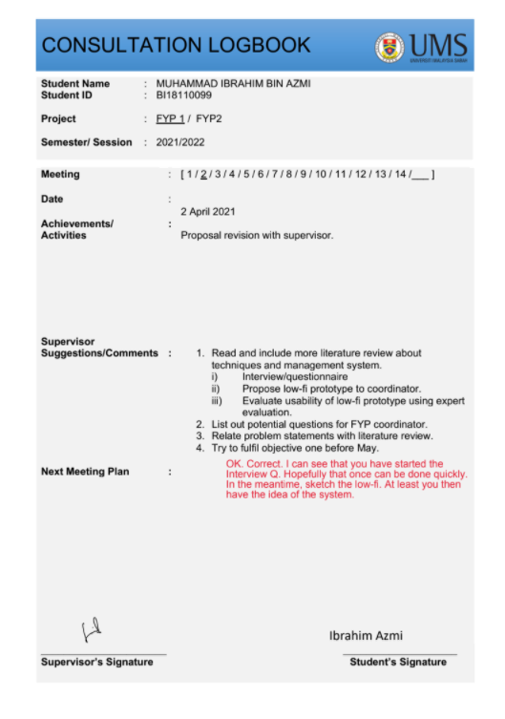

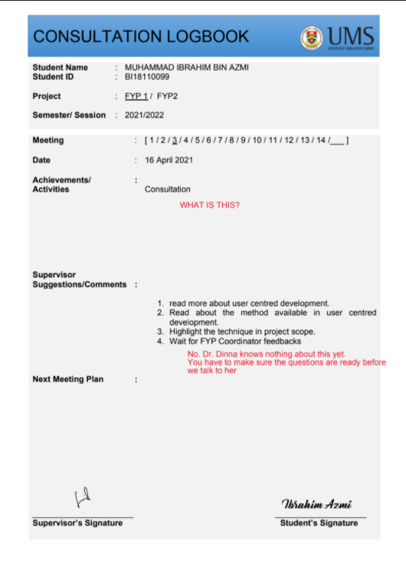

1. Turnitin Report

