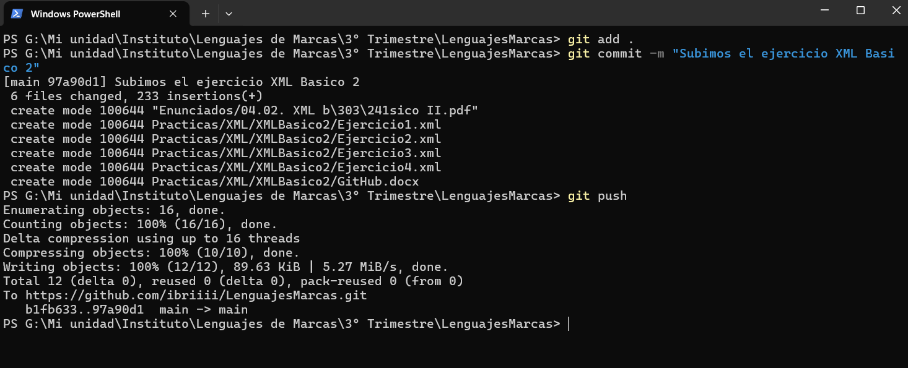

Link: <https://github.com/ibriiii/LenguajesMarcas/tree/97a90d1d72cc56fe0d94f8b0e08abb5595a9c64b/Practicas/XML>