SSIS INTRO

Create an SSIS package that integrates data from an Excel file and a Flat File, performs transformations, and loads the data into a SQL Server table. The task includes additional complexities such as row-specific data extraction, custom delimiters, and the use of variables for dynamic configuration.

**Requirements**

**Data Sources**:

* + **Excel File**:
    - Data starts at **row 4** (ignore rows above).
    - Column names are present in **row 5**.

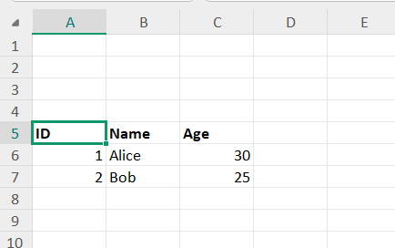

* + **Flat File**:
    - Contains a header row that matches the schema of the Excel file.

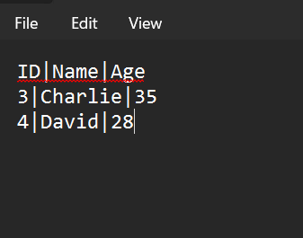

* + - .

**SQL Table**:

* Use a **variable** to store the destination SQL table name.
* **Challenge**:
  + If the table does not exist, dynamically create it using an SSIS **Execute SQL Task** based on the schema of the source data.
  + Add a timestamp column (LoadDateTime) in the table to track when each row was processed.

**Transformations**:

* Add a derived column to calculate the MonthsForAge( for example 36 months for 3 years old
* Add a derived column to include the source type (e.g., "Excel" or "Flat File") for each row. This column should be in the sql target table

**Data Integration**:

* + Combine the data from both sources using a Union All transformation after ensuring column alignment and standardization.

****Dynamic Configuration**:**

* Use SSIS **variables** to:
  + Store file paths for the Excel and Flat File sources.

**Use a **Conditional Split Transformation** to:**

* Exclude rows where people is under 18 years old

· Log all rows that fail validation into a Flat File (ErrorLog.txt).

· Include the reason for failure in the error log (e.g., "Missing Age" or "Age < 18").