**Requirements**

1. **Source Files**:
   * A flat file with |-delimited data.
   * An Excel file (ensure the Excel driver is installed if you're using a 64-bit environment).
   * A CSV file.
   * Sample data
   * 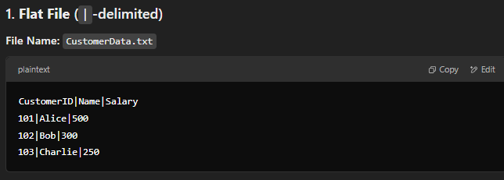
   * A screenshot of a computer

     Description automatically generated
2. **Target Table**:
   * A SQL table with the required columns:
     + CustomerID, Name, Salary, Position, LoadDate, etc.
3. **SSIS Tasks**:
   * **Execute SQL Task**: To check if the target table exists or create it if needed.
   * **Data Flow Task**: To process the three sources and transform the data.
4. **Derived Columns**:
   * LoadDate: Current system date/time.
   * Position: Derived from the Salary column with the given logic.
5. **Error Handling**:
   * Add error rows to a separate error table or log.
6. **Control Flow**:
   * Use precedence constraints to proceed only if the table check passes.