CLASS 46

Overall overview:

You need to create an SSIS package to perform the following tasks:

1. **Calculate Average Salary:** Use an Execute SQL Task to get the average salary from the first table (SalaryFactTable) and store it in a variable (User::AvgSalary). Display this variable's value using a Script Task.
2. **Filter Salaries:** Use another Execute SQL Task to retrieve salaries greater than the average salary from the second table (SecondSalaryTable). Store the result in an Object variable (User::FilteredSalaries) and display the filtered data using a Script Task.
3. **Export to File:** Write the filtered data to a CSV file. The file name should dynamically include the table name and the current date in the format SecondSalaryTable_ddMMyyyy.csv. Use a Data Flow Task for this.

Salary Fact Table  
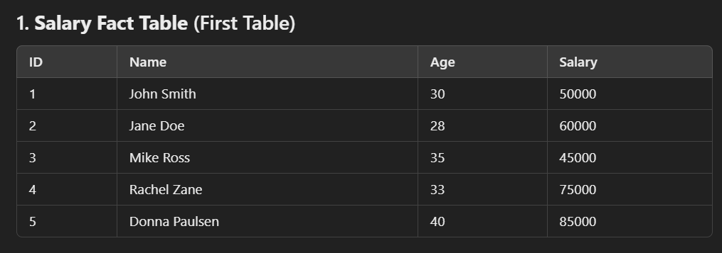

Second Salary Fact Table

The result from script task and the data in the destination file should look like this   
