Class 48

Task 1. Use Scrip Task

First. Create folder create multiple txt and csv files.

Requirement:

In folder, identify and filter files that:

1. Have the .txt extension.
2. End with the current date in the format ddMMyyyy.txt (e.g., Employees_25012025.txt if today's date is January 25, 2025).

Read the content of the filtered .txt files. Each file contains employee details in a structured format (e.g., ID, Name, Salary).

Insert the data from these files into the SQL Employees table. Ensure that each line from the file corresponds to a row in the table.

**2nd Task Requirements:**

**Task Requirements:**

* **Input Data:  
  A folder containing 3 Excel files, each with 2 sheets. Each sheet contains the following data structure:**
  + **Columns: ID, Name**
  + **Example Data**

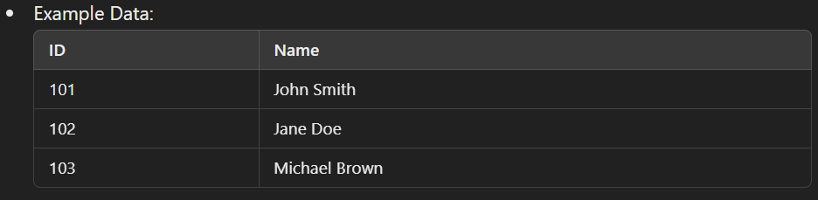

**• Processing Requirements:**

1. **Loop through each Excel file in the folder.**
2. **For each file, process all sheets (2 sheets per file( should be dynamically if there are more sheets).**
3. **Extract data from each sheet.**

**• Output Requirements:**

1. **Insert the data from each sheet into a SQL Customer table.**
2. **Save the data from each sheet to a .txt file. The file name should match the sheet name (e.g., Sheet1.txt, Sheet2.txt).**