**SSIS Task Overview: Handling Missing Customers & Error Logging**

**Task Objective:**

1. Load a **Customers** file into a **SQL table**.

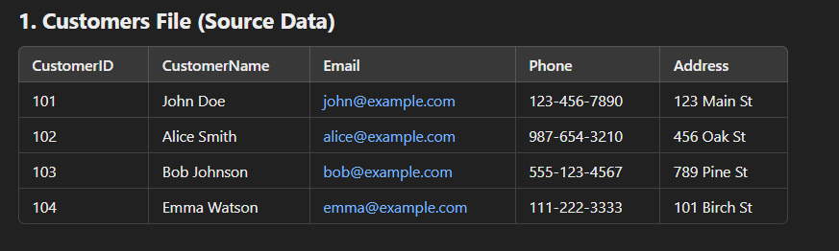

1. Validate each **CustomerID** against a **Lookup Table**:
   * If **exists**, load into the **Customers Table**.
   * If **not exists**, load into the **Customers_ErrorTable**.

1. Send an **email notification** listing missing customers.
2. Implement an **Event Handler** to capture and log errors.
3. Update the **SSISLog Table** with error details.

**SSIS Components to Use:**

1. **Data Flow Task** → Load and validate CustomerID using a **Lookup Transformation**.
2. **Conditional Split** → Route missing CustomerIDs to **Customers_ErrorTable**.
3. **Execute SQL Task** → Insert missing customers into the **Customers_ErrorTable** table.
4. **Script Task** → Notify about missing customers via email.
5. **Event Handler (OnError Event)** → Capture errors, send email with details, and update the **SSISLog Table**.

**Process Flow:**

1. Extract data from the **Customers File**.
2. Perform a **Lookup** against the **Customer Reference Table**.
3. Route missing **CustomerIDs** to the **Error Table**.
4. Send an **email notification** listing missing customers.
5. Capture **package errors** via the **Event Handler** and send an email with error details (message, date, package name, runner ID/name).
6. Update the **SSISLog Table** with error details.