**SSIS Task Overview: Loading Excel Files into an SQL Table with Execution Logging**

**Task Objective:**

You need to create an SSIS package that:

1. **Loads multiple Excel files** into a SQL table using a **Foreach Loop Container**. Do **incremental load**.
2. **Logs errors** (if the process fails) into a dedicated SQL error log table.

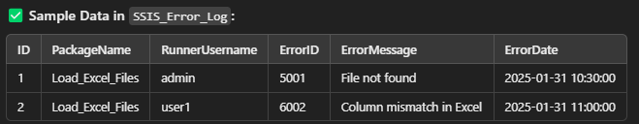

1. **Logs successful executions** into a separate SQL success log table, tracking details like inserted and updated rows.

