**SSIS Task: Loading Student Registration Data from OLTP to OLAP**

**Overview**

**This SSIS package will:**

1. **Extract student registration data from an OLTP table.**

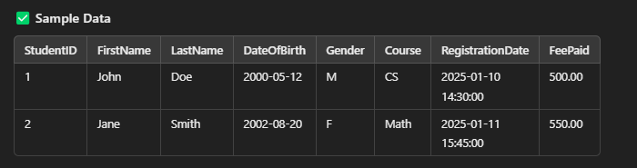

1. **Transform the data (clean, lookup, and aggregate).**
2. **Load the data into an OLAP system (Fact & Dimension Tables).**

**

**Dim_Course**

**Fact_Students_registration**

1. **Log Execution Details (Success/Failure Logs).**