**SSIS Task: Incremental Load Using Slowly Changing Dimension (SCD) Type 0 with IsActive Flag**

**Source sample data  
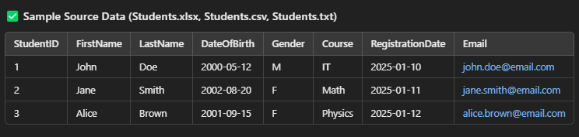**

**Existing target data  
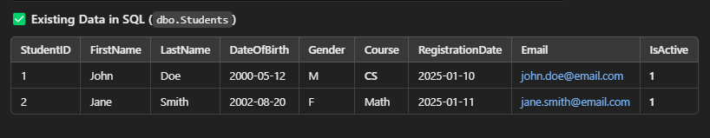**

* **Extract** data from multiple file sources (Excel, CSV, TXT).
* **Transform** using **Lookup** to check for existing records and **Derived Columns** to modify or add new calculated columns.
* **Load** data incrementally into a SQL table using **Slowly Changing Dimension (SCD) Type 0 with an IsActive flag**:
  + **If the record is new → Insert it with IsActive = 1.**
  + **If the record exists and has changed → Insert as a new row and set previous record's IsActive = 0.**

Result should be like:

