**SSIS Task: Incremental Load (incremental load type_1) for Student Data Using Lookup and Derived Columns.  
Before progressing create these sources and target table  
Source files example:**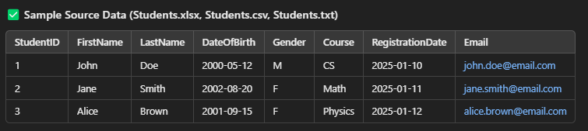

**

* **Extract** data from multiple file sources (Excel, CSV, TXT).
* **Transform** using **Lookup** to check for existing records and **Derived Columns** to modify or add new calculated columns.
* **Load** data incrementally into a SQL table:
  + **Insert** new student records.
  + **Update** existing student records if any changes are detected.