*As business application support specialists you will need to know and understand how the applications work as well as how people will be using the applications. In this lab we’ll look at doing some basic work with Excel. Also, we’ll be creating formulas and incorporating some of the built in functions.*

NOTE: This lab has multiple parts and you are expected to complete all of them. Only one of which will be marked.

Contents

Skills Tested 2

Preparation 3

Lab 2 3

Part A (12 marks) 3

Part B (12 marks) 4

Part C (12 marks) 5

Assignment 2 7

Part A (25 marks) 7

Part C (50 marks) 10

Submission Guidelines 13

# Skills Tested

* Open a new workbook.
* Save a workbook.
* Update the Properties of a workbook.
* Understanding cell references.
* Understanding cell ranges.
* Basic formulas applying the BEDMAS concepts.
* Entering text into a cell.
* Sizing columns.
* Copy and paste cell values.
* Creating formulas using hard coded values.
* Creating formulas using cell references.
* Using the fill handle to copy a formula down through a range of cells.
* Search for a built in function using the Insert Function option.
* Use a built in function – SUM, IF, AND, LOG, ROUNDUP, VLOOKUP, DEC2BIN.
* Formatting different aspects of a worksheet (fill colour, number formatting, borders, and cell alignment).
* Inserting rows.
* Using the Insert Function system.
* Using functions: MIN, MAX, COUNT, COUNTIF, SUMIF, AVERAGEIF, MID, LEFT, RIGHT, CONCATENATE, UPPER, LOWER.

# Preparation

1. As you go through the steps in this assignment, please make sure you save regularly and often.
2. From Blackboard, download and save the Assign2Distro.xlsx file to your desktop.
3. Rename it ***yourfullname_assign2.xlsx***.

# Lab 2

## Part A (12 marks)

At the end of the formula bar, you’ll see the formula button. When you click that button you’ll see the *Insert Formula* dialogue box. Here you can search through the available formulas and get information about them.

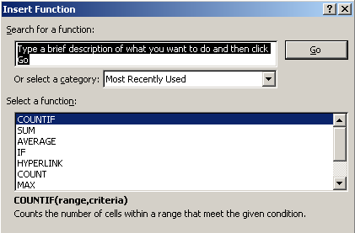

Let’s use this box to apply a few functions.

1. Open the accompanying workbook and select the Lab 2 Part A tab.
2. Here you can see a list of stocks and some stats for each one.
3. Click cell I2.
4. Open the Insert Formula dialogue (notice it adds the = sign for you), and look up the MIN function. This function “returns the smallest number in a set of values.”
5. Click OK.
6. Select the range of cells under the Volume title (F2:F19).
7. Click OK.
8. Now, do the same for the MAX and look up the COUNT function to get the total number of stocks, also applying them to the Volume column.

There are also functions that let us be more selective when analyzing data. These are the conditional logic functions: SUMIF, COUNTIF, and AVERAGEIF.

1. Click cell I6 so that it is active.
2. Open the Insert Function dialogue.
3. Look up the COUNTIF function. Its purpose is to count values that meet the criteria you set.
4. Click OK and it opens the Function Arguments dialogue. This dialogue’s purpose is to walk you through creating the function.

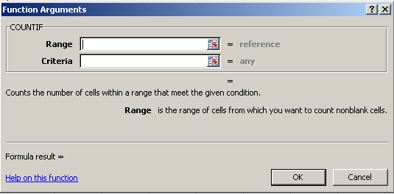

Let’s pick the range first.

1. Click the button at the end of the Range box. This reduces the dialogue allowing you to select the range you want to base the function on.
2. Select the range containing the volumes.
3. Click the button again to return to the *Function Arguments* box.
4. Type into the Criteria box, “>400000” with the quotes. This is what we are basing our count on. We will count how many values are above 400, 000.
5. Click OK.

The number should show as 5.

Now you try it.

Apply the same principles and use the SUMIF function and the AVERAGEIF functions to determine the sum of volumes over 400, 000 and the average of those same options.

## Part B (12 marks)

*Sometimes, you have a large list of information and you want to sort through it, filter it, and just generally manipulate that large list, but not damage the data. Excel provides a structure called a Table not to be confused with a simple set of structured data on a page. An Excel Table is a powerful filtering and manipulation tool for dealing with large lists of data.*

1. Click on the Lab 2 Part B tab. Here is a large list of data.
2. Add the following titles across the top of the list. Tables, to be effective, require a set of titles (Excel adds defaults, but it's always better to have your own):

|  |  |
| --- | --- |
| A1 | Category |
| B1 | Title |
| C1 | Subtitle |
| D1 | Date |
| E1 | Length |
| F1 | Notes |
| G1 | Format |

1. Turn that list into an Excel Table (Insert->Table and don’t choose Pivot tables). If you are asked about external data ranges simply say Yes to the prompt and make sure you check the *My Table has Headers* option. If there is data on the page that you don’t want to include, simply select the range that contains the data to be included in the table and then use Insert-Table. (1 mark)

You will notice that Excel has changed your titles. Each title now has an arrow at the end of it and the rows are banded to make them easier to read. These dropdowns allow you to filter the data.

1. Click the Date dropdown. Here are all your options.
2. Sort the dates smallest to largest. Notice how quick that was.
3. Now, click the date column header again. See all the check marks in the lower section?
4. Uncheck the Select All option.
5. Check the 1947 one and click OK. Only the movie(s) from 1947 are visible.
6. And, when done you can clear any and all filters (except any sorting that you did), by opening the drop down again and selecting Clear Filter. Clear the filter from the date column.

Doing all that allowed us to reduce the data down to only what we wanted to see. Notice that it didn’t damage the data at all.

1. Answer the following questions and record your answers here before you move on. Remember to clear any filters before trying the next question. Place your answers in the cells on the worksheet labelled *Lab2PartBAns* (1 mark each)
   1. How many Steven Segal movies are in DVD format? HINT: they are labelled as Segal or Seagal in the Notes column. Also, find a way to add a total row at the bottom that shows summarized numbers. Answer: ______32______
   2. What date is the earliest movie? Answer: __1925_____
   3. How many action movies were made in 2009? Answer: ____20
   4. How many hours of movies are there? Answer: ____194318__
2. We have a new movie to add to the Table. Insert a row at the top of the Table just below the titles, and enter the following movie (2 marks):

ACTION, John Wick, 2013, 120, Keanu, Blu-Ray

1. If you notice, we have some movies appearing more than once (by title). Remove any duplicate movies. Hint: there is a button called *Remove Duplicates*. *NOTE: This change is permanent.* (2 marks)
2. We sold our copies of 300. Delete these row(s). (1 mark)
3. Remove the Table by converting it back into a simple range (leave the formatting as it is). HINT: Look for *Convert to Range*. (1 mark)

## Part C (12 marks)

*Most users are looking to create simple charts that will visually describe the numbers ("a picture is worth a thousand words or numbers" as the old saying goes).*

*Most charts will either show one line of data or two so the numbers can be compared.*

*In this part of the lab you will show two lines to compare two sets of data on the same chart. You’ll see an image sample of what we are looking for in the worksheet.*

Complete the following using the small table found on the tab Lab2PartC:

1. In column F calculate each student's average of the test scores **without** using any functions to 2 decimal places (1 mark).
2. In column G calculate each student's average using the average function to 2 decimal places (1 mark).
3. In row 8 cell A8 add the title Average then calculate the average score for each test using the average function to 2 decimal places (1 mark).
4. In row 9 cell A9 add the title Median then calculate the median for each test (you might have to research this function) to 2 decimal places (1 mark).

When working with data, it is sometimes helpful to set off data that meets certain conditions. For example, show grades that are under the 50% cut off. Excel has a function called conditional formatting. This allows you to set all kinds of rules for highlighting your data.

1. Select all the data in the table (only the grades and not your formulas).
2. On the Home tab, click the conditional formatting button. Here are all the possible ways you can format your cells.
3. Add conditional formatting to the cells that will show a red background whenever anyone has a grade below 50 (2 marks).

Finally, we can add the chart. The key to adding charts of any type is selecting a range of cells that form a square or rectangle. This may mean you need to select empty cells or ones that you don’t want to complete a rectangle.

1. We want to design a line chart on the same sheet that will compare the median progression versus the average over the four tests.
2. Select the titles first (Test 1-Test 4 include the Student First cell).
3. While holding CTRL, select the average and median values for those tests (the two rows at the bottom).
4. On the Insert tab, find the Line Chart and click it. And there you go, a line chart comparing the median and average for the four tests. (3 marks)

When it comes to charts you will also want to make some changes to how they look.

1. Click anywhere on your chart. Two new context tabs appear on the ribbon. These can be used to manage the appearance and properties of your chart.
2. Between these two tabs you can control your chart. See if you can do the following (3 marks):
   1. Change the title of the chart to something more befitting its function.
   2. Change the scale of the vertical bar to run from 40-100.
   3. Change the colour of the Average line to yellow.

# Assignment 2

## Part A (25 marks)

*One of the most common calculations student have trouble understanding is the weighted grade that Blackboard uses to display your work. A weighted grade simply means that a piece of graded work is not equally worth the same portion of your final grade as every other piece of work you’ll do. For example, in some cases you will write a lab. That lab will be graded out of 25. Let’s say you complete the lab and are assessed a value of 19. That means you have achieved a grade percentage of 19/25*100=76% for that lab. In the grand scheme of things that lab is only worth 1.5% of your final grade. The 1.5% value is the weight that the lab carries towards your final possible 100% in the class. Now, to see what that lab actually means to your final grade you multiply the weight by the percentage you got on the lab to get the weighted grade or 1.5*.76= 1.14%. Now, you go through all the assignments for the class doing this calculation for each component. Once you have the weighted grades you total them up to give you your final grade.*

*In this exercise, you’ll create a small sheet that demonstrates how these weighted grades are calculated.*

On the Assign 2 Part A tab complete the following steps:

1. Add the following titles to the listed cells. I’ve included a description for each column for clarity. You do not need to add those to the worksheet (1 mark):

|  |  |  |
| --- | --- | --- |
| Cell Reference | Title | Reason |
| A1 | Assignment Title | Name of the assignment. |
| B1 | Assigned Grade | What the student was grades. |
| C1 | Assignment Value | What the assignment was worth. |
| D1 | Assignment % | The percentage received. |
| E1 | Weighted Value | The weighted value assigned to the assignment. |
| F1 | Weighted Grade | Final value towards final mark. |

1. Resize the columns so you can see the column titles (1 mark).
2. In cell D2 write the formula that will calculate your percentage on a given assignment (Assigned Grade/Assignment value). Use cell references for this calculation (2 marks).

*NOTE: a cell reference is the letter of the column followed by the number of the row –*

*example A1.*

*NOTE: Don’t worry if you see the following error appear in the empty cells:* ***#DIV/0!****. This error simply means that the formula is trying to divide by 0 because there are no values in the cells it is trying to use to do its calculations.*

1. Use the fill handle to copy this formula down through the range D2:D6 (1 mark).
2. In cell F2 write the formula that will calculate the final weighted grade for this assignment (Weighted Value*Assignment %). Use cell references for this formula. (2 marks).
3. Use the fill handle to copy this formula down through the range F2:F6 (1 mark).
4. In cell E7, total up the weighted values above using the SUM function and a cell range (2 marks).
5. In cell F7, total up the weighted values above using the SUM function and a cell range (2 marks).
6. Let’s test our work by adding the following grades for a quarter of a class. Check your work against the values in the image below (1 marks):

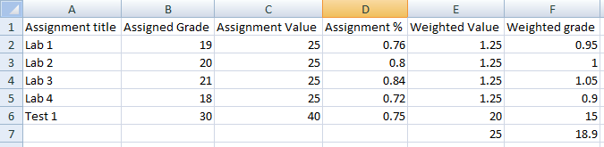

1. Now you just need to clean up a little bit to make sure the sheet looks better (6 marks):
   1. Add all borders to the range A1:F7.
   2. Format the numbers and empty cells in the *Assignment %* column as percentage.
   3. Format the *Weighted Grade* column so the numbers and empty cells are formatted as three decimal places.
   4. Center the titles across the top of the table.
   5. Change the fill colour in the range A1:F1 to the *White, background 1, Darker 25%* colour option (first column, fourth one down).
   6. Change the fill colour in the range E7:F7 to the *standard yellow.*
2. Insert five (5) more rows so we can add in the next portion of the class (1 mark).
3. Modify your worksheet as needed so tha‘t these new rows function like the others – check your formulas to ensure they now cover the proper ranges, check to ensure the new cells are formatted correctly, etc (5 marks).
4. To check your formulas:
   1. Press CTRL+~.
   2. Doing so will switch your cells so they show the formula rather than the values.
   3. Press it again to go back.
5. Your submission should look like the following image, but have all the functionality listed above:

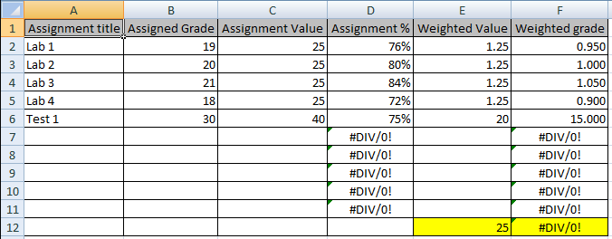

## Part C (50 marks)

*Sometimes users will call in and ask you about things you may never have experienced working with before the call came through. Try to complete the following steps to build a functioning worksheet. Use the following resources to try and solve this particular worksheet: the tool tips that appear, the built in help, Internet resources, and ask questions of your fellow students.*

*Step 1: The user wishes to create a worksheet where they will enter an IP address into the cells of a worksheet. Each octet will occupy its own cell. The user then wishes to determine if the IP address is Class A, B, or C (keep it simple and don’t test for D or E).* *As you know, to determine the class of an IP address you check the first octet.*

On the *Part C* tab complete the following steps:

1. Label cells A1:D1 *Octet 1*, *Octet 2*, *Octet 3*, and *Octet 4*. The user will enter each separate octet into the cells below the titles. And, label cell A4 as *Class*. (1 mark)
2. Since an IP address’ class is determined with a range of values, we will have to have a way to check if a value in a cell falls within a range of values. To do that, we will have to perform two simultaneous checks against a value (whether it’s above a certain value and whether it’s below another value) before we determine what to do. For example, class A is between 0 and 126; so our value must be 0 or more *and* 126 or less to qualify. Both options must be true. Find a function that will check whether all arguments are true, and returns true if all arguments are true. HINT: Boolean logic.
3. Also, we’ll need a way to return one of two values to the user based on a particular value. For example, if we find a class A address, we’ll need to return *Class A* to the cell so the user can see the result, or *Not Class A* if the address isn’t in the range for a class A. Do some research to find a built in function that will allow you to check whether a condition is met, and returns one value if true, and another value if false.
4. In cell B4, use the two functions you found in steps 2 and 3 to determine if the IP Address is class A (1-126). If it is Class A show the result *Class A* in cell B4. If it isn’t class A then show *Not Class A* in cell B4 (7 marks).
5. Without changing the existing functionality (showing whether the IP address is class A), modify the formula to determine if the IP address is class B (128-191). Showing *Class B* if it is and *Not Class B* if it isn’t (4 marks).
6. And now, modify the formula to determine if the IP address is class C (192-223). Showing *Class C* if it is and *Not Class C* if it isn’t (4 marks).
7. One last thing, modify the formula so that if the IP address doesn’t fall within any of these ranges the message reads *Not a class A, B, or C* (1 mark).
8. At this point, your worksheet should look like this, but have all the functionality above:

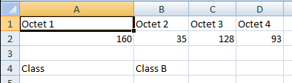

*Step 2: Our user wishes to continue on and calculate a subnet mask using the provided IP address.*

1. In A6 enter the label *Number of Subnets*. The user will provide us with the number of subnets they will use in B6.
2. The formula to calculate the number of bits we require in the last octet for the subnet is Log2(number_of_subnets+2). Determine the function you need to use to find the number of bits we use to finish the subnet mask.
3. You can guess that using the function in step 2 will give us a value with decimal places. We need to find another function that will *always* round the value up to the closest whole number. Find such a function.
4. Add the label *Number of Bits* to cell A7. In cell B7, combine the functions you found in steps 2 and 3 to actually calculate the number of bits by using the number provided by the user (5 marks).
5. Now we use the number of bits to determine what the final octet in the subnet mask looks like. There are a few ways this can be done. To keep things relatively simple, we’ll create a table of possible values and then use that table to determine the final octet. Build the following table on your worksheet in the range F2:G10. If our final octet in the subnet mast uses 1 bit that octet has the decimal equivalent of 128, etc. (2 marks):

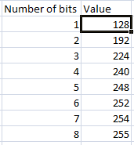

1. In cell A8 add the title *Last Octet*.
2. Now, we need a function that will look up the number of bits in the first column and return the value from the right. Find such a function. *HINT: look values up vertically.*
3. In cell B8 use the function from step 7 to return the decimal equivalent for our last octet (3 marks).
4. In cell A10 add the title *Subnet Mask*. Copy and paste the titles from A1:D1 into A11:D11 (1 mark).
5. In cell A12 type in 255. All subnet masks begin with 255 in the first octet.
6. Write a formula in cell B12 that meets this condition: if the value in B4 is *Class A* show the value in B8. Otherwise show the value 255 (4 marks).
7. Write a formula in cell C12 that meets the following condition: if the value in B4 is *Class B* show the value in B8. If the value in B4 is Class C then show the val
8. ue 255. Otherwise, show a value of 0 (8 marks).
9. Write a formula in cell D12 that meets the following condition: if the value in B4 is *Class C* show the value in B8. Otherwise, show a value of 0 (4 marks).
10. Look up a function to convert decimal numbers to their binary equivalent.
11. In cells A13:D13 use the function from step 14 to show the subnet mask in binary form showing all eight digits (4 marks).
12. Clean up the worksheet (2 marks):
    1. Resize columns as necessary so the user can read the values.
    2. Merge and Center the *Subnet* title across the range A10:D10.
    3. Add borders as in the image below step 17.
    4. Right align the binary numbers in the range A13:D13.
13. Your submission should look like the following image, but have all the functionality listed above:

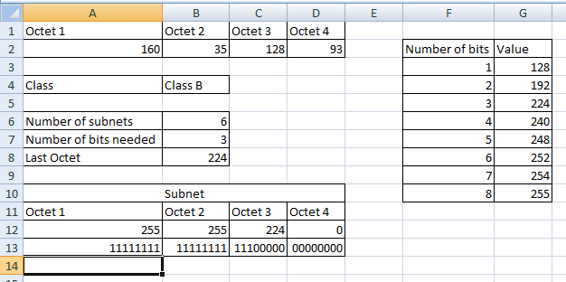

# Submission Guidelines

Please save your final copy using the instructions provided at the beginning of this lab. You should have three worksheets (Part A, Part B, and Part C).

Submit 2 files for marking to the link on Blackboard found under Assignments.

* your final copy (*.xlsx)
* and the original template file (*.xltx)

Check blackboard for the due date of this assignment.