Part A

Explain the differences between:

|  |  |
| --- | --- |
| Footer |  |
| Footnote |  |
| Endnote |  |

<http://en.wikipedia.org/wiki/Computer_network>

A **computer network** or **data network** is a telecommunications network which allows computers to exchange data. In computer networks, networked computing devices pass data to each other along network links (data connections). Data is transferred in the form of packets. The connections between nodes are established using either cable media or wireless media. The best-known computer network is the Internet.

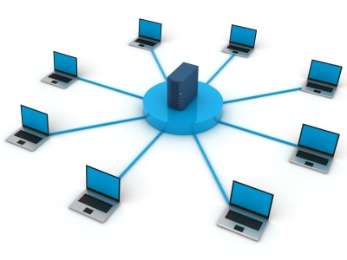

<http://aspne.com/images/computer_network.jpg>

In 1969 the University of California at Los Angeles, the Stanford Research Institute, the University of California at Santa Barbara, and the University of Utah became connected as the beginning of the ARPANET network using 50 kbit/s circuits.

In 1972 commercial services using X.25 were deployed, and later used as an underlying infrastructure for expanding TCP/IP networks.

In 1973, Robert Metcalfe wrote a formal memo at Xerox PARC describing Ethernet, a networking system that was based on the Aloha network, developed in the 1960s by Norman Abramson and colleagues at the University of Hawaii. In July 1976, Robert Metcalfe and David Boggs published their paper "Ethernet: Distributed Packet Switching for Local Computer Networks" and collaborated on several patents received in 1977 and 1978. In 1979 Robert Metcalfe pursued making Ethernet an open standard.

In 1976 John Murphy of Data point Corporation created ARCNET, a token-passing network first used to share storage devices.

In 1995 the transmission speed capacity for Ethernet increased from 10 Mbit/s to 100 Mbit/s. By 1998, Ethernet supported transmission speeds of a Gigabit. The ability of Ethernet to scale easily (such as quickly adapting to support new fiber optic cable speeds) is a contributing factor to its continued use as of 2015

<http://aspne.com/images/computer_network.jpg>



Computer communication links that do not support packets, such as traditional point-to-point telecommunication links, simply transmit data as a bit stream. However, most information in computer networks is carried in *packets*. A network packet is a formatted unit of data (a list of bits or bytes, usually a few tens of bytes to a few kilobytes long) carried by a packet-switched network.

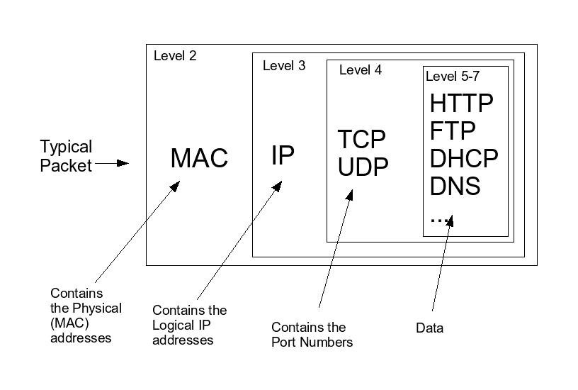

<https://tournasdimitrios1.files.wordpress.com/2011/01/networkpacket.jpg>