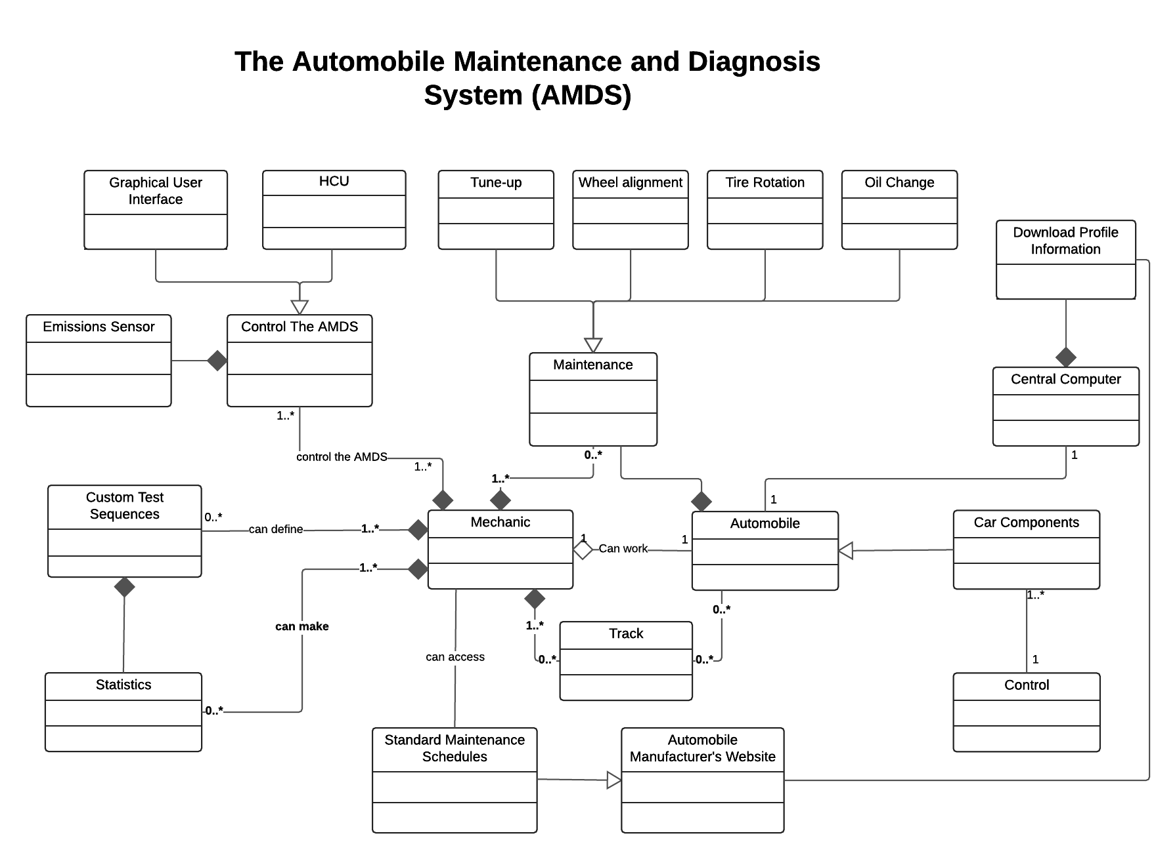

**Mechanic Class:**

Responsible for the storing the main mechanic attribute such as name, id and assigned car, in addition the Mechanic class Responsible for implementing the main mechanic such as maintenance(), track the car state and test().

**Automobile Class:**

Responsible for storing the Automobile attribute such as id, name and the assigned mechanic, as well as this class perform the maintenance type.

**Maintenance Class:**

This class responsible for specifying the the maintenance type and the part of the car that the maintenance will be done on. In addition, this class will contain information such as car name, mechanic name and the task that will be performed.

**Track Class:**

This class responsible for track the cars states which will be done by the mechanic. The track class will contain information about all the work done on the car.

**Car Companies Class:**

The is class will allow the system to control the car companies such as engine, transmission and most others.

**Central Computer Class:**

This class is responsible for detecting when a new pod is attached to the system, as well as, this check if the internet is availability or not and based it will connect to manufacturer's website to download the appropriate profile information for the pod.

**Standard Maintenance Schedules Class:**

This class is responsible for allowing the mechanic to access the maintenance schedules from the automobile manufacturer's website

**Control The AMDS Class:**

Class class allows the user to select an option to Control The AMDS it’s contain two option which are Graphical User Interface and handheld control unit (HCU).

**Emissions Sensor Class:**

This class connected to the main AMDS Control which allows the user to read exhaust gas emissions from the car.

**Custom Test Sequences Class:**

This class responsible for performing the test which can be specified by the mechanic. This class also allows the the mechanic to build the test sequence from individual test step building blocks. This class will store any performed test for future usages.

**Statistics Class:**

The class allows the user to displays different Statistics regarding to tests performed and all the maintainers done to the cars.